**Work report**

**Sitagliptin**

**KK-032**

**Calculation table:**

|  |  |  |  |  |  |
| --- | --- | --- | --- | --- | --- |
| Sr. No | Comp. | Mol. wt. | µmol | Eq. wt. | Wt. taken |
| 1 | Dehydrositagliptin (1) | 405.30 | 125 | 50 | 50 mg |
| 2 | Rh(COD)2BF4 | 406.07 | 2.5 | 1 | 1 mg |
| 3 | HL | 592.57 | 5 | 2 | 2.96 mg |
| 4 | Triethyl amine | 101.19 | 20 | 8 | 2 mg |

**Procedure:** A glass vial (4 mL) equipped with Teflon coated magnetic needle was cooled under vacuum and transferred to a glove box. The vial was then charged with 50 mg of enamine (**1**), 1 mg of [Rh(COD)2BF4] (2 mol%) and ligand (HL). Reaction vial was then closed using screwcap, transferred to a large opening Schlenk type container and was then taken out from the glove box. 2 mL dry THF was added followed by triethyl amine to the vial in inert atmosphere and the resultant reaction slurry was stirred for 1 hour at room temperature (25 °C). After that the reaction vial was shifted to an autoclave and the autoclave was purged three times using hydrogen gas (40 bars). Finally, the autoclave was pressurized to 30 bar hydrogen pressure at room temperature for 12 hrs time period. After the 12 hrs time period, excess pressure was released and the autoclave was opened. The vials were taken out from the autoclave. The thus obtained reaction mixture was passed through neutral alumina bed, the filtrate was collect and dried to yield residue. The resultant residue was then analysed by TLC only starting was present.

**Reaction conditions:** Temp: RT Press.: 30 bar Solvent: THF Time: 12hrs

**Result: 00%** conversion **00%** ee

**KK-033**

**Calculation table:**

|  |  |  |  |  |  |
| --- | --- | --- | --- | --- | --- |
| Sr. No | Comp. | Mol. wt. | µmol | Eq. wt. | Wt. taken |
| 1 | Dehydrositagliptin (1) | 405.30 | 125 | 50 | 50 mg |
| 2 | Rh(COD)2BF4 | 406.07 | 2.5 | 1 | 1 mg |
| 3 | HL | 592.57 | 5 | 2 | 2.96 mg |
| 4 | Triethyl amine | 101.19 | 20 | 8 | 2 mg |

**Procedure:** A glass vial (4 mL) equipped with Teflon coated magnetic needle was cooled under vacuum and transferred to a glove box. The vial was then charged with 50 mg of enamine (**1**), 1 mg of [Rh(COD)2BF4] (2 mol%) and ligand (HL). Reaction vial was then closed using screwcap, transferred to a large opening Schlenk type container and was then taken out from the glove box. 2 mL dry THF was added followed by triethyl amine (2 mg) to the vial in inert atmosphere and the resultant reaction slurry was stirred for 1 hour at room temperature (25 °C). After that the reaction vial was shifted to an autoclave and the autoclave was purged three times using hydrogen gas (40 bars). Finally, the autoclave was pressurized to 30 bar hydrogen pressure at room temperature for 12 hrs time period. After the 12 hrs time period, excess pressure was released and the autoclave was opened. The vials were taken out from the autoclave. The thus obtained reaction mixture was passed through neutral alumina bed, the filtrate was collect and dried to yield residue. The resultant residue was then analysed by TLC only starting was present.

**Reaction conditions:** Temp: RT Press.: 30 bar Solvent: THF Time: 12hrs

**Result: 00%** conversion **00%** ee

**KK-036**

**Calculation table:**

|  |  |  |  |  |  |
| --- | --- | --- | --- | --- | --- |
| Sr. No | Comp. | Mol. wt. | µmol | Eq. wt. | Wt. taken |
| 1 | Dehydrositagliptin (1) | 405.30 | 125 | 50 | 50 mg |
| 2 | Rh(COD)2BF4 | 406.07 | 2.5 | 1 | 1 mg |
| 3 | HL | 592.57 | 5 | 2 | 2.96 mg |

**Procedure:** A glass vial (4 mL) equipped with Teflon coated magnetic needle was cooled under vacuum and transferred to a glove box. The vial was then charged with 50 mg of enamine (**1**), 1 mg of [Rh(COD)2BF4] (2 mol%) and ligand (HL). Reaction vial was then closed using screwcap, transferred to a large opening Schlenk type container and was then taken out from the glove box. 2 mL dry THF was added to the vial in inert atmosphere and the resultant reaction slurry was stirred for 1 hour at room temperature (25 °C). After that the reaction vial was shifted to an autoclave and the autoclave was purged three times using hydrogen gas (40 bars). Finally, the autoclave was pressurized to 30 bar hydrogen pressure at room temperature for 6 hrs time period. After the 6 hrs time period, excess pressure was released and the autoclave was opened. The vials were taken out from the autoclave. The thus obtained reaction mixture was passed through neutral alumina bed, the filtrate was collect and dried to yield residue. The resultant residue was then analysed by HPLC.

**Reaction conditions:** Temp: RT Press.: 30 bar Solvent: THF Time: 6 hrs

**Result: 00%** conversion **00%** ee

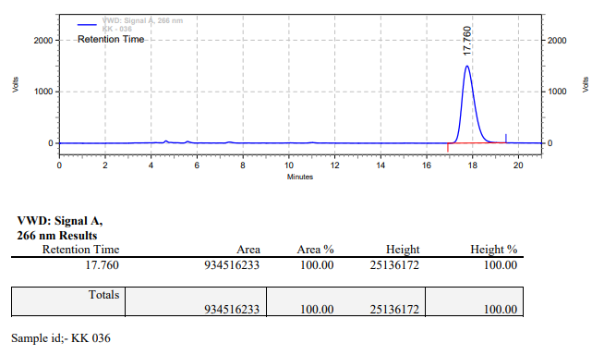

**KK-037**

**Calculation table:**

|  |  |  |  |  |  |
| --- | --- | --- | --- | --- | --- |
| Sr. No | Comp. | Mol. wt. | µmol | Eq. wt. | Wt. taken |
| 1 | Dehydrositagliptin (1) | 405.30 | 125 | 50 | 50 mg |
| 2 | Rh(COD)2BF4 | 406.07 | 2.5 | 1 | 1 mg |
| 3 | HL | 592.57 | 5 | 2 | 2.96 mg |

**Procedure:** A glass vial (4 mL) equipped with Teflon coated magnetic needle was cooled under vacuum and transferred to a glove box. The vial was then charged with 50 mg of enamine (**1**), 1 mg of [Rh(COD)2BF4] (2 mol%) and ligand (HL). Reaction vial was then closed using screwcap, transferred to a large opening Schlenk type container and was then taken out from the glove box. 2 mL dry THF was added to the vial in inert atmosphere and the resultant reaction slurry was stirred for 1 hour at room temperature (25 °C). After that the reaction vial was shifted to an autoclave and the autoclave was purged three times using hydrogen gas (40 bars). Finally, the autoclave was pressurized to 30 bar hydrogen pressure at room temperature for 6 hrs time period. After the 6 hrs time period, excess pressure was released and the autoclave was opened. The vials were taken out from the autoclave. The thus obtained reaction mixture was passed through neutral alumina bed, the filtrate was collect and dried to yield residue. The resultant residue was then analysed by HPLC.

**Reaction conditions:** Temp: RT Press.: 30 bar Solvent: THF Time: 6 hrs

**Result: 00%** conversion **00%** ee

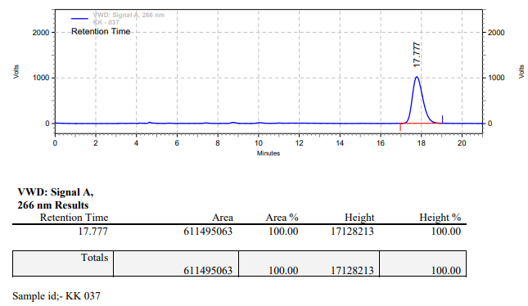

**KK-038**

**Calculation table:**

|  |  |  |  |  |  |
| --- | --- | --- | --- | --- | --- |
| Sr. No | Comp. | Mol. wt. | µmol | Eq. wt. | Wt. taken |
| 1 | Dehydrositagliptin (1) | 405.30 | 125 | 50 | 50 mg |
| 2 | Rh(COD)2BF4 | 406.07 | 2.5 | 1 | 1 mg |
| 3 | HL | 592.57 | 5 | 2 | 2.96 mg |
| 4 | Triethyl amine | 101.19 | 20 | 8 | 2 mg |

**Procedure:** A glass vial (4 mL) equipped with Teflon coated magnetic needle was cooled under vacuum and transferred to a glove box. The vial was then charged with 50 mg of enamine (**1**), 1 mg of [Rh(COD)2BF4] (2 mol%) and ligand (HL). Reaction vial was then closed using screwcap, transferred to a large opening Schlenk type container and was then taken out from the glove box. 2 mL dry THF was added followed by triethyl amine to the vial in inert atmosphere and the resultant reaction slurry was stirred for 1 hour at room temperature (25 °C). After that the reaction vial was shifted to an autoclave and the autoclave was purged three times using hydrogen gas (40 bars). Finally, the autoclave was pressurized to 30 bar hydrogen pressure at room temperature for 6 hrs time period. After the 6 hrs time period, excess pressure was released and the autoclave was opened. The vials were taken out from the autoclave. The thus obtained reaction mixture was passed through neutral alumina bed, the filtrate was collect and dried to yield residue. The resultant residue was then analysed by TLC only starting was present.

**Reaction conditions:** Temp: RT Press.: 30 bar Solvent: THF Time: 6 hrs

**Result: 00%** conversion **00%** ee

**KK-039**

**Calculation table:**

|  |  |  |  |  |  |
| --- | --- | --- | --- | --- | --- |
| Sr. No | Comp. | Mol. wt. | µmol | Eq. wt. | Wt. taken |
| 1 | Dehydrositagliptin (1) | 405.30 | 125 | 50 | 50 mg |
| 2 | Rh(COD)2BF4 | 406.07 | 2.5 | 1 | 1 mg |
| 3 | HL | 592.57 | 5 | 2 | 2.96 mg |
| 4 | Triethyl amine | 101.19 | 20 | 8 | 2 mg |

**Procedure:** A glass vial (4 mL) equipped with Teflon coated magnetic needle was cooled under vacuum and transferred to a glove box. The vial was then charged with 50 mg of enamine (**1**), 1 mg of [Rh(COD)2BF4] (2 mol%) and ligand (HL). Reaction vial was then closed using screwcap, transferred to a large opening Schlenk type container and was then taken out from the glove box. 2 mL dry THF was added followed by triethyl amine to the vial in inert atmosphere and the resultant reaction slurry was stirred for 1 hour at room temperature (25 °C). After that the reaction vial was shifted to an autoclave and the autoclave was purged three times using hydrogen gas (40 bars). Finally, the autoclave was pressurized to 30 bar hydrogen pressure at room temperature for 6 hrs time period. After the 6 hrs time period, excess pressure was released and the autoclave was opened. The vials were taken out from the autoclave. The thus obtained reaction mixture was passed through neutral alumina bed, the filtrate was collect and dried to yield residue. The resultant residue was then analysed by HPLC.

**Reaction conditions:** Temp: RT Press.: 30 bar Solvent: THF Time: 6 hrs

**Result: 00%** conversion **00%** ee

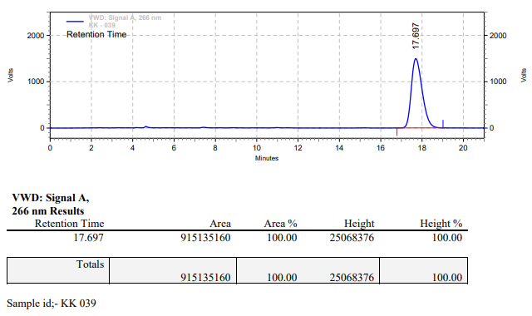

**KK-040**



**Calculation table:**

|  |  |  |  |  |  |
| --- | --- | --- | --- | --- | --- |
| Sr. No | Comp. | Mol. wt. | mmol | Eq. wt. | Wt. taken |
| 1 | Dehydrositagliptin (1) | 405.30 | 1.42 | 1 | 576 mg |
| 2 | Rh(COD)2OTf | 468.30 | 0.0021 | 1.50x10-3 | 1 mg |
| 3 | tBu-Josiphos | 542.45 | 0.0022 | 1.55x10-3 | 1.2 mg |
| 4 | Ammonium chloride | 53.49 | 0.0021 | 1.50x10-3 | 0.1 mg |

**Procedure:** A glass vial (15 mL) equipped with Teflon coated magnetic needle was cooled under vacuum and transferred to a glove box. The vial was then charged with 576 mg of enamine (**1**), 1 mg of [Rh(COD)2OTf] (0.15 mol%), tBu-Josiphos and ammonium chloride. Reaction vial was then closed using screwcap, transferred to a large opening Schlenk type container and was then taken out from the glove box. 5 mL dry methanol was added to the vial in inert atmosphere and the resultant reaction slurry was stirred for 1 hour at room temperature (25 °C). After that the reaction vial was shifted to an autoclave and the autoclave was purged three times using hydrogen gas (40 bars). Finally, the autoclave was pressurized to 20 bar hydrogen pressure at 50°C for 17 hrs time period. After the 17 hrs time period, the autoclave was cooled to room temperature (25 °C), excess pressure was released and the autoclave was opened. The vials were taken out from the autoclave. The thus obtained reaction mixture was passed through neutral alumina bed, the filtrate was collect and dried to yield residue. The resultant residue was then analysed by HPLC.

**Reaction conditions:** Temp: 50°C Press.: 20 bar Solvent: Methanol Time: 17 hrs

**Result: 00%** conversion **00%** ee

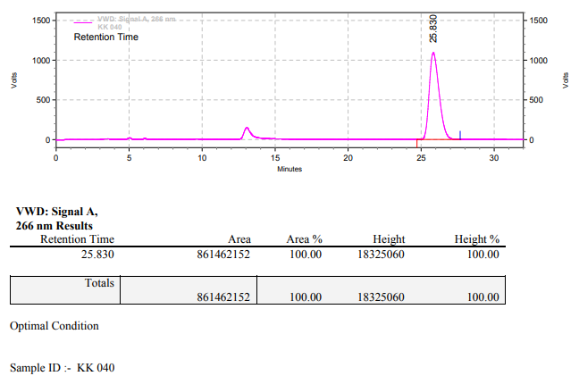

**KK-046**



**Calculation table:**

|  |  |  |  |  |  |
| --- | --- | --- | --- | --- | --- |
| Sr. No | Comp. | Mol. wt. | mmol | Eq. wt. | Wt. taken |
| 1 | Dehydrositagliptin (1) | 405.30 | 0.2135 | 100 | 86 mg |
| 2 | Rh(COD)2OTf | 468.30 | 0.0021 | 1 | 1 mg |
| 3 | tBu-Josiphos | 542.45 | 0.0022 | 1.05 | 1.2 mg |
| 4 | Ammonium chloride | 53.49 | 0.0021 | 1 | 0.1 mg |

**Procedure:** A glass vial (4 mL) equipped with Teflon coated magnetic needle was cooled under vacuum and transferred to a glove box. The vial was then charged with 86 mg of enamine (**1**), 1 mg of [Rh(COD)2OTf] (1 mol%), tBu-Josiphos and ammonium chloride. Reaction vial was then closed using screwcap, transferred to a large opening Schlenk type container and was then taken out from the glove box. 2 mL dry methanol was added to the vial in inert atmosphere and the resultant reaction slurry was stirred for 1 hour at room temperature (25 °C). After that the reaction vial was shifted to an autoclave and the autoclave was purged three times using hydrogen gas (40 bars). Finally, the autoclave was pressurized to 20 bar hydrogen pressure at 50°C for 17 hrs time period. After the 17 hrs time period, the autoclave was cooled to room temperature (25 °C), excess pressure was released and the autoclave was opened. The vials were taken out from the autoclave. The thus obtained reaction mixture was passed through neutral alumina bed, the filtrate was collect and dried to yield residue. The resultant residue was then analysed by HPLC.

**Reaction conditions:** Temp: 50°C Press.: 20 bar Solvent: Methanol Time: 17 hrs

**Result: 20%** conversion **94.5%** ee

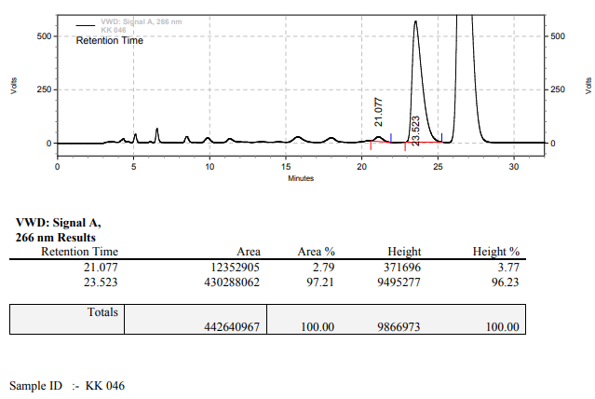

**KK-047**



**Calculation table:**

|  |  |  |  |  |  |
| --- | --- | --- | --- | --- | --- |
| Sr. No | Comp. | Mol. wt. | mmol | Eq. wt. | Wt. taken |
| 1 | Dehydrositagliptin (1) | 405.30 | 0.1386 | 66 | 56.17 mg |
| 2 | Rh(COD)2OTf | 468.30 | 0.0021 | 1 | 1 mg |
| 3 | tBu-Josiphos | 542.45 | 0.0022 | 1.05 | 1.19 mg |
| 4 | Ammonium chloride | 53.49 | 0.0021 | 1 | 0.1 mg |

**Procedure:** A glass vial (4 mL) equipped with Teflon coated magnetic needle was cooled under vacuum and transferred to a glove box. The vial was then charged with 56.17 mg of enamine (**1**), 1 mg of [Rh(COD)2OTf], tBu-Josiphos and ammonium chloride. Reaction vial was then closed using screwcap, transferred to a large opening Schlenk type container and was then taken out from the glove box. 2 mL dry methanol was added to the vial in inert atmosphere and the resultant reaction slurry was stirred for 1 hour at room temperature (25 °C). After that the reaction vial was shifted to an autoclave and the autoclave was purged three times using hydrogen gas (40 bars). Finally, the autoclave was pressurized to 20 bar hydrogen pressure at 50°C for 17 hrs time period. After the 17 hrs time period, the autoclave was cooled to room temperature (25 °C), excess pressure was released and the autoclave was opened. The vials were taken out from the autoclave. The thus obtained reaction mixture was passed through neutral alumina bed, the filtrate was collect and dried to yield residue. The resultant residue was then analysed by HPLC.

**Reaction conditions:** Temp: 50°C Press.: 20 bar Solvent: Methanol Time: 17 hrs

**Result: 99%** conversion **96%** ee

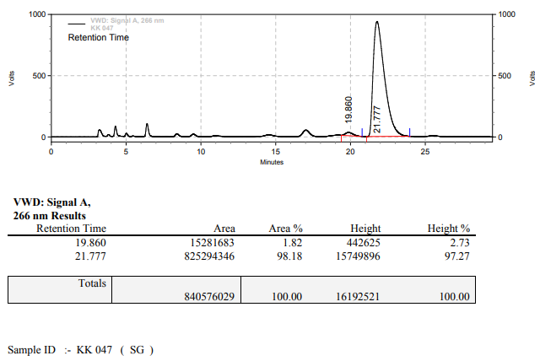

**KK-051**



**Calculation table:**

|  |  |  |  |  |  |
| --- | --- | --- | --- | --- | --- |
| Sr. No | Comp. | Mol. wt. | mmol | Eq. wt. | Wt. taken |
| 1 | Dehydrositagliptin (1) | 405.30 | 1.42 | 1 | 576 mg |
| 2 | Rh(COD)2OTf | 468.30 | 0.0021 | 1.50x10-3 | 1 mg |
| 3 | tBu-Josiphos | 542.45 | 0.0022 | 1.55x10-3 | 1.2 mg |
| 4 | Ammonium chloride | 53.49 | 0.0021 | 1.50x10-3 | 0.1 mg |

**Procedure:** A glass vial (50 mL) equipped with Teflon coated magnetic needle was cooled under vacuum and transferred to a glove box. The vial was then charged with 576 mg of enamine (**1**), 1 mg of [Rh(COD)2OTf] (0.15 mol%), tBu-Josiphos and ammonium chloride. Reaction vial was then closed using screwcap, transferred to a large opening Schlenk type container and was then taken out from the glove box. 20 mL dry methanol was added to the vial in inert atmosphere and the resultant reaction slurry was stirred for 1 hour at room temperature (25 °C). After that the reaction vial was shifted to an autoclave and the autoclave was purged three times using hydrogen gas (40 bars). Finally, the autoclave was pressurized to 20 bar hydrogen pressure at 50°C for 18 hrs time period. After the 18 hrs time period, the autoclave was cooled to room temperature (25 °C), excess pressure was released and the autoclave was opened. The vials were taken out from the autoclave. The thus obtained reaction mixture was passed through neutral alumina bed, the filtrate was collect and dried to yield residue. The resultant residue was then analysed by HPLC.

**Reaction conditions:** Temp: 50°C Press.: 20 bar Solvent: Methanol Time: 18 hrs

**Result: 10%** conversion **99%** ee

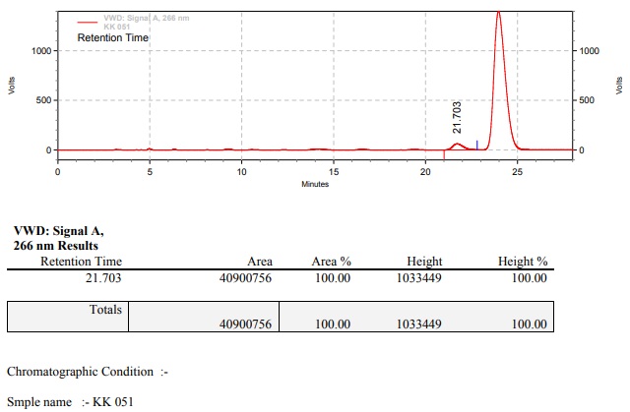

**KK-054**



**Calculation table:**

|  |  |  |  |  |  |
| --- | --- | --- | --- | --- | --- |
| Sr. No | Comp. | Mol. wt. | mmol | Eq. wt. | Wt. taken |
| 1 | Dehydrositagliptin (1) | 405.30 | 1.42 | 1 | 576 mg |
| 2 | Rh(COD)2OTf | 468.30 | 0.0021 | 1.50x10-3 | 1 mg |
| 3 | tBu-Josiphos | 542.45 | 0.0022 | 1.55x10-3 | 1.2 mg |
| 4 | Ammonium chloride | 53.49 | 0.0021 | 1.50x10-3 | 0.1 mg |

**Procedure:** A glass vial (50 mL) equipped with Teflon coated magnetic needle was cooled under vacuum and transferred to a glove box. The vial was then charged with 576 mg of enamine (**1**), 1 mg of [Rh(COD)2OTf] (0.15 mol%), tBu-Josiphos and ammonium chloride. Reaction vial was then closed using screwcap, transferred to a large opening Schlenk type container and was then taken out from the glove box. 20 mL dry methanol was added to the vial in inert atmosphere and the resultant reaction slurry was stirred for 1 hour at room temperature (25 °C). After that the reaction vial was shifted to an autoclave and the autoclave was purged three times using hydrogen gas (40 bars). Finally, the autoclave was pressurized to 20 bar hydrogen pressure at 50°C for 18 hrs time period. After the 18 hrs time period, the autoclave was cooled to room temperature (25 °C), excess pressure was released and the autoclave was opened. The vials were taken out from the autoclave. The thus obtained reaction mixture was passed through neutral alumina bed, the filtrate was collect and dried to yield residue. The resultant residue was then analysed by HPLC.

**Reaction conditions:** Temp: 50°C Press.: 20 bar Solvent: Methanol Time: 18 hrs

**Result:** conversion ee

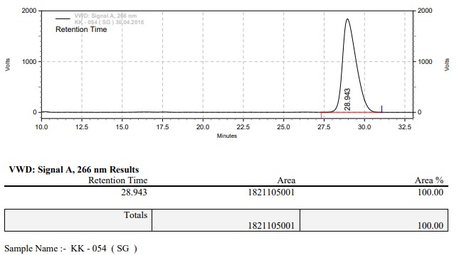

**KK-057**



Calculation table:

|  |  |  |  |  |  |
| --- | --- | --- | --- | --- | --- |
| Sr. No | Comp. | Mol. wt. | mmol | Eq. wt. | Wt. taken |
| 1 | Dehydrositagliptin (1) | 405.30 | 1.42 | 1 | 576 mg |
| 2 | Rh(COD)2OTf | 468.30 | 0.0021 | 1.50x10-3 | 1 mg |
| 3 | tBu-Josiphos | 542.45 | 0.0022 | 1.55x10-3 | 1.2 mg |
| 4 | Ammonium chloride | 53.49 | 0.0021 | 1.50x10-3 | 0.1 mg |

**Procedure:** A glass vial (50 mL) equipped with Teflon coated magnetic needle was cooled under vacuum and transferred to a glove box. The vial was then charged with 576 mg of enamine (**1**), 1 mg of [Rh(COD)OTf] (0.15 mol%), tBu-Josiphos and ammonium chloride. Reaction vial was then closed using screwcap, transferred to a large opening Schlenk type container and was then taken out from the glove box. 20 mL dry THF was added to the vial in inert atmosphere and the resultant reaction slurry was stirred for 1 hour at room temperature (25 °C). After that the reaction vial was shifted to an autoclave and the autoclave was purged three times using hydrogen gas (40 bars). Finally, the autoclave was pressurized to 20 bar hydrogen pressure at 50°C for 17 hrs time period. After the 17 hrs time period, the autoclave was cooled to room temperature (25 °C), excess pressure was released and the autoclave was opened. The vials were taken out from the autoclave. The thus obtained reaction mixture was passed through neutral alumina bed, the filtrate was collect and dried to yield residue. The resultant residue was then analysed by HPLC.

**Reaction conditions:** Temp: 50°C Press.: 20 bar Solvent: THF Time: 17 hrs

**Result: 00%** conversion **00%** ee

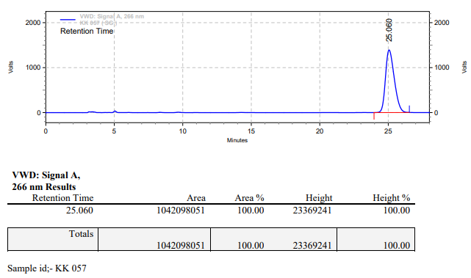

**KK-059**



**Calculation table:**

|  |  |  |  |  |  |
| --- | --- | --- | --- | --- | --- |
| Sr. No | Comp. | Mol. wt. | mmol | Eq. wt. | Wt. taken |
| 1 | Dehydrositagliptin (1) | 405.30 | 0.2135 | 100 | 86 mg |
| 2 | Rh(COD)2OTf | 468.30 | 0.0021 | 1 | 1 mg |
| 3 | L4 | 306.36 | 0.0022 | 1.05 | 0.7 mg |
| 4 | Ammonium chloride | 53.49 | 0.0021 | 1 | 0.1 mg |

**Procedure:** A glass vial (4 mL) equipped with Teflon coated magnetic needle was cooled under vacuum and transferred to a glove box. The vial was then charged with 86 mg of enamine (**1**), 1 mg of [Rh(COD)2OTf] (1 mol%), ligand (L4) and ammonium chloride. Reaction vial was then closed using screwcap, transferred to a large opening Schlenk type container and was then taken out from the glove box. 2 mL dry methanol was added to the vial in inert atmosphere and the resultant reaction slurry was stirred for 1 hour at room temperature (25 °C). After that the reaction vial was shifted to an autoclave and the autoclave was purged three times using hydrogen gas (40 bars). Finally, the autoclave was pressurized to 20 bar hydrogen pressure at 50°C for 17 hrs time period. After the 17 hrs time period, the autoclave was cooled to room temperature (25 °C), excess pressure was released and the autoclave was opened. The vials were taken out from the autoclave. The thus obtained reaction mixture was passed through neutral alumina bed, the filtrate was collect and dried to yield residue. The resultant residue was then analysed by HPLC.

**Reaction conditions:** Temp: 50°C Press.: 20 bar Solvent: methanol Time: 17 hrs

**Result: 00%** conversion **00%** ee

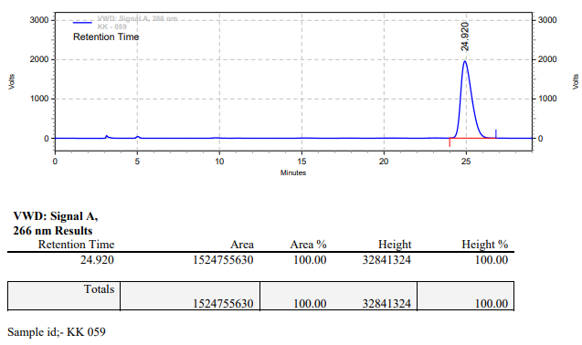

**KK-060**



**Calculation table:**

|  |  |  |  |  |  |
| --- | --- | --- | --- | --- | --- |
| Sr. No | Comp. | Mol. wt. | mmol | Eq. wt. | Wt. taken |
| 1 | Dehydrositagliptin (1) | 405.30 | 0.2135 | 100 | 86 mg |
| 2 | Rh(COD)2OTf | 468.30 | 0.0021 | 1 | 1 mg |
| 3 | L3 | 414.29 | 0.0022 | 1.05 | 0.9 mg |
| 4 | Ammonium chloride | 53.49 | 0.0021 | 1 | 0.1 mg |

**Procedure:** A glass vial (4 mL) equipped with Teflon coated magnetic needle was cooled under vacuum and transferred to a glove box. The vial was then charged with 86 mg of enamine (**1**), 1 mg of [Rh(COD)2OTf], ligand (L3) and ammonium chloride. Reaction vial was then closed using screwcap, transferred to a large opening Schlenk type container and was then taken out from the glove box. 2 mL dry methanol was added to the vial in inert atmosphere and the resultant reaction slurry was stirred for 1 hour at room temperature (25 °C). After that the reaction vial was shifted to an autoclave and the autoclave was purged three times using hydrogen gas (40 bars). Finally, the autoclave was pressurized to 20 bar hydrogen pressure at 50°C for 17 hrs time period. After the 17 hrs time period, the autoclave was cooled to room temperature (25 °C), excess pressure was released and the autoclave was opened. The vials were taken out from the autoclave. The thus obtained reaction mixture was passed through neutral alumina bed, the filtrate was collect and dried to yield residue. The resultant residue was then analysed by HPLC.

**Reaction conditions:** Temp: 50°C Press.: 20 bar Solvent: methanol Time: 17 hrs

**Result:** 20% conversion 85% ee

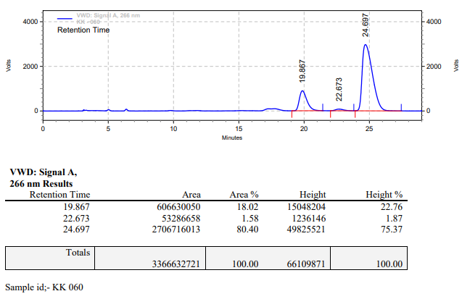

**KK-061**



**Calculation table:**

|  |  |  |  |  |  |
| --- | --- | --- | --- | --- | --- |
| Sr. No | Comp. | Mol. wt. | mmol | Eq. wt. | Wt. taken |
| 1 | Dehydrositagliptin (1) | 405.30 | 0.2135 | 100 | 86 mg |
| 2 | Rh(COD)2OTf | 468.30 | 0.0021 | 1 | 1 mg |
| 3 | L1 | 496.53 | 0.0022 | 1.05 | 1.1 mg |
| 4 | Ammonium chloride | 53.49 | 0.0021 | 1 | 0.1 mg |

**Procedure:** A glass vial (4 mL) equipped with Teflon coated magnetic needle was cooled under vacuum and transferred to a glove box. The vial was then charged with 86 mg of enamine (**1**), 1 mg of [Rh(COD)OTf] (1 mol%), ligand (L1) and ammonium chloride. Reaction vial was then closed using screwcap, transferred to a large opening Schlenk type container and was then taken out from the glove box. 2 mL dry methanol was added to the vial in inert atmosphere and the resultant reaction slurry was stirred for 1 hour at room temperature (25 °C). After that the reaction vial was shifted to an autoclave and the autoclave was purged three times using hydrogen gas (40 bars). Finally, the autoclave was pressurized to 20 bar hydrogen pressure at 50°C for 17 hrs time period. After the 17 hrs time period, the autoclave was cooled to room temperature (25 °C), excess pressure was released and the autoclave was opened. The vials were taken out from the autoclave. The thus obtained reaction mixture was passed through neutral alumina bed, the filtrate was collect and dried to yield residue. The resultant residue was then analysed by HPLC.

**Reaction conditions:** Temp: 50°C Press.: 20 bar Solvent: methanol Time: 17 hrs

**Result:**  **00%** conversion **00%** ee

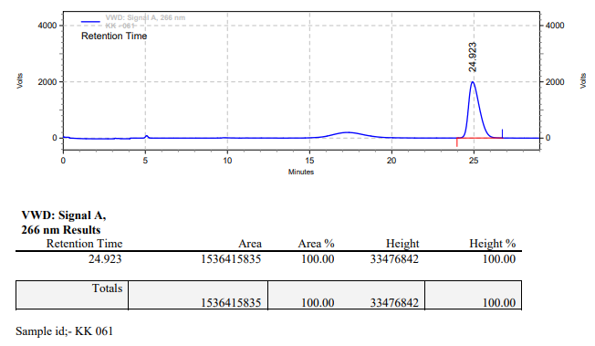

**KK-062**



**Calculation table:**

|  |  |  |  |  |  |
| --- | --- | --- | --- | --- | --- |
| Sr. No | Comp. | Mol. wt. | mmol | Eq. wt. | Wt. taken |
| 1 | Dehydrositagliptin (1) | 405.30 | 0.2135 | 100 | 86 mg |
| 2 | Rh(COD)2OTf | 468.30 | 0.0021 | 1 | 1 mg |
| 3 | L3 | 414.29 | 0.0022 | 1.05 | 0.9 mg |
| 4 | Ammonium chloride | 53.49 | 0.0021 | 1 | 0.1 mg |

Procedure: A glass vial (4 mL) equipped with Teflon coated magnetic needle was cooled under vacuum and transferred to a glove box. The vial was then charged with 86 mg of enamine (1), 1 mg of [Rh(COD)2OTf] (1 mol%), ligand (L2) and ammonium chloride. Reaction vial was then closed using screwcap, transferred to a large opening Schlenk type container and was then taken out from the glove box. 2 mL dry methanol was added to the vial in inert atmosphere and the resultant reaction slurry was stirred for 1 hour at room temperature (25 °C). After that the reaction vial was shifted to an autoclave and the autoclave was purged three times using hydrogen gas (40 bars). Finally, the autoclave was pressurized to 20 bar hydrogen pressure at 50°C for 17 hrs time period. After the 17 hrs time period, the autoclave was cooled to room temperature (25 °C), excess pressure was released and the autoclave was opened. The vials were taken out from the autoclave. The thus obtained reaction mixture was passed through neutral alumina bed, the filtrate was collect and dried to yield residue. The resultant residue was then analysed by HPLC.

**Reaction conditions:** Temp: 50°C Press.: 20 bar Solvent: methanol Time: 17 hrs

**Result: 00%** conversion **00%** ee

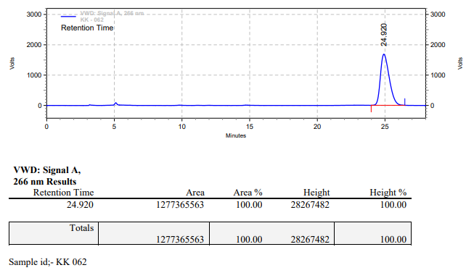

**KK-069**



**Calculation table:**

|  |  |  |  |  |  |
| --- | --- | --- | --- | --- | --- |
| Sr. No | Comp. | Mol. wt. | mmol | Eq. wt. | Wt. taken |
| 1 | Dehydrositagliptin (1) | 405.30 | 0.2135 | 100 | 86 mg |
| 2 | Rh(COD)2OTf | 468.30 | 0.0021 | 1 | 1 mg |
| 3 | L3 | 414.29 | 0.0022 | 1.05 | 0.9 mg |
| 4 | Ammonium chloride | 53.49 | 0.0021 | 1 | 0.1 mg |

**Procedure:** A glass vial (4 mL) equipped with Teflon coated magnetic needle was cooled under vacuum and transferred to a glove box. The vial was then charged with 86 mg of enamine (**1**), 1 mg of [Rh(COD)2OTf] (1 mol%), ligand (L3) and ammonium chloride. Reaction vial was then closed using screwcap, transferred to a large opening Schlenk type container and was then taken out from the glove box. 2 mL dry methanol was added to the vial in inert atmosphere and the resultant reaction slurry was stirred for 1 hour at room temperature (25 °C). After that the reaction vial was shifted to an autoclave and the autoclave was purged three times using hydrogen gas (40 bars). Finally, the autoclave was pressurized to 20 bar hydrogen pressure at 90°C for 17 hrs time period. After the 17 hrs time period, the autoclave was cooled to room temperature (25 °C), excess pressure was released and the autoclave was opened. The vials were taken out from the autoclave. The thus obtained reaction mixture was passed through neutral alumina bed, the filtrate was collect and dried to yield residue. The resultant residue was then analysed by HPLC.

**Reaction conditions:** Temp: 90°C Press.: 20 bar Solvent: methanol Time: 17 hrs

**Result:** 90% conversion 87% ee

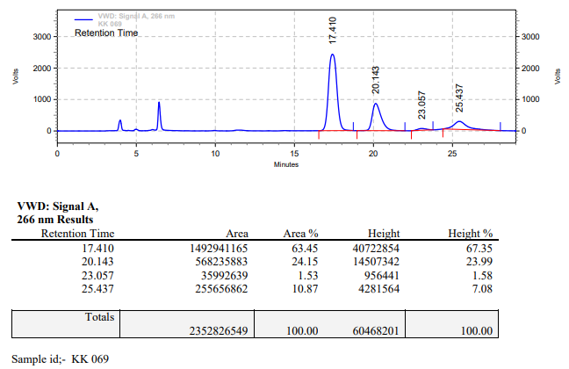

**KK-070**



**Calculation table:**

|  |  |  |  |  |  |
| --- | --- | --- | --- | --- | --- |
| Sr. No | Comp. | Mol. wt. | mmol | Eq. wt. | Wt. taken |
| 1 | Dehydrositagliptin (1) | 405.30 | 0.2135 | 100 | 86 mg |
| 2 | Rh(COD)2OTf | 468.30 | 0.0021 | 1 | 1 mg |
| 3 | L3 | 414.29 | 0.0022 | 1.05 | 0.9 mg |
| 4 | Ammonium chloride | 53.49 | 0.0021 | 1 | 0.1 mg |

**Procedure:** A glass vial (4 mL) equipped with Teflon coated magnetic needle was cooled under vacuum and transferred to a glove box. The vial was then charged with 86 mg of enamine (**1**), 1 mg of [Rh(COD)2OTf], ligand (L3) and ammonium chloride. Reaction vial was then closed using screwcap, transferred to a large opening Schlenk type container and was then taken out from the glove box. 2 mL dry methanol was added to the vial in inert atmosphere and the resultant reaction slurry was stirred for 1 hour at room temperature (25 °C). After that the reaction vial was shifted to an autoclave and the autoclave was purged three times using hydrogen gas (40 bars). Finally, the autoclave was pressurized to 20 bar hydrogen pressure at 90°C for 17 hrs time period. After the 17 hrs time period, the autoclave was cooled to room temperature (25 °C), excess pressure was released and the autoclave was opened. The vials were taken out from the autoclave. The thus obtained reaction mixture was passed through neutral alumina bed, the filtrate was collect and dried to yield residue. The resultant residue was then analysed by HPLC.

**Reaction conditions:** Temp: 90°C Press.: 20 bar Solvent: methanol Time: 17 hrs

**Result:** 75% conversion 85% ee

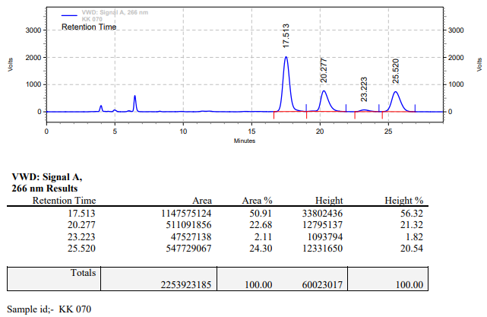

**KK-071**

**Calculation table:**

|  |  |  |  |  |  |
| --- | --- | --- | --- | --- | --- |
| Sr. No | Comp. | Mol. wt. | µmol | Eq. wt. | Wt. taken |
| 1 | Dehydrositagliptin (1) | 405.30 | 0.2135 | 100 | 86 mg |
| 2 | Rh(COD)2OTf | 468.30 | 0.0021 | 1 | 1 mg |
| 3 | HL | 592.57 | 0.0022 | 1.05 | 1.3 mg |
| 4 | Ammonium chloride | 53.49 | 0.0021 | 1 | 0.1 mg |

**Procedure:** A glass vial (4 mL) equipped with Teflon coated magnetic needle was cooled under vacuum and transferred to a glove box. The vial was then charged with 86 mg of enamine (**1**), 1 mg of [Rh(COD)2OTF] (1 mol%), ligand (HL) and ammonium chloride. Reaction vial was then closed using screwcap, transferred to a large opening Schlenk type container and was then taken out from the glove box. 2 mL dry THF was added to the vial in inert atmosphere and the resultant reaction slurry was stirred for 1 hour at room temperature (25 °C). After that the reaction vial was shifted to an autoclave and the autoclave was purged three times using hydrogen gas (40 bars). Finally, the autoclave was pressurized to 20 bar hydrogen pressure at 80°C for 17 hrs time period. After the 17 hrs time period, excess pressure was released and the autoclave was opened. The vials were taken out from the autoclave. The thus obtained reaction mixture was passed through neutral alumina bed, the filtrate was collect and dried to yield residue. The resultant residue was then analysed by HPLC.

**Reaction conditions:** Temp: 80°C Press.: 20 bar Solvent: THF Time: 17 hrs

**Result: 00%** conversion **00%** ee

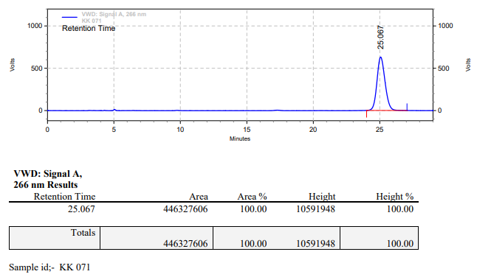

**KK-072**

**Calculation table:**

|  |  |  |  |  |  |
| --- | --- | --- | --- | --- | --- |
| Sr. No | Comp. | Mol. wt. | µmol | Eq. wt. | Wt. taken |
| 1 | Dehydrositagliptin (1) | 405.30 | 0.2135 | 100 | 86 mg |
| 2 | Rh(COD)2OTf | 468.30 | 0.0021 | 1 | 1 mg |
| 3 | HL | 592.57 | 0.0022 | 1.05 | 1.3 mg |
| 4 | Ammonium chloride | 53.49 | 0.0021 | 1 | 0.1 mg |

**Procedure:** A glass vial (4 mL) equipped with Teflon coated magnetic needle was cooled under vacuum and transferred to a glove box. The vial was then charged with 86 mg of enamine (**1**), 1 mg of [Rh(COD)2OTF] (1 mol%), ligand (HL) and ammonium chloride. Reaction vial was then closed using screwcap, transferred to a large opening Schlenk type container and was then taken out from the glove box. 2 mL dry THF was added to the vial in inert atmosphere and the resultant reaction slurry was stirred for 1 hour at room temperature (25 °C). After that the reaction vial was shifted to an autoclave and the autoclave was purged three times using hydrogen gas (40 bars). Finally, the autoclave was pressurized to 20 bar hydrogen pressure at 80°C for 17 hrs time period. After the 17 hrs time period, excess pressure was released and the autoclave was opened. The vials were taken out from the autoclave. The thus obtained reaction mixture was passed through neutral alumina bed, the filtrate was collect and dried to yield residue. The resultant residue was then analysed by HPLC.

**Reaction conditions:** Temp: 80°C Press.: 20 bar Solvent: THF Time: 17 hrs

**Result: 00%** conversion **00%** ee

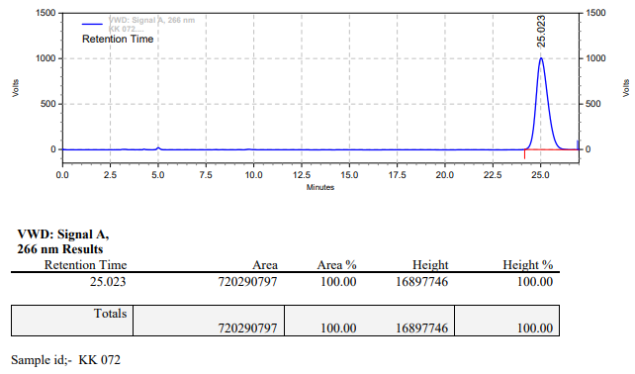

**KK-073**

**Calculation table:**

|  |  |  |  |  |  |
| --- | --- | --- | --- | --- | --- |
| Sr. No | Comp. | Mol. wt. | µmol | Eq. wt. | Wt. taken |
| 1 | Dehydrositagliptin (1) | 405.30 | 0.2400 | 100 | 97 mg |
| 2 | Rh(COD)2BF4 | 405.07 | 0.0024 | 1 | 1 mg |
| 3 | HL | 592.57 | 0.0026 | 1.05 | 1.5 mg |
| 4 | Ammonium chloride | 53.49 | 0.0024 | 1 | 0.1 mg |

**Procedure:** A glass vial (4 mL) equipped with Teflon coated magnetic needle was cooled under vacuum and transferred to a glove box. The vial was then charged with 97 mg of enamine (**1**), 1 mg of [Rh(COD)2BF4] (1 mol%), ligand (HL) and ammonium chloride. Reaction vial was then closed using screwcap, transferred to a large opening Schlenk type container and was then taken out from the glove box. 2 mL dry THF was added to the vial in inert atmosphere and the resultant reaction slurry was stirred for 1 hour at room temperature (25 °C). After that the reaction vial was shifted to an autoclave and the autoclave was purged three times using hydrogen gas (40 bars). Finally, the autoclave was pressurized to 20 bar hydrogen pressure at 80 °C for 17 hrs time period. After the 17 hrs time period, excess pressure was released and the autoclave was opened. The vials were taken out from the autoclave. The thus obtained reaction mixture was passed through neutral alumina bed, the filtrate was collect and dried to yield residue. The resultant residue was then analysed by HPLC.

**Reaction conditions:** Temp: 80 °C Press.: 20 bar Solvent: THF Time: 17 hrs

**Result: 00%** conversion **00%** ee

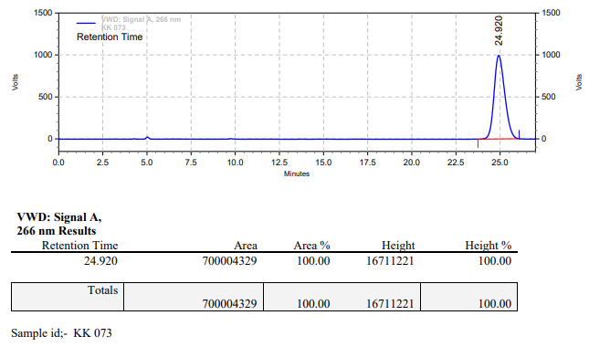

**KK-074**

**Calculation table:**

|  |  |  |  |  |  |
| --- | --- | --- | --- | --- | --- |
| Sr. No | Comp. | Mol. wt. | µmol | Eq. wt. | Wt. taken |
| 1 | Dehydrositagliptin (1) | 405.30 | 0.2400 | 100 | 97 mg |
| 2 | Rh(COD)2BF4 | 405.07 | 0.0024 | 1 | 1 mg |
| 3 | HL | 592.57 | 0.0026 | 1.05 | 1.5 mg |
| 4 | Ammonium chloride | 53.49 | 0.0024 | 1 | 0.1 mg |

**Procedure:** A glass vial (4 mL) equipped with Teflon coated magnetic needle was cooled under vacuum and transferred to a glove box. The vial was then charged with 97 mg of enamine (**1**), 1 mg of [Rh(COD)2BF4] (1 mol%), ligand (HL) and ammonium chloride. Reaction vial was then closed using screwcap, transferred to a large opening Schlenk type container and was then taken out from the glove box. 2 mL dry THF was added to the vial in inert atmosphere and the resultant reaction slurry was stirred for 1 hour at room temperature (25 °C). After that the reaction vial was shifted to an autoclave and the autoclave was purged three times using hydrogen gas (40 bars). Finally, the autoclave was pressurized to 20 bar hydrogen pressure at 80°C for 17 hrs time period. After the 17 hrs time period, excess pressure was released and the autoclave was opened. The vials were taken out from the autoclave. The thus obtained reaction mixture was passed through neutral alumina bed, the filtrate was collect and dried to yield residue. The resultant residue was then analysed by HPLC.

**Reaction conditions:** Temp: 80°C Press.: 20 bar Solvent: THF Time: 17 hrs

**Result: 00%** conversion **00%** ee

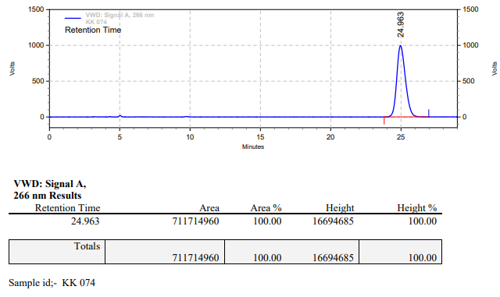

**KK-079**



**Calculation table:**

|  |  |  |  |  |  |
| --- | --- | --- | --- | --- | --- |
| Sr. No | Comp. | Mol. wt. | mmol | Eq. wt. | Wt. taken |
| 1 | Dehydrositagliptin (1) | 405.30 | 0.2135 | 100 | 86 mg |
| 2 | Rh(COD)2OTf | 468.30 | 0.0021 | 1 | 1 mg |
| 3 | L3 | 414.29 | 0.0022 | 1.05 | 0.9 mg |

**Procedure:** A glass vial (4 mL) equipped with Teflon coated magnetic needle was cooled under vacuum and transferred to a glove box. The vial was then charged with 86 mg of enamine (**1**), 1 mg of [Rh(COD)2OTf] (1 mol%), and ligand (L3). Reaction vial was then closed using screwcap, transferred to a large opening Schlenk type container and was then taken out from the glove box. 2 mL dry methanol was added to the vial in inert atmosphere and the resultant reaction slurry was stirred for 1 hour at room temperature (25 °C). After that the reaction vial was shifted to an autoclave and the autoclave was purged three times using hydrogen gas (40 bars). Finally, the autoclave was pressurized to 20 bar hydrogen pressure at 90°C for 17 hrs time period. After the 17 hrs time period, the autoclave was cooled to room temperature (25 °C), excess pressure was released and the autoclave was opened. The vials were taken out from the autoclave. The thus obtained reaction mixture was passed through neutral alumina bed, the filtrate was collect and dried to yield residue. The resultant residue was then analysed by HPLC.

**Reaction conditions:** Temp: 90°C Press.: 20 bar Solvent: methanol Time: 17 hrs

**Result: 95%** conversion **80%** ee

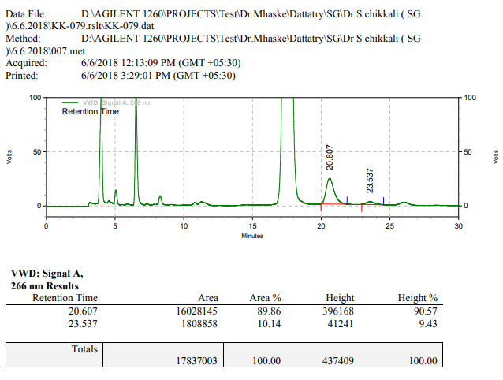

**KK-080**



**Calculation table:**

|  |  |  |  |  |  |
| --- | --- | --- | --- | --- | --- |
| Sr. No | Comp. | Mol. wt. | mmol | Eq. wt. | Wt. taken |
| 1 | Dehydrositagliptin (1) | 405.30 | 0.2135 | 100 | 99 mg |
| 2 | Rh(COD)2BF4 | 405.07 | 0.0021 | 1 | 1.1 mg |
| 3 | L3 | 414.29 | 0.0022 | 1.05 | 1 mg |

**Procedure:** A glass vial (4 mL) equipped with Teflon coated magnetic needle was cooled under vacuum and transferred to a glove box. The vial was then charged with 99 mg of enamine (**1**), 1 mg of [Rh(COD)2BF4] (1 mol%), and ligand (L3). Reaction vial was then closed using screwcap, transferred to a large opening Schlenk type container and was then taken out from the glove box. 2 mL dry methanol was added to the vial in inert atmosphere and the resultant reaction slurry was stirred for 1 hour at room temperature (25 °C). After that the reaction vial was shifted to an autoclave and the autoclave was purged three times using hydrogen gas (40 bars). Finally, the autoclave was pressurized to 20 bar hydrogen pressure at 90°C for 17 hrs time period. After the 17 hrs time period, the autoclave was cooled to room temperature (25 °C), excess pressure was released and the autoclave was opened. The vials were taken out from the autoclave. The thus obtained reaction mixture was passed through neutral alumina bed, the filtrate was collect and dried to yield residue. The resultant residue was then analysed by HPLC.

**Reaction conditions:** Temp: 90°C Press.: 20 bar Solvent: methanol Time: 17 hrs

**Result: 95%** conversion **66%** ee

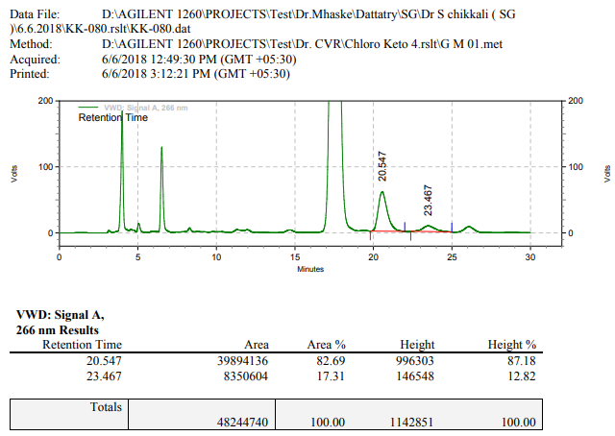

**KK-081**



**Calculation table:**

|  |  |  |  |  |  |
| --- | --- | --- | --- | --- | --- |
| Sr. No | Comp. | Mol. wt. | mmol | Eq. wt. | Wt. taken |
| 1 | Dehydrositagliptin (1) | 405.30 | 0.2135 | 100 | 99 mg |
| 2 | Rh(COD)2BF4 | 468.30 | 0.0021 | 1 | 1 mg |
| 3 | L3 | 414.29 | 0.0022 | 1.05 | 1.1 mg |
| 4 | Ammonium chloride | 53.49 | 0.0021 | 1 | 0.1 mg |

**Procedure:** A glass vial (4 mL) equipped with Teflon coated magnetic needle was cooled under vacuum and transferred to a glove box. The vial was then charged with 99 mg of enamine (**1**), 1 mg of [Rh(COD)2BF4] (1 mol%), ligand (L3) and ammonium chloride. Reaction vial was then closed using screwcap, transferred to a large opening Schlenk type container and was then taken out from the glove box. 2 mL dry methanol was added to the vial in inert atmosphere and the resultant reaction slurry was stirred for 1 hour at room temperature (25 °C). After that the reaction vial was shifted to an autoclave and the autoclave was purged three times using hydrogen gas (40 bars). Finally, the autoclave was pressurized to 20 bar hydrogen pressure at 90°C for 17 hrs time period. After the 17 hrs time period, the autoclave was cooled to room temperature (25 °C), excess pressure was released and the autoclave was opened. The vials were taken out from the autoclave. The thus obtained reaction mixture was passed through neutral alumina bed, the filtrate was collect and dried to yield residue. The resultant residue was then analysed by HPLC.

**Reaction conditions:** Temp: 90°C Press.: 20 bar Solvent: methanol Time: 17 hrs

**Result: 95%** conversion **68%** ee

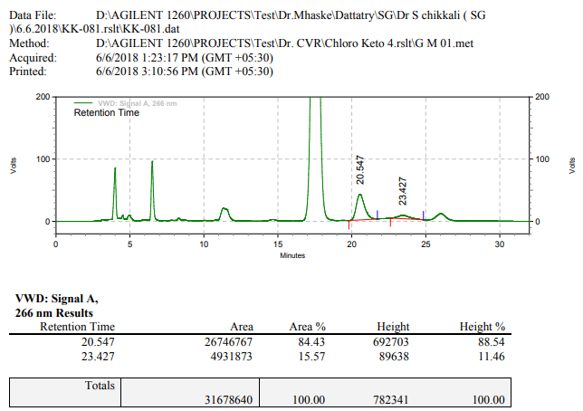

**KK-082**



**Calculation table:**

|  |  |  |  |  |  |
| --- | --- | --- | --- | --- | --- |
| Sr. No | Comp. | Mol. wt. | µmol | Eq. wt. | Wt. taken |
| 1 | Dehydrositagliptin (1) | 405.30 | 213 | 100 | 86 mg |
| 2 | Rh(COD)2OTf | 468.30 | 2.13 | 1 | 1 mg |
| 3 | tBu-Josiphos | 542.45 | 2.24 | 1.05 | 1.2 mg |

**Procedure:** A glass vial (4 mL) equipped with Teflon coated magnetic needle was cooled under vacuum and transferred to a glove box. The vial was then charged with 86 mg of enamine (**1**), 1 mg of [Rh(COD)OTf] (1 mol%), and tBu-Josiphos. Reaction vial was then closed using screwcap, transferred to a large opening Schlenk type container and was then taken out from the glove box. 2 mL dry methanol was added to the vial in inert atmosphere and the resultant reaction slurry was stirred for 1 hour at room temperature (25 °C). After that the reaction vial was shifted to an autoclave and the autoclave was purged three times using hydrogen gas (40 bars). Finally, the autoclave was pressurized to 20 bar hydrogen pressure at 90°C for 17 hrs time period. After the 17 hrs time period, the autoclave was cooled to room temperature (25 °C), excess pressure was released and the autoclave was opened. The vials were taken out from the autoclave. The thus obtained reaction mixture was passed through neutral alumina bed, the filtrate was collect and dried to yield residue. The resultant residue was then analysed by HPLC.

**Reaction conditions:** Temp: 90°C Press.: 20 bar Solvent: Methanol Time: 17 hrs

**Result: 00%** conversion **00%** ee

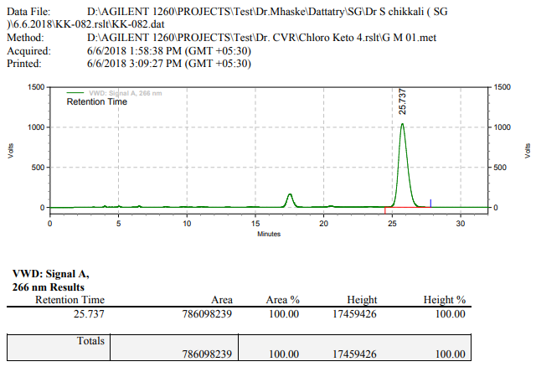

**KK-095**

**Calculation table:**

|  |  |  |  |  |  |
| --- | --- | --- | --- | --- | --- |
| Sr. No | Comp. | Mol. wt. | µmol | Eq. wt. | Wt. taken |
| 1 | Dehydrositagliptin (1) | 405.30 | 0.2135 | 100 | 86 mg |
| 2 | Rh(COD)2OTf | 468.30 | 0.0021 | 1 | 1 mg |
| 3 | HL | 592.57 | 0.0022 | 1.05 | 1.3 mg |
| 4 | Ammonium chloride | 53.49 | 0.0021 | 1 | 0.1 mg |

**Procedure:** A glass vial (4 mL) equipped with Teflon coated magnetic needle was cooled under vacuum and transferred to a glove box. The vial was then charged with 86 mg of enamine (**1**), 1 mg of [Rh(COD)2OTf] (1 mol%), ligand (HL) and ammonium chloride. Reaction vial was then closed using screwcap, transferred to a large opening Schlenk type container and was then taken out from the glove box. 2 mL dry DCM was added to the vial in inert atmosphere and the resultant reaction slurry was stirred for 1 hour at room temperature (25 °C). After that the reaction vial was shifted to an autoclave and the autoclave was purged three times using hydrogen gas (40 bars). Finally, the autoclave was pressurized to 20 bar hydrogen pressure at 60 °C for 17 hrs time period. After the 17 hrs time period, excess pressure was released and the autoclave was opened. The vials were taken out from the autoclave. The thus obtained reaction mixture was passed through neutral alumina bed, the filtrate was collect and dried to yield residue. The resultant residue was then analysed by HPLC.

**Reaction conditions:** Temp: 60 °C Press.: 20 bar Solvent: DCM Time: 17 hrs

**Result: 00%** conversion **00%** ee

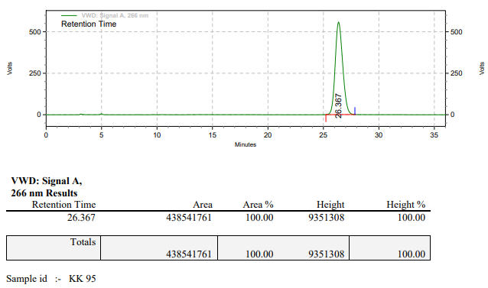

**KK-096**

**Calculation table:**

|  |  |  |  |  |  |
| --- | --- | --- | --- | --- | --- |
| Sr. No | Comp. | Mol. wt. | µmol | Eq. wt. | Wt. taken |
| 1 | Dehydrositagliptin (1) | 405.30 | 0.2135 | 100 | 86 mg |
| 2 | Rh(COD)2OTf | 468.30 | 0.0021 | 1 | 1 mg |
| 3 | HL | 592.57 | 0.0022 | 1.05 | 1.3 mg |
| 4 | Ammonium chloride | 53.49 | 0.0021 | 1 | 0.1 mg |

**Procedure:** A glass vial (4 mL) equipped with Teflon coated magnetic needle was cooled under vacuum and transferred to a glove box. The vial was then charged with 86 mg of enamine (**1**), 1 mg of [Rh(COD)2OTf] (1 mol%), ligand (HL) and ammonium chloride. Reaction vial was then closed using screwcap, transferred to a large opening Schlenk type container and was then taken out from the glove box. 2 mL dry 1,4-dioxane was added to the vial in inert atmosphere and the resultant reaction slurry was stirred for 1 hour at room temperature (25 °C). After that the reaction vial was shifted to an autoclave and the autoclave was purged three times using hydrogen gas (40 bars). Finally, the autoclave was pressurized to 20 bar hydrogen pressure at 60°C for 17 hrs time period. After the 17 hrs time period, excess pressure was released and the autoclave was opened. The vials were taken out from the autoclave. The thus obtained reaction mixture was passed through neutral alumina bed, the filtrate was collect and dried to yield residue. The resultant residue was then analysed by HPLC.

**Reaction conditions:** Temp: 60 °C Press.: 20 bar Solvent: 1,4-dioxane Time: 17 hrs

**Result: 00%** conversion **00%** ee

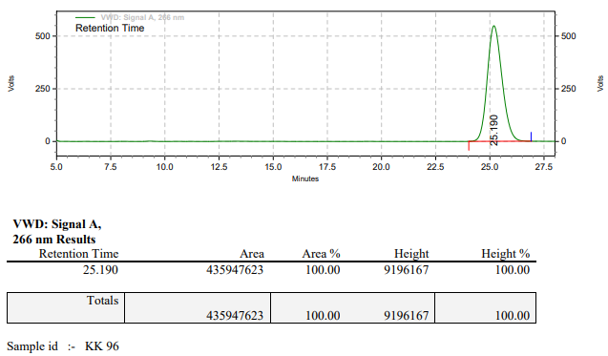

**KK-097**

**Calculation table:**

|  |  |  |  |  |  |
| --- | --- | --- | --- | --- | --- |
| Sr. No | Comp. | Mol. wt. | µmol | Eq. wt. | Wt. taken |
| 1 | Dehydrositagliptin (1) | 405.30 | 0.2135 | 100 | 86 mg |
| 2 | Rh(COD)2OTf | 468.30 | 0.0021 | 1 | 1 mg |
| 3 | HL | 592.57 | 0.0022 | 1.05 | 1.3 mg |
| 4 | Ammonium chloride | 53.49 | 0.0021 | 1 | 0.1 mg |

**Procedure:** A glass vial (4 mL) equipped with Teflon coated magnetic needle was cooled under vacuum and transferred to a glove box. The vial was then charged with 86 mg of enamine (**1**), 1 mg of [Rh(COD)2OTf] (1 mol%), ligand (HL) and ammonium chloride. Reaction vial was then closed using screwcap, transferred to a large opening Schlenk type container and was then taken out from the glove box. 2 mL dry toluene was added to the vial in inert atmosphere and the resultant reaction slurry was stirred for 1 hour at room temperature (25 °C). After that the reaction vial was shifted to an autoclave and the autoclave was purged three times using hydrogen gas (40 bars). Finally, the autoclave was pressurized to 20 bar hydrogen pressure at 60°C for 17 hrs time period. After the 17 hrs time period, excess pressure was released and the autoclave was opened. The vials were taken out from the autoclave. The thus obtained reaction mixture was passed through neutral alumina bed, the filtrate was collect and dried to yield residue. The resultant residue was then analysed by HPLC.

**Reaction conditions:** Temp: 60 °C Press.: 20 bar Solvent: Toluene Time: 17 hrs

**Result: 00%** conversion **00%** ee

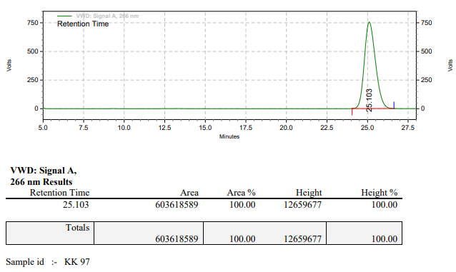

**KK-127**

**Calculation table:**

|  |  |  |  |  |  |
| --- | --- | --- | --- | --- | --- |
| Sr. No | Comp. | Mol. wt. | µmol | Eq. wt. | Wt. taken |
| 1 | Dehydrositagliptin (1) | 405.30 | 0.2135 | 100 | 86 mg |
| 2 | Rh(COD)2OTf | 468.30 | 0.0021 | 1 | 1 mg |
| 3 | HL | 592.57 | 0.0022 | 1.05 | 1.3 mg |

**Procedure:** A glass vial (4 mL) equipped with Teflon coated magnetic needle was cooled under vacuum and transferred to a glove box. The vial was then charged with 86 mg of enamine (**1**), 1 mg of [Rh(COD)2OTf] (1 mol%) and ligand (HL). Reaction vial was then closed using screwcap, transferred to a large opening Schlenk type container and was then taken out from the glove box. 2 mL dry THF was added to the vial in inert atmosphere and the resultant reaction slurry was stirred for 1 hour at room temperature (25°C). After that the reaction vial was shifted to an autoclave and the autoclave was purged three times using hydrogen gas (40 bars). Finally, the autoclave was pressurized to 20 bar hydrogen pressure at 90°C for 18 hrs time period. After the 18 hrs time period, excess pressure was released and the autoclave was opened. The vials were taken out from the autoclave. The thus obtained reaction mixture was passed through neutral alumina bed, the filtrate was collect and dried to yield residue. The resultant residue was then analysed by TLC only starting was present.

**Reaction conditions:** Temp: 90 °C Press.: 20 bar Solvent: THF Time: 18 hrs

**Result: 00%** conversion **00%** ee

**KK-128**

**Calculation table:**

|  |  |  |  |  |  |
| --- | --- | --- | --- | --- | --- |
| Sr. No | Comp. | Mol. wt. | µmol | Eq. wt. | Wt. taken |
| 1 | Dehydrositagliptin (1) | 405.30 | 0.2135 | 100 | 86 mg |
| 2 | Rh(COD)2OTf | 468.30 | 0.0021 | 1 | 1 mg |
| 3 | HL | 592.57 | 0.0022 | 1.05 | 1.3 mg |
| 4 | Ammonium chloride | 53.49 | 0.0021 | 1 | 0.1 mg |

**Procedure:** A glass vial (4 mL) equipped with Teflon coated magnetic needle was cooled under vacuum and transferred to a glove box. The vial was then charged with 86 mg of enamine (**1**), 1 mg of [Rh(COD)2OTf] (1 mol%), ligand (HL) and ammonium chloride. Reaction vial was then closed using screwcap, transferred to a large opening Schlenk type container and was then taken out from the glove box. 2 mL dry THF was added to the vial in inert atmosphere and the resultant reaction slurry was stirred for 1 hour at room temperature (25 °C). After that the reaction vial was shifted to an autoclave and the autoclave was purged three times using hydrogen gas (40 bars). Finally, the autoclave was pressurized to 20 bar hydrogen pressure at 90°C for 18 hrs time period. After the 18 hrs time period, excess pressure was released and the autoclave was opened. The vials were taken out from the autoclave. The thus obtained reaction mixture was passed through neutral alumina bed, the filtrate was collect and dried to yield residue. The resultant residue was then analysed by TLC only starting was present.

**Reaction conditions:** Temp: 90 °C Press.: 20 bar Solvent: THF Time: 18 hrs

**Result: 00%** conversion **00%** ee

**KK-135**



**Calculation table:**

|  |  |  |  |  |  |
| --- | --- | --- | --- | --- | --- |
| Sr. No | Comp. | Mol. wt. | mmol | Eq. wt. | Wt. taken |
| 1 | Dehydrositagliptin (1) | 405.30 | 0.2135 | 100 | 86 mg |
| 2 | Rh(COD)2OTf | 468.30 | 0.0021 | 1 | 1 mg |
| 3 | L3 | 414.29 | 0.0022 | 1.05 | 0.9 mg |

**Procedure:** A glass vial (4 mL) equipped with Teflon coated magnetic needle was cooled under vacuum and transferred to a glove box. The vial was then charged with 86 mg of enamine (**1**), 1 mg of [Rh(COD)2OTf] (1 mol%) and ligand (L3). Reaction vial was then closed using screwcap, transferred to a large opening Schlenk type container and was then taken out from the glove box. 2 mL dry methanol was added to the vial in inert atmosphere and the resultant reaction slurry was stirred for 1 hour at room temperature (25 °C). After that the reaction vial was shifted to an autoclave and the autoclave was purged three times using hydrogen gas (40 bars). Finally, the autoclave was pressurized to 20 bar hydrogen pressure at room temperature for 17 hrs time period. After the 17 hrs time period, the autoclave was cooled to room temperature (25 °C), excess pressure was released and the autoclave was opened. The vials were taken out from the autoclave. The thus obtained reaction mixture was passed through neutral alumina bed, the filtrate was collect and dried to yield residue. The resultant residue was then analysed by HPLC.

**Reaction conditions:** Temp: RT Press.: 20 bar Solvent: methanol Time: 17 hrs

**Result: 00%** conversion **00%** ee

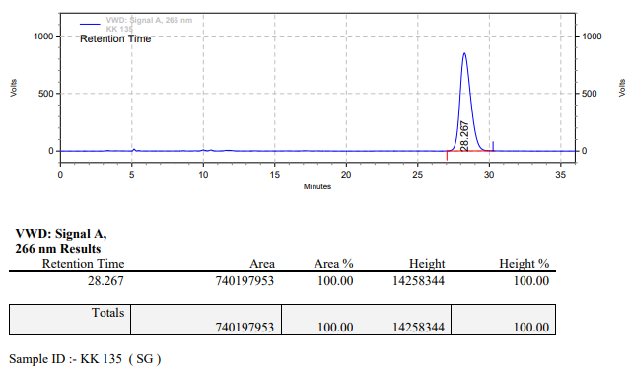

**KK-136**



**Calculation table:**

|  |  |  |  |  |  |
| --- | --- | --- | --- | --- | --- |
| Sr. No | Comp. | Mol. wt. | mmol | Eq. wt. | Wt. taken |
| 1 | Dehydrositagliptin (1) | 405.30 | 0.2135 | 100 | 86 mg |
| 2 | Rh(COD)2OTf | 468.30 | 0.0021 | 1 | 1 mg |
| 3 | L3 | 414.29 | 0.0022 | 1.05 | 0.9 mg |
| 4 | Ammonium chloride | 53.49 | 0.0021 | 1 | 0.1 mg |

**Procedure:** A glass vial (4 mL) equipped with Teflon coated magnetic needle was cooled under vacuum and transferred to a glove box. The vial was then charged with 86 mg of enamine (**1**), 1 mg of [Rh(COD)2OTf] (1 mol%), ligand (L3) and ammonium chloride. Reaction vial was then closed using screwcap, transferred to a large opening Schlenk type container and was then taken out from the glove box. 2 mL dry methanol was added to the vial in inert atmosphere and the resultant reaction slurry was stirred for 1 hour at room temperature (25 °C). After that the reaction vial was shifted to an autoclave and the autoclave was purged three times using hydrogen gas (40 bars). Finally, the autoclave was pressurized to 20 bar hydrogen pressure at room temperature for 17 hrs time period. After the 17 hrs time period, the autoclave was cooled to room temperature (25 °C), excess pressure was released and the autoclave was opened. The vials were taken out from the autoclave. The thus obtained reaction mixture was passed through neutral alumina bed, the filtrate was collect and dried to yield residue. The resultant residue was then analysed by HPLC.

**Reaction conditions:** Temp: RT Press.: 20 bar Solvent: methanol Time: 17 hrs

**Result: 00%** conversion **00%** ee

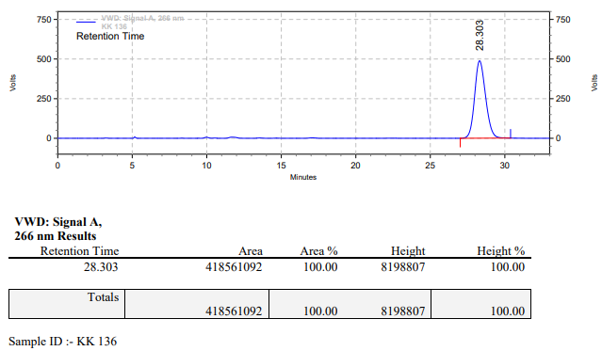

**KK-137**



**Calculation table:**

|  |  |  |  |  |  |
| --- | --- | --- | --- | --- | --- |
| Sr. No | Comp. | Mol. wt. | mmol | Eq. wt. | Wt. taken |
| 1 | Dehydrositagliptin (1) | 405.30 | 0.2135 | 100 | 86 mg |
| 2 | Rh(COD)2OTf | 468.30 | 0.0021 | 1 | 1 mg |
| 3 | L3 | 414.29 | 0.0022 | 1.05 | 0.9 mg |

**Procedure:** A glass vial (4 mL) equipped with Teflon coated magnetic needle was cooled under vacuum and transferred to a glove box. The vial was then charged with 86 mg of enamine (**1**), 1 mg of [Rh(COD)2OTf] (1 mol%) and ligand (L3). Reaction vial was then closed using screwcap, transferred to a large opening Schlenk type container and was then taken out from the glove box. 2 mL dry methanol was added to the vial in inert atmosphere and the resultant reaction slurry was stirred for 1 hour at room temperature (25 °C). After that the reaction vial was shifted to an autoclave and the autoclave was purged three times using hydrogen gas (40 bars). Finally, the autoclave was pressurized to 20 bar hydrogen pressure at 60°C for 18 hrs time period. After the 18 hrs time period, the autoclave was cooled to room temperature (25 °C), excess pressure was released and the autoclave was opened. The vials were taken out from the autoclave. The thus obtained reaction mixture was passed through neutral alumina bed, the filtrate was collect and dried to yield residue. The resultant residue was then analysed by HPLC.

**Reaction conditions:** Temp: 60°C Press.: 20 bar Solvent: methanol Time: 18 hrs

**Result: 30%** conversion **85%** ee

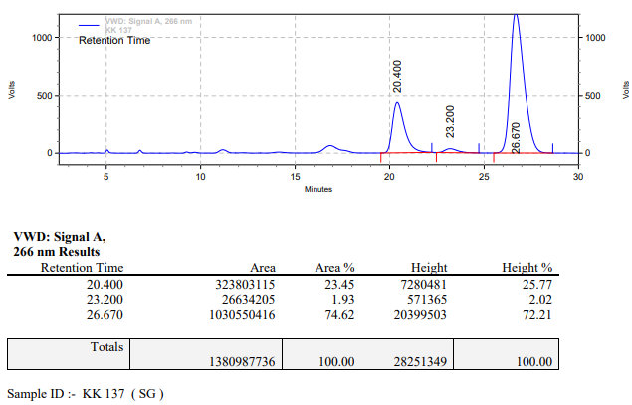

**KK-138**



**Calculation table:**

|  |  |  |  |  |  |
| --- | --- | --- | --- | --- | --- |
| Sr. No | Comp. | Mol. wt. | mmol | Eq. wt. | Wt. taken |
| 1 | Dehydrositagliptin (1) | 405.30 | 0.2135 | 100 | 86 mg |
| 2 | Rh(COD)2OTf | 468.30 | 0.0021 | 1 | 1 mg |
| 3 | L3 | 414.29 | 0.0022 | 1.05 | 0.9 mg |
| 4 | Ammonium chloride | 53.49 | 0.0021 | 1 | 0.1 mg |

**Procedure:** A glass vial (4 mL) equipped with Teflon coated magnetic needle was cooled under vacuum and transferred to a glove box. The vial was then charged with 86 mg of enamine (**1**), 1 mg of [Rh(COD)2OTf] (1 mol%), ligand (L3) and ammonium chloride. Reaction vial was then closed using screwcap, transferred to a large opening Schlenk type container and was then taken out from the glove box. 2 mL dry methanol was added to the vial in inert atmosphere and the resultant reaction slurry was stirred for 1 hour at room temperature (25 °C). After that the reaction vial was shifted to an autoclave and the autoclave was purged three times using hydrogen gas (40 bars). Finally, the autoclave was pressurized to 20 bar hydrogen pressure at 60°C for 12 hrs time period. After the 12 hrs time period, the autoclave was cooled to room temperature (25 °C), excess pressure was released and the autoclave was opened. The vials were taken out from the autoclave. The thus obtained reaction mixture was passed through neutral alumina bed, the filtrate was collect and dried to yield residue. The resultant residue was then analysed by HPLC.

**Reaction conditions:** Temp: 60°C Press.: 20 bar Solvent: methanol Time: 12 hrs

**Result: 30%** conversion **85%** ee

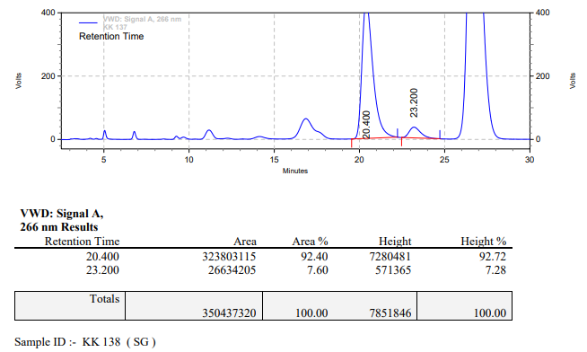

**KK-139**



**Calculation table:**

|  |  |  |  |  |  |
| --- | --- | --- | --- | --- | --- |
| Sr. No | Comp. | Mol. wt. | mmol | Eq. wt. | Wt. taken |
| 1 | Dehydrositagliptin (1) | 405.30 | 0.2135 | 100 | 86 mg |
| 2 | Rh(COD)2OTf | 468.30 | 0.0021 | 1 | 1 mg |
| 3 | L3 | 414.29 | 0.0022 | 1.05 | 0.9 mg |

**Procedure:** A glass vial (4 mL) equipped with Teflon coated magnetic needle was cooled under vacuum and transferred to a glove box. The vial was then charged with 86 mg of enamine (**1**), 1 mg of [Rh(COD)2OTf] (1 mol%) and ligand (L3). Reaction vial was then closed using screwcap, transferred to a large opening Schlenk type container and was then taken out from the glove box. 2 mL dry DCM was added to the vial in inert atmosphere and the resultant reaction slurry was stirred for 1 hour at room temperature (25 °C). After that the reaction vial was shifted to an autoclave and the autoclave was purged three times using hydrogen gas (40 bars). Finally, the autoclave was pressurized to 20 bar hydrogen pressure at 60°C for 18 hrs time period. After the 18 hrs time period, the autoclave was cooled to room temperature (25 °C), excess pressure was released and the autoclave was opened. The vials were taken out from the autoclave. The thus obtained reaction mixture was passed through neutral alumina bed, the filtrate was collect and dried to yield residue. The resultant residue was then analysed by TLC only starting was present.

**Reaction conditions:** Temp: 60°C Press.: 20 bar Solvent: DCM Time: 18 hrs

**Result: 00%** conversion **00%** ee

**KK-140**



**Calculation table:**

|  |  |  |  |  |  |
| --- | --- | --- | --- | --- | --- |
| Sr. No | Comp. | Mol. wt. | mmol | Eq. wt. | Wt. taken |
| 1 | Dehydrositagliptin (1) | 405.30 | 0.2135 | 100 | 86 mg |
| 2 | Rh(COD)2OTf | 468.30 | 0.0021 | 1 | 1 mg |
| 3 | L3 | 414.29 | 0.0022 | 1.05 | 0.9 mg |

**Procedure:** A glass vial (4 mL) equipped with Teflon coated magnetic needle was cooled under vacuum and transferred to a glove box. The vial was then charged with 86 mg of enamine (**1**), 1 mg of [Rh(COD)2OTf] (1 mol%) and ligand (L3). Reaction vial was then closed using screwcap, transferred to a large opening Schlenk type container and was then taken out from the glove box. 2 mL dry THF was added to the vial in inert atmosphere and the resultant reaction slurry was stirred for 1 hour at room temperature (25 °C). After that the reaction vial was shifted to an autoclave and the autoclave was purged three times using hydrogen gas (40 bars). Finally, the autoclave was pressurized to 20 bar hydrogen pressure at 60°C for 18 hrs time period. After the 18 hrs time period, the autoclave was cooled to room temperature (25 °C), excess pressure was released and the autoclave was opened. The vials were taken out from the autoclave. The thus obtained reaction mixture was passed through neutral alumina bed, the filtrate was collect and dried to yield residue. The resultant residue was then analysed by HPLC.

**Reaction conditions:** Temp: 60°C Press.: 20 bar Solvent: THF Time: 18 hrs

**Result: 00%** conversion **00%** ee

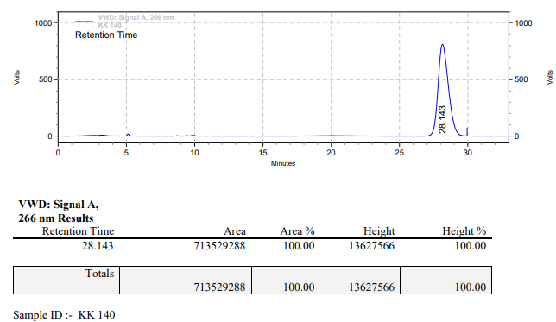

**KK-141**



**Calculation table:**

|  |  |  |  |  |  |
| --- | --- | --- | --- | --- | --- |
| Sr. No | Comp. | Mol. wt. | mmol | Eq. wt. | Wt. taken |
| 1 | Dehydrositagliptin (1) | 405.30 | 0.2135 | 100 | 86 mg |
| 2 | Rh(COD)2OTf | 468.30 | 0.0021 | 1 | 1 mg |
| 3 | L3 | 414.29 | 0.0022 | 1.05 | 0.9 mg |

**Procedure:** A glass vial (4 mL) equipped with Teflon coated magnetic needle was cooled under vacuum and transferred to a glove box. The vial was then charged with 86 mg of enamine (**1**), 1 mg of [Rh(COD)2OTf] (1 mol%) and ligand (L3). Reaction vial was then closed using screwcap, transferred to a large opening Schlenk type container and was then taken out from the glove box. 2 mL dry TFE (trifluoroethanol) was added to the vial in inert atmosphere and the resultant reaction slurry was stirred for 1 hour at room temperature (25 °C). After that the reaction vial was shifted to an autoclave and the autoclave was purged three times using hydrogen gas (40 bars). Finally, the autoclave was pressurized to 20 bar hydrogen pressure at 60°C for 18 hrs time period. After the 18 hrs time period, the autoclave was cooled to room temperature (25 °C), excess pressure was released and the autoclave was opened. The vials were taken out from the autoclave. The thus obtained reaction mixture was passed through neutral alumina bed, the filtrate was collect and dried to yield residue. The resultant residue was then analysed by HPLC.

**Reaction conditions:** Temp: 60°C Press.: 20 bar Solvent: TFE Time: 18 hrs

**Result: 10%** conversion **00%** ee

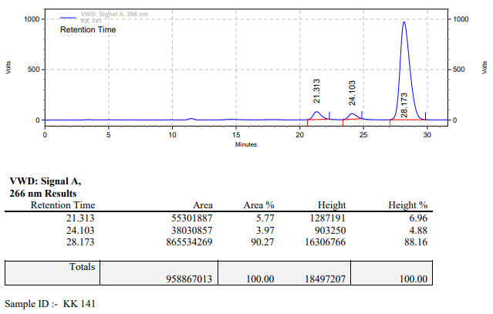

**KK-142**



**Calculation table:**

|  |  |  |  |  |  |
| --- | --- | --- | --- | --- | --- |
| Sr. No | Comp. | Mol. wt. | mmol | Eq. wt. | Wt. taken |
| 1 | Dehydrositagliptin (1) | 405.30 | 0.2135 | 100 | 86 mg |
| 2 | Rh(COD)2OTf | 468.30 | 0.0021 | 1 | 1 mg |
| 3 | L3 | 414.29 | 0.0022 | 1.05 | 0.9 mg |

**Procedure:** A glass vial (4 mL) equipped with Teflon coated magnetic needle was cooled under vacuum and transferred to a glove box. The vial was then charged with 86 mg of enamine (**1**), 1 mg of [Rh(COD)2OTf] (1 mol%) and ligand (L3). Reaction vial was then closed using screwcap, transferred to a large opening Schlenk type container and was then taken out from the glove box. 2 mL dry toluene was added to the vial in inert atmosphere and the resultant reaction slurry was stirred for 1 hour at room temperature (25 °C). After that the reaction vial was shifted to an autoclave and the autoclave was purged three times using hydrogen gas (40 bars). Finally, the autoclave was pressurized to 20 bar hydrogen pressure at 60°C for 18 hrs time period. After the 18 hrs time period, the autoclave was cooled to room temperature (25 °C), excess pressure was released and the autoclave was opened. The vials were taken out from the autoclave. The thus obtained reaction mixture was passed through neutral alumina bed, the filtrate was collect and dried to yield residue. The resultant residue was then analysed by TLC only starting was present.

**Reaction conditions:** Temp: 60°C Press.: 20 bar Solvent: Toluene Time: 18 hrs

**Result: 00%** conversion **00%** ee

**KK-143**



**Calculation table:**

|  |  |  |  |  |  |
| --- | --- | --- | --- | --- | --- |
| Sr. No | Comp. | Mol. wt. | mmol | Eq. wt. | Wt. taken |
| 1 | Dehydrositagliptin (1) | 405.30 | 0.2135 | 100 | 86 mg |
| 2 | Rh(COD)2OTf | 468.30 | 0.0021 | 1 | 1 mg |
| 3 | L3 | 414.29 | 0.0022 | 1.05 | 0.9 mg |

**Procedure:** A glass vial (4 mL) equipped with Teflon coated magnetic needle was cooled under vacuum and transferred to a glove box. The vial was then charged with 86 mg of enamine (**1**), 1 mg of [Rh(COD)2OTf] (1 mol%) and L3. Reaction vial was then closed using screwcap, transferred to a large opening Schlenk type container and was then taken out from the glove box. 2 mL dry 1,4-dioxane was added to the vial in inert atmosphere and the resultant reaction slurry was stirred for 1 hour at room temperature (25 °C). After that the reaction vial was shifted to an autoclave and the autoclave was purged three times using hydrogen gas (40 bars). Finally, the autoclave was pressurized to 20 bar hydrogen pressure at 60°C for 18 hrs time period. After the 18 hrs time period, the autoclave was cooled to room temperature (25 °C), excess pressure was released and the autoclave was opened. The vials were taken out from the autoclave. The thus obtained reaction mixture was passed through neutral alumina bed, the filtrate was collect and dried to yield residue. The resultant residue was then analysed by HPLC.

**Reaction conditions:** Temp: 60°C Press.: 20 bar Solvent: 1,4-dioxane Time: 18 hrs

**Result: 00%** conversion **00%** ee

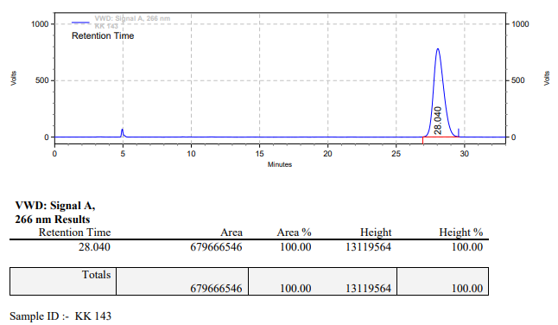

**KK-144**



**Calculation table:**

|  |  |  |  |  |  |
| --- | --- | --- | --- | --- | --- |
| Sr. No | Comp. | Mol. wt. | mmol | Eq. wt. | Wt. taken |
| 1 | Dehydrositagliptin (1) | 405.30 | 0.2135 | 100 | 86 mg |
| 2 | Rh(COD)2OTf | 468.30 | 0.0021 | 1 | 1 mg |
| 3 | L3 | 414.29 | 0.0022 | 1.05 | 0.9 mg |

**Procedure:** A glass vial (4 mL) equipped with Teflon coated magnetic needle was cooled under vacuum and transferred to a glove box. The vial was then charged with 86 mg of enamine (**1**), 1 mg of [Rh(COD)2OTf] (1 mol%) and L3. Reaction vial was then closed using screwcap, transferred to a large opening Schlenk type container and was then taken out from the glove box. 2 mL dry ethyl acetate was added to the vial in inert atmosphere and the resultant reaction slurry was stirred for 1 hour at room temperature (25 °C). After that the reaction vial was shifted to an autoclave and the autoclave was purged three times using hydrogen gas (40 bars). Finally, the autoclave was pressurized to 20 bar hydrogen pressure at 60°C for 18 hrs time period. After the 18 hrs time period, the autoclave was cooled to room temperature (25 °C), excess pressure was released and the autoclave was opened. The vials were taken out from the autoclave. The thus obtained reaction mixture was passed through neutral alumina bed, the filtrate was collect and dried to yield residue. The resultant residue was then analysed by HPLC.

**Reaction conditions:** Temp: 60°C Press.: 20 bar Solvent: Ethyl acetate Time: 18 hrs

**Result: 00%** conversion **00%** ee

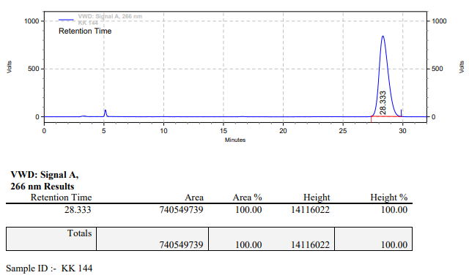

**KK-145**



**Calculation table:**

|  |  |  |  |  |  |
| --- | --- | --- | --- | --- | --- |
| Sr. No | Comp. | Mol. wt. | mmol | Eq. wt. | Wt. taken |
| 1 | Dehydrositagliptin (1) | 405.30 | 0.2135 | 100 | 86 mg |
| 2 | Rh(COD)2OTf | 468.30 | 0.0021 | 1 | 1 mg |
| 3 | L3 | 414.29 | 0.0022 | 1.05 | 0.9 mg |
| 4 | Acetic acid | 60.05 | 0.0106 | 5 | 0.6 mg |

**Procedure:** A glass vial (4 mL) equipped with Teflon coated magnetic needle was cooled under vacuum and transferred to a glove box. The vial was then charged with 86 mg of enamine (**1**), 1 mg of [Rh(COD)2OTf] (1 mol%) and L3. Reaction vial was then closed using screwcap, transferred to a large opening Schlenk type container and was then taken out from the glove box. 2 mL dry methanol was added followed by acetic acid to the vial in inert atmosphere and the resultant reaction slurry was stirred for 1 hour at room temperature (25 °C). After that the reaction vial was shifted to an autoclave and the autoclave was purged three times using hydrogen gas (40 bars). Finally, the autoclave was pressurized to 20 bar hydrogen pressure at 60°C for 18 hrs time period. After the 18 hrs time period, the autoclave was cooled to room temperature (25 °C), excess pressure was released and the autoclave was opened. The vials were taken out from the autoclave. The thus obtained reaction mixture was passed through neutral alumina bed, the filtrate was collect and dried to yield residue. The resultant residue was then analysed by HPLC.

**Reaction conditions:** Temp: 60°C Press.: 20 bar Solvent: methanol Time: 18 hrs

**Result: 12%** conversion **69%** ee

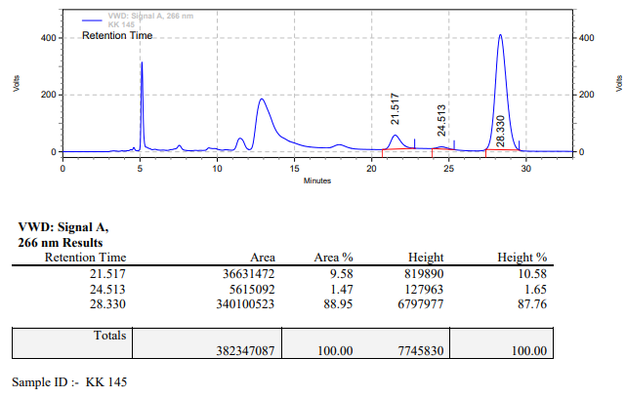

**KK-146**



**Calculation table:**

|  |  |  |  |  |  |
| --- | --- | --- | --- | --- | --- |
| Sr. No | Comp. | Mol. wt. | mmol | Eq. wt. | Wt. taken |
| 1 | Dehydrositagliptin (1) | 405.30 | 0.2135 | 100 | 86 mg |
| 2 | Rh(COD)2OTf | 468.30 | 0.0021 | 1 | 1 mg |
| 3 | L3 | 414.29 | 0.0022 | 1.05 | 0.9 mg |
| 4 | Acetic acid | 60.05 | 0.0106 | 5 | 0.6 mg |

**Procedure:** A glass vial (4 mL) equipped with Teflon coated magnetic needle was cooled under vacuum and transferred to a glove box. The vial was then charged with 86 mg of enamine (**1**), 1 mg of [Rh(COD)2OTf] and L3. Reaction vial was then closed using screwcap, transferred to a large opening Schlenk type container and was then taken out from the glove box. 2 mL dry methanol was added followed by acetic acid to the vial in inert atmosphere and the resultant reaction slurry was stirred for 1 hour at room temperature (25 °C). After that the reaction vial was shifted to an autoclave and the autoclave was purged three times using hydrogen gas (40 bars). Finally, the autoclave was pressurized to 20 bar hydrogen pressure at 60°C for 18 hrs time period. After the 18 hrs time period, the autoclave was cooled to room temperature (25 °C), excess pressure was released and the autoclave was opened. The vials were taken out from the autoclave. The thus obtained reaction mixture was passed through neutral alumina bed, the filtrate was collect and dried to yield residue. The resultant residue was then analysed by TLC only starting was present.

**Reaction conditions:** Temp: 60°C Press.: 20 bar Solvent: methanol Time: 18 hrs

**Result: 00%** conversion **00%** ee

**KK-147**



**Calculation table:**

|  |  |  |  |  |  |
| --- | --- | --- | --- | --- | --- |
| Sr. No | Comp. | Mol. wt. | mmol | Eq. wt. | Wt. taken |
| 1 | Dehydrositagliptin (1) | 405.30 | 0.2135 | 100 | 86 mg |
| 2 | Rh(COD)2OTf | 468.30 | 0.0021 | 1 | 1 mg |
| 3 | L3 | 414.29 | 0.0022 | 1.05 | 0.9 mg |
| 4 | Acetic acid | 60.05 | 0.0106 | 5 | 0.6 mg |

**Procedure:** A glass vial (4 mL) equipped with Teflon coated magnetic needle was cooled under vacuum and transferred to a glove box. The vial was then charged with 86 mg of enamine (**1**), 1 mg of [Rh(COD)2OTf] (1 mol%) and L3. Reaction vial was then closed using screwcap, transferred to a large opening Schlenk type container and was then taken out from the glove box. 2 mL dry methanol was added followed by acetic acid to the vial in inert atmosphere and the resultant reaction slurry was stirred for 1 hour at room temperature (25 °C). After that the reaction vial was shifted to an autoclave and the autoclave was purged three times using hydrogen gas (40 bars). Finally, the autoclave was pressurized to 30 bar hydrogen pressure at 90°C for 18 hrs time period. After the 18 hrs time period, the autoclave was cooled to room temperature (25 °C), excess pressure was released and the autoclave was opened. The vials were taken out from the autoclave. The thus obtained reaction mixture was passed through neutral alumina bed, the filtrate was collect and dried to yield residue. The resultant residue was then analysed by HPLC.

**Reaction conditions:** Temp: 90°C Press.: 30 bar Solvent: methanol Time: 18 hrs

**Result: 90%** conversion **84%** ee

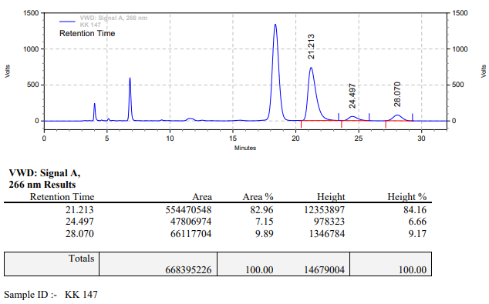

**KK-148**



**Calculation table:**

|  |  |  |  |  |  |
| --- | --- | --- | --- | --- | --- |
| Sr. No | Comp. | Mol. wt. | mmol | Eq. wt. | Wt. taken |
| 1 | Dehydrositagliptin (1) | 405.30 | 0.2135 | 100 | 86 mg |
| 2 | Rh(COD)2OTf | 468.30 | 0.0021 | 1 | 1 mg |
| 3 | L3 | 414.29 | 0.0022 | 1.05 | 0.9 mg |
| 4 | Acetic acid | 60.05 | 0.0106 | 5 | 0.6 mg |

**Procedure:** A glass vial (4 mL) equipped with Teflon coated magnetic needle was cooled under vacuum and transferred to a glove box. The vial was then charged with 86 mg of enamine (**1**), 1 mg of [Rh(COD)2OTf] and L3. Reaction vial was then closed using screwcap, transferred to a large opening Schlenk type container and was then taken out from the glove box. 2 mL dry methanol was added followed by acetic acid to the vial in inert atmosphere and the resultant reaction slurry was stirred for 1 hour at room temperature (25 °C). After that the reaction vial was shifted to an autoclave and the autoclave was purged three times using hydrogen gas (40 bars). Finally, the autoclave was pressurized to 30 bar hydrogen pressure at 90°C for 18 hrs time period. After the 18 hrs time period, the autoclave was cooled to room temperature (25 °C), excess pressure was released and the autoclave was opened. The vials were taken out from the autoclave. The thus obtained reaction mixture was passed through neutral alumina bed, the filtrate was collect and dried to yield residue. The resultant residue was then analysed by HPLC.

**Reaction conditions:** Temp: 90°C Press.: 30 bar Solvent: methanol Time: 18 hrs

**Result: 92%** conversion **70%** ee

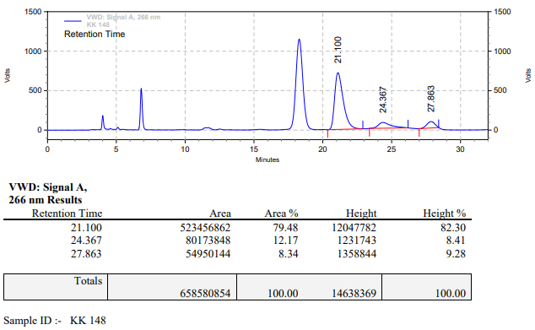

**KK-149**



**Calculation table:**

|  |  |  |  |  |  |
| --- | --- | --- | --- | --- | --- |
| Sr. No | Comp. | Mol. wt. | mmol | Eq. wt. | Wt. taken |
| 1 | Dehydrositagliptin (1) | 405.30 | 0.2135 | 100 | 86 mg |
| 2 | Rh(COD)2OTf | 468.30 | 0.0021 | 1 | 1 mg |
| 3 | L3 | 414.29 | 0.0022 | 1.05 | 0.9 mg |
| 4 | Phosphoric acid | 97.99 | 1.9100 | 9 (to substrate) | 188 mg |

**Procedure:** A glass vial (4 mL) equipped with Teflon coated magnetic needle was cooled under vacuum and transferred to a glove box. The vial was then charged with 86 mg of enamine (**1**), 1 mg of [Rh(COD)2OTf] (1 mol%) and L3. Reaction vial was then closed using screwcap, transferred to a large opening Schlenk type container and was then taken out from the glove box. 2 mL dry methanol was added followed by phosphoric acid to the vial in inert atmosphere and the resultant reaction slurry was stirred for 1 hour at room temperature (25 °C). After that the reaction vial was shifted to an autoclave and the autoclave was purged three times using hydrogen gas (40 bars). Finally, the autoclave was pressurized to 30 bar hydrogen pressure at 90°C for 18 hrs time period. After the 18 hrs time period, the autoclave was cooled to room temperature (25 °C), excess pressure was released and the autoclave was opened. The vials were taken out from the autoclave. The thus obtained reaction mixture was passed through neutral alumina bed, the filtrate was collect and dried to yield residue. The resultant residue was then analysed by HPLC.

**Reaction conditions:** Temp: 90°C Press.: 30 bar Solvent: methanol Time: 18 hrs

**Result: 99%** conversion **00%** ee

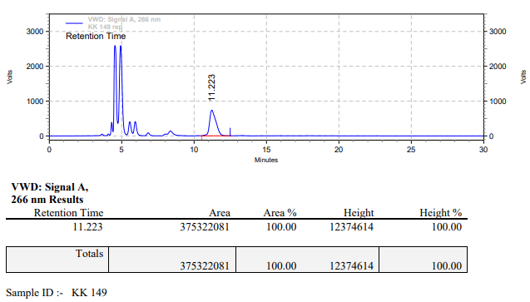

**KK-150**



**Calculation table:**

|  |  |  |  |  |  |
| --- | --- | --- | --- | --- | --- |
| Sr. No | Comp. | Mol. wt. | mmol | Eq. wt. | Wt. taken |
| 1 | Dehydrositagliptin (1) | 405.30 | 0.2135 | 100 | 86 mg |
| 2 | Rh(COD)2OTf | 468.30 | 0.0021 | 1 | 1 mg |
| 3 | L3 | 414.29 | 0.0022 | 1.05 | 0.9 mg |
| 4 | Acetic acid | 60.05 | 0.0161 | 7.7 | 0.97 mg |

**Procedure:** A glass vial (4 mL) equipped with Teflon coated magnetic needle was cooled under vacuum and transferred to a glove box. The vial was then charged with 86 mg of enamine (**1**), 1 mg of [Rh(COD)2OTf] (1 mol%) and L3. Reaction vial was then closed using screwcap, transferred to a large opening Schlenk type container and was then taken out from the glove box. 2 mL dry methanol was added followed by acetic acid to the vial in inert atmosphere and the resultant reaction slurry was stirred for 1 hour at room temperature (25 °C). After that the reaction vial was shifted to an autoclave and the autoclave was purged three times using hydrogen gas (40 bars). Finally, the autoclave was pressurized to 30 bar hydrogen pressure at 90°C for 18 hrs time period. After the 18 hrs time period, the autoclave was cooled to room temperature (25 °C), excess pressure was released and the autoclave was opened. The vials were taken out from the autoclave. The thus obtained reaction mixture was passed through neutral alumina bed, the filtrate was collect and dried to yield residue. The resultant residue was then analysed by HPLC.

**Reaction conditions:** Temp: 90°C Press.: 30 bar Solvent: methanol Time: 18 hrs

**Result: 93%** conversion **63%** ee

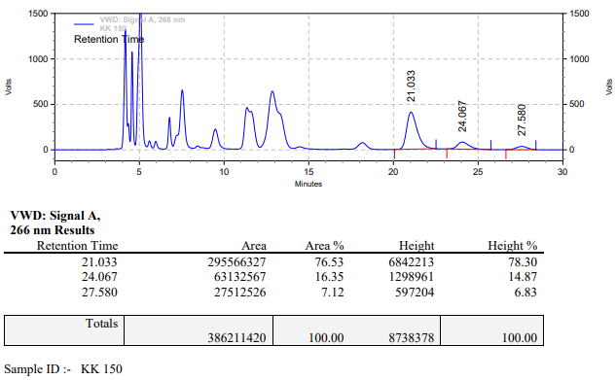

**KK-151**



**Calculation table:**

|  |  |  |  |  |  |
| --- | --- | --- | --- | --- | --- |
| Sr. No | Comp. | Mol. wt. | mmol | Eq. wt. | Wt. taken |
| 1 | Dehydrositagliptin (1) | 405.30 | 24770 | 100 | 1000 mg |
| 2 | Rh(COD)2OTf | 468.30 | 0.0247 | 1 | 12 mg |
| 3 | L3 | 414.29 | 0.0260 | 1.05 | 11 mg |
| 4 | Acetic acid | 60.05 | 0.1238 | 5 | 7 mg |

**Procedure:** A high pressure Parr reactor (100 mL) equipped with Teflon coated magnetic needle was charged with 1 g of enamine (**1**), under argon atmosphere. Subsequently, 12 mg of [Rh(COD)2OTf] (1 mol%) and 11 mg of ligand **L3** (0.0260 mmol) was added to the above reactor. 20 mL dry methanol was added followed by acetic acid to the reactor in inert atmosphere and the resultant reaction slurry was stirred for 1 hour at room temperature (25 °C). After that the autoclave was purged three times using hydrogen gas (40 bars). Finally, the autoclave was pressurized to 30 bar hydrogen pressure at 90°C for 18 hrs time period. After the 18 hrs time period, the autoclave was cooled to room temperature (25 °C), excess pressure was released and the autoclave was opened. The thus obtained reaction mixture was passed through neutral alumina bed, the filtrate was collect and dried to yield residue. The resultant residue was then analysed by HPLC.

**Reaction conditions:** Temp: 90°C Press.: 30 bar Solvent: methanol Time: 18 hrs

**Result: 85%** conversion **83%** ee

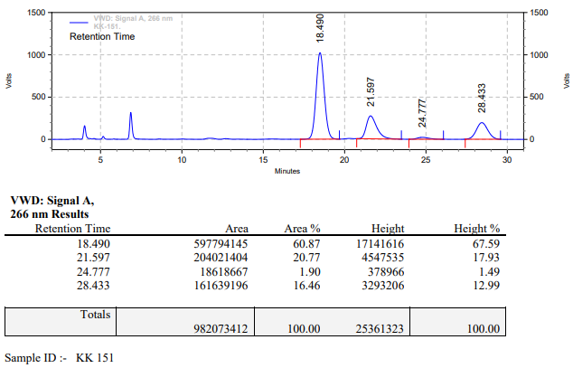

**KK-152**



**Calculation table:**

|  |  |  |  |  |  |
| --- | --- | --- | --- | --- | --- |
| Sr. No | Comp. | Mol. wt. | mmol | Eq. wt. | Wt. taken |
| 1 | Dehydrositagliptin (1) | 405.30 | 24770 | 100 | 1000 mg |
| 2 | Rh(COD)2OTf | 468.30 | 0.0247 | 1 | 12 mg |
| 3 | L3 | 414.29 | 0.0260 | 1.05 | 11 mg |

**Procedure:** A high pressure Parr reactor (100 mL) equipped with Teflon coated magnetic needle was charged with 1 g of enamine (**1**), under argon atmosphere. Subsequently, 12 mg of [Rh(COD)2OTf] (1 mol%) and 11 mg of ligand **L3** (0.0260 mmol) was added to the above reactor. 20 mL dry methanol was added to the reactor in inert atmosphere and the resultant reaction slurry was stirred for 1 hour at room temperature (25 °C). After that the autoclave was purged three times using hydrogen gas (40 bars). Finally, the autoclave was pressurized to 20 bar hydrogen pressure at 60°C for 18 hrs time period. After the 18 hrs time period, the autoclave was cooled to room temperature (25 °C), excess pressure was released and the autoclave was opened. The thus obtained reaction mixture was passed through neutral alumina bed, the filtrate was collect and dried to yield residue. The resultant residue was then analysed by HPLC.

**Reaction conditions:** Temp: 60°C Press.: 20 bar Solvent: methanol Time: 18 hrs

**Result: 12%** conversion **84%** ee

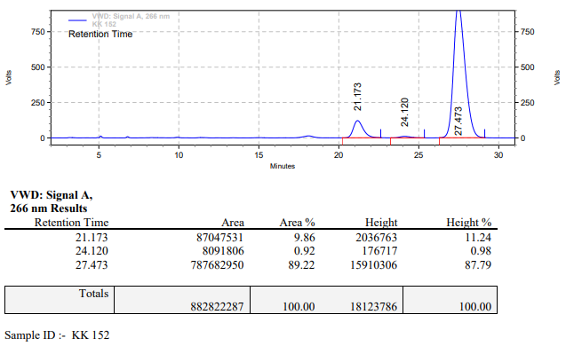

**KK-153**



**Calculation table:**

|  |  |  |  |  |  |
| --- | --- | --- | --- | --- | --- |
| Sr. No | Comp. | Mol. wt. | mmol | Eq. wt. | Wt. taken |
| 1 | Dehydrositagliptin (1) | 405.30 | 0.2135 | 100 | 86 mg |
| 2 | Rh(COD)2OTf | 468.30 | 0.0021 | 1 | 1 mg |
| 3 | L3 | 414.29 | 0.0022 | 1.05 | 0.9 mg |

**Procedure:** A glass vial (4 mL) equipped with Teflon coated magnetic needle was cooled under vacuum and transferred to a glove box. The vial was then charged with 86 mg of enamine (**1**), 1 mg of [Rh(COD)2OTf] (1 mol%) and L3. Reaction vial was then closed using screwcap, transferred to a large opening Schlenk type container and was then taken out from the glove box. 2 mL dry methanol was added to the vial in inert atmosphere and the resultant reaction slurry was stirred for 1 hour at room temperature (25 °C). After that the reaction vial was shifted to an autoclave and the autoclave was purged three times using hydrogen gas (40 bars). Finally, the autoclave was pressurized to 30 bar hydrogen pressure at 70°C for 24 hrs time period. After the 24 hrs time period, the autoclave was cooled to room temperature (25 °C), excess pressure was released and the autoclave was opened. The vials were taken out from the autoclave. The thus obtained reaction mixture was passed through neutral alumina bed, the filtrate was collect and dried to yield residue. The resultant residue was then analysed by HPLC.

**Reaction conditions:** Temp: 70°C Press.: 30 bar Solvent: methanol Time: 24 hrs

**Result: 91%** conversion **58%** ee

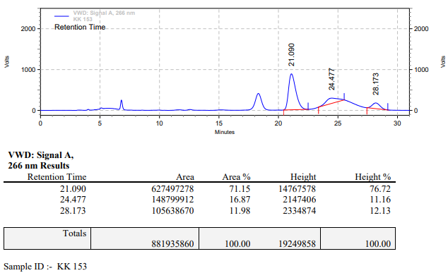

**KK-154**



**Calculation table:**

|  |  |  |  |  |  |
| --- | --- | --- | --- | --- | --- |
| Sr. No | Comp. | Mol. wt. | mmol | Eq. wt. | Wt. taken |
| 1 | Dehydrositagliptin (1) | 405.30 | 0.2135 | 100 | 86 mg |
| 2 | Rh(COD)2OTf | 468.30 | 0.0021 | 1 | 1 mg |
| 3 | L3 | 414.29 | 0.0022 | 1.05 | 0.9 mg |
| 4 | Ammonium chloride | 53.49 | 0.0021 | 1 | 0.1 mg |

**Procedure:** A glass vial (4 mL) equipped with Teflon coated magnetic needle was cooled under vacuum and transferred to a glove box. The vial was then charged with 86 mg of enamine (**1**), 1 mg of [Rh(COD)2OTf], L3 and ammonium chloride. Reaction vial was then closed using screwcap, transferred to a large opening Schlenk type container and was then taken out from the glove box. 2 mL dry methanol was added to the vial in inert atmosphere and the resultant reaction slurry was stirred for 1 hour at room temperature (25 °C). After that the reaction vial was shifted to an autoclave and the autoclave was purged three times using hydrogen gas (40 bars). Finally, the autoclave was pressurized to 30 bar hydrogen pressure at 70 °C for 24 hrs time period. After the 24 hrs time period, the autoclave was cooled to room temperature (25 °C), excess pressure was released and the autoclave was opened. The vials were taken out from the autoclave. The thus obtained reaction mixture was passed through neutral alumina bed, the filtrate was collect and dried to yield residue. The resultant residue was then analysed by HPLC.

**Reaction conditions:** Temp: 70°C Press.: 30 bar Solvent: methanol Time: 24 hrs

**Result: 87%** conversion **90%** ee

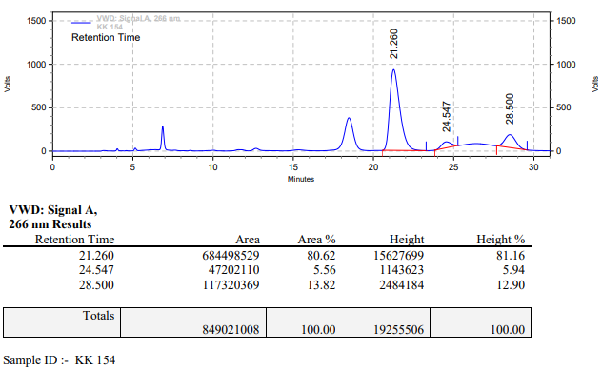

**KK-155**



**Calculation table:**

|  |  |  |  |  |  |
| --- | --- | --- | --- | --- | --- |
| Sr. No | Comp. | Mol. wt. | mmol | Eq. wt. | Wt. taken |
| 1 | Dehydrositagliptin (1) | 405.30 | 0.2135 | 100 | 86 mg |
| 2 | Rh(COD)2OTf | 468.30 | 0.0021 | 1 | 1 mg |
| 3 | L3 | 414.29 | 0.0022 | 1.05 | 0.9 mg |
| 4 | Acetic acid | 60.05 | 0.0106 | 5 | 0.6 mg |

**Procedure:** A glass vial (4 mL) equipped with Teflon coated magnetic needle was cooled under vacuum and transferred to a glove box. The vial was then charged with 86 mg of enamine (**1**), 1 mg of [Rh(COD)2OTf] and L3. Reaction vial was then closed using screwcap, transferred to a large opening Schlenk type container and was then taken out from the glove box. 2 mL dry methanol was added followed by acetic acid to the vial in inert atmosphere and the resultant reaction slurry was stirred for 1 hour at room temperature (25 °C). After that the reaction vial was shifted to an autoclave and the autoclave was purged three times using hydrogen gas (40 bars). Finally, the autoclave was pressurized to 30 bar hydrogen pressure at 70°C for 24 hrs time period. After the 24 hrs time period, the autoclave was cooled to room temperature (25 °C), excess pressure was released and the autoclave was opened. The vials were taken out from the autoclave. The thus obtained reaction mixture was passed through neutral alumina bed, the filtrate was collect and dried to yield residue. The resultant residue was then analysed by HPLC.

**Reaction conditions:** Temp: 70°C Press.: 30 bar Solvent: methanol Time: 24 hrs

**Result: 74%** conversion **85%** ee

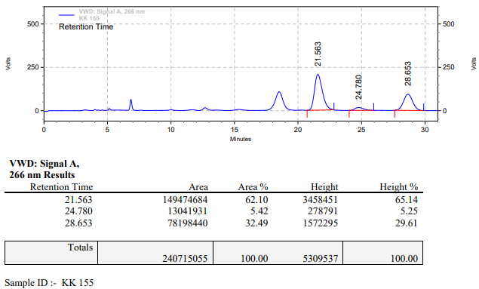

**KK-156**



**Calculation table:**

|  |  |  |  |  |  |
| --- | --- | --- | --- | --- | --- |
| Sr. No | Comp. | Mol. wt. | mmol | Eq. wt. | Wt. taken |
| 1 | Dehydrositagliptin (1) | 405.30 | 0.2135 | 100 | 86 mg |
| 2 | Rh(COD)2OTf | 468.30 | 0.0021 | 1 | 1 mg |
| 3 | L3 | 414.29 | 0.0022 | 1.05 | 0.9 mg |
| 4 | Phosphoric acid | 97.99 | 0.0105 | 5 | 1.02 mg |

**Procedure:** A glass vial (4 mL) equipped with Teflon coated magnetic needle was cooled under vacuum and transferred to a glove box. The vial was then charged with 86 mg of enamine (**1**), 1 mg of [Rh(COD)2OTf] (1 mol%) and L3. Reaction vial was then closed using screwcap, transferred to a large opening Schlenk type container and was then taken out from the glove box. 2 mL dry methanol was added followed by phosphoric acid to the vial in inert atmosphere and the resultant reaction slurry was stirred for 1 hour at room temperature (25 °C). After that the reaction vial was shifted to an autoclave and the autoclave was purged three times using hydrogen gas (40 bars). Finally, the autoclave was pressurized to 30 bar hydrogen pressure at 70°C for 24 hrs time period. After the 24 hrs time period, the autoclave was cooled to room temperature (25 °C), excess pressure was released and the autoclave was opened. The vials were taken out from the autoclave. The thus obtained reaction mixture was passed through neutral alumina bed, the filtrate was collect and dried to yield residue. The resultant residue was then analysed by HPLC.

**Reaction conditions:** Temp: 70°C Press.: 30 bar Solvent: methanol Time: 24 hrs

**Result: 94%** conversion **88%** ee

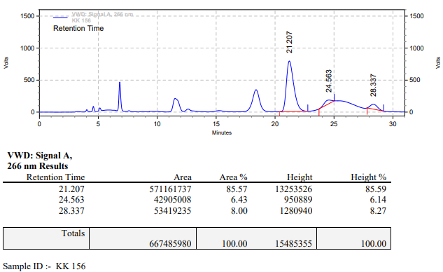

**KK-157**



**Calculation table:**

|  |  |  |  |  |  |
| --- | --- | --- | --- | --- | --- |
| Sr. No | Comp. | Mol. wt. | mmol | Eq. wt. | Wt. taken |
| 1 | Dehydrositagliptin (1) | 405.30 | 0.2135 | 100 | 86 mg |
| 2 | Rh(COD)2OTf | 468.30 | 0.0021 | 1 | 1 mg |
| 3 | L3 | 414.29 | 0.0022 | 1.05 | 0.9 mg |

**Procedure:** A glass vial (4 mL) equipped with Teflon coated magnetic needle was cooled under vacuum and transferred to a glove box. The vial was then charged with 86 mg of enamine (**1**), 1 mg of [Rh(COD)2OTf] (1 mol%) and L3. Reaction vial was then closed using screwcap, transferred to a large opening Schlenk type container and was then taken out from the glove box. 2 mL dry methanol was added to the vial in inert atmosphere and the resultant reaction slurry was stirred for 1 hour at room temperature (25 °C). After that the reaction vial was shifted to an autoclave and the autoclave was purged three times using hydrogen gas (40 bars). Finally, the autoclave was pressurized to 30 bar hydrogen pressure at 65°C for 24 hrs time period. After the 24 hrs time period, the autoclave was cooled to room temperature (25 °C), excess pressure was released and the autoclave was opened. The vials were taken out from the autoclave. The thus obtained reaction mixture was passed through neutral alumina bed, the filtrate was collect and dried to yield residue. The resultant residue was then analysed by HPLC.

**Reaction conditions:** Temp: 65°C Press.: 30 bar Solvent: methanol Time: 24 hrs

**Result: 50%** conversion **90%** ee

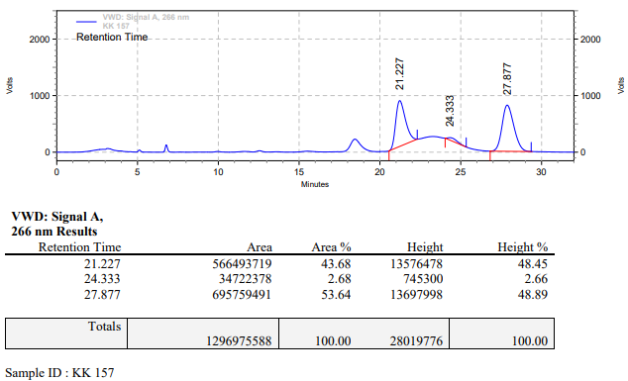

**KK-158**



**Calculation table:**

|  |  |  |  |  |  |
| --- | --- | --- | --- | --- | --- |
| Sr. No | Comp. | Mol. wt. | mmol | Eq. wt. | Wt. taken |
| 1 | Dehydrositagliptin (1) | 405.30 | 0.2135 | 100 | 86 mg |
| 2 | Rh(COD)2OTf | 468.30 | 0.0021 | 1 | 1 mg |
| 3 | L3 | 414.29 | 0.0022 | 1.05 | 0.9 mg |
| 4 | Ammonium chloride | 53.49 | 0.0021 | 1 | 0.1 mg |

**Procedure:** A glass vial (4 mL) equipped with Teflon coated magnetic needle was cooled under vacuum and transferred to a glove box. The vial was then charged with 86 mg of enamine (**1**), 1 mg of [Rh(COD)2OTf] (1 mol%), L3 and ammonium chloride. Reaction vial was then closed using screwcap, transferred to a large opening Schlenk type container and was then taken out from the glove box. 2 mL dry methanol was added to the vial in inert atmosphere and the resultant reaction slurry was stirred for 1 hour at room temperature (25 °C). After that the reaction vial was shifted to an autoclave and the autoclave was purged three times using hydrogen gas (40 bars). Finally, the autoclave was pressurized to 30 bar hydrogen pressure at 65 °C for 24 hrs time period. After the 24 hrs time period, the autoclave was cooled to room temperature (25 °C), excess pressure was released and the autoclave was opened. The vials were taken out from the autoclave. The thus obtained reaction mixture was passed through neutral alumina bed, the filtrate was collect and dried to yield residue. The resultant residue was then analysed by HPLC.

**Reaction conditions:** Temp: 65°C Press.: 30 bar Solvent: methanol Time: 24 hrs

**Result: 61%** conversion **87%** ee

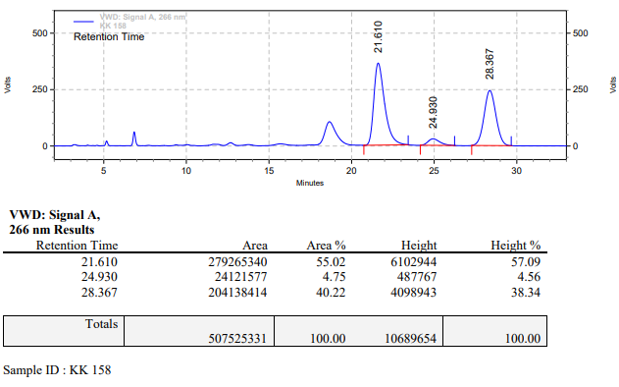

**KK-159**



**Calculation table:**

|  |  |  |  |  |  |
| --- | --- | --- | --- | --- | --- |
| Sr. No | Comp. | Mol. wt. | mmol | Eq. wt. | Wt. taken |
| 1 | Dehydrositagliptin (1) | 405.30 | 0.2135 | 100 | 86 mg |
| 2 | Rh(COD)2OTf | 468.30 | 0.0021 | 1 | 1 mg |
| 3 | L3 | 414.29 | 0.0022 | 1.05 | 0.9 mg |
| 4 | Acetic acid | 60.05 | 0.0106 | 5 | 0.6 mg |

**Procedure:** A glass vial (4 mL) equipped with Teflon coated magnetic needle was cooled under vacuum and transferred to a glove box. The vial was then charged with 86 mg of enamine (**1**), 1 mg of [Rh(COD)2OTf] (1 mol%) and L3. Reaction vial was then closed using screwcap, transferred to a large opening Schlenk type container and was then taken out from the glove box. 2 mL dry methanol was added followed by acetic acid to the vial in inert atmosphere and the resultant reaction slurry was stirred for 1 hour at room temperature (25 °C). After that the reaction vial was shifted to an autoclave and the autoclave was purged three times using hydrogen gas (40 bars). Finally, the autoclave was pressurized to 30 bar hydrogen pressure at 65°C for 24 hrs time period. After the 24 hrs time period, the autoclave was cooled to room temperature (25 °C), excess pressure was released and the autoclave was opened. The vials were taken out from the autoclave. The thus obtained reaction mixture was passed through neutral alumina bed, the filtrate was collect and dried to yield residue. The resultant residue was then analysed by HPLC.

**Reaction conditions:** Temp: 65°C Press.: 30 bar Solvent: methanol Time: 24 hrs

**Result: 20%** conversion **50%** ee

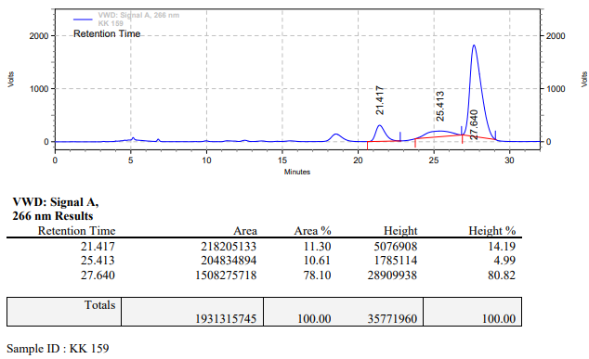

**KK-160**



**Calculation table:**

|  |  |  |  |  |  |
| --- | --- | --- | --- | --- | --- |
| Sr. No | Comp. | Mol. wt. | mmol | Eq. wt. | Wt. taken |
| 1 | Dehydrositagliptin (1) | 405.30 | 0.2135 | 100 | 86 mg |
| 2 | Rh(COD)2OTf | 468.30 | 0.0021 | 1 | 1 mg |
| 3 | L3 | 414.29 | 0.0022 | 1.05 | 0.9 mg |
| 4 | Phosphoric acid | 97.99 | 0.0105 | 5 | 1 mg |

**Procedure:** A glass vial (4 mL) equipped with Teflon coated magnetic needle was cooled under vacuum and transferred to a glove box. The vial was then charged with 86 mg of enamine (**1**), 1 mg of [Rh(COD)2OTf] (1 mol%) and L3. Reaction vial was then closed using screwcap, transferred to a large opening Schlenk type container and was then taken out from the glove box. 2 mL dry methanol was added followed by phosphoric acid to the vial in inert atmosphere and the resultant reaction slurry was stirred for 1 hour at room temperature (25 °C). After that the reaction vial was shifted to an autoclave and the autoclave was purged three times using hydrogen gas (40 bars). Finally, the autoclave was pressurized to 30 bar hydrogen pressure at 65°C for 24 hrs time period. After the 24 hrs time period, the autoclave was cooled to room temperature (25 °C), excess pressure was released and the autoclave was opened. The vials were taken out from the autoclave. The thus obtained reaction mixture was passed through neutral alumina bed, the filtrate was collect and dried to yield residue. The resultant residue was then analysed by HPLC.

**Reaction conditions:** Temp: 65°C Press.: 30 bar Solvent: methanol Time: 24 hrs

**Result: 30%** conversion **60%** ee

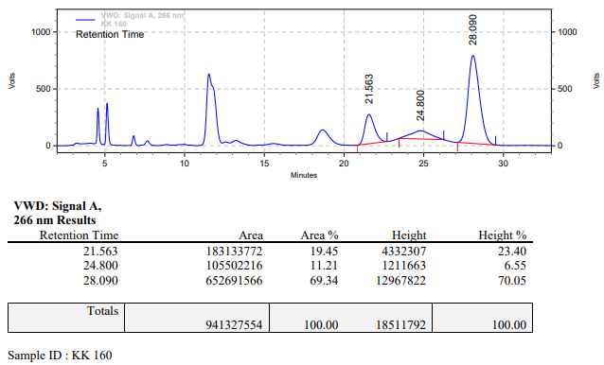

**KK-161**



**Calculation table:**

|  |  |  |  |  |  |
| --- | --- | --- | --- | --- | --- |
| Sr. No | Comp. | Mol. wt. | mmol | Eq. wt. | Wt. taken |
| 1 | Dehydrositagliptin (1) | 405.30 | 0.1413 | 100 | 57 mg |
| 2 | [FeH(CO)4]PNP | 707.48 | 0.0014 | 1 | 1 mg |
| 3 | tBu-Josiphos | 542.45 | 0.0015 | 1.05 | 0.8 mg |

**Procedure:** A glass vial (4 mL) equipped with Teflon coated magnetic needle was cooled under vacuum and transferred to a glove box. The vial was then charged with 57 mg of enamine (**1**), 1 mg of [FeH(CO)4]PNP(1 mol%) and tBu-Josiphos. Reaction vial was then closed using screwcap, transferred to a large opening Schlenk type container and was then taken out from the glove box. 2 mL dry methanol was added to the vial in inert atmosphere and the resultant reaction slurry was stirred for 1 hour at room temperature (25 °C). After that the reaction vial was shifted to an autoclave and the autoclave was purged three times using hydrogen gas (40 bars). Finally, the autoclave was pressurized to 30 bar hydrogen pressure at 60°C for 48 hrs time period. After the 48 hrs time period, the autoclave was cooled to room temperature (25 °C), excess pressure was released and the autoclave was opened. The vials were taken out from the autoclave. The thus obtained reaction mixture was passed through neutral alumina bed, the filtrate was collect and dried to yield residue. The resultant residue was then analysed by HPLC.

**Reaction conditions:** Temp: 60°C Press.: 30 bar Solvent: methanol Time: 48 hrs

**Result: 00%** conversion **00%** ee

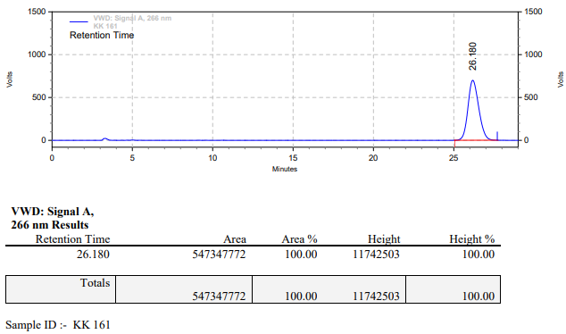

**KK-162**



**Calculation table:**

|  |  |  |  |  |  |
| --- | --- | --- | --- | --- | --- |
| Sr. No | Comp. | Mol. wt. | mmol | Eq. wt. | Wt. taken |
| 1 | Dehydrositagliptin (1) | 405.30 | 0.1413 | 100 | 57 mg |
| 2 | [FeH(CO)4]PNP | 707.48 | 0.0014 | 1 | 1 mg |
| 3 | HL | 592.55 | 0.0015 | 1.05 | 0.9 mg |

**Procedure:** A glass vial (4 mL) equipped with Teflon coated magnetic needle was cooled under vacuum and transferred to a glove box. The vial was then charged with 57 mg of enamine (**1**), 1 mg of [FeH(CO)4]PNP(1 mol%) and ligand (HL). Reaction vial was then closed using screwcap, transferred to a large opening Schlenk type container and was then taken out from the glove box. 2 mL dry toluene was added to the vial in inert atmosphere and the resultant reaction slurry was stirred for 1 hour at room temperature (25 °C). After that the reaction vial was shifted to an autoclave and the autoclave was purged three times using hydrogen gas (40 bars). Finally, the autoclave was pressurized to 30 bar hydrogen pressure at 60°C for 48 hrs time period. After the 48 hrs time period, the autoclave was cooled to room temperature (25 °C), excess pressure was released and the autoclave was opened. The vials were taken out from the autoclave. The thus obtained reaction mixture was passed through neutral alumina bed, the filtrate was collect and dried to yield residue. The resultant residue was then analysed by HPLC.

**Reaction conditions:** Temp: 60°C Press.: 30 bar Solvent: toluene Time: 48 hrs

**Result: 00%** conversion **00%** ee

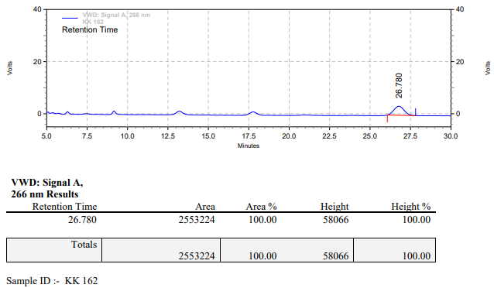

**KK-163**



**Calculation table:**

|  |  |  |  |  |  |
| --- | --- | --- | --- | --- | --- |
| Sr. No | Comp. | Mol. wt. | mmol | Eq. wt. | Wt. taken |
| 1 | Dehydrositagliptin (1) | 405.30 | 0.1413 | 100 | 57 mg |
| 2 | [FeH(CO)4]PNP | 707.48 | 0.0014 | 1 | 1 mg |
| 3 | L4 | 306.36 | 0.0014 | 1.05 | 0.5 mg |

**Procedure:** A glass vial (4 mL) equipped with Teflon coated magnetic needle was cooled under vacuum and transferred to a glove box. The vial was then charged with 57 mg of enamine (**1**), 1 mg of [FeH(CO)4]PNP(1 mol%) and ligand (L4). Reaction vial was then closed using screwcap, transferred to a large opening Schlenk type container and was then taken out from the glove box. 2 mL dry methanol was added to the vial in inert atmosphere and the resultant reaction slurry was stirred for 1 hour at room temperature (25 °C). After that the reaction vial was shifted to an autoclave and the autoclave was purged three times using hydrogen gas (40 bars). Finally, the autoclave was pressurized to 30 bar hydrogen pressure at 60°C for 48 hrs time period. After the 48 hrs time period, the autoclave was cooled to room temperature (25 °C), excess pressure was released and the autoclave was opened. The vials were taken out from the autoclave. The thus obtained reaction mixture was passed through neutral alumina bed, the filtrate was collect and dried to yield residue. The resultant residue was then analysed by HPLC.

**Reaction conditions:** Temp: 60°C Press.: 30 bar Solvent: methanol Time: 48 hrs

**Result: 00%** conversion **00%** ee

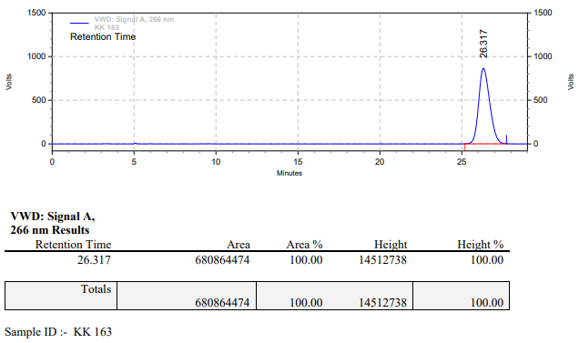

**KK-164**



**Calculation table:**

|  |  |  |  |  |  |
| --- | --- | --- | --- | --- | --- |
| Sr. No | Comp. | Mol. wt. | mmol | Eq. wt. | Wt. taken |
| 1 | Dehydrositagliptin (1) | 405.30 | 0.1413 | 100 | 57 mg |
| 2 | [FeH(CO)4]PNP | 707.48 | 0.0014 | 1 | 1 mg |
| 3 | L3 | 414.30 | 0.0015 | 1.05 | 0.6 mg |

**Procedure:** A glass vial (4 mL) equipped with Teflon coated magnetic needle was cooled under vacuum and transferred to a glove box. The vial was then charged with 57 mg of enamine (**1**), 1 mg of [FeH(CO)4]PNP(1 mol%) and ligand (L3). Reaction vial was then closed using screwcap, transferred to a large opening Schlenk type container and was then taken out from the glove box. 2 mL dry methanol was added to the vial in inert atmosphere and the resultant reaction slurry was stirred for 1 hour at room temperature (25 °C). After that the reaction vial was shifted to an autoclave and the autoclave was purged three times using hydrogen gas (40 bars). Finally, the autoclave was pressurized to 30 bar hydrogen pressure at 60°C for 48 hrs time period. After the 48 hrs time period, the autoclave was cooled to room temperature (25 °C), excess pressure was released and the autoclave was opened. The vials were taken out from the autoclave. The thus obtained reaction mixture was passed through neutral alumina bed, the filtrate was collect and dried to yield residue. The resultant residue was then analysed by HPLC.

**Reaction conditions:** Temp: 60°C Press.: 30 bar Solvent: methanol Time: 48 hrs

**Result: 00%** conversion **00%** ee

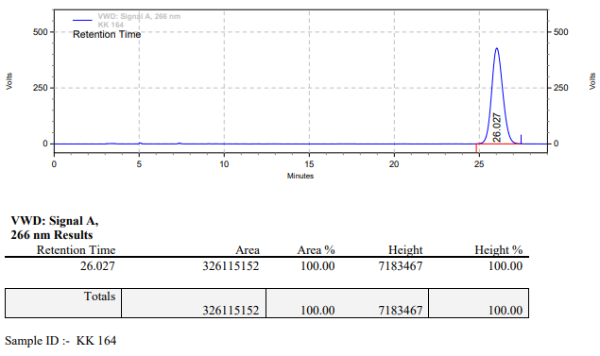

**KK-165**



**Calculation table:**

|  |  |  |  |  |  |
| --- | --- | --- | --- | --- | --- |
| Sr. No | Comp. | Mol. wt. | mmol | Eq. wt. | Wt. taken |
| 1 | Dehydrositagliptin (1) | 405.30 | 0.1413 | 100 | 57 mg |
| 2 | [FeH(CO)4]PNP | 707.48 | 0.0014 | 1 | 1 mg |
| 3 | L1 | 496.53 | 0.0015 | 1.05 | 0.8 mg |

**Procedure:** A glass vial (4 mL) equipped with Teflon coated magnetic needle was cooled under vacuum and transferred to a glove box. The vial was then charged with 57 mg of enamine (**1**), 1 mg of [FeH(CO)4]PNP and ligand (L1). Reaction vial was then closed using screwcap, transferred to a large opening Schlenk type container and was then taken out from the glove box. 2 mL dry methanol was added to the vial in inert atmosphere and the resultant reaction slurry was stirred for 1 hour at room temperature (25 °C). After that the reaction vial was shifted to an autoclave and the autoclave was purged three times using hydrogen gas (40 bars). Finally, the autoclave was pressurized to 30 bar hydrogen pressure at 60°C for 48 hrs time period. After the 48 hrs time period, the autoclave was cooled to room temperature (25 °C), excess pressure was released and the autoclave was opened. The vials were taken out from the autoclave. The thus obtained reaction mixture was passed through neutral alumina bed, the filtrate was collect and dried to yield residue. The resultant residue was then analysed by HPLC.

**Reaction conditions:** Temp: 60°C Press.: 30 bar Solvent: methanol Time: 48 hrs

**Result: 00%** conversion **00%** ee

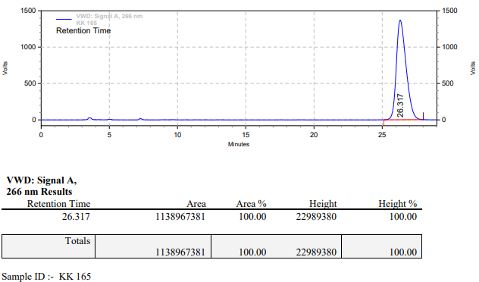

**KK-166**



**Calculation table:**

|  |  |  |  |  |  |
| --- | --- | --- | --- | --- | --- |
| Sr. No | Comp. | Mol. wt. | mmol | Eq. wt. | Wt. taken |
| 1 | Dehydrositagliptin (1) | 405.30 | 0.1413 | 100 | 57 mg |
| 2 | [FeH(CO)4]PNP | 707.48 | 0.0014 | 1 | 1 mg |
| 3 | L2 | 426.47 | 0.0015 | 1.05 | 0.6 mg |

**Procedure:** A glass vial (4 mL) equipped with Teflon coated magnetic needle was cooled under vacuum and transferred to a glove box. The vial was then charged with 57 mg of enamine (**1**), 1 mg of [FeH(CO)4]PNP(1 mol%) and ligand (L2). Reaction vial was then closed using screwcap, transferred to a large opening Schlenk type container and was then taken out from the glove box. 2 mL dry methanol was added to the vial in inert atmosphere and the resultant reaction slurry was stirred for 1 hour at room temperature (25 °C). After that the reaction vial was shifted to an autoclave and the autoclave was purged three times using hydrogen gas (40 bars). Finally, the autoclave was pressurized to 30 bar hydrogen pressure at 60°C for 48 hrs time period. After the 48 hrs time period, the autoclave was cooled to room temperature (25 °C), excess pressure was released and the autoclave was opened. The vials were taken out from the autoclave. The thus obtained reaction mixture was passed through neutral alumina bed, the filtrate was collect and dried to yield residue. The resultant residue was then analysed by HPLC.

**Reaction conditions:** Temp: 60°C Press.: 30 bar Solvent: methanol Time: 48 hrs

**Result: 00%** conversion **00%** ee

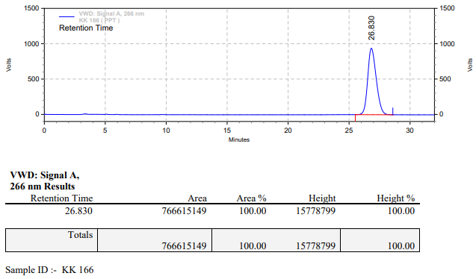

**KK-167**



**Calculation table:**

|  |  |  |  |  |  |
| --- | --- | --- | --- | --- | --- |
| Sr. No | Comp. | Mol. wt. | mmol | Eq. wt. | Wt. taken |
| 1 | Dehydrositagliptin (1) | 405.30 | 0.4270 | 200 | 173 mg |
| 2 | Rh(COD)2OTf | 468.30 | 0.0021 | 1 | 1 mg |
| 3 | L3 | 414.29 | 0.0022 | 1.05 | 0.9 mg |

**Procedure:** A glass vial (15 mL) equipped with Teflon coated magnetic needle was cooled under vacuum and transferred to a glove box. The vial was then charged with 173 mg of enamine (**1**), 1 mg of [Rh(COD)2OTf] (0.5 mol%) and ligand (L3). Reaction vial was then closed using screwcap, transferred to a large opening Schlenk type container and was then taken out from the glove box. 5 mL dry methanol was added to the vial in inert atmosphere and the resultant reaction slurry was stirred for 1 hour at room temperature (25 °C). After that the reaction vial was shifted to an autoclave and the autoclave was purged three times using hydrogen gas (40 bars). Finally, the autoclave was pressurized to 30 bar hydrogen pressure at 60°C for 18 hrs time period. After the 18 hrs time period, the autoclave was cooled to room temperature (25 °C), excess pressure was released and the autoclave was opened. The vials were taken out from the autoclave. The thus obtained reaction mixture was passed through neutral alumina bed, the filtrate was collect and dried to yield residue. The resultant residue was then analysed by HPLC.

**Reaction conditions:** Temp: 60°C Press.: 30 bar Solvent: methanol Time: 18 hrs

**Result: 00%** conversion **00%** ee

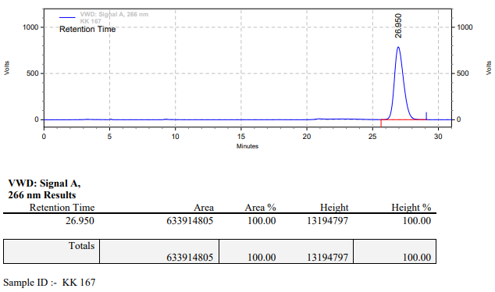

**KK-168**



**Calculation table:**

|  |  |  |  |  |  |
| --- | --- | --- | --- | --- | --- |
| Sr. No | Comp. | Mol. wt. | mmol | Eq. wt. | Wt. taken |
| 1 | Dehydrositagliptin (1) | 405.30 | 0.4270 | 200 | 173 mg |
| 2 | Rh(COD)2OTf | 468.30 | 0.0021 | 1 | 1 mg |
| 3 | L3 | 414.29 | 0.0022 | 1.05 | 0.9 mg |
| 4 | Ammonium chloride | 53.49 | 0.0021 | 1 | 0.1 mg |

**Procedure:** A glass vial (15 mL) equipped with Teflon coated magnetic needle was cooled under vacuum and transferred to a glove box. The vial was then charged with 173 mg of enamine (**1**), 1 mg of [Rh(COD)2OTf] (0.5 mol%), ligand (L3) and ammonium chloride. Reaction vial was then closed using screwcap, transferred to a large opening Schlenk type container and was then taken out from the glove box. 5 mL dry methanol was added to the vial in inert atmosphere and the resultant reaction slurry was stirred for 1 hour at room temperature (25 °C). After that the reaction vial was shifted to an autoclave and the autoclave was purged three times using hydrogen gas (40 bars). Finally, the autoclave was pressurized to 30 bar hydrogen pressure at 60°C for 18 hrs time period. After the 18 hrs time period, the autoclave was cooled to room temperature (25 °C), excess pressure was released and the autoclave was opened. The vials were taken out from the autoclave. The thus obtained reaction mixture was passed through neutral alumina bed, the filtrate was collect and dried to yield residue. The resultant residue was then analysed by HPLC.

**Reaction conditions:** Temp: 60°C Press.: 30 bar Solvent: methanol Time: 18 hrs

**Result: 00%** conversion **00%** ee

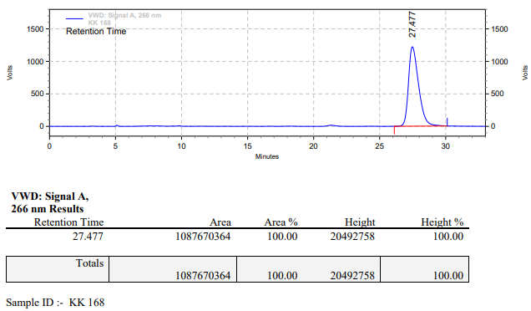

**KK-169**



**Calculation table:**

|  |  |  |  |  |  |
| --- | --- | --- | --- | --- | --- |
| Sr. No | Comp. | Mol. wt. | mmol | Eq. wt. | Wt. taken |
| 1 | Dehydrositagliptin (1) | 405.30 | 0.4270 | 200 | 173 mg |
| 2 | Rh(COD)2OTf | 468.30 | 0.0021 | 1 | 1 mg |
| 3 | L3 | 414.29 | 0.0022 | 1.05 | 0.9 mg |
| 4 | Acetic acid | 60.05 | 0.0106 | 5 | 0.6 mg |

**Procedure:** A glass vial (15 mL) equipped with Teflon coated magnetic needle was cooled under vacuum and transferred to a glove box. The vial was then charged with 172.68 mg of enamine (**1**), 1 mg of [Rh(COD)2OTf], ligand (L3). Reaction vial was then closed using screwcap, transferred to a large opening Schlenk type container and was then taken out from the glove box. 5 mL dry methanol was added followed by acetic acid to the vial in inert atmosphere and the resultant reaction slurry was stirred for 1 hour at room temperature (25 °C). After that the reaction vial was shifted to an autoclave and the autoclave was purged three times using hydrogen gas (40 bars). Finally, the autoclave was pressurized to 30 bar hydrogen pressure at 60°C for 18 hrs time period. After the 18 hrs time period, the autoclave was cooled to room temperature (25 °C), excess pressure was released and the autoclave was opened. The vials were taken out from the autoclave. The thus obtained reaction mixture was passed through neutral alumina bed, the filtrate was collect and dried to yield residue. The resultant residue was then analysed by HPLC.

**Reaction conditions:** Temp: 60°C Press.: 30 bar Solvent: methanol Time: 18 hrs

**Result: 00%** conversion **00%** ee

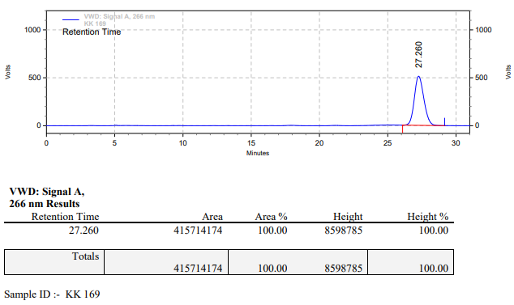

**KK-170**



**Calculation table:**

|  |  |  |  |  |  |
| --- | --- | --- | --- | --- | --- |
| Sr. No | Comp. | Mol. wt. | mmol | Eq. wt. | Wt. taken |
| 1 | Dehydrositagliptin (1) | 405.30 | 0.4270 | 200 | 173 mg |
| 2 | Rh(COD)2OTf | 468.30 | 0.0021 | 1 | 1 mg |
| 3 | L3 | 414.29 | 0.0022 | 1.05 | 0.9 mg |
| 4 | Phosphoric acid | 97.99 | 0.0106 | 5 | 1.0 mg |

**Procedure:** A glass vial (15 mL) equipped with Teflon coated magnetic needle was cooled under vacuum and transferred to a glove box. The vial was then charged with 172.68 mg of enamine (**1**), 1 mg of [Rh(COD)2OTf] (0.5 mol%), ligand (L3). Reaction vial was then closed using screwcap, transferred to a large opening Schlenk type container and was then taken out from the glove box. 5 mL dry methanol was added followed by phosphoric acid to the vial in inert atmosphere and the resultant reaction slurry was stirred for 1 hour at room temperature (25 °C). After that the reaction vial was shifted to an autoclave and the autoclave was purged three times using hydrogen gas (40 bars). Finally, the autoclave was pressurized to 30 bar hydrogen pressure at 60°C for 18 hrs time period. After the 18 hrs time period, the autoclave was cooled to room temperature (25 °C), excess pressure was released and the autoclave was opened. The vials were taken out from the autoclave. The thus obtained reaction mixture was passed through neutral alumina bed, the filtrate was collect and dried to yield residue. The resultant residue was then analysed by HPLC.

**Reaction conditions:** Temp: 60°C Press.: 30 bar Solvent: methanol Time: 18 hrs

**Result: 00%** conversion **00%** ee

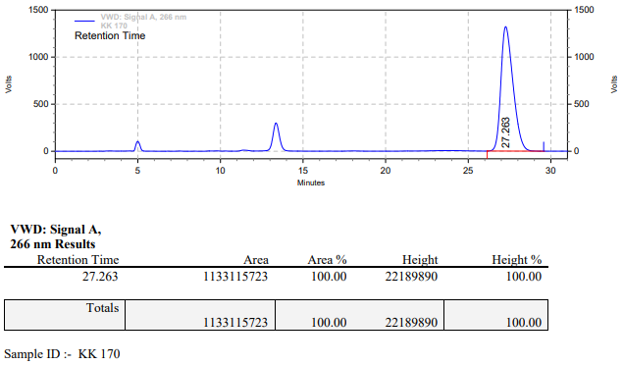

**KK-173**



**Calculation table:**

|  |  |  |  |  |  |
| --- | --- | --- | --- | --- | --- |
| Sr. No | Comp. | Mol. wt. | mmol | Eq. wt. | Wt. taken |
| 1 | Dehydrositagliptin (1) | 405.30 | 0.1413 | 100 | 57 mg |
| 2 | [FeH(CO)4]PNP | 707.48 | 0.0014 | 1 | 1 mg |
| 3 | L4 | 306.36 | 0.0014 | 1.05 | 0.5 mg |

**Procedure:** A glass vial (4 mL) equipped with Teflon coated magnetic needle was cooled under vacuum and transferred to a glove box. The vial was then charged with 57 mg of enamine (**1**), 1 mg of [FeH(CO)4]PNP (1 mol%) and ligand (L4). Reaction vial was then closed using screwcap, transferred to a large opening Schlenk type container and was then taken out from the glove box. 2 mL dry methanol was added to the vial in inert atmosphere and the resultant reaction slurry was stirred for 1 hour at room temperature (25 °C). After that the reaction vial was shifted to an autoclave and the autoclave was purged three times using hydrogen gas (40 bars). Finally, the autoclave was pressurized to 30 bar hydrogen pressure at 100°C for 48 hrs time period. After the 48 hrs time period, the autoclave was cooled to room temperature (25 °C), excess pressure was released and the autoclave was opened. The vials were taken out from the autoclave. The thus obtained reaction mixture was passed through neutral alumina bed, the filtrate was collect and dried to yield residue. The resultant residue was then analysed by HPLC.

**Reaction conditions:** Temp: 100°C Press.: 30 bar Solvent: methanol Time: 48 hrs

**Result: 00%** conversion **00%** ee

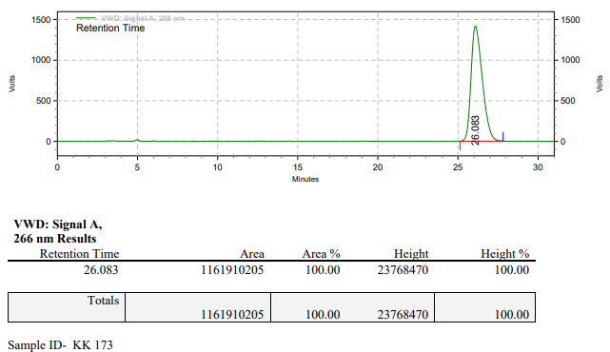

**KK-174**



**Calculation table:**

|  |  |  |  |  |  |
| --- | --- | --- | --- | --- | --- |
| Sr. No | Comp. | Mol. wt. | mmol | Eq. wt. | Wt. taken |
| 1 | Dehydrositagliptin (1) | 405.30 | 0.1413 | 100 | 57 mg |
| 2 | [FeH(CO)4]PNP | 707.48 | 0.0014 | 1 | 1 mg |
| 3 | L3 | 414.30 | 0.0015 | 1.05 | 0.6 mg |

**Procedure:** A glass vial (4 mL) equipped with Teflon coated magnetic needle was cooled under vacuum and transferred to a glove box. The vial was then charged with 57 mg of enamine (**1**), 1 mg of [FeH(CO)4]PNP (1 mol%) and ligand (L3). Reaction vial was then closed using screwcap, transferred to a large opening Schlenk type container and was then taken out from the glove box. 2 mL dry methanol was added to the vial in inert atmosphere and the resultant reaction slurry was stirred for 1 hour at room temperature (25 °C). After that the reaction vial was shifted to an autoclave and the autoclave was purged three times using hydrogen gas (40 bars). Finally, the autoclave was pressurized to 30 bar hydrogen pressure at 100°C for 48 hrs time period. After the 48 hrs time period, the autoclave was cooled to room temperature (25 °C), excess pressure was released and the autoclave was opened. The vials were taken out from the autoclave. The thus obtained reaction mixture was passed through neutral alumina bed, the filtrate was collect and dried to yield residue. The resultant residue was then analysed by HPLC.

**Reaction conditions:** Temp: 100°C Press.: 30 bar Solvent: methanol Time: 48 hrs

**Result: 00%** conversion **00%** ee

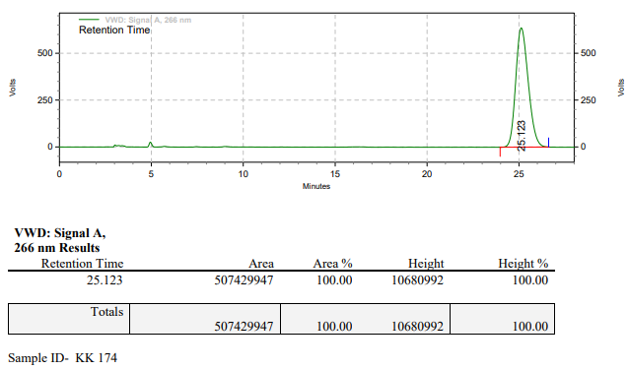

**KK-176**



**Calculation table:**

|  |  |  |  |  |  |
| --- | --- | --- | --- | --- | --- |
| Sr. No | Comp. | Mol. wt. | mmol | Eq. wt. | Wt. taken |
| 1 | Dehydrositagliptin (1) | 405.30 | 0.1413 | 100 | 57 mg |
| 2 | [FeH(CO)4]PNP | 707.48 | 0.0014 | 1 | 1 mg |
| 3 | tBu-Josiphos | 542.45 | 0.0015 | 1.05 | 0.8 mg |

**Procedure:** A glass vial (4 mL) equipped with Teflon coated magnetic needle was cooled under vacuum and transferred to a glove box. The vial was then charged with 57 mg of enamine (**1**), 1 mg of [FeH(CO)4]PNP (1 mol%) and tBu-Josiphos. Reaction vial was then closed using screwcap, transferred to a large opening Schlenk type container and was then taken out from the glove box. 2 mL dry methanol was added to the vial in inert atmosphere and the resultant reaction slurry was stirred for 1 hour at room temperature (25 °C). After that the reaction vial was shifted to an autoclave and the autoclave was purged three times using hydrogen gas (40 bars). Finally, the autoclave was pressurized to 30 bar hydrogen pressure at 100°C for 48 hrs time period. After the 48 hrs time period, the autoclave was cooled to room temperature (25 °C), excess pressure was released and the autoclave was opened. The vials were taken out from the autoclave. The thus obtained reaction mixture was passed through neutral alumina bed, the filtrate was collect and dried to yield residue. The resultant residue was then analysed by HPLC.

**Reaction conditions:** Temp: 100°C Press.: 30 bar Solvent: methanol Time: 48 hrs

**Result: 00%** conversion **00%** ee

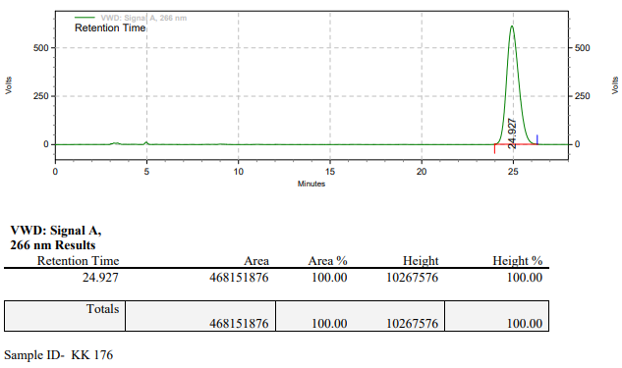

**KK-189**



**Calculation table:**

|  |  |  |  |  |  |
| --- | --- | --- | --- | --- | --- |
| Sr. No | Comp. | Mol. wt. | mmol | Eq. wt. | Wt. taken |
| 1 | Dehydrositagliptin (1) | 405.30 | 0.2135 | 100 | 86 mg |
| 2 | Rh(COD)2OTf | 468.30 | 0.0021 | 1 | 1 mg |
| 3 | L3 | 414.29 | 0.0022 | 1.05 | 0.9 mg |
| 4 | Ammonium chloride | 53.49 | 0.0021 | 1 | 0.1 mg |

**Procedure:** A glass vial (4 mL) equipped with Teflon coated magnetic needle was cooled under vacuum and transferred to a glove box. The vial was then charged with 86 mg of enamine (**1**), 1 mg of [Rh(COD)2OTf] (1 mol%), ligand (L3) and ammonium chloride. Reaction vial was then closed using screwcap, transferred to a large opening Schlenk type container and was then taken out from the glove box. 2 mL dry methanol was added to the vial in inert atmosphere and the resultant reaction slurry was stirred for 1 hour at room temperature (25 °C). After that the reaction vial was shifted to an autoclave and the autoclave was purged three times using hydrogen gas (40 bars). Finally, the autoclave was pressurized to 30 bar hydrogen pressure at 60°C for 18 hrs time period. After the 18 hrs time period, the autoclave was cooled to room temperature (25 °C), excess pressure was released and the autoclave was opened. The vials were taken out from the autoclave. The thus obtained reaction mixture was passed through neutral alumina bed, the filtrate was collect and dried to yield residue. The resultant residue was then analysed by HPLC.

**Reaction conditions:** Temp: 60°C Press.: 30 bar Solvent: methanol Time: 18 hrs

**Result: 15%** conversion 8**0%** ee

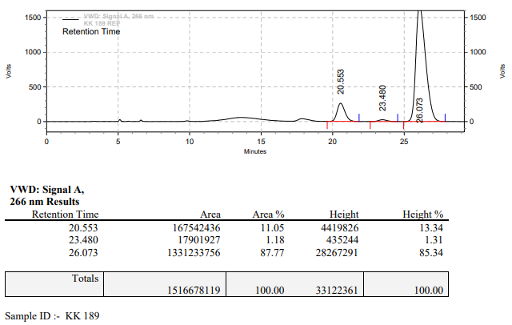

**KK-190**



**Calculation table:**

|  |  |  |  |  |  |
| --- | --- | --- | --- | --- | --- |
| Sr. No | Comp. | Mol. wt. | mmol | Eq. wt. | Wt. taken |
| 1 | Dehydrositagliptin (1) | 405.30 | 0.4200 | 200 | 173 mg |
| 2 | Rh(COD)2OTf | 468.30 | 0.0021 | 1 | 1 mg |
| 3 | L3 | 414.29 | 0.0022 | 1.05 | 0.9 mg |
| 4 | Ammonium chloride | 53.49 | 0.0021 | 1 | 0.1 mg |

**Procedure:** A glass vial (15 mL) equipped with Teflon coated magnetic needle was cooled under vacuum and transferred to a glove box. The vial was then charged with 173 mg of enamine (**1**), 1 mg of [Rh(COD)2OTf], ligand (L3) and ammonium chloride. Reaction vial was then closed using screwcap, transferred to a large opening Schlenk type container and was then taken out from the glove box. 5 mL dry methanol was added to the vial in inert atmosphere and the resultant reaction slurry was stirred for 1 hour at room temperature (25 °C). After that the reaction vial was shifted to an autoclave and the autoclave was purged three times using hydrogen gas (40 bars). Finally, the autoclave was pressurized to 30 bar hydrogen pressure at 60°C for 18 hrs time period. After the 18 hrs time period, the autoclave was cooled to room temperature (25 °C), excess pressure was released and the autoclave was opened. The vials were taken out from the autoclave. The thus obtained reaction mixture was passed through neutral alumina bed, the filtrate was collect and dried to yield residue. The resultant residue was then analysed by HPLC.

**Reaction conditions:** Temp: 60°C Press.: 30 bar Solvent: methanol Time: 18 hrs

**Result: 7%** conversion 8**0%** ee

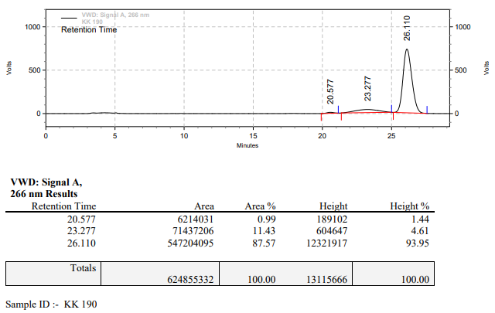

**KK-191**



**Calculation table:**

|  |  |  |  |  |  |
| --- | --- | --- | --- | --- | --- |
| Sr. No | Comp. | Mol. wt. | mmol | Eq. wt. | Wt. taken |
| 1 | Dehydrositagliptin (1) | 405.30 | 24770 | 100 | 1000 mg |
| 2 | Rh(COD)2OTf | 468.30 | 0.0247 | 1 | 12 mg |
| 3 | L3 | 414.29 | 0.0260 | 1.05 | 11 mg |
| 4 | Acetic acid | 60.05 | 0.1238 | 5 | 7 mg |

**Procedure:** A high pressure Parr reactor (100 mL) equipped with Teflon coated magnetic needle was charged with 1 g of enamine (**1**), under argon atmosphere. Subsequently, 12 mg of [Rh(COD)2OTf] (1 mol%) and 11 mg of ligand **L3** (0.0260 mmol) was added to the above reactor. 20 mL dry methanol was added followed by acetic acid to the reactor in inert atmosphere and the resultant reaction slurry was stirred for 1 hour at room temperature (25 °C). After that the autoclave was purged three times using hydrogen gas (40 bars). Finally, the autoclave was pressurized to 30 bar hydrogen pressure at 70°C for 48 hrs time period. After the 48 hrs time period, the autoclave was cooled to room temperature (25 °C), excess pressure was released and the autoclave was opened. The thus obtained reaction mixture was passed through neutral alumina bed, the filtrate was collect and dried to yield residue. The resultant residue was then analysed by HPLC.

**Reaction conditions:** Temp: 70°C Press.: 30 bar Solvent: methanol Time: 48 hrs

**Result: 10%** conversion **85%** ee

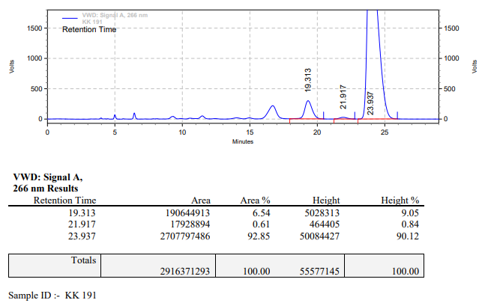

**KK-192**



**Calculation table:**

|  |  |  |  |  |  |
| --- | --- | --- | --- | --- | --- |
| Sr. No | Comp. | Mol. wt. | mmol | Eq. wt. | Wt. taken |
| 1 | Dehydrositagliptin (1) | 405.30 | 0.1409 | 66 | 57 mg |
| 2 | Rh(COD)2OTf | 468.30 | 0.0021 | 1 | 1 mg |
| 3 | L3 | 414.29 | 0.0021 | 1 | 1 mg |
| 4 | Ammonium chloride | 53.49 | 0.0021 | 1 | 0.1 mg |

**Procedure:** A glass vial (4 mL) equipped with Teflon coated magnetic needle was cooled under vacuum and transferred to a glove box. The vial was then charged with 56.98 mg of enamine (**1**), 1 mg of [Rh(COD)2OTf], ligand (L3) and ammonium chloride. Reaction vial was then closed using screwcap, transferred to a large opening Schlenk type container and was then taken out from the glove box. 2 mL dry methanol was added to the vial in inert atmosphere and the resultant reaction slurry was stirred for 1 hour at room temperature (25 °C). After that the reaction vial was shifted to an autoclave and the autoclave was purged three times using hydrogen gas (40 bars). Finally, the autoclave was pressurized to 30 bar hydrogen pressure at 70°C for 18 hrs time period. After the 18 hrs time period, the autoclave was cooled to room temperature (25 °C), excess pressure was released and the autoclave was opened. The vials were taken out from the autoclave. The thus obtained reaction mixture was passed through neutral alumina bed, the filtrate was collect and dried to yield residue. The resultant residue was then analysed by HPLC.

**Reaction conditions:** Temp: 70°C Press.: 30 bar Solvent: methanol Time: 18 hrs

**Result: 84%** conversion 8**5%** ee

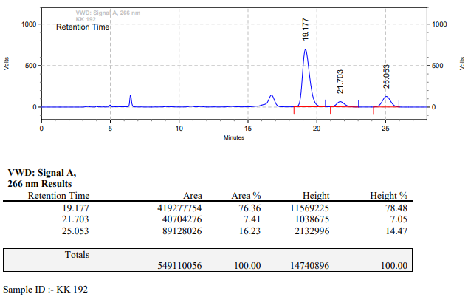

**KK-193**



**Calculation table:**

|  |  |  |  |  |  |
| --- | --- | --- | --- | --- | --- |
| Sr. No | Comp. | Mol. wt. | mmol | Eq. wt. | Wt. taken |
| 1 | Dehydrositagliptin (1) | 405.30 | 0.2135 | 100 | 86 mg |
| 2 | Rh(COD)2OTf | 468.30 | 0.0021 | 1 | 1 mg |
| 3 | L3 | 414.29 | 0.0042 | 2 | 1.7 mg |
| 4 | Ammonium chloride | 53.49 | 0.0021 | 1 | 0.1 mg |

**Procedure:** A glass vial (4 mL) equipped with Teflon coated magnetic needle was cooled under vacuum and transferred to a glove box. The vial was then charged with 86 mg of enamine (**1**), 1 mg of [Rh(COD)2OTf] (1 mol%), ligand (L3) and ammonium chloride. Reaction vial was then closed using screwcap, transferred to a large opening Schlenk type container and was then taken out from the glove box. 2 mL dry methanol was added to the vial in inert atmosphere and the resultant reaction slurry was stirred for 1 hour at room temperature (25 °C). After that the reaction vial was shifted to an autoclave and the autoclave was purged three times using hydrogen gas (40 bars). Finally, the autoclave was pressurized to 30 bar hydrogen pressure at 70°C for 18 hrs time period. After the 18 hrs time period, the autoclave was cooled to room temperature (25 °C), excess pressure was released and the autoclave was opened. The vials were taken out from the autoclave. The thus obtained reaction mixture was passed through neutral alumina bed, the filtrate was collect and dried to yield residue. The resultant residue was then analysed by HPLC.

**Reaction conditions:** Temp: 70°C Press.: 30 bar Solvent: methanol Time: 18 hrs

**Result: 90%** conversion 8**5%** ee

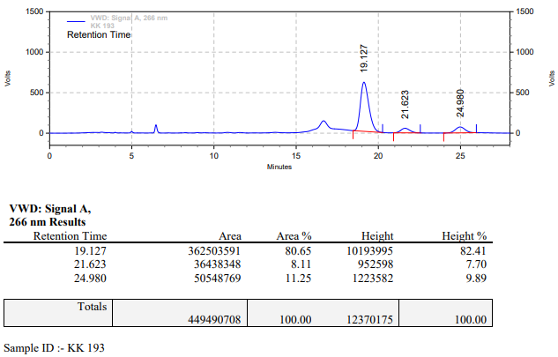

**KK-196**



**Calculation table:**

|  |  |  |  |  |  |
| --- | --- | --- | --- | --- | --- |
| Sr. No | Comp. | Mol. wt. | mmol | Eq. wt. | Wt. taken |
| 1 | Dehydrositagliptin (1) | 405.30 | 0.2135 | 200 | 86 mg |
| 2 | Rh(COD)2OTf | 468.30 | 0.0010 | 1 | 0.5 mg |
| 3 | L3 | 414.29 | 0.0010 | 1.05 | 0.4 mg |
| 4 | Ammonium chloride | 53.49 | 0.0100 | 10 | 0.5 mg |

**Procedure:** A glass vial (4 mL) equipped with Teflon coated magnetic needle was cooled under vacuum and transferred to a glove box. The vial was then charged with 86 mg of enamine (**1**), 1 mg of [Rh(COD)2OTf], ligand (L3) and ammonium chloride. Reaction vial was then closed using screwcap, transferred to a large opening Schlenk type container and was then taken out from the glove box. 2 mL dry methanol was added to the vial in inert atmosphere and the resultant reaction slurry was stirred for 1 hour at room temperature (25 °C). After that the reaction vial was shifted to an autoclave and the autoclave was purged three times using hydrogen gas (40 bars). Finally, the autoclave was pressurized to 30 bar hydrogen pressure at 70°C for 48 hrs time period. After the 48 hrs time period, the autoclave was cooled to room temperature (25 °C), excess pressure was released and the autoclave was opened. The vials were taken out from the autoclave. The thus obtained reaction mixture was passed through neutral alumina bed, the filtrate was collect and dried to yield residue. The resultant residue was then analysed by HPLC.

**Reaction conditions:** Temp: 70°C Press.: 30 bar Solvent: methanol Time: 48 hrs

**Result: 00%** conversion **00%** ee

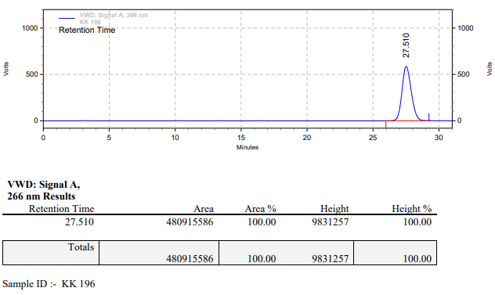

**KK-197**



**Calculation table:**

|  |  |  |  |  |  |
| --- | --- | --- | --- | --- | --- |
| Sr. No | Comp. | Mol. wt. | mmol | Eq. wt. | Wt. taken |
| 1 | Dehydrositagliptin (1) | 405.30 | 0.4271 | 200 | 173 mg |
| 2 | Rh(COD)2OTf | 468.30 | 0.0021 | 1 | 1 mg |
| 3 | L3 | 414.29 | 0.0022 | 1.05 | 0.9 mg |
| 4 | Acetic acid | 60.05 | 0.0106 | 5 | 0.6 mg |

**Procedure:** A glass vial (15 mL) equipped with Teflon coated magnetic needle was cooled under vacuum and transferred to a glove box. The vial was then charged with 173 mg of enamine (**1**), 1 mg of [Rh(COD)2OTf] (0.5 mol%) and ligand (L3). Reaction vial was then closed using screwcap, transferred to a large opening Schlenk type container and was then taken out from the glove box. 5 mL dry methanol was added followed by acetic acid to the vial in inert atmosphere and the resultant reaction slurry was stirred for 1 hour at room temperature (25 °C). After that the reaction vial was shifted to an autoclave and the autoclave was purged three times using hydrogen gas (40 bars). Finally, the autoclave was pressurized to 30 bar hydrogen pressure at 70°C for 48 hrs time period. After the 48 hrs time period, the autoclave was cooled to room temperature (25 °C), excess pressure was released and the autoclave was opened. The vials were taken out from the autoclave. The thus obtained reaction mixture was passed through neutral alumina bed, the filtrate was collect and dried to yield residue. The resultant residue was then analysed by HPLC.

**Reaction conditions:** Temp: 70°C Press.: 30 bar Solvent: methanol Time: 48 hrs

**Result: 00%** conversion **00%** ee

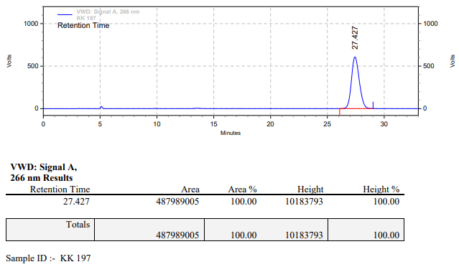

**KK-198**



**Calculation table:**

|  |  |  |  |  |  |
| --- | --- | --- | --- | --- | --- |
| Sr. No | Comp. | Mol. wt. | mmol | Eq. wt. | Wt. taken |
| 1 | Dehydrositagliptin (1) | 405.30 | 0.2135 | 100 | 86 mg |
| 2 | Rh(COD)2OTf | 468.30 | 0.0021 | 1 | 1 mg |
| 3 | L3 | 414.29 | 0.0026 | 1.2 | 1.1 mg |

**Procedure:** A glass vial (4 mL) equipped with Teflon coated magnetic needle was cooled under vacuum and transferred to a glove box. The vial was then charged with 86 mg of enamine (**1**), 1 mg of [Rh(COD)2OTf] (1 mol%) and ligand (L3). Reaction vial was then closed using screwcap, transferred to a large opening Schlenk type container and was then taken out from the glove box. 2 mL dry methanol was added to the vial in inert atmosphere and the resultant reaction slurry was stirred for 1 hour at room temperature (25 °C). After that the reaction vial was shifted to an autoclave and the autoclave was purged three times using hydrogen gas (40 bars). Finally, the autoclave was pressurized to 30 bar hydrogen pressure at 70°C for 18 hrs time period. After the 18 hrs time period, the autoclave was cooled to room temperature (25 °C), excess pressure was released and the autoclave was opened. The vials were taken out from the autoclave. The thus obtained reaction mixture was passed through neutral alumina bed, the filtrate was collect and dried to yield residue. The resultant residue was then analysed by HPLC.

**Reaction conditions:** Temp: 70°C Press.: 30 bar Solvent: methanol Time: 18 hrs

**Result: 00%** conversion **00%** ee

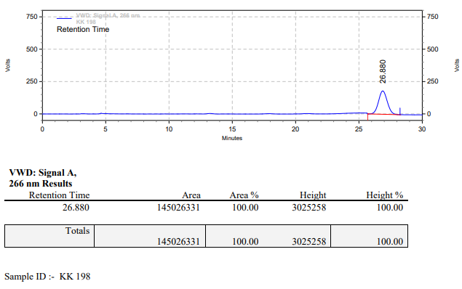

**KK-199**



**Calculation table:**

|  |  |  |  |  |  |
| --- | --- | --- | --- | --- | --- |
| Sr. No | Comp. | Mol. wt. | mmol | Eq. wt. | Wt. taken |
| 1 | Dehydrositagliptin (1) | 405.30 | 0.2135 | 100 | 86 mg |
| 2 | Rh(COD)2OTf | 468.30 | 0.0021 | 1 | 1 mg |
| 3 | L3 | 414.29 | 0.0026 | 1.2 | 1.1 mg |
| 4 | Ammonium chloride | 53.49 | 0.0021 | 1 | 0.1 mg |

**Procedure:** A glass vial (4 mL) equipped with Teflon coated magnetic needle was cooled under vacuum and transferred to a glove box. The vial was then charged with 86 mg of enamine (**1**), 1 mg of [Rh(COD)2OTf], ligand (L3) and ammonium chloride. Reaction vial was then closed using screwcap, transferred to a large opening Schlenk type container and was then taken out from the glove box. 2 mL dry methanol was added to the vial in inert atmosphere and the resultant reaction slurry was stirred for 1 hour at room temperature (25 °C). After that the reaction vial was shifted to an autoclave and the autoclave was purged three times using hydrogen gas (40 bars). Finally, the autoclave was pressurized to 30 bar hydrogen pressure at 70°C for 18 hrs time period. After the 18 hrs time period, the autoclave was cooled to room temperature (25 °C), excess pressure was released and the autoclave was opened. The vials were taken out from the autoclave. The thus obtained reaction mixture was passed through neutral alumina bed, the filtrate was collect and dried to yield residue. The resultant residue was then analysed by HPLC.

**Reaction conditions:** Temp: 70°C Press.: 30 bar Solvent: methanol Time: 18 hrs

**Result: 00%** conversion **00%** ee

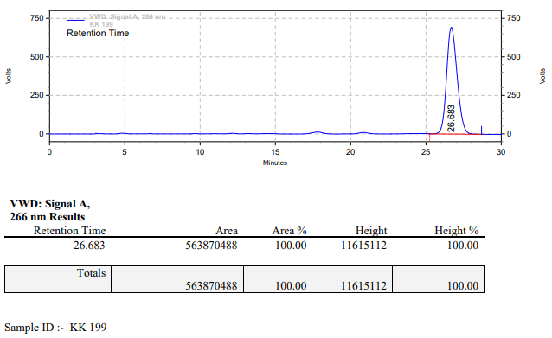

**KK-200**



**Calculation table:**

|  |  |  |  |  |  |
| --- | --- | --- | --- | --- | --- |
| Sr. No | Comp. | Mol. wt. | mmol | Eq. wt. | Wt. taken |
| 1 | Dehydrositagliptin (1) | 405.30 | 0.2135 | 100 | 86 mg |
| 2 | Rh(COD)2OTf | 468.30 | 0.0021 | 1 | 1 mg |
| 3 | L3 | 414.29 | 0.0026 | 1.2 | 1.1 mg |
| 4 | Acetic acid | 60.05 | 0.0106 | 5 | 0.6 mg |

**Procedure:** A glass vial (4 mL) equipped with Teflon coated magnetic needle was cooled under vacuum and transferred to a glove box. The vial was then charged with 86 mg of enamine (**1**), 1 mg of [Rh(COD)2OTf] (1 mol%) and ligand (L3). Reaction vial was then closed using screwcap, transferred to a large opening Schlenk type container and was then taken out from the glove box. 2 mL dry methanol was added followed by acetic acid to the vial in inert atmosphere and the resultant reaction slurry was stirred for 1 hour at room temperature (25 °C). After that the reaction vial was shifted to an autoclave and the autoclave was purged three times using hydrogen gas (40 bars). Finally, the autoclave was pressurized to 30 bar hydrogen pressure at 70°C for 18 hrs time period. After the 18 hrs time period, the autoclave was cooled to room temperature (25 °C), excess pressure was released and the autoclave was opened. The vials were taken out from the autoclave. The thus obtained reaction mixture was passed through neutral alumina bed, the filtrate was collect and dried to yield residue. The resultant residue was then analysed by HPLC.

**Reaction conditions:** Temp: 70°C Press.: 30 bar Solvent: methanol Time: 18 hrs

**Result: 18%** conversion **76%** ee

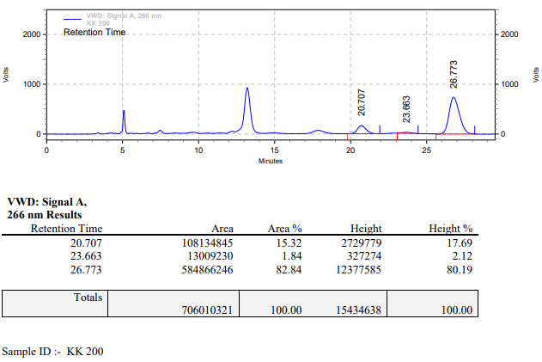

**KK-201**



**Calculation table:**

|  |  |  |  |  |  |
| --- | --- | --- | --- | --- | --- |
| Sr. No | Comp. | Mol. wt. | mmol | Eq. wt. | Wt. taken |
| 1 | Dehydrositagliptin (1) | 405.30 | 0.2135 | 100 | 86 mg |
| 2 | Rh(COD)2OTf | 468.30 | 0.0021 | 1 | 1 mg |
| 3 | L3 | 414.29 | 0.0026 | 1.2 | 1.1 mg |
| 4 | Phosphoric acid | 97.66 | 0.0106 | 5 | 1.02 mg |

**Procedure:** A glass vial (4 mL) equipped with Teflon coated magnetic needle was cooled under vacuum and transferred to a glove box. The vial was then charged with 86 mg of enamine (**1**), 1 mg of [Rh(COD)2OTf] (1 mol%) and ligand (L3). Reaction vial was then closed using screwcap, transferred to a large opening Schlenk type container and was then taken out from the glove box. 2 mL dry methanol was added followed by phosphoric acid to the vial in inert atmosphere and the resultant reaction slurry was stirred for 1 hour at room temperature (25 °C). After that the reaction vial was shifted to an autoclave and the autoclave was purged three times using hydrogen gas (40 bars). Finally, the autoclave was pressurized to 30 bar hydrogen pressure at 70°C for 18 hrs time period. After the 18 hrs time period, the autoclave was cooled to room temperature (25 °C), excess pressure was released and the autoclave was opened. The vials were taken out from the autoclave. The thus obtained reaction mixture was passed through neutral alumina bed, the filtrate was collect and dried to yield residue. The resultant residue was then analysed by HPLC.

**Reaction conditions:** Temp: 70°C Press.: 30 bar Solvent: methanol Time: 18 hrs

**Result: 100%** conversion **00%** ee

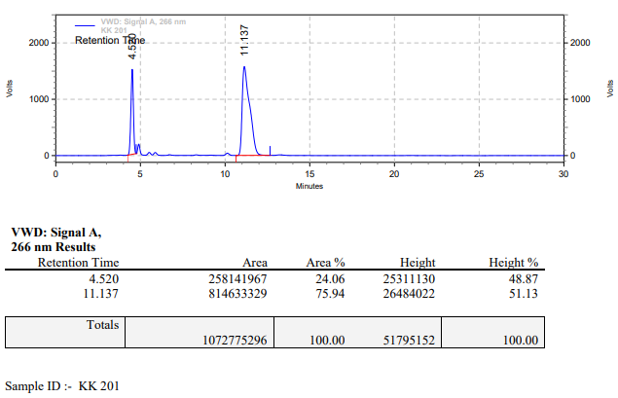

**KK-202**



**Calculation table:**

|  |  |  |  |  |  |
| --- | --- | --- | --- | --- | --- |
| Sr. No | Comp. | Mol. wt. | mmol | Eq. wt. | Wt. taken |
| 1 | Dehydrositagliptin (1) | 405.30 | 0.2135 | 100 | 86 mg |
| 2 | Rh(COD)2OTf | 468.30 | 0.0021 | 1 | 1 mg |
| 3 | L3 | 414.29 | 0.0022 | 1.05 | 0.9 mg |
| 4 | Ammonium chloride | 53.49 | 0.0021 | 1 | 0.1 mg |

**Procedure:** A glass vial (4 mL) equipped with Teflon coated magnetic needle was cooled under vacuum and transferred to a glove box. The vial was then charged with 86 mg of enamine (**1**), 1 mg of [Rh(COD)2OTf] (1 mol%), ligand (L3) and ammonium chloride. Reaction vial was then closed using screwcap, transferred to a large opening Schlenk type container and was then taken out from the glove box. 2 mL dry methanol was added to the vial in inert atmosphere and the resultant reaction slurry was stirred for 1 hour at room temperature (25 °C). After that the reaction vial was shifted to an autoclave and the autoclave was purged three times using hydrogen gas (40 bars). Finally, the autoclave was pressurized to 30 bar hydrogen pressure at 70°C for 18 hrs time period. After the 18 hrs time period, the autoclave was cooled to room temperature (25 °C), excess pressure was released and the autoclave was opened. The vials were taken out from the autoclave. The thus obtained reaction mixture was passed through neutral alumina bed, the filtrate was collect and dried to yield residue. The resultant residue was then analysed by HPLC.

**Reaction conditions:** Temp: 70°C Press.: 30 bar Solvent: methanol Time: 18 hrs

**Result: 00%** conversion **00%** ee

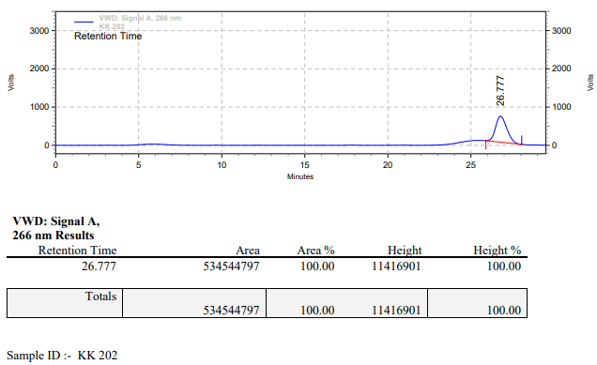

**KK-203**



**Calculation table:**

|  |  |  |  |  |  |
| --- | --- | --- | --- | --- | --- |
| Sr. No | Comp. | Mol. wt. | mmol | Eq. wt. | Wt. taken |
| 1 | Dehydrositagliptin (1) | 405.30 | 0.2135 | 100 | 86 mg |
| 2 | Rh(COD)2OTf | 468.30 | 0.0021 | 1 | 1 mg |
| 3 | L3 | 414.29 | 0.0022 | 1.05 | 0.9 mg |

**Procedure:** A glass vial (4 mL) equipped with Teflon coated magnetic needle was cooled under vacuum and transferred to a glove box. The vial was then charged with 86 mg of enamine (**1**), 1 mg of [Rh(COD)2OTf] (1 mol%) and ligand (L3). Reaction vial was then closed using screwcap, transferred to a large opening Schlenk type container and was then taken out from the glove box. 2 mL dry methanol was added to the vial in inert atmosphere and the resultant reaction slurry was stirred for 1 hour at room temperature (25 °C). After that the reaction vial was shifted to an autoclave and the autoclave was purged three times using hydrogen gas (40 bars). Finally, the autoclave was pressurized to 30 bar hydrogen pressure at 70°C for 48 hrs time period. After the 48 hrs time period, the autoclave was cooled to room temperature (25 °C), excess pressure was released and the autoclave was opened. The vials were taken out from the autoclave. The thus obtained reaction mixture was passed through neutral alumina bed, the filtrate was collect and dried to yield residue. The resultant residue was then analysed by HPLC.

**Reaction conditions:** Temp: 70°C Press.: 30 bar Solvent: methanol Time: 48 hrs

**Result: 00%** conversion **00%** ee

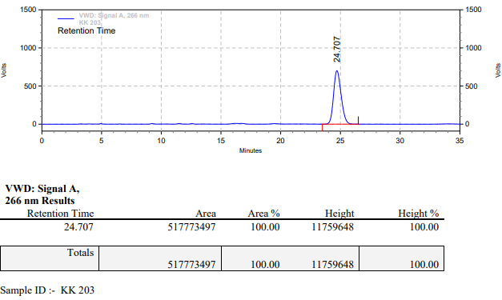

**KK-204**



**Calculation table:**

|  |  |  |  |  |  |
| --- | --- | --- | --- | --- | --- |
| Sr. No | Comp. | Mol. wt. | mmol | Eq. wt. | Wt. taken |
| 1 | Dehydrositagliptin (1) | 405.30 | 0.2135 | 100 | 86 mg |
| 2 | Rh(COD)2OTf | 468.30 | 0.0021 | 1 | 1 mg |
| 3 | L3 | 414.29 | 0.0022 | 1.05 | 0.9 mg |
| 4 | Ammonium chloride | 53.49 | 0.0021 | 1 | 0.1 mg |

**Procedure:** A glass vial (4 mL) equipped with Teflon coated magnetic needle was cooled under vacuum and transferred to a glove box. The vial was then charged with 86 mg of enamine (**1**), 1 mg of [Rh(COD)2OTf], ligand (L3) and ammonium chloride. Reaction vial was then closed using screwcap, transferred to a large opening Schlenk type container and was then taken out from the glove box. 2 mL dry methanol was added to the vial in inert atmosphere and the resultant reaction slurry was stirred for 1 hour at room temperature (25 °C). After that the reaction vial was shifted to an autoclave and the autoclave was purged three times using hydrogen gas (40 bars). Finally, the autoclave was pressurized to 30 bar hydrogen pressure at 70°C for 48 hrs time period. After the 48 hrs time period, the autoclave was cooled to room temperature (25 °C), excess pressure was released and the autoclave was opened. The vials were taken out from the autoclave. The thus obtained reaction mixture was passed through neutral alumina bed, the filtrate was collect and dried to yield residue. The resultant residue was then analysed by HPLC.

**Reaction conditions:** Temp: 70°C Press.: 30 bar Solvent: methanol Time: 48 hrs

**Result: 00%** conversion **00%** ee

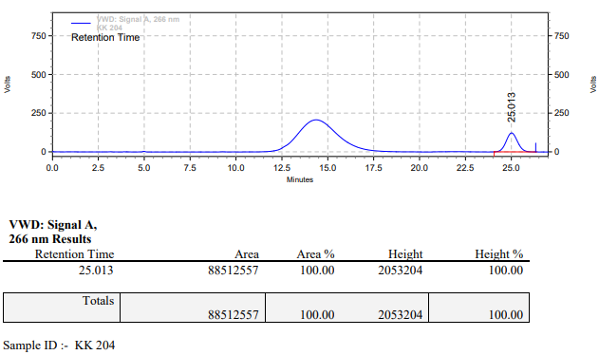

**KK-205**



**Calculation table:**

|  |  |  |  |  |  |
| --- | --- | --- | --- | --- | --- |
| Sr. No | Comp. | Mol. wt. | mmol | Eq. wt. | Wt. taken |
| 1 | Dehydrositagliptin (1) | 405.30 | 0.2135 | 100 | 86 mg |
| 2 | Rh(COD)2OTf | 468.30 | 0.0021 | 1 | 1 mg |
| 3 | L3 | 414.29 | 0.0026 | 1.2 | 1.1 mg |
| 4 | Acetic acid | 60.05 | 0.0106 | 5 | 0.6 mg |

**Procedure:** A glass vial (4 mL) equipped with Teflon coated magnetic needle was cooled under vacuum and transferred to a glove box. The vial was then charged with 86 mg of enamine (**1**), 1 mg of [Rh(COD)2OTf] and ligand (L3). Reaction vial was then closed using screwcap, transferred to a large opening Schlenk type container and was then taken out from the glove box. 2 mL dry methanol was added followed by acetic acid to the vial in inert atmosphere and the resultant reaction slurry was stirred for 1 hour at room temperature (25 °C). After that the reaction vial was shifted to an autoclave and the autoclave was purged three times using hydrogen gas (40 bars). Finally, the autoclave was pressurized to 30 bar hydrogen pressure at 70°C for 48 hrs time period. After the 48 hrs time period, the autoclave was cooled to room temperature (25 °C), excess pressure was released and the autoclave was opened. The vials were taken out from the autoclave. The thus obtained reaction mixture was passed through neutral alumina bed, the filtrate was collect and dried to yield residue. The resultant residue was then analysed by HPLC.

**Reaction conditions:** Temp: 70°C Press.: 30 bar Solvent: methanol Time: 48 hrs

**Result: 03%** conversion **82%** ee

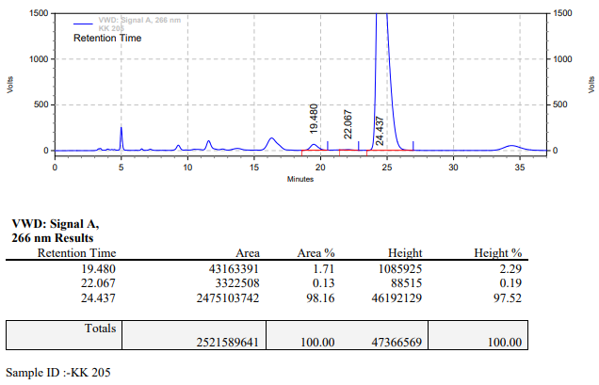

**KK-206**



**Calculation table:**

|  |  |  |  |  |  |
| --- | --- | --- | --- | --- | --- |
| Sr. No | Comp. | Mol. wt. | mmol | Eq. wt. | Wt. taken |
| 1 | Dehydrositagliptin (1) | 405.30 | 0.2135 | 100 | 86 mg |
| 2 | Rh(COD)2OTf | 468.30 | 0.0021 | 1 | 1 mg |
| 3 | L3 | 414.29 | 0.0022 | 1.05 | 0.9 mg |
| 4 | Phosphoric acid | 97.66 | 0.0106 | 5 | 1.02 mg |

**Procedure:** A glass vial (4 mL) equipped with Teflon coated magnetic needle was cooled under vacuum and transferred to a glove box. The vial was then charged with 86 mg of enamine (**1**), 1 mg of [Rh(COD)2OTf] and ligand (L3). Reaction vial was then closed using screwcap, transferred to a large opening Schlenk type container and was then taken out from the glove box. 2 mL dry methanol was added followed by phosphoric acid to the vial in inert atmosphere and the resultant reaction slurry was stirred for 1 hour at room temperature (25 °C). After that the reaction vial was shifted to an autoclave and the autoclave was purged three times using hydrogen gas (40 bars). Finally, the autoclave was pressurized to 30 bar hydrogen pressure at 70°C for 48 hrs time period. After the 48 hrs time period, the autoclave was cooled to room temperature (25 °C), excess pressure was released and the autoclave was opened. The vials were taken out from the autoclave. The thus obtained reaction mixture was passed through neutral alumina bed, the filtrate was collect and dried to yield residue. The resultant residue was then analysed by HPLC.

**Reaction conditions:** Temp: 70°C Press.: 30 bar Solvent: methanol Time: 48 hrs

**Result: 100%** conversion **00%** ee

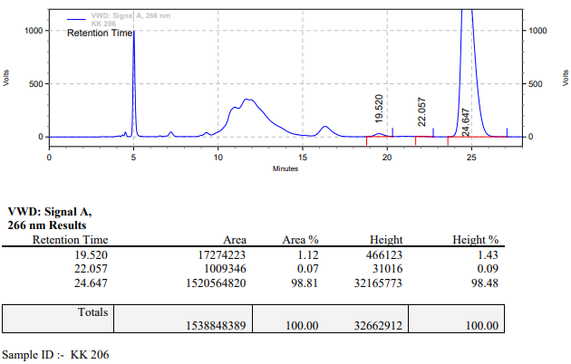

**KK-207**



**Calculation table:**

|  |  |  |  |  |  |
| --- | --- | --- | --- | --- | --- |
| Sr. No | Comp. | Mol. wt. | mmol | Eq. wt. | Wt. taken |
| 1 | Dehydrositagliptin (1) | 405.30 | 0.2135 | 100 | 86 mg |
| 2 | Rh(COD)2OTf | 468.30 | 0.0021 | 1 | 1 mg |
| 3 | L3 | 414.29 | 0.0022 | 1.05 | 0.9 mg |

**Procedure:** A glass vial (4 mL) equipped with Teflon coated magnetic needle was cooled under vacuum and transferred to a glove box. The vial was then charged with 86 mg of enamine (**1**), 1 mg of [Rh(COD)2OTf] (1 mol%) and ligand (L3). Reaction vial was then closed using screwcap, transferred to a large opening Schlenk type container and was then taken out from the glove box. 2 mL dry methanol was added to the vial in inert atmosphere and the resultant reaction slurry was stirred for 1 hour at room temperature (25 °C). After that the reaction vial was shifted to an autoclave and the autoclave was purged three times using hydrogen gas (40 bars). Finally, the autoclave was pressurized to 30 bar hydrogen pressure at 70°C for 48 hrs time period. After the 48 hrs time period, the autoclave was cooled to room temperature (25 °C), excess pressure was released and the autoclave was opened. The vials were taken out from the autoclave. The thus obtained reaction mixture was passed through neutral alumina bed, the filtrate was collect and dried to yield residue. The resultant residue was then analysed by TLC only starting was present.

**Reaction conditions:** Temp: 70°C Press.: 30 bar Solvent: methanol Time: 48 hrs

**Result: 00%** conversion **00%** ee

**KK-208**



**Calculation table:**

|  |  |  |  |  |  |
| --- | --- | --- | --- | --- | --- |
| Sr. No | Comp. | Mol. wt. | mmol | Eq. wt. | Wt. taken |
| 1 | Dehydrositagliptin (1) | 405.30 | 0.2135 | 100 | 86 mg |
| 2 | Rh(COD)2OTf | 468.30 | 0.0021 | 1 | 1 mg |
| 3 | L3 | 414.29 | 0.0022 | 1.05 | 0.9 mg |
| 4 | Ammonium chloride | 53.49 | 0.0021 | 1 | 0.1 mg |

**Procedure:** A glass vial (4 mL) equipped with Teflon coated magnetic needle was cooled under vacuum and transferred to a glove box. The vial was then charged with 86 mg of enamine (**1**), 1 mg of [Rh(COD)2OTf], ligand (L3) and ammonium chloride. Reaction vial was then closed using screwcap, transferred to a large opening Schlenk type container and was then taken out from the glove box. 2 mL dry methanol was added to the vial in inert atmosphere and the resultant reaction slurry was stirred for 1 hour at room temperature (25 °C). After that the reaction vial was shifted to an autoclave and the autoclave was purged three times using hydrogen gas (40 bars). Finally, the autoclave was pressurized to 30 bar hydrogen pressure at 70°C for 48 hrs time period. After the 48 hrs time period, the autoclave was cooled to room temperature (25 °C), excess pressure was released and the autoclave was opened. The vials were taken out from the autoclave. The thus obtained reaction mixture was passed through neutral alumina bed, the filtrate was collect and dried to yield residue. The resultant residue was then analysed by HPLC.

**Reaction conditions:** Temp: 70°C Press.: 30 bar Solvent: methanol Time: 48 hrs

**Result: 00%** conversion **00%** ee

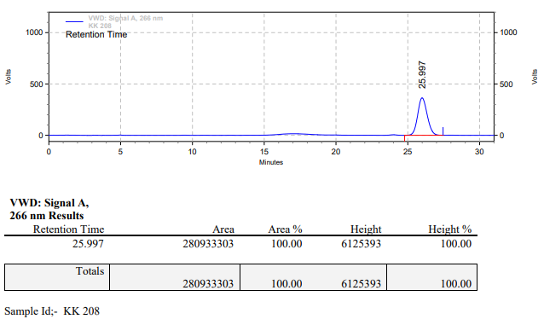

**KK-209**



**Calculation table:**

|  |  |  |  |  |  |
| --- | --- | --- | --- | --- | --- |
| Sr. No | Comp. | Mol. wt. | mmol | Eq. wt. | Wt. taken |
| 1 | Dehydrositagliptin (1) | 405.30 | 0.2135 | 100 | 86 mg |
| 2 | Rh(COD)2OTf | 468.30 | 0.0021 | 1 | 1 mg |
| 3 | L3 | 414.29 | 0.0022 | 1.05 | 0.9 mg |
| 4 | Acetic acid | 60.05 | 0.0106 | 5 | 0.6 mg |

**Procedure:** A glass vial (4 mL) equipped with Teflon coated magnetic needle was cooled under vacuum and transferred to a glove box. The vial was then charged with 86 mg of enamine (**1**), 1 mg of [Rh(COD)2OTf] (1 mol%) and ligand (L3). Reaction vial was then closed using screwcap, transferred to a large opening Schlenk type container and was then taken out from the glove box. 2 mL dry methanol was added followed by acetic acid to the vial in inert atmosphere and the resultant reaction slurry was stirred for 1 hour at room temperature (25 °C). After that the reaction vial was shifted to an autoclave and the autoclave was purged three times using hydrogen gas (40 bars). Finally, the autoclave was pressurized to 30 bar hydrogen pressure at 70°C for 48 hrs time period. After the 48 hrs time period, the autoclave was cooled to room temperature (25 °C), excess pressure was released and the autoclave was opened. The vials were taken out from the autoclave. The thus obtained reaction mixture was passed through neutral alumina bed, the filtrate was collect and dried to yield residue. The resultant residue was then analysed by TLC only starting was present.

**Reaction conditions:** Temp: 70°C Press.: 30 bar Solvent: methanol Time: 48 hrs

**Result: 00%** conversion **00%** ee

**KK-210**



**Calculation table:**

|  |  |  |  |  |  |
| --- | --- | --- | --- | --- | --- |
| Sr. No | Comp. | Mol. wt. | mmol | Eq. wt. | Wt. taken |
| 1 | Dehydrositagliptin (1) | 405.30 | 0.2135 | 100 | 86 mg |
| 2 | Rh(COD)2OTf | 468.30 | 0.0021 | 1 | 1 mg |
| 3 | L3 | 414.29 | 0.0022 | 1.05 | 0.9 mg |
| 4 | Phosphoric acid | 97.66 | 0.0106 | 5 | 1.02 mg |

**Procedure:** A glass vial (4 mL) equipped with Teflon coated magnetic needle was cooled under vacuum and transferred to a glove box. The vial was then charged with 86 mg of enamine (**1**), 1 mg of [Rh(COD)2OTf] and ligand (L3). Reaction vial was then closed using screwcap, transferred to a large opening Schlenk type container and was then taken out from the glove box. 2 mL dry methanol was added followed by phosphoric acid to the vial in inert atmosphere and the resultant reaction slurry was stirred for 1 hour at room temperature (25 °C). After that the reaction vial was shifted to an autoclave and the autoclave was purged three times using hydrogen gas (40 bars). Finally, the autoclave was pressurized to 30 bar hydrogen pressure at 70°C for 48 hrs time period. After the 48 hrs time period, the autoclave was cooled to room temperature (25 °C), excess pressure was released and the autoclave was opened. The vials were taken out from the autoclave. The thus obtained reaction mixture was passed through neutral alumina bed, the filtrate was collect and dried to yield residue. The resultant residue was then analysed by HPLC.

**Reaction conditions:** Temp: 70°C Press.: 30 bar Solvent: methanol Time: 48 hrs

**Result: 00%** conversion **00%** ee

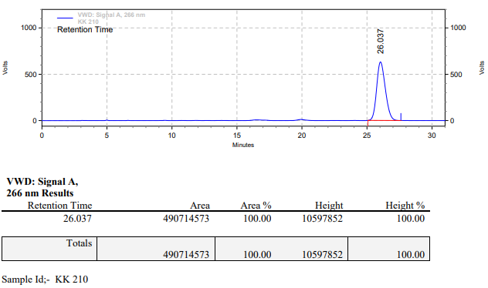

**KK-211**



**Calculation table:**

|  |  |  |  |  |  |
| --- | --- | --- | --- | --- | --- |
| Sr. No | Comp. | Mol. wt. | mmol | Eq. wt. | Wt. taken |
| 1 | Dehydrositagliptin (1) | 405.30 | 0.2135 | 100 | 86 mg |
| 2 | Rh(COD)2OTf | 468.30 | 0.0021 | 1 | 1 mg |
| 3 | L3 | 414.29 | 0.0022 | 1.05 | 0.9 mg |

**Procedure:** A glass vial (4 mL) equipped with Teflon coated magnetic needle was cooled under vacuum and transferred to a glove box. The vial was then charged with 86 mg of enamine (**1**), 1 mg of [Rh(COD)2OTf] and ligand (L3). Reaction vial was then closed using screwcap, transferred to a large opening Schlenk type container and was then taken out from the glove box. 2 mL dry methanol was added to the vial in inert atmosphere and the resultant reaction slurry was stirred for 1 hour at room temperature (25 °C). After that the reaction vial was shifted to an autoclave and the autoclave was purged three times using hydrogen gas (40 bars). Finally, the autoclave was pressurized to 30 bar hydrogen pressure at 70°C for 40 hrs time period. After the 40 hrs time period, the autoclave was cooled to room temperature (25 °C), excess pressure was released and the autoclave was opened. The vials were taken out from the autoclave. The thus obtained reaction mixture was passed through neutral alumina bed, the filtrate was collect and dried to yield residue. The resultant residue was then analysed by HPLC.

**Reaction conditions:** Temp: 70°C Press.: 30 bar Solvent: methanol Time: 40 hrs

**Result: 98%** conversion **10%** ee

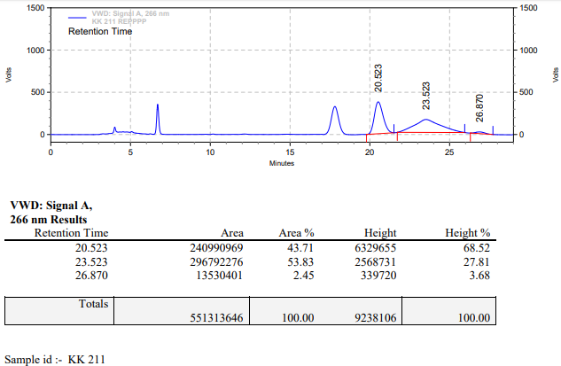

**KK-212**



**Calculation table:**

|  |  |  |  |  |  |
| --- | --- | --- | --- | --- | --- |
| Sr. No | Comp. | Mol. wt. | mmol | Eq. wt. | Wt. taken |
| 1 | Dehydrositagliptin (1) | 405.30 | 0.2135 | 100 | 86 mg |
| 2 | Rh(COD)2OTf | 468.30 | 0.0021 | 1 | 1 mg |
| 3 | L3 | 414.29 | 0.0022 | 1.05 | 0.9 mg |
| 4 | Ammonium chloride | 53.49 | 0.0021 | 1 | 0.1 mg |

**Procedure:** A glass vial (4 mL) equipped with Teflon coated magnetic needle was cooled under vacuum and transferred to a glove box. The vial was then charged with 86 mg of enamine (**1**), 1 mg of [Rh(COD)2OTf], ligand (L3) and ammonium chloride. Reaction vial was then closed using screwcap, transferred to a large opening Schlenk type container and was then taken out from the glove box. 2 mL dry methanol was added to the vial in inert atmosphere and the resultant reaction slurry was stirred for 1 hour at room temperature (25 °C). After that the reaction vial was shifted to an autoclave and the autoclave was purged three times using hydrogen gas (40 bars). Finally, the autoclave was pressurized to 30 bar hydrogen pressure at 70°C for 40 hrs time period. After the 40 hrs time period, the autoclave was cooled to room temperature (25 °C), excess pressure was released and the autoclave was opened. The vials were taken out from the autoclave. The thus obtained reaction mixture was passed through neutral alumina bed, the filtrate was collect and dried to yield residue. The resultant residue was then analysed by HPLC.

**Reaction conditions:** Temp: 70°C Press.: 30 bar Solvent: methanol Time: 40 hrs

**Result: 58%** conversion **83%** ee

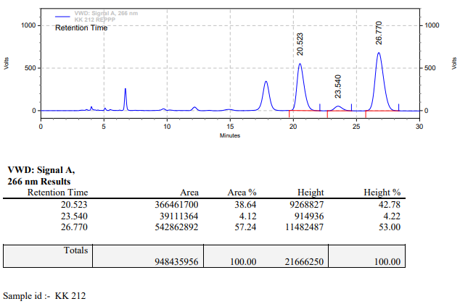

**KK-213**



**Calculation table:**

|  |  |  |  |  |  |
| --- | --- | --- | --- | --- | --- |
| Sr. No | Comp. | Mol. wt. | mmol | Eq. wt. | Wt. taken |
| 1 | Dehydrositagliptin (1) | 405.30 | 0.2135 | 100 | 86 mg |
| 2 | Rh(COD)2OTf | 468.30 | 0.0021 | 1 | 1 mg |
| 3 | L3 | 414.29 | 0.0022 | 1.05 | 0.9 mg |
| 4 | Acetic acid | 60.05 | 0.0106 | 5 | 0.6 mg |

**Procedure:** A glass vial (4 mL) equipped with Teflon coated magnetic needle was cooled under vacuum and transferred to a glove box. The vial was then charged with 86 mg of enamine (**1**), 1 mg of [Rh(COD)2OTf] and ligand (L3). Reaction vial was then closed using screwcap, transferred to a large opening Schlenk type container and was then taken out from the glove box. 2 mL dry methanol was added followed by acetic acid to the vial in inert atmosphere and the resultant reaction slurry was stirred for 1 hour at room temperature (25 °C). After that the reaction vial was shifted to an autoclave and the autoclave was purged three times using hydrogen gas (40 bars). Finally, the autoclave was pressurized to 30 bar hydrogen pressure at 70°C for 40 hrs time period. After the 40 hrs time period, the autoclave was cooled to room temperature (25 °C), excess pressure was released and the autoclave was opened. The vials were taken out from the autoclave. The thus obtained reaction mixture was passed through neutral alumina bed, the filtrate was collect and dried to yield residue. The resultant residue was then analysed by HPLC.

**Reaction conditions:** Temp: 70°C Press.: 30 bar Solvent: methanol Time: 40 hrs

**Result: 72%** conversion **23%** ee

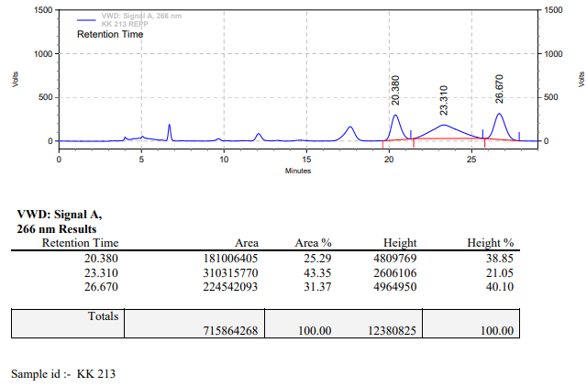

**KK-214**



**Calculation table:**

|  |  |  |  |  |  |
| --- | --- | --- | --- | --- | --- |
| Sr. No | Comp. | Mol. wt. | mmol | Eq. wt. | Wt. taken |
| 1 | Dehydrositagliptin (1) | 405.30 | 0.2135 | 100 | 86 mg |
| 2 | Rh(COD)2OTf | 468.30 | 0.0021 | 1 | 1 mg |
| 3 | L3 | 414.29 | 0.0022 | 1.05 | 0.9 mg |
| 4 | Phosphoric acid | 97.66 | 0.0106 | 5 | 1 mg |

**Procedure:** A glass vial (4 mL) equipped with Teflon coated magnetic needle was cooled under vacuum and transferred to a glove box. The vial was then charged with 86 mg of enamine (**1**), 1 mg of [Rh(COD)2OTf] (1 mol%) and ligand (L3). Reaction vial was then closed using screwcap, transferred to a large opening Schlenk type container and was then taken out from the glove box. 2 mL dry methanol was added followed by phosphoric acid to the vial in inert atmosphere and the resultant reaction slurry was stirred for 1 hour at room temperature (25 °C). After that the reaction vial was shifted to an autoclave and the autoclave was purged three times using hydrogen gas (40 bars). Finally, the autoclave was pressurized to 30 bar hydrogen pressure at 70°C for 40 hrs time period. After the 40 hrs time period, the autoclave was cooled to room temperature (25 °C), excess pressure was released and the autoclave was opened. The vials were taken out from the autoclave. The thus obtained reaction mixture was passed through neutral alumina bed, the filtrate was collect and dried to yield residue. The resultant residue was then analysed by HPLC.

**Reaction conditions:** Temp: 70°C Press.: 30 bar Solvent: methanol Time: 40 hrs

**Result: 73%** conversion **83%** ee

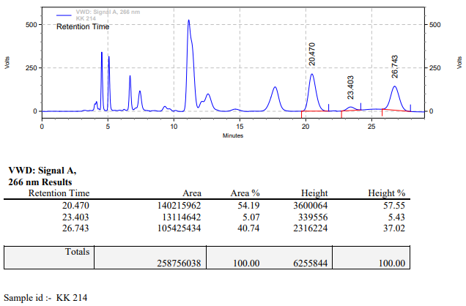

**KK-215**



**Calculation table:**

|  |  |  |  |  |  |
| --- | --- | --- | --- | --- | --- |
| Sr. No | Comp. | Mol. wt. | mmol | Eq. wt. | Wt. taken |
| 1 | Dehydrositagliptin (1) | 405.30 | 0.2135 | 100 | 86 mg |
| 2 | Rh(COD)2OTf | 468.30 | 0.0021 | 1 | 1 mg |
| 3 | L3 | 414.29 | 0.0022 | 1.05 | 0.9 mg |

**Procedure:** A glass vial (4 mL) equipped with Teflon coated magnetic needle was cooled under vacuum and transferred to a glove box. The vial was then charged with 86 mg of enamine (**1**), 1 mg of [Rh(COD)2OTf] (1 mol%) and ligand (L3). Reaction vial was then closed using screwcap, transferred to a large opening Schlenk type container and was then taken out from the glove box. 2 mL dry methanol was added to the vial in inert atmosphere and the resultant reaction slurry was stirred for 1 hour at room temperature (25 °C). After that the reaction vial was shifted to an autoclave and the autoclave was purged three times using hydrogen gas (40 bars). Finally, the autoclave was pressurized to 30 bar hydrogen pressure at 70°C for 18 hrs time period. After the 18 hrs time period, the autoclave was cooled to room temperature (25 °C), excess pressure was released and the autoclave was opened. The vials were taken out from the autoclave. The thus obtained reaction mixture was passed through neutral alumina bed, the filtrate was collect and dried to yield residue. The resultant residue was then analysed by HPLC.

**Reaction conditions:** Temp: 70°C Press.: 30 bar Solvent: methanol Time: 18 hrs

**Result: 70%** conversion **82%** ee

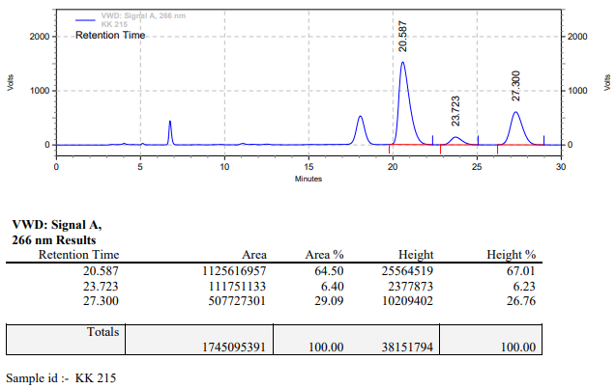

**KK-216**



**Calculation table:**

|  |  |  |  |  |  |
| --- | --- | --- | --- | --- | --- |
| Sr. No | Comp. | Mol. wt. | mmol | Eq. wt. | Wt. taken |
| 1 | Dehydrositagliptin (1) | 405.30 | 0.2135 | 100 | 86 mg |
| 2 | Rh(COD)2OTf | 468.30 | 0.0021 | 1 | 1 mg |
| 3 | L3 | 414.29 | 0.0022 | 1.05 | 0.9 mg |
| 4 | Ammonium chloride | 53.49 | 0.0021 | 1 | 0.1 mg |

**Procedure:** A glass vial (4 mL) equipped with Teflon coated magnetic needle was cooled under vacuum and transferred to a glove box. The vial was then charged with 86 mg of enamine (**1**), 1 mg of [Rh(COD)2OTf] (1 mol%), ligand (L3) and ammonium chloride. Reaction vial was then closed using screwcap, transferred to a large opening Schlenk type container and was then taken out from the glove box. 2 mL dry methanol was added to the vial in inert atmosphere and the resultant reaction slurry was stirred for 1 hour at room temperature (25 °C). After that the reaction vial was shifted to an autoclave and the autoclave was purged three times using hydrogen gas (40 bars). Finally, the autoclave was pressurized to 30 bar hydrogen pressure at 70°C for 18 hrs time period. After the 18 hrs time period, the autoclave was cooled to room temperature (25 °C), excess pressure was released and the autoclave was opened. The vials were taken out from the autoclave. The thus obtained reaction mixture was passed through neutral alumina bed, the filtrate was collect and dried to yield residue. TLC shows starting was present.

**Reaction conditions:** Temp: 70°C Press.: 30 bar Solvent: methanol Time: 18 hrs

**Result: 00%** conversion **00%** ee

**KK-217**



**Calculation table:**

|  |  |  |  |  |  |
| --- | --- | --- | --- | --- | --- |
| Sr. No | Comp. | Mol. wt. | mmol | Eq. wt. | Wt. taken |
| 1 | Dehydrositagliptin (1) | 405.30 | 0.2135 | 100 | 86 mg |
| 2 | Rh(COD)2OTf | 468.30 | 0.0021 | 1 | 1 mg |
| 3 | L3 | 414.29 | 0.0022 | 1.05 | 0.9 mg |

**Procedure:** A glass vial (4 mL) equipped with Teflon coated magnetic needle was cooled under vacuum and transferred to a glove box. The vial was then charged with 86 mg of enamine (**1**), 1 mg of [Rh(COD)2OTf] (1 mol%) and ligand (L3). Reaction vial was then closed using screwcap, transferred to a large opening Schlenk type container and was then taken out from the glove box. 2 mL dry methanol was added to the vial in inert atmosphere and the resultant reaction slurry was stirred for 1 hour at room temperature (25 °C). After that the reaction vial was shifted to an autoclave and the autoclave was purged three times using hydrogen gas (40 bars). Finally, the autoclave was pressurized to 30 bar hydrogen pressure at 70°C for 18 hrs time period. After the 18 hrs time period, the autoclave was cooled to room temperature (25 °C), excess pressure was released and the autoclave was opened. The vials were taken out from the autoclave. The thus obtained reaction mixture was passed through neutral alumina bed, the filtrate was collect and dried to yield residue. The resultant residue was then analysed by HPLC.

**Reaction conditions:** Temp: 70°C Press.: 30 bar Solvent: methanol Time: 18 hrs

**Result: 70%** conversion **82%** ee

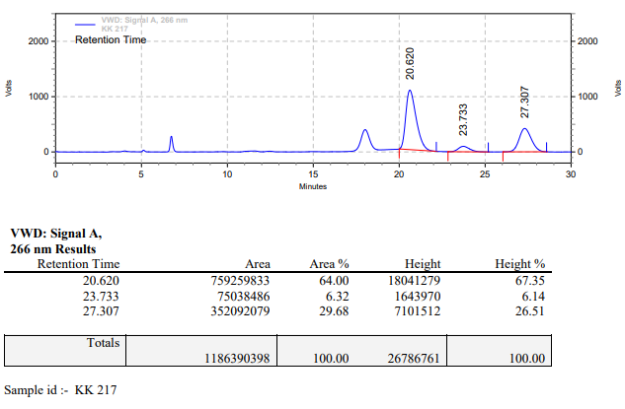

**KK-218**



**Calculation table:**

|  |  |  |  |  |  |
| --- | --- | --- | --- | --- | --- |
| Sr. No | Comp. | Mol. wt. | mmol | Eq. wt. | Wt. taken |
| 1 | Dehydrositagliptin (1) | 405.30 | 0.2135 | 100 | 86 mg |
| 2 | Rh(COD)2OTf | 468.30 | 0.0021 | 1 | 1 mg |
| 3 | L3 | 414.29 | 0.0022 | 1.05 | 0.9 mg |
| 4 | Ammonium chloride | 53.49 | 0.0021 | 1 | 0.1 mg |

**Procedure:** A glass vial (4 mL) equipped with Teflon coated magnetic needle was cooled under vacuum and transferred to a glove box. The vial was then charged with 86 mg of enamine (**1**), 1 mg of [Rh(COD)2OTf] (1 mol%), ligand (L3) and ammonium chloride. Reaction vial was then closed using screwcap, transferred to a large opening Schlenk type container and was then taken out from the glove box. 2 mL dry methanol was added to the vial in inert atmosphere and the resultant reaction slurry was stirred for 1 hour at room temperature (25 °C). After that the reaction vial was shifted to an autoclave and the autoclave was purged three times using hydrogen gas (40 bars). Finally, the autoclave was pressurized to 30 bar hydrogen pressure at 70°C for 18 hrs time period. After the 18 hrs time period, the autoclave was cooled to room temperature (25 °C), excess pressure was released and the autoclave was opened. The vials were taken out from the autoclave. The thus obtained reaction mixture was passed through neutral alumina bed, the filtrate was collect and dried to yield residue. TLC shows starting was present.

**Reaction conditions:** Temp: 70°C Press.: 30 bar Solvent: methanol Time: 18 hrs

**Result: 00%** conversion **00%** ee

**KK-219**



**Calculation table:**

|  |  |  |  |  |  |
| --- | --- | --- | --- | --- | --- |
| Sr. No | Comp. | Mol. wt. | mmol | Eq. wt. | Wt. taken |
| 1 | Dehydrositagliptin (1) | 405.30 | 0.2135 | 100 | 86 mg |
| 2 | Rh(COD)2OTf | 468.30 | 0.0021 | 1 | 1 mg |
| 3 | L3 | 414.29 | 0.0022 | 1.05 | 0.9 mg |

**Procedure:** A glass vial (4 mL) equipped with Teflon coated magnetic needle was cooled under vacuum and transferred to a glove box. The vial was then charged with 86 mg of enamine (**1**), 1 mg of [Rh(COD)2OTf] (1 mol%) and ligand (L3). Reaction vial was then closed using screwcap, transferred to a large opening Schlenk type container and was then taken out from the glove box. 2 mL dry methanol was added to the vial in inert atmosphere and the resultant reaction slurry was stirred for 1 hour at room temperature (25 °C). After that the reaction vial was shifted to an autoclave and the autoclave was purged three times using hydrogen gas (40 bars). Finally, the autoclave was pressurized to 30 bar hydrogen pressure at 70°C for 24 hrs time period. After the 24 hrs time period, the autoclave was cooled to room temperature (25 °C), excess pressure was released and the autoclave was opened. The vials were taken out from the autoclave. The thus obtained reaction mixture was passed through neutral alumina bed, the filtrate was collect and dried to yield residue. The resultant residue was then analysed by HPLC.

**Reaction conditions:** Temp: 70°C Press.: 30 bar Solvent: methanol Time: 24 hrs

**Result: 50%** conversion **82%** ee

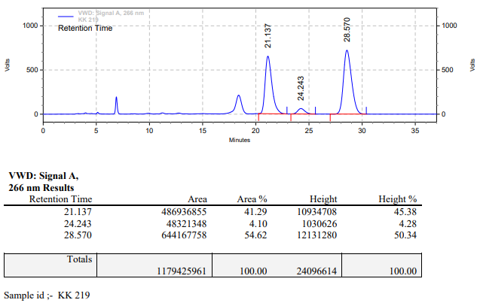

**KK-220**



**Calculation table:**

|  |  |  |  |  |  |
| --- | --- | --- | --- | --- | --- |
| Sr. No | Comp. | Mol. wt. | mmol | Eq. wt. | Wt. taken |
| 1 | Dehydrositagliptin (1) | 405.30 | 0.2135 | 100 | 86 mg |
| 2 | Rh(COD)2OTf | 468.30 | 0.0021 | 1 | 1 mg |
| 3 | L3 | 414.29 | 0.0022 | 1.05 | 0.9 mg |

**Procedure:** A glass vial (4 mL) equipped with Teflon coated magnetic needle was cooled under vacuum and transferred to a glove box. The vial was then charged with 86 mg of enamine (**1**), 1 mg of [Rh(COD)2OTf] (1 mol%) and ligand (L3). Reaction vial was then closed using screwcap, transferred to a large opening Schlenk type container and was then taken out from the glove box. 2 mL dry methanol was added to the vial in inert atmosphere and the resultant reaction slurry was stirred for 1 hour at room temperature (25 °C). After that the reaction vial was shifted to an autoclave and the autoclave was purged three times using hydrogen gas (40 bars). Finally, the autoclave was pressurized to 30 bar hydrogen pressure at 70°C for 24 hrs time period. After the 24 hrs time period, the autoclave was cooled to room temperature (25 °C), excess pressure was released and the autoclave was opened. The vials were taken out from the autoclave. The thus obtained reaction mixture was passed through neutral alumina bed, the filtrate was collect and dried to yield residue. The resultant residue was then analysed by HPLC.

**Reaction conditions:** Temp: 70°C Press.: 30 bar Solvent: methanol Time: 24 hrs

**Result: 45%** conversion **82%** ee

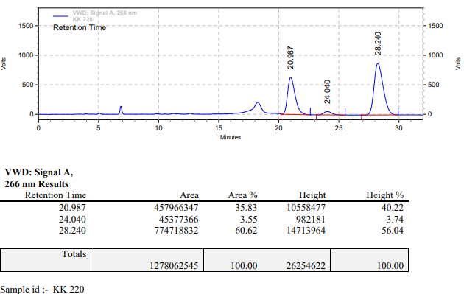

**KK-221**



**Calculation table:**

|  |  |  |  |  |  |
| --- | --- | --- | --- | --- | --- |
| Sr. No | Comp. | Mol. wt. | mmol | Eq. wt. | Wt. taken |
| 1 | Dehydrositagliptin (1) | 405.30 | 0.2135 | 100 | 86 mg |
| 2 | Rh(COD)2OTf | 468.30 | 0.0021 | 1 | 1 mg |
| 3 | L3 | 414.29 | 0.0022 | 1.05 | 0.9 mg |

**Procedure:** A glass vial (4 mL) equipped with Teflon coated magnetic needle was cooled under vacuum and transferred to a glove box. The vial was then charged with 86 mg of enamine (**1**), 1 mg of [Rh(COD)2OTf] (1 mol%) and ligand (L3). Reaction vial was then closed using screwcap, transferred to a large opening Schlenk type container and was then taken out from the glove box. 2 mL dry methanol was added to the vial in inert atmosphere and the resultant reaction slurry was stirred for 1 hour at room temperature (25 °C). After that the reaction vial was shifted to an autoclave and the autoclave was purged three times using hydrogen gas (40 bars). Finally, the autoclave was pressurized to 30 bar hydrogen pressure at 70°C for 24 hrs time period. After the 24 hrs time period, the autoclave was cooled to room temperature (25 °C), excess pressure was released and the autoclave was opened. The vials were taken out from the autoclave. The thus obtained reaction mixture was passed through neutral alumina bed, the filtrate was collect and dried to yield residue. The resultant residue was then analysed by HPLC.

**Reaction conditions:** Temp: 70°C Press.: 30 bar Solvent: methanol Time: 24 hrs

**Result: 00%** conversion **00%** ee

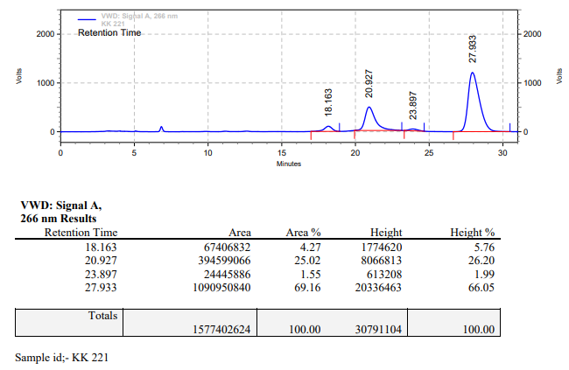

**KK-222**



**Calculation table:**

|  |  |  |  |  |  |
| --- | --- | --- | --- | --- | --- |
| Sr. No | Comp. | Mol. wt. | mmol | Eq. wt. | Wt. taken |
| 1 | Dehydrositagliptin (1) | 405.30 | 0.2135 | 100 | 86 mg |
| 2 | Rh(COD)2OTf | 468.30 | 0.0021 | 1 | 1 mg |
| 3 | L3 | 414.29 | 0.0026 | 1.25 | 1.1 mg |

**Procedure:** A glass vial (4 mL) equipped with Teflon coated magnetic needle was cooled under vacuum and transferred to a glove box. The vial was then charged with 86 mg of enamine (**1**), 1 mg of [Rh(COD)2OTf] (1 mol%) and ligand (L3). Reaction vial was then closed using screwcap, transferred to a large opening Schlenk type container and was then taken out from the glove box. 2 mL dry methanol was added to the vial in inert atmosphere and the resultant reaction slurry was stirred for 1 hour at room temperature (25 °C). After that the reaction vial was shifted to an autoclave and the autoclave was purged three times using hydrogen gas (40 bars). Finally, the autoclave was pressurized to 30 bar hydrogen pressure at 70°C for 13 hrs time period. After the 13 hrs time period, the autoclave was cooled to room temperature (25 °C), excess pressure was released and the autoclave was opened. The vials were taken out from the autoclave. The thus obtained reaction mixture was passed through neutral alumina bed, the filtrate was collect and dried to yield residue. The resultant residue was then analysed by HPLC.

**Reaction conditions:** Temp: 70°C Press.: 30 bar Solvent: methanol Time: 13 hrs

**Result: 20%** conversion **86%** ee

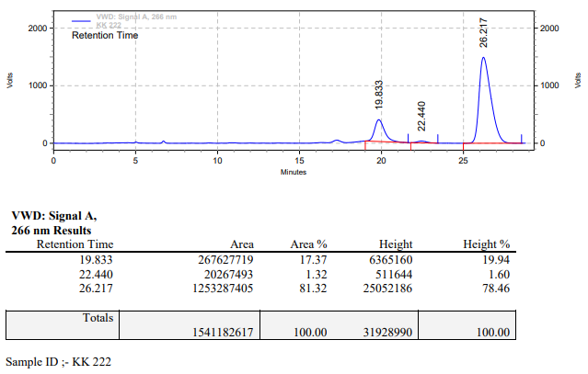

**KK-223**



**Calculation table:**

|  |  |  |  |  |  |
| --- | --- | --- | --- | --- | --- |
| Sr. No | Comp. | Mol. wt. | mmol | Eq. wt. | Wt. taken |
| 1 | Dehydrositagliptin (1) | 405.30 | 0.2135 | 100 | 86 mg |
| 2 | Rh(COD)2OTf | 468.30 | 0.0021 | 1 | 1 mg |
| 3 | L3 | 414.29 | 0.0032 | 1.5 | 1.3 mg |

**Procedure:** A glass vial (4 mL) equipped with Teflon coated magnetic needle was cooled under vacuum and transferred to a glove box. The vial was then charged with 86 mg of enamine (**1**), 1 mg of [Rh(COD)2OTf] (1 mol%) and ligand (L3). Reaction vial was then closed using screwcap, transferred to a large opening Schlenk type container and was then taken out from the glove box. 2 mL dry methanol was added to the vial in inert atmosphere and the resultant reaction slurry was stirred for 1 hour at room temperature (25 °C). After that the reaction vial was shifted to an autoclave and the autoclave was purged three times using hydrogen gas (40 bars). Finally, the autoclave was pressurized to 30 bar hydrogen pressure at 70°C for 13 hrs time period. After the 13 hrs time period, the autoclave was cooled to room temperature (25 °C), excess pressure was released and the autoclave was opened. The vials were taken out from the autoclave. The thus obtained reaction mixture was passed through neutral alumina bed, the filtrate was collect and dried to yield residue. The resultant residue was then analysed by HPLC.

**Reaction conditions:** Temp: 70°C Press.: 30 bar Solvent: methanol Time: 13 hrs

**Result: 65%** conversion **83%** ee

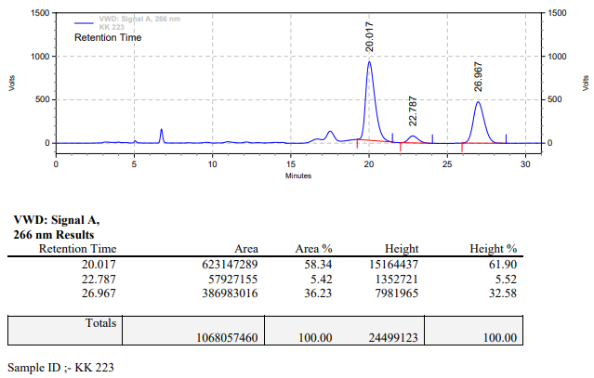

**KK-224**



**Calculation table:**

|  |  |  |  |  |  |
| --- | --- | --- | --- | --- | --- |
| Sr. No | Comp. | Mol. wt. | mmol | Eq. wt. | Wt. taken |
| 1 | Dehydrositagliptin (1) | 405.30 | 0.2135 | 100 | 86 mg |
| 2 | Rh(COD)2OTf | 468.30 | 0.0021 | 1 | 1 mg |
| 3 | L3 | 414.29 | 0.0042 | 2 | 1.7 mg |

**Procedure:** A glass vial (4 mL) equipped with Teflon coated magnetic needle was cooled under vacuum and transferred to a glove box. The vial was then charged with 86 mg of enamine (**1**), 1 mg of [Rh(COD)2OTf] (1 mol%) and ligand (L3). Reaction vial was then closed using screwcap, transferred to a large opening Schlenk type container and was then taken out from the glove box. 2 mL dry methanol was added to the vial in inert atmosphere and the resultant reaction slurry was stirred for 1 hour at room temperature (25 °C). After that the reaction vial was shifted to an autoclave and the autoclave was purged three times using hydrogen gas (40 bars). Finally, the autoclave was pressurized to 30 bar hydrogen pressure at 70°C for 13 hrs time period. After the 13 hrs time period, the autoclave was cooled to room temperature (25 °C), excess pressure was released and the autoclave was opened. The vials were taken out from the autoclave. The thus obtained reaction mixture was passed through neutral alumina bed, the filtrate was collect and dried to yield residue. The resultant residue was then analysed by HPLC.

**Reaction conditions:** Temp: 70°C Press.: 30 bar Solvent: methanol Time: 13 hrs

**Result: 45%** conversion **82%** ee

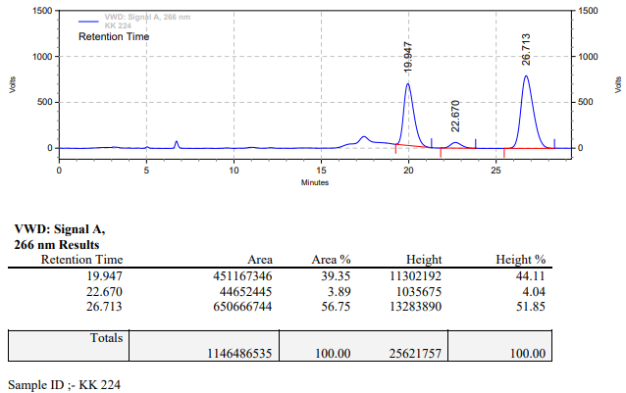

**KK-225**



**Calculation table:**

|  |  |  |  |  |  |
| --- | --- | --- | --- | --- | --- |
| Sr. No | Comp. | Mol. wt. | mmol | Eq. wt. | Wt. taken |
| 1 | Dehydrositagliptin (1) | 405.30 | 0.2135 | 100 | 86 mg |
| 2 | Rh(COD)2OTf | 468.30 | 0.0021 | 1 | 1 mg |
| 3 | L3 | 414.29 | 0.0052 | 2.5 | 2.2 mg |

**Procedure:** A glass vial (4 mL) equipped with Teflon coated magnetic needle was cooled under vacuum and transferred to a glove box. The vial was then charged with 86 mg of enamine (**1**), 1 mg of [Rh(COD)2OTf] (1 mol%) and ligand (L3). Reaction vial was then closed using screwcap, transferred to a large opening Schlenk type container and was then taken out from the glove box. 2 mL dry methanol was added to the vial in inert atmosphere and the resultant reaction slurry was stirred for 1 hour at room temperature (25 °C). After that the reaction vial was shifted to an autoclave and the autoclave was purged three times using hydrogen gas (40 bars). Finally, the autoclave was pressurized to 30 bar hydrogen pressure at 70°C for 13 hrs time period. After the 13 hrs time period, the autoclave was cooled to room temperature (25 °C), excess pressure was released and the autoclave was opened. The vials were taken out from the autoclave. The thus obtained reaction mixture was passed through neutral alumina bed, the filtrate was collect and dried to yield residue. The resultant residue was then analysed by HPLC.

**Reaction conditions:** Temp: 70°C Press.: 30 bar Solvent: methanol Time: 13 hrs

**Result: 61%** conversion **82%** ee

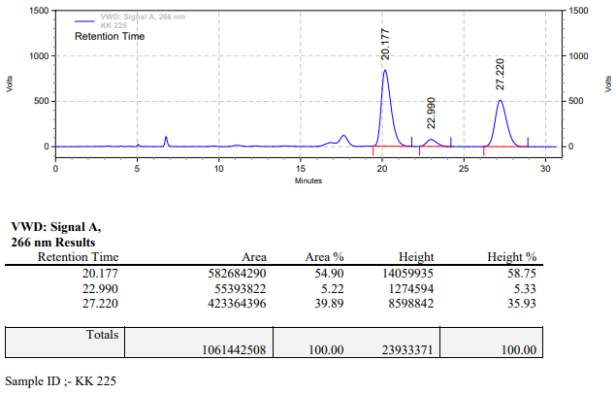

**KK-226**



**Calculation table:**

|  |  |  |  |  |  |
| --- | --- | --- | --- | --- | --- |
| Sr. No | Comp. | Mol. wt. | mmol | Eq. wt. | Wt. taken |
| 1 | Dehydrositagliptin (1) | 405.30 | 0.4270 | 200 | 173 mg |
| 2 | Rh(COD)2OTf | 468.30 | 0.0021 | 1 | 1 mg |
| 3 | L3 | 414.29 | 0.0022 | 1.05 | 0.9 mg |

**Procedure:** A glass vial (15 mL) equipped with Teflon coated magnetic needle was cooled under vacuum and transferred to a glove box. The vial was then charged with 173 mg of enamine (**1**), 1 mg of [Rh(COD)2OTf] (0.5 mol%) and ligand (L3). Reaction vial was then closed using screwcap, transferred to a large opening Schlenk type container and was then taken out from the glove box. 5 mL dry methanol was added to the vial in inert atmosphere and the resultant reaction slurry was stirred for 1 hour at room temperature (25 °C). After that the reaction vial was shifted to an autoclave and the autoclave was purged three times using hydrogen gas (40 bars). Finally, the autoclave was pressurized to 30 bar hydrogen pressure at 70°C for 18 hrs time period. After the 18 hrs time period, the autoclave was cooled to room temperature (25 °C), excess pressure was released and the autoclave was opened. The vials were taken out from the autoclave. The thus obtained reaction mixture was passed through neutral alumina bed, the filtrate was collect and dried to yield residue. The resultant residue was then analysed by HPLC.

**Reaction conditions:** Temp: 70°C Press.: 30 bar Solvent: methanol Time: 18 hrs

**Result: 00%** conversion **00%** ee

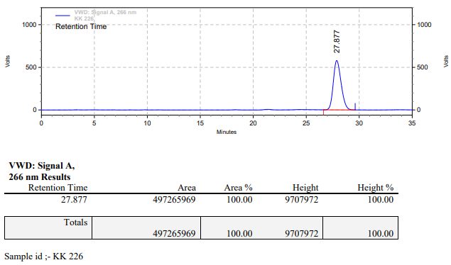

**KK-227**



**Calculation table:**

|  |  |  |  |  |  |
| --- | --- | --- | --- | --- | --- |
| Sr. No | Comp. | Mol. wt. | mmol | Eq. wt. | Wt. taken |
| 1 | Dehydrositagliptin (1) | 405.30 | 0.1386 | 66 | 57 mg |
| 2 | Rh(COD)2OTf | 468.30 | 0.0021 | 1 | 1 mg |
| 3 | L3 | 414.29 | 0.0022 | 1.05 | 0.9 mg |

**Procedure:** A glass vial (4 mL) equipped with Teflon coated magnetic needle was cooled under vacuum and transferred to a glove box. The vial was then charged with 57 mg of enamine (**1**), 1 mg of [Rh(COD)2OTf] and ligand (L3). Reaction vial was then closed using screwcap, transferred to a large opening Schlenk type container and was then taken out from the glove box. 2 mL dry methanol was added to the vial in inert atmosphere and the resultant reaction slurry was stirred for 1 hour at room temperature (25 °C). After that the reaction vial was shifted to an autoclave and the autoclave was purged three times using hydrogen gas (40 bars). Finally, the autoclave was pressurized to 30 bar hydrogen pressure at 70°C for 18 hrs time period. After the 18 hrs time period, the autoclave was cooled to room temperature (25 °C), excess pressure was released and the autoclave was opened. The vials were taken out from the autoclave. The thus obtained reaction mixture was passed through neutral alumina bed, the filtrate was collect and dried to yield residue. The resultant residue was then analysed by HPLC.

**Reaction conditions:** Temp: 70°C Press.: 30 bar Solvent: methanol Time: 18 hrs

**Result: 74%** conversion **81%** ee

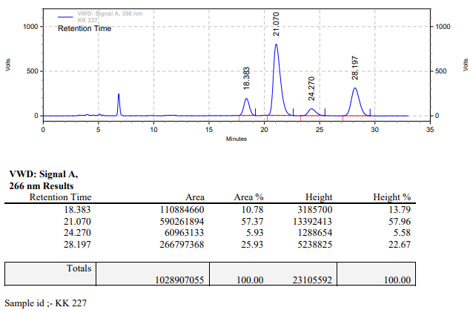

**KK-228**



**Calculation table:**

|  |  |  |  |  |  |
| --- | --- | --- | --- | --- | --- |
| Sr. No | Comp. | Mol. wt. | mmol | Eq. wt. | Wt. taken |
| 1 | Dehydrositagliptin (1) | 405.30 | 0.1067 | 50 | 43 mg |
| 2 | Rh(COD)2OTf | 468.30 | 0.0021 | 1 | 1 mg |
| 3 | L3 | 414.29 | 0.0021 | 1 | 0.9 mg |

**Procedure:** A glass vial (4 mL) equipped with Teflon coated magnetic needle was cooled under vacuum and transferred to a glove box. The vial was then charged with 43 mg of enamine (**1**), 1 mg of [Rh(COD)2OTf] (2 mol%) and ligand (L3). Reaction vial was then closed using screwcap, transferred to a large opening Schlenk type container and was then taken out from the glove box. 2 mL dry methanol was added to the vial in inert atmosphere and the resultant reaction slurry was stirred for 1 hour at room temperature (25 °C). After that the reaction vial was shifted to an autoclave and the autoclave was purged three times using hydrogen gas (40 bars). Finally, the autoclave was pressurized to 30 bar hydrogen pressure at 70°C for 12 hrs time period. After the 12 hrs time period, the autoclave was cooled to room temperature (25 °C), excess pressure was released and the autoclave was opened. The vials were taken out from the autoclave. The thus obtained reaction mixture was passed through neutral alumina bed, the filtrate was collect and dried to yield residue. The resultant residue was then analysed by HPLC.

**Reaction conditions:** Temp: 70°C Press.: 30 bar Solvent: methanol Time: 12 hrs

**Result: 14%** conversion **83%** ee

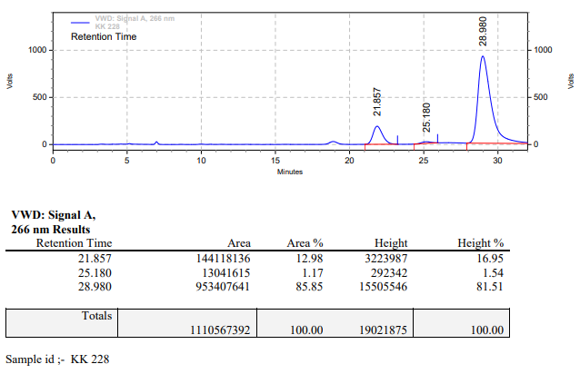

**KK-229**



**Calculation table:**

|  |  |  |  |  |  |
| --- | --- | --- | --- | --- | --- |
| Sr. No | Comp. | Mol. wt. | mmol | Eq. wt. | Wt. taken |
| 1 | Dehydrositagliptin (1) | 405.30 | 0.1067 | 50 | 43 mg |
| 2 | Rh(COD)2OTf | 468.30 | 0.0021 | 1 | 1 mg |
| 3 | L3 | 414.29 | 0.0021 | 1 | 0.9 mg |
| 4 | Ammonium chloride | 53.49 | 0.0021 | 1 | 0.1 mg |

**Procedure:** A glass vial (4 mL) equipped with Teflon coated magnetic needle was cooled under vacuum and transferred to a glove box. The vial was then charged with 43 mg of enamine (**1**), 1 mg of [Rh(COD)2OTf] (2 mol%), ligand (L3)and ammonium chloride. Reaction vial was then closed using screwcap, transferred to a large opening Schlenk type container and was then taken out from the glove box. 2 mL dry methanol was added to the vial in inert atmosphere and the resultant reaction slurry was stirred for 1 hour at room temperature (25 °C). After that the reaction vial was shifted to an autoclave and the autoclave was purged three times using hydrogen gas (40 bars). Finally, the autoclave was pressurized to 30 bar hydrogen pressure at 70°C for 12 hrs time period. After the 12 hrs time period, the autoclave was cooled to room temperature (25 °C), excess pressure was released and the autoclave was opened. The vials were taken out from the autoclave. The thus obtained reaction mixture was passed through neutral alumina bed, the filtrate was collect and dried to yield residue. The resultant residue was then analysed by HPLC.

**Reaction conditions:** Temp: 70°C Press.: 30 bar Solvent: methanol Time: 12 hrs

**Result: 51%** conversion **83%** ee

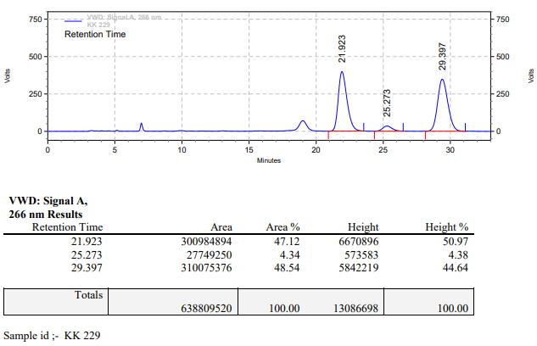

**KK-230**



**Calculation table:**

|  |  |  |  |  |  |
| --- | --- | --- | --- | --- | --- |
| Sr. No | Comp. | Mol. wt. | mmol | Eq. wt. | Wt. taken |
| 1 | Dehydrositagliptin (1) | 405.30 | 0.1067 | 50 | 43 mg |
| 2 | Rh(COD)2OTf | 468.30 | 0.0021 | 1 | 1 mg |
| 3 | L3 | 414.29 | 0.0021 | 1 | 0.9 mg |

**Procedure:** A glass vial (4 mL) equipped with Teflon coated magnetic needle was cooled under vacuum and transferred to a glove box. The vial was then charged with 43 mg of enamine (**1**), 1 mg of [Rh(COD)2OTf] (2 mol%) and ligand (L3). Reaction vial was then closed using screwcap, transferred to a large opening Schlenk type container and was then taken out from the glove box. 2 mL dry methanol was added to the vial in inert atmosphere and the resultant reaction slurry was stirred for 1 hour at room temperature (25 °C). After that the reaction vial was shifted to an autoclave and the autoclave was purged three times using hydrogen gas (40 bars). Finally, the autoclave was pressurized to 30 bar hydrogen pressure at 50°C for 12 hrs time period. After the 12 hrs time period, the autoclave was cooled to room temperature (25 °C), excess pressure was released and the autoclave was opened. The vials were taken out from the autoclave. The thus obtained reaction mixture was passed through neutral alumina bed, the filtrate was collect and dried to yield residue. The resultant residue was then analysed by HPLC.

**Reaction conditions:** Temp: 50°C Press.: 30 bar Solvent: methanol Time: 12 hrs

**Result: 14%** conversion **83%** ee

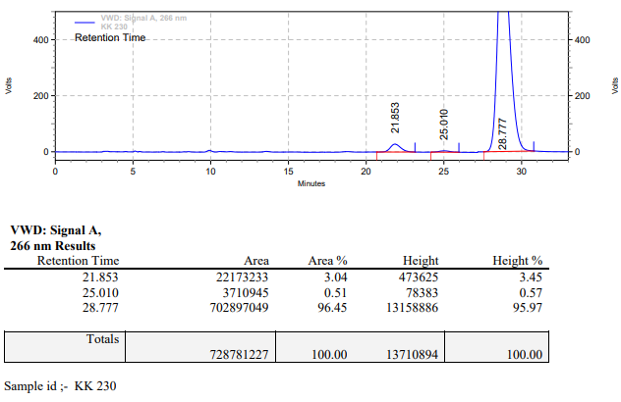

**KK-231**



**Calculation table:**

|  |  |  |  |  |  |
| --- | --- | --- | --- | --- | --- |
| Sr. No | Comp. | Mol. wt. | mmol | Eq. wt. | Wt. taken |
| 1 | Dehydrositagliptin (1) | 405.30 | 0.1067 | 50 | 43 mg |
| 2 | Rh(COD)2OTf | 468.30 | 0.0021 | 1 | 1 mg |
| 3 | L3 | 414.29 | 0.0021 | 1 | 0.9 mg |
| 4 | Ammonium chloride | 53.49 | 0.0021 | 1 | 0.1 mg |

**Procedure:** A glass vial (4 mL) equipped with Teflon coated magnetic needle was cooled under vacuum and transferred to a glove box. The vial was then charged with 43 mg of enamine (**1**), 1 mg of [Rh(COD)2OTf] (2 mol%), ligand (L3)and ammonium chloride. Reaction vial was then closed using screwcap, transferred to a large opening Schlenk type container and was then taken out from the glove box. 2 mL dry methanol was added to the vial in inert atmosphere and the resultant reaction slurry was stirred for 1 hour at room temperature (25 °C). After that the reaction vial was shifted to an autoclave and the autoclave was purged three times using hydrogen gas (40 bars). Finally, the autoclave was pressurized to 30 bar hydrogen pressure at 50°C for 12 hrs time period. After the 12 hrs time period, the autoclave was cooled to room temperature (25 °C), excess pressure was released and the autoclave was opened. The vials were taken out from the autoclave. The thus obtained reaction mixture was passed through neutral alumina bed, the filtrate was collect and dried to yield residue. The resultant residue was then analysed by HPLC.

**Reaction conditions:** Temp: 50°C Press.: 30 bar Solvent: methanol Time: 12 hrs

**Result: 06%** conversion **81%** ee

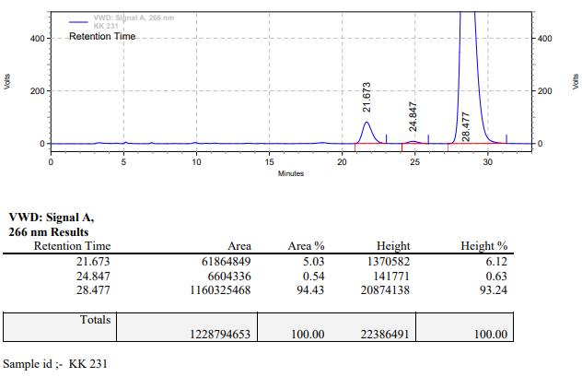

**KK-232**



**Calculation table:**

|  |  |  |  |  |  |
| --- | --- | --- | --- | --- | --- |
| Sr. No | Comp. | Mol. wt. | mmol | Eq. wt. | Wt. taken |
| 1 | Dehydrositagliptin (1) | 405.30 | 0.2135 | 50 | 86 mg |
| 2 | Rh(COD)2OTf | 468.30 | 0.0042 | 1 | 2 mg |
| 3 | L3 | 414.29 | 0.0042 | 1 | 1.8 mg |

**Procedure:** A glass vial (4 mL) equipped with Teflon coated magnetic needle was cooled under vacuum and transferred to a glove box. The vial was then charged with 86 mg of enamine (**1**), 2 mg of [Rh(COD)2OTf] (2 mol%) and ligand (L3). Reaction vial was then closed using screwcap, transferred to a large opening Schlenk type container and was then taken out from the glove box. 2 mL dry methanol was added to the vial in inert atmosphere and the resultant reaction slurry was stirred for 1 hour at room temperature (25 °C). After that the reaction vial was shifted to an autoclave and the autoclave was purged three times using hydrogen gas (40 bars). Finally, the autoclave was pressurized to 30 bar hydrogen pressure at 70°C for 18 hrs time period. After the 18 hrs time period, the autoclave was cooled to room temperature (25 °C), excess pressure was released and the autoclave was opened. The vials were taken out from the autoclave. The thus obtained reaction mixture was passed through neutral alumina bed, the filtrate was collect and dried to yield residue. The resultant residue was then analysed by HPLC.

**Reaction conditions:** Temp: 70°C Press.: 30 bar Solvent: methanol Time: 18 hrs

**Result: 74%** conversion **84%** ee

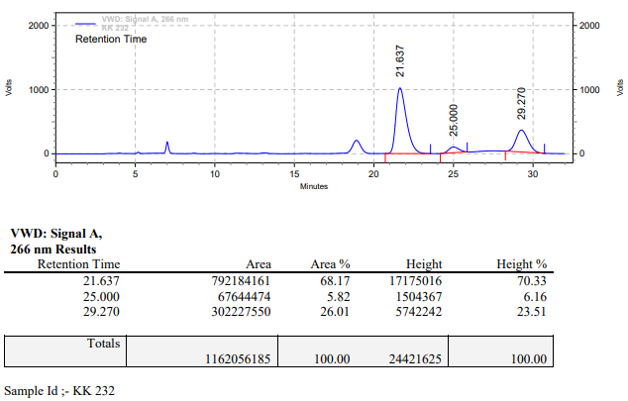

**KK-233**



**Calculation table:**

|  |  |  |  |  |  |
| --- | --- | --- | --- | --- | --- |
| Sr. No | Comp. | Mol. wt. | mmol | Eq. wt. | Wt. taken |
| 1 | Dehydrositagliptin (1) | 405.30 | 0.2135 | 50 | 86 mg |
| 2 | Rh(COD)2OTf | 468.30 | 0.0042 | 1 | 2 mg |
| 3 | L3 | 414.29 | 0.0042 | 1 | 1.8 mg |
| 4 | Ammonium chloride | 53.49 | 0.0042 | 1 | 0.2 mg |

**Procedure:** A glass vial (4 mL) equipped with Teflon coated magnetic needle was cooled under vacuum and transferred to a glove box. The vial was then charged with 86 mg of enamine (**1**), 2 mg of [Rh(COD)2OTf] (2 mol%), ligand (L3) and ammonium chloride. Reaction vial was then closed using screwcap, transferred to a large opening Schlenk type container and was then taken out from the glove box. 2 mL dry methanol was added to the vial in inert atmosphere and the resultant reaction slurry was stirred for 1 hour at room temperature (25 °C). After that the reaction vial was shifted to an autoclave and the autoclave was purged three times using hydrogen gas (40 bars). Finally, the autoclave was pressurized to 30 bar hydrogen pressure at 70°C for 18 hrs time period. After the 18 hrs time period, the autoclave was cooled to room temperature (25 °C), excess pressure was released and the autoclave was opened. The vials were taken out from the autoclave. The thus obtained reaction mixture was passed through neutral alumina bed, the filtrate was collect and dried to yield residue. The resultant residue was then analysed by HPLC.

**Reaction conditions:** Temp: 70°C Press.: 30 bar Solvent: methanol Time: 18 hrs

**Result: 89%** conversion 82**%** ee

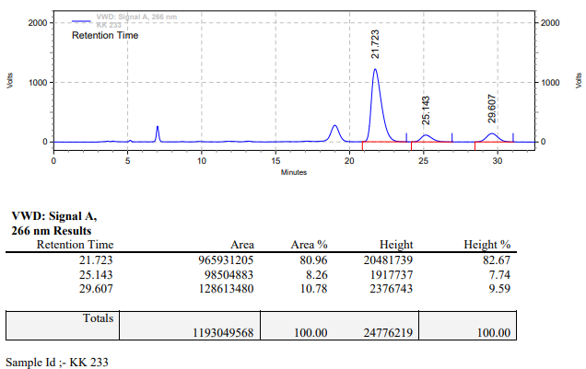

**KK-234**



**Calculation table:**

|  |  |  |  |  |  |
| --- | --- | --- | --- | --- | --- |
| Sr. No | Comp. | Mol. wt. | mmol | Eq. wt. | Wt. taken |
| 1 | Dehydrositagliptin (1) | 405.30 | 0.2135 | 50 | 86 mg |
| 2 | Rh(COD)2OTf | 468.30 | 0.0042 | 1 | 2 mg |
| 3 | L3 | 414.29 | 0.0042 | 1 | 1.8 mg |

**Procedure:** A glass vial (4 mL) equipped with Teflon coated magnetic needle was cooled under vacuum and transferred to a glove box. The vial was then charged with 86 mg of enamine (**1**), 2 mg of [Rh(COD)2OTf] (2 mol%) and ligand (L3). Reaction vial was then closed using screwcap, transferred to a large opening Schlenk type container and was then taken out from the glove box. 2 mL dry methanol was added to the vial in inert atmosphere and the resultant reaction slurry was stirred for 1 hour at room temperature (25 °C). After that the reaction vial was shifted to an autoclave and the autoclave was purged three times using hydrogen gas (40 bars). Finally, the autoclave was pressurized to 30 bar hydrogen pressure at 50°C for 70 hrs time period. After the 70 hrs time period, the autoclave was cooled to room temperature (25 °C), excess pressure was released and the autoclave was opened. The vials were taken out from the autoclave. The thus obtained reaction mixture was passed through neutral alumina bed, the filtrate was collect and dried to yield residue. The resultant residue was then analysed by HPLC.

**Reaction conditions:** Temp: 50°C Press.: 30 bar Solvent: methanol Time: 70 hrs

**Result: 46%** conversion **79%** ee

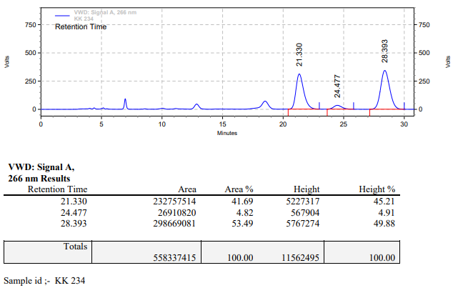

**KK-235**



**Calculation table:**

|  |  |  |  |  |  |
| --- | --- | --- | --- | --- | --- |
| Sr. No | Comp. | Mol. wt. | mmol | Eq. wt. | Wt. taken |
| 1 | Dehydrositagliptin (1) | 405.30 | 0.2135 | 50 | 86 mg |
| 2 | Rh(COD)2OTf | 468.30 | 0.0042 | 1 | 2 mg |
| 3 | L3 | 414.29 | 0.0042 | 1 | 1.8 mg |
| 4 | Ammonium chloride | 53.49 | 0.0042 | 1 | 0.2 mg |

**Procedure:** A glass vial (4 mL) equipped with Teflon coated magnetic needle was cooled under vacuum and transferred to a glove box. The vial was then charged with 86 mg of enamine (**1**), 2 mg of [Rh(COD)2OTf] (2 mol%), ligand (L3) and ammonium chloride. Reaction vial was then closed using screwcap, transferred to a large opening Schlenk type container and was then taken out from the glove box. 2 mL dry methanol was added to the vial in inert atmosphere and the resultant reaction slurry was stirred for 1 hour at room temperature (25 °C). After that the reaction vial was shifted to an autoclave and the autoclave was purged three times using hydrogen gas (40 bars). Finally, the autoclave was pressurized to 30 bar hydrogen pressure at 50°C for 70 hrs time period. After the 70 hrs time period, the autoclave was cooled to room temperature (25 °C), excess pressure was released and the autoclave was opened. The vials were taken out from the autoclave. The thus obtained reaction mixture was passed through neutral alumina bed, the filtrate was collect and dried to yield residue. The resultant residue was then analysed by HPLC.

**Reaction conditions:** Temp: 50°C Press.: 30 bar Solvent: methanol Time: 70 hrs

**Result: 46%** conversion **79%** ee

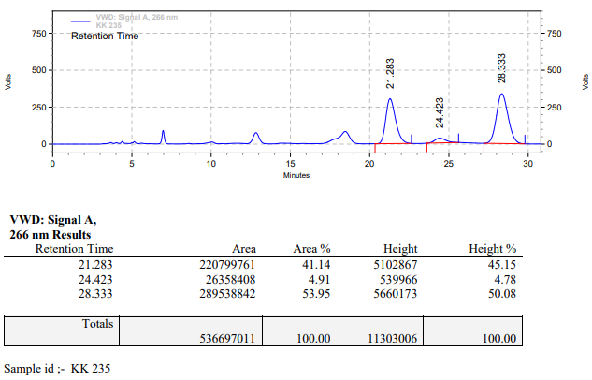

**KK-236**



**Calculation table:**

|  |  |  |  |  |  |
| --- | --- | --- | --- | --- | --- |
| Sr. No | Comp. | Mol. wt. | mmol | Eq. wt. | Wt. taken |
| 1 | Dehydrositagliptin (1) | 405.30 | 0.2135 | 50 | 86 mg |
| 2 | Rh(COD)2OTf | 468.30 | 0.0042 | 1 | 2 mg |
| 3 | L3 | 414.29 | 0.0042 | 1 | 1.8 mg |

**Procedure:** A glass vial (4 mL) equipped with Teflon coated magnetic needle was cooled under vacuum and transferred to a glove box. The vial was then charged with 86 mg of enamine (**1**), 2 mg of [Rh(COD)2OTf] (2 mol%) and ligand (L3). Reaction vial was then closed using screwcap, transferred to a large opening Schlenk type container and was then taken out from the glove box. 1 mL dry methanol was added to the vial in inert atmosphere and the resultant reaction slurry was stirred for 1 hour at room temperature (25 °C). After that the reaction vial was shifted to an autoclave and the autoclave was purged three times using hydrogen gas (40 bars). Finally, the autoclave was pressurized to 30 bar hydrogen pressure at 70°C for 18 hrs time period. After the 18 hrs time period, the autoclave was cooled to room temperature (25 °C), excess pressure was released and the autoclave was opened. The vials were taken out from the autoclave. The thus obtained reaction mixture was passed through neutral alumina bed, the filtrate was collect and dried to yield residue. The resultant residue was then analysed by HPLC.

**Reaction conditions:** Temp: 70°C Press.: 30 bar Solvent: methanol Time: 18 hrs

**Result: 91%** conversion **82%** ee

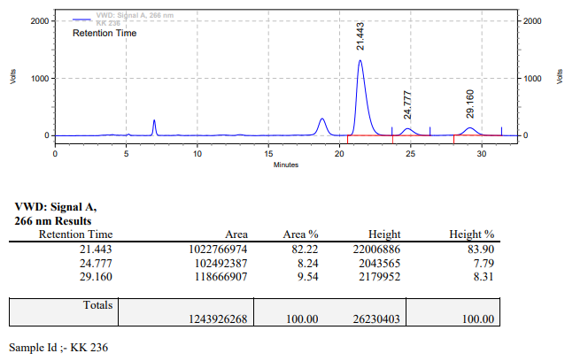

**KK-237**



**Calculation table:**

|  |  |  |  |  |  |
| --- | --- | --- | --- | --- | --- |
| Sr. No | Comp. | Mol. wt. | mmol | Eq. wt. | Wt. taken |
| 1 | Dehydrositagliptin (1) | 405.30 | 0.2135 | 50 | 86 mg |
| 2 | Rh(COD)2OTf | 468.30 | 0.0042 | 1 | 2 mg |
| 3 | L3 | 414.29 | 0.0042 | 1 | 1.8 mg |

**Procedure:** A glass vial (4 mL) equipped with Teflon coated magnetic needle was cooled under vacuum and transferred to a glove box. The vial was then charged with 86 mg of enamine (**1**), 2 mg of [Rh(COD)2OTf] (2 mol%) and ligand (L3). Reaction vial was then closed using screwcap, transferred to a large opening Schlenk type container and was then taken out from the glove box. 2 mL dry methanol was added to the vial in inert atmosphere and the resultant reaction slurry was stirred for 1 hour at room temperature (25 °C). After that the reaction vial was shifted to an autoclave and the autoclave was purged three times using hydrogen gas (40 bars). Finally, the autoclave was pressurized to 30 bar hydrogen pressure at 70°C for 24 hrs time period. After the 24 hrs time period, the autoclave was cooled to room temperature (25 °C), excess pressure was released and the autoclave was opened. The vials were taken out from the autoclave. The thus obtained reaction mixture was passed through neutral alumina bed, the filtrate was collect and dried to yield residue. The resultant residue was then analysed by HPLC.

**Reaction conditions:** Temp: 70°C Press.: 30 bar Solvent: methanol Time: 24 hrs

**Result: 58%** conversion **82%** ee

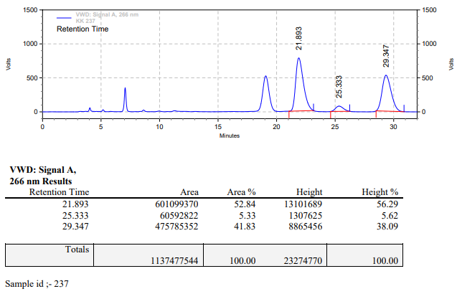

**KK-238**



**Calculation table:**

|  |  |  |  |  |  |
| --- | --- | --- | --- | --- | --- |
| Sr. No | Comp. | Mol. wt. | mmol | Eq. wt. | Wt. taken |
| 1 | Dehydrositagliptin (1) | 405.30 | 0.2135 | 50 | 86 mg |
| 2 | Rh(COD)2OTf | 468.30 | 0.0042 | 1 | 2 mg |
| 3 | L3 | 414.29 | 0.0084 | 2 | 3.5 mg |

**Procedure:** A glass vial (4 mL) equipped with Teflon coated magnetic needle was cooled under vacuum and transferred to a glove box. The vial was then charged with 86 mg of enamine (**1**), 2 mg of [Rh(COD)2OTf] (2 mol%) and ligand (L3). Reaction vial was then closed using screwcap, transferred to a large opening Schlenk type container and was then taken out from the glove box. 2 mL dry methanol was added to the vial in inert atmosphere and the resultant reaction slurry was stirred for 1 hour at room temperature (25 °C). After that the reaction vial was shifted to an autoclave and the autoclave was purged three times using hydrogen gas (40 bars). Finally, the autoclave was pressurized to 30 bar hydrogen pressure at 70°C for 24 hrs time period. After the 24 hrs time period, the autoclave was cooled to room temperature (25 °C), excess pressure was released and the autoclave was opened. The vials were taken out from the autoclave. The thus obtained reaction mixture was passed through neutral alumina bed, the filtrate was collect and dried to yield residue. The resultant residue was then analysed by HPLC.

**Reaction conditions:** Temp: 70°C Press.: 30 bar Solvent: methanol Time: 24 hrs

**Result: 92%** conversion **81%** ee

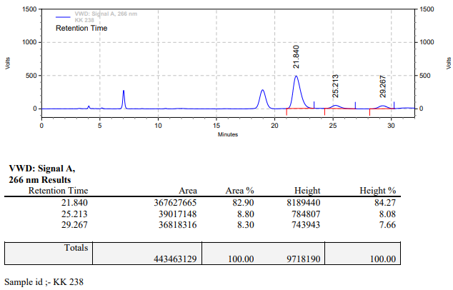

**KK-239**



**Calculation table:**

|  |  |  |  |  |  |
| --- | --- | --- | --- | --- | --- |
| Sr. No | Comp. | Mol. wt. | mmol | Eq. wt. | Wt. taken |
| 1 | Dehydrositagliptin (1) | 405.30 | 0.2135 | 50 | 86 mg |
| 2 | Rh(COD)2OTf | 468.30 | 0.0042 | 1 | 2 mg |
| 3 | L3 | 414.29 | 0.0168 | 4 | 7 mg |

**Procedure:** A glass vial (4 mL) equipped with Teflon coated magnetic needle was cooled under vacuum and transferred to a glove box. The vial was then charged with 86 mg of enamine (**1**), 2 mg of [Rh(COD)2OTf] (2 mol%) and ligand (L3). Reaction vial was then closed using screwcap, transferred to a large opening Schlenk type container and was then taken out from the glove box. 2 mL dry methanol was added to the vial in inert atmosphere and the resultant reaction slurry was stirred for 1 hour at room temperature (25 °C). After that the reaction vial was shifted to an autoclave and the autoclave was purged three times using hydrogen gas (40 bars). Finally, the autoclave was pressurized to 30 bar hydrogen pressure at 70°C for 24 hrs time period. After the 24 hrs time period, the autoclave was cooled to room temperature (25 °C), excess pressure was released and the autoclave was opened. The vials were taken out from the autoclave. The thus obtained reaction mixture was passed through neutral alumina bed, the filtrate was collect and dried to yield residue. The resultant residue was then analysed by HPLC.

**Reaction conditions:** Temp: 70°C Press.: 30 bar Solvent: methanol Time: 24 hrs

**Result: 26%** conversion **89%** ee

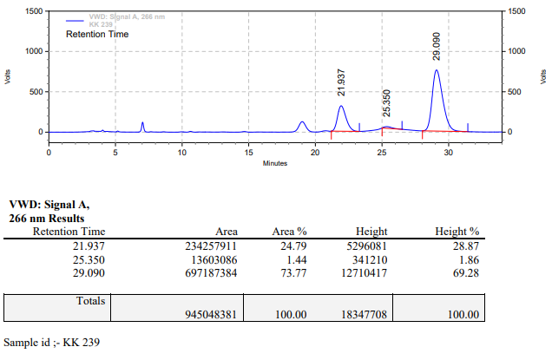

**KK-240**



**Calculation table:**

|  |  |  |  |  |  |
| --- | --- | --- | --- | --- | --- |
| Sr. No | Comp. | Mol. wt. | mmol | Eq. wt. | Wt. taken |
| 1 | Dehydrositagliptin (1) | 405.30 | 0.2135 | 50 | 86 mg |
| 2 | Rh(COD)2OTf | 468.30 | 0.0042 | 1 | 2 mg |
| 3 | L3 | 414.29 | 0.0042 | 1 | 1.8 mg |
| 4 | Ammonium chloride | 53.49 | 0.0042 | 1 | 0.2 mg |

**Procedure:** A glass vial (4 mL) equipped with Teflon coated magnetic needle was cooled under vacuum and transferred to a glove box. The vial was then charged with 86 mg of enamine (**1**), 2 mg of [Rh(COD)2OTf] (2 mol%), ligand (L3) and ammonium chloride. Reaction vial was then closed using screwcap, transferred to a large opening Schlenk type container and was then taken out from the glove box. 2 mL dry methanol was added to the vial in inert atmosphere and the resultant reaction slurry was stirred for 1 hour at room temperature (25 °C). After that the reaction vial was shifted to an autoclave and the autoclave was purged three times using hydrogen gas (40 bars). Finally, the autoclave was pressurized to 30 bar hydrogen pressure at 70°C for 24 hrs time period. After the 24 hrs time period, the autoclave was cooled to room temperature (25 °C), excess pressure was released and the autoclave was opened. The vials were taken out from the autoclave. The thus obtained reaction mixture was passed through neutral alumina bed, the filtrate was collect and dried to yield residue. The resultant residue was then analysed by HPLC.

**Reaction conditions:** Temp: 70°C Press.: 30 bar Solvent: methanol Time: 24 hrs

**Result: 13%** conversion **85%** ee

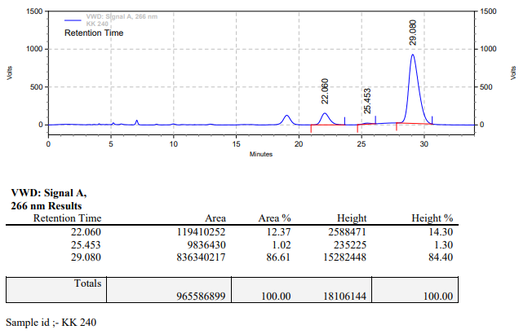

**KK-241**



**Calculation table:**

|  |  |  |  |  |  |
| --- | --- | --- | --- | --- | --- |
| Sr. No | Comp. | Mol. wt. | mmol | Eq. wt. | Wt. taken |
| 1 | Dehydrositagliptin (1) | 405.30 | 0.2135 | 50 | 86 mg |
| 2 | Rh(COD)2OTf | 468.30 | 0.0042 | 1 | 2 mg |
| 3 | L3 | 414.29 | 0.0084 | 2 | 3.5 mg |
| 4 | Ammonium chloride | 53.49 | 0.0042 | 1 | 0.2 mg |

**Procedure:** A glass vial (4 mL) equipped with Teflon coated magnetic needle was cooled under vacuum and transferred to a glove box. The vial was then charged with 86 mg of enamine (**1**), 2 mg of [Rh(COD)2OTf] (2 mol%), ligand (L3) and ammonium chloride. Reaction vial was then closed using screwcap, transferred to a large opening Schlenk type container and was then taken out from the glove box. 2 mL dry methanol was added to the vial in inert atmosphere and the resultant reaction slurry was stirred for 1 hour at room temperature (25 °C). After that the reaction vial was shifted to an autoclave and the autoclave was purged three times using hydrogen gas (40 bars). Finally, the autoclave was pressurized to 30 bar hydrogen pressure at 70°C for 24 hrs time period. After the 24 hrs time period, the autoclave was cooled to room temperature (25 °C), excess pressure was released and the autoclave was opened. The vials were taken out from the autoclave. The thus obtained reaction mixture was passed through neutral alumina bed, the filtrate was collect and dried to yield residue. The resultant residue was then analysed by HPLC.

**Reaction conditions:** Temp: 70°C Press.: 30 bar Solvent: methanol Time: 24 hrs

**Result: 89%** conversion **83%** ee

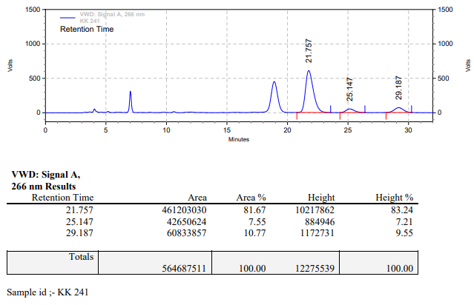

**KK-242**



**Calculation table:**

|  |  |  |  |  |  |
| --- | --- | --- | --- | --- | --- |
| Sr. No | Comp. | Mol. wt. | mmol | Eq. wt. | Wt. taken |
| 1 | Dehydrositagliptin (1) | 405.30 | 0.2135 | 50 | 86 mg |
| 2 | Rh(COD)2OTf | 468.30 | 0.0042 | 1 | 2 mg |
| 3 | L3 | 414.29 | 0.0168 | 4 | 7 mg |
| 4 | Ammonium chloride | 53.49 | 0.0042 | 1 | 0.2 mg |

**Procedure:** A glass vial (4 mL) equipped with Teflon coated magnetic needle was cooled under vacuum and transferred to a glove box. The vial was then charged with 86 mg of enamine (**1**), 2 mg of [Rh(COD)2OTf] (2 mol%), ligand (L3) and ammonium chloride. Reaction vial was then closed using screwcap, transferred to a large opening Schlenk type container and was then taken out from the glove box. 2 mL dry methanol was added to the vial in inert atmosphere and the resultant reaction slurry was stirred for 1 hour at room temperature (25 °C). After that the reaction vial was shifted to an autoclave and the autoclave was purged three times using hydrogen gas (40 bars). Finally, the autoclave was pressurized to 30 bar hydrogen pressure at 70°C for 24 hrs time period. After the 24 hrs time period, the autoclave was cooled to room temperature (25 °C), excess pressure was released and the autoclave was opened. The vials were taken out from the autoclave. The thus obtained reaction mixture was passed through neutral alumina bed, the filtrate was collect and dried to yield residue. The resultant residue was then analysed by HPLC.

**Reaction conditions:** Temp: 70°C Press.: 30 bar Solvent: methanol Time: 24 hrs

**Result: 02%** conversion **92%** ee

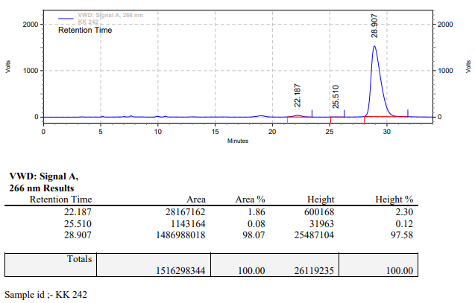

**KK-243**



**Calculation table:**

|  |  |  |  |  |  |
| --- | --- | --- | --- | --- | --- |
| Sr. No | Comp. | Mol. wt. | mmol | Eq. wt. | Wt. taken |
| 1 | Dehydrositagliptin (1) | 405.30 | 0.2135 | 50 | 86 mg |
| 2 | Rh(COD)2OTf | 468.30 | 0.0042 | 1 | 2 mg |
| 3 | L3 | 414.29 | 0.0042 | 1 | 1.8 mg |

**Procedure:** A glass vial (4 mL) equipped with Teflon coated magnetic needle was cooled under vacuum and transferred to a glove box. The vial was then charged with 86 mg of enamine (**1**), 2 mg of [Rh(COD)2OTf] (2 mol%) and ligand (L3). Reaction vial was then closed using screwcap, transferred to a large opening Schlenk type container and was then taken out from the glove box. 2 mL dry methanol was added to the vial in inert atmosphere and the resultant reaction slurry was stirred for 1 hour at room temperature (25 °C). After that the reaction vial was shifted to an autoclave and the autoclave was purged three times using hydrogen gas (40 bars). Finally, the autoclave was pressurized to 30 bar hydrogen pressure at 50°C for 24 hrs time period. After the 24 hrs time period, the autoclave was cooled to room temperature (25 °C), excess pressure was released and the autoclave was opened. The vials were taken out from the autoclave. The thus obtained reaction mixture was passed through neutral alumina bed, the filtrate was collect and dried to yield residue. The resultant residue was then analysed by HPLC.

**Reaction conditions:** Temp: 50°C Press.: 30 bar Solvent: methanol Time: 24 hrs

**Result: 06%** conversion **83%** ee

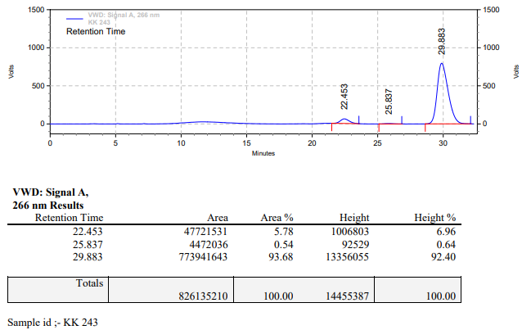

**KK-244**



**Calculation table:**

|  |  |  |  |  |  |
| --- | --- | --- | --- | --- | --- |
| Sr. No | Comp. | Mol. wt. | mmol | Eq. wt. | Wt. taken |
| 1 | Dehydrositagliptin (1) | 405.30 | 0.2135 | 50 | 86 mg |
| 2 | Rh(COD)2OTf | 468.30 | 0.0042 | 1 | 2 mg |
| 3 | L3 | 414.29 | 0.0084 | 2 | 3.5 mg |

**Procedure:** A glass vial (4 mL) equipped with Teflon coated magnetic needle was cooled under vacuum and transferred to a glove box. The vial was then charged with 86 mg of enamine (**1**), 2 mg of [Rh(COD)2OTf] (2 mol%) and ligand (L3). Reaction vial was then closed using screwcap, transferred to a large opening Schlenk type container and was then taken out from the glove box. 2 mL dry methanol was added to the vial in inert atmosphere and the resultant reaction slurry was stirred for 1 hour at room temperature (25 °C). After that the reaction vial was shifted to an autoclave and the autoclave was purged three times using hydrogen gas (40 bars). Finally, the autoclave was pressurized to 30 bar hydrogen pressure at 50°C for 24 hrs time period. After the 24 hrs time period, the autoclave was cooled to room temperature (25 °C), excess pressure was released and the autoclave was opened. The vials were taken out from the autoclave. The thus obtained reaction mixture was passed through neutral alumina bed, the filtrate was collect and dried to yield residue. The resultant residue was then analysed by HPLC.

**Reaction conditions:** Temp: 50°C Press.: 30 bar Solvent: methanol Time: 24 hrs

**Result: 04%** conversion **84%** ee

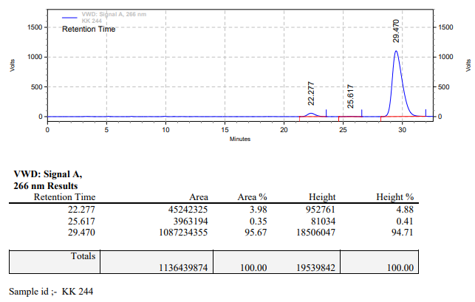

**KK-245**



**Calculation table:**

|  |  |  |  |  |  |
| --- | --- | --- | --- | --- | --- |
| Sr. No | Comp. | Mol. wt. | mmol | Eq. wt. | Wt. taken |
| 1 | Dehydrositagliptin (1) | 405.30 | 0.2135 | 50 | 86 mg |
| 2 | Rh(COD)2OTf | 468.30 | 0.0042 | 1 | 2 mg |
| 3 | L3 | 414.29 | 0.0168 | 4 | 7 mg |

**Procedure:** A glass vial (4 mL) equipped with Teflon coated magnetic needle was cooled under vacuum and transferred to a glove box. The vial was then charged with 86 mg of enamine (**1**), 2 mg of [Rh(COD)2OTf] (2 mol%) and ligand (L3). Reaction vial was then closed using screwcap, transferred to a large opening Schlenk type container and was then taken out from the glove box. 2 mL dry methanol was added to the vial in inert atmosphere and the resultant reaction slurry was stirred for 1 hour at room temperature (25 °C). After that the reaction vial was shifted to an autoclave and the autoclave was purged three times using hydrogen gas (40 bars). Finally, the autoclave was pressurized to 30 bar hydrogen pressure at 50°C for 24 hrs time period. After the 24 hrs time period, the autoclave was cooled to room temperature (25 °C), excess pressure was released and the autoclave was opened. The vials were taken out from the autoclave. The thus obtained reaction mixture was passed through neutral alumina bed, the filtrate was collect and dried to yield residue. The resultant residue was then analysed by HPLC.

**Reaction conditions:** Temp: 50°C Press.: 30 bar Solvent: methanol Time: 24 hrs

**Result: 00%** conversion **00%** ee

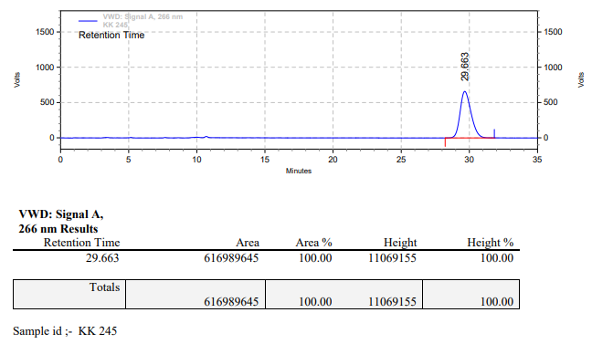

**KK-246**



**Calculation table:**

|  |  |  |  |  |  |
| --- | --- | --- | --- | --- | --- |
| Sr. No | Comp. | Mol. wt. | mmol | Eq. wt. | Wt. taken |
| 1 | Dehydrositagliptin (1) | 405.30 | 0.2135 | 50 | 86 mg |
| 2 | Rh(COD)2OTf | 468.30 | 0.0042 | 1 | 2 mg |
| 3 | L3 | 414.29 | 0.0042 | 1 | 1.8 mg |
| 4 | Ammonium chloride | 53.49 | 0.0042 | 1 | 0.2 mg |

**Procedure:** A glass vial (4 mL) equipped with Teflon coated magnetic needle was cooled under vacuum and transferred to a glove box. The vial was then charged with 86 mg of enamine (**1**), 2 mg of [Rh(COD)2OTf] (2 mol%), ligand (L3) and ammonium chloride. Reaction vial was then closed using screwcap, transferred to a large opening Schlenk type container and was then taken out from the glove box. 2 mL dry methanol was added to the vial in inert atmosphere and the resultant reaction slurry was stirred for 1 hour at room temperature (25 °C). After that the reaction vial was shifted to an autoclave and the autoclave was purged three times using hydrogen gas (40 bars). Finally, the autoclave was pressurized to 30 bar hydrogen pressure at 50°C for 24 hrs time period. After the 24 hrs time period, the autoclave was cooled to room temperature (25 °C), excess pressure was released and the autoclave was opened. The vials were taken out from the autoclave. The thus obtained reaction mixture was passed through neutral alumina bed, the filtrate was collect and dried to yield residue. The resultant residue was then analysed by HPLC.

**Reaction conditions:** Temp: 50°C Press.: 30 bar Solvent: methanol Time: 24 hrs

**Result: 07%** conversion **81%** ee

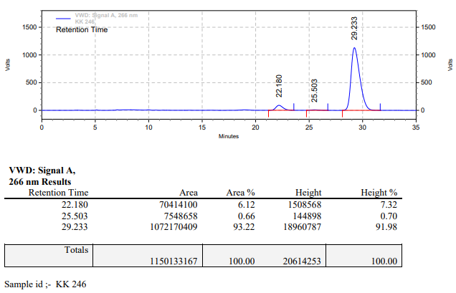

**KK-247**



**Calculation table:**

|  |  |  |  |  |  |
| --- | --- | --- | --- | --- | --- |
| Sr. No | Comp. | Mol. wt. | mmol | Eq. wt. | Wt. taken |
| 1 | Dehydrositagliptin (1) | 405.30 | 0.2135 | 50 | 86 mg |
| 2 | Rh(COD)2OTf | 468.30 | 0.0042 | 1 | 2 mg |
| 3 | L3 | 414.29 | 0.0084 | 2 | 3.5 mg |
| 4 | Ammonium chloride | 53.49 | 0.0042 | 1 | 0.2 mg |

**Procedure:** A glass vial (4 mL) equipped with Teflon coated magnetic needle was cooled under vacuum and transferred to a glove box. The vial was then charged with 86 mg of enamine (**1**), 2 mg of [Rh(COD)2OTf] (2 mol%), ligand (L3) and ammonium chloride. Reaction vial was then closed using screwcap, transferred to a large opening Schlenk type container and was then taken out from the glove box. 2 mL dry methanol was added to the vial in inert atmosphere and the resultant reaction slurry was stirred for 1 hour at room temperature (25 °C). After that the reaction vial was shifted to an autoclave and the autoclave was purged three times using hydrogen gas (40 bars). Finally, the autoclave was pressurized to 30 bar hydrogen pressure at 50°C for 24 hrs time period. After the 24 hrs time period, the autoclave was cooled to room temperature (25 °C), excess pressure was released and the autoclave was opened. The vials were taken out from the autoclave. The thus obtained reaction mixture was passed through neutral alumina bed, the filtrate was collect and dried to yield residue. The resultant residue was then analysed by HPLC.

**Reaction conditions:** Temp: 50°C Press.: 30 bar Solvent: methanol Time: 24 hrs

**Result: 26%** conversion **83%** ee

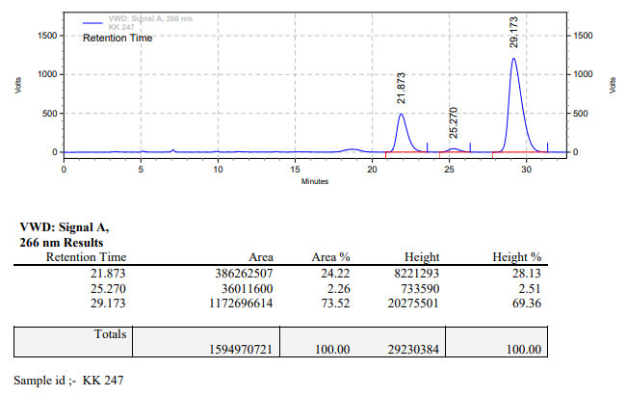

**KK-248**



**Calculation table:**

|  |  |  |  |  |  |
| --- | --- | --- | --- | --- | --- |
| Sr. No | Comp. | Mol. wt. | mmol | Eq. wt. | Wt. taken |
| 1 | Dehydrositagliptin (1) | 405.30 | 0.2135 | 50 | 86 mg |
| 2 | Rh(COD)2OTf | 468.30 | 0.0042 | 1 | 2 mg |
| 3 | L3 | 414.29 | 0.0168 | 4 | 7 mg |
| 4 | Ammonium chloride | 53.49 | 0.0042 | 1 | 0.2 mg |

**Procedure:** A glass vial (4 mL) equipped with Teflon coated magnetic needle was cooled under vacuum and transferred to a glove box. The vial was then charged with 86 mg of enamine (**1**), 2 mg of [Rh(COD)2OTf] (2 mol%), ligand (L3) and ammonium chloride. Reaction vial was then closed using screwcap, transferred to a large opening Schlenk type container and was then taken out from the glove box. 2 mL dry methanol was added to the vial in inert atmosphere and the resultant reaction slurry was stirred for 1 hour at room temperature (25 °C). After that the reaction vial was shifted to an autoclave and the autoclave was purged three times using hydrogen gas (40 bars). Finally, the autoclave was pressurized to 30 bar hydrogen pressure at 50°C for 24 hrs time period. After the 24 hrs time period, the autoclave was cooled to room temperature (25 °C), excess pressure was released and the autoclave was opened. The vials were taken out from the autoclave. The thus obtained reaction mixture was passed through neutral alumina bed, the filtrate was collect and dried to yield residue. The resultant residue was then analysed by HPLC.

**Reaction conditions:** Temp: 50°C Press.: 30 bar Solvent: methanol Time: 24 hrs

**Result: 00%** conversion **00%** ee

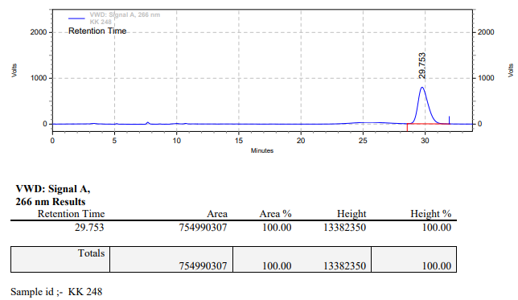

**KK-249**



**Calculation table:**

|  |  |  |  |  |  |
| --- | --- | --- | --- | --- | --- |
| Sr. No | Comp. | Mol. wt. | mmol | Eq. wt. | Wt. taken |
| 1 | Dehydrositagliptin (1) | 405.30 | 0.2135 | 100 | 86 mg |
| 2 | Rh(COD)2OTf | 468.30 | 0.0021 | 1 | 1 mg |
| 3 | L3 | 414.29 | 0.0042 | 2 | 1.8 mg |
| 4 | Salicylic acid | 138.12 | 0.2135 | 100 | 29.5 mg |

**Procedure:** A glass vial (4 mL) equipped with Teflon coated magnetic needle was cooled under vacuum and transferred to a glove box. The vial was then charged with 86 mg of enamine (**1**), 1 mg of [Rh(COD)2OTf] (2 mol%), ligand (L3) and salicylic acid. Reaction vial was then closed using screwcap, transferred to a large opening Schlenk type container and was then taken out from the glove box. 2 mL dry methanol was added to the vial in inert atmosphere and the resultant reaction slurry was stirred for 1 hour at room temperature (25 °C). After that the reaction vial was shifted to an autoclave and the autoclave was purged three times using hydrogen gas (40 bars). Finally, the autoclave was pressurized to 30 bar hydrogen pressure at 70°C for 24 hrs time period. After the 24 hrs time period, the autoclave was cooled to room temperature (25 °C), excess pressure was released and the autoclave was opened. The vials were taken out from the autoclave. The thus obtained reaction mixture was passed through neutral alumina bed, the filtrate was collect and dried to yield residue. The resultant residue was then analysed by HPLC.

**Reaction conditions:** Temp: 70°C Press.: 30 bar Solvent: methanol Time: 24 hrs

**Result: 94%** conversion **18%** ee

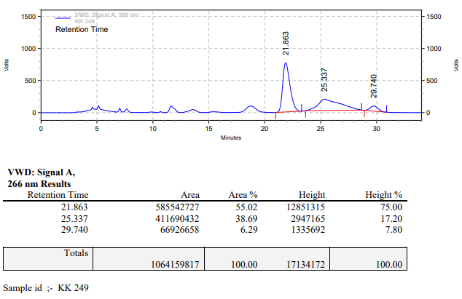

**KK-250**



**Calculation table:**

|  |  |  |  |  |  |
| --- | --- | --- | --- | --- | --- |
| Sr. No | Comp. | Mol. wt. | mmol | Eq. wt. | Wt. taken |
| 1 | Dehydrositagliptin (1) | 405.30 | 0.2135 | 100 | 86 mg |
| 2 | Rh(COD)2OTf | 468.30 | 0.0021 | 1 | 1 mg |
| 3 | L3 | 414.29 | 0.0042 | 2 | 1.8 mg |
| 4 | Salicylic acid | 138.12 | 0.2135 | 100 | 29.5 mg |
| 5 | Ammonium chloride | 53.49 | 0.2135 | 100 | 11.4 mg |

**Procedure:** A glass vial (4 mL) equipped with Teflon coated magnetic needle was cooled under vacuum and transferred to a glove box. The vial was then charged with 86 mg of enamine (**1**), 1 mg of [Rh(COD)2OTf] (1 mol%), ligand (L3), salicylic acid and ammonium chloride. Reaction vial was then closed using screwcap, transferred to a large opening Schlenk type container and was then taken out from the glove box. 2 mL dry methanol was added to the vial in inert atmosphere and the resultant reaction slurry was stirred for 1 hour at room temperature (25 °C). After that the reaction vial was shifted to an autoclave and the autoclave was purged three times using hydrogen gas (40 bars). Finally, the autoclave was pressurized to 30 bar hydrogen pressure at 70°C for 24 hrs time period. After the 24 hrs time period, the autoclave was cooled to room temperature (25 °C), excess pressure was released and the autoclave was opened. The vials were taken out from the autoclave. The thus obtained reaction mixture was passed through neutral alumina bed, the filtrate was collect and dried to yield residue. The resultant residue was then analysed by HPLC.

**Reaction conditions:** Temp: 70°C Press.: 30 bar Solvent: methanol Time: 24 hrs

**Result: 13%** conversion **74%** ee

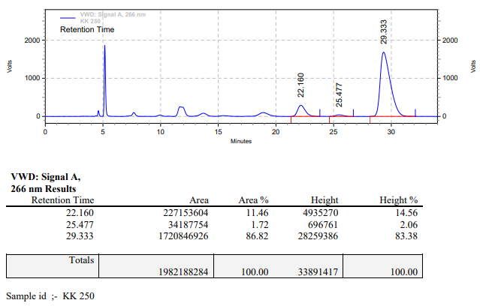

**KK-251**



**Calculation table:**

|  |  |  |  |  |  |
| --- | --- | --- | --- | --- | --- |
| Sr. No | Comp. | Mol. wt. | mmol | Eq. wt. | Wt. taken |
| 1 | Dehydrositagliptin (1) | 405.30 | 0.2135 | 100 | 86 mg |
| 2 | Rh(COD)2OTf | 468.30 | 0.0021 | 1 | 1 mg |
| 3 | L3 | 414.29 | 0.0042 | 2 | 1.8 mg |
| 4 | Salicylic acid | 138.12 | 0.2135 | 100 | 29.5 mg |

**Procedure:** A glass vial (4 mL) equipped with Teflon coated magnetic needle was cooled under vacuum and transferred to a glove box. The vial was then charged with 86 mg of enamine (**1**), 1 mg of [Rh(COD)2OTf] (1 mol%), ligand (L3) and salicylic acid. Reaction vial was then closed using screwcap, transferred to a large opening Schlenk type container and was then taken out from the glove box. 2 mL dry methanol was added to the vial in inert atmosphere and the resultant reaction slurry was stirred for 1 hour at room temperature (25 °C). After that the reaction vial was shifted to an autoclave and the autoclave was purged three times using hydrogen gas (40 bars). Finally, the autoclave was pressurized to 30 bar hydrogen pressure at 70°C for 24 hrs time period. After the 24 hrs time period, the autoclave was cooled to room temperature (25 °C), excess pressure was released and the autoclave was opened. The vials were taken out from the autoclave. The thus obtained reaction mixture was passed through neutral alumina bed, the filtrate was collect and dried to yield residue. The resultant residue was then analysed by HPLC.

**Reaction conditions:** Temp: 70°C Press.: 30 bar Solvent: methanol Time: 24 hrs

**Result: 92%** conversion **82%** ee

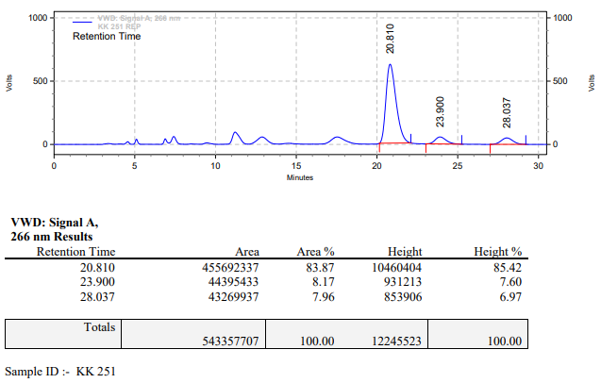

**KK-252**



**Calculation table:**

|  |  |  |  |  |  |
| --- | --- | --- | --- | --- | --- |
| Sr. No | Comp. | Mol. wt. | mmol | Eq. wt. | Wt. taken |
| 1 | Dehydrositagliptin (1) | 405.30 | 0.2135 | 100 | 86 mg |
| 2 | Rh(COD)2OTf | 468.30 | 0.0021 | 1 | 1 mg |
| 3 | L3 | 414.29 | 0.0042 | 2 | 1.8 mg |

**Procedure:** A glass vial (4 mL) equipped with Teflon coated magnetic needle was cooled under vacuum and transferred to a glove box. The vial was then charged with 86 mg of enamine (**1**), 1 mg of [Rh(COD)2OTf] (1 mol%) and ligand (L3). Reaction vial was then closed using screwcap, transferred to a large opening Schlenk type container and was then taken out from the glove box. 2 mL dry methanol was added to the vial in inert atmosphere and the resultant reaction slurry was stirred for 1 hour at room temperature (25 °C). After that the reaction vial was shifted to an autoclave and the autoclave was purged three times using hydrogen gas (40 bars). Finally, the autoclave was pressurized to 30 bar hydrogen pressure at 70°C for 24 hrs time period. After the 24 hrs time period, the autoclave was cooled to room temperature (25 °C), excess pressure was released and the autoclave was opened. The vials were taken out from the autoclave. The thus obtained reaction mixture was passed through neutral alumina bed, the filtrate was collect and dried to yield residue. The resultant residue was then analysed by HPLC.

**Reaction conditions:** Temp: 70°C Press.: 30 bar Solvent: methanol Time: 24 hrs

**Result: 45%** conversion **02%** ee

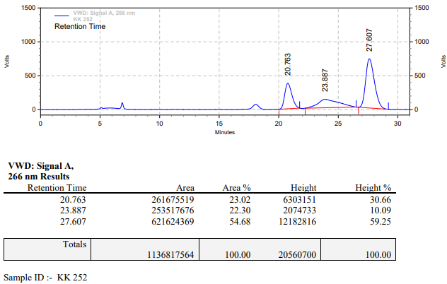

**KK-253**



**Calculation table:**

|  |  |  |  |  |  |
| --- | --- | --- | --- | --- | --- |
| Sr. No | Comp. | Mol. wt. | mmol | Eq. wt. | Wt. taken |
| 1 | Dehydrositagliptin (1) | 405.30 | 0.2135 | 100 | 86 mg |
| 2 | Rh(COD)2OTf | 468.30 | 0.0021 | 1 | 1 mg |
| 3 | L3 | 414.29 | 0.0021 | 1 | 0.9 mg |
| 4 | Ammonium chloride | 53.49 | 0.0021 | 1 | 0.1 mg |

**Procedure:** A glass vial (4 mL) equipped with Teflon coated magnetic needle was cooled under vacuum and transferred to a glove box. The vial was then charged with 86 mg of enamine (**1**), 1 mg of [Rh(COD)2OTf] (1 mol%), ligand (L3) and ammonium chloride. Reaction vial was then closed using screwcap, transferred to a large opening Schlenk type container and was then taken out from the glove box. 2 mL dry methanol was added followed by catalytic amount of water to the vial in inert atmosphere and the resultant reaction slurry was stirred for 1 hour at room temperature (25 °C). After that the reaction vial was shifted to an autoclave and the autoclave was purged three times using hydrogen gas (40 bars). Finally, the autoclave was pressurized to 30 bar hydrogen pressure at 70°C for 24 hrs time period. After the 24 hrs time period, the autoclave was cooled to room temperature (25 °C), excess pressure was released and the autoclave was opened. The vials were taken out from the autoclave. The thus obtained reaction mixture was passed through neutral alumina bed, the filtrate was collect and dried to yield residue. The resultant residue was then analysed by HPLC.

**Reaction conditions:** Temp: 70°C Press.: 30 bar Solvent: methanol Time: 24 hrs

**Result: 09%** conversion **83%** ee

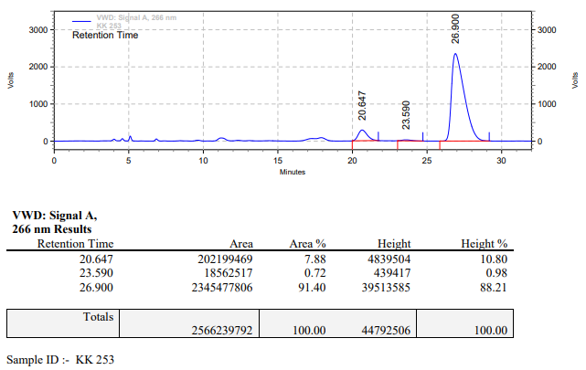

**KK-254**



**Calculation table:**

|  |  |  |  |  |  |
| --- | --- | --- | --- | --- | --- |
| Sr. No | Comp. | Mol. wt. | mmol | Eq. wt. | Wt. taken |
| 1 | Dehydrositagliptin (1) | 405.30 | 0.2837 | 1 | 115 mg |
| 2 | Rh(COD)2OTf | 468.30 | 0.0028 | 0.01 | 1.3 mg |
| 3 | L3 | 414.29 | 0.0028 | 0.01 | 1.2 mg |
| 4 | Ammonium chloride | 53.49 | 0.0028 | 0.01 | 0.2 mg |

**Procedure:** A glass vial (4 mL) equipped with Teflon coated magnetic needle was cooled under vacuum and transferred to a glove box. The vial was then charged with 115 mg of enamine (**1**), 1.3 mg of [Rh(COD)2OTf], ligand (L3) and ammonium chloride. Reaction vial was then closed using screwcap, transferred to a large opening Schlenk type container and was then taken out from the glove box. 2 mL dry methanol was added followed by catalytic amount of water to the vial in inert atmosphere and the resultant reaction slurry was stirred for 1 hour at room temperature (25 °C). After that the reaction vial was shifted to an autoclave and the autoclave was purged three times using hydrogen gas (40 bars). Finally, the autoclave was pressurized to 30 bar hydrogen pressure at 70°C for 18 hrs time period. After the 18 hrs time period, the autoclave was cooled to room temperature (25 °C), excess pressure was released and the autoclave was opened. The vials were taken out from the autoclave. The thus obtained reaction mixture was passed through neutral alumina bed, the filtrate was collect and dried to yield residue. The resultant residue was then analysed by HPLC.

**Reaction conditions:** Temp: 70°C Press.: 30 bar Solvent: methanol Time: 18 hrs

**Result: 100%** conversion **00%** ee

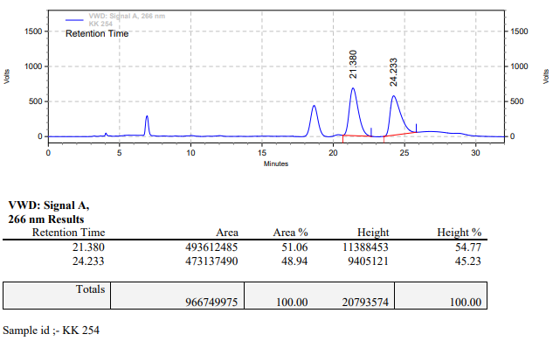

**KK-255**



**Calculation table:**

|  |  |  |  |  |  |
| --- | --- | --- | --- | --- | --- |
| Sr. No | Comp. | Mol. wt. | mmol | Eq. wt. | Wt. taken |
| 1 | Dehydrositagliptin (1) | 405.30 | 0.2135 | 100 | 86 mg |
| 2 | Rh(COD)2OTf | 468.30 | 0.0021 | 1 | 1 mg |
| 3 | L3 | 414.29 | 0.0021 | 1 | 0.9 mg |
| 4 | Salicylic acid | 138.12 | 0.1050 | 50 | 14.5 mg |

**Procedure:** A glass vial (4 mL) equipped with Teflon coated magnetic needle was cooled under vacuum and transferred to a glove box. The vial was then charged with 86 mg of enamine (**1**), 1 mg of [Rh(COD)2OTf] (1 mol%), ligand (L3) and salicylic acid. Reaction vial was then closed using screwcap, transferred to a large opening Schlenk type container and was then taken out from the glove box. 2 mL dry methanol was added to the vial in inert atmosphere and the resultant reaction slurry was stirred for 1 hour at room temperature (25 °C). After that the reaction vial was shifted to an autoclave and the autoclave was purged three times using hydrogen gas (40 bars). Finally, the autoclave was pressurized to 30 bar hydrogen pressure at 70°C for 18 hrs time period. After the 18 hrs time period, the autoclave was cooled to room temperature (25 °C), excess pressure was released and the autoclave was opened. The vials were taken out from the autoclave. The thus obtained reaction mixture was passed through neutral alumina bed, the filtrate was collect and dried to yield residue. The resultant residue was then analysed by HPLC.

**Reaction conditions:** Temp: 70°C Press.: 30 bar Solvent: methanol Time: 18 hrs

**Result: 50%** conversion **91%** ee

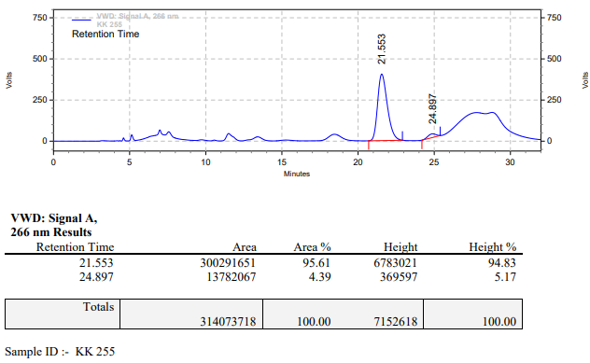

**KK-256**



**Calculation table:**

|  |  |  |  |  |  |
| --- | --- | --- | --- | --- | --- |
| Sr. No | Comp. | Mol. wt. | mmol | Eq. wt. | Wt. taken |
| 1 | Dehydrositagliptin (1) | 405.30 | 0.2135 | 100 | 86 mg |
| 2 | Rh(COD)2OTf | 468.30 | 0.0021 | 1 | 1 mg |
| 3 | L3 | 414.29 | 0.0021 | 1 | 0.9 mg |
| 4 | Salicylic acid | 138.12 | 0.3202 | 150 | 44.2 mg |

**Procedure:** A glass vial (4 mL) equipped with Teflon coated magnetic needle was cooled under vacuum and transferred to a glove box. The vial was then charged with 86 mg of enamine (**1**), 1 mg of [Rh(COD)2OTf] (1 mol%), ligand (L3) and salicylic acid. Reaction vial was then closed using screwcap, transferred to a large opening Schlenk type container and was then taken out from the glove box. 2 mL dry methanol was added to the vial in inert atmosphere and the resultant reaction slurry was stirred for 1 hour at room temperature (25 °C). After that the reaction vial was shifted to an autoclave and the autoclave was purged three times using hydrogen gas (40 bars). Finally, the autoclave was pressurized to 30 bar hydrogen pressure at 70°C for 18 hrs time period. After the 18 hrs time period, the autoclave was cooled to room temperature (25 °C), excess pressure was released and the autoclave was opened. The vials were taken out from the autoclave. The thus obtained reaction mixture was passed through neutral alumina bed, the filtrate was collect and dried to yield residue. The resultant residue was then analysed by HPLC.

**Reaction conditions:** Temp: 70°C Press.: 30 bar Solvent: methanol Time: 18 hrs

**Result: 86%** conversion **84%** ee

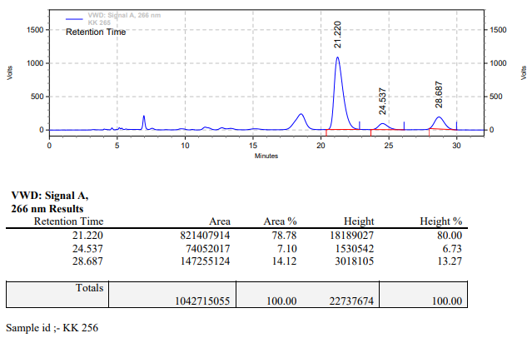

**KK-257**



**Calculation table:**

|  |  |  |  |  |  |
| --- | --- | --- | --- | --- | --- |
| Sr. No | Comp. | Mol. wt. | mmol | Eq. wt. | Wt. taken |
| 1 | Dehydrositagliptin (1) | 405.30 | 0.2135 | 100 | 86 mg |
| 2 | Rh(COD)2OTf | 468.30 | 0.0021 | 1 | 1 mg |
| 3 | L3 | 414.29 | 0.0021 | 1 | 0.9 mg |
| 4 | Salicylic acid | 138.12 | 0.4270 | 200 | 58 mg |

**Procedure:** A glass vial (4 mL) equipped with Teflon coated magnetic needle was cooled under vacuum and transferred to a glove box. The vial was then charged with 86 mg of enamine (**1**), 1 mg of [Rh(COD)2OTf] (1 mol%), ligand (L3) and salicylic acid. Reaction vial was then closed using screwcap, transferred to a large opening Schlenk type container and was then taken out from the glove box. 2 mL dry methanol was added to the vial in inert atmosphere and the resultant reaction slurry was stirred for 1 hour at room temperature (25 °C). After that the reaction vial was shifted to an autoclave and the autoclave was purged three times using hydrogen gas (40 bars). Finally, the autoclave was pressurized to 30 bar hydrogen pressure at 70°C for 18 hrs time period. After the 18 hrs time period, the autoclave was cooled to room temperature (25 °C), excess pressure was released and the autoclave was opened. The vials were taken out from the autoclave. The thus obtained reaction mixture was passed through neutral alumina bed, the filtrate was collect and dried to yield residue. The resultant residue was then analysed by HPLC.

**Reaction conditions:** Temp: 70°C Press.: 30 bar Solvent: methanol Time: 18 hrs

**Result: 82%** conversion **82%** ee

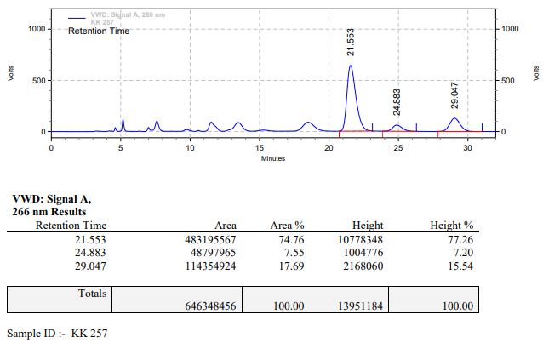

**KK-258**



**Calculation table:**

|  |  |  |  |  |  |
| --- | --- | --- | --- | --- | --- |
| Sr. No | Comp. | Mol. wt. | mmol | Eq. wt. | Wt. taken |
| 1 | Dehydrositagliptin (1) | 405.30 | 0.2135 | 100 | 86 mg |
| 2 | Rh(COD)2OTf | 468.30 | 0.0021 | 1 | 1 mg |
| 3 | L3 | 414.29 | 0.0021 | 1 | 0.9 mg |

**Procedure:** A glass vial (4 mL) equipped with Teflon coated magnetic needle was cooled under vacuum and transferred to a glove box. The vial was then charged with 86 mg of enamine (**1**), 1 mg of [Rh(COD)2OTf] (1 mol%) and ligand (L3). Reaction vial was then closed using screwcap, transferred to a large opening Schlenk type container and was then taken out from the glove box. 2 mL dry amyl alcohol was added to the vial in inert atmosphere and the resultant reaction slurry was stirred for 1 hour at room temperature (25 °C). After that the reaction vial was shifted to an autoclave and the autoclave was purged three times using hydrogen gas (40 bars). Finally, the autoclave was pressurized to 30 bar hydrogen pressure at 90°C for 24 hrs time period. After the 24 hrs time period, the autoclave was cooled to room temperature (25 °C), excess pressure was released and the autoclave was opened. The vials were taken out from the autoclave. The thus obtained reaction mixture was passed through neutral alumina bed, the filtrate was collect and dried to yield residue. The resultant residue was then analysed by HPLC.

**Reaction conditions:** Temp: 90°C Press.: 30 bar Solvent: amyl alcohol Time: 24 hrs

**Result: 00%** conversion **00%** ee

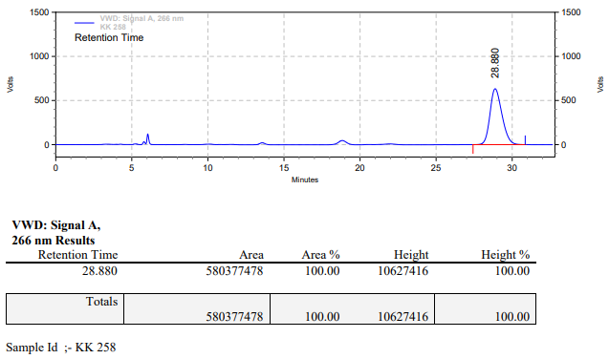

**KK-259**



**Calculation table:**

|  |  |  |  |  |  |
| --- | --- | --- | --- | --- | --- |
| Sr. No | Comp. | Mol. wt. | mmol | Eq. wt. | Wt. taken |
| 1 | Dehydrositagliptin (1) | 405.30 | 0.2135 | 100 | 86 mg |
| 2 | Rh(COD)2OTf | 468.30 | 0.0021 | 1 | 1 mg |
| 3 | L3 | 414.29 | 0.0021 | 1 | 0.9 mg |
| 4 | Ammonium chloride | 53.49 | 0.0021 | 1 | 0.1 mg |

**Procedure:** A glass vial (4 mL) equipped with Teflon coated magnetic needle was cooled under vacuum and transferred to a glove box. The vial was then charged with 86 mg of enamine (**1**), 1 mg of [Rh(COD)2OTf] (1 mol%), ligand (L3) and ammonium chloride. Reaction vial was then closed using screwcap, transferred to a large opening Schlenk type container and was then taken out from the glove box. 2 mL dry amyl alcohol was added followed to the vial in inert atmosphere and the resultant reaction slurry was stirred for 1 hour at room temperature (25 °C). After that the reaction vial was shifted to an autoclave and the autoclave was purged three times using hydrogen gas (40 bars). Finally, the autoclave was pressurized to 30 bar hydrogen pressure at 90°C for 24 hrs time period. After the 24 hrs time period, the autoclave was cooled to room temperature (25 °C), excess pressure was released and the autoclave was opened. The vials were taken out from the autoclave. The thus obtained reaction mixture was passed through neutral alumina bed, the filtrate was collect and dried to yield residue. The resultant residue was then analysed by HPLC.

**Reaction conditions:** Temp: 90°C Press.: 30 bar Solvent: amyl alcohol Time: 24 hrs

**Result: 03%** conversion **80%** ee

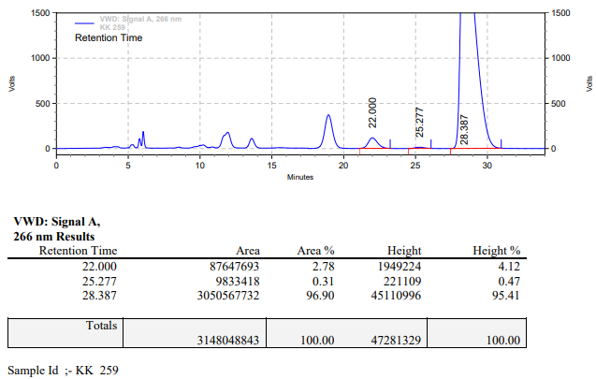

**KK-260**



**Calculation table:**

|  |  |  |  |  |  |
| --- | --- | --- | --- | --- | --- |
| Sr. No | Comp. | Mol. wt. | mmol | Eq. wt. | Wt. taken |
| 1 | Dehydrositagliptin (1) | 405.30 | 0.2135 | 100 | 86 mg |
| 2 | Rh(COD)2OTf | 468.30 | 0.0021 | 1 | 1 mg |
| 3 | L3 | 414.29 | 0.0021 | 1 | 0.9 mg |
| 4 | Salicylic acid | 138.12 | 0.2135 | 100 | 29.4 mg |

**Procedure:** A glass vial (4 mL) equipped with Teflon coated magnetic needle was cooled under vacuum and transferred to a glove box. The vial was then charged with 86 mg of enamine (**1**), 1 mg of [Rh(COD)2OTf] (1 mol%), ligand (L3) and salicylic acid. Reaction vial was then closed using screwcap, transferred to a large opening Schlenk type container and was then taken out from the glove box. 2 mL dry amyl alcohol was added to the vial in inert atmosphere and the resultant reaction slurry was stirred for 1 hour at room temperature (25 °C). After that the reaction vial was shifted to an autoclave and the autoclave was purged three times using hydrogen gas (40 bars). Finally, the autoclave was pressurized to 30 bar hydrogen pressure at 90°C for 24 hrs time period. After the 24 hrs time period, the autoclave was cooled to room temperature (25 °C), excess pressure was released and the autoclave was opened. The vials were taken out from the autoclave. The thus obtained reaction mixture was passed through neutral alumina bed, the filtrate was collect and dried to yield residue. The resultant residue was then analysed by HPLC.

**Reaction conditions:** Temp: 90°C Press.: 30 bar Solvent: amyl alcohol Time: 24 hrs

**Result: 92%** conversion **88%** ee

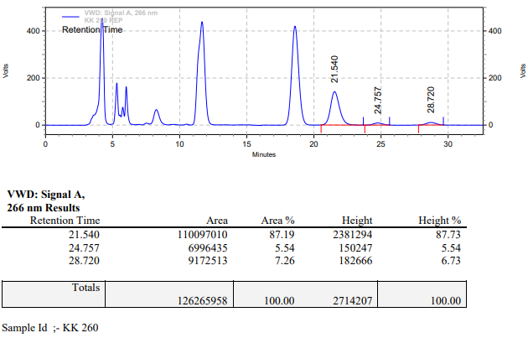

**KK-261**



**Calculation table:**

|  |  |  |  |  |  |
| --- | --- | --- | --- | --- | --- |
| Sr. No | Comp. | Mol. wt. | mmol | Eq. wt. | Wt. taken |
| 1 | Dehydrositagliptin (1) | 405.30 | 0.2135 | 100 | 86 mg |
| 2 | Rh(COD)2OTf | 468.30 | 0.0021 | 1 | 1 mg |
| 3 | L3 | 414.29 | 0.0021 | 1 | 0.9 mg |
| 4 | BF3∙Et2O | 141.93 | 0.0021 | 1 | 0.3 mg |

**Procedure:** A glass vial (4 mL) equipped with Teflon coated magnetic needle was cooled under vacuum and transferred to a glove box. The vial was then charged with 86 mg of enamine (**1**), 1 mg of [Rh(COD)2OTf] (1 mol%) and ligand (L3). Reaction vial was then closed using screwcap, transferred to a large opening Schlenk type container and was then taken out from the glove box. 2 mL dry methanol was added followed by BF3∙Et2O to the vial in inert atmosphere and the resultant reaction slurry was stirred for 1 hour at room temperature (25 °C). After that the reaction vial was shifted to an autoclave and the autoclave was purged three times using hydrogen gas (40 bars). Finally, the autoclave was pressurized to 30 bar hydrogen pressure at 70°C for 24 hrs time period. After the 24 hrs time period, the autoclave was cooled to room temperature (25 °C), excess pressure was released and the autoclave was opened. The vials were taken out from the autoclave. The thus obtained reaction mixture was passed through neutral alumina bed, the filtrate was collect and dried to yield residue. The resultant residue was then analysed by HPLC.

**Reaction conditions:** Temp: 70°C Press.: 30 bar Solvent: methanol Time: 24 hrs

**Result: 00%** conversion **00%** ee

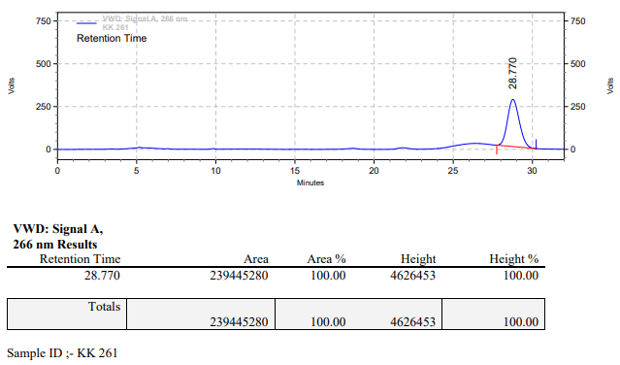

**KK-262**



**Calculation table:**

|  |  |  |  |  |  |
| --- | --- | --- | --- | --- | --- |
| Sr. No | Comp. | Mol. wt. | mmol | Eq. wt. | Wt. taken |
| 1 | Dehydrositagliptin (1) | 405.30 | 0.2135 | 100 | 86 mg |
| 2 | Rh(COD)2OTf | 468.30 | 0.0021 | 1 | 1 mg |
| 3 | L3 | 414.29 | 0.0021 | 1 | 0.9 mg |
| 4 | BF3∙Et2O | 141.93 | 0.0021 | 1 | 0.3 mg |
| 5 | Ammonium chloride | 53.49 | 0.0021 | 1 | 0.1 mg |

**Procedure:** A glass vial (4 mL) equipped with Teflon coated magnetic needle was cooled under vacuum and transferred to a glove box. The vial was then charged with 86 mg of enamine (**1**), 1 mg of [Rh(COD)2OTf] (1 mol%), ligand (L3) and ammonium chloride. Reaction vial was then closed using screwcap, transferred to a large opening Schlenk type container and was then taken out from the glove box. 2 mL dry methanol was added followed by BF3∙Et2O to the vial in inert atmosphere and the resultant reaction slurry was stirred for 1 hour at room temperature (25 °C). After that the reaction vial was shifted to an autoclave and the autoclave was purged three times using hydrogen gas (40 bars). Finally, the autoclave was pressurized to 30 bar hydrogen pressure at 70°C for 24 hrs time period. After the 24 hrs time period, the autoclave was cooled to room temperature (25 °C), excess pressure was released and the autoclave was opened. The vials were taken out from the autoclave. The thus obtained reaction mixture was passed through neutral alumina bed, the filtrate was collect and dried to yield residue. The resultant residue was then analysed by HPLC.

**Reaction conditions:** Temp: 70°C Press.: 30 bar Solvent: methanol Time: 24 hrs

**Result: 00%** conversion **00%** ee

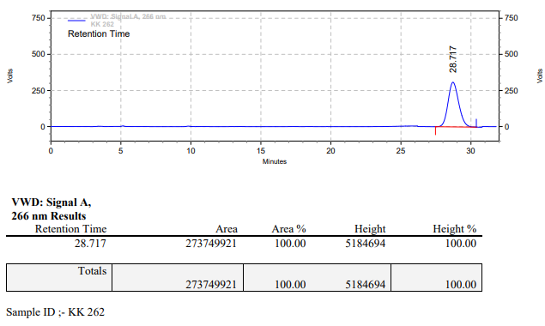

**KK-263**



**Calculation table:**

|  |  |  |  |  |  |
| --- | --- | --- | --- | --- | --- |
| Sr. No | Comp. | Mol. wt. | mmol | Eq. wt. | Wt. taken |
| 1 | Dehydrositagliptin (1) | 405.30 | 0.2135 | 100 | 86 mg |
| 2 | Rh(COD)2OTf | 468.30 | 0.0021 | 1 | 1 mg |
| 3 | L3 | 414.29 | 0.0021 | 1 | 0.9 mg |
| 4 | BF3∙Et2O | 141.93 | 0.0021 | 1 | 0.3 mg |
| 5 | Salicylic acid | 138.12 | 0.2135 | 100 | 29.4 mg |

**Procedure:** A glass vial (4 mL) equipped with Teflon coated magnetic needle was cooled under vacuum and transferred to a glove box. The vial was then charged with 86 mg of enamine (**1**), 1 mg of [Rh(COD)2OTf] (1 mol%), ligand (L3) and salicylic acid. Reaction vial was then closed using screwcap, transferred to a large opening Schlenk type container and was then taken out from the glove box. 2 mL dry methanol was added followed by BF3∙Et2O to the vial in inert atmosphere and the resultant reaction slurry was stirred for 1 hour at room temperature (25 °C). After that the reaction vial was shifted to an autoclave and the autoclave was purged three times using hydrogen gas (40 bars). Finally, the autoclave was pressurized to 30 bar hydrogen pressure at 70°C for 24 hrs time period. After the 24 hrs time period, the autoclave was cooled to room temperature (25 °C), excess pressure was released and the autoclave was opened. The vials were taken out from the autoclave. The thus obtained reaction mixture was passed through neutral alumina bed, the filtrate was collect and dried to yield residue. The resultant residue was then analysed by HPLC.

**Reaction conditions:** Temp: 70°C Press.: 30 bar Solvent: methanol Time: 24 hrs

**Result: 00%** conversion **00%** ee

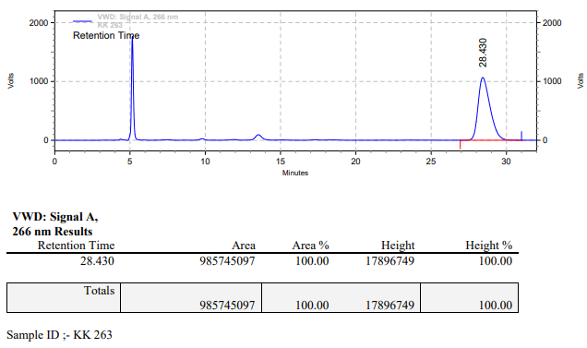

**KK-264**



**Calculation table:**

|  |  |  |  |  |  |
| --- | --- | --- | --- | --- | --- |
| Sr. No | Comp. | Mol. wt. | mmol | Eq. wt. | Wt. taken |
| 1 | Dehydrositagliptin (1) | 405.30 | 0.2135 | 100 | 86 mg |
| 2 | Rh(COD)2OTf | 468.30 | 0.0021 | 1 | 1 mg |
| 3 | L3 | 414.29 | 0.0021 | 1 | 0.9 mg |
| 4 | BF3∙Et2O | 141.93 | 0.0042 | 2 | 0.6 mg |

**Procedure:** A glass vial (4 mL) equipped with Teflon coated magnetic needle was cooled under vacuum and transferred to a glove box. The vial was then charged with 86 mg of enamine (**1**), 1 mg of [Rh(COD)2OTf] (1 mol%) and ligand (L3). Reaction vial was then closed using screwcap, transferred to a large opening Schlenk type container and was then taken out from the glove box. 2 mL dry methanol was added followed by BF3∙Et2O to the vial in inert atmosphere and the resultant reaction slurry was stirred for 1 hour at room temperature (25 °C). After that the reaction vial was shifted to an autoclave and the autoclave was purged three times using hydrogen gas (40 bars). Finally, the autoclave was pressurized to 30 bar hydrogen pressure at 70°C for 24 hrs time period. After the 24 hrs time period, the autoclave was cooled to room temperature (25 °C), excess pressure was released and the autoclave was opened. The vials were taken out from the autoclave. The thus obtained reaction mixture was passed through neutral alumina bed, the filtrate was collect and dried to yield residue. The resultant residue was then analysed by HPLC.

**Reaction conditions:** Temp: 70°C Press.: 30 bar Solvent: methanol Time: 24 hrs

**Result: 04%** conversion **84%** ee

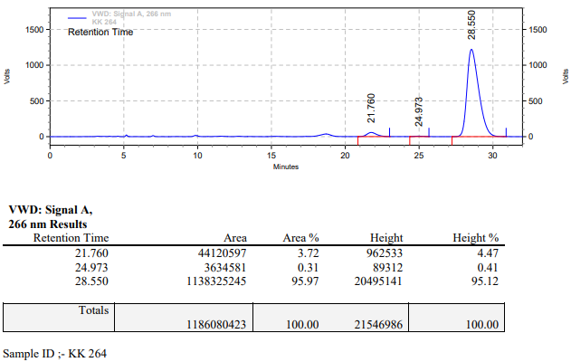

**KK-265**



**Calculation table:**

|  |  |  |  |  |  |
| --- | --- | --- | --- | --- | --- |
| Sr. No | Comp. | Mol. wt. | mmol | Eq. wt. | Wt. taken |
| 1 | Dehydrositagliptin (1) | 405.30 | 0.2135 | 100 | 86 mg |
| 2 | Rh(COD)2OTf | 468.30 | 0.0021 | 1 | 1 mg |
| 3 | L3 | 414.29 | 0.0021 | 1 | 0.9 mg |
| 4 | BF3∙Et2O | 141.93 | 0.0042 | 2 | 0.6 mg |
| 5 | Ammonium chloride | 53.49 | 0.0021 | 1 | 0.1 mg |

**Procedure:** A glass vial (4 mL) equipped with Teflon coated magnetic needle was cooled under vacuum and transferred to a glove box. The vial was then charged with 86 mg of enamine (**1**), 1 mg of [Rh(COD)2OTf] (1 mol%), ligand (L3) and ammonium chloride. Reaction vial was then closed using screwcap, transferred to a large opening Schlenk type container and was then taken out from the glove box. 2 mL dry methanol was added followed by BF3∙Et2O to the vial in inert atmosphere and the resultant reaction slurry was stirred for 1 hour at room temperature (25 °C). After that the reaction vial was shifted to an autoclave and the autoclave was purged three times using hydrogen gas (40 bars). Finally, the autoclave was pressurized to 30 bar hydrogen pressure at 70°C for 24 hrs time period. After the 24 hrs time period, the autoclave was cooled to room temperature (25 °C), excess pressure was released and the autoclave was opened. The vials were taken out from the autoclave. The thus obtained reaction mixture was passed through neutral alumina bed, the filtrate was collect and dried to yield residue. The resultant residue was then analysed by HPLC.

**Reaction conditions:** Temp: 70°C Press.: 30 bar Solvent: methanol Time: 24 hrs

**Result: 00%** conversion **00%** ee

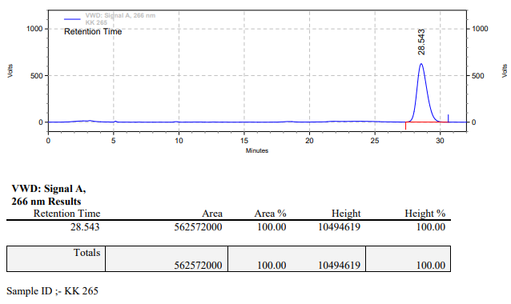

**KK-266**



**Calculation table:**

|  |  |  |  |  |  |
| --- | --- | --- | --- | --- | --- |
| Sr. No | Comp. | Mol. wt. | mmol | Eq. wt. | Wt. taken |
| 1 | Dehydrositagliptin (1) | 405.30 | 0.2135 | 100 | 86 mg |
| 2 | Rh(COD)2OTf | 468.30 | 0.0021 | 1 | 1 mg |
| 3 | L3 | 414.29 | 0.0021 | 1 | 0.9 mg |
| 4 | BF3∙Et2O | 141.93 | 0.0042 | 2 | 0.6 mg |
| 5 | Salicylic acid | 138.12 | 0.2135 | 100 | 29.4 mg |

**Procedure:** A glass vial (4 mL) equipped with Teflon coated magnetic needle was cooled under vacuum and transferred to a glove box. The vial was then charged with 86 mg of enamine (**1**), 1 mg of [Rh(COD)2OTf] (1 mol%), ligand (L3) and salicylic acid. Reaction vial was then closed using screwcap, transferred to a large opening Schlenk type container and was then taken out from the glove box. 2 mL dry methanol was added followed by BF3∙Et2O to the vial in inert atmosphere and the resultant reaction slurry was stirred for 1 hour at room temperature (25 °C). After that the reaction vial was shifted to an autoclave and the autoclave was purged three times using hydrogen gas (40 bars). Finally, the autoclave was pressurized to 30 bar hydrogen pressure at 70°C for 24 hrs time period. After the 24 hrs time period, the autoclave was cooled to room temperature (25 °C), excess pressure was released and the autoclave was opened. The vials were taken out from the autoclave. The thus obtained reaction mixture was passed through neutral alumina bed, the filtrate was collect and dried to yield residue. The resultant residue was then analysed by HPLC.

**Reaction conditions:** Temp: 70°C Press.: 30 bar Solvent: methanol Time: 24 hrs

**Result: 00%** conversion **00%** ee

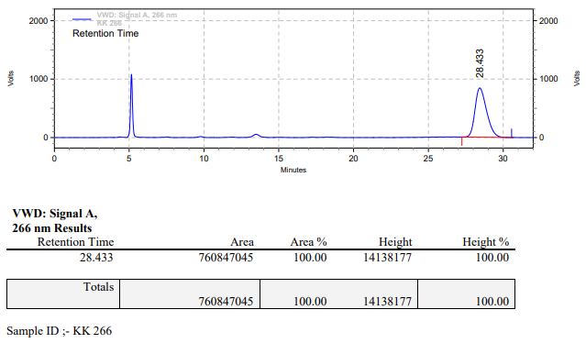

**KK-267**



**Calculation table:**

|  |  |  |  |  |  |
| --- | --- | --- | --- | --- | --- |
| Sr. No | Comp. | Mol. wt. | mmol | Eq. wt. | Wt. taken |
| 1 | Dehydrositagliptin (1) | 405.30 | 0.2135 | 100 | 86 mg |
| 2 | Rh(COD)2OTf | 468.30 | 0.0021 | 1 | 1 mg |
| 3 | L3 | 414.29 | 0.0021 | 1 | 0.9 mg |

**Procedure:** A glass vial (4 mL) equipped with Teflon coated magnetic needle was cooled under vacuum and transferred to a glove box. The vial was then charged with 86 mg of enamine (**1**), 1 mg of [Rh(COD)2OTf] (1 mol%) and ligand (L3). Reaction vial was then closed using screwcap, transferred to a large opening Schlenk type container and was then taken out from the glove box. 2 mL dry TFE (trifluoroethanol) was added to the vial in inert atmosphere and the resultant reaction slurry was stirred for 1 hour at room temperature (25 °C). After that the reaction vial was shifted to an autoclave and the autoclave was purged three times using hydrogen gas (40 bars). Finally, the autoclave was pressurized to 30 bar hydrogen pressure at 70°C for 20 hrs time period. After the 20 hrs time period, the autoclave was cooled to room temperature (25 °C), excess pressure was released and the autoclave was opened. The vials were taken out from the autoclave. The thus obtained reaction mixture was passed through neutral alumina bed, the filtrate was collect and dried to yield residue. The resultant residue was then analysed by HPLC.

**Reaction conditions:** Temp: 70°C Press.: 30 bar Solvent: TFE Time: 20 hrs

**Result: 00%** conversion **00%** ee

**KK-268**



**Calculation table:**

|  |  |  |  |  |  |
| --- | --- | --- | --- | --- | --- |
| Sr. No | Comp. | Mol. wt. | mmol | Eq. wt. | Wt. taken |
| 1 | Dehydrositagliptin (1) | 405.30 | 0.2135 | 100 | 86 mg |
| 2 | Rh(COD)2OTf | 468.30 | 0.0021 | 1 | 1 mg |
| 3 | L3 | 414.29 | 0.0032 | 1.5 | 1.3 mg |

**Procedure:** A glass vial (4 mL) equipped with Teflon coated magnetic needle was cooled under vacuum and transferred to a glove box. The vial was then charged with 86 mg of enamine (**1**), 1 mg of [Rh(COD)2OTf] (1 mol%) and ligand (L3). Reaction vial was then closed using screwcap, transferred to a large opening Schlenk type container and was then taken out from the glove box. 2 mL dry TFE (trifluoroethanol) was added to the vial in inert atmosphere and the resultant reaction slurry was stirred for 1 hour at room temperature (25 °C). After that the reaction vial was shifted to an autoclave and the autoclave was purged three times using hydrogen gas (40 bars). Finally, the autoclave was pressurized to 30 bar hydrogen pressure at 70°C for 20 hrs time period. After the 20 hrs time period, the autoclave was cooled to room temperature (25 °C), excess pressure was released and the autoclave was opened. The vials were taken out from the autoclave. The thus obtained reaction mixture was passed through neutral alumina bed, the filtrate was collect and dried to yield residue. The resultant residue was then analysed by HPLC.

**Reaction conditions:** Temp: 70°C Press.: 30 bar Solvent: TFE Time: 20 hrs

**Result: 92%** conversion **15%** ee

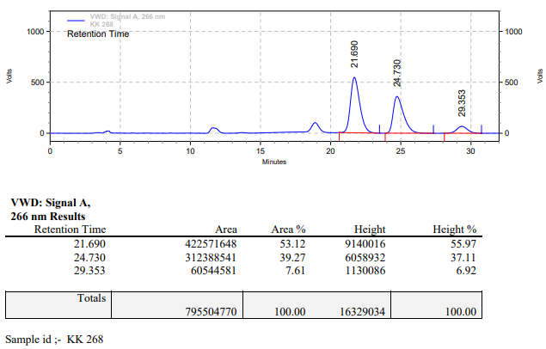

**KK-269**



**Calculation table:**

|  |  |  |  |  |  |
| --- | --- | --- | --- | --- | --- |
| Sr. No | Comp. | Mol. wt. | mmol | Eq. wt. | Wt. taken |
| 1 | Dehydrositagliptin (1) | 405.30 | 0.2135 | 100 | 86 mg |
| 2 | Rh(COD)2OTf | 468.30 | 0.0021 | 1 | 1 mg |
| 3 | L3 | 414.29 | 0.0042 | 2 | 1.8 mg |

**Procedure:** A glass vial (4 mL) equipped with Teflon coated magnetic needle was cooled under vacuum and transferred to a glove box. The vial was then charged with 86 mg of enamine (**1**), 1 mg of [Rh(COD)2OTf] (1 mol%) and ligand (L3). Reaction vial was then closed using screwcap, transferred to a large opening Schlenk type container and was then taken out from the glove box. 2 mL dry TFE (trifluoroethanol) was added to the vial in inert atmosphere and the resultant reaction slurry was stirred for 1 hour at room temperature (25 °C). After that the reaction vial was shifted to an autoclave and the autoclave was purged three times using hydrogen gas (40 bars). Finally, the autoclave was pressurized to 30 bar hydrogen pressure at 70°C for 20 hrs time period. After the 20 hrs time period, the autoclave was cooled to room temperature (25 °C), excess pressure was released and the autoclave was opened. The vials were taken out from the autoclave. The thus obtained reaction mixture was passed through neutral alumina bed, the filtrate was collect and dried to yield residue. The resultant residue was then analysed by HPLC.

**Reaction conditions:** Temp: 70°C Press.: 30 bar Solvent: TFE Time: 20 hrs

**Result: 49%** conversion **15%** ee

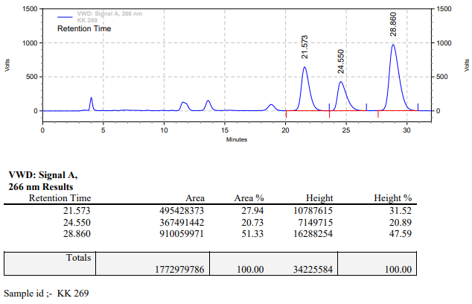

**KK-270**



**Calculation table:**

|  |  |  |  |  |  |
| --- | --- | --- | --- | --- | --- |
| Sr. No | Comp. | Mol. wt. | mmol | Eq. wt. | Wt. taken |
| 1 | Dehydrositagliptin (1) | 405.30 | 0.2135 | 100 | 86 mg |
| 2 | Rh(COD)2OTf | 468.30 | 0.0021 | 1 | 1 mg |
| 3 | L3 | 414.29 | 0.0042 | 2 | 1.8 mg |
| 4 | Ammonium salicylate | 155.15 | 0.2135 | 100 | 33.4 mg |

**Procedure:** A glass vial (4 mL) equipped with Teflon coated magnetic needle was cooled under vacuum and transferred to a glove box. The vial was then charged with 86 mg of enamine (**1**), 1 mg of [Rh(COD)2OTf] (1 mol%), ligand (L3) and ammonium salicylate. Reaction vial was then closed using screwcap, transferred to a large opening Schlenk type container and was then taken out from the glove box. 2 mL dry methanol was added to the vial in inert atmosphere and the resultant reaction slurry was stirred for 1 hour at room temperature (25 °C). After that the reaction vial was shifted to an autoclave and the autoclave was purged three times using hydrogen gas (40 bars). Finally, the autoclave was pressurized to 30 bar hydrogen pressure at 70°C for 24 hrs time period. After the 24 hrs time period, the autoclave was cooled to room temperature (25 °C), excess pressure was released and the autoclave was opened. The vials were taken out from the autoclave. The thus obtained reaction mixture was passed through neutral alumina bed, the filtrate was collect and dried to yield residue. The resultant residue was then analysed by HPLC.

**Reaction conditions:** Temp: 70°C Press.: 30 bar Solvent: Methanol Time: 24 hrs

**Result: 40%** conversion **83%** ee

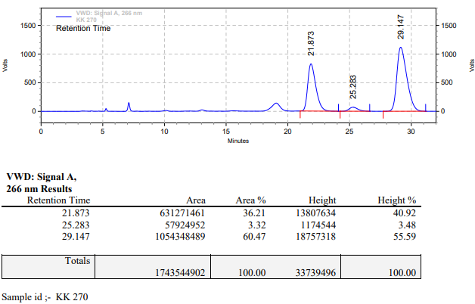

**KK-271**



**Calculation table:**

|  |  |  |  |  |  |
| --- | --- | --- | --- | --- | --- |
| Sr. No | Comp. | Mol. wt. | mmol | Eq. wt. | Wt. taken |
| 1 | Dehydrositagliptin (1) | 405.30 | 0.2135 | 100 | 86 mg |
| 2 | Rh(COD)2OTf | 468.30 | 0.0021 | 1 | 1 mg |
| 3 | L3 | 414.29 | 0.0032 | 1.5 | 1.3 mg |

**Procedure:** A glass vial (4 mL) equipped with Teflon coated magnetic needle was cooled under vacuum and transferred to a glove box. The vial was then charged with 86 mg of enamine (**1**), 1 mg of [Rh(COD)2OTf] (1 mol%) and ligand (L3). Reaction vial was then closed using screwcap, transferred to a large opening Schlenk type container and was then taken out from the glove box. 2 mL dry methanol:TFE (Trifluoroethanol) (90:10) was added to the vial in inert atmosphere and the resultant reaction slurry was stirred for 1 hour at room temperature (25 °C). After that the reaction vial was shifted to an autoclave and the autoclave was purged three times using hydrogen gas (40 bars). Finally, the autoclave was pressurized to 30 bar hydrogen pressure at 70°C for 24 hrs time period. After the 24 hrs time period, the autoclave was cooled to room temperature (25 °C), excess pressure was released and the autoclave was opened. The vials were taken out from the autoclave. The thus obtained reaction mixture was passed through neutral alumina bed, the filtrate was collect and dried to yield residue. The resultant residue was then analysed by HPLC.

**Reaction conditions:** Temp: 70°C Press.: 30 bar Solvent: MeOH:TFE (90:10) Time: 24 hrs

**Result: 30%** conversion **88%** ee

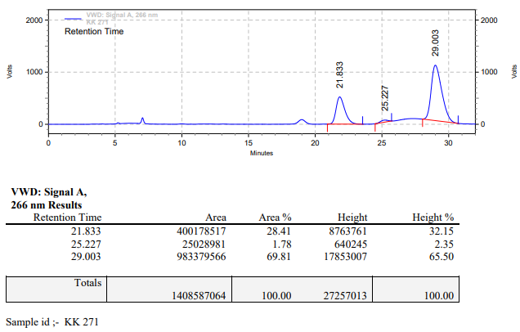

**KK-272**



**Calculation table:**

|  |  |  |  |  |  |
| --- | --- | --- | --- | --- | --- |
| Sr. No | Comp. | Mol. wt. | mmol | Eq. wt. | Wt. taken |
| 1 | Dehydrositagliptin (1) | 405.30 | 0.2135 | 100 | 86 mg |
| 2 | Rh(COD)2OTf | 468.30 | 0.0021 | 1 | 1 mg |
| 3 | L3 | 414.29 | 0.0032 | 1.5 | 1.3 mg |

**Procedure:** A glass vial (4 mL) equipped with Teflon coated magnetic needle was cooled under vacuum and transferred to a glove box. The vial was then charged with 86 mg of enamine (**1**), 1 mg of [Rh(COD)2OTf] (1 mol%) and ligand (L3). Reaction vial was then closed using screwcap, transferred to a large opening Schlenk type container and was then taken out from the glove box. 2 mL dry methanol:TFE (Trifluoroethanol) (80:20) was added to the vial in inert atmosphere and the resultant reaction slurry was stirred for 1 hour at room temperature (25 °C). After that the reaction vial was shifted to an autoclave and the autoclave was purged three times using hydrogen gas (40 bars). Finally, the autoclave was pressurized to 30 bar hydrogen pressure at 70°C for 24 hrs time period. After the 24 hrs time period, the autoclave was cooled to room temperature (25 °C), excess pressure was released and the autoclave was opened. The vials were taken out from the autoclave. The thus obtained reaction mixture was passed through neutral alumina bed, the filtrate was collect and dried to yield residue. The resultant residue was then analysed by HPLC.

**Reaction conditions:** Temp: 70°C Press.: 30 bar Solvent: MeOH:TFE (80:20) Time: 24 hrs

**Result: 65%** conversion **77%** ee

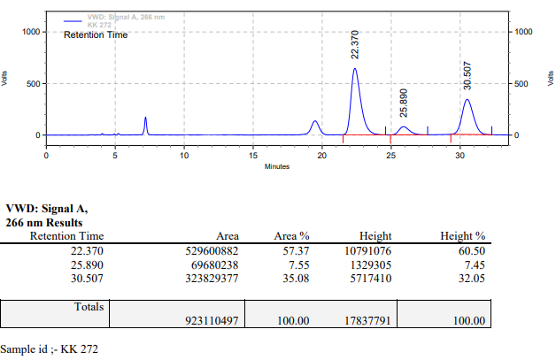

**KK-273**



**Calculation table:**

|  |  |  |  |  |  |
| --- | --- | --- | --- | --- | --- |
| Sr. No | Comp. | Mol. wt. | mmol | Eq. wt. | Wt. taken |
| 1 | Dehydrositagliptin (1) | 405.30 | 0.2135 | 100 | 86 mg |
| 2 | Rh(COD)2OTf | 468.30 | 0.0021 | 1 | 1 mg |
| 3 | L3 | 414.29 | 0.0032 | 1.5 | 1.3 mg |

**Procedure:** A glass vial (4 mL) equipped with Teflon coated magnetic needle was cooled under vacuum and transferred to a glove box. The vial was then charged with 86 mg of enamine (**1**), 1 mg of [Rh(COD)2OTf] (1 mol%) and ligand (L3). Reaction vial was then closed using screwcap, transferred to a large opening Schlenk type container and was then taken out from the glove box. 2 mL dry methanol:TFE (Trifluoroethanol) (70:30) was added to the vial in inert atmosphere and the resultant reaction slurry was stirred for 1 hour at room temperature (25 °C). After that the reaction vial was shifted to an autoclave and the autoclave was purged three times using hydrogen gas (40 bars). Finally, the autoclave was pressurized to 30 bar hydrogen pressure at 70°C for 24 hrs time period. After the 24 hrs time period, the autoclave was cooled to room temperature (25 °C), excess pressure was released and the autoclave was opened. The vials were taken out from the autoclave. The thus obtained reaction mixture was passed through neutral alumina bed, the filtrate was collect and dried to yield residue. The resultant residue was then analysed by HPLC.

**Reaction conditions:** Temp: 70°C Press.: 30 bar Solvent: MeOH:TFE (70:30) Time: 24 hrs

**Result: 77%** conversion **73%** ee

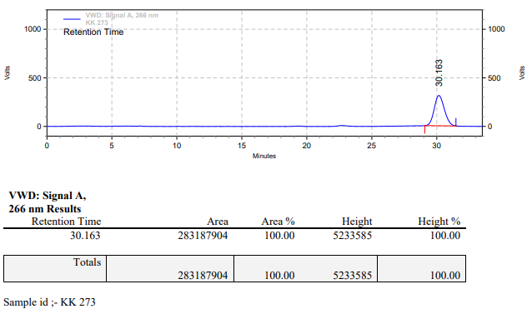

**KK-274**



**Calculation table:**

|  |  |  |  |  |  |
| --- | --- | --- | --- | --- | --- |
| Sr. No | Comp. | Mol. wt. | mmol | Eq. wt. | Wt. taken |
| 1 | Dehydrositagliptin (1) | 405.30 | 0.2135 | 100 | 86 mg |
| 2 | Rh(COD)2OTf | 468.30 | 0.0021 | 1 | 1 mg |
| 3 | L3 | 414.29 | 0.0032 | 1.5 | 1.3 mg |

**Procedure:** A glass vial (4 mL) equipped with Teflon coated magnetic needle was cooled under vacuum and transferred to a glove box. The vial was then charged with 86 mg of enamine (**1**), 1 mg of [Rh(COD)2OTf] (1 mol%) and ligand (L3). Reaction vial was then closed using screwcap, transferred to a large opening Schlenk type container and was then taken out from the glove box. 2 mL dry methanol:TFE (Trifluoroethanol) (60:40) was added to the vial in inert atmosphere and the resultant reaction slurry was stirred for 1 hour at room temperature (25 °C). After that the reaction vial was shifted to an autoclave and the autoclave was purged three times using hydrogen gas (40 bars). Finally, the autoclave was pressurized to 30 bar hydrogen pressure at 70°C for 24 hrs time period. After the 24 hrs time period, the autoclave was cooled to room temperature (25 °C), excess pressure was released and the autoclave was opened. The vials were taken out from the autoclave. The thus obtained reaction mixture was passed through neutral alumina bed, the filtrate was collect and dried to yield residue. The resultant residue was then analysed by HPLC.

**Reaction conditions:** Temp: 70°C Press.: 30 bar Solvent: MeOH:TFE (60:40) Time: 24 hrs

**Result: 88%** conversion **67%** ee

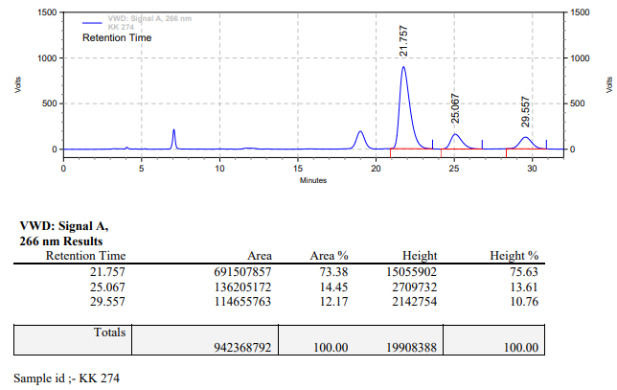

**KK-275**



**Calculation table:**

|  |  |  |  |  |  |
| --- | --- | --- | --- | --- | --- |
| Sr. No | Comp. | Mol. wt. | mmol | Eq. wt. | Wt. taken |
| 1 | Dehydrositagliptin (1) | 405.30 | 0.2135 | 100 | 86 mg |
| 2 | Rh(COD)2OTf | 468.30 | 0.0021 | 1 | 1 mg |
| 3 | L3 | 414.29 | 0.0032 | 1.5 | 1.3 mg |

**Procedure:** A glass vial (4 mL) equipped with Teflon coated magnetic needle was cooled under vacuum and transferred to a glove box. The vial was then charged with 86 mg of enamine (**1**), 1 mg of [Rh(COD)2OTf] (1 mol%) and ligand (L3). Reaction vial was then closed using screwcap, transferred to a large opening Schlenk type container and was then taken out from the glove box. 2 mL dry methanol:TFE (Trifluoroethanol) (50:50) was added to the vial in inert atmosphere and the resultant reaction slurry was stirred for 1 hour at room temperature (25 °C). After that the reaction vial was shifted to an autoclave and the autoclave was purged three times using hydrogen gas (40 bars). Finally, the autoclave was pressurized to 30 bar hydrogen pressure at 70°C for 24 hrs time period. After the 24 hrs time period, the autoclave was cooled to room temperature (25 °C), excess pressure was released and the autoclave was opened. The vials were taken out from the autoclave. The thus obtained reaction mixture was passed through neutral alumina bed, the filtrate was collect and dried to yield residue. The resultant residue was then analysed by HPLC.

**Reaction conditions:** Temp: 70°C Press.: 30 bar Solvent: MeOH:TFE (50:50) Time: 24 hrs

**Result: 90%** conversion **62%** ee

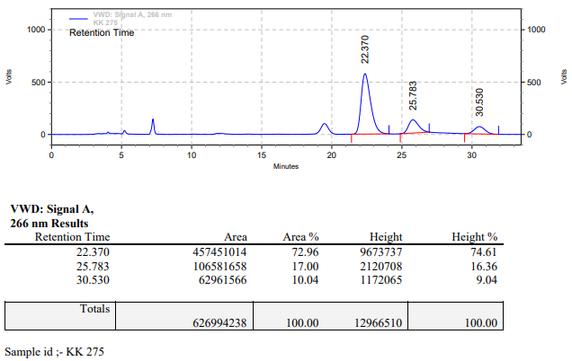

**KK-276**



**Calculation table:**

|  |  |  |  |  |  |
| --- | --- | --- | --- | --- | --- |
| Sr. No | Comp. | Mol. wt. | mmol | Eq. wt. | Wt. taken |
| 1 | Dehydrositagliptin (1) | 405.30 | 0.2135 | 100 | 86 mg |
| 2 | Rh(COD)2OTf | 468.30 | 0.0021 | 1 | 1 mg |
| 3 | L3 | 414.29 | 0.0043 | 2 | 1.8 mg |

**Procedure:** A glass vial (4 mL) equipped with Teflon coated magnetic needle was cooled under vacuum and transferred to a glove box. The vial was then charged with 86 mg of enamine (**1**), 1 mg of [Rh(COD)2OTf] (1 mol%) and ligand (L3). Reaction vial was then closed using screwcap, transferred to a large opening Schlenk type container and was then taken out from the glove box. 2 mL dry methanol:TFE (Trifluoroethanol) (90:10) was added to the vial in inert atmosphere and the resultant reaction slurry was stirred for 1 hour at room temperature (25 °C). After that the reaction vial was shifted to an autoclave and the autoclave was purged three times using hydrogen gas (40 bars). Finally, the autoclave was pressurized to 30 bar hydrogen pressure at 70°C for 24 hrs time period. After the 24 hrs time period, the autoclave was cooled to room temperature (25 °C), excess pressure was released and the autoclave was opened. The vials were taken out from the autoclave. The thus obtained reaction mixture was passed through neutral alumina bed, the filtrate was collect and dried to yield residue. The resultant residue was then analysed by HPLC.

**Reaction conditions:** Temp: 70°C Press.: 30 bar Solvent: MeOH:TFE (90:10) Time: 24 hrs

**Result: 70%** conversion **82%** ee

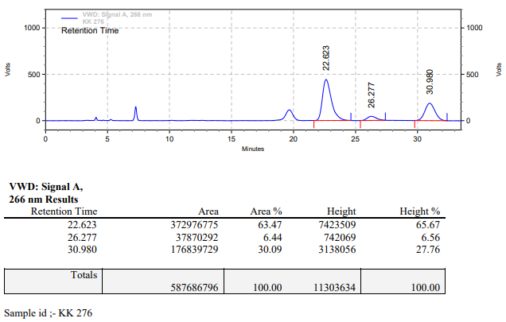

**KK-277**



**Calculation table:**

|  |  |  |  |  |  |
| --- | --- | --- | --- | --- | --- |
| Sr. No | Comp. | Mol. wt. | mmol | Eq. wt. | Wt. taken |
| 1 | Dehydrositagliptin (1) | 405.30 | 0.2135 | 100 | 86 mg |
| 2 | Rh(COD)2OTf | 468.30 | 0.0021 | 1 | 1 mg |
| 3 | L3 | 414.29 | 0.0043 | 2 | 1.8 mg |

**Procedure:** A glass vial (4 mL) equipped with Teflon coated magnetic needle was cooled under vacuum and transferred to a glove box. The vial was then charged with 86 mg of enamine (**1**), 1 mg of [Rh(COD)2OTf] (1 mol%) and ligand (L3). Reaction vial was then closed using screwcap, transferred to a large opening Schlenk type container and was then taken out from the glove box. 2 mL dry methanol:TFE (Trifluoroethanol) (80:20) was added to the vial in inert atmosphere and the resultant reaction slurry was stirred for 1 hour at room temperature (25 °C). After that the reaction vial was shifted to an autoclave and the autoclave was purged three times using hydrogen gas (40 bars). Finally, the autoclave was pressurized to 30 bar hydrogen pressure at 70°C for 24 hrs time period. After the 24 hrs time period, the autoclave was cooled to room temperature (25 °C), excess pressure was released and the autoclave was opened. The vials were taken out from the autoclave. The thus obtained reaction mixture was passed through neutral alumina bed, the filtrate was collect and dried to yield residue. The resultant residue was then analysed by HPLC.

**Reaction conditions:** Temp: 70°C Press.: 30 bar Solvent: MeOH:TFE (80:20) Time: 24 hrs

**Result: 51%** conversion **75%** ee

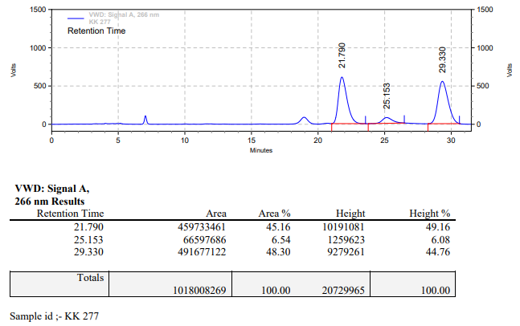

**KK-278**



**Calculation table:**

|  |  |  |  |  |  |
| --- | --- | --- | --- | --- | --- |
| Sr. No | Comp. | Mol. wt. | mmol | Eq. wt. | Wt. taken |
| 1 | Dehydrositagliptin (1) | 405.30 | 0.2135 | 100 | 86 mg |
| 2 | Rh(COD)2OTf | 468.30 | 0.0021 | 1 | 1 mg |
| 3 | L3 | 414.29 | 0.0043 | 2 | 1.8 mg |

**Procedure:** A glass vial (4 mL) equipped with Teflon coated magnetic needle was cooled under vacuum and transferred to a glove box. The vial was then charged with 86 mg of enamine (**1**), 1 mg of [Rh(COD)2OTf] (1 mol%) and ligand (L3). Reaction vial was then closed using screwcap, transferred to a large opening Schlenk type container and was then taken out from the glove box. 2 mL dry methanol:TFE (Trifluoroethanol) (70:30) was added to the vial in inert atmosphere and the resultant reaction slurry was stirred for 1 hour at room temperature (25 °C). After that the reaction vial was shifted to an autoclave and the autoclave was purged three times using hydrogen gas (40 bars). Finally, the autoclave was pressurized to 30 bar hydrogen pressure at 70°C for 24 hrs time period. After the 24 hrs time period, the autoclave was cooled to room temperature (25 °C), excess pressure was released and the autoclave was opened. The vials were taken out from the autoclave. The thus obtained reaction mixture was passed through neutral alumina bed, the filtrate was collect and dried to yield residue. The resultant residue was then analysed by HPLC.

**Reaction conditions:** Temp: 70°C Press.: 30 bar Solvent: MeOH:TFE (70:30) Time: 24 hrs

**Result: 77%** conversion **74%** ee

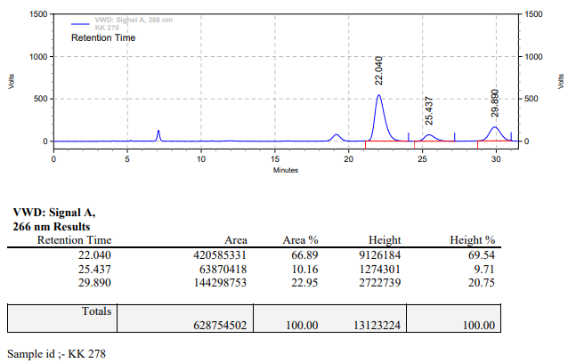

**KK-279**



**Calculation table:**

|  |  |  |  |  |  |
| --- | --- | --- | --- | --- | --- |
| Sr. No | Comp. | Mol. wt. | mmol | Eq. wt. | Wt. taken |
| 1 | Dehydrositagliptin (1) | 405.30 | 0.2135 | 100 | 86 mg |
| 2 | Rh(COD)2OTf | 468.30 | 0.0021 | 1 | 1 mg |
| 3 | L3 | 414.29 | 0.0043 | 2 | 1.8 mg |

**Procedure:** A glass vial (4 mL) equipped with Teflon coated magnetic needle was cooled under vacuum and transferred to a glove box. The vial was then charged with 86 mg of enamine (**1**), 1 mg of [Rh(COD)2OTf] (1 mol%) and ligand (L3). Reaction vial was then closed using screwcap, transferred to a large opening Schlenk type container and was then taken out from the glove box. 2 mL dry methanol:TFE (Trifluoroethanol) (60:40) was added to the vial in inert atmosphere and the resultant reaction slurry was stirred for 1 hour at room temperature (25 °C). After that the reaction vial was shifted to an autoclave and the autoclave was purged three times using hydrogen gas (40 bars). Finally, the autoclave was pressurized to 30 bar hydrogen pressure at 70°C for 24 hrs time period. After the 24 hrs time period, the autoclave was cooled to room temperature (25 °C), excess pressure was released and the autoclave was opened. The vials were taken out from the autoclave. The thus obtained reaction mixture was passed through neutral alumina bed, the filtrate was collect and dried to yield residue. The resultant residue was then analysed by HPLC.

**Reaction conditions:** Temp: 70°C Press.: 30 bar Solvent: MeOH:TFE (60:40) Time: 24 hrs

**Result: 96%** conversion **67%** ee

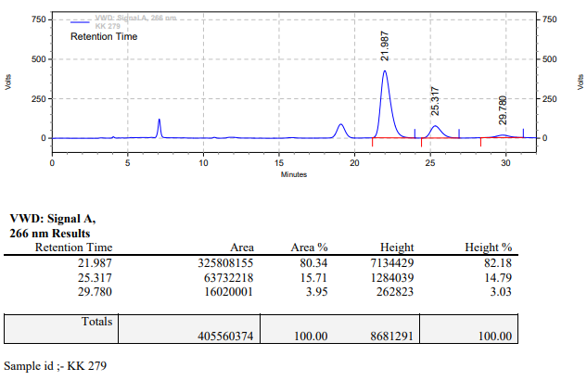

**KK-280**



**Calculation table:**

|  |  |  |  |  |  |
| --- | --- | --- | --- | --- | --- |
| Sr. No | Comp. | Mol. wt. | mmol | Eq. wt. | Wt. taken |
| 1 | Dehydrositagliptin (1) | 405.30 | 0.2135 | 100 | 86 mg |
| 2 | Rh(COD)2OTf | 468.30 | 0.0021 | 1 | 1 mg |
| 3 | L3 | 414.29 | 0.0043 | 2 | 1.8 mg |

**Procedure:** A glass vial (4 mL) equipped with Teflon coated magnetic needle was cooled under vacuum and transferred to a glove box. The vial was then charged with 86 mg of enamine (**1**), 1 mg of [Rh(COD)2OTf] (1 mol%) and ligand (L3). Reaction vial was then closed using screwcap, transferred to a large opening Schlenk type container and was then taken out from the glove box. 2 mL dry methanol:TFE (Trifluoroethanol) (50:50) was added to the vial in inert atmosphere and the resultant reaction slurry was stirred for 1 hour at room temperature (25 °C). After that the reaction vial was shifted to an autoclave and the autoclave was purged three times using hydrogen gas (40 bars). Finally, the autoclave was pressurized to 30 bar hydrogen pressure at 70°C for 24 hrs time period. After the 24 hrs time period, the autoclave was cooled to room temperature (25 °C), excess pressure was released and the autoclave was opened. The vials were taken out from the autoclave. The thus obtained reaction mixture was passed through neutral alumina bed, the filtrate was collect and dried to yield residue. The resultant residue was then analysed by HPLC.

**Reaction conditions:** Temp: 70°C Press.: 30 bar Solvent: MeOH:TFE (50:50) Time: 24 hrs

**Result: 90%** conversion **62%** ee

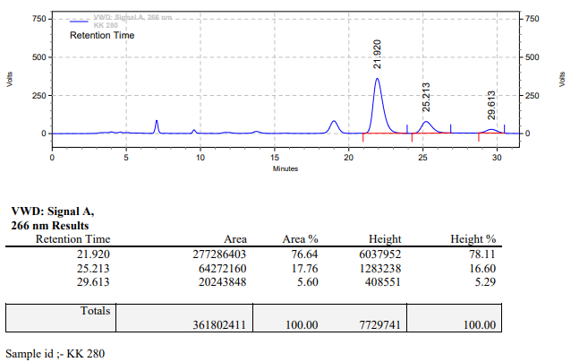

**KK-281**



**Calculation table:**

|  |  |  |  |  |  |
| --- | --- | --- | --- | --- | --- |
| Sr. No | Comp. | Mol. wt. | mmol | Eq. wt. | Wt. taken |
| 1 | Dehydrositagliptin (1) | 405.30 | 0.2135 | 100 | 86 mg |
| 2 | Rh(COD)2OTf | 468.30 | 0.0021 | 1 | 1 mg |
| 3 | L3 | 414.29 | 0.0064 | 3 | 2.6 mg |

**Procedure:** A glass vial (4 mL) equipped with Teflon coated magnetic needle was cooled under vacuum and transferred to a glove box. The vial was then charged with 86 mg of enamine (**1**), 1 mg of [Rh(COD)2OTf] (1 mol%) and ligand (L3). Reaction vial was then closed using screwcap, transferred to a large opening Schlenk type container and was then taken out from the glove box. 2 mL dry methanol:TFE (Trifluoroethanol) (90:10) was added to the vial in inert atmosphere and the resultant reaction slurry was stirred for 1 hour at room temperature (25 °C). After that the reaction vial was shifted to an autoclave and the autoclave was purged three times using hydrogen gas (40 bars). Finally, the autoclave was pressurized to 30 bar hydrogen pressure at 70°C for 24 hrs time period. After the 24 hrs time period, the autoclave was cooled to room temperature (25 °C), excess pressure was released and the autoclave was opened. The vials were taken out from the autoclave. The thus obtained reaction mixture was passed through neutral alumina bed, the filtrate was collect and dried to yield residue. The resultant residue was then analysed by HPLC.

**Reaction conditions:** Temp: 70°C Press.: 30 bar Solvent: MeOH:TFE (90:10) Time: 24 hrs

**Result: 38%** conversion **74%** ee

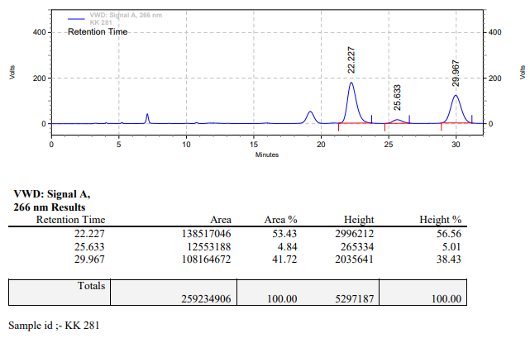

**KK-282**



**Calculation table:**

|  |  |  |  |  |  |
| --- | --- | --- | --- | --- | --- |
| Sr. No | Comp. | Mol. wt. | mmol | Eq. wt. | Wt. taken |
| 1 | Dehydrositagliptin (1) | 405.30 | 0.2135 | 100 | 86 mg |
| 2 | Rh(COD)2OTf | 468.30 | 0.0021 | 1 | 1 mg |
| 3 | L3 | 414.29 | 0.0064 | 3 | 2.6 mg |

**Procedure:** A glass vial (4 mL) equipped with Teflon coated magnetic needle was cooled under vacuum and transferred to a glove box. The vial was then charged with 86 mg of enamine (**1**), 1 mg of [Rh(COD)2OTf] (1 mol%) and ligand (L3). Reaction vial was then closed using screwcap, transferred to a large opening Schlenk type container and was then taken out from the glove box. 2 mL dry methanol:TFE (Trifluoroethanol) (80:20) was added to the vial in inert atmosphere and the resultant reaction slurry was stirred for 1 hour at room temperature (25 °C). After that the reaction vial was shifted to an autoclave and the autoclave was purged three times using hydrogen gas (40 bars). Finally, the autoclave was pressurized to 30 bar hydrogen pressure at 70°C for 24 hrs time period. After the 24 hrs time period, the autoclave was cooled to room temperature (25 °C), excess pressure was released and the autoclave was opened. The vials were taken out from the autoclave. The thus obtained reaction mixture was passed through neutral alumina bed, the filtrate was collect and dried to yield residue. The resultant residue was then analysed by HPLC.

**Reaction conditions:** Temp: 70°C Press.: 30 bar Solvent: MeOH:TFE (80:20) Time: 24 hrs

**Result: 04%** conversion **83%** ee

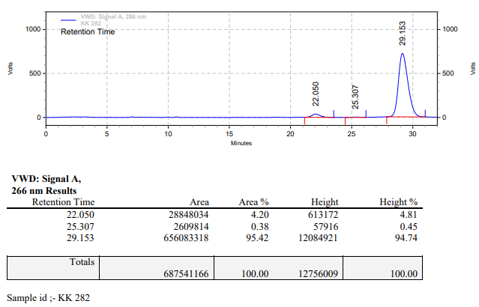

**KK-283**



**Calculation table:**

|  |  |  |  |  |  |
| --- | --- | --- | --- | --- | --- |
| Sr. No | Comp. | Mol. wt. | mmol | Eq. wt. | Wt. taken |
| 1 | Dehydrositagliptin (1) | 405.30 | 0.2135 | 100 | 86 mg |
| 2 | Rh(COD)2OTf | 468.30 | 0.0021 | 1 | 1 mg |
| 3 | L3 | 414.29 | 0.0064 | 3 | 2.6 mg |

**Procedure:** A glass vial (4 mL) equipped with Teflon coated magnetic needle was cooled under vacuum and transferred to a glove box. The vial was then charged with 86 mg of enamine (**1**), 1 mg of [Rh(COD)2OTf] (1 mol%) and ligand (L3). Reaction vial was then closed using screwcap, transferred to a large opening Schlenk type container and was then taken out from the glove box. 2 mL dry methanol:TFE (Trifluoroethanol) (70:30) was added to the vial in inert atmosphere and the resultant reaction slurry was stirred for 1 hour at room temperature (25 °C). After that the reaction vial was shifted to an autoclave and the autoclave was purged three times using hydrogen gas (40 bars). Finally, the autoclave was pressurized to 30 bar hydrogen pressure at 70°C for 24 hrs time period. After the 24 hrs time period, the autoclave was cooled to room temperature (25 °C), excess pressure was released and the autoclave was opened. The vials were taken out from the autoclave. The thus obtained reaction mixture was passed through neutral alumina bed, the filtrate was collect and dried to yield residue. The resultant residue was then analysed by HPLC.

**Reaction conditions:** Temp: 70°C Press.: 30 bar Solvent: MeOH:TFE (70:30) Time: 24 hrs

**Result: 13%** conversion **76%** ee

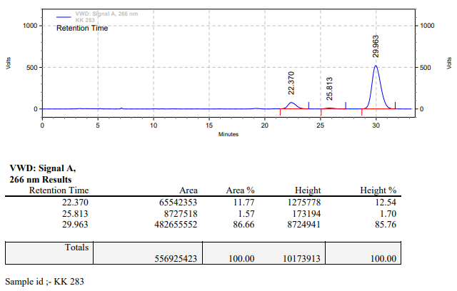

**KK-284**



**Calculation table:**

|  |  |  |  |  |  |
| --- | --- | --- | --- | --- | --- |
| Sr. No | Comp. | Mol. wt. | mmol | Eq. wt. | Wt. taken |
| 1 | Dehydrositagliptin (1) | 405.30 | 0.2135 | 100 | 86 mg |
| 2 | Rh(COD)2OTf | 468.30 | 0.0021 | 1 | 1 mg |
| 3 | L3 | 414.29 | 0.0064 | 3 | 2.6 mg |

**Procedure:** A glass vial (4 mL) equipped with Teflon coated magnetic needle was cooled under vacuum and transferred to a glove box. The vial was then charged with 86 mg of enamine (**1**), 1 mg of [Rh(COD)2OTf] (1 mol%) and ligand (L3). Reaction vial was then closed using screwcap, transferred to a large opening Schlenk type container and was then taken out from the glove box. 2 mL dry methanol:TFE (Trifluoroethanol) (60:40) was added to the vial in inert atmosphere and the resultant reaction slurry was stirred for 1 hour at room temperature (25 °C). After that the reaction vial was shifted to an autoclave and the autoclave was purged three times using hydrogen gas (40 bars). Finally, the autoclave was pressurized to 30 bar hydrogen pressure at 70°C for 24 hrs time period. After the 24 hrs time period, the autoclave was cooled to room temperature (25 °C), excess pressure was released and the autoclave was opened. The vials were taken out from the autoclave. The thus obtained reaction mixture was passed through neutral alumina bed, the filtrate was collect and dried to yield residue. The resultant residue was then analysed by HPLC.

**Reaction conditions:** Temp: 70°C Press.: 30 bar Solvent: MeOH:TFE (60:40) Time: 24 hrs

**Result: 20%** conversion **87%** ee

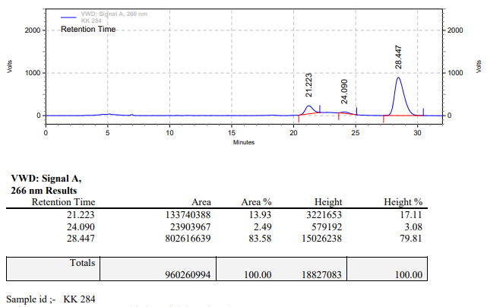

**KK-285**



**Calculation table:**

|  |  |  |  |  |  |
| --- | --- | --- | --- | --- | --- |
| Sr. No | Comp. | Mol. wt. | mmol | Eq. wt. | Wt. taken |
| 1 | Dehydrositagliptin (1) | 405.30 | 0.2135 | 100 | 86 mg |
| 2 | Rh(COD)2OTf | 468.30 | 0.0021 | 1 | 1 mg |
| 3 | L3 | 414.29 | 0.0064 | 3 | 2.6 mg |

**Procedure:** A glass vial (4 mL) equipped with Teflon coated magnetic needle was cooled under vacuum and transferred to a glove box. The vial was then charged with 86 mg of enamine (**1**), 1 mg of [Rh(COD)2OTf] (1 mol%) and ligand (L3). Reaction vial was then closed using screwcap, transferred to a large opening Schlenk type container and was then taken out from the glove box. 2 mL dry methanol:TFE (Trifluoroethanol) (50:50) was added to the vial in inert atmosphere and the resultant reaction slurry was stirred for 1 hour at room temperature (25 °C). After that the reaction vial was shifted to an autoclave and the autoclave was purged three times using hydrogen gas (40 bars). Finally, the autoclave was pressurized to 30 bar hydrogen pressure at 70°C for 24 hrs time period. After the 24 hrs time period, the autoclave was cooled to room temperature (25 °C), excess pressure was released and the autoclave was opened. The vials were taken out from the autoclave. The thus obtained reaction mixture was passed through neutral alumina bed, the filtrate was collect and dried to yield residue. The resultant residue was then analysed by HPLC.

**Reaction conditions:** Temp: 70°C Press.: 30 bar Solvent: MeOH:TFE (50:50) Time: 24 hrs

**Result: 37%** conversion **61%** ee

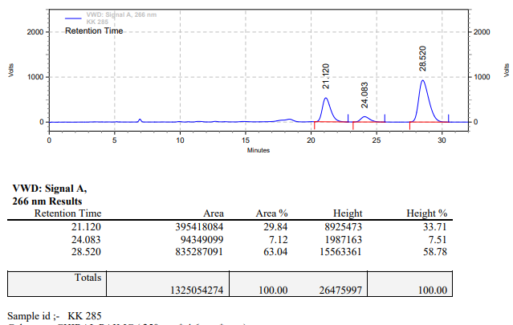

**KK-286**



**Calculation table:**

|  |  |  |  |  |  |
| --- | --- | --- | --- | --- | --- |
| Sr. No | Comp. | Mol. wt. | mmol | Eq. wt. | Wt. taken |
| 1 | Dehydrositagliptin (1) | 405.30 | 0.2135 | 100 | 86 mg |
| 2 | Rh(COD)2OTf | 468.30 | 0.0021 | 1 | 1 mg |
| 3 | L3 | 414.29 | 0.0021 | 1 | 0.9 mg |

**Procedure:** A glass vial (4 mL) equipped with Teflon coated magnetic needle was cooled under vacuum and transferred to a glove box. The vial was then charged with 86 mg of enamine (**1**), 1 mg of [Rh(COD)2OTf] (1 mol%) and ligand (L3). Reaction vial was then closed using screwcap, transferred to a large opening Schlenk type container and was then taken out from the glove box. 2 mL dry ethanol was added to the vial in inert atmosphere and the resultant reaction slurry was stirred for 1 hour at room temperature (25 °C). After that the reaction vial was shifted to an autoclave and the autoclave was purged three times using hydrogen gas (40 bars). Finally, the autoclave was pressurized to 30 bar hydrogen pressure at 70°C for 24 hrs time period. After the 24 hrs time period, the autoclave was cooled to room temperature (25 °C), excess pressure was released and the autoclave was opened. The vials were taken out from the autoclave. The thus obtained reaction mixture was passed through neutral alumina bed, the filtrate was collect and dried to yield residue. The resultant residue was then analysed by HPLC.

**Reaction conditions:** Temp: 70°C Press.: 30 bar Solvent: ethanol Time: 24 hrs

**Result: 00%** conversion **00%** ee

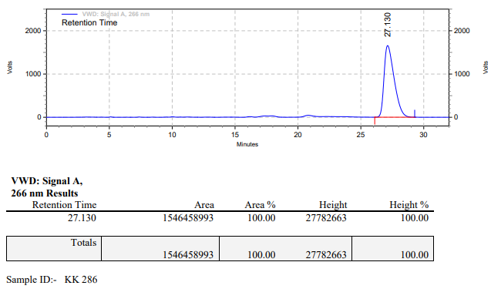

**KK-287**



**Calculation table:**

|  |  |  |  |  |  |
| --- | --- | --- | --- | --- | --- |
| Sr. No | Comp. | Mol. wt. | mmol | Eq. wt. | Wt. taken |
| 1 | Dehydrositagliptin (1) | 405.30 | 0.2135 | 100 | 86 mg |
| 2 | Rh(COD)2OTf | 468.30 | 0.0021 | 1 | 1 mg |
| 3 | L3 | 414.29 | 0.0021 | 1 | 0.9 mg |
| 4 | Ammonium chloride | 53.49 | 0.0021 | 1 | 0.1 mg |

**Procedure:** A glass vial (4 mL) equipped with Teflon coated magnetic needle was cooled under vacuum and transferred to a glove box. The vial was then charged with 86 mg of enamine (**1**), 1 mg of [Rh(COD)2OTf] (1 mol%), ligand (L3) and ammonium chloride. Reaction vial was then closed using screwcap, transferred to a large opening Schlenk type container and was then taken out from the glove box. 2 mL dry ethanol was added to the vial in inert atmosphere and the resultant reaction slurry was stirred for 1 hour at room temperature (25 °C). After that the reaction vial was shifted to an autoclave and the autoclave was purged three times using hydrogen gas (40 bars). Finally, the autoclave was pressurized to 30 bar hydrogen pressure at 70°C for 24 hrs time period. After the 24 hrs time period, the autoclave was cooled to room temperature (25 °C), excess pressure was released and the autoclave was opened. The vials were taken out from the autoclave. The thus obtained reaction mixture was passed through neutral alumina bed, the filtrate was collect and dried to yield residue. The resultant residue was then analysed by HPLC.

**Reaction conditions:** Temp: 70°C Press.: 30 bar Solvent: ethanol Time: 24 hrs

**Result: 00%** conversion **00%** ee

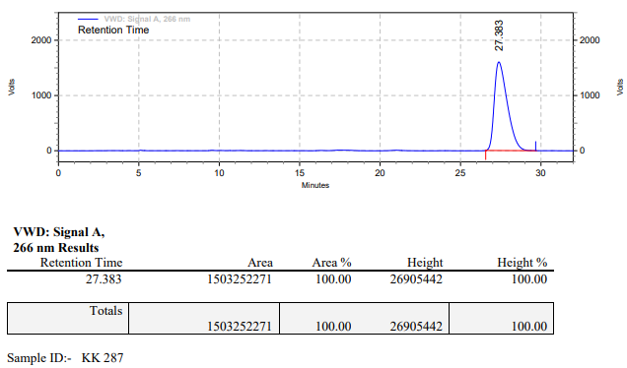

**KK-288**



**Calculation table:**

|  |  |  |  |  |  |
| --- | --- | --- | --- | --- | --- |
| Sr. No | Comp. | Mol. wt. | mmol | Eq. wt. | Wt. taken |
| 1 | Dehydrositagliptin (1) | 405.30 | 0.2135 | 100 | 86 mg |
| 2 | Rh(COD)2OTf | 468.30 | 0.0021 | 1 | 1 mg |
| 3 | L3 | 414.29 | 0.0021 | 1 | 0.9 mg |
| 4 | Phosphoric acid | 97.99 | 0.0021 | 1 | 0.2 mg |

**Procedure:** A glass vial (4 mL) equipped with Teflon coated magnetic needle was cooled under vacuum and transferred to a glove box. The vial was then charged with 86 mg of enamine (**1**), 1 mg of [Rh(COD)2OTf] (1 mol%) and ligand (L3). Reaction vial was then closed using screwcap, transferred to a large opening Schlenk type container and was then taken out from the glove box. 2 mL dry methanol was added followed by phosphoric acid to the vial in inert atmosphere and the resultant reaction slurry was stirred for 1 hour at room temperature (25 °C). After that the reaction vial was shifted to an autoclave and the autoclave was purged three times using hydrogen gas (40 bars). Finally, the autoclave was pressurized to 30 bar hydrogen pressure at 70°C for 24 hrs time period. After the 24 hrs time period, the autoclave was cooled to room temperature (25 °C), excess pressure was released and the autoclave was opened. The vials were taken out from the autoclave. The thus obtained reaction mixture was passed through neutral alumina bed, the filtrate was collect and dried to yield residue. The resultant residue was then analysed by HPLC.

**Reaction conditions:** Temp: 70°C Press.: 30 bar Solvent: methanol Time: 24 hrs

**Result: 00%** conversion **00%** ee

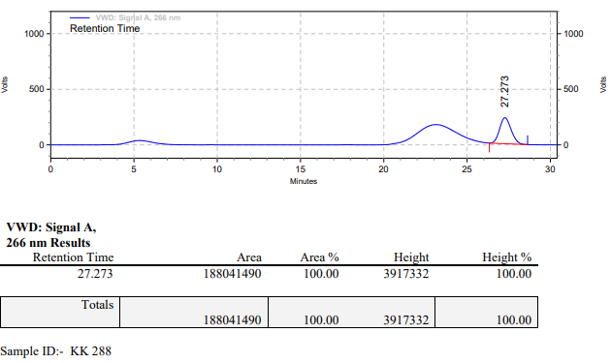

**KK-289**



**Calculation table:**

|  |  |  |  |  |  |
| --- | --- | --- | --- | --- | --- |
| Sr. No | Comp. | Mol. wt. | mmol | Eq. wt. | Wt. taken |
| 1 | Dehydrositagliptin (1) | 405.30 | 0.2135 | 100 | 86 mg |
| 2 | Rh(COD)2OTf | 468.30 | 0.0021 | 1 | 1 mg |
| 3 | L3 | 414.29 | 0.0021 | 1 | 0.9 mg |
| 4 | Phosphoric acid | 97.99 | 0.0021 | 1 | 0.2 mg |

**Procedure:** A glass vial (4 mL) equipped with Teflon coated magnetic needle was cooled under vacuum and transferred to a glove box. The vial was then charged with 86 mg of enamine (**1**), 1 mg of [Rh(COD)2OTf] (1 mol%) and ligand (L3). Reaction vial was then closed using screwcap, transferred to a large opening Schlenk type container and was then taken out from the glove box. 2 mL dry methanol was added followed by phosphoric acid to the vial in inert atmosphere and the resultant reaction slurry was stirred for 1 hour at room temperature (25 °C). After that the reaction vial was shifted to an autoclave and the autoclave was purged three times using hydrogen gas (40 bars). Finally, the autoclave was pressurized to 30 bar hydrogen pressure at 70°C for 24 hrs time period. After the 24 hrs time period, the autoclave was cooled to room temperature (25 °C), excess pressure was released and the autoclave was opened. The vials were taken out from the autoclave. The thus obtained reaction mixture was passed through neutral alumina bed, the filtrate was collect and dried to yield residue. The resultant residue was then analysed by HPLC.

**Reaction conditions:** Temp: 70°C Press.: 30 bar Solvent: methanol Time: 24 hrs

**Result: 00%** conversion **00%** ee

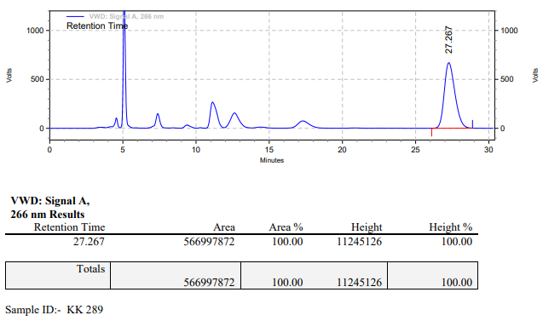

**KK-290**



**Calculation table:**

|  |  |  |  |  |  |
| --- | --- | --- | --- | --- | --- |
| Sr. No | Comp. | Mol. wt. | mmol | Eq. wt. | Wt. taken |
| 1 | Dehydrositagliptin (1) | 405.30 | 0.2135 | 100 | 86 mg |
| 2 | Rh(COD)2OTf | 468.30 | 0.0021 | 1 | 1 mg |
| 3 | L3 | 414.29 | 0.0021 | 1 | 0.9 mg |

**Procedure:** A glass vial (4 mL) equipped with Teflon coated magnetic needle was cooled under vacuum and transferred to a glove box. The vial was then charged with 86 mg of enamine (**1**), 1 mg of [Rh(COD)2OTf] (1 mol%) and ligand (L3). Reaction vial was then closed using screwcap, transferred to a large opening Schlenk type container and was then taken out from the glove box. 2 mL dry acetonitrile was added to the vial in inert atmosphere and the resultant reaction slurry was stirred for 1 hour at room temperature (25 °C). After that the reaction vial was shifted to an autoclave and the autoclave was purged three times using hydrogen gas (40 bars). Finally, the autoclave was pressurized to 30 bar hydrogen pressure at 70°C for 18 hrs time period. After the 18 hrs time period, the autoclave was cooled to room temperature (25 °C), excess pressure was released and the autoclave was opened. The vials were taken out from the autoclave. The thus obtained reaction mixture was passed through neutral alumina bed, the filtrate was collect and dried to yield residue. The resultant residue was then analysed by HPLC.

**Reaction conditions:** Temp: 70°C Press.: 30 bar Solvent: Acetonitrile Time: 18 hrs

**Result: 00%** conversion **00%** ee

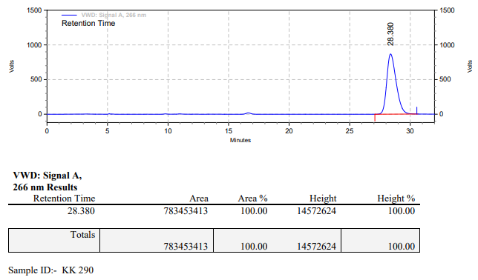

**KK-291**



**Calculation table:**

|  |  |  |  |  |  |
| --- | --- | --- | --- | --- | --- |
| Sr. No | Comp. | Mol. wt. | mmol | Eq. wt. | Wt. taken |
| 1 | Dehydrositagliptin (1) | 405.30 | 0.2135 | 100 | 86 mg |
| 2 | Rh(COD)2OTf | 468.30 | 0.0021 | 1 | 1 mg |
| 3 | L3 | 414.29 | 0.0021 | 1 | 0.9 mg |
| 4 | Ammonium chloride | 53.49 | 0.0021 | 1 | 0.1 mg |

**Procedure:** A glass vial (4 mL) equipped with Teflon coated magnetic needle was cooled under vacuum and transferred to a glove box. The vial was then charged with 86 mg of enamine (**1**), 1 mg of [Rh(COD)2OTf] (1 mol%), ligand (L3), and ammonium chloride. Reaction vial was then closed using screwcap, transferred to a large opening Schlenk type container and was then taken out from the glove box. 2 mL dry acetonitrile was added to the vial in inert atmosphere and the resultant reaction slurry was stirred for 1 hour at room temperature (25 °C). After that the reaction vial was shifted to an autoclave and the autoclave was purged three times using hydrogen gas (40 bars). Finally, the autoclave was pressurized to 30 bar hydrogen pressure at 70°C for 18 hrs time period. After the 18 hrs time period, the autoclave was cooled to room temperature (25 °C), excess pressure was released and the autoclave was opened. The vials were taken out from the autoclave. The thus obtained reaction mixture was passed through neutral alumina bed, the filtrate was collect and dried to yield residue. The resultant residue was then analysed by HPLC.

**Reaction conditions:** Temp: 70°C Press.: 30 bar Solvent: Acetonitrile Time: 18 hrs

**Result: 00%** conversion **00%** ee

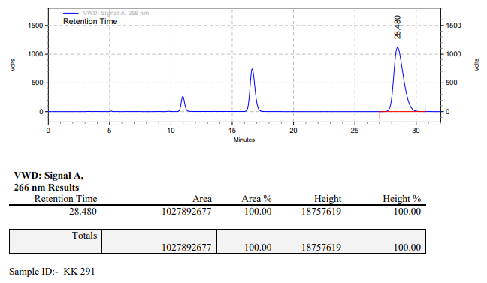

**KK-292**



**Calculation table:**

|  |  |  |  |  |  |
| --- | --- | --- | --- | --- | --- |
| Sr. No | Comp. | Mol. wt. | mmol | Eq. wt. | Wt. taken |
| 1 | Dehydrositagliptin (1) | 405.30 | 0.2135 | 100 | 86 mg |
| 2 | Rh(COD)2OTf | 468.30 | 0.0021 | 1 | 1 mg |
| 3 | L3 | 414.29 | 0.0021 | 1 | 0.9 mg |
| 4 | Phosphoric acid | 97.99 | 0.2135 | 100 | 20 mg |

**Procedure:** A glass vial (4 mL) equipped with Teflon coated magnetic needle was cooled under vacuum and transferred to a glove box. The vial was then charged with 86 mg of enamine (**1**), 1 mg of [Rh(COD)2OTf] (1 mol%) and ligand (L3). Reaction vial was then closed using screwcap, transferred to a large opening Schlenk type container and was then taken out from the glove box. 2 mL dry methanol was added followed by phosphoric acid to the vial in inert atmosphere and the resultant reaction slurry was stirred for 1 hour at room temperature (25 °C). After that the reaction vial was shifted to an autoclave and the autoclave was purged three times using hydrogen gas (40 bars). Finally, the autoclave was pressurized to 30 bar hydrogen pressure at 70°C for 18 hrs time period. After the 18 hrs time period, the autoclave was cooled to room temperature (25 °C), excess pressure was released and the autoclave was opened. The vials were taken out from the autoclave. The thus obtained reaction mixture was passed through neutral alumina bed, the filtrate was collect and dried to yield residue. The resultant residue was then analysed by HPLC.

**Reaction conditions:** Temp: 70°C Press.: 30 bar Solvent: Methanol Time: 18 hrs

**Result: 100%** conversion **00%** ee

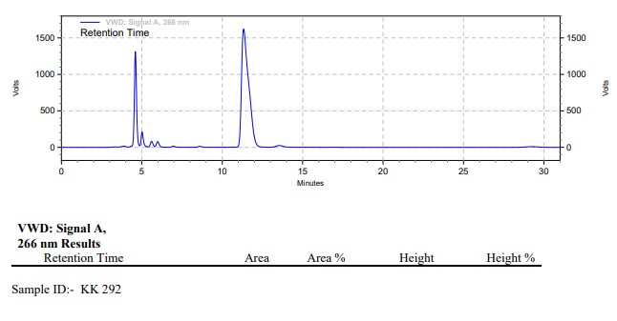

**KK-293**



**Calculation table:**

|  |  |  |  |  |  |
| --- | --- | --- | --- | --- | --- |
| Sr. No | Comp. | Mol. wt. | mmol | Eq. wt. | Wt. taken |
| 1 | Dehydrositagliptin (1) | 405.30 | 0.2135 | 100 | 86 mg |
| 2 | Rh(COD)2OTf | 468.30 | 0.0021 | 1 | 1 mg |
| 3 | L3 | 414.29 | 0.0021 | 1 | 0.9 mg |

**Procedure:** A glass vial (4 mL) equipped with Teflon coated magnetic needle was cooled under vacuum and transferred to a glove box. The vial was then charged with 86 mg of enamine (**1**), 1 mg of [Rh(COD)2OTf] (1 mol%) and ligand (L3). Reaction vial was then closed using screwcap, transferred to a large opening Schlenk type container and was then taken out from the glove box. 2 mL dry isopropyl alcohol was added to the vial in inert atmosphere and the resultant reaction slurry was stirred for 1 hour at room temperature (25 °C). After that the reaction vial was shifted to an autoclave and the autoclave was purged three times using hydrogen gas (40 bars). Finally, the autoclave was pressurized to 30 bar hydrogen pressure at 70°C for 18 hrs time period. After the 18 hrs time period, the autoclave was cooled to room temperature (25 °C), excess pressure was released and the autoclave was opened. The vials were taken out from the autoclave. The thus obtained reaction mixture was passed through neutral alumina bed, the filtrate was collect and dried to yield residue. The resultant residue was then analysed by HPLC.

**Reaction conditions:** Temp: 70°C Press.: 30 bar Solvent: isopropyl alcohol Time: 18 hrs

**Result: 00%** conversion **00%** ee

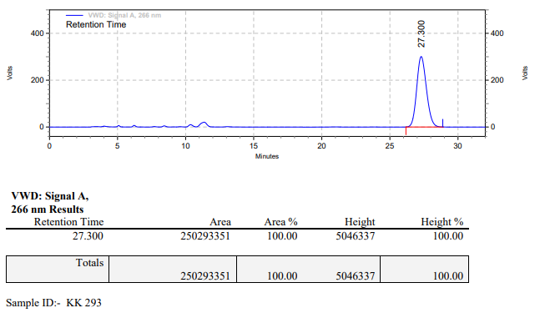

**KK-294**



**Calculation table:**

|  |  |  |  |  |  |
| --- | --- | --- | --- | --- | --- |
| Sr. No | Comp. | Mol. wt. | mmol | Eq. wt. | Wt. taken |
| 1 | Dehydrositagliptin (1) | 405.30 | 0.2135 | 100 | 86 mg |
| 2 | Rh(COD)2OTf | 468.30 | 0.0021 | 1 | 1 mg |
| 3 | L3 | 414.29 | 0.0021 | 1 | 0.9 mg |
| 4 | Ammonium chloride | 53.49 | 0.0021 | 1 | 0.1 mg |

**Procedure:** A glass vial (4 mL) equipped with Teflon coated magnetic needle was cooled under vacuum and transferred to a glove box. The vial was then charged with 86 mg of enamine (**1**), 1 mg of [Rh(COD)2OTf] (1 mol%), ligand (L3) and ammonium chloride. Reaction vial was then closed using screwcap, transferred to a large opening Schlenk type container and was then taken out from the glove box. 2 mL dry isopropyl alcohol was added to the vial in inert atmosphere and the resultant reaction slurry was stirred for 1 hour at room temperature (25 °C). After that the reaction vial was shifted to an autoclave and the autoclave was purged three times using hydrogen gas (40 bars). Finally, the autoclave was pressurized to 30 bar hydrogen pressure at 70°C for 18 hrs time period. After the 18 hrs time period, the autoclave was cooled to room temperature (25 °C), excess pressure was released and the autoclave was opened. The vials were taken out from the autoclave. The thus obtained reaction mixture was passed through neutral alumina bed, the filtrate was collect and dried to yield residue. The resultant residue was then analysed by HPLC.

**Reaction conditions:** Temp: 70°C Press.: 30 bar Solvent: isopropyl alcohol Time: 18 hrs

**Result: 00%** conversion **00%** ee

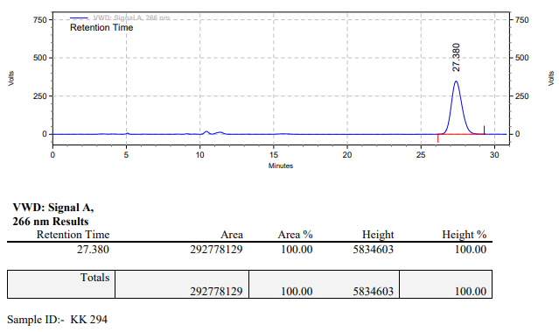

**KK-295**



**Calculation table:**

|  |  |  |  |  |  |
| --- | --- | --- | --- | --- | --- |
| Sr. No | Comp. | Mol. wt. | mmol | Eq. wt. | Wt. taken |
| 1 | Dehydrositagliptin (1) | 405.30 | 0.2135 | 100 | 86 mg |
| 2 | Rh(COD)2OTf | 468.30 | 0.0021 | 1 | 1 mg |
| 3 | L3 | 414.29 | 0.0021 | 1 | 0.9 mg |
| 4 | Ammonium chloride | 53.49 | 0.0021 | 1 | 0.1 mg |

**Procedure:** A glass vial (4 mL) equipped with Teflon coated magnetic needle was cooled under vacuum and transferred to a glove box. The vial was then charged with 86 mg of enamine (**1**), 1 mg of [Rh(COD)2OTf] (1 mol%), ligand (L3) and ammonium chloride. Reaction vial was then closed using screwcap, transferred to a large opening Schlenk type container and was then taken out from the glove box. 2 mL dry methanol was added to the vial in inert atmosphere and the resultant reaction slurry was stirred for 1 hour at room temperature (25 °C). After that the reaction vial was shifted to an autoclave and the autoclave was purged three times using hydrogen gas (40 bars). Finally, the autoclave was pressurized to 30 bar hydrogen pressure at 70°C for 18 hrs time period. After the 18 hrs time period, the autoclave was cooled to room temperature (25 °C), excess pressure was released and the autoclave was opened. The vials were taken out from the autoclave. The thus obtained reaction mixture was passed through neutral alumina bed, the filtrate was collect and dried to yield residue. The resultant residue was then analysed by HPLC.

**Reaction conditions:** Temp: 70°C Press.: 30 bar Solvent: methanol Time: 18 hrs

**Result: 00%** conversion **00%** ee

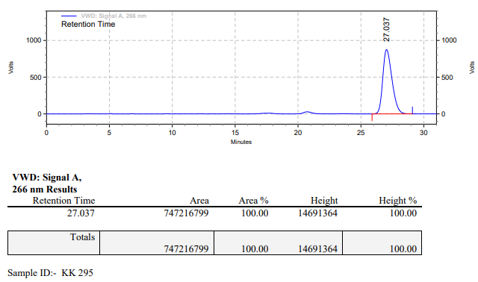

**KK-296**



**Calculation table:**

|  |  |  |  |  |  |
| --- | --- | --- | --- | --- | --- |
| Sr. No | Comp. | Mol. wt. | mmol | Eq. wt. | Wt. taken |
| 1 | Dehydrositagliptin (1) | 405.30 | 0.2135 | 100 | 86 mg |
| 2 | Rh(COD)2OTf | 468.30 | 0.0021 | 1 | 1 mg |
| 3 | L11 | 470.39 | 0.0021 | 1 | 1 mg |

**Procedure:** A glass vial (4 mL) equipped with Teflon coated magnetic needle was cooled under vacuum and transferred to a glove box. The vial was then charged with 86 mg of enamine (**1**), 1 mg of [Rh(COD)2OTf] (1 mol%) and ligand (L11). Reaction vial was then closed using screwcap, transferred to a large opening Schlenk type container and was then taken out from the glove box. 2 mL dry methanol was added to the vial in inert atmosphere and the resultant reaction slurry was stirred for 1 hour at room temperature (25 °C). After that the reaction vial was shifted to an autoclave and the autoclave was purged three times using hydrogen gas (40 bars). Finally, the autoclave was pressurized to 30 bar hydrogen pressure at 70°C for 24 hrs time period. After the 24 hrs time period, the autoclave was cooled to room temperature (25 °C), excess pressure was released and the autoclave was opened. The vials were taken out from the autoclave. The thus obtained reaction mixture was passed through neutral alumina bed, the filtrate was collect and dried to yield residue. The resultant residue was then analysed by HPLC.

**Reaction conditions:** Temp: 70°C Press.: 30 bar Solvent: methanol Time: 24 hrs

**Result: 32%** conversion **79%** ee

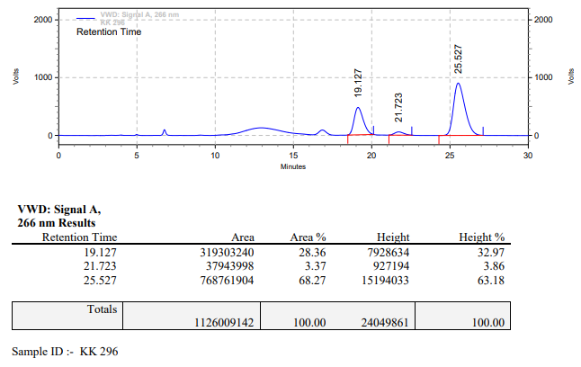

**KK-297**



**Calculation table:**

|  |  |  |  |  |  |
| --- | --- | --- | --- | --- | --- |
| Sr. No | Comp. | Mol. wt. | mmol | Eq. wt. | Wt. taken |
| 1 | Dehydrositagliptin (1) | 405.30 | 0.2135 | 100 | 86 mg |
| 2 | Rh(COD)2OTf | 468.30 | 0.0021 | 1 | 1 mg |
| 3 | L11 | 470.39 | 0.0021 | 1 | 1 mg |
| 4 | Ammonium chloride | 53.49 | 0.0021 | 1 | 0.1 mg |

**Procedure:** A glass vial (4 mL) equipped with Teflon coated magnetic needle was cooled under vacuum and transferred to a glove box. The vial was then charged with 86 mg of enamine (**1**), 1 mg of [Rh(COD)2OTf] (1 mol%), ligand (L11) and ammonium chloride. Reaction vial was then closed using screwcap, transferred to a large opening Schlenk type container and was then taken out from the glove box. 2 mL dry methanol was added to the vial in inert atmosphere and the resultant reaction slurry was stirred for 1 hour at room temperature (25 °C). After that the reaction vial was shifted to an autoclave and the autoclave was purged three times using hydrogen gas (40 bars). Finally, the autoclave was pressurized to 30 bar hydrogen pressure at 70°C for 24 hrs time period. After the 24 hrs time period, the autoclave was cooled to room temperature (25 °C), excess pressure was released and the autoclave was opened. The vials were taken out from the autoclave. The thus obtained reaction mixture was passed through neutral alumina bed, the filtrate was collect and dried to yield residue. The resultant residue was then analysed by HPLC.

**Reaction conditions:** Temp: 70°C Press.: 30 bar Solvent: methanol Time: 24 hrs

**Result: 26%** conversion **84%** ee

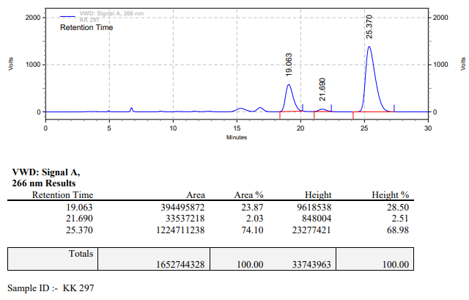

**KK-298**



**Calculation table:**

|  |  |  |  |  |  |
| --- | --- | --- | --- | --- | --- |
| Sr. No | Comp. | Mol. wt. | mmol | Eq. wt. | Wt. taken |
| 1 | Dehydrositagliptin (1) | 405.30 | 0.2135 | 100 | 86 mg |
| 2 | Rh(COD)2OTf | 468.30 | 0.0021 | 1 | 1 mg |
| 3 | L11 | 470.39 | 0.0021 | 1 | 1 mg |
| 4 | Acetic acid | 60.05 | 0.0021 | 1 | 0.1 mg |

**Procedure:** A glass vial (4 mL) equipped with Teflon coated magnetic needle was cooled under vacuum and transferred to a glove box. The vial was then charged with 86 mg of enamine (**1**), 1 mg of [Rh(COD)2OTf] (1 mol%) and ligand (L11). Reaction vial was then closed using screwcap, transferred to a large opening Schlenk type container and was then taken out from the glove box. 2 mL dry methanol was added followed by acetic acid to the vial in inert atmosphere and the resultant reaction slurry was stirred for 1 hour at room temperature (25 °C). After that the reaction vial was shifted to an autoclave and the autoclave was purged three times using hydrogen gas (40 bars). Finally, the autoclave was pressurized to 30 bar hydrogen pressure at 70°C for 24 hrs time period. After the 24 hrs time period, the autoclave was cooled to room temperature (25 °C), excess pressure was released and the autoclave was opened. The vials were taken out from the autoclave. The thus obtained reaction mixture was passed through neutral alumina bed, the filtrate was collect and dried to yield residue. The resultant residue was then analysed by HPLC.

**Reaction conditions:** Temp: 70°C Press.: 30 bar Solvent: methanol Time: 24 hrs

**Result: 19%** conversion **85%** ee

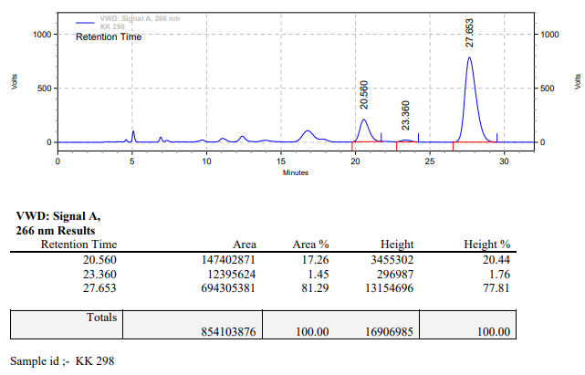

**KK-299**



**Calculation table:**

|  |  |  |  |  |  |
| --- | --- | --- | --- | --- | --- |
| Sr. No | Comp. | Mol. wt. | mmol | Eq. wt. | Wt. taken |
| 1 | Dehydrositagliptin (1) | 405.30 | 0.2135 | 100 | 86 mg |
| 2 | Rh(COD)2OTf | 468.30 | 0.0021 | 1 | 1 mg |
| 3 | L11 | 470.39 | 0.0021 | 1 | 1 mg |
| 4 | Phosphoric acid | 97.99 | 0.0021 | 1 | 0.2 mg |

**Procedure:** A glass vial (4 mL) equipped with Teflon coated magnetic needle was cooled under vacuum and transferred to a glove box. The vial was then charged with 86 mg of enamine (**1**), 1 mg of [Rh(COD)2OTf] (1 mol%) and ligand (L11). Reaction vial was then closed using screwcap, transferred to a large opening Schlenk type container and was then taken out from the glove box. 2 mL dry methanol was added followed by phosphoric acid to the vial in inert atmosphere and the resultant reaction slurry was stirred for 1 hour at room temperature (25 °C). After that the reaction vial was shifted to an autoclave and the autoclave was purged three times using hydrogen gas (40 bars). Finally, the autoclave was pressurized to 30 bar hydrogen pressure at 70°C for 24 hrs time period. After the 24 hrs time period, the autoclave was cooled to room temperature (25 °C), excess pressure was released and the autoclave was opened. The vials were taken out from the autoclave. The thus obtained reaction mixture was passed through neutral alumina bed, the filtrate was collect and dried to yield residue. The resultant residue was then analysed by HPLC.

**Reaction conditions:** Temp: 70°C Press.: 30 bar Solvent: methanol Time: 24 hrs

**Result: 29%** conversion **86%** ee

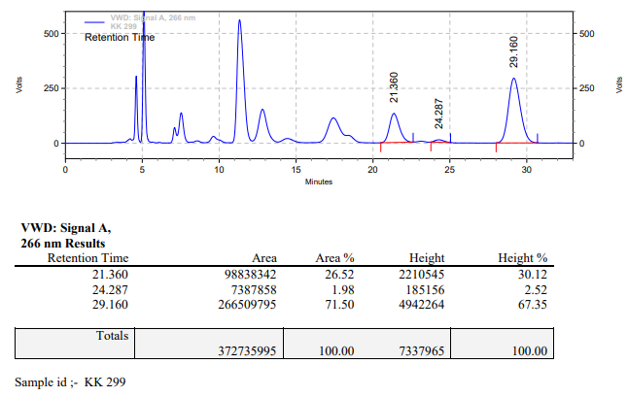

**KK-300**



**Calculation table:**

|  |  |  |  |  |  |
| --- | --- | --- | --- | --- | --- |
| Sr. No | Comp. | Mol. wt. | mmol | Eq. wt. | Wt. taken |
| 1 | Dehydrositagliptin (1) | 405.30 | 0.2135 | 100 | 86 mg |
| 2 | Rh(COD)2OTf | 468.30 | 0.0021 | 1 | 1 mg |
| 3 | L11 | 470.39 | 0.0021 | 1 | 1 mg |
| 4 | Salicylic acid | 138.12 | 0.2135 | 100 | 29 mg |

**Procedure:** A glass vial (4 mL) equipped with Teflon coated magnetic needle was cooled under vacuum and transferred to a glove box. The vial was then charged with 86 mg of enamine (**1**), 1 mg of [Rh(COD)2OTf] (1 mol%), ligand (L11) and salicylic acid. Reaction vial was then closed using screwcap, transferred to a large opening Schlenk type container and was then taken out from the glove box. 2 mL dry methanol was added to the vial in inert atmosphere and the resultant reaction slurry was stirred for 1 hour at room temperature (25 °C). After that the reaction vial was shifted to an autoclave and the autoclave was purged three times using hydrogen gas (40 bars). Finally, the autoclave was pressurized to 30 bar hydrogen pressure at 70°C for 24 hrs time period. After the 24 hrs time period, the autoclave was cooled to room temperature (25 °C), excess pressure was released and the autoclave was opened. The vials were taken out from the autoclave. The thus obtained reaction mixture was passed through neutral alumina bed, the filtrate was collect and dried to yield residue. The resultant residue was then analysed by HPLC.

**Reaction conditions:** Temp: 70°C Press.: 30 bar Solvent: methanol Time: 24 hrs

**Result: 69%** conversion **85%** ee

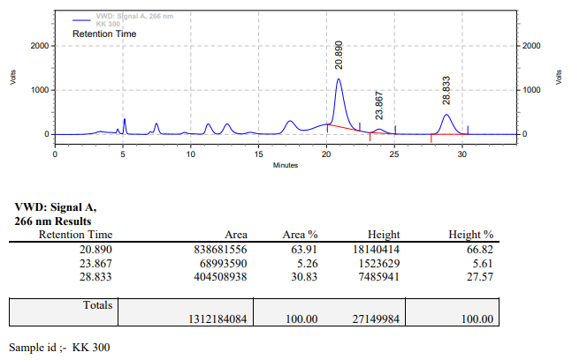

**KK-301**



**Calculation table:**

|  |  |  |  |  |  |
| --- | --- | --- | --- | --- | --- |
| Sr. No | Comp. | Mol. wt. | mmol | Eq. wt. | Wt. taken |
| 1 | Dehydrositagliptin (1) | 405.30 | 0.2135 | 100 | 86 mg |
| 2 | Rh(COD)2OTf | 468.30 | 0.0021 | 1 | 1 mg |
| 3 | L11 | 470.39 | 0.0021 | 1 | 1 mg |

**Procedure:** A glass vial (4 mL) equipped with Teflon coated magnetic needle was cooled under vacuum and transferred to a glove box. The vial was then charged with 86 mg of enamine (**1**), 1 mg of [Rh(COD)2OTf] (1 mol%) and ligand (L11). Reaction vial was then closed using screwcap, transferred to a large opening Schlenk type container and was then taken out from the glove box. 2 mL dry methanol:TFE (20:80) was added to the vial in inert atmosphere and the resultant reaction slurry was stirred for 1 hour at room temperature (25 °C). After that the reaction vial was shifted to an autoclave and the autoclave was purged three times using hydrogen gas (40 bars). Finally, the autoclave was pressurized to 30 bar hydrogen pressure at RT for 24 hrs time period. After the 24 hrs time period, the autoclave was cooled to room temperature (25 °C), excess pressure was released and the autoclave was opened. The vials were taken out from the autoclave. The thus obtained reaction mixture was passed through neutral alumina bed, the filtrate was collect and dried to yield residue. The resultant residue was then analysed by HPLC.

**Reaction conditions:** Temp: RT Press.: 30 bar Solvent: methanol:TFE (20:80) Time: 24 hrs

**Result: 00%** conversion **00%** ee

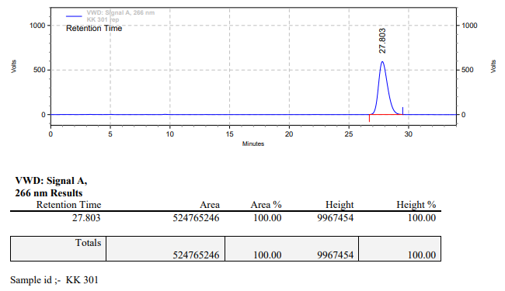

**KK-302**



**Calculation table:**

|  |  |  |  |  |  |
| --- | --- | --- | --- | --- | --- |
| Sr. No | Comp. | Mol. wt. | mmol | Eq. wt. | Wt. taken |
| 1 | Dehydrositagliptin (1) | 405.30 | 0.2135 | 100 | 86 mg |
| 2 | Rh(COD)2OTf | 468.30 | 0.0021 | 1 | 1 mg |
| 3 | L11 | 470.39 | 0.0043 | 2 | 2 mg |
| 4 | Ammonium chloride | 53.49 | 0.0021 | 1 | 0.1 mg |

**Procedure:** A glass vial (4 mL) equipped with Teflon coated magnetic needle was cooled under vacuum and transferred to a glove box. The vial was then charged with 86 mg of enamine (**1**), 1 mg of [Rh(COD)2OTf] (1 mol%), ligand (L11) and ammonium chloride. Reaction vial was then closed using screwcap, transferred to a large opening Schlenk type container and was then taken out from the glove box. 2 mL dry methanol was added to the vial in inert atmosphere and the resultant reaction slurry was stirred for 1 hour at room temperature (25 °C). After that the reaction vial was shifted to an autoclave and the autoclave was purged three times using hydrogen gas (40 bars). Finally, the autoclave was pressurized to 30 bar hydrogen pressure at 70°C for 24 hrs time period. After the 24 hrs time period, the autoclave was cooled to room temperature (25 °C), excess pressure was released and the autoclave was opened. The vials were taken out from the autoclave. The thus obtained reaction mixture was passed through neutral alumina bed, the filtrate was collect and dried to yield residue. The resultant residue was then analysed by HPLC.

**Reaction conditions:** Temp: 70°C Press.: 30 bar Solvent: methanol Time: 24 hrs

**Result: 30%** conversion **81%** ee

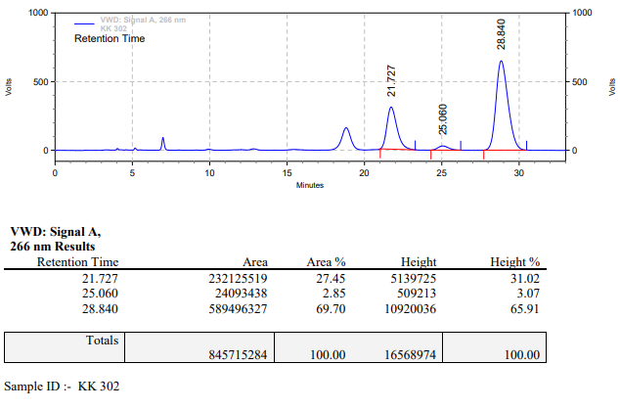

**KK-303**



**Calculation table:**

|  |  |  |  |  |  |
| --- | --- | --- | --- | --- | --- |
| Sr. No | Comp. | Mol. wt. | mmol | Eq. wt. | Wt. taken |
| 1 | Dehydrositagliptin (1) | 405.30 | 0.2135 | 100 | 86 mg |
| 2 | Rh(COD)2OTf | 468.30 | 0.0021 | 1 | 1 mg |
| 3 | L11 | 470.39 | 0.0063 | 3 | 3 mg |
| 4 | Ammonium chloride | 53.49 | 0.0021 | 1 | 0.1 mg |

**Procedure:** A glass vial (4 mL) equipped with Teflon coated magnetic needle was cooled under vacuum and transferred to a glove box. The vial was then charged with 86 mg of enamine (**1**), 1 mg of [Rh(COD)2OTf] (1 mol%), ligand (L11) and ammonium chloride. Reaction vial was then closed using screwcap, transferred to a large opening Schlenk type container and was then taken out from the glove box. 2 mL dry methanol was added to the vial in inert atmosphere and the resultant reaction slurry was stirred for 1 hour at room temperature (25 °C). After that the reaction vial was shifted to an autoclave and the autoclave was purged three times using hydrogen gas (40 bars). Finally, the autoclave was pressurized to 30 bar hydrogen pressure at 70°C for 24 hrs time period. After the 24 hrs time period, the autoclave was cooled to room temperature (25 °C), excess pressure was released and the autoclave was opened. The vials were taken out from the autoclave. The thus obtained reaction mixture was passed through neutral alumina bed, the filtrate was collect and dried to yield residue. The resultant residue was then analysed by HPLC.

**Reaction conditions:** Temp: 70°C Press.: 30 bar Solvent: methanol Time: 24 hrs

**Result: 35%** conversion **02%** ee

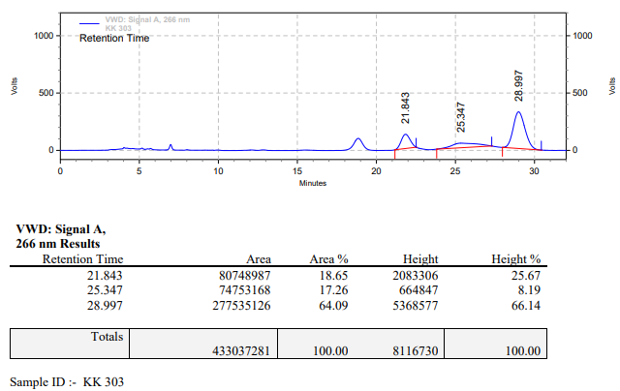

**KK-304**



**Calculation table:**

|  |  |  |  |  |  |
| --- | --- | --- | --- | --- | --- |
| Sr. No | Comp. | Mol. wt. | mmol | Eq. wt. | Wt. taken |
| 1 | Dehydrositagliptin (1) | 405.30 | 0.2135 | 100 | 86 mg |
| 2 | Rh(COD)2OTf | 468.30 | 0.0021 | 1 | 1 mg |
| 3 | L11 | 470.39 | 0.0084 | 4 | 4 mg |
| 4 | Ammonium chloride | 53.49 | 0.0021 | 1 | 0.1 mg |

**Procedure:** A glass vial (4 mL) equipped with Teflon coated magnetic needle was cooled under vacuum and transferred to a glove box. The vial was then charged with 86 mg of enamine (**1**), 1 mg of [Rh(COD)2OTf] (1 mol%), ligand (L11) and ammonium chloride. Reaction vial was then closed using screwcap, transferred to a large opening Schlenk type container and was then taken out from the glove box. 2 mL dry methanol was added to the vial in inert atmosphere and the resultant reaction slurry was stirred for 1 hour at room temperature (25 °C). After that the reaction vial was shifted to an autoclave and the autoclave was purged three times using hydrogen gas (40 bars). Finally, the autoclave was pressurized to 30 bar hydrogen pressure at 70°C for 24 hrs time period. After the 24 hrs time period, the autoclave was cooled to room temperature (25 °C), excess pressure was released and the autoclave was opened. The vials were taken out from the autoclave. The thus obtained reaction mixture was passed through neutral alumina bed, the filtrate was collect and dried to yield residue. The resultant residue was then analysed by HPLC.

**Reaction conditions:** Temp: 70°C Press.: 30 bar Solvent: methanol Time: 24 hrs

**Result: 08%** conversion **87%** ee

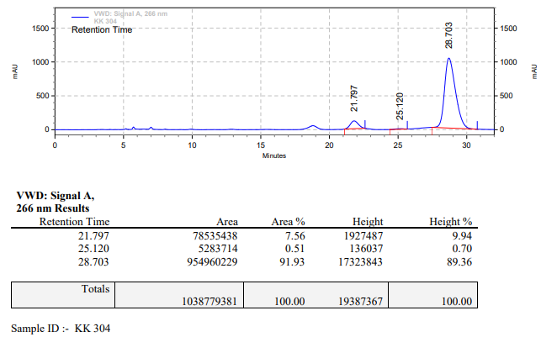

**KK-305**



**Calculation table:**

|  |  |  |  |  |  |
| --- | --- | --- | --- | --- | --- |
| Sr. No | Comp. | Mol. wt. | mmol | Eq. wt. | Wt. taken |
| 1 | Dehydrositagliptin (1) | 405.30 | 0.2135 | 100 | 86 mg |
| 2 | Rh(COD)2OTf | 468.30 | 0.0021 | 1 | 1 mg |
| 3 | L11 | 470.39 | 0.0105 | 5 | 5 mg |
| 4 | Ammonium chloride | 53.49 | 0.0021 | 1 | 0.1 mg |

**Procedure:** A glass vial (4 mL) equipped with Teflon coated magnetic needle was cooled under vacuum and transferred to a glove box. The vial was then charged with 86 mg of enamine (**1**), 1 mg of [Rh(COD)2OTf] (1 mol%), ligand (L11) and ammonium chloride. Reaction vial was then closed using screwcap, transferred to a large opening Schlenk type container and was then taken out from the glove box. 2 mL dry methanol was added to the vial in inert atmosphere and the resultant reaction slurry was stirred for 1 hour at room temperature (25 °C). After that the reaction vial was shifted to an autoclave and the autoclave was purged three times using hydrogen gas (40 bars). Finally, the autoclave was pressurized to 30 bar hydrogen pressure at 70°C for 24 hrs time period. After the 24 hrs time period, the autoclave was cooled to room temperature (25 °C), excess pressure was released and the autoclave was opened. The vials were taken out from the autoclave. The thus obtained reaction mixture was passed through neutral alumina bed, the filtrate was collect and dried to yield residue. The resultant residue was then analysed by HPLC.

**Reaction conditions:** Temp: 70°C Press.: 30 bar Solvent: methanol Time: 24 hrs

**Result: 05%** conversion **83%** ee

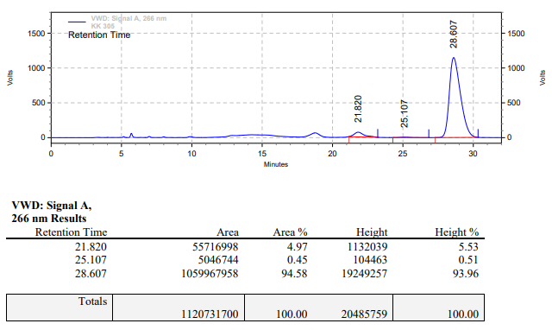

**KK-306**



**Calculation table:**

|  |  |  |  |  |  |
| --- | --- | --- | --- | --- | --- |
| Sr. No | Comp. | Mol. wt. | mmol | Eq. wt. | Wt. taken |
| 1 | Dehydrositagliptin (1) | 405.30 | 0.2135 | 100 | 86 mg |
| 2 | Rh(COD)2OTf | 468.30 | 0.0021 | 1 | 1 mg |
| 3 | L3 | 414.30 | 0.0021 | 1 | 0.9 mg |

**Procedure:** A glass vial (4 mL) equipped with Teflon coated magnetic needle was cooled under vacuum and transferred to a glove box. The vial was then charged with 86 mg of enamine (**1**), 1 mg of [Rh(COD)2OTf] (1 mol%) and ligand (L3). Reaction vial was then closed using screwcap, transferred to a large opening Schlenk type container and was then taken out from the glove box. 2 mL dry methanol was added to the vial in inert atmosphere and the resultant reaction slurry was stirred for 1 hour at room temperature (25 °C). After that the reaction vial was shifted to an autoclave and the autoclave was purged three times using hydrogen gas (40 bars). Finally, the autoclave was pressurized to 30 bar hydrogen pressure at 80°C for 24 hrs time period. After the 24 hrs time period, the autoclave was cooled to room temperature (25 °C), excess pressure was released and the autoclave was opened. The vials were taken out from the autoclave. The thus obtained reaction mixture was passed through neutral alumina bed, the filtrate was collect and dried to yield residue. The resultant residue was then analysed by HPLC.

**Reaction conditions:** Temp: 80°C Press.: 30 bar Solvent: methanol Time: 24 hrs

**Result: 00%** conversion **00%** ee

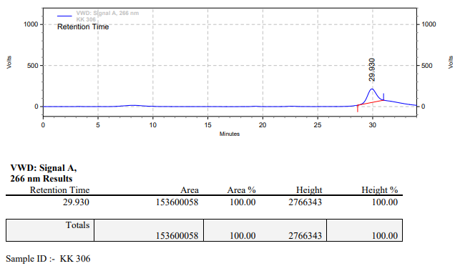

**KK-307**



**Calculation table:**

|  |  |  |  |  |  |
| --- | --- | --- | --- | --- | --- |
| Sr. No | Comp. | Mol. wt. | mmol | Eq. wt. | Wt. taken |
| 1 | Dehydrositagliptin (1) | 405.30 | 0.2135 | 100 | 86 mg |
| 2 | Rh(COD)2OTf | 468.30 | 0.0021 | 1 | 1 mg |
| 3 | L3 | 414.30 | 0.0021 | 1 | 0.9 mg |
| 4 | Ammonium chloride | 53.49 | 0.0021 | 1 | 0.1 mg |

**Procedure:** A glass vial (4 mL) equipped with Teflon coated magnetic needle was cooled under vacuum and transferred to a glove box. The vial was then charged with 86 mg of enamine (**1**), 1 mg of [Rh(COD)2OTf] (1 mol%), ligand (L3) and ammonium chloride. Reaction vial was then closed using screwcap, transferred to a large opening Schlenk type container and was then taken out from the glove box. 2 mL dry methanol was added to the vial in inert atmosphere and the resultant reaction slurry was stirred for 1 hour at room temperature (25 °C). After that the reaction vial was shifted to an autoclave and the autoclave was purged three times using hydrogen gas (40 bars). Finally, the autoclave was pressurized to 30 bar hydrogen pressure at 80°C for 24 hrs time period. After the 24 hrs time period, the autoclave was cooled to room temperature (25 °C), excess pressure was released and the autoclave was opened. The vials were taken out from the autoclave. The thus obtained reaction mixture was passed through neutral alumina bed, the filtrate was collect and dried to yield residue. The resultant residue was then analysed by HPLC.

**Reaction conditions:** Temp: 80°C Press.: 30 bar Solvent: methanol Time: 24 hrs

**Result: 27%** conversion 79**%** ee

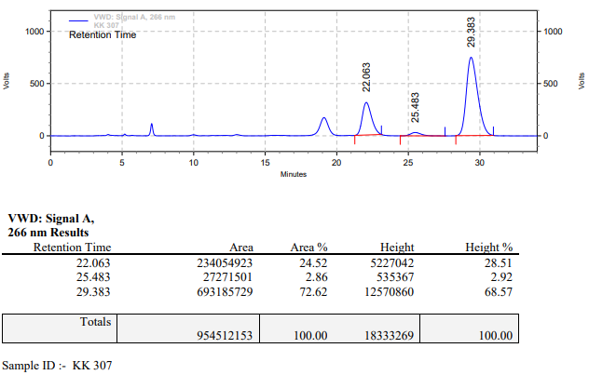

**KK-308**



**Calculation table:**

|  |  |  |  |  |  |
| --- | --- | --- | --- | --- | --- |
| Sr. No | Comp. | Mol. wt. | mmol | Eq. wt. | Wt. taken |
| 1 | Dehydrositagliptin (1) | 405.30 | 0.2135 | 100 | 86 mg |
| 2 | Rh(COD)2OTf | 468.30 | 0.0021 | 1 | 1 mg |
| 3 | L3 | 414.30 | 0.0021 | 1 | 0.9 mg |
| 4 | Phosphoric acid | 97.99 | 0.0021 | 1 | 0.2 mg |

**Procedure:** A glass vial (4 mL) equipped with Teflon coated magnetic needle was cooled under vacuum and transferred to a glove box. The vial was then charged with 86 mg of enamine (**1**), 1 mg of [Rh(COD)2OTf] (1 mol%) and ligand (L3). Reaction vial was then closed using screwcap, transferred to a large opening Schlenk type container and was then taken out from the glove box. 2 mL dry methanol was added followed by phosphoric acid to the vial in inert atmosphere and the resultant reaction slurry was stirred for 1 hour at room temperature (25 °C). After that the reaction vial was shifted to an autoclave and the autoclave was purged three times using hydrogen gas (40 bars). Finally, the autoclave was pressurized to 30 bar hydrogen pressure at 80°C for 24 hrs time period. After the 24 hrs time period, the autoclave was cooled to room temperature (25 °C), excess pressure was released and the autoclave was opened. The vials were taken out from the autoclave. The thus obtained reaction mixture was passed through neutral alumina bed, the filtrate was collect and dried to yield residue. The resultant residue was then analysed by HPLC.

**Reaction conditions:** Temp: 80°C Press.: 30 bar Solvent: methanol Time: 24 hrs

**Result: 23%** conversion **84%** ee

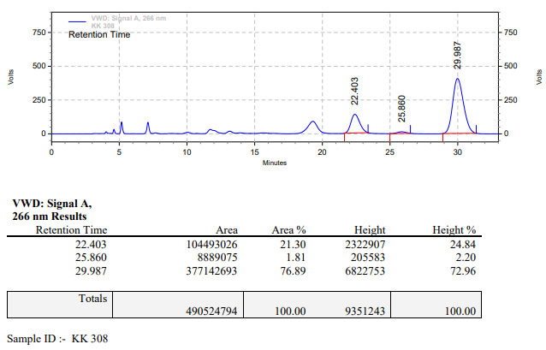

**KK-309**



**Calculation table:**

|  |  |  |  |  |  |
| --- | --- | --- | --- | --- | --- |
| Sr. No | Comp. | Mol. wt. | mmol | Eq. wt. | Wt. taken |
| 1 | Dehydrositagliptin (1) | 405.30 | 0.2135 | 100 | 86 mg |
| 2 | Rh(COD)2OTf | 468.30 | 0.0021 | 1 | 1 mg |
| 3 | L3 | 414.30 | 0.0021 | 1 | 0.9 mg |
| 4 | Acetic acid | 60.05 | 0.0021 | 1 | 0.1 mg |

**Procedure:** A glass vial (4 mL) equipped with Teflon coated magnetic needle was cooled under vacuum and transferred to a glove box. The vial was then charged with 86 mg of enamine (**1**), 1 mg of [Rh(COD)2OTf] (1 mol%) and ligand (L3). Reaction vial was then closed using screwcap, transferred to a large opening Schlenk type container and was then taken out from the glove box. 2 mL dry methanol was added followed by acetic acid to the vial in inert atmosphere and the resultant reaction slurry was stirred for 1 hour at room temperature (25 °C). After that the reaction vial was shifted to an autoclave and the autoclave was purged three times using hydrogen gas (40 bars). Finally, the autoclave was pressurized to 30 bar hydrogen pressure at 80°C for 24 hrs time period. After the 24 hrs time period, the autoclave was cooled to room temperature (25 °C), excess pressure was released and the autoclave was opened. The vials were taken out from the autoclave. The thus obtained reaction mixture was passed through neutral alumina bed, the filtrate was collect and dried to yield residue. The resultant residue was then analysed by HPLC.

**Reaction conditions:** Temp: 80°C Press.: 30 bar Solvent: methanol Time: 24 hrs

**Result: 43%** conversion **84%** ee

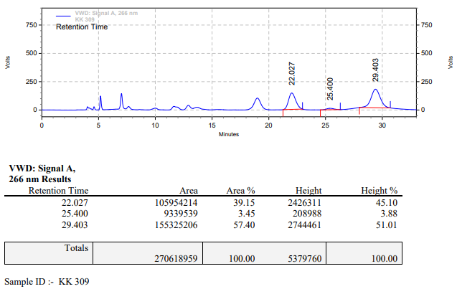

**KK-310**



**Calculation table:**

|  |  |  |  |  |  |
| --- | --- | --- | --- | --- | --- |
| Sr. No | Comp. | Mol. wt. | mmol | Eq. wt. | Wt. taken |
| 1 | Dehydrositagliptin (1) | 405.30 | 0.2135 | 100 | 86 mg |
| 2 | Rh(COD)2OTf | 468.30 | 0.0021 | 1 | 1 mg |
| 3 | L3 | 414.30 | 0.0021 | 1 | 0.9 mg |
| 4 | Salicylic acid | 138.12 | 0.2135 | 100 | 29 mg |

**Procedure:** A glass vial (4 mL) equipped with Teflon coated magnetic needle was cooled under vacuum and transferred to a glove box. The vial was then charged with 86 mg of enamine (**1**), 1 mg of [Rh(COD)2OTf] (1 mol%), ligand (L3) and salicylic acid. Reaction vial was then closed using screwcap, transferred to a large opening Schlenk type container and was then taken out from the glove box. 2 mL dry methanol was added to the vial in inert atmosphere and the resultant reaction slurry was stirred for 1 hour at room temperature (25 °C). After that the reaction vial was shifted to an autoclave and the autoclave was purged three times using hydrogen gas (40 bars). Finally, the autoclave was pressurized to 30 bar hydrogen pressure at 80°C for 24 hrs time period. After the 24 hrs time period, the autoclave was cooled to room temperature (25 °C), excess pressure was released and the autoclave was opened. The vials were taken out from the autoclave. The thus obtained reaction mixture was passed through neutral alumina bed, the filtrate was collect and dried to yield residue. The resultant residue was then analysed by HPLC.

**Reaction conditions:** Temp: 80°C Press.: 30 bar Solvent: methanol Time: 24 hrs

**Result: 90%** conversion **87%** ee

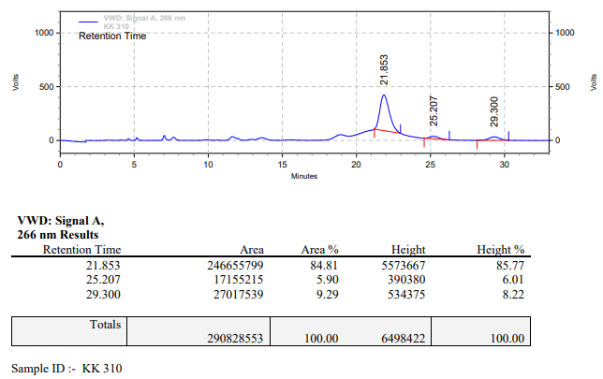

**KK-311**



**Calculation table:**

|  |  |  |  |  |  |
| --- | --- | --- | --- | --- | --- |
| Sr. No | Comp. | Mol. wt. | mmol | Eq. wt. | Wt. taken |
| 1 | Dehydrositagliptin (1) | 405.30 | 0.2135 | 100 | 86 mg |
| 2 | Rh(COD)2OTf | 468.30 | 0.0021 | 1 | 1 mg |
| 3 | L11 | 470.39 | 0.0021 | 1 | 1 mg |

**Procedure:** A glass vial (4 mL) equipped with Teflon coated magnetic needle was cooled under vacuum and transferred to a glove box. The vial was then charged with 86 mg of enamine (**1**), 1 mg of [Rh(COD)2OTf] (1 mol%) and ligand (L11). Reaction vial was then closed using screwcap, transferred to a large opening Schlenk type container and was then taken out from the glove box. 2 mL dry methanol was added to the vial in inert atmosphere and the resultant reaction slurry was stirred for 1 hour at room temperature (25°C). After that the reaction vial was shifted to an autoclave and the autoclave was purged three times using hydrogen gas (40 bars). Finally, the autoclave was pressurized to 30 bar hydrogen pressure at 80°C for 24 hrs time period. After the 24 hrs time period, the autoclave was cooled to room temperature (25°C), excess pressure was released and the autoclave was opened. The vials were taken out from the autoclave. The thus obtained reaction mixture was passed through neutral alumina bed, the filtrate was collect and dried to yield residue. The resultant residue was then analysed by HPLC.

**Reaction conditions:** Temp: 80°C Press.: 30 bar Solvent: methanol Time: 24 hrs

**Result: 22%** conversion **00%** ee

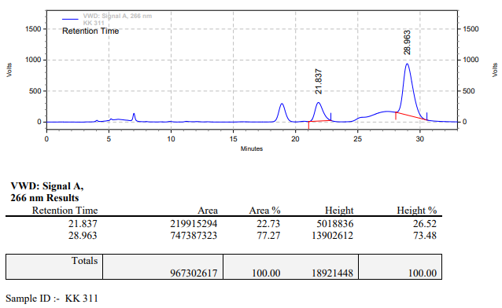

**KK-312**



**Calculation table:**

|  |  |  |  |  |  |
| --- | --- | --- | --- | --- | --- |
| Sr. No | Comp. | Mol. wt. | mmol | Eq. wt. | Wt. taken |
| 1 | Dehydrositagliptin (1) | 405.30 | 0.2135 | 100 | 86 mg |
| 2 | Rh(COD)2OTf | 468.30 | 0.0021 | 1 | 1 mg |
| 3 | L11 | 470.39 | 0.0021 | 1 | 1 mg |
| 4 | Ammonium chloride | 53.49 | 0.0021 | 1 | 0.1 mg |

**Procedure:** A glass vial (4 mL) equipped with Teflon coated magnetic needle was cooled under vacuum and transferred to a glove box. The vial was then charged with 86 mg of enamine (**1**), 1 mg of [Rh(COD)2OTf] (1 mol%), ligand (L11) and ammonium chloride. Reaction vial was then closed using screwcap, transferred to a large opening Schlenk type container and was then taken out from the glove box. 2 mL dry methanol was added to the vial in inert atmosphere and the resultant reaction slurry was stirred for 1 hour at room temperature (25°C). After that the reaction vial was shifted to an autoclave and the autoclave was purged three times using hydrogen gas (40 bars). Finally, the autoclave was pressurized to 30 bar hydrogen pressure at 80°C for 24 hrs time period. After the 24 hrs time period, the autoclave was cooled to room temperature (25°C), excess pressure was released and the autoclave was opened. The vials were taken out from the autoclave. The thus obtained reaction mixture was passed through neutral alumina bed, the filtrate was collect and dried to yield residue. The resultant residue was then analysed by HPLC.

**Reaction conditions:** Temp: 80°C Press.: 30 bar Solvent: methanol Time: 24 hrs

**Result: 31%** conversion 84**%** ee

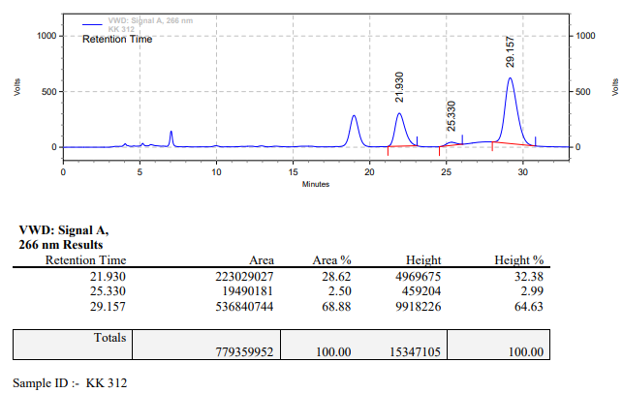

**KK-313**



**Calculation table:**

|  |  |  |  |  |  |
| --- | --- | --- | --- | --- | --- |
| Sr. No | Comp. | Mol. wt. | mmol | Eq. wt. | Wt. taken |
| 1 | Dehydrositagliptin (1) | 405.30 | 0.2135 | 100 | 86 mg |
| 2 | Rh(COD)2OTf | 468.30 | 0.0021 | 1 | 1 mg |
| 3 | L11 | 470.39 | 0.0021 | 1 | 1 mg |
| 4 | Phosphoric acid | 97.99 | 0.0021 | 1 | 0.2 mg |

**Procedure:** A glass vial (4 mL) equipped with Teflon coated magnetic needle was cooled under vacuum and transferred to a glove box. The vial was then charged with 86 mg of enamine (**1**), 1 mg of [Rh(COD)2OTf] (1 mol%) and ligand (L11). Reaction vial was then closed using screwcap, transferred to a large opening Schlenk type container and was then taken out from the glove box. 2 mL dry methanol was added followed by phosphoric acid to the vial in inert atmosphere and the resultant reaction slurry was stirred for 1 hour at room temperature (25°C). After that the reaction vial was shifted to an autoclave and the autoclave was purged three times using hydrogen gas (40 bars). Finally, the autoclave was pressurized to 30 bar hydrogen pressure at 80°C for 24 hrs time period. After the 24 hrs time period, the autoclave was cooled to room temperature (25°C), excess pressure was released and the autoclave was opened. The vials were taken out from the autoclave. The thus obtained reaction mixture was passed through neutral alumina bed, the filtrate was collect and dried to yield residue. The resultant residue was then analysed by HPLC.

**Reaction conditions:** Temp: 80°C Press.: 30 bar Solvent: Methanol Time: 24 hrs

**Result: 87%** conversion **00%** ee

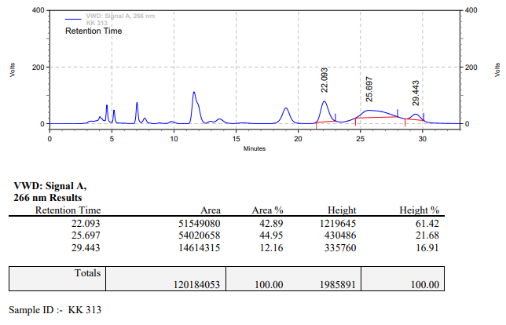

**KK-314**



**Calculation table:**

|  |  |  |  |  |  |
| --- | --- | --- | --- | --- | --- |
| Sr. No | Comp. | Mol. wt. | mmol | Eq. wt. | Wt. taken |
| 1 | Dehydrositagliptin (1) | 405.30 | 0.2135 | 100 | 86 mg |
| 2 | Rh(COD)2OTf | 468.30 | 0.0021 | 1 | 1 mg |
| 3 | L11 | 470.39 | 0.0021 | 1 | 1 mg |
| 4 | Acetic acid | 60.05 | 0.0021 | 1 | 0.1mg |

**Procedure:** A glass vial (4 mL) equipped with Teflon coated magnetic needle was cooled under vacuum and transferred to a glove box. The vial was then charged with 86 mg of enamine (**1**), 1 mg of [Rh(COD)2OTf] (1 mol%) and ligand (L11). Reaction vial was then closed using screwcap, transferred to a large opening Schlenk type container and was then taken out from the glove box. 2 mL dry methanol was added followed by acetic acid to the vial in inert atmosphere and the resultant reaction slurry was stirred for 1 hour at room temperature (25°C). After that the reaction vial was shifted to an autoclave and the autoclave was purged three times using hydrogen gas (40 bars). Finally, the autoclave was pressurized to 30 bar hydrogen pressure at 80°C for 24 hrs time period. After the 24 hrs time period, the autoclave was cooled to room temperature (25°C), excess pressure was released and the autoclave was opened. The vials were taken out from the autoclave. The thus obtained reaction mixture was passed through neutral alumina bed, the filtrate was collect and dried to yield residue. The resultant residue was then analysed by HPLC.

**Reaction conditions:** Temp: 80°C Press.: 30 bar Solvent: Methanol Time: 24 hrs

**Result: 57%** conversion **84%** ee

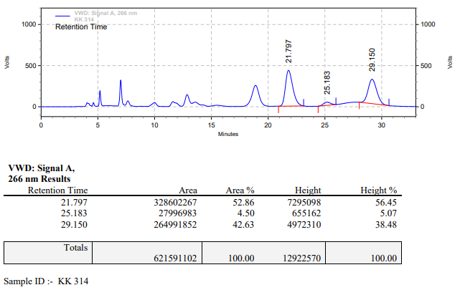

**KK-315**



**Calculation table:**

|  |  |  |  |  |  |
| --- | --- | --- | --- | --- | --- |
| Sr. No | Comp. | Mol. wt. | mmol | Eq. wt. | Wt. taken |
| 1 | Dehydrositagliptin (1) | 405.30 | 0.2135 | 100 | 86 mg |
| 2 | Rh(COD)2OTf | 468.30 | 0.0021 | 1 | 1 mg |
| 3 | L11 | 470.39 | 0.0021 | 1 | 1 mg |
| 4 | Salicylic acid | 138.12 | 0.2135 | 100 | 29 mg |

**Procedure:** A glass vial (4 mL) equipped with Teflon coated magnetic needle was cooled under vacuum and transferred to a glove box. The vial was then charged with 86 mg of enamine (**1**), 1 mg of [Rh(COD)2OTf] (1 mol%), ligand (L11) and salicylic acid. Reaction vial was then closed using screwcap, transferred to a large opening Schlenk type container and was then taken out from the glove box. 2 mL dry methanol was added to the vial in inert atmosphere and the resultant reaction slurry was stirred for 1 hour at room temperature (25°C). After that the reaction vial was shifted to an autoclave and the autoclave was purged three times using hydrogen gas (40 bars). Finally, the autoclave was pressurized to 30 bar hydrogen pressure at 70°C for 24 hrs time period. After the 24 hrs time period, the autoclave was cooled to room temperature (25°C), excess pressure was released and the autoclave was opened. The vials were taken out from the autoclave. The thus obtained reaction mixture was passed through neutral alumina bed, the filtrate was collect and dried to yield residue. The resultant residue was then analysed by HPLC.

**Reaction conditions:** Temp: 70°C Press.: 30 bar Solvent: Methanol Time: 24 hrs

**Result: 95%** conversion **83%** ee

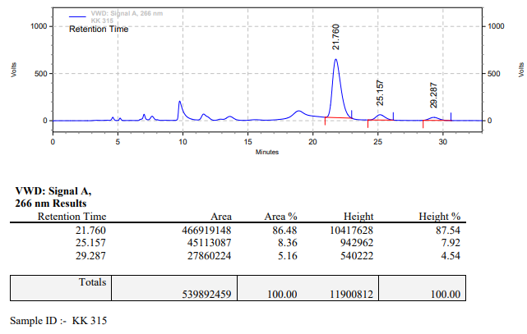

**KK-316**



**Calculation table:**

|  |  |  |  |  |  |
| --- | --- | --- | --- | --- | --- |
| Sr. No | Comp. | Mol. wt. | mmol | Eq. wt. | Wt. taken |
| 1 | Dehydrositagliptin (1) | 405.30 | 0.2135 | 100 | 86 mg |
| 2 | Rh(COD)2OTf | 468.30 | 0.0021 | 1 | 1 mg |
| 3 | L11 | 470.39 | 0.0021 | 1 | 1 mg |
| 4 | Salicylic acid | 138.12 | 0.1050 | 50 | 15 mg |

**Procedure:** A glass vial (4 mL) equipped with Teflon coated magnetic needle was cooled under vacuum and transferred to a glove box. The vial was then charged with 86 mg of enamine (**1**), 1 mg of [Rh(COD)2OTf] (1 mol%), ligand (L11) and salicylic acid. Reaction vial was then closed using screwcap, transferred to a large opening Schlenk type container and was then taken out from the glove box. 2 mL dry methanol was added to the vial in inert atmosphere and the resultant reaction slurry was stirred for 1 hour at room temperature (25°C). After that the reaction vial was shifted to an autoclave and the autoclave was purged three times using hydrogen gas (40 bars). Finally, the autoclave was pressurized to 30 bar hydrogen pressure at 80°C for 24 hrs time period. After the 24 hrs time period, the autoclave was cooled to room temperature (25°C), excess pressure was released and the autoclave was opened. The vials were taken out from the autoclave. The thus obtained reaction mixture was passed through neutral alumina bed, the filtrate was collect and dried to yield residue. The resultant residue was then analysed by HPLC.

**Reaction conditions:** Temp: 80°C Press.: 30 bar Solvent: Methanol Time: 24 hrs

**Result: 95%** conversion **85%** ee

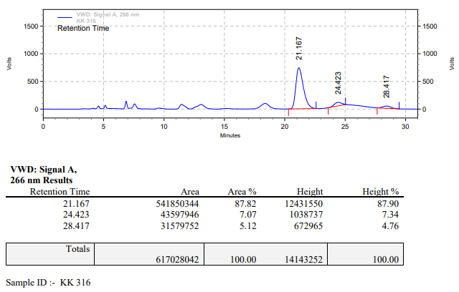

**KK-317**



**Calculation table:**

|  |  |  |  |  |  |
| --- | --- | --- | --- | --- | --- |
| Sr. No | Comp. | Mol. wt. | mmol | Eq. wt. | Wt. taken |
| 1 | Dehydrositagliptin (1) | 405.30 | 0.2135 | 100 | 86 mg |
| 2 | Rh(COD)2OTf | 468.30 | 0.0021 | 1 | 1 mg |
| 3 | L11 | 470.39 | 0.0021 | 1 | 1 mg |
| 4 | Salicylic acid | 138.12 | 0.2135 | 100 | 29 mg |

**Procedure:** A glass vial (4 mL) equipped with Teflon coated magnetic needle was cooled under vacuum and transferred to a glove box. The vial was then charged with 86 mg of enamine (**1**), 1 mg of [Rh(COD)2OTf] (1 mol%), ligand (L11) and salicylic acid. Reaction vial was then closed using screwcap, transferred to a large opening Schlenk type container and was then taken out from the glove box. 2 mL dry methanol was added to the vial in inert atmosphere and the resultant reaction slurry was stirred for 1 hour at room temperature (25°C). After that the reaction vial was shifted to an autoclave and the autoclave was purged three times using hydrogen gas (40 bars). Finally, the autoclave was pressurized to 30 bar hydrogen pressure at 80°C for 24 hrs time period. After the 24 hrs time period, the autoclave was cooled to room temperature (25°C), excess pressure was released and the autoclave was opened. The vials were taken out from the autoclave. The thus obtained reaction mixture was passed through neutral alumina bed, the filtrate was collect and dried to yield residue. The resultant residue was then analysed by HPLC.

**Reaction conditions:** Temp: 80°C Press.: 30 bar Solvent: Methanol Time: 24 hrs

**Result: 98%** conversion **84%** ee

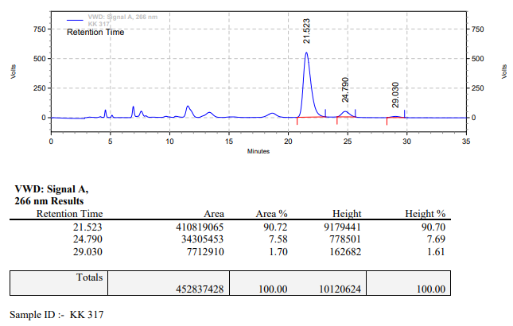

**KK-318**



**Calculation table:**

|  |  |  |  |  |  |
| --- | --- | --- | --- | --- | --- |
| Sr. No | Comp. | Mol. wt. | mmol | Eq. wt. | Wt. taken |
| 1 | Dehydrositagliptin (1) | 405.30 | 0.2135 | 100 | 86 mg |
| 2 | Rh(COD)2OTf | 468.30 | 0.0021 | 1 | 1 mg |
| 3 | L11 | 470.39 | 0.0021 | 1 | 1 mg |
| 4 | Salicylic acid | 138.12 | 0.3150 | 150 | 45 mg |

**Procedure:** A glass vial (4 mL) equipped with Teflon coated magnetic needle was cooled under vacuum and transferred to a glove box. The vial was then charged with 86 mg of enamine (**1**), 1 mg of [Rh(COD)2OTf] (1 mol%), ligand (L11) and salicylic acid. Reaction vial was then closed using screwcap, transferred to a large opening Schlenk type container and was then taken out from the glove box. 2 mL dry methanol was added to the vial in inert atmosphere and the resultant reaction slurry was stirred for 1 hour at room temperature (25°C). After that the reaction vial was shifted to an autoclave and the autoclave was purged three times using hydrogen gas (40 bars). Finally, the autoclave was pressurized to 30 bar hydrogen pressure at 80°C for 24 hrs time period. After the 24 hrs time period, the autoclave was cooled to room temperature (25°C), excess pressure was released and the autoclave was opened. The vials were taken out from the autoclave. The thus obtained reaction mixture was passed through neutral alumina bed, the filtrate was collect and dried to yield residue. The resultant residue was then analysed by HPLC.

**Reaction conditions:** Temp: 80°C Press.: 30 bar Solvent: Methanol Time: 24 hrs

**Result: 64%** conversion **85%** ee

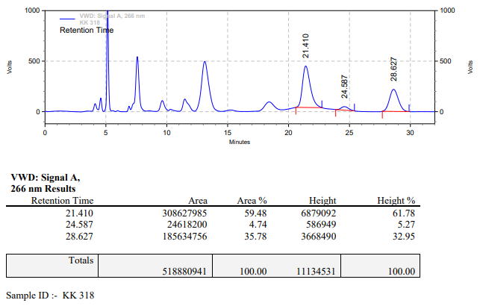

**KK-319**



**Calculation table:**

|  |  |  |  |  |  |
| --- | --- | --- | --- | --- | --- |
| Sr. No | Comp. | Mol. wt. | mmol | Eq. wt. | Wt. taken |
| 1 | Dehydrositagliptin (1) | 405.30 | 0.2135 | 1 | 86 mg |
| 2 | Rh(COD)2OTf | 468.30 | 0.0063 | 3 mol% | 3 mg |
| 3 | L3 | 414.29 | 0.0063 | 3 mol% | 2.7 mg |
| 4 | Ammonium chloride | 53.49 | 0.0063 | 3 mol% | 0.3 mg |

**Procedure:** A glass vial (4 mL) equipped with Teflon coated magnetic needle was cooled under vacuum and transferred to a glove box. The vial was then charged with 86 mg of enamine (**1**), 3 mg of [Rh(COD)2OTf] (3 mol%), ligand (L3) and ammonium chloride. Reaction vial was then closed using screwcap, transferred to a large opening Schlenk type container and was then taken out from the glove box. 2 mL dry methanol was added to the vial in inert atmosphere and the resultant reaction slurry was stirred for 1 hour at room temperature (25°C). After that the reaction vial was shifted to an autoclave and the autoclave was purged three times using hydrogen gas (40 bars). Finally, the autoclave was pressurized to 30 bar hydrogen pressure at 70°C for 14 hrs time period. After the 14 hrs time period, the autoclave was cooled to room temperature (25°C), excess pressure was released and the autoclave was opened. The vials were taken out from the autoclave. The thus obtained reaction mixture was passed through neutral alumina bed, the filtrate was collect and dried to yield residue. The resultant residue was then analysed by HPLC.

**Reaction conditions:** Temp: 70°C Press.: 30 bar Solvent: Methanol Time: 14 hrs

**Result: 99%** conversion **82%** ee

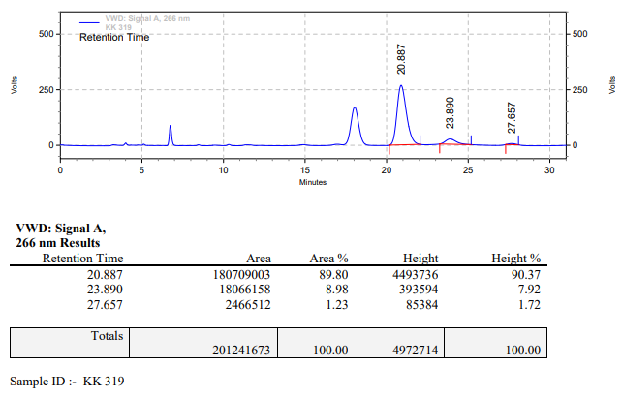

**KK-320**



**Calculation table:**

|  |  |  |  |  |  |
| --- | --- | --- | --- | --- | --- |
| Sr. No | Comp. | Mol. wt. | mmol | Eq. wt. | Wt. taken |
| 1 | Dehydrositagliptin (1) | 405.30 | 0.2135 | 1 | 86 mg |
| 2 | Rh(COD)2OTf | 468.30 | 0.0085 | 4 mol% | 4 mg |
| 3 | L3 | 414.29 | 0.0085 | 4 mol% | 3.5 mg |
| 4 | Ammonium chloride | 53.49 | 0.0085 | 4 mol% | 0.4 mg |

**Procedure:** A glass vial (4 mL) equipped with Teflon coated magnetic needle was cooled under vacuum and transferred to a glove box. The vial was then charged with 86 mg of enamine (**1**), 4 mg of [Rh(COD)2OTf] (4 mol%), ligand (L3) and ammonium chloride. Reaction vial was then closed using screwcap, transferred to a large opening Schlenk type container and was then taken out from the glove box. 2 mL dry methanol was added to the vial in inert atmosphere and the resultant reaction slurry was stirred for 1 hour at room temperature (25°C). After that the reaction vial was shifted to an autoclave and the autoclave was purged three times using hydrogen gas (40 bars). Finally, the autoclave was pressurized to 30 bar hydrogen pressure at 70°C for 14 hrs time period. After the 14 hrs time period, the autoclave was cooled to room temperature (25°C), excess pressure was released and the autoclave was opened. The vials were taken out from the autoclave. The thus obtained reaction mixture was passed through neutral alumina bed, the filtrate was collect and dried to yield residue. The resultant residue was then analysed by HPLC.

**Reaction conditions:** Temp: 70°C Press.: 30 bar Solvent: Methanol Time: 14 hrs

**Result: 99%** conversion **87%** ee

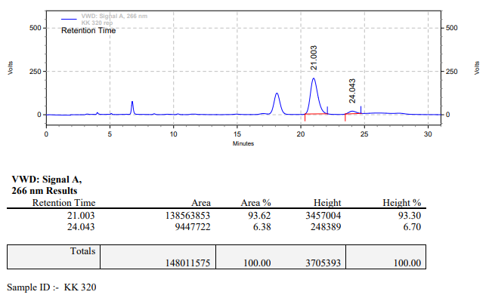

**KK-321**



**Calculation table:**

|  |  |  |  |  |  |
| --- | --- | --- | --- | --- | --- |
| Sr. No | Comp. | Mol. wt. | mmol | Eq. wt. | Wt. taken |
| 1 | Dehydrositagliptin (1) | 405.30 | 0.2135 | 1 | 86 mg |
| 2 | Rh(COD)2OTf | 468.30 | 0.0106 | 5 mol% | 5 mg |
| 3 | L3 | 414.29 | 0.0106 | 5 mol% | 4.4 mg |
| 4 | Ammonium chloride | 53.49 | 0.0106 | 5 mol% | 0.6 mg |

**Procedure:** A glass vial (4 mL) equipped with Teflon coated magnetic needle was cooled under vacuum and transferred to a glove box. The vial was then charged with 86 mg of enamine (**1**), 5 mg of [Rh(COD)2OTf] (5 mol%), ligand (L3) and ammonium chloride. Reaction vial was then closed using screwcap, transferred to a large opening Schlenk type container and was then taken out from the glove box. 2 mL dry methanol was added to the vial in inert atmosphere and the resultant reaction slurry was stirred for 1 hour at room temperature (25°C). After that the reaction vial was shifted to an autoclave and the autoclave was purged three times using hydrogen gas (40 bars). Finally, the autoclave was pressurized to 30 bar hydrogen pressure at 70°C for 14 hrs time period. After the 14 hrs time period, the autoclave was cooled to room temperature (25°C), excess pressure was released and the autoclave was opened. The vials were taken out from the autoclave. The thus obtained reaction mixture was passed through neutral alumina bed, the filtrate was collect and dried to yield residue. The resultant residue was then analysed by HPLC.

**Reaction conditions:** Temp: 70°C Press.: 30 bar Solvent: Methanol Time: 14 hrs

**Result: 99%** conversion **85%** ee

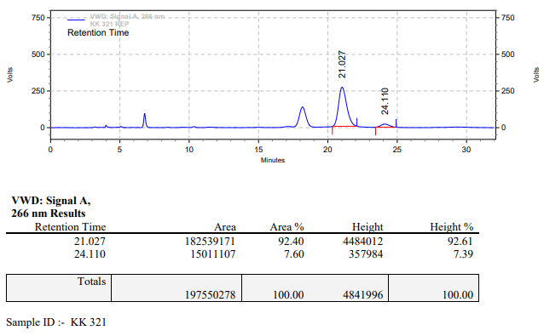

**KK-322**



**Calculation table:**

|  |  |  |  |  |  |
| --- | --- | --- | --- | --- | --- |
| Sr. No | Comp. | Mol. wt. | mmol | Eq. wt. | Wt. taken |
| 1 | Dehydrositagliptin (1) | 405.30 | 0.2135 | 100 | 86 mg |
| 2 | Rh(COD)2OTf | 468.30 | 0.0021 | 1 | 1 mg |
| 3 | L3 | 414.29 | 0.0021 | 1 | 0.9 mg |
| 4 | Ammonium chloride | 53.49 | 0.0021 | 1 | 0.1 mg |

**Procedure:** A glass vial (4 mL) equipped with Teflon coated magnetic needle was cooled under vacuum and transferred to a glove box. The vial was then charged with 86 mg of enamine (**1**), 1 mg of [Rh(COD)2OTf] (1 mol%), ligand (L3) and ammonium chloride. Reaction vial was then closed using screwcap, transferred to a large opening Schlenk type container and was then taken out from the glove box. 2 mL dry methanol was added to the vial in inert atmosphere and the resultant reaction slurry was stirred for 1 hour at room temperature (25°C). After that the reaction vial was shifted to an autoclave and the autoclave was purged three times using hydrogen gas (40 bars). Finally, the autoclave was pressurized to 30 bar hydrogen pressure at 70°C for 12 hrs time period. After the 12 hrs time period, the autoclave was cooled to room temperature (25°C), excess pressure was released and the autoclave was opened. The vials were taken out from the autoclave. The thus obtained reaction mixture was passed through neutral alumina bed, the filtrate was collect and dried to yield residue. The resultant residue was then analysed by HPLC.

**Reaction conditions:** Temp: 70°C Press.: 30 bar Solvent: Methanol Time: 12 hrs

**Result: 66%** conversion **84%** ee

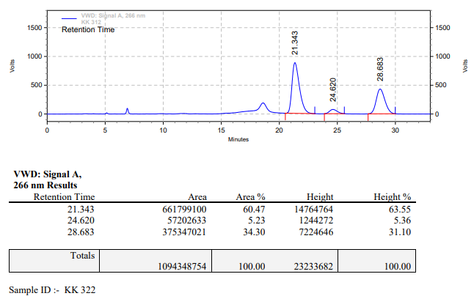

**KK-323**



**Calculation table:**

|  |  |  |  |  |  |
| --- | --- | --- | --- | --- | --- |
| Sr. No | Comp. | Mol. wt. | mmol | Eq. wt. | Wt. taken |
| 1 | Dehydrositagliptin (1) | 405.30 | 0.2135 | 1 | 86 mg |
| 2 | Rh(COD)2OTf | 468.30 | 0.0042 | 2 mol% | 2 mg |
| 3 | L3 | 414.29 | 0.0042 | 2 mol% | 1.8 mg |
| 4 | Ammonium chloride | 53.49 | 0.0042 | 2 mol% | 0.2 mg |

**Procedure:** A glass vial (4 mL) equipped with Teflon coated magnetic needle was cooled under vacuum and transferred to a glove box. The vial was then charged with 86 mg of enamine (**1**), 21 mg of [Rh(COD)2OTf] (2 mol%), ligand (L3) and ammonium chloride. Reaction vial was then closed using screwcap, transferred to a large opening Schlenk type container and was then taken out from the glove box. 2 mL dry methanol was added to the vial in inert atmosphere and the resultant reaction slurry was stirred for 1 hour at room temperature (25°C). After that the reaction vial was shifted to an autoclave and the autoclave was purged three times using hydrogen gas (40 bars). Finally, the autoclave was pressurized to 30 bar hydrogen pressure at 70°C for 12 hrs time period. After the 12 hrs time period, the autoclave was cooled to room temperature (25°C), excess pressure was released and the autoclave was opened. The vials were taken out from the autoclave. The thus obtained reaction mixture was passed through neutral alumina bed, the filtrate was collect and dried to yield residue. The resultant residue was then analysed by HPLC.

**Reaction conditions:** Temp: 70°C Press.: 30 bar Solvent: Methanol Time: 12 hrs

**Result: 89%** conversion **88%** ee

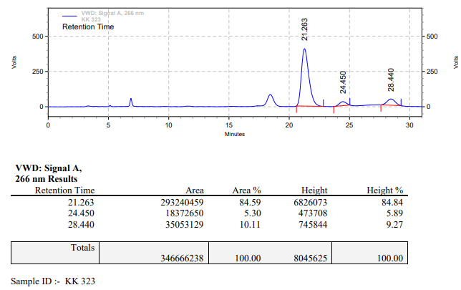

**KK-324**



**Calculation table:**

|  |  |  |  |  |  |
| --- | --- | --- | --- | --- | --- |
| Sr. No | Comp. | Mol. wt. | mmol | Eq. wt. | Wt. taken |
| 1 | Dehydrositagliptin (1) | 405.30 | 0.2135 | 1 | 86 mg |
| 2 | Rh(COD)2OTf | 468.30 | 0.0063 | 3 mol% | 3 mg |
| 3 | L3 | 414.29 | 0.0063 | 3 mol% | 2.7 mg |
| 4 | Ammonium chloride | 53.49 | 0.0063 | 3 mol% | 0.3 mg |

**Procedure:** A glass vial (4 mL) equipped with Teflon coated magnetic needle was cooled under vacuum and transferred to a glove box. The vial was then charged with 86 mg of enamine (**1**), 3 mg of [Rh(COD)2OTf] (3 mol%), ligand (L3) and ammonium chloride. Reaction vial was then closed using screwcap, transferred to a large opening Schlenk type container and was then taken out from the glove box. 2 mL dry methanol was added to the vial in inert atmosphere and the resultant reaction slurry was stirred for 1 hour at room temperature (25°C). After that the reaction vial was shifted to an autoclave and the autoclave was purged three times using hydrogen gas (40 bars). Finally, the autoclave was pressurized to 30 bar hydrogen pressure at 70°C for 12 hrs time period. After the 12 hrs time period, the autoclave was cooled to room temperature (25°C), excess pressure was released and the autoclave was opened. The vials were taken out from the autoclave. The thus obtained reaction mixture was passed through neutral alumina bed, the filtrate was collect and dried to yield residue. The resultant residue was then analysed by HPLC.

**Reaction conditions:** Temp: 70°C Press.: 30 bar Solvent: Methanol Time: 12 hrs

**Result: 90%** conversion **80%** ee

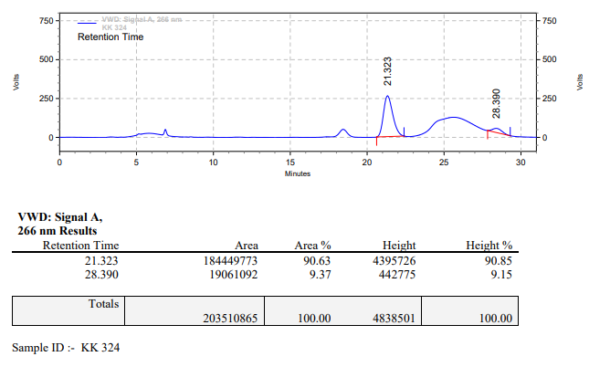

**KK-325**



**Calculation table:**

|  |  |  |  |  |  |
| --- | --- | --- | --- | --- | --- |
| Sr. No | Comp. | Mol. wt. | mmol | Eq. wt. | Wt. taken |
| 1 | Dehydrositagliptin (1) | 405.30 | 0.2135 | 1 | 86 mg |
| 2 | Rh(COD)2OTf | 468.30 | 0.0085 | 4 mol% | 4 mg |
| 3 | L3 | 414.29 | 0.0085 | 4 mol% | 3.5 mg |
| 4 | Ammonium chloride | 53.49 | 0.0085 | 4 mol% | 0.4 mg |

**Procedure:** A glass vial (4 mL) equipped with Teflon coated magnetic needle was cooled under vacuum and transferred to a glove box. The vial was then charged with 86 mg of enamine (**1**), 4 mg of [Rh(COD)2OTf] (4 mol%), ligand (L3) and ammonium chloride. Reaction vial was then closed using screwcap, transferred to a large opening Schlenk type container and was then taken out from the glove box. 2 mL dry methanol was added to the vial in inert atmosphere and the resultant reaction slurry was stirred for 1 hour at room temperature (25°C). After that the reaction vial was shifted to an autoclave and the autoclave was purged three times using hydrogen gas (40 bars). Finally, the autoclave was pressurized to 30 bar hydrogen pressure at 70°C for 12 hrs time period. After the 12 hrs time period, the autoclave was cooled to room temperature (25°C), excess pressure was released and the autoclave was opened. The vials were taken out from the autoclave. The thus obtained reaction mixture was passed through neutral alumina bed, the filtrate was collect and dried to yield residue. The resultant residue was then analysed by HPLC.

**Reaction conditions:** Temp: 70°C Press.: 30 bar Solvent: Methanol Time: 12 hrs

**Result: 99%** conversion **84%** ee

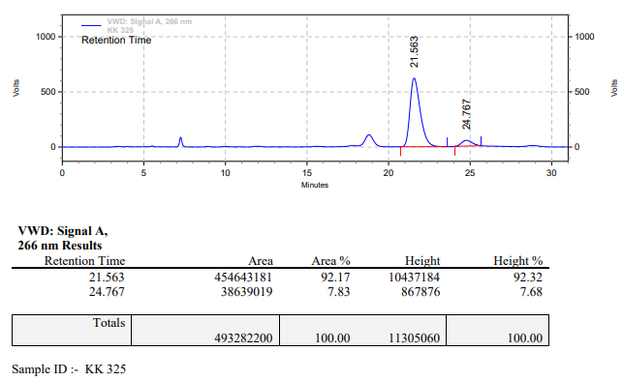

**KK-326**



**Calculation table:**

|  |  |  |  |  |  |
| --- | --- | --- | --- | --- | --- |
| Sr. No | Comp. | Mol. wt. | mmol | Eq. wt. | Wt. taken |
| 1 | Dehydrositagliptin (1) | 405.30 | 0.2135 | 1 | 86 mg |
| 2 | Rh(COD)2OTf | 468.30 | 0.0106 | 5 mol% | 5 mg |
| 3 | L3 | 414.29 | 0.0106 | 5 mol% | 4.4 mg |
| 4 | Ammonium chloride | 53.49 | 0.0106 | 5 mol% | 0.6 mg |

**Procedure:** A glass vial (4 mL) equipped with Teflon coated magnetic needle was cooled under vacuum and transferred to a glove box. The vial was then charged with 86 mg of enamine (**1**), 5 mg of [Rh(COD)2OTf] (5 mol%), ligand (L3) and ammonium chloride. Reaction vial was then closed using screwcap, transferred to a large opening Schlenk type container and was then taken out from the glove box. 2 mL dry methanol was added to the vial in inert atmosphere and the resultant reaction slurry was stirred for 1 hour at room temperature (25°C). After that the reaction vial was shifted to an autoclave and the autoclave was purged three times using hydrogen gas (40 bars). Finally, the autoclave was pressurized to 30 bar hydrogen pressure at 70°C for 12 hrs time period. After the 12 hrs time period, the autoclave was cooled to room temperature (25°C), excess pressure was released and the autoclave was opened. The vials were taken out from the autoclave. The thus obtained reaction mixture was passed through neutral alumina bed, the filtrate was collect and dried to yield residue. The resultant residue was then analysed by HPLC.

**Reaction conditions:** Temp: 70°C Press.: 30 bar Solvent: Methanol Time: 12 hrs

**Result: 99%** conversion **85%** ee

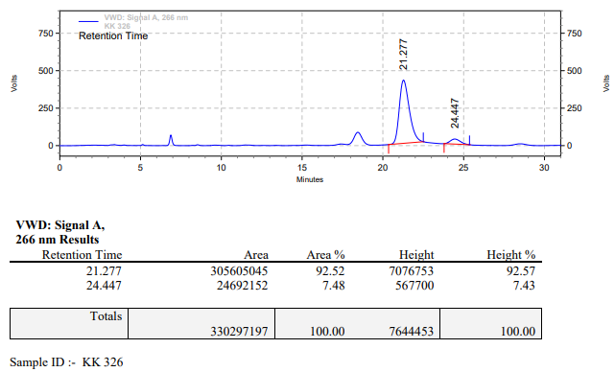

**KK-327**



**Calculation table:**

|  |  |  |  |  |  |
| --- | --- | --- | --- | --- | --- |
| Sr. No | Comp. | Mol. wt. | mmol | Eq. wt. | Wt. taken |
| 1 | Dehydrositagliptin (1) | 405.30 | 0.2135 | 1 | 172 mg |
| 2 | Rh(COD)2OTf | 468.30 | 0.0021 | 0.5 mol% | 1 mg |
| 3 | L3 | 414.29 | 0.0021 | 0.5 mol% | 0.9 mg |
| 4 | Ammonium chloride | 53.49 | 0.0021 | 0.5 mol% | 0.1 mg |

**Procedure:** A glass vial (4 mL) equipped with Teflon coated magnetic needle was cooled under vacuum and transferred to a glove box. The vial was then charged with 172 mg of enamine (**1**), 1 mg of [Rh(COD)2OTf] (1 mol%), ligand (L3) and ammonium chloride. Reaction vial was then closed using screwcap, transferred to a large opening Schlenk type container and was then taken out from the glove box. 2 mL dry methanol was added to the vial in inert atmosphere and the resultant reaction slurry was stirred for 1 hour at room temperature (25°C). After that the reaction vial was shifted to an autoclave and the autoclave was purged three times using hydrogen gas (40 bars). Finally, the autoclave was pressurized to 30 bar hydrogen pressure at 70°C for 12 hrs time period. After the 12 hrs time period, the autoclave was cooled to room temperature (25°C), excess pressure was released and the autoclave was opened. The vials were taken out from the autoclave. The thus obtained reaction mixture was passed through neutral alumina bed, the filtrate was collect and dried to yield residue. The resultant residue was then analysed by HPLC.

**Reaction conditions:** Temp: 70°C Press.: 30 bar Solvent: Methanol Time: 12 hrs

**Result: 22%** conversion **80%** ee

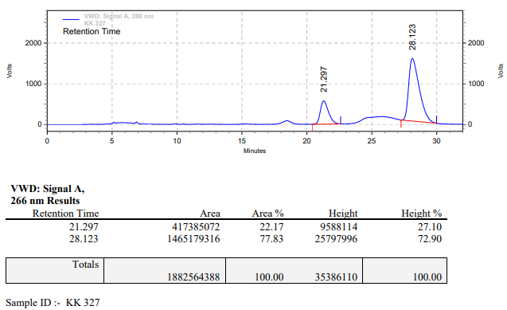

**KK-328**



**Calculation table:**

|  |  |  |  |  |  |
| --- | --- | --- | --- | --- | --- |
| Sr. No | Comp. | Mol. wt. | mmol | Eq. wt. | Wt. taken |
| 1 | Dehydrositagliptin (1) | 405.30 | 0.2135 | 1 | 172 mg |
| 2 | Rh(COD)2OTf | 468.30 | 0.0021 | 0.5 mol% | 1 mg |
| 3 | L3 | 414.29 | 0.0021 | 0.5 mol% | 0.9 mg |
| 4 | Ammonium chloride | 53.49 | 0.0021 | 0.5 mol% | 0.1 mg |

**Procedure:** A glass vial (15 mL) equipped with Teflon coated magnetic needle was cooled under vacuum and transferred to a glove box. The vial was then charged with 172 mg of enamine (**1**), 1 mg of [Rh(COD)2OTf] (1 mol%), ligand (L3) and ammonium chloride. Reaction vial was then closed using screwcap, transferred to a large opening Schlenk type container and was then taken out from the glove box. 4 mL dry methanol was added to the vial in inert atmosphere and the resultant reaction slurry was stirred for 1 hour at room temperature (25°C). After that the reaction vial was shifted to an autoclave and the autoclave was purged three times using hydrogen gas (40 bars). Finally, the autoclave was pressurized to 30 bar hydrogen pressure at 70°C for 12 hrs time period. After the 12 hrs time period, the autoclave was cooled to room temperature (25°C), excess pressure was released and the autoclave was opened. The vials were taken out from the autoclave. The thus obtained reaction mixture was passed through neutral alumina bed, the filtrate was collect and dried to yield residue. The resultant residue was then analysed by HPLC.

**Reaction conditions:** Temp: 70°C Press.: 30 bar Solvent: Methanol Time: 12 hrs

**Result: 00%** conversion **00%** ee

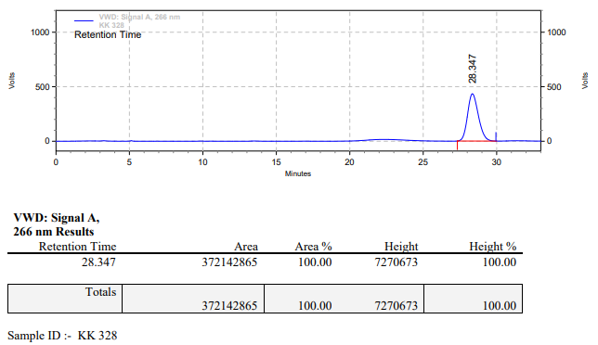

**KK-329**



**Calculation table:**

|  |  |  |  |  |  |
| --- | --- | --- | --- | --- | --- |
| Sr. No | Comp. | Mol. wt. | mmol | Eq. wt. | Wt. taken |
| 1 | Dehydrositagliptin (1) | 405.30 | 0.2135 | 100 | 86 mg |
| 2 | Rh(COD)2OTf | 468.30 | 0.0021 | 1 | 1 mg |
| 3 | L3 | 414.29 | 0.0021 | 1 | 0.9 mg |
| 4 | Ammonium chloride | 53.49 | 0.0021 | 1 | 0.1 mg |

**Procedure:** A glass vial (4 mL) equipped with Teflon coated magnetic needle was cooled under vacuum and transferred to a glove box. The vial was then charged with 86 mg of enamine (**1**), 1 mg of [Rh(COD)2OTf] (1 mol%), ligand (L3) and ammonium chloride. Reaction vial was then closed using screwcap, transferred to a large opening Schlenk type container and was then taken out from the glove box. 2 mL dry methanol was added to the vial in inert atmosphere and the resultant reaction slurry was stirred for 1 hour at room temperature (25°C). After that the reaction vial was shifted to an autoclave and the autoclave was purged three times using hydrogen gas (40 bars). Finally, the autoclave was pressurized to 30 bar hydrogen pressure at 70°C for 6 hrs time period. After the 6 hrs time period, the autoclave was cooled to room temperature (25°C), excess pressure was released and the autoclave was opened. The vials were taken out from the autoclave. The thus obtained reaction mixture was passed through neutral alumina bed, the filtrate was collect and dried to yield residue. The resultant residue was then analysed by HPLC.

**Reaction conditions:** Temp: 70°C Press.: 30 bar Solvent: Methanol Time: 6 hrs

**Result: 00%** conversion **00%** ee

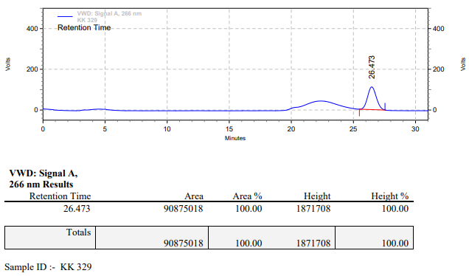

**KK-330**



**Calculation table:**

|  |  |  |  |  |  |
| --- | --- | --- | --- | --- | --- |
| Sr. No | Comp. | Mol. wt. | mmol | Eq. wt. | Wt. taken |
| 1 | Dehydrositagliptin (1) | 405.30 | 0.2135 | 1 | 86 mg |
| 2 | Rh(COD)2OTf | 468.30 | 0.0042 | 2 mol% | 2 mg |
| 3 | L3 | 414.29 | 0.0042 | 2 mol% | 1.8 mg |
| 4 | Ammonium chloride | 53.49 | 0.0042 | 2 mol% | 0.2 mg |

**Procedure:** A glass vial (4 mL) equipped with Teflon coated magnetic needle was cooled under vacuum and transferred to a glove box. The vial was then charged with 86 mg of enamine (**1**), 21 mg of [Rh(COD)2OTf] (2 mol%), ligand (L3) and ammonium chloride. Reaction vial was then closed using screwcap, transferred to a large opening Schlenk type container and was then taken out from the glove box. 2 mL dry methanol was added to the vial in inert atmosphere and the resultant reaction slurry was stirred for 1 hour at room temperature (25°C). After that the reaction vial was shifted to an autoclave and the autoclave was purged three times using hydrogen gas (40 bars). Finally, the autoclave was pressurized to 30 bar hydrogen pressure at 70°C for 6 hrs time period. After the 6 hrs time period, the autoclave was cooled to room temperature (25°C), excess pressure was released and the autoclave was opened. The vials were taken out from the autoclave. The thus obtained reaction mixture was passed through neutral alumina bed, the filtrate was collect and dried to yield residue. The resultant residue was then analysed by HPLC.

**Reaction conditions:** Temp: 70°C Press.: 30 bar Solvent: Methanol Time: 6 hrs

**Result: 59%** conversion **84%** ee

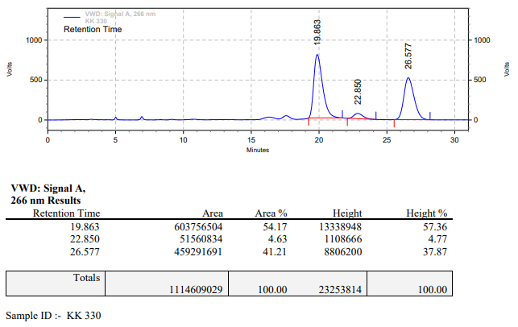

**KK-331**



**Calculation table:**

|  |  |  |  |  |  |
| --- | --- | --- | --- | --- | --- |
| Sr. No | Comp. | Mol. wt. | mmol | Eq. wt. | Wt. taken |
| 1 | Dehydrositagliptin (1) | 405.30 | 0.2135 | 1 | 86 mg |
| 2 | Rh(COD)2OTf | 468.30 | 0.0063 | 3 mol% | 3 mg |
| 3 | L3 | 414.29 | 0.0063 | 3 mol% | 2.7 mg |
| 4 | Ammonium chloride | 53.49 | 0.0063 | 3 mol% | 0.3 mg |

**Procedure:** A glass vial (4 mL) equipped with Teflon coated magnetic needle was cooled under vacuum and transferred to a glove box. The vial was then charged with 86 mg of enamine (**1**), 3 mg of [Rh(COD)2OTf] (3 mol%), ligand (L3) and ammonium chloride. Reaction vial was then closed using screwcap, transferred to a large opening Schlenk type container and was then taken out from the glove box. 2 mL dry methanol was added to the vial in inert atmosphere and the resultant reaction slurry was stirred for 1 hour at room temperature (25°C). After that the reaction vial was shifted to an autoclave and the autoclave was purged three times using hydrogen gas (40 bars). Finally, the autoclave was pressurized to 30 bar hydrogen pressure at 70°C for 6 hrs time period. After the 6 hrs time period, the autoclave was cooled to room temperature (25°C), excess pressure was released and the autoclave was opened. The vials were taken out from the autoclave. The thus obtained reaction mixture was passed through neutral alumina bed, the filtrate was collect and dried to yield residue. The resultant residue was then analysed by HPLC.

**Reaction conditions:** Temp: 70°C Press.: 30 bar Solvent: Methanol Time: 6 hrs

**Result: 84%** conversion **87%** ee

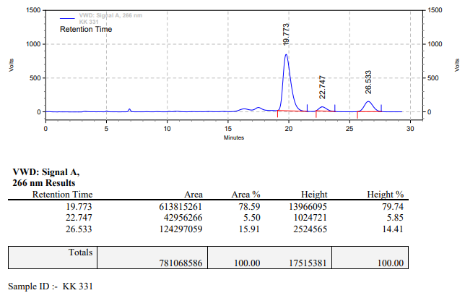

**KK-332**



**Calculation table:**

|  |  |  |  |  |  |
| --- | --- | --- | --- | --- | --- |
| Sr. No | Comp. | Mol. wt. | mmol | Eq. wt. | Wt. taken |
| 1 | Dehydrositagliptin (1) | 405.30 | 0.2135 | 1 | 86 mg |
| 2 | Rh(COD)2OTf | 468.30 | 0.0085 | 4 mol% | 4 mg |
| 3 | L3 | 414.29 | 0.0085 | 4 mol% | 3.5 mg |
| 4 | Ammonium chloride | 53.49 | 0.0085 | 4 mol% | 0.4 mg |

**Procedure:** A glass vial (4 mL) equipped with Teflon coated magnetic needle was cooled under vacuum and transferred to a glove box. The vial was then charged with 86 mg of enamine (**1**), 4 mg of [Rh(COD)2OTf] (4 mol%), ligand (L3) and ammonium chloride. Reaction vial was then closed using screwcap, transferred to a large opening Schlenk type container and was then taken out from the glove box. 2 mL dry methanol was added to the vial in inert atmosphere and the resultant reaction slurry was stirred for 1 hour at room temperature (25°C). After that the reaction vial was shifted to an autoclave and the autoclave was purged three times using hydrogen gas (40 bars). Finally, the autoclave was pressurized to 30 bar hydrogen pressure at 70°C for 6 hrs time period. After the 6 hrs time period, the autoclave was cooled to room temperature (25°C), excess pressure was released and the autoclave was opened. The vials were taken out from the autoclave. The thus obtained reaction mixture was passed through neutral alumina bed, the filtrate was collect and dried to yield residue. The resultant residue was then analysed by HPLC.

**Reaction conditions:** Temp: 70°C Press.: 30 bar Solvent: Methanol Time: 6 hrs

**Result: 93%** conversion **84%** ee

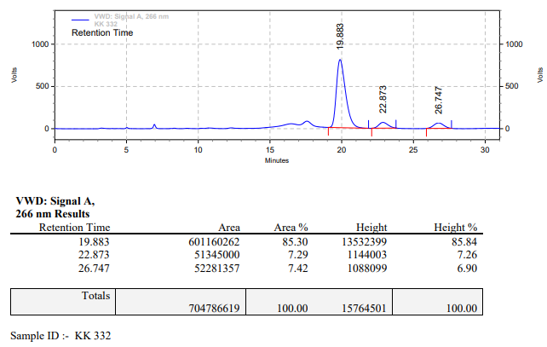

**KK-333**



**Calculation table:**

|  |  |  |  |  |  |
| --- | --- | --- | --- | --- | --- |
| Sr. No | Comp. | Mol. wt. | mmol | Eq. wt. | Wt. taken |
| 1 | Dehydrositagliptin (1) | 405.30 | 0.2135 | 1 | 86 mg |
| 2 | Rh(COD)2OTf | 468.30 | 0.0106 | 5 mol% | 5 mg |
| 3 | L3 | 414.29 | 0.0106 | 5 mol% | 4.4 mg |
| 4 | Ammonium chloride | 53.49 | 0.0106 | 5 mol% | 0.6 mg |

**Procedure:** A glass vial (4 mL) equipped with Teflon coated magnetic needle was cooled under vacuum and transferred to a glove box. The vial was then charged with 86 mg of enamine (**1**), 5 mg of [Rh(COD)2OTf] (5 mol%), ligand (L3) and ammonium chloride. Reaction vial was then closed using screwcap, transferred to a large opening Schlenk type container and was then taken out from the glove box. 2 mL dry methanol was added to the vial in inert atmosphere and the resultant reaction slurry was stirred for 1 hour at room temperature (25°C). After that the reaction vial was shifted to an autoclave and the autoclave was purged three times using hydrogen gas (40 bars). Finally, the autoclave was pressurized to 30 bar hydrogen pressure at 70°C for 6 hrs time period. After the 6 hrs time period, the autoclave was cooled to room temperature (25°C), excess pressure was released and the autoclave was opened. The vials were taken out from the autoclave. The thus obtained reaction mixture was passed through neutral alumina bed, the filtrate was collect and dried to yield residue. The resultant residue was then analysed by HPLC.

**Reaction conditions:** Temp: 70°C Press.: 30 bar Solvent: Methanol Time: 6 hrs

**Result: 91%** conversion **83%** ee

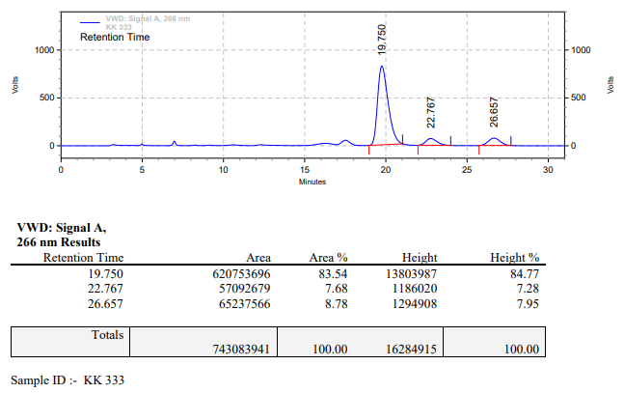

**KK-334**



**Calculation table:**

|  |  |  |  |  |  |
| --- | --- | --- | --- | --- | --- |
| Sr. No | Comp. | Mol. wt. | mmol | Eq. wt. | Wt. taken |
| 1 | Dehydrositagliptin (1) | 405.30 | 0.2135 | 100 | 86 mg |
| 2 | Rh(COD)2OTf | 468.30 | 0.0021 | 1 | 1 mg |
| 3 | L11 | 470.49 | 0.0021 | 1 | 1 mg |
| 4 | Ammonium chloride | 53.49 | 0.0021 | 1 | 0.1 mg |

**Procedure:** A glass vial (4 mL) equipped with Teflon coated magnetic needle was cooled under vacuum and transferred to a glove box. The vial was then charged with 86 mg of enamine (**1**), 1 mg of [Rh(COD)2OTf] (1 mol%), ligand (L11) and ammonium chloride. Reaction vial was then closed using screwcap, transferred to a large opening Schlenk type container and was then taken out from the glove box. 2 mL dry methanol was added to the vial in inert atmosphere and the resultant reaction slurry was stirred for 1 hour at room temperature (25°C). After that the reaction vial was shifted to an autoclave and the autoclave was purged three times using hydrogen gas (40 bars). Finally, the autoclave was pressurized to 30 bar hydrogen pressure at 70°C for 6 hrs time period. After the 6 hrs time period, the autoclave was cooled to room temperature (25°C), excess pressure was released and the autoclave was opened. The vials were taken out from the autoclave. The thus obtained reaction mixture was passed through neutral alumina bed, the filtrate was collect and dried to yield residue. The resultant residue was then analysed by HPLC.

**Reaction conditions:** Temp: 70°C Press.: 30 bar Solvent: Methanol Time: 6 hrs

**Result: 15%** conversion **79%** ee

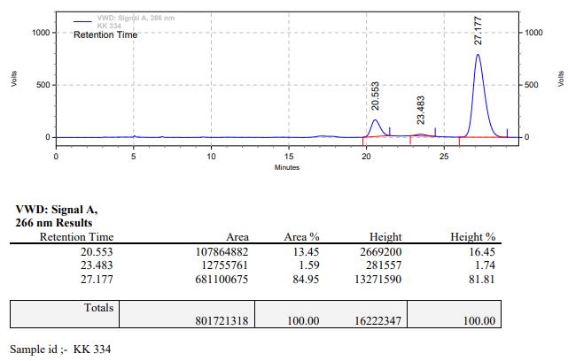

**KK-335**



**Calculation table:**

|  |  |  |  |  |  |
| --- | --- | --- | --- | --- | --- |
| Sr. No | Comp. | Mol. wt. | mmol | Eq. wt. | Wt. taken |
| 1 | Dehydrositagliptin (1) | 405.30 | 0.2135 | 1 | 86 mg |
| 2 | Rh(COD)2OTf | 468.30 | 0.0042 | 2 mol% | 2 mg |
| 3 | L11 | 470.49 | 0.0042 | 2 mol% | 2 mg |
| 4 | Ammonium chloride | 53.49 | 0.0042 | 2 mol% | 0.2 mg |

**Procedure:** A glass vial (4 mL) equipped with Teflon coated magnetic needle was cooled under vacuum and transferred to a glove box. The vial was then charged with 86 mg of enamine (**1**), 21 mg of [Rh(COD)2OTf] (2 mol%), ligand (L11) and ammonium chloride. Reaction vial was then closed using screwcap, transferred to a large opening Schlenk type container and was then taken out from the glove box. 2 mL dry methanol was added to the vial in inert atmosphere and the resultant reaction slurry was stirred for 1 hour at room temperature (25°C). After that the reaction vial was shifted to an autoclave and the autoclave was purged three times using hydrogen gas (40 bars). Finally, the autoclave was pressurized to 30 bar hydrogen pressure at 70°C for 6 hrs time period. After the 6 hrs time period, the autoclave was cooled to room temperature (25°C), excess pressure was released and the autoclave was opened. The vials were taken out from the autoclave. The thus obtained reaction mixture was passed through neutral alumina bed, the filtrate was collect and dried to yield residue. The resultant residue was then analysed by HPLC.

**Reaction conditions:** Temp: 70°C Press.: 30 bar Solvent: Methanol Time: 6 hrs

**Result: 16%** conversion **85%** ee

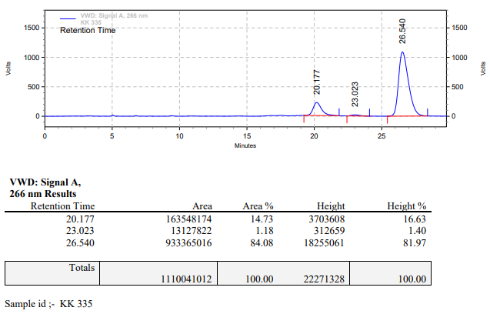

**KK-336**



**Calculation table:**

|  |  |  |  |  |  |
| --- | --- | --- | --- | --- | --- |
| Sr. No | Comp. | Mol. wt. | mmol | Eq. wt. | Wt. taken |
| 1 | Dehydrositagliptin (1) | 405.30 | 0.2135 | 1 | 86 mg |
| 2 | Rh(COD)2OTf | 468.30 | 0.0063 | 3 mol% | 3 mg |
| 3 | L11 | 470.49 | 0.0063 | 3 mol% | 3 mg |
| 4 | Ammonium chloride | 53.49 | 0.0063 | 3 mol% | 0.3 mg |

**Procedure:** A glass vial (4 mL) equipped with Teflon coated magnetic needle was cooled under vacuum and transferred to a glove box. The vial was then charged with 86 mg of enamine (**1**), 3 mg of [Rh(COD)2OTf] (3 mol%), ligand (L11) and ammonium chloride. Reaction vial was then closed using screwcap, transferred to a large opening Schlenk type container and was then taken out from the glove box. 2 mL dry methanol was added to the vial in inert atmosphere and the resultant reaction slurry was stirred for 1 hour at room temperature (25°C). After that the reaction vial was shifted to an autoclave and the autoclave was purged three times using hydrogen gas (40 bars). Finally, the autoclave was pressurized to 30 bar hydrogen pressure at 70°C for 6 hrs time period. After the 6 hrs time period, the autoclave was cooled to room temperature (25°C), excess pressure was released and the autoclave was opened. The vials were taken out from the autoclave. The thus obtained reaction mixture was passed through neutral alumina bed, the filtrate was collect and dried to yield residue. The resultant residue was then analysed by HPLC.

**Reaction conditions:** Temp: 70°C Press.: 30 bar Solvent: Methanol Time: 6 hrs

**Result: 59%** conversion **83%** ee

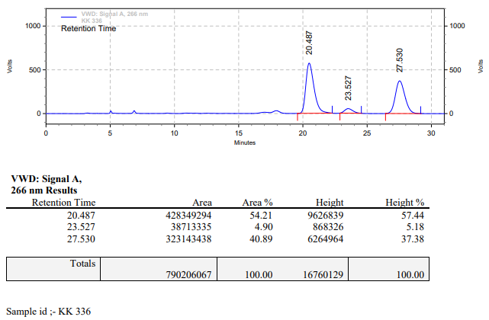

**KK-337**



**Calculation table:**

|  |  |  |  |  |  |
| --- | --- | --- | --- | --- | --- |
| Sr. No | Comp. | Mol. wt. | mmol | Eq. wt. | Wt. taken |
| 1 | Dehydrositagliptin (1) | 405.30 | 0.2135 | 1 | 86 mg |
| 2 | Rh(COD)2OTf | 468.30 | 0.0085 | 4 mol% | 4 mg |
| 3 | L11 | 470.49 | 0.0085 | 4 mol% | 4 mg |
| 4 | Ammonium chloride | 53.49 | 0.0085 | 4 mol% | 0.4 mg |

**Procedure:** A glass vial (4 mL) equipped with Teflon coated magnetic needle was cooled under vacuum and transferred to a glove box. The vial was then charged with 86 mg of enamine (**1**), 4 mg of [Rh(COD)2OTf] (4 mol%), ligand (L11) and ammonium chloride. Reaction vial was then closed using screwcap, transferred to a large opening Schlenk type container and was then taken out from the glove box. 2 mL dry methanol was added to the vial in inert atmosphere and the resultant reaction slurry was stirred for 1 hour at room temperature (25°C). After that the reaction vial was shifted to an autoclave and the autoclave was purged three times using hydrogen gas (40 bars). Finally, the autoclave was pressurized to 30 bar hydrogen pressure at 70°C for 6 hrs time period. After the 6 hrs time period, the autoclave was cooled to room temperature (25°C), excess pressure was released and the autoclave was opened. The vials were taken out from the autoclave. The thus obtained reaction mixture was passed through neutral alumina bed, the filtrate was collect and dried to yield residue. The resultant residue was then analysed by HPLC.

**Reaction conditions:** Temp: 70°C Press.: 30 bar Solvent: Methanol Time: 6 hrs

**Result: 67%** conversion **81%** ee

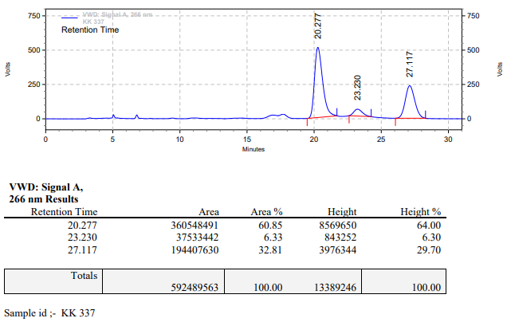

**KK-338**



**Calculation table:**

|  |  |  |  |  |  |
| --- | --- | --- | --- | --- | --- |
| Sr. No | Comp. | Mol. wt. | mmol | Eq. wt. | Wt. taken |
| 1 | Dehydrositagliptin (1) | 405.30 | 0.2135 | 1 | 86 mg |
| 2 | Rh(COD)2OTf | 468.30 | 0.0106 | 5 mol% | 5 mg |
| 3 | L11 | 470.49 | 0.0106 | 5 mol% | 5 mg |
| 4 | Ammonium chloride | 53.49 | 0.0106 | 5 mol% | 0.6 mg |

**Procedure:** A glass vial (4 mL) equipped with Teflon coated magnetic needle was cooled under vacuum and transferred to a glove box. The vial was then charged with 86 mg of enamine (**1**), 5 mg of [Rh(COD)2OTf] (5 mol%), ligand (L11) and ammonium chloride. Reaction vial was then closed using screwcap, transferred to a large opening Schlenk type container and was then taken out from the glove box. 2 mL dry methanol was added to the vial in inert atmosphere and the resultant reaction slurry was stirred for 1 hour at room temperature (25°C). After that the reaction vial was shifted to an autoclave and the autoclave was purged three times using hydrogen gas (40 bars). Finally, the autoclave was pressurized to 30 bar hydrogen pressure at 70°C for 6 hrs time period. After the 6 hrs time period, the autoclave was cooled to room temperature (25°C), excess pressure was released and the autoclave was opened. The vials were taken out from the autoclave. The thus obtained reaction mixture was passed through neutral alumina bed, the filtrate was collect and dried to yield residue. The resultant residue was then analysed by HPLC.

**Reaction conditions:** Temp: 70°C Press.: 30 bar Solvent: Methanol Time: 6 hrs

**Result: 84%** conversion **86%** ee

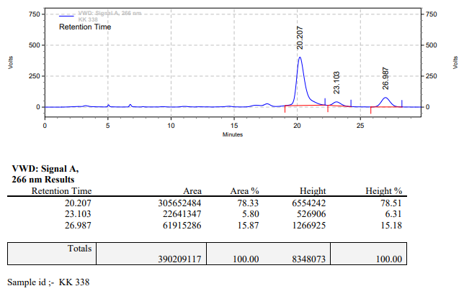

**KK-339**



**Calculation table:**

|  |  |  |  |  |  |
| --- | --- | --- | --- | --- | --- |
| Sr. No | Comp. | Mol. wt. | mmol | Eq. wt. | Wt. taken |
| 1 | Dehydrositagliptin (1) | 405.30 | 0.2135 | 100 | 86 mg |
| 2 | Rh(COD)2OTf | 468.30 | 0.0021 | 1 | 1 mg |
| 3 | L3 | 414.29 | 0.0021 | 1 | 0.9 mg |
| 4 | Ammonium chloride | 53.49 | 0.0210 | 10 | 1 mg |

**Procedure:** A glass vial (4 mL) equipped with Teflon coated magnetic needle was cooled under vacuum and transferred to a glove box. The vial was then charged with 86 mg of enamine (**1**), 1 mg of [Rh(COD)2OTf] (1 mol%), ligand (L3) and ammonium chloride. Reaction vial was then closed using screwcap, transferred to a large opening Schlenk type container and was then taken out from the glove box. 2 mL dry methanol was added to the vial in inert atmosphere and the resultant reaction slurry was stirred for 1 hour at room temperature (25°C). After that the reaction vial was shifted to an autoclave and the autoclave was purged three times using hydrogen gas (40 bars). Finally, the autoclave was pressurized to 40 bar hydrogen pressure at 70°C for 12 hrs time period. After the 12 hrs time period, the autoclave was cooled to room temperature (25°C), excess pressure was released and the autoclave was opened. The vials were taken out from the autoclave. The thus obtained reaction mixture was passed through neutral alumina bed, the filtrate was collect and dried to yield residue. The resultant residue was then analysed by HPLC.

**Reaction conditions:** Temp: 70°C Press.: 40 bar Solvent: Methanol Time: 12 hrs

**Result: 22%** conversion **83%** ee

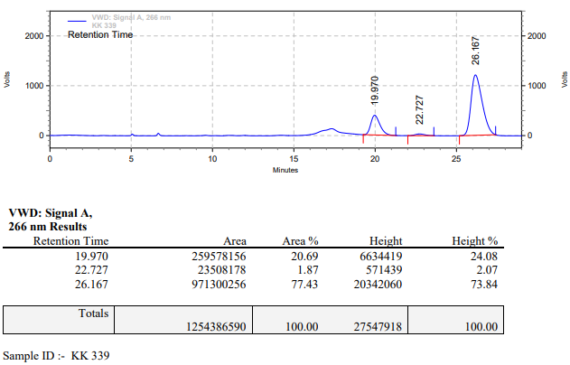

**KK-340**



**Calculation table:**

|  |  |  |  |  |  |
| --- | --- | --- | --- | --- | --- |
| Sr. No | Comp. | Mol. wt. | mmol | Eq. wt. | Wt. taken |
| 1 | Dehydrositagliptin (1) | 405.30 | 0.2135 | 100 | 86 mg |
| 2 | Rh(COD)2OTf | 468.30 | 0.0021 | 1 | 1 mg |
| 3 | L3 | 414.29 | 0.0042 | 2 | 1.8 mg |
| 4 | Ammonium chloride | 53.49 | 0.0210 | 10 | 1 mg |

**Procedure:** A glass vial (4 mL) equipped with Teflon coated magnetic needle was cooled under vacuum and transferred to a glove box. The vial was then charged with 86 mg of enamine (**1**), 1 mg of [Rh(COD)2OTf] (1 mol%), ligand (L3) and ammonium chloride. Reaction vial was then closed using screwcap, transferred to a large opening Schlenk type container and was then taken out from the glove box. 2 mL dry methanol was added to the vial in inert atmosphere and the resultant reaction slurry was stirred for 1 hour at room temperature (25°C). After that the reaction vial was shifted to an autoclave and the autoclave was purged three times using hydrogen gas (40 bars). Finally, the autoclave was pressurized to 40 bar hydrogen pressure at 70°C for 12 hrs time period. After the 12 hrs time period, the autoclave was cooled to room temperature (25°C), excess pressure was released and the autoclave was opened. The vials were taken out from the autoclave. The thus obtained reaction mixture was passed through neutral alumina bed, the filtrate was collect and dried to yield residue. The resultant residue was then analysed by HPLC.

**Reaction conditions:** Temp: 70°C Press.: 40 bar Solvent: Methanol Time: 12 hrs

**Result: 15%** conversion **93%** ee

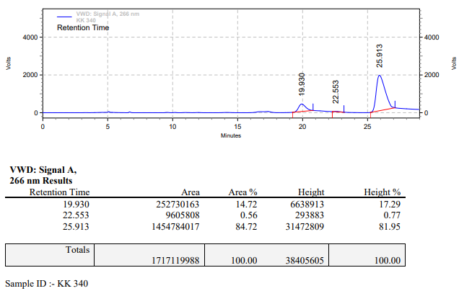

**KK-341**



**Calculation table:**

|  |  |  |  |  |  |
| --- | --- | --- | --- | --- | --- |
| Sr. No | Comp. | Mol. wt. | mmol | Eq. wt. | Wt. taken |
| 1 | Dehydrositagliptin (1) | 405.30 | 0.2135 | 100 | 86 mg |
| 2 | Rh(COD)2OTf | 468.30 | 0.0021 | 1 | 1 mg |
| 3 | L11 | 470.49 | 0.0021 | 1 | 1 mg |
| 4 | Ammonium chloride | 53.49 | 0.0210 | 10 | 1 mg |

**Procedure:** A glass vial (4 mL) equipped with Teflon coated magnetic needle was cooled under vacuum and transferred to a glove box. The vial was then charged with 86 mg of enamine (**1**), 1 mg of [Rh(COD)2OTf] (1 mol%), ligand (L11) and ammonium chloride. Reaction vial was then closed using screwcap, transferred to a large opening Schlenk type container and was then taken out from the glove box. 2 mL dry methanol was added to the vial in inert atmosphere and the resultant reaction slurry was stirred for 1 hour at room temperature (25°C). After that the reaction vial was shifted to an autoclave and the autoclave was purged three times using hydrogen gas (40 bars). Finally, the autoclave was pressurized to 40 bar hydrogen pressure at 70°C for 12 hrs time period. After the 12 hrs time period, the autoclave was cooled to room temperature (25°C), excess pressure was released and the autoclave was opened. The vials were taken out from the autoclave. The thus obtained reaction mixture was passed through neutral alumina bed, the filtrate was collect and dried to yield residue. The resultant residue was then analysed by HPLC.

**Reaction conditions:** Temp: 70°C Press.: 40 bar Solvent: Methanol Time: 12 hrs

**Result: 07%** conversion **80%** ee

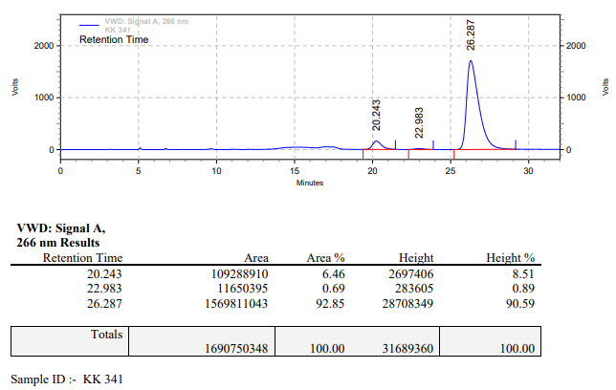

**KK-342**



**Calculation table:**

|  |  |  |  |  |  |
| --- | --- | --- | --- | --- | --- |
| Sr. No | Comp. | Mol. wt. | mmol | Eq. wt. | Wt. taken |
| 1 | Dehydrositagliptin (1) | 405.30 | 0.2135 | 100 | 86 mg |
| 2 | Rh(COD)2OTf | 468.30 | 0.0021 | 1 | 1 mg |
| 3 | L11 | 470.49 | 0.0042 | 2 | 2 mg |
| 4 | Ammonium chloride | 53.49 | 0.0210 | 10 | 1 mg |

**Procedure:** A glass vial (4 mL) equipped with Teflon coated magnetic needle was cooled under vacuum and transferred to a glove box. The vial was then charged with 86 mg of enamine (**1**), 1 mg of [Rh(COD)2OTf] (1 mol%), ligand (L11) and ammonium chloride. Reaction vial was then closed using screwcap, transferred to a large opening Schlenk type container and was then taken out from the glove box. 2 mL dry methanol was added to the vial in inert atmosphere and the resultant reaction slurry was stirred for 1 hour at room temperature (25°C). After that the reaction vial was shifted to an autoclave and the autoclave was purged three times using hydrogen gas (40 bars). Finally, the autoclave was pressurized to 40 bar hydrogen pressure at 70°C for 12 hrs time period. After the 12 hrs time period, the autoclave was cooled to room temperature (25°C), excess pressure was released and the autoclave was opened. The vials were taken out from the autoclave. The thus obtained reaction mixture was passed through neutral alumina bed, the filtrate was collect and dried to yield residue. The resultant residue was then analysed by HPLC.

**Reaction conditions:** Temp: 70°C Press.: 40 bar Solvent: Methanol Time: 12 hrs

**Result: 55%** conversion **84%** ee

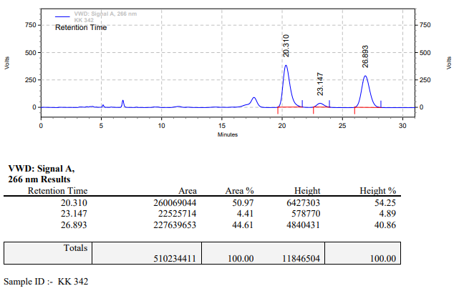

**KK-343**



**Calculation table:**

|  |  |  |  |  |  |
| --- | --- | --- | --- | --- | --- |
| Sr. No | Comp. | Mol. wt. | mmol | Eq. wt. | Wt. taken |
| 1 | Dehydrositagliptin (1) | 405.30 | 0.2135 | 100 | 86 mg |
| 2 | Rh(COD)2OTf | 468.30 | 0.0021 | 1 | 1 mg |
| 3 | L3 | 414.29 | 0.0021 | 1 | 0.9 mg |
| 4 | Ammonium chloride | 53.49 | 0.0210 | 10 | 1 mg |

**Procedure:** A glass vial (4 mL) equipped with Teflon coated magnetic needle was cooled under vacuum and transferred to a glove box. The vial was then charged with 86 mg of enamine (**1**), 1 mg of [Rh(COD)2OTf] (1 mol%), ligand (L3) and ammonium chloride. Reaction vial was then closed using screwcap, transferred to a large opening Schlenk type container and was then taken out from the glove box. 2 mL dry methanol was added to the vial in inert atmosphere and the resultant reaction slurry was stirred for 1 hour at room temperature (25°C). After that the reaction vial was shifted to an autoclave and the autoclave was purged three times using hydrogen gas (40 bars). Finally, the autoclave was pressurized to 30 bar hydrogen pressure at 70°C for 12 hrs time period. After the 12 hrs time period, the autoclave was cooled to room temperature (25°C), excess pressure was released and the autoclave was opened. The vials were taken out from the autoclave. The thus obtained reaction mixture was passed through neutral alumina bed, the filtrate was collect and dried to yield residue. The resultant residue was then analysed by HPLC.

**Reaction conditions:** Temp: 70°C Press.: 30 bar Solvent: Methanol Time: 12 hrs

**Result: 20%** conversion **89%** ee

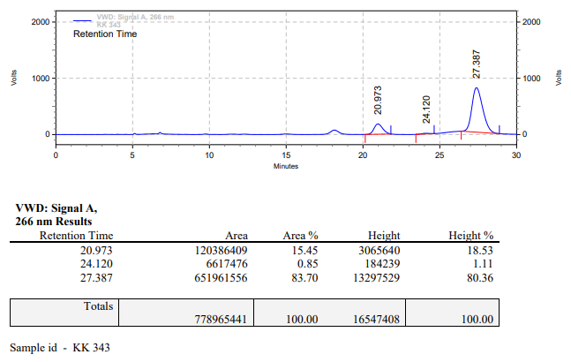

**KK-344**



**Calculation table:**

|  |  |  |  |  |  |
| --- | --- | --- | --- | --- | --- |
| Sr. No | Comp. | Mol. wt. | mmol | Eq. wt. | Wt. taken |
| 1 | Dehydrositagliptin (1) | 405.30 | 0.2135 | 100 | 86 mg |
| 2 | Rh(COD)2OTf | 468.30 | 0.0021 | 1 | 1 mg |
| 3 | L3 | 414.29 | 0.0021 | 1 | 0.9 mg |
| 4 | Ammonium chloride | 53.49 | 0.0210 | 10 | 1 mg |

**Procedure:** A glass vial (4 mL) equipped with Teflon coated magnetic needle was cooled under vacuum and transferred to a glove box. The vial was then charged with 86 mg of enamine (**1**), 1 mg of [Rh(COD)2OTf] (1 mol%), ligand (L3) and ammonium chloride. Reaction vial was then closed using screwcap, transferred to a large opening Schlenk type container and was then taken out from the glove box. 2 mL dry methanol was added to the vial in inert atmosphere and the resultant reaction slurry was stirred for 1 hour at room temperature (25°C). After that the reaction vial was shifted to an autoclave and the autoclave was purged three times using hydrogen gas (40 bars). Finally, the autoclave was pressurized to 30 bar hydrogen pressure at 70°C for 12 hrs time period. After the 12 hrs time period, the autoclave was cooled to room temperature (25°C), excess pressure was released and the autoclave was opened. The vials were taken out from the autoclave. The thus obtained reaction mixture was passed through neutral alumina bed, the filtrate was collect and dried to yield residue. The resultant residue was then analysed by HPLC.

**Reaction conditions:** Temp: 70°C Press.: 30 bar Solvent: Methanol Time: 12 hrs

**Result: 44%** conversion **85%** ee

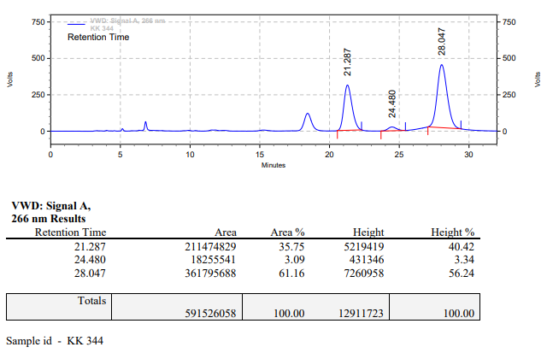

**KK-345**



**Calculation table:**

|  |  |  |  |  |  |
| --- | --- | --- | --- | --- | --- |
| Sr. No | Comp. | Mol. wt. | mmol | Eq. wt. | Wt. taken |
| 1 | Dehydrositagliptin (1) | 405.30 | 0.2135 | 100 | 86 mg |
| 2 | Rh(COD)2OTf | 468.30 | 0.0021 | 1 | 1 mg |
| 3 | L3 | 414.29 | 0.0021 | 1 | 0.9 mg |
| 4 | Ammonium chloride | 53.49 | 0.0210 | 10 | 1 mg |

**Procedure:** A glass vial (4 mL) equipped with Teflon coated magnetic needle was cooled under vacuum and transferred to a glove box. The vial was then charged with 86 mg of enamine (**1**), 1 mg of [Rh(COD)2OTf] (1 mol%), ligand (L3) and ammonium chloride. Reaction vial was then closed using screwcap, transferred to a large opening Schlenk type container and was then taken out from the glove box. 2 mL dry methanol was added to the vial in inert atmosphere and the resultant reaction slurry was stirred for 1 hour at room temperature (25°C). After that the reaction vial was shifted to an autoclave and the autoclave was purged three times using hydrogen gas (40 bars). Finally, the autoclave was pressurized to 40 bar hydrogen pressure at 70°C for 12 hrs time period. After the 12 hrs time period, the autoclave was cooled to room temperature (25°C), excess pressure was released and the autoclave was opened. The vials were taken out from the autoclave. The thus obtained reaction mixture was passed through neutral alumina bed, the filtrate was collect and dried to yield residue. The resultant residue was then analysed by HPLC.

**Reaction conditions:** Temp: 70°C Press.: 40 bar Solvent: Methanol Time: 12 hrs

**Result: 31%** conversion **86%** ee

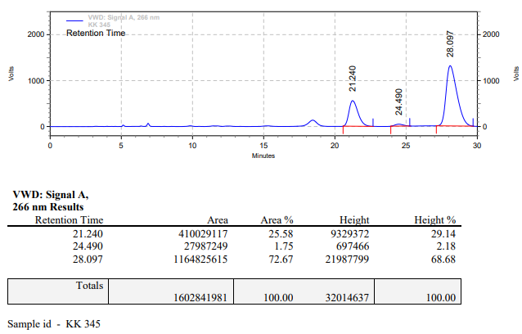

**KK-346**



**Calculation table:**

|  |  |  |  |  |  |
| --- | --- | --- | --- | --- | --- |
| Sr. No | Comp. | Mol. wt. | mmol | Eq. wt. | Wt. taken |
| 1 | Dehydrositagliptin (1) | 405.30 | 0.2135 | 100 | 86 mg |
| 2 | Rh(COD)2OTf | 468.30 | 0.0021 | 1 | 1 mg |
| 3 | L3 | 414.29 | 0.0042 | 2 | 1.8 mg |
| 4 | Ammonium chloride | 53.49 | 0.0210 | 10 | 1 mg |

**Procedure:** A glass vial (4 mL) equipped with Teflon coated magnetic needle was cooled under vacuum and transferred to a glove box. The vial was then charged with 86 mg of enamine (**1**), 1 mg of [Rh(COD)2OTf] (1 mol%), ligand (L3) and ammonium chloride. Reaction vial was then closed using screwcap, transferred to a large opening Schlenk type container and was then taken out from the glove box. 2 mL dry methanol was added to the vial in inert atmosphere and the resultant reaction slurry was stirred for 1 hour at room temperature (25°C). After that the reaction vial was shifted to an autoclave and the autoclave was purged three times using hydrogen gas (40 bars). Finally, the autoclave was pressurized to 30 bar hydrogen pressure at 70°C for 12 hrs time period. After the 12 hrs time period, the autoclave was cooled to room temperature (25°C), excess pressure was released and the autoclave was opened. The vials were taken out from the autoclave. The thus obtained reaction mixture was passed through neutral alumina bed, the filtrate was collect and dried to yield residue. The resultant residue was then analysed by HPLC.

**Reaction conditions:** Temp: 70°C Press.: 30 bar Solvent: Methanol Time: 12 hrs

**Result: 74%** conversion **86%** ee

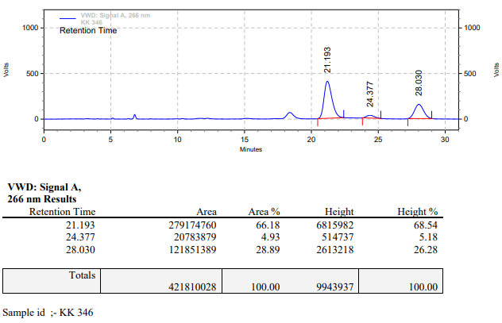

**KK-347**



**Calculation table:**

|  |  |  |  |  |  |
| --- | --- | --- | --- | --- | --- |
| Sr. No | Comp. | Mol. wt. | mmol | Eq. wt. | Wt. taken |
| 1 | Dehydrositagliptin (1) | 405.30 | 0.2135 | 100 | 86 mg |
| 2 | Rh(COD)2OTf | 468.30 | 0.0021 | 1 | 1 mg |
| 3 | L11 | 414.29 | 0.0021 | 1 | 1 mg |
| 4 | Ammonium chloride | 53.49 | 0.0210 | 10 | 1 mg |

**Procedure:** A glass vial (4 mL) equipped with Teflon coated magnetic needle was cooled under vacuum and transferred to a glove box. The vial was then charged with 86 mg of enamine (**1**), 1 mg of [Rh(COD)2OTf] (1 mol%), ligand (L11) and ammonium chloride. Reaction vial was then closed using screwcap, transferred to a large opening Schlenk type container and was then taken out from the glove box. 2 mL dry methanol was added to the vial in inert atmosphere and the resultant reaction slurry was stirred for 1 hour at room temperature (25°C). After that the reaction vial was shifted to an autoclave and the autoclave was purged three times using hydrogen gas (40 bars). Finally, the autoclave was pressurized to 30 bar hydrogen pressure at 70°C for 12 hrs time period. After the 12 hrs time period, the autoclave was cooled to room temperature (25°C), excess pressure was released and the autoclave was opened. The vials were taken out from the autoclave. The thus obtained reaction mixture was passed through neutral alumina bed, the filtrate was collect and dried to yield residue. The resultant residue was then analysed by HPLC.

**Reaction conditions:** Temp: 70°C Press.: 30 bar Solvent: Methanol Time: 12 hrs

**Result: 18%** conversion **84%** ee

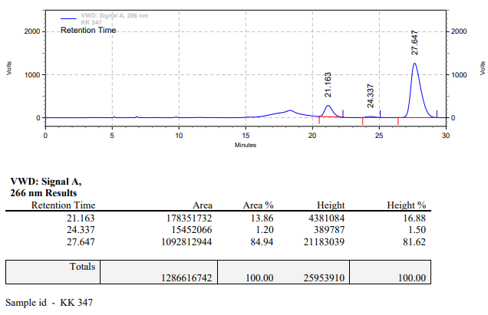

**KK-348**



**Calculation table:**

|  |  |  |  |  |  |
| --- | --- | --- | --- | --- | --- |
| Sr. No | Comp. | Mol. wt. | mmol | Eq. wt. | Wt. taken |
| 1 | Dehydrositagliptin (1) | 405.30 | 0.2135 | 100 | 86 mg |
| 2 | Rh(COD)2OTf | 468.30 | 0.0021 | 1 | 1 mg |
| 3 | L11 | 414.29 | 0.0042 | 2 | 2 mg |
| 4 | Ammonium chloride | 53.49 | 0.0210 | 10 | 1 mg |

**Procedure:** A glass vial (4 mL) equipped with Teflon coated magnetic needle was cooled under vacuum and transferred to a glove box. The vial was then charged with 86 mg of enamine (**1**), 1 mg of [Rh(COD)2OTf] (1 mol%), ligand (L11) and ammonium chloride. Reaction vial was then closed using screwcap, transferred to a large opening Schlenk type container and was then taken out from the glove box. 2 mL dry methanol was added to the vial in inert atmosphere and the resultant reaction slurry was stirred for 1 hour at room temperature (25°C). After that the reaction vial was shifted to an autoclave and the autoclave was purged three times using hydrogen gas (40 bars). Finally, the autoclave was pressurized to 30 bar hydrogen pressure at 70°C for 12 hrs time period. After the 12 hrs time period, the autoclave was cooled to room temperature (25°C), excess pressure was released and the autoclave was opened. The vials were taken out from the autoclave. The thus obtained reaction mixture was passed through neutral alumina bed, the filtrate was collect and dried to yield residue. The resultant residue was then analysed by HPLC.

**Reaction conditions:** Temp: 70°C Press.: 30 bar Solvent: Methanol Time: 12 hrs

**Result: 18%** conversion **83%** ee

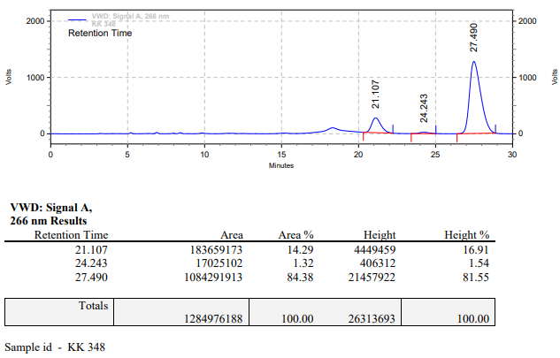

**KK-349**



**Calculation table:**

|  |  |  |  |  |  |
| --- | --- | --- | --- | --- | --- |
| Sr. No | Comp. | Mol. wt. | mmol | Eq. wt. | Wt. taken |
| 1 | Dehydrositagliptin (1) | 405.30 | 0.2135 | 100 | 86 mg |
| 2 | Rh(COD)2OTf | 468.30 | 0.0021 | 1 | 1 mg |
| 3 | L3 | 414.29 | 0.0021 | 1 | 0.9 mg |
| 4 | Boric acid | 61.83 | 0.0215 | 10 | 1.3 mg |

**Procedure:** A glass vial (4 mL) equipped with Teflon coated magnetic needle was cooled under vacuum and transferred to a glove box. The vial was then charged with 86 mg of enamine (**1**), 1 mg of [Rh(COD)2OTf] (1 mol%), ligand (L3) and boric acid. Reaction vial was then closed using screwcap, transferred to a large opening Schlenk type container and was then taken out from the glove box. 2 mL dry methanol was added to the vial in inert atmosphere and the resultant reaction slurry was stirred for 1 hour at room temperature (25°C). After that the reaction vial was shifted to an autoclave and the autoclave was purged three times using hydrogen gas (40 bars). Finally, the autoclave was pressurized to 30 bar hydrogen pressure at 70°C for 24 hrs time period. After the 24 hrs time period, the autoclave was cooled to room temperature (25°C), excess pressure was released and the autoclave was opened. The vials were taken out from the autoclave. The thus obtained reaction mixture was passed through neutral alumina bed, the filtrate was collect and dried to yield residue. The resultant residue was then analysed by HPLC.

**Reaction conditions:** Temp: 70°C Press.: 30 bar Solvent: Methanol Time: 24 hrs

**Result: 50%** conversion **83%** ee

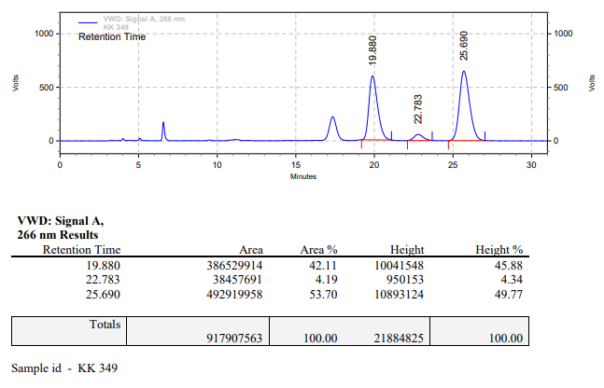

**KK-350**



**Calculation table:**

|  |  |  |  |  |  |
| --- | --- | --- | --- | --- | --- |
| Sr. No | Comp. | Mol. wt. | mmol | Eq. wt. | Wt. taken |
| 1 | Dehydrositagliptin (1) | 405.30 | 0.2135 | 100 | 86 mg |
| 2 | Rh(COD)2OTf | 468.30 | 0.0021 | 1 | 1 mg |
| 3 | L3 | 414.29 | 0.0021 | 2 | 1.8 mg |
| 4 | Potassium bisulphate | 136.17 | 0.0420 | 20 | 5.8 mg |

**Procedure:** A glass vial (4 mL) equipped with Teflon coated magnetic needle was cooled under vacuum and transferred to a glove box. The vial was then charged with 86 mg of enamine (**1**), 1 mg of [Rh(COD)2OTf] (1 mol%), ligand (L3) and potassium bisulphate. Reaction vial was then closed using screwcap, transferred to a large opening Schlenk type container and was then taken out from the glove box. 2 mL dry methanol was added to the vial in inert atmosphere and the resultant reaction slurry was stirred for 1 hour at room temperature (25°C). After that the reaction vial was shifted to an autoclave and the autoclave was purged three times using hydrogen gas (40 bars). Finally, the autoclave was pressurized to 30 bar hydrogen pressure at 70°C for 24 hrs time period. After the 24 hrs time period, the autoclave was cooled to room temperature (25°C), excess pressure was released and the autoclave was opened. The vials were taken out from the autoclave. The thus obtained reaction mixture was passed through neutral alumina bed, the filtrate was collect and dried to yield residue. The resultant residue was then analysed by HPLC.

**Reaction conditions:** Temp: 70°C Press.: 30 bar Solvent: Methanol Time: 24 hrs

**Result: 86%** conversion 84**%** ee

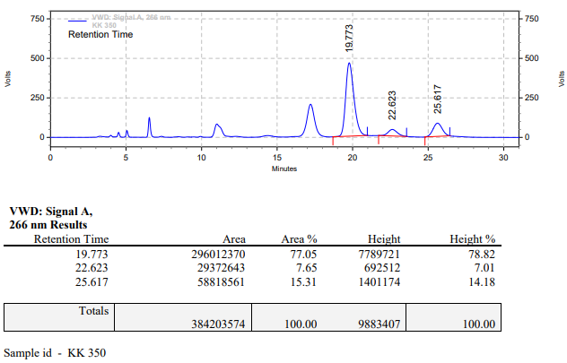

**KK-351**



**Calculation table:**

|  |  |  |  |  |  |
| --- | --- | --- | --- | --- | --- |
| Sr. No | Comp. | Mol. wt. | mmol | Eq. wt. | Wt. taken |
| 1 | Dehydrositagliptin (1) | 405.30 | 0.2135 | 100 | 86 mg |
| 2 | Rh(COD)2OTf | 468.30 | 0.0021 | 1 | 1 mg |
| 3 | L11 | 470.39 | 0.0021 | 1 | 1 mg |
| 4 | Potassium bisulphate | 136.17 | 0.0420 | 20 | 5.8 mg |

**Procedure:** A glass vial (4 mL) equipped with Teflon coated magnetic needle was cooled under vacuum and transferred to a glove box. The vial was then charged with 86 mg of enamine (**1**), 1 mg of [Rh(COD)2OTf] (1 mol%), ligand (L11) and potassium bisulphate. Reaction vial was then closed using screwcap, transferred to a large opening Schlenk type container and was then taken out from the glove box. 2 mL dry methanol was added to the vial in inert atmosphere and the resultant reaction slurry was stirred for 1 hour at room temperature (25°C). After that the reaction vial was shifted to an autoclave and the autoclave was purged three times using hydrogen gas (40 bars). Finally, the autoclave was pressurized to 30 bar hydrogen pressure at 70°C for 24 hrs time period. After the 24 hrs time period, the autoclave was cooled to room temperature (25°C), excess pressure was released and the autoclave was opened. The vials were taken out from the autoclave. The thus obtained reaction mixture was passed through neutral alumina bed, the filtrate was collect and dried to yield residue. The resultant residue was then analysed by HPLC.

**Reaction conditions:** Temp: 70°C Press.: 30 bar Solvent: Methanol Time: 24 hrs

**Result: 81%** conversion **82%** ee

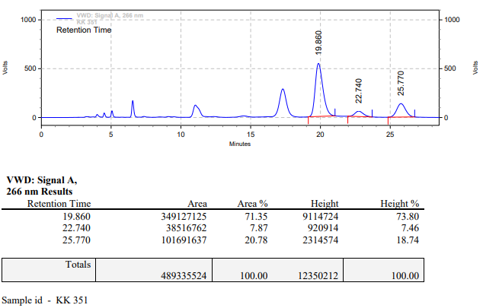

**KK-352**



**Calculation table:**

|  |  |  |  |  |  |
| --- | --- | --- | --- | --- | --- |
| Sr. No | Comp. | Mol. wt. | mmol | Eq. wt. | Wt. taken |
| 1 | Dehydrositagliptin (1) | 405.30 | 0.2135 | 100 | 86 mg |
| 2 | Rh(COD)2OTf | 468.30 | 0.0021 | 1 | 1 mg |
| 3 | L11 | 470.39 | 0.0042 | 2 | 2 mg |
| 4 | Boric acid | 61.83 | 0.0213 | 10 | 1.3 mg |

**Procedure:** A glass vial (4 mL) equipped with Teflon coated magnetic needle was cooled under vacuum and transferred to a glove box. The vial was then charged with 86 mg of enamine (**1**), 1 mg of [Rh(COD)2OTf], ligand (L11) and boric acid. Reaction vial was then closed using screwcap, transferred to a large opening Schlenk type container and was then taken out from the glove box. 2 mL dry methanol was added to the vial in inert atmosphere and the resultant reaction slurry was stirred for 1 hour at room temperature (25°C). After that the reaction vial was shifted to an autoclave and the autoclave was purged three times using hydrogen gas (40 bars). Finally, the autoclave was pressurized to 30 bar hydrogen pressure at 70°C for 24 hrs time period. After the 24 hrs time period, the autoclave was cooled to room temperature (25°C), excess pressure was released and the autoclave was opened. The vials were taken out from the autoclave. The thus obtained reaction mixture was passed through neutral alumina bed, the filtrate was collect and dried to yield residue. The resultant residue was then analysed by HPLC.

**Reaction conditions:** Temp: 70°C Press.: 30 bar Solvent: Methanol Time: 24 hrs

**Result: 73%** conversion **81%** ee

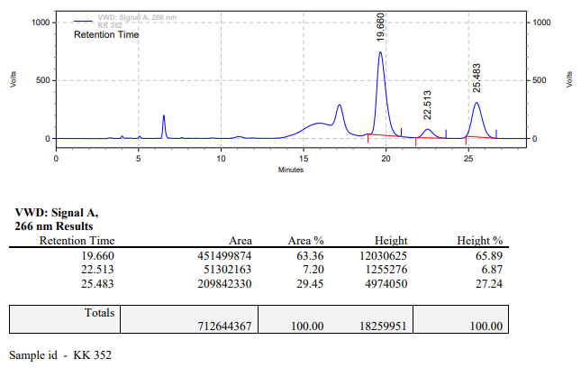

**KK-353**



**Calculation table:**

|  |  |  |  |  |  |
| --- | --- | --- | --- | --- | --- |
| Sr. No | Comp. | Mol. wt. | mmol | Eq. wt. | Wt. taken |
| 1 | Dehydrositagliptin (1) | 405.30 | 0.2135 | 100 | 86 mg |
| 2 | Rh(COD)2OTf | 468.30 | 0.0021 | 1 | 1 mg |
| 3 | L3 | 414.29 | 0.0021 | 1 | 0.9 mg |
| 4 | Boric acid | 61.83 | 0.0215 | 10 | 1.3 mg |

**Procedure:** A glass vial (4 mL) equipped with Teflon coated magnetic needle was cooled under vacuum and transferred to a glove box. The vial was then charged with 86 mg of enamine (**1**), 1 mg of [Rh(COD)2OTf] (1 mol%), ligand (L3) and boric acid. Reaction vial was then closed using screwcap, transferred to a large opening Schlenk type container and was then taken out from the glove box. 2 mL dry methanol was added to the vial in inert atmosphere and the resultant reaction slurry was stirred for 1 hour at room temperature (25°C). After that the reaction vial was shifted to an autoclave and the autoclave was purged three times using hydrogen gas (40 bars). Finally, the autoclave was pressurized to 30 bar hydrogen pressure at 70°C for 24 hrs time period. After the 24 hrs time period, the autoclave was cooled to room temperature (25°C), excess pressure was released and the autoclave was opened. The vials were taken out from the autoclave. The thus obtained reaction mixture was passed through neutral alumina bed, the filtrate was collect and dried to yield residue. The resultant residue was then analysed by HPLC.

**Reaction conditions:** Temp: 70°C Press.: 30 bar Solvent: Methanol Time: 24 hrs

**Result: 00%** conversion **00%** ee

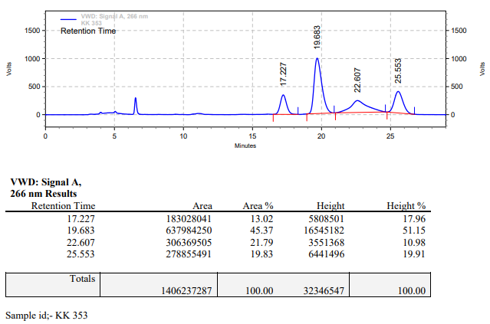

**KK-355**



**Calculation table:**

|  |  |  |  |  |  |
| --- | --- | --- | --- | --- | --- |
| Sr. No | Comp. | Mol. wt. | mmol | Eq. wt. | Wt. taken |
| 1 | Dehydrositagliptin (1) | 405.30 | 0.2135 | 100 | 86 mg |
| 2 | Rh(COD)2OTf | 468.30 | 0.0021 | 1 | 1 mg |
| 3 | L3 | 414.29 | 0.0021 | 1 | 0.9 mg |
| 4 | Ammonium chloride | 53.49 | 0.0215 | 10 | 1 mg |

**Procedure:** A glass vial (4 mL) equipped with Teflon coated magnetic needle was cooled under vacuum and transferred to a glove box. The vial was then charged with 86 mg of enamine (**1**), 1 mg of [Rh(COD)2OTf] (1 mol%), ligand (L3) and ammonium chloride. Reaction vial was then closed using screwcap, transferred to a large opening Schlenk type container and was then taken out from the glove box. 2 mL dry methanol was added to the vial in inert atmosphere and the resultant reaction slurry was stirred for 1 hour at room temperature (25°C). After that the reaction vial was shifted to an autoclave and the autoclave was purged three times using hydrogen gas (50 bars). Finally, the autoclave was pressurized to 50 bar hydrogen pressure at 70°C for 24 hrs time period. After the 24 hrs time period, the autoclave was cooled to room temperature (25°C), excess pressure was released and the autoclave was opened. The vials were taken out from the autoclave. The thus obtained reaction mixture was passed through neutral alumina bed, the filtrate was collect and dried to yield residue. The resultant residue was then analysed by HPLC.

**Reaction conditions:** Temp: 70°C Press.: 50 bar Solvent: Methanol Time: 24 hrs

**Result: 65%** conversion **83%** ee

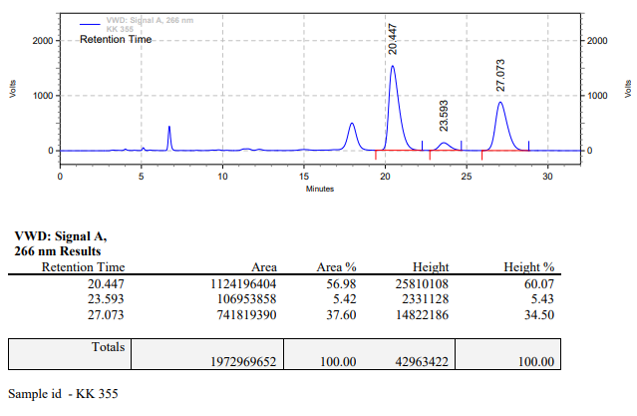

**KK-356**



**Calculation table:**

|  |  |  |  |  |  |
| --- | --- | --- | --- | --- | --- |
| Sr. No | Comp. | Mol. wt. | mmol | Eq. wt. | Wt. taken |
| 1 | Dehydrositagliptin (1) | 405.30 | 2.4770 | 1 | 1000 mg |
| 2 | Rh(COD)2OTf | 468.30 | 0.0247 | 1 mol% | 12 mg |
| 3 | L3 | 414.29 | 0.0247 | 1 mol% | 11 mg |
| 4 | Phosphoric acid | 97.99 | 0.1238 | 5 mol% | 12 mg |

**Procedure:** A high pressure Parr reactor (100 mL) equipped with Teflon coated magnetic needle was charged with 1 g of enamine (**1**), under argon atmosphere. Subsequently, 12 mg of [Rh(COD)2OTf] (1 mol%) and 11 mg of ligand **L3** was added to the above reactor. 20 mL dry methanol was added followed by phosphoric acid to the reactor in inert atmosphere and the resultant reaction slurry was stirred for 1 hour at room temperature (25 °C). After that the autoclave was purged three times using hydrogen gas (40 bars). Finally, the autoclave was pressurized to 30 bar hydrogen pressure at 75°C for 24 hrs time period. After the 24 hrs time period, the autoclave was cooled to room temperature (25 °C), excess pressure was released and the autoclave was opened. The thus obtained reaction mixture was passed through neutral alumina bed, the filtrate was collect and dried to yield residue. The resultant residue was then analysed by HPLC.

**Reaction conditions:** Temp: 75°C Press.: 30 bar Solvent: methanol Time: 24 hrs

**Result: 65%** conversion **85%** ee

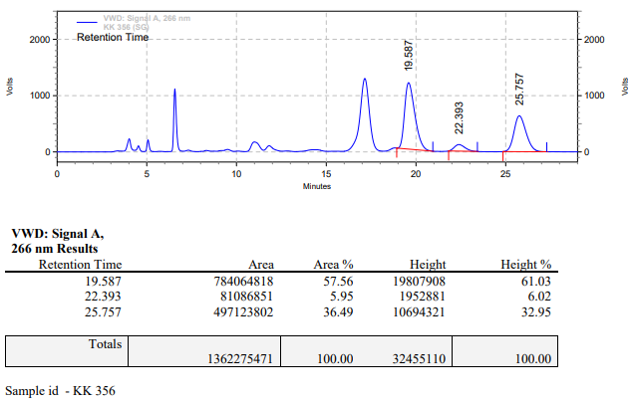

**KK-357**



**Calculation table:**

|  |  |  |  |  |  |
| --- | --- | --- | --- | --- | --- |
| Sr. No | Comp. | Mol. wt. | mmol | Eq. wt. | Wt. taken |
| 1 | Dehydrositagliptin (1) | 405.30 | 0.2135 | 100 | 86 mg |
| 2 | Rh(COD)2OTf | 468.30 | 0.0021 | 1 | 1 mg |
| 3 | L3 | 414.29 | 0.0021 | 1 | 0.9 mg |
| 4 | Ammonium chloride | 53.49 | 0.0215 | 10 | 1 mg |

**Procedure:** A glass vial (4 mL) equipped with Teflon coated magnetic needle was cooled under vacuum and transferred to a glove box. The vial was then charged with 86 mg of enamine (**1**), 1 mg of [Rh(COD)2OTf] (1 mol%), ligand (L3) and ammonium chloride. Reaction vial was then closed using screwcap, transferred to a large opening Schlenk type container and was then taken out from the glove box. 2 mL dry methanol was added to the vial in inert atmosphere and the resultant reaction slurry was stirred for 1 hour at room temperature (25°C). After that the reaction vial was shifted to an autoclave and the autoclave was purged three times using hydrogen gas (40 bars). Finally, the autoclave was pressurized to 30 bar hydrogen pressure at 70°C for 24 hrs time period. After the 24 hrs time period, the autoclave was cooled to room temperature (25°C), excess pressure was released and the autoclave was opened. The vials were taken out from the autoclave. The thus obtained reaction mixture was passed through neutral alumina bed, the filtrate was collect and dried to yield residue. The resultant residue was then analysed by HPLC.

**Reaction conditions:** Temp: 70°C Press.: 30 bar Solvent: Methanol Time: 24 hrs

**Result: 00%** conversion **00%** ee

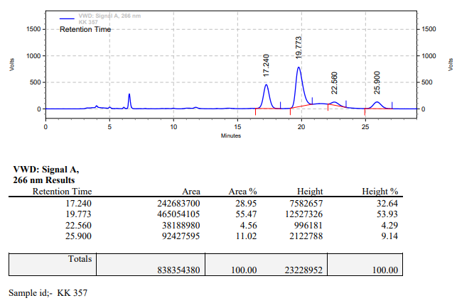

**KK-358**



**Calculation table:**

|  |  |  |  |  |  |
| --- | --- | --- | --- | --- | --- |
| Sr. No | Comp. | Mol. wt. | mmol | Eq. wt. | Wt. taken |
| 1 | Dehydrositagliptin (1) | 405.30 | 0.2135 | 100 | 86 mg |
| 2 | Rh(COD)2OTf | 468.30 | 0.0021 | 1 | 1 mg |
| 3 | L11 | 414.29 | 0.0021 | 1 | 1 mg |
| 4 | Ammonium chloride | 53.49 | 0.0215 | 10 | 1 mg |

**Procedure:** A glass vial (4 mL) equipped with Teflon coated magnetic needle was cooled under vacuum and transferred to a glove box. The vial was then charged with 86 mg of enamine (**1**), 1 mg of [Rh(COD)2OTf] (1 mol%), ligand (L11) and ammonium chloride. Reaction vial was then closed using screwcap, transferred to a large opening Schlenk type container and was then taken out from the glove box. 2 mL dry methanol was added to the vial in inert atmosphere and the resultant reaction slurry was stirred for 1 hour at room temperature (25°C). After that the reaction vial was shifted to an autoclave and the autoclave was purged three times using hydrogen gas (40 bars). Finally, the autoclave was pressurized to 30 bar hydrogen pressure at 70°C for 24 hrs time period. After the 24 hrs time period, the autoclave was cooled to room temperature (25°C), excess pressure was released and the autoclave was opened. The vials were taken out from the autoclave. The thus obtained reaction mixture was passed through neutral alumina bed, the filtrate was collect and dried to yield residue. The resultant residue was then analysed by HPLC.

**Reaction conditions:** Temp: 70°C Press.: 30 bar Solvent: Methanol Time: 24 hrs

**Result: 00%** conversion **00%** ee

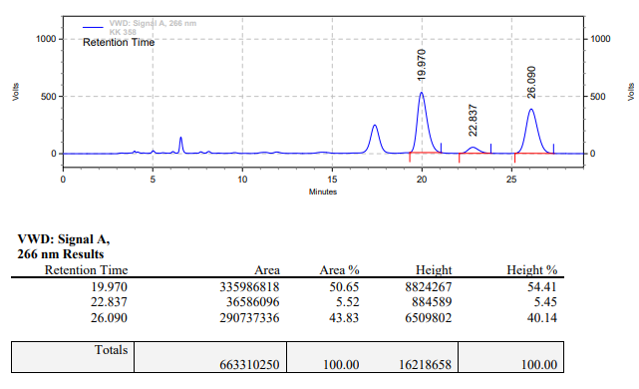

**KK-360**



**Calculation table:**

|  |  |  |  |  |  |
| --- | --- | --- | --- | --- | --- |
| Sr. No | Comp. | Mol. wt. | mmol | Eq. wt. | Wt. taken |
| 1 | Dehydrositagliptin (1) | 405.30 | 0.2135 | 100 | 86 mg |
| 2 | Rh(COD)2OTf | 468.30 | 0.0021 | 1 | 1 mg |
| 3 | tBu-Josiphos | 542.45 | 0.0021 | 1 | 1.1 mg |
| 4 | Ammonium chloride | 53.49 | 0.0213 | 10 | 1 mg |

**Procedure:** A glass vial (4 mL) equipped with Teflon coated magnetic needle was cooled under vacuum and transferred to a glove box. The vial was then charged with 86 mg of enamine (**1**), 1 mg of [Rh(COD)OTf], tBu-Josiphos and ammonium chloride. Reaction vial was then closed using screwcap, transferred to a large opening Schlenk type container and was then taken out from the glove box. 2 mL dry methanol was added to the vial in inert atmosphere and the resultant reaction slurry was stirred for 1 hour at room temperature (25 °C). After that the reaction vial was shifted to an autoclave and the autoclave was purged three times using hydrogen gas (40 bars). Finally, the autoclave was pressurized to 30 bar hydrogen pressure at 70°C for 24 hrs time period. After the 24 hrs time period, the autoclave was cooled to room temperature (25 °C), excess pressure was released and the autoclave was opened. The vials were taken out from the autoclave. The thus obtained reaction mixture was passed through neutral alumina bed, the filtrate was collect and dried to yield residue. The resultant residue was then analysed by HPLC.

**Reaction conditions:** Temp: 70°C Press.: 30 bar Solvent: Methanol Time: 24 hrs

**Result: 88%** conversion **96%** ee

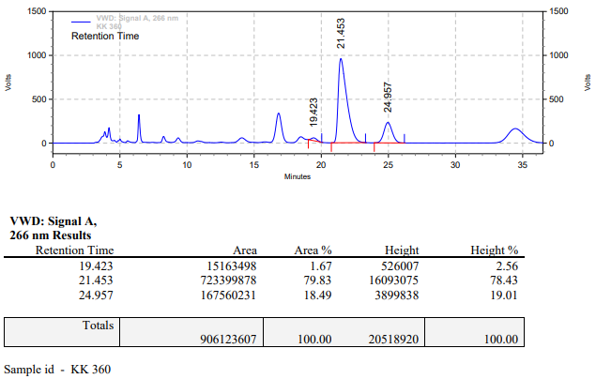

**KK-361**



**Calculation table:**

|  |  |  |  |  |  |
| --- | --- | --- | --- | --- | --- |
| Sr. No | Comp. | Mol. wt. | mmol | Eq. wt. | Wt. taken |
| 1 | Dehydrositagliptin (1) | 405.30 | 0.2135 | 100 | 86 mg |
| 2 | Rh(COD)2OTf | 468.30 | 0.0021 | 1 | 1 mg |
| 3 | tBu-Josiphos | 542.45 | 0.0021 | 1 | 1.1 mg |
| 4 | Ammonium chloride | 53.49 | 0.0213 | 10 | 1 mg |

**Procedure:** A glass vial (4 mL) equipped with Teflon coated magnetic needle was cooled under vacuum and transferred to a glove box. The vial was then charged with 86 mg of enamine (**1**), 1 mg of [Rh(COD)OTf], tBu-Josiphos and ammonium chloride. Reaction vial was then closed using screwcap, transferred to a large opening Schlenk type container and was then taken out from the glove box. 2 mL dry methanol was added to the vial in inert atmosphere and the resultant reaction slurry was stirred for 1 hour at room temperature (25 °C). After that the reaction vial was shifted to an autoclave and the autoclave was purged three times using hydrogen gas (40 bars). Finally, the autoclave was pressurized to 30 bar hydrogen pressure at 70°C for 24 hrs time period. After the 24 hrs time period, the autoclave was cooled to room temperature (25 °C), excess pressure was released and the autoclave was opened. The vials were taken out from the autoclave. The thus obtained reaction mixture was passed through neutral alumina bed, the filtrate was collect and dried to yield residue. The resultant residue was then analysed by HPLC.

**Reaction conditions:** Temp: 70°C Press.: 30 bar Solvent: Methanol Time: 24 hrs

**Result: 97%** conversion **96%** ee

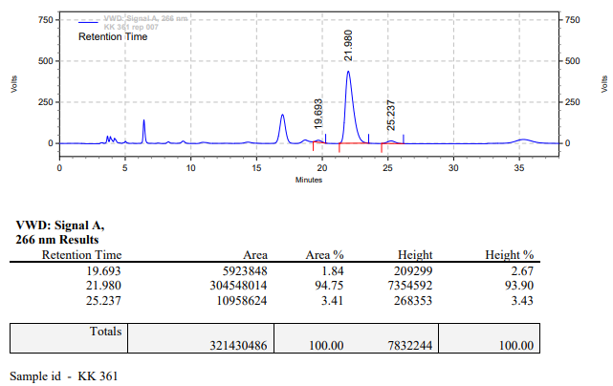

**KK-363**



**Calculation table:**

|  |  |  |  |  |  |
| --- | --- | --- | --- | --- | --- |
| Sr. No | Comp. | Mol. wt. | mmol | Eq. wt. | Wt. taken |
| 1 | Dehydrositagliptin (1) | 405.30 | 2.4770 | 1 | 1000 mg |
| 2 | Rh(COD)2OTf | 468.30 | 0.0247 | 1 mol% | 12 mg |
| 3 | L3 | 414.29 | 0.0247 | 1 mol% | 11 mg |
| 4 | Phosphoric acid | 97.99 | 0.3715 | 15 mol% | 36 mg |

**Procedure:** A high pressure Parr reactor (100 mL) equipped with Teflon coated magnetic needle was charged with 1 g of enamine (**1**), under argon atmosphere. Subsequently, 12 mg of [Rh(COD)2OTf] (1 mol%) and 11 mg of ligand **L3** was added to the above reactor. 20 mL dry methanol was added followed by phosphoric acid to the reactor in inert atmosphere and the resultant reaction slurry was stirred for 1 hour at room temperature (25 °C). After that the autoclave was purged three times using hydrogen gas (40 bars). Finally, the autoclave was pressurized to 30 bar hydrogen pressure at 70°C for 24 hrs time period. After the 24 hrs time period, the autoclave was cooled to room temperature (25 °C), excess pressure was released and the autoclave was opened. The thus obtained reaction mixture was passed through neutral alumina bed, the filtrate was collect and dried to yield residue. The resultant residue was then analysed by HPLC.

**Reaction conditions:** Temp: 70°C Press.: 30 bar Solvent: methanol Time: 24 hrs

**Result: 34%** conversion **56%** ee

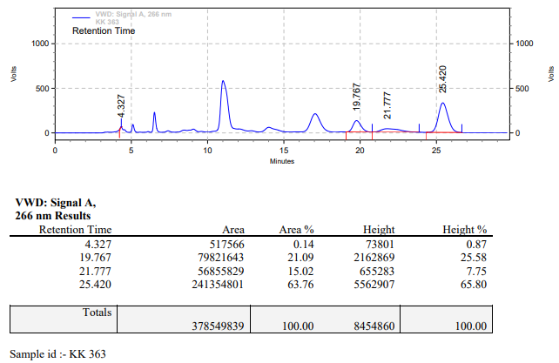

**KK-364**



**Calculation table:**

|  |  |  |  |  |  |
| --- | --- | --- | --- | --- | --- |
| Sr. No | Comp. | Mol. wt. | mmol | Eq. wt. | Wt. taken |
| 1 | Dehydrositagliptin (1) | 405.30 | 24.6730 | 1 | 10,000 mg |
| 2 | Rh(COD)2OTf | 468.30 | 0.2467 | 1 mol% | 115 mg |
| 3 | L3 | 414.29 | 0.2467 | 1 mol% | 102 mg |
| 4 | Phosphoric acid | 97.99 | 3.7009 | 15 mol% | 362 mg |

**Procedure:** A high pressure Parr reactor (450 mL) equipped with Teflon coated magnetic needle was charged with 10 g of enamine (**1**), under argon atmosphere. Subsequently, 115 mg of [Rh(COD)2OTf] (1 mol%) and 102 mg of ligand **L3** was added to the above reactor. 200 mL dry methanol was added followed by phosphoric acid to the reactor in inert atmosphere and the resultant reaction slurry was stirred for 1 hour at room temperature (25 °C). After that the autoclave was purged three times using hydrogen gas (40 bars). Finally, the autoclave was pressurized to 30 bar hydrogen pressure at 65°C for 24 hrs time period. After the 24 hrs time period, the autoclave was cooled to room temperature (25 °C), excess pressure was released and the autoclave was opened. The thus obtained reaction mixture was passed through neutral alumina bed, the filtrate was collect and dried to yield residue. The resultant residue was then analysed by HPLC.

**Reaction conditions:** Temp: 65°C Press.: 30 bar Solvent: methanol Time: 24 hrs

**Result: 80%** conversion 82**%** ee

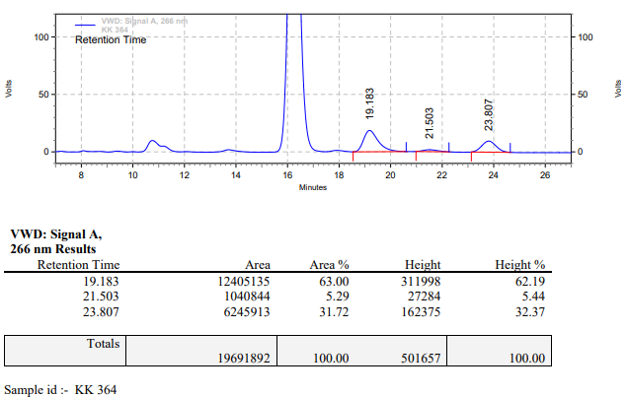

**KK-366**



**Calculation table:**

|  |  |  |  |  |  |
| --- | --- | --- | --- | --- | --- |
| Sr. No | Comp. | Mol. wt. | mmol | Eq. wt. | Wt. taken |
| 1 | Dehydrositagliptin (1) | 405.30 | 12.3365 | 1 | 5,000 mg |
| 2 | Rh(COD)2OTf | 468.30 | 0.1233 | 1 mol% | 57 mg |
| 3 | L3 | 414.29 | 0.1233 | 1 mol% | 51 mg |
| 4 | Phosphoric acid | 97.99 | 1.8504 | 15 mol% | 181 mg |

**Procedure:** A high pressure Parr reactor (450 mL) equipped with Teflon coated magnetic needle was charged with 10 g of enamine (**1**), under argon atmosphere. Subsequently, 57 mg of [Rh(COD)2OTf] (1 mol%) and 51 mg of ligand **L3** was added to the above reactor. 100 mL dry methanol was added followed by phosphoric acid to the reactor in inert atmosphere and the resultant reaction slurry was stirred for 1 hour at room temperature (25 °C). After that the autoclave was purged three times using hydrogen gas (40 bars). Finally, the autoclave was pressurized to 30 bar hydrogen pressure at 50°C for 24 hrs time period. After the 24 hrs time period, the autoclave was cooled to room temperature (25 °C), excess pressure was released and the autoclave was opened. The thus obtained reaction mixture was passed through neutral alumina bed, the filtrate was collect and dried to yield residue. The resultant residue was then analysed by HPLC.

**Reaction conditions:** Temp: 50°C Press.: 30 bar Solvent: methanol Time: 24 hrs

**Result: 34%** conversion **83%** ee

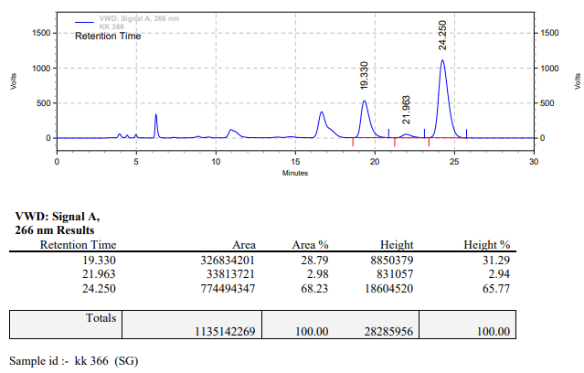

**KK-367**



**Calculation table:**

|  |  |  |  |  |  |
| --- | --- | --- | --- | --- | --- |
| Sr. No | Comp. | Mol. wt. | mmol | Eq. wt. | Wt. taken |
| 1 | Dehydrositagliptin (1) | 405.30 | 0.2413 | 100 | 98 mg |
| 2 | Rh(COD)2OTf | 468.30 | 0.0024 | 1 | 1.1 mg |
| 3 | L3 | 414.29 | 0.0024 | 1 | 1 mg |
| 4 | Phosphoric acid | 97.99 | 0.2413 | 100 | 24 mg |

**Procedure:** A high pressure Parr reactor (450 mL) equipped with Teflon coated magnetic needle was charged with 10 g of enamine (**1**), under argon atmosphere. Subsequently, 1.1 mg of [Rh(COD)2OTf] (1 mol%) and 1 mg of ligand **L3** was added to the above reactor. 200 mL dry methanol was added followed by phosphoric acid to the reactor in inert atmosphere and the resultant reaction slurry was stirred for 1 hour at room temperature (25 °C). After that the autoclave was purged three times using hydrogen gas (40 bars). Finally, the autoclave was pressurized to 30 bar hydrogen pressure at 70°C for 24 hrs time period. After the 24 hrs time period, the autoclave was cooled to room temperature (25 °C), excess pressure was released and the autoclave was opened. The thus obtained reaction mixture was passed through neutral alumina bed, the filtrate was collect and dried to yield residue. The resultant residue was then analysed by TLC, only starting was present.

**Reaction conditions:** Temp: 70°C Press.: 30 bar Solvent: methanol Time: 24 hrs

**Result: 00%** conversion **00%** ee

**KK-369**



**Calculation table:**

|  |  |  |  |  |  |
| --- | --- | --- | --- | --- | --- |
| Sr. No | Comp. | Mol. wt. | mmol | Eq. wt. | Wt. taken |
| 1 | Sitagliptin | 407.32 | 2.9460 | 1 | 1200 mg |
| 2 | Phosphoric acid | 97.99 | 3.5353 | 1.2 | 346 mg |

**Procedure:** 1200 mg of Sitagliptin free base (**1**) was weighted in a round bottom flask and 2 ml isopropanol was added to it. Subsequently, 480 µL degassed water and 173 µL H3PO4 was added to the above flask. The flask was heated to 60 °C for one hour, after which it was cooled to ambient temperature to yield off white precipitate. The precipitate was separated and dried in vacuum to Yield sitagliptin-phosphate salt.

**Result: 80%** conversion

**KK-370**



**Calculation table:**

|  |  |  |  |  |  |
| --- | --- | --- | --- | --- | --- |
| Sr. No | Comp. | Mol. wt. | mmol | Eq. wt. | Wt. taken |
| 1 | Dehydrositagliptin (1) | 405.30 | 0.2135 | 100 | 86 mg |
| 2 | Rh(COD)2OTf | 468.30 | 0.0021 | 1 | 1 mg |
| 3 | L12 | 526.51 | 0.0021 | 1 | 1.1 mg |
| 4 | Ammonium chloride | 53.49 | 0.0215 | 10 | 1 mg |

**Procedure:** A glass vial (4 mL) equipped with Teflon coated magnetic needle was cooled under vacuum and transferred to a glove box. The vial was then charged with 86 mg of enamine (**1**), 1 mg of [Rh(COD)2OTf] (1 mol%), ligand (L12) and ammonium chloride. Reaction vial was then closed using screwcap, transferred to a large opening Schlenk type container and was then taken out from the glove box. 2 mL dry methanol was added to the vial in inert atmosphere and the resultant reaction slurry was stirred for 1 hour at room temperature (25°C). After that the reaction vial was shifted to an autoclave and the autoclave was purged three times using hydrogen gas (40 bars). Finally, the autoclave was pressurized to 30 bar hydrogen pressure at 70°C for 18 hrs time period. After the 18 hrs time period, the autoclave was cooled to room temperature (25°C), excess pressure was released and the autoclave was opened. The vials were taken out from the autoclave. The thus obtained reaction mixture was passed through neutral alumina bed, the filtrate was collect and dried to yield residue. The resultant residue was then analysed by TLC, only starting was present.

**Reaction conditions:** Temp: 70°C Press.: 30 bar Solvent: Methanol Time: 18 hrs

**Result: 00%** conversion **00%** ee

**KK-371**



**Calculation table:**

|  |  |  |  |  |  |
| --- | --- | --- | --- | --- | --- |
| Sr. No | Comp. | Mol. wt. | mmol | Eq. wt. | Wt. taken |
| 1 | Dehydrositagliptin (1) | 405.30 | 0.2135 | 100 | 86 mg |
| 2 | Rh(COD)2OTf | 468.30 | 0.0021 | 1 | 1 mg |
| 3 | L12 | 526.51 | 0.0021 | 1 | 1.1 mg |
| 4 | Salicylic acid | 138.12 | 0.2135 | 100 | 29 mg |

**Procedure:** A glass vial (4 mL) equipped with Teflon coated magnetic needle was cooled under vacuum and transferred to a glove box. The vial was then charged with 86 mg of enamine (**1**), 1 mg of [Rh(COD)2OTf] (1 mol%), ligand (L12) and salicylic acid. Reaction vial was then closed using screwcap, transferred to a large opening Schlenk type container and was then taken out from the glove box. 2 mL dry methanol was added to the vial in inert atmosphere and the resultant reaction slurry was stirred for 1 hour at room temperature (25°C). After that the reaction vial was shifted to an autoclave and the autoclave was purged three times using hydrogen gas (40 bars). Finally, the autoclave was pressurized to 30 bar hydrogen pressure at 70°C for 18 hrs time period. After the 18 hrs time period, the autoclave was cooled to room temperature (25°C), excess pressure was released and the autoclave was opened. The vials were taken out from the autoclave. The thus obtained reaction mixture was passed through neutral alumina bed, the filtrate was collect and dried to yield residue. The resultant residue was then analysed by HPLC.

**Reaction conditions:** Temp: 70°C Press.: 30 bar Solvent: Methanol Time: 18 hrs

**Result: 70%** conversion **90%** ee

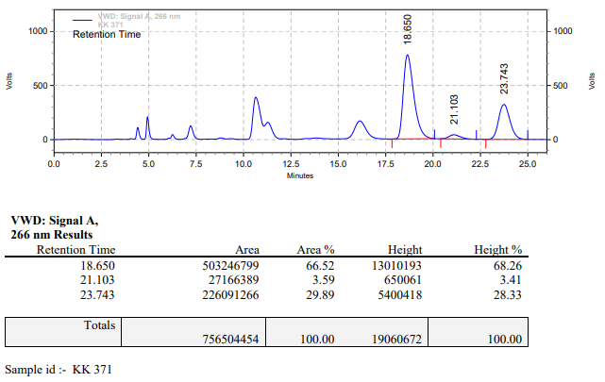

**KK-372**



**Calculation table:**

|  |  |  |  |  |  |
| --- | --- | --- | --- | --- | --- |
| Sr. No | Comp. | Mol. wt. | mmol | Eq. wt. | Wt. taken |
| 1 | Dehydrositagliptin (1) | 405.30 | 0.2135 | 100 | 86 mg |
| 2 | Rh(COD)2OTf | 468.30 | 0.0021 | 1 | 1 mg |
| 3 | L12 | 526.51 | 0.0021 | 1 | 1.1 mg |
| 4 | Phosphoric acid | 97.99 | 0.4270 | 200 | 42 mg |

**Procedure:** A glass vial (4 mL) equipped with Teflon coated magnetic needle was cooled under vacuum and transferred to a glove box. The vial was then charged with 86 mg of enamine (**1**), 1 mg of [Rh(COD)2OTf] (1 mol%) and ligand (L12). Reaction vial was then closed using screwcap, transferred to a large opening Schlenk type container and was then taken out from the glove box. 2 mL dry methanol was added followed by phosphoric acid to the vial in inert atmosphere and the resultant reaction slurry was stirred for 1 hour at room temperature (25°C). After that the reaction vial was shifted to an autoclave and the autoclave was purged three times using hydrogen gas (40 bars). Finally, the autoclave was pressurized to 30 bar hydrogen pressure at 70°C for 18 hrs time period. After the 18 hrs time period, the autoclave was cooled to room temperature (25°C), excess pressure was released and the autoclave was opened. The vials were taken out from the autoclave. The thus obtained reaction mixture was passed through neutral alumina bed, the filtrate was collect and dried to yield residue. The resultant residue was then analysed by HPLC.

**Reaction conditions:** Temp: 70°C Press.: 30 bar Solvent: Methanol Time: 18 hrs

**Result: 95%** conversion **78%** ee

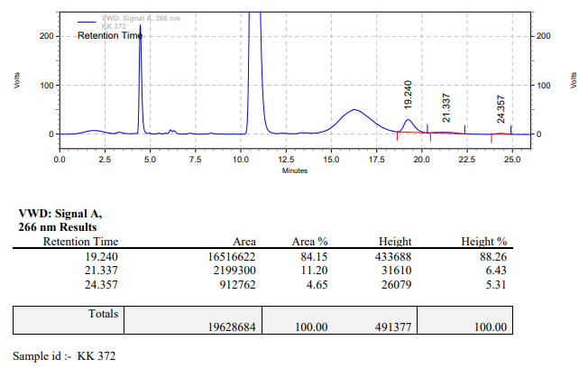

**KK-373**



**Calculation table:**

|  |  |  |  |  |  |
| --- | --- | --- | --- | --- | --- |
| Sr. No | Comp. | Mol. wt. | mmol | Eq. wt. | Wt. taken |
| 1 | Dehydrositagliptin (1) | 405.30 | 0.2135 | 100 | 86 mg |
| 2 | Rh(COD)2OTf | 468.30 | 0.0021 | 1 | 1 mg |
| 3 | L12 | 526.51 | 0.0021 | 1 | 1.1 mg |
| 4 | Ammonium chloride | 53.49 | 0.0215 | 10 | 1 mg |

**Procedure:** A glass vial (4 mL) equipped with Teflon coated magnetic needle was cooled under vacuum and transferred to a glove box. The vial was then charged with 86 mg of enamine (**1**), 1 mg of [Rh(COD)2OTf] (1 mol%), ligand (L12) and ammonium chloride. Reaction vial was then closed using screwcap, transferred to a large opening Schlenk type container and was then taken out from the glove box. 2 mL dry methanol was added to the vial in inert atmosphere and the resultant reaction slurry was stirred for 1 hour at room temperature (25°C). After that the reaction vial was shifted to an autoclave and the autoclave was purged three times using hydrogen gas (40 bars). Finally, the autoclave was pressurized to 30 bar hydrogen pressure at 60°C for 18 hrs time period. After the 18 hrs time period, the autoclave was cooled to room temperature (25°C), excess pressure was released and the autoclave was opened. The vials were taken out from the autoclave. The thus obtained reaction mixture was passed through neutral alumina bed, the filtrate was collect and dried to yield residue. The resultant residue was then analysed by HPLC.

**Reaction conditions:** Temp: 60°C Press.: 30 bar Solvent: Methanol Time: 18 hrs

**Result: 05%** conversion **88%** ee

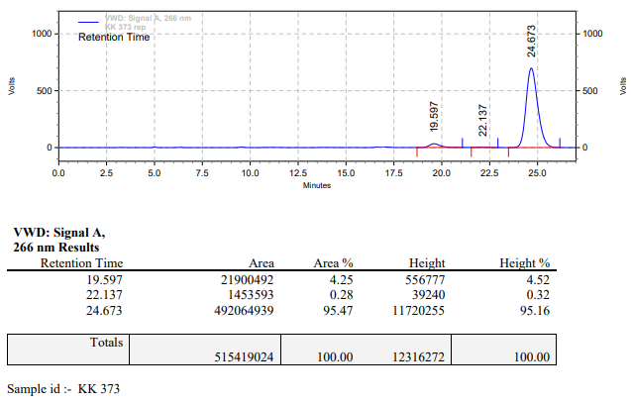

**KK-374**



**Calculation table:**

|  |  |  |  |  |  |
| --- | --- | --- | --- | --- | --- |
| Sr. No | Comp. | Mol. wt. | mmol | Eq. wt. | Wt. taken |
| 1 | Dehydrositagliptin (1) | 405.30 | 0.2135 | 100 | 86 mg |
| 2 | Rh(COD)2OTf | 468.30 | 0.0021 | 1 | 1 mg |
| 3 | L12 | 526.51 | 0.0021 | 1 | 1.1 mg |
| 4 | Phosphoric acid | 97.99 | 0.2135 | 100 | 20 mg |

**Procedure:** A glass vial (4 mL) equipped with Teflon coated magnetic needle was cooled under vacuum and transferred to a glove box. The vial was then charged with 86 mg of enamine (**1**), 1 mg of [Rh(COD)2OTf] (1 mol%) and ligand (L12). Reaction vial was then closed using screwcap, transferred to a large opening Schlenk type container and was then taken out from the glove box. 2 mL dry methanol was added followed by phosphoric acid to the vial in inert atmosphere and the resultant reaction slurry was stirred for 1 hour at room temperature (25°C). After that the reaction vial was shifted to an autoclave and the autoclave was purged three times using hydrogen gas (40 bars). Finally, the autoclave was pressurized to 30 bar hydrogen pressure at 60°C for 18 hrs time period. After the 18 hrs time period, the autoclave was cooled to room temperature (25°C), excess pressure was released and the autoclave was opened. The vials were taken out from the autoclave. The thus obtained reaction mixture was passed through neutral alumina bed, the filtrate was collect and dried to yield residue. The resultant residue was then analysed by HPLC.

**Reaction conditions:** Temp: 60°C Press.: 30 bar Solvent: Methanol Time: 18 hrs

**Result: 04%** conversion **87%** ee

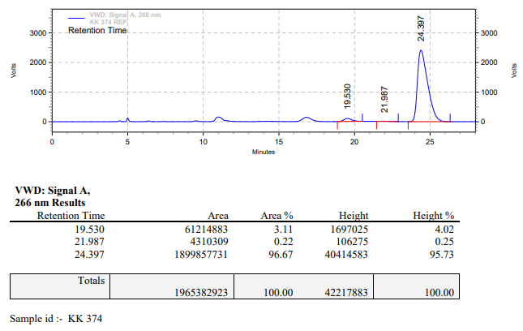

**KK-375**



**Calculation table:**

|  |  |  |  |  |  |
| --- | --- | --- | --- | --- | --- |
| Sr. No | Comp. | Mol. wt. | mmol | Eq. wt. | Wt. taken |
| 1 | Dehydrositagliptin (1) | 405.30 | 0.2135 | 100 | 86 mg |
| 2 | Rh(COD)2OTf | 468.30 | 0.0021 | 1 | 1 mg |
| 3 | L12 | 526.51 | 0.0021 | 1 | 1.1 mg |
| 4 | Salicylic acid | 138.12 | 0.2135 | 100 | 29 mg |

**Procedure:** A glass vial (4 mL) equipped with Teflon coated magnetic needle was cooled under vacuum and transferred to a glove box. The vial was then charged with 86 mg of enamine (**1**), 1 mg of [Rh(COD)2OTf] (1 mol%), ligand (L12) and salicylic acid. Reaction vial was then closed using screwcap, transferred to a large opening Schlenk type container and was then taken out from the glove box. 2 mL dry methanol was added to the vial in inert atmosphere and the resultant reaction slurry was stirred for 1 hour at room temperature (25°C). After that the reaction vial was shifted to an autoclave and the autoclave was purged three times using hydrogen gas (40 bars). Finally, the autoclave was pressurized to 30 bar hydrogen pressure at 60°C for 18 hrs time period. After the 18 hrs time period, the autoclave was cooled to room temperature (25°C), excess pressure was released and the autoclave was opened. The vials were taken out from the autoclave. The thus obtained reaction mixture was passed through neutral alumina bed, the filtrate was collect and dried to yield residue. The resultant residue was then analysed by HPLC.

**Reaction conditions:** Temp: 60°C Press.: 30 bar Solvent: Methanol Time: 18 hrs

**Result: 58%** conversion **90%** ee

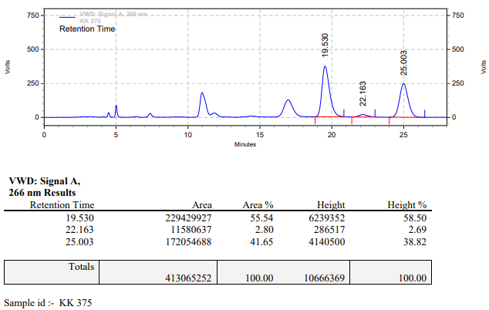

**KK-376**



**Calculation table:**

|  |  |  |  |  |  |
| --- | --- | --- | --- | --- | --- |
| Sr. No | Comp. | Mol. wt. | mmol | Eq. wt. | Wt. taken |
| 1 | Dehydrositagliptin (1) | 405.30 | 0.2135 | 100 | 86 mg |
| 2 | Rh(COD)2OTf | 468.30 | 0.0021 | 1 | 1 mg |
| 3 | L12 | 526.51 | 0.0021 | 1 | 1.1 mg |

**Procedure:** A glass vial (4 mL) equipped with Teflon coated magnetic needle was cooled under vacuum and transferred to a glove box. The vial was then charged with 86 mg of enamine (**1**), 1 mg of [Rh(COD)2OTf] (1 mol%) and ligand (L12). Reaction vial was then closed using screwcap, transferred to a large opening Schlenk type container and was then taken out from the glove box. 2 mL dry methanol was added to the vial in inert atmosphere and the resultant reaction slurry was stirred for 1 hour at room temperature (25°C). After that the reaction vial was shifted to an autoclave and the autoclave was purged three times using hydrogen gas (40 bars). Finally, the autoclave was pressurized to 30 bar hydrogen pressure at 60°C for 18 hrs time period. After the 18 hrs time period, the autoclave was cooled to room temperature (25°C), excess pressure was released and the autoclave was opened. The vials were taken out from the autoclave. The thus obtained reaction mixture was passed through neutral alumina bed, the filtrate was collect and dried to yield residue. The resultant residue was then analysed by HPLC.

**Reaction conditions:** Temp: 60°C Press.: 30 bar Solvent: Methanol Time: 18 hrs

**Result: 05%** conversion **80%** ee

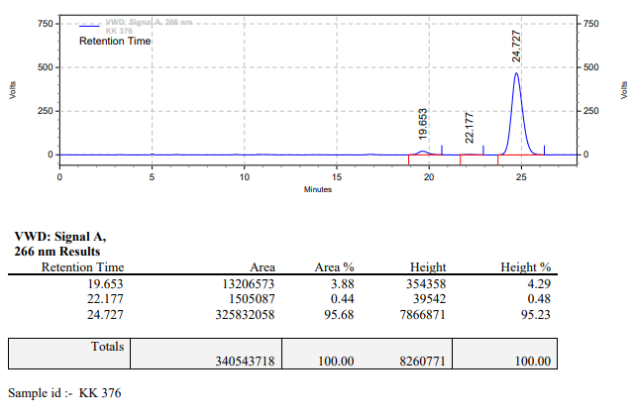

**KK-378**



**Calculation table:**

|  |  |  |  |  |  |
| --- | --- | --- | --- | --- | --- |
| Sr. No | Comp. | Mol. wt. | mmol | Eq. wt. | Wt. taken |
| 1 | Dehydrositagliptin (1) | 405.30 | 0.2135 | 100 | 86 mg |
| 2 | Rh(COD)2OTf | 468.30 | 0.0021 | 1 | 1 mg |
| 3 | L12 | 526.51 | 0.0042 | 2 | 2.2 mg |
| 4 | Salicylic acid | 138.12 | 0.2135 | 100 | 29 mg |

**Procedure:** A glass vial (4 mL) equipped with Teflon coated magnetic needle was cooled under vacuum and transferred to a glove box. The vial was then charged with 86 mg of enamine (**1**), 1 mg of [Rh(COD)2OTf], ligand (L12) and salicylic acid. Reaction vial was then closed using screwcap, transferred to a large opening Schlenk type container and was then taken out from the glove box. 2 mL dry methanol was added to the vial in inert atmosphere and the resultant reaction slurry was stirred for 1 hour at room temperature (25°C). After that the reaction vial was shifted to an autoclave and the autoclave was purged three times using hydrogen gas (40 bars). Finally, the autoclave was pressurized to 30 bar hydrogen pressure at 70°C for 18 hrs time period. After the 18 hrs time period, the autoclave was cooled to room temperature (25°C), excess pressure was released and the autoclave was opened. The vials were taken out from the autoclave. The thus obtained reaction mixture was passed through neutral alumina bed, the filtrate was collect and dried to yield residue. The resultant residue was then analysed by HPLC.

**Reaction conditions:** Temp: 70°C Press.: 30 bar Solvent: Methanol Time: 18 hrs

**Result: 90%** conversion **90%** ee

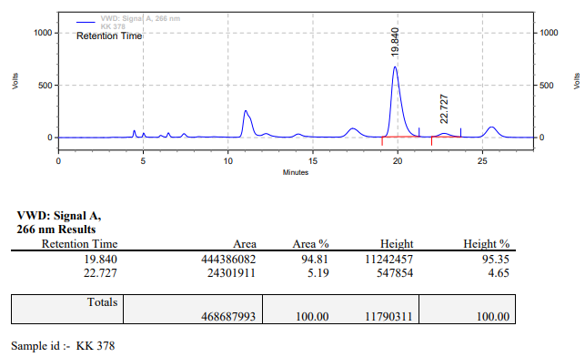

**KK-379**



**Calculation table:**

|  |  |  |  |  |  |
| --- | --- | --- | --- | --- | --- |
| Sr. No | Comp. | Mol. wt. | mmol | Eq. wt. | Wt. taken |
| 1 | Dehydrositagliptin (1) | 405.30 | 0.2135 | 100 | 86 mg |
| 2 | Rh(COD)2OTf | 468.30 | 0.0021 | 1 | 1 mg |
| 3 | L12 | 526.51 | 0.0063 | 3 | 3.3 mg |
| 4 | Salicylic acid | 138.12 | 0.2135 | 100 | 29 mg |

**Procedure:** A glass vial (4 mL) equipped with Teflon coated magnetic needle was cooled under vacuum and transferred to a glove box. The vial was then charged with 86 mg of enamine (**1**), 1 mg of [Rh(COD)2OTf] (1 mol%), ligand (L12) and salicylic acid. Reaction vial was then closed using screwcap, transferred to a large opening Schlenk type container and was then taken out from the glove box. 2 mL dry methanol was added to the vial in inert atmosphere and the resultant reaction slurry was stirred for 1 hour at room temperature (25°C). After that the reaction vial was shifted to an autoclave and the autoclave was purged three times using hydrogen gas (40 bars). Finally, the autoclave was pressurized to 30 bar hydrogen pressure at 70°C for 18 hrs time period. After the 18 hrs time period, the autoclave was cooled to room temperature (25°C), excess pressure was released and the autoclave was opened. The vials were taken out from the autoclave. The thus obtained reaction mixture was passed through neutral alumina bed, the filtrate was collect and dried to yield residue. The resultant residue was then analysed by HPLC.

**Reaction conditions:** Temp: 70°C Press.: 30 bar Solvent: Methanol Time: 18 hrs

**Result: 90%** conversion **92%** ee

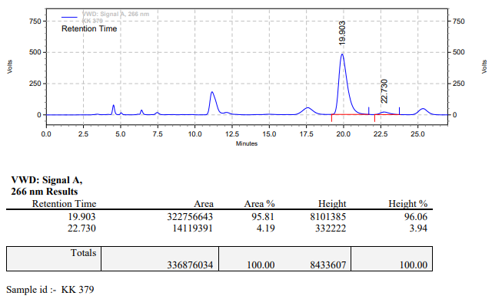

**KK-380**



**Calculation table:**

|  |  |  |  |  |  |
| --- | --- | --- | --- | --- | --- |
| Sr. No | Comp. | Mol. wt. | mmol | Eq. wt. | Wt. taken |
| 1 | Dehydrositagliptin (1) | 405.30 | 0.2135 | 100 | 86 mg |
| 2 | Rh(COD)2OTf | 468.30 | 0.0021 | 1 | 1 mg |
| 3 | L12 | 526.51 | 0.0084 | 4 | 4.4 mg |
| 4 | Salicylic acid | 138.12 | 0.2135 | 100 | 29 mg |

**Procedure:** A glass vial (4 mL) equipped with Teflon coated magnetic needle was cooled under vacuum and transferred to a glove box. The vial was then charged with 86 mg of enamine (**1**), 1 mg of [Rh(COD)2OTf] (1 mol%), ligand (L12) and salicylic acid. Reaction vial was then closed using screwcap, transferred to a large opening Schlenk type container and was then taken out from the glove box. 2 mL dry methanol was added to the vial in inert atmosphere and the resultant reaction slurry was stirred for 1 hour at room temperature (25°C). After that the reaction vial was shifted to an autoclave and the autoclave was purged three times using hydrogen gas (40 bars). Finally, the autoclave was pressurized to 30 bar hydrogen pressure at 70°C for 18 hrs time period. After the 18 hrs time period, the autoclave was cooled to room temperature (25°C), excess pressure was released and the autoclave was opened. The vials were taken out from the autoclave. The thus obtained reaction mixture was passed through neutral alumina bed, the filtrate was collect and dried to yield residue. The resultant residue was then analysed by HPLC.

**Reaction conditions:** Temp: 70°C Press.: 30 bar Solvent: Methanol Time: 18 hrs

**Result: 95%** conversion **92%** ee

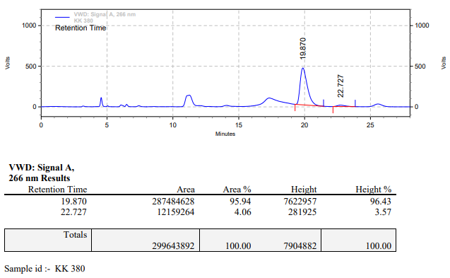

**KK-381**



**Calculation table:**

|  |  |  |  |  |  |
| --- | --- | --- | --- | --- | --- |
| Sr. No | Comp. | Mol. wt. | mmol | Eq. wt. | Wt. taken |
| 1 | Dehydrositagliptin (1) | 405.30 | 0.2135 | 100 | 86 mg |
| 2 | Rh(COD)2OTf | 468.30 | 0.0021 | 1 | 1 mg |
| 3 | L12 | 526.51 | 0.0021 | 1 | 1.1 mg |
| 4 | Salicylic acid | 138.12 | 0.1050 | 50 | 15 mg |

**Procedure:** A glass vial (4 mL) equipped with Teflon coated magnetic needle was cooled under vacuum and transferred to a glove box. The vial was then charged with 86 mg of enamine (**1**), 1 mg of [Rh(COD)2OTf] (1 mol%), ligand (L12) and salicylic acid. Reaction vial was then closed using screwcap, transferred to a large opening Schlenk type container and was then taken out from the glove box. 2 mL dry methanol was added to the vial in inert atmosphere and the resultant reaction slurry was stirred for 1 hour at room temperature (25°C). After that the reaction vial was shifted to an autoclave and the autoclave was purged three times using hydrogen gas (40 bars). Finally, the autoclave was pressurized to 30 bar hydrogen pressure at 70°C for 18 hrs time period. After the 18 hrs time period, the autoclave was cooled to room temperature (25°C), excess pressure was released and the autoclave was opened. The vials were taken out from the autoclave. The thus obtained reaction mixture was passed through neutral alumina bed, the filtrate was collect and dried to yield residue. The resultant residue was then analysed by HPLC.

**Reaction conditions:** Temp: 70°C Press.: 30 bar Solvent: Methanol Time: 18 hrs

**Result: 50%** conversion 84**%** ee

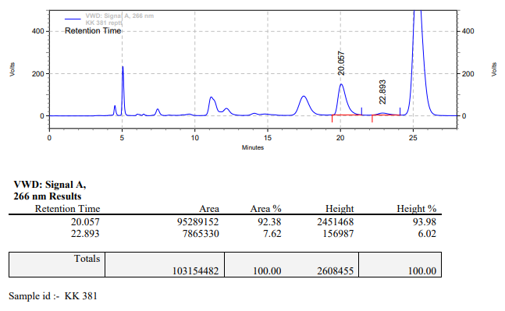

**KK-382**



**Calculation table:**

|  |  |  |  |  |  |
| --- | --- | --- | --- | --- | --- |
| Sr. No | Comp. | Mol. wt. | mmol | Eq. wt. | Wt. taken |
| 1 | Dehydrositagliptin (1) | 405.30 | 0.2135 | 100 | 86 mg |
| 2 | Rh(COD)2OTf | 468.30 | 0.0021 | 1 | 1 mg |
| 3 | L12 | 526.51 | 0.0021 | 1 | 1.1 mg |
| 4 | Salicylic acid | 138.12 | 0.3150 | 150 | 44 mg |

**Procedure:** A glass vial (4 mL) equipped with Teflon coated magnetic needle was cooled under vacuum and transferred to a glove box. The vial was then charged with 86 mg of enamine (**1**), 1 mg of [Rh(COD)2OTf] (1 mol%), ligand (L12) and salicylic acid. Reaction vial was then closed using screwcap, transferred to a large opening Schlenk type container and was then taken out from the glove box. 2 mL dry methanol was added to the vial in inert atmosphere and the resultant reaction slurry was stirred for 1 hour at room temperature (25°C). After that the reaction vial was shifted to an autoclave and the autoclave was purged three times using hydrogen gas (40 bars). Finally, the autoclave was pressurized to 30 bar hydrogen pressure at 70°C for 18 hrs time period. After the 18 hrs time period, the autoclave was cooled to room temperature (25°C), excess pressure was released and the autoclave was opened. The vials were taken out from the autoclave. The thus obtained reaction mixture was passed through neutral alumina bed, the filtrate was collect and dried to yield residue. The resultant residue was then analysed by HPLC.

**Reaction conditions:** Temp: 70°C Press.: 30 bar Solvent: Methanol Time: 18 hrs

**Result: 95%** conversion **92%** ee

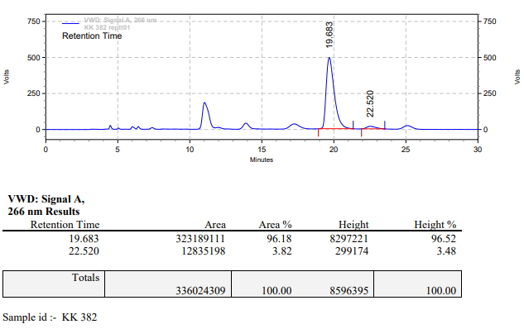

**KK-383**



**Calculation table:**

|  |  |  |  |  |  |
| --- | --- | --- | --- | --- | --- |
| Sr. No | Comp. | Mol. wt. | mmol | Eq. wt. | Wt. taken |
| 1 | Dehydrositagliptin (1) | 405.30 | 0.2135 | 100 | 86 mg |
| 2 | Rh(COD)2OTf | 468.30 | 0.0021 | 1 | 1 mg |
| 3 | L12 | 526.51 | 0.0021 | 1 | 1.1 mg |
| 4 | Salicylic acid | 138.12 | 0.4200 | 200 | 59 mg |

**Procedure:** A glass vial (4 mL) equipped with Teflon coated magnetic needle was cooled under vacuum and transferred to a glove box. The vial was then charged with 86 mg of enamine (**1**), 1 mg of [Rh(COD)2OTf] (1 mol%), ligand (L12) and salicylic acid. Reaction vial was then closed using screwcap, transferred to a large opening Schlenk type container and was then taken out from the glove box. 2 mL dry methanol was added to the vial in inert atmosphere and the resultant reaction slurry was stirred for 1 hour at room temperature (25°C). After that the reaction vial was shifted to an autoclave and the autoclave was purged three times using hydrogen gas (40 bars). Finally, the autoclave was pressurized to 30 bar hydrogen pressure at 70°C for 18 hrs time period. After the 18 hrs time period, the autoclave was cooled to room temperature (25°C), excess pressure was released and the autoclave was opened. The vials were taken out from the autoclave. The thus obtained reaction mixture was passed through neutral alumina bed, the filtrate was collect and dried to yield residue. The resultant residue was then analysed by HPLC.

**Reaction conditions:** Temp: 70°C Press.: 30 bar Solvent: Methanol Time: 18 hrs

**Result: 95%** conversion **92%** ee

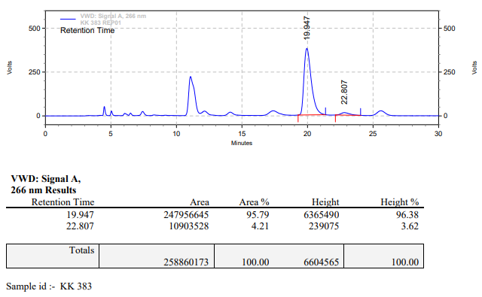

**KK-384**



**Calculation table:**

|  |  |  |  |  |  |
| --- | --- | --- | --- | --- | --- |
| Sr. No | Comp. | Mol. wt. | mmol | Eq. wt. | Wt. taken |
| 1 | Dehydrositagliptin (1) | 405.30 | 0.2135 | 100 | 86 mg |
| 2 | Rh(COD)2OTf | 468.30 | 0.0021 | 1 | 1 mg |
| 3 | L12 | 526.51 | 0.0042 | 2 | 2.2 mg |
| 4 | Salicylic acid | 138.12 | 0.4200 | 200 | 59 mg |

**Procedure:** A glass vial (4 mL) equipped with Teflon coated magnetic needle was cooled under vacuum and transferred to a glove box. The vial was then charged with 86 mg of enamine (**1**), 1 mg of [Rh(COD)2OTf] (1 mol%), ligand (L12) and salicylic acid. Reaction vial was then closed using screwcap, transferred to a large opening Schlenk type container and was then taken out from the glove box. 2 mL dry methanol was added to the vial in inert atmosphere and the resultant reaction slurry was stirred for 1 hour at room temperature (25°C). After that the reaction vial was shifted to an autoclave and the autoclave was purged three times using hydrogen gas (40 bars). Finally, the autoclave was pressurized to 30 bar hydrogen pressure at 70°C for 18 hrs time period. After the 18 hrs time period, the autoclave was cooled to room temperature (25°C), excess pressure was released and the autoclave was opened. The vials were taken out from the autoclave. The thus obtained reaction mixture was passed through neutral alumina bed, the filtrate was collect and dried to yield residue. The resultant residue was then analysed by HPLC.

**Reaction conditions:** Temp: 70°C Press.: 30 bar Solvent: Methanol Time: 18 hrs

**Result: 95%** conversion **92%** ee

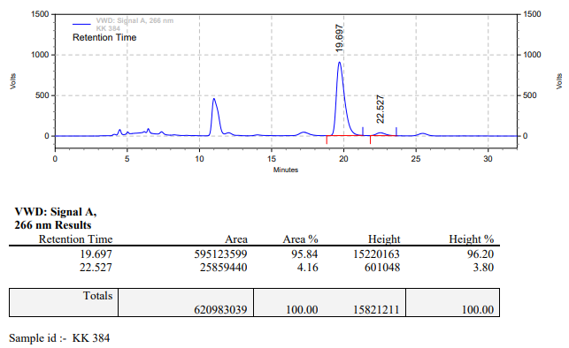

**KK-385**



**Calculation table:**

|  |  |  |  |  |  |
| --- | --- | --- | --- | --- | --- |
| Sr. No | Comp. | Mol. wt. | mmol | Eq. wt. | Wt. taken |
| 1 | Dehydrositagliptin (1) | 405.30 | 0.2135 | 100 | 86 mg |
| 2 | Rh(COD)2OTf | 468.30 | 0.0021 | 1 | 1 mg |
| 3 | L12 | 526.51 | 0.0063 | 3 | 3.3 mg |
| 4 | Salicylic acid | 138.12 | 0.4200 | 200 | 59 mg |

**Procedure:** A glass vial (4 mL) equipped with Teflon coated magnetic needle was cooled under vacuum and transferred to a glove box. The vial was then charged with 86 mg of enamine (**1**), 1 mg of [Rh(COD)2OTf] (1 mol%), ligand (L12) and salicylic acid. Reaction vial was then closed using screwcap, transferred to a large opening Schlenk type container and was then taken out from the glove box. 2 mL dry methanol was added to the vial in inert atmosphere and the resultant reaction slurry was stirred for 1 hour at room temperature (25°C). After that the reaction vial was shifted to an autoclave and the autoclave was purged three times using hydrogen gas (40 bars). Finally, the autoclave was pressurized to 30 bar hydrogen pressure at 70°C for 18 hrs time period. After the 18 hrs time period, the autoclave was cooled to room temperature (25°C), excess pressure was released and the autoclave was opened. The vials were taken out from the autoclave. The thus obtained reaction mixture was passed through neutral alumina bed, the filtrate was collect and dried to yield residue. The resultant residue was then analysed by HPLC.

**Reaction conditions:** Temp: 70°C Press.: 30 bar Solvent: Methanol Time: 18 hrs

**Result: 95%** conversion **92%** ee

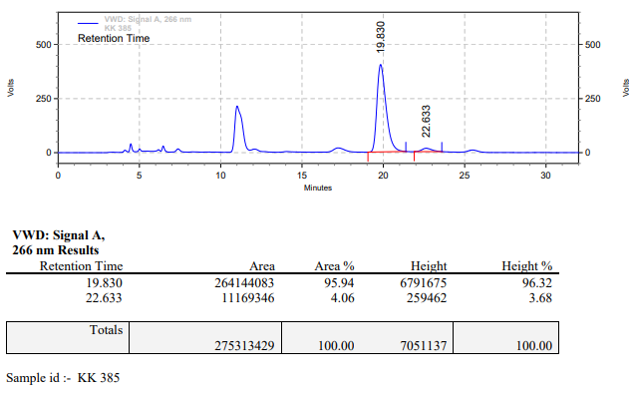

**KK-386**



**Calculation table:**

|  |  |  |  |  |  |
| --- | --- | --- | --- | --- | --- |
| Sr. No | Comp. | Mol. wt. | mmol | Eq. wt. | Wt. taken |
| 1 | Dehydrositagliptin (1) | 405.30 | 0.2135 | 100 | 86 mg |
| 2 | Rh(COD)2OTf | 468.30 | 0.0021 | 1 | 1 mg |
| 3 | L12 | 526.51 | 0.0042 | 2 | 2.2 mg |
| 4 | Salicylic acid | 138.12 | 0.4200 | 200 | 59 mg |

**Procedure:** A glass vial (4 mL) equipped with Teflon coated magnetic needle was cooled under vacuum and transferred to a glove box. The vial was then charged with 86 mg of enamine (**1**), 1 mg of [Rh(COD)2OTf] (1 mol%), ligand (L12) and salicylic acid. Reaction vial was then closed using screwcap, transferred to a large opening Schlenk type container and was then taken out from the glove box. 2 mL dry methanol was added to the vial in inert atmosphere and the resultant reaction slurry was stirred for 1 hour at room temperature (25°C). After that the reaction vial was shifted to an autoclave and the autoclave was purged three times using hydrogen gas (40 bars). Finally, the autoclave was pressurized to 30 bar hydrogen pressure at 60°C for 18 hrs time period. After the 18 hrs time period, the autoclave was cooled to room temperature (25°C), excess pressure was released and the autoclave was opened. The vials were taken out from the autoclave. The thus obtained reaction mixture was passed through neutral alumina bed, the filtrate was collect and dried to yield residue. The resultant residue was then analysed by HPLC.

**Reaction conditions:** Temp: 60°C Press.: 30 bar Solvent: Methanol Time: 18 hrs

**Result: 95%** conversion **94%** ee

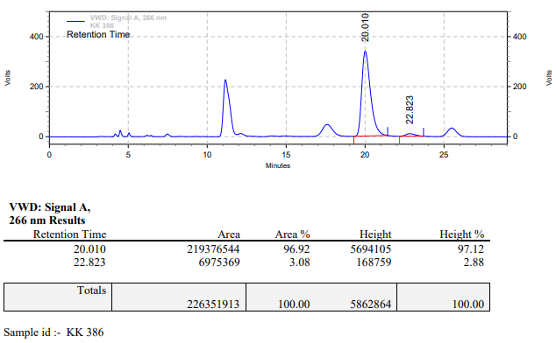

**KK-387**



**Calculation table:**

|  |  |  |  |  |  |
| --- | --- | --- | --- | --- | --- |
| Sr. No | Comp. | Mol. wt. | mmol | Eq. wt. | Wt. taken |
| 1 | Dehydrositagliptin (1) | 405.30 | 0.2135 | 100 | 86 mg |
| 2 | Rh(COD)2OTf | 468.30 | 0.0021 | 1 | 1 mg |
| 3 | L12 | 526.51 | 0.0063 | 3 | 3.3 mg |
| 4 | Salicylic acid | 138.12 | 0.4200 | 200 | 59 mg |

**Procedure:** A glass vial (4 mL) equipped with Teflon coated magnetic needle was cooled under vacuum and transferred to a glove box. The vial was then charged with 86 mg of enamine (**1**), 1 mg of [Rh(COD)2OTf] (1 mol%), ligand (L12) and salicylic acid. Reaction vial was then closed using screwcap, transferred to a large opening Schlenk type container and was then taken out from the glove box. 2 mL dry methanol was added to the vial in inert atmosphere and the resultant reaction slurry was stirred for 1 hour at room temperature (25°C). After that the reaction vial was shifted to an autoclave and the autoclave was purged three times using hydrogen gas (40 bars). Finally, the autoclave was pressurized to 30 bar hydrogen pressure at 60°C for 18 hrs time period. After the 18 hrs time period, the autoclave was cooled to room temperature (25°C), excess pressure was released and the autoclave was opened. The vials were taken out from the autoclave. The thus obtained reaction mixture was passed through neutral alumina bed, the filtrate was collect and dried to yield residue. The resultant residue was then analysed by HPLC.

**Reaction conditions:** Temp: 60°C Press.: 30 bar Solvent: Methanol Time: 18 hrs

**Result: 95%** conversion **94%** ee

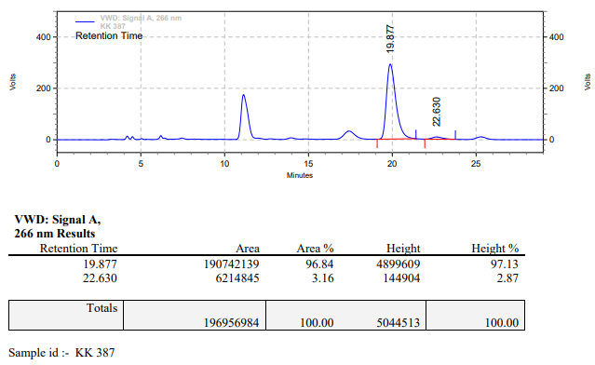

**KK-388**



**Calculation table:**

|  |  |  |  |  |  |
| --- | --- | --- | --- | --- | --- |
| Sr. No | Comp. | Mol. wt. | mmol | Eq. wt. | Wt. taken |
| 1 | Dehydrositagliptin (1) | 405.30 | 0.2135 | 100 | 86 mg |
| 2 | Rh(COD)2OTf | 468.30 | 0.0021 | 1 | 1 mg |
| 3 | L12 | 526.51 | 0.0042 | 2 | 2.2 mg |
| 4 | Salicylic acid | 138.12 | 0.4200 | 200 | 59 mg |

**Procedure:** A glass vial (4 mL) equipped with Teflon coated magnetic needle was cooled under vacuum and transferred to a glove box. The vial was then charged with 86 mg of enamine (**1**), 1 mg of [Rh(COD)2OTf] (1 mol%), ligand (L12) and salicylic acid. Reaction vial was then closed using screwcap, transferred to a large opening Schlenk type container and was then taken out from the glove box. 2 mL dry methanol was added to the vial in inert atmosphere and the resultant reaction slurry was stirred for 1 hour at room temperature (25°C). After that the reaction vial was shifted to an autoclave and the autoclave was purged three times using hydrogen gas (40 bars). Finally, the autoclave was pressurized to 30 bar hydrogen pressure at 50°C for 18 hrs time period. After the 18 hrs time period, the autoclave was cooled to room temperature (25°C), excess pressure was released and the autoclave was opened. The vials were taken out from the autoclave. The thus obtained reaction mixture was passed through neutral alumina bed, the filtrate was collect and dried to yield residue. The resultant residue was then analysed by HPLC.

**Reaction conditions:** Temp: 50°C Press.: 30 bar Solvent: Methanol Time: 18 hrs

**Result: 90%** conversion **95%** ee

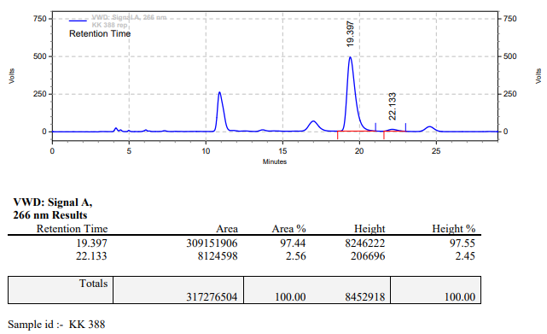

**KK-389**



**Calculation table:**

|  |  |  |  |  |  |
| --- | --- | --- | --- | --- | --- |
| Sr. No | Comp. | Mol. wt. | mmol | Eq. wt. | Wt. taken |
| 1 | Dehydrositagliptin (1) | 405.30 | 0.2135 | 100 | 86 mg |
| 2 | Rh(COD)2OTf | 468.30 | 0.0021 | 1 | 1 mg |
| 3 | L12 | 526.51 | 0.0025 | 1.2 | 1.3 mg |
| 4 | Salicylic acid | 138.12 | 0.4200 | 200 | 59 mg |

**Procedure:** A glass vial (4 mL) equipped with Teflon coated magnetic needle was cooled under vacuum and transferred to a glove box. The vial was then charged with 86 mg of enamine (**1**), 1 mg of [Rh(COD)2OTf] (1 mol%), ligand (L12) and salicylic acid. Reaction vial was then closed using screwcap, transferred to a large opening Schlenk type container and was then taken out from the glove box. 2 mL dry methanol was added to the vial in inert atmosphere and the resultant reaction slurry was stirred for 1 hour at room temperature (25°C). After that the reaction vial was shifted to an autoclave and the autoclave was purged three times using hydrogen gas (40 bars). Finally, the autoclave was pressurized to 30 bar hydrogen pressure at 50°C for 18 hrs time period. After the 18 hrs time period, the autoclave was cooled to room temperature (25°C), excess pressure was released and the autoclave was opened. The vials were taken out from the autoclave. The thus obtained reaction mixture was passed through neutral alumina bed, the filtrate was collect and dried to yield residue. The resultant residue was then analysed by HPLC.

**Reaction conditions:** Temp: 50°C Press.: 30 bar Solvent: Methanol Time: 18 hrs

**Result: 80%** conversion **95%** ee

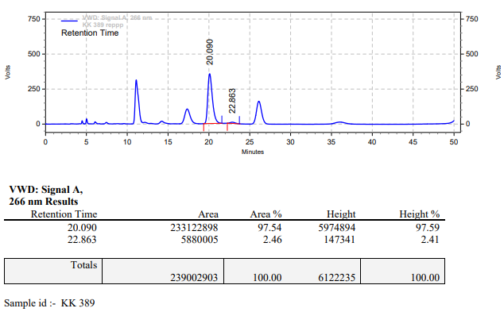

**KK-390**



**Calculation table:**

|  |  |  |  |  |  |
| --- | --- | --- | --- | --- | --- |
| Sr. No | Comp. | Mol. wt. | mmol | Eq. wt. | Wt. taken |
| 1 | Dehydrositagliptin (1) | 405.30 | 0.2135 | 100 | 86 mg |
| 2 | Rh(COD)2OTf | 468.30 | 0.0021 | 1 | 1 mg |
| 3 | L12 | 526.51 | 0.0063 | 3 | 3.3 mg |
| 4 | Salicylic acid | 138.12 | 0.4200 | 200 | 59 mg |

**Procedure:** A glass vial (4 mL) equipped with Teflon coated magnetic needle was cooled under vacuum and transferred to a glove box. The vial was then charged with 86 mg of enamine (**1**), 1 mg of [Rh(COD)2OTf] (1 mol%), ligand (L12) and salicylic acid. Reaction vial was then closed using screwcap, transferred to a large opening Schlenk type container and was then taken out from the glove box. 2 mL dry methanol was added to the vial in inert atmosphere and the resultant reaction slurry was stirred for 1 hour at room temperature (25°C). After that the reaction vial was shifted to an autoclave and the autoclave was purged three times using hydrogen gas (40 bars). Finally, the autoclave was pressurized to 30 bar hydrogen pressure at 50°C for 18 hrs time period. After the 18 hrs time period, the autoclave was cooled to room temperature (25°C), excess pressure was released and the autoclave was opened. The vials were taken out from the autoclave. The thus obtained reaction mixture was passed through neutral alumina bed, the filtrate was collect and dried to yield residue. The resultant residue was then analysed by HPLC.

**Reaction conditions:** Temp: 50°C Press.: 30 bar Solvent: Methanol Time: 18 hrs

**Result: 85%** conversion **95%** ee

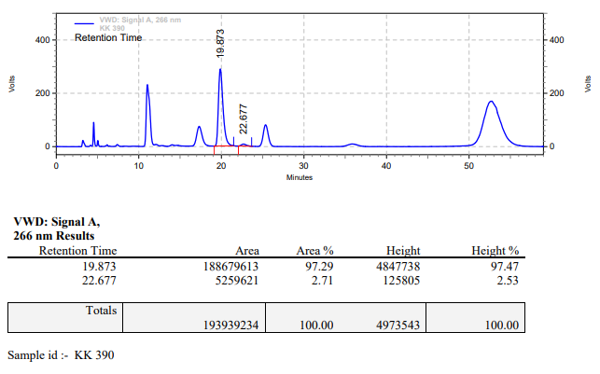

**KK-391**



**Calculation table:**

|  |  |  |  |  |  |
| --- | --- | --- | --- | --- | --- |
| Sr. No | Comp. | Mol. wt. | mmol | Eq. wt. | Wt. taken |
| 1 | Dehydrositagliptin (1) | 405.30 | 0.2135 | 100 | 86 mg |
| 2 | Rh(COD)2OTf | 468.30 | 0.0021 | 1 | 1 mg |
| 3 | L12 | 526.51 | 0.0025 | 1.2 | 1.3 mg |
| 4 | Salicylic acid | 138.12 | 0.4200 | 200 | 59 mg |

**Procedure:** A glass vial (4 mL) equipped with Teflon coated magnetic needle was cooled under vacuum and transferred to a glove box. The vial was then charged with 86 mg of enamine (**1**), 1 mg of [Rh(COD)2OTf] (1 mol%), ligand (L12) and salicylic acid. Reaction vial was then closed using screwcap, transferred to a large opening Schlenk type container and was then taken out from the glove box. 2 mL dry methanol was added to the vial in inert atmosphere and the resultant reaction slurry was stirred for 1 hour at room temperature (25°C). After that the reaction vial was shifted to an autoclave and the autoclave was purged three times using hydrogen gas (40 bars). Finally, the autoclave was pressurized to 30 bar hydrogen pressure at 45°C for 18 hrs time period. After the 18 hrs time period, the autoclave was cooled to room temperature (25°C), excess pressure was released and the autoclave was opened. The vials were taken out from the autoclave. The thus obtained reaction mixture was passed through neutral alumina bed, the filtrate was collect and dried to yield residue. The resultant residue was then analysed by HPLC.

**Reaction conditions:** Temp: 45°C Press.: 30 bar Solvent: Methanol Time: 18 hrs

**Result: 90%** conversion **95%** ee

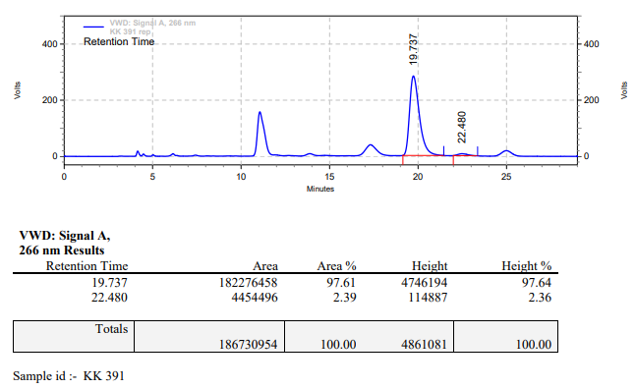

**KK-392**



**Calculation table:**

|  |  |  |  |  |  |
| --- | --- | --- | --- | --- | --- |
| Sr. No | Comp. | Mol. wt. | mmol | Eq. wt. | Wt. taken |
| 1 | Dehydrositagliptin (1) | 405.30 | 0.2135 | 100 | 86 mg |
| 2 | Rh(COD)2OTf | 468.30 | 0.0021 | 1 | 1 mg |
| 3 | L12 | 526.51 | 0.0042 | 2 | 2.2 mg |
| 4 | Salicylic acid | 138.12 | 0.4200 | 200 | 59 mg |

**Procedure:** A glass vial (4 mL) equipped with Teflon coated magnetic needle was cooled under vacuum and transferred to a glove box. The vial was then charged with 86 mg of enamine (**1**), 1 mg of [Rh(COD)2OTf] (1 mol%), ligand (L12) and salicylic acid. Reaction vial was then closed using screwcap, transferred to a large opening Schlenk type container and was then taken out from the glove box. 2 mL dry methanol was added to the vial in inert atmosphere and the resultant reaction slurry was stirred for 1 hour at room temperature (25°C). After that the reaction vial was shifted to an autoclave and the autoclave was purged three times using hydrogen gas (40 bars). Finally, the autoclave was pressurized to 30 bar hydrogen pressure at 45°C for 18 hrs time period. After the 18 hrs time period, the autoclave was cooled to room temperature (25°C), excess pressure was released and the autoclave was opened. The vials were taken out from the autoclave. The thus obtained reaction mixture was passed through neutral alumina bed, the filtrate was collect and dried to yield residue. The resultant residue was then analysed by HPLC.

**Reaction conditions:** Temp: 45°C Press.: 30 bar Solvent: Methanol Time: 18 hrs

**Result: 85%** conversion **96%** ee

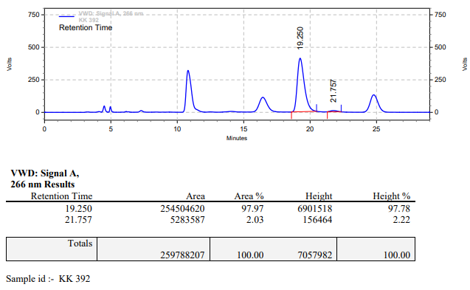

**KK-393**



**Calculation table:**

|  |  |  |  |  |  |
| --- | --- | --- | --- | --- | --- |
| Sr. No | Comp. | Mol. wt. | mmol | Eq. wt. | Wt. taken |
| 1 | Dehydrositagliptin (1) | 405.30 | 0.2135 | 100 | 86 mg |
| 2 | Rh(COD)2OTf | 468.30 | 0.0021 | 1 | 1 mg |
| 3 | L12 | 526.51 | 0.0063 | 3 | 3.3 mg |
| 4 | Salicylic acid | 138.12 | 0.4200 | 200 | 59 mg |

**Procedure:** A glass vial (4 mL) equipped with Teflon coated magnetic needle was cooled under vacuum and transferred to a glove box. The vial was then charged with 86 mg of enamine (**1**), 1 mg of [Rh(COD)2OTf] (1 mol%), ligand (L12) and salicylic acid. Reaction vial was then closed using screwcap, transferred to a large opening Schlenk type container and was then taken out from the glove box. 2 mL dry methanol was added to the vial in inert atmosphere and the resultant reaction slurry was stirred for 1 hour at room temperature (25°C). After that the reaction vial was shifted to an autoclave and the autoclave was purged three times using hydrogen gas (40 bars). Finally, the autoclave was pressurized to 30 bar hydrogen pressure at 45°C for 18 hrs time period. After the 18 hrs time period, the autoclave was cooled to room temperature (25°C), excess pressure was released and the autoclave was opened. The vials were taken out from the autoclave. The thus obtained reaction mixture was passed through neutral alumina bed, the filtrate was collect and dried to yield residue. The resultant residue was then analysed by HPLC.

**Reaction conditions:** Temp: 45°C Press.: 30 bar Solvent: Methanol Time: 18 hrs

**Result: 00%** conversion **00%** ee

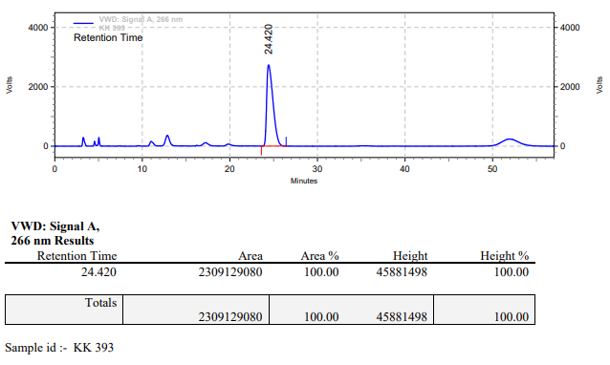

**KK-394**



**Calculation table:**

|  |  |  |  |  |  |
| --- | --- | --- | --- | --- | --- |
| Sr. No | Comp. | Mol. wt. | mmol | Eq. wt. | Wt. taken |
| 1 | Dehydrositagliptin (1) | 405.30 | 0.2135 | 100 | 86 mg |
| 2 | Rh(COD)2OTf | 468.30 | 0.0021 | 1 | 1 mg |
| 3 | L12 | 526.51 | 0.0025 | 1.2 | 1.3 mg |
| 4 | Salicylic acid | 138.12 | 0.4200 | 200 | 59 mg |

**Procedure:** A glass vial (4 mL) equipped with Teflon coated magnetic needle was cooled under vacuum and transferred to a glove box. The vial was then charged with 86 mg of enamine (**1**), 1 mg of [Rh(COD)2OTf] (1 mol%), ligand (L12) and salicylic acid. Reaction vial was then closed using screwcap, transferred to a large opening Schlenk type container and was then taken out from the glove box. 2 mL dry methanol was added to the vial in inert atmosphere and the resultant reaction slurry was stirred for 1 hour at room temperature (25°C). After that the reaction vial was shifted to an autoclave and the autoclave was purged three times using hydrogen gas (40 bars). Finally, the autoclave was pressurized to 30 bar hydrogen pressure at 40°C for 24 hrs time period. After the 24 hrs time period, the autoclave was cooled to room temperature (25°C), excess pressure was released and the autoclave was opened. The vials were taken out from the autoclave. The thus obtained reaction mixture was passed through neutral alumina bed, the filtrate was collect and dried to yield residue. The resultant residue was then analysed by HPLC.

**Reaction conditions:** Temp: 40°C Press.: 30 bar Solvent: Methanol Time: 24 hrs

**Result: 00%** conversion **00%** ee

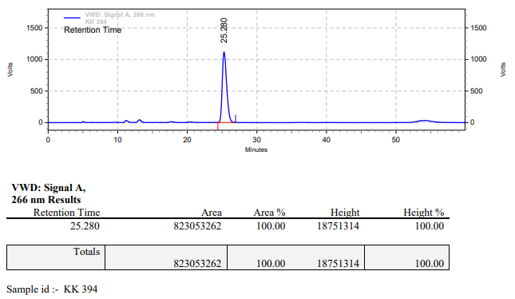

**KK-395**



**Calculation table:**

|  |  |  |  |  |  |
| --- | --- | --- | --- | --- | --- |
| Sr. No | Comp. | Mol. wt. | mmol | Eq. wt. | Wt. taken |
| 1 | Dehydrositagliptin (1) | 405.30 | 0.2135 | 100 | 86 mg |
| 2 | Rh(COD)2OTf | 468.30 | 0.0021 | 1 | 1 mg |
| 3 | L12 | 526.51 | 0.0042 | 2 | 2.2 mg |
| 4 | Salicylic acid | 138.12 | 0.4200 | 200 | 59 mg |

**Procedure:** A glass vial (4 mL) equipped with Teflon coated magnetic needle was cooled under vacuum and transferred to a glove box. The vial was then charged with 86 mg of enamine (**1**), 1 mg of [Rh(COD)2OTf] (1 mol%), ligand (L12) and salicylic acid. Reaction vial was then closed using screwcap, transferred to a large opening Schlenk type container and was then taken out from the glove box. 2 mL dry methanol was added to the vial in inert atmosphere and the resultant reaction slurry was stirred for 1 hour at room temperature (25°C). After that the reaction vial was shifted to an autoclave and the autoclave was purged three times using hydrogen gas (40 bars). Finally, the autoclave was pressurized to 30 bar hydrogen pressure at 40°C for 24 hrs time period. After the 24 hrs time period, the autoclave was cooled to room temperature (25°C), excess pressure was released and the autoclave was opened. The vials were taken out from the autoclave. The thus obtained reaction mixture was passed through neutral alumina bed, the filtrate was collect and dried to yield residue. The resultant residue was then analysed by HPLC.

**Reaction conditions:** Temp: 40°C Press.: 30 bar Solvent: Methanol Time: 24 hrs

**Result: 60%** conversion **95%** ee

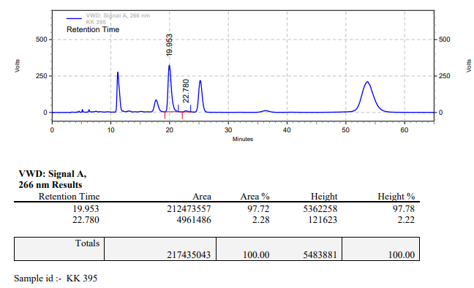

**KK-396**



**Calculation table:**

|  |  |  |  |  |  |
| --- | --- | --- | --- | --- | --- |
| Sr. No | Comp. | Mol. wt. | mmol | Eq. wt. | Wt. taken |
| 1 | Dehydrositagliptin (1) | 405.30 | 0.2135 | 100 | 86 mg |
| 2 | Rh(COD)2OTf | 468.30 | 0.0021 | 1 | 1 mg |
| 3 | L12 | 526.51 | 0.0063 | 3 | 3.3 mg |
| 4 | Salicylic acid | 138.12 | 0.4200 | 200 | 59 mg |

**Procedure:** A glass vial (4 mL) equipped with Teflon coated magnetic needle was cooled under vacuum and transferred to a glove box. The vial was then charged with 86 mg of enamine (**1**), 1 mg of [Rh(COD)2OTf] (1 mol%), ligand (L12) and salicylic acid. Reaction vial was then closed using screwcap, transferred to a large opening Schlenk type container and was then taken out from the glove box. 2 mL dry methanol was added to the vial in inert atmosphere and the resultant reaction slurry was stirred for 1 hour at room temperature (25°C). After that the reaction vial was shifted to an autoclave and the autoclave was purged three times using hydrogen gas (40 bars). Finally, the autoclave was pressurized to 30 bar hydrogen pressure at 40°C for 24 hrs time period. After the 24 hrs time period, the autoclave was cooled to room temperature (25°C), excess pressure was released and the autoclave was opened. The vials were taken out from the autoclave. The thus obtained reaction mixture was passed through neutral alumina bed, the filtrate was collect and dried to yield residue. The resultant residue was then analysed by HPLC.

**Reaction conditions:** Temp: 40°C Press.: 30 bar Solvent: Methanol Time: 24 hrs

**Result: 40%** conversion **96%** ee

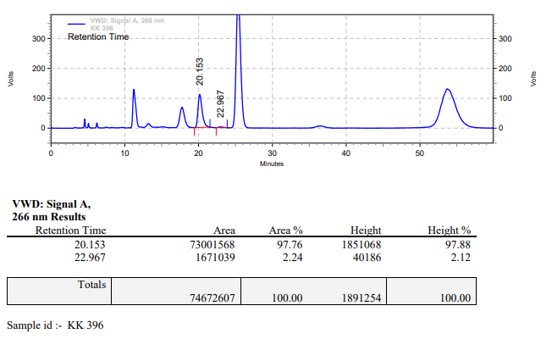

**KK-397**



**Calculation table:**

|  |  |  |  |  |  |
| --- | --- | --- | --- | --- | --- |
| Sr. No | Comp. | Mol. wt. | mmol | Eq. wt. | Wt. taken |
| 1 | Dehydrositagliptin (1) | 405.30 | 0.2135 | 100 | 86 mg |
| 2 | Rh(COD)2OTf | 468.30 | 0.0021 | 1 | 1 mg |
| 3 | L12 | 526.51 | 0.0025 | 1.2 | 1.3 mg |
| 4 | Salicylic acid | 138.12 | 0.4200 | 200 | 59 mg |

**Procedure:** A glass vial (4 mL) equipped with Teflon coated magnetic needle was cooled under vacuum and transferred to a glove box. The vial was then charged with 86 mg of enamine (**1**), 1 mg of [Rh(COD)2OTf] (1 mol%), ligand (L12) and salicylic acid. Reaction vial was then closed using screwcap, transferred to a large opening Schlenk type container and was then taken out from the glove box. 2 mL dry methanol was added to the vial in inert atmosphere and the resultant reaction slurry was stirred for 1 hour at room temperature (25°C). After that the reaction vial was shifted to an autoclave and the autoclave was purged three times using hydrogen gas (40 bars). Finally, the autoclave was pressurized to 30 bar hydrogen pressure at 40°C for 24 hrs time period. After the 24 hrs time period, the autoclave was cooled to room temperature (25°C), excess pressure was released and the autoclave was opened. The vials were taken out from the autoclave. The thus obtained reaction mixture was passed through neutral alumina bed, the filtrate was collect and dried to yield residue. The resultant residue was then analysed by HPLC.

**Reaction conditions:** Temp: 40°C Press.: 30 bar Solvent: Methanol Time: 24 hrs

**Result: 05%** conversion **96%** ee

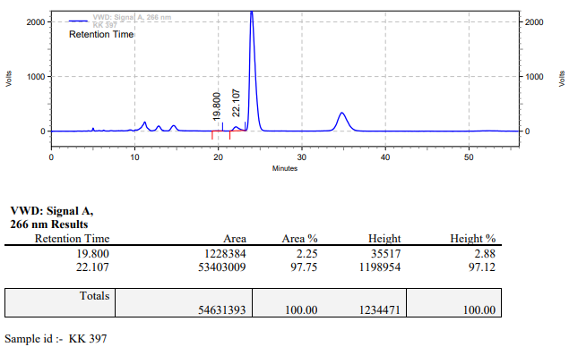

**KK-398**



**Calculation table:**

|  |  |  |  |  |  |
| --- | --- | --- | --- | --- | --- |
| Sr. No | Comp. | Mol. wt. | mmol | Eq. wt. | Wt. taken |
| 1 | Dehydrositagliptin (1) | 405.30 | 0.2135 | 100 | 86 mg |
| 2 | Rh(COD)2OTf | 468.30 | 0.0021 | 1 | 1 mg |
| 3 | L12 | 526.51 | 0.0042 | 2 | 2.2 mg |
| 4 | Salicylic acid | 138.12 | 0.4200 | 200 | 59 mg |

**Procedure:** A glass vial (4 mL) equipped with Teflon coated magnetic needle was cooled under vacuum and transferred to a glove box. The vial was then charged with 86 mg of enamine (**1**), 1 mg of [Rh(COD)2OTf] (1 mol%), ligand (L12) and salicylic acid. Reaction vial was then closed using screwcap, transferred to a large opening Schlenk type container and was then taken out from the glove box. 2 mL dry methanol was added to the vial in inert atmosphere and the resultant reaction slurry was stirred for 1 hour at room temperature (25°C). After that the reaction vial was shifted to an autoclave and the autoclave was purged three times using hydrogen gas (40 bars). Finally, the autoclave was pressurized to 30 bar hydrogen pressure at 40°C for 24 hrs time period. After the 24 hrs time period, the autoclave was cooled to room temperature (25°C), excess pressure was released and the autoclave was opened. The vials were taken out from the autoclave. The thus obtained reaction mixture was passed through neutral alumina bed, the filtrate was collect and dried to yield residue. The resultant residue was then analysed by HPLC.

**Reaction conditions:** Temp: 40°C Press.: 30 bar Solvent: Methanol Time: 24 hrs

**Result: 05%** conversion **95%** ee

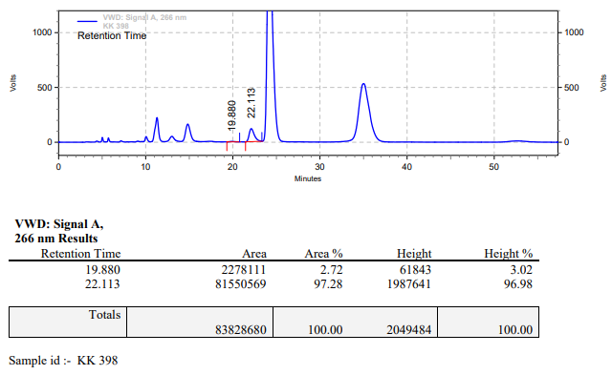

**KK-399**



**Calculation table:**

|  |  |  |  |  |  |
| --- | --- | --- | --- | --- | --- |
| Sr. No | Comp. | Mol. wt. | mmol | Eq. wt. | Wt. taken |
| 1 | Dehydrositagliptin (1) | 405.30 | 0.2135 | 100 | 86 mg |
| 2 | Rh(COD)2OTf | 468.30 | 0.0021 | 1 | 1 mg |
| 3 | L12 | 526.51 | 0.0063 | 3 | 3.3 mg |
| 4 | Salicylic acid | 138.12 | 0.4200 | 200 | 59 mg |

**Procedure:** A glass vial (4 mL) equipped with Teflon coated magnetic needle was cooled under vacuum and transferred to a glove box. The vial was then charged with 86 mg of enamine (**1**), 1 mg of [Rh(COD)2OTf] (1 mol%), ligand (L12) and salicylic acid. Reaction vial was then closed using screwcap, transferred to a large opening Schlenk type container and was then taken out from the glove box. 2 mL dry methanol was added to the vial in inert atmosphere and the resultant reaction slurry was stirred for 1 hour at room temperature (25°C). After that the reaction vial was shifted to an autoclave and the autoclave was purged three times using hydrogen gas (40 bars). Finally, the autoclave was pressurized to 30 bar hydrogen pressure at 40°C for 24 hrs time period. After the 24 hrs time period, the autoclave was cooled to room temperature (25°C), excess pressure was released and the autoclave was opened. The vials were taken out from the autoclave. The thus obtained reaction mixture was passed through neutral alumina bed, the filtrate was collect and dried to yield residue. The resultant residue was then analysed by HPLC.

**Reaction conditions:** Temp: 40°C Press.: 30 bar Solvent: Methanol Time: 24 hrs

**Result: 35%** conversion **95%** ee

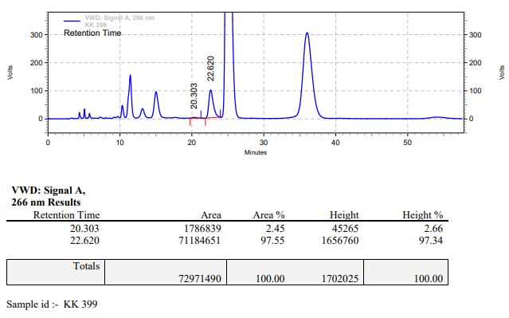

**KK-400**



**Calculation table:**

|  |  |  |  |  |  |
| --- | --- | --- | --- | --- | --- |
| Sr. No | Comp. | Mol. wt. | mmol | Eq. wt. | Wt. taken |
| 1 | Dehydrositagliptin (1) | 405.30 | 0.2135 | 100 | 86 mg |
| 2 | Rh(COD)2OTf | 468.30 | 0.0021 | 1 | 1 mg |
| 3 | L12 | 526.51 | 0.0025 | 1.2 | 1.3 mg |
| 4 | Salicylic acid | 138.12 | 0.4200 | 200 | 59 mg |

**Procedure:** A glass vial (4 mL) equipped with Teflon coated magnetic needle was cooled under vacuum and transferred to a glove box. The vial was then charged with 86 mg of enamine (**1**), 1 mg of [Rh(COD)2OTf] (1 mol%), ligand (L12) and salicylic acid. Reaction vial was then closed using screwcap, transferred to a large opening Schlenk type container and was then taken out from the glove box. 2 mL dry methanol was added to the vial in inert atmosphere and the resultant reaction slurry was stirred for 1 hour at room temperature (25°C). After that the reaction vial was shifted to an autoclave and the autoclave was purged three times using hydrogen gas (40 bars). Finally, the autoclave was pressurized to 30 bar hydrogen pressure at 35°C for 18 hrs time period. After the 18 hrs time period, the autoclave was cooled to room temperature (25°C), excess pressure was released and the autoclave was opened. The vials were taken out from the autoclave. The thus obtained reaction mixture was passed through neutral alumina bed, the filtrate was collect and dried to yield residue. The resultant residue was then analysed by HPLC.

**Reaction conditions:** Temp: 35°C Press.: 30 bar Solvent: Methanol Time: 18 hrs

**Result: 05%** conversion **95%** ee

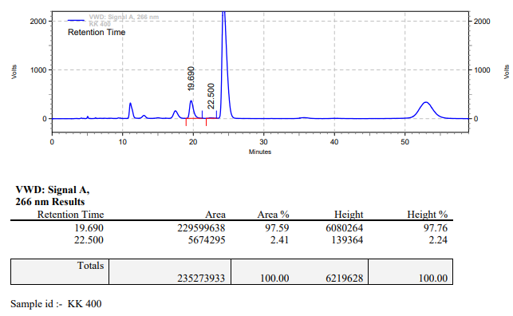

**KK-401**



**Calculation table:**

|  |  |  |  |  |  |
| --- | --- | --- | --- | --- | --- |
| Sr. No | Comp. | Mol. wt. | mmol | Eq. wt. | Wt. taken |
| 1 | Dehydrositagliptin (1) | 405.30 | 0.2135 | 100 | 86 mg |
| 2 | Rh(COD)2OTf | 468.30 | 0.0021 | 1 | 1 mg |
| 3 | L12 | 526.51 | 0.0042 | 2 | 2.2 mg |
| 4 | Salicylic acid | 138.12 | 0.4200 | 200 | 59 mg |

**Procedure:** A glass vial (4 mL) equipped with Teflon coated magnetic needle was cooled under vacuum and transferred to a glove box. The vial was then charged with 86 mg of enamine (**1**), 1 mg of [Rh(COD)2OTf] (1 mol%), ligand (L12) and salicylic acid. Reaction vial was then closed using screwcap, transferred to a large opening Schlenk type container and was then taken out from the glove box. 2 mL dry methanol was added to the vial in inert atmosphere and the resultant reaction slurry was stirred for 1 hour at room temperature (25°C). After that the reaction vial was shifted to an autoclave and the autoclave was purged three times using hydrogen gas (40 bars). Finally, the autoclave was pressurized to 30 bar hydrogen pressure at 35°C for 18 hrs time period. After the 18 hrs time period, the autoclave was cooled to room temperature (25°C), excess pressure was released and the autoclave was opened. The vials were taken out from the autoclave. The thus obtained reaction mixture was passed through neutral alumina bed, the filtrate was collect and dried to yield residue. The resultant residue was then analysed by HPLC.

**Reaction conditions:** Temp: 35°C Press.: 30 bar Solvent: Methanol Time: 18 hrs

**Result: 05%** conversion **96%** ee

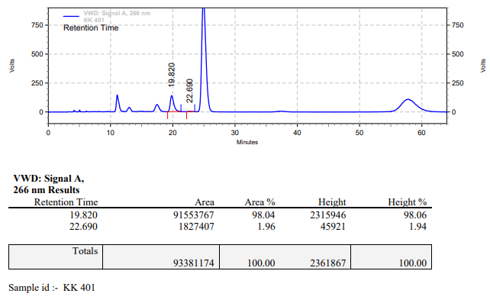

**KK-402**



**Calculation table:**

|  |  |  |  |  |  |
| --- | --- | --- | --- | --- | --- |
| Sr. No | Comp. | Mol. wt. | mmol | Eq. wt. | Wt. taken |
| 1 | Dehydrositagliptin (1) | 405.30 | 0.2135 | 100 | 86 mg |
| 2 | Rh(COD)2OTf | 468.30 | 0.0021 | 1 | 1 mg |
| 3 | L12 | 526.51 | 0.0063 | 3 | 3.3 mg |
| 4 | Salicylic acid | 138.12 | 0.4200 | 200 | 59 mg |

**Procedure:** A glass vial (4 mL) equipped with Teflon coated magnetic needle was cooled under vacuum and transferred to a glove box. The vial was then charged with 86 mg of enamine (**1**), 1 mg of [Rh(COD)2OTf] (1 mol%), ligand (L12) and salicylic acid. Reaction vial was then closed using screwcap, transferred to a large opening Schlenk type container and was then taken out from the glove box. 2 mL dry methanol was added to the vial in inert atmosphere and the resultant reaction slurry was stirred for 1 hour at room temperature (25°C). After that the reaction vial was shifted to an autoclave and the autoclave was purged three times using hydrogen gas (40 bars). Finally, the autoclave was pressurized to 30 bar hydrogen pressure at 35°C for 18 hrs time period. After the 18 hrs time period, the autoclave was cooled to room temperature (25°C), excess pressure was released and the autoclave was opened. The vials were taken out from the autoclave. The thus obtained reaction mixture was passed through neutral alumina bed, the filtrate was collect and dried to yield residue. The resultant residue was then analysed by HPLC.

**Reaction conditions:** Temp: 35°C Press.: 30 bar Solvent: Methanol Time: 18 hrs

**Result: 05%** conversion **96%** ee

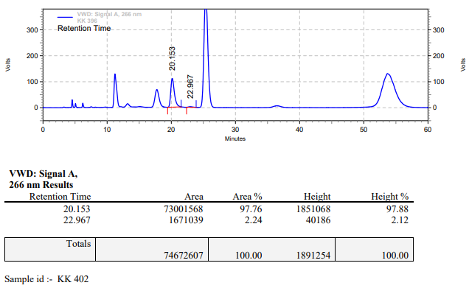

**KK-403**



**Calculation table:**

|  |  |  |  |  |  |
| --- | --- | --- | --- | --- | --- |
| Sr. No | Comp. | Mol. wt. | mmol | Eq. wt. | Wt. taken |
| 1 | Dehydrositagliptin (1) | 405.30 | 0.2135 | 100 | 86 mg |
| 2 | Rh(COD)2OTf | 468.30 | 0.0021 | 1 | 1 mg |
| 3 | L12 | 526.51 | 0.0025 | 1.2 | 1.3 mg |
| 4 | Salicylic acid | 138.12 | 0.2135 | 100 | 29 mg |

**Procedure:** A glass vial (4 mL) equipped with Teflon coated magnetic needle was cooled under vacuum and transferred to a glove box. The vial was then charged with 86 mg of enamine (**1**), 1 mg of [Rh(COD)2OTf] (1 mol%), ligand (L12) and salicylic acid. Reaction vial was then closed using screwcap, transferred to a large opening Schlenk type container and was then taken out from the glove box. 2 mL dry methanol was added to the vial in inert atmosphere and the resultant reaction slurry was stirred for 1 hour at room temperature (25°C). After that the reaction vial was shifted to an autoclave and the autoclave was purged three times using hydrogen gas (40 bars). Finally, the autoclave was pressurized to 30 bar hydrogen pressure at 50°C for 18 hrs time period. After the 18 hrs time period, the autoclave was cooled to room temperature (25°C), excess pressure was released and the autoclave was opened. The vials were taken out from the autoclave. The thus obtained reaction mixture was passed through neutral alumina bed, the filtrate was collect and dried to yield residue. The resultant residue was then analysed by HPLC.

**Reaction conditions:** Temp: 50°C Press.: 30 bar Solvent: Methanol Time: 18 hrs

**Result: 95%** conversion **95%** ee

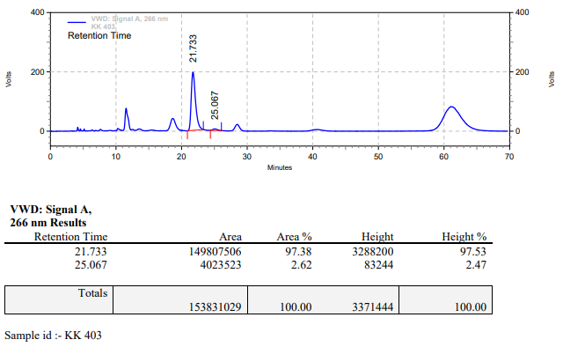

**KK-404**



**Calculation table:**

|  |  |  |  |  |  |
| --- | --- | --- | --- | --- | --- |
| Sr. No | Comp. | Mol. wt. | mmol | Eq. wt. | Wt. taken |
| 1 | Dehydrositagliptin (1) | 405.30 | 0.2135 | 100 | 86 mg |
| 2 | Rh(COD)2OTf | 468.30 | 0.0021 | 1 | 1 mg |
| 3 | L12 | 526.51 | 0.0042 | 2 | 2.2 mg |
| 4 | Salicylic acid | 138.12 | 0.2135 | 100 | 29 mg |

**Procedure:** A glass vial (4 mL) equipped with Teflon coated magnetic needle was cooled under vacuum and transferred to a glove box. The vial was then charged with 86 mg of enamine (**1**), 1 mg of [Rh(COD)2OTf] (1 mol%), ligand (L12) and salicylic acid. Reaction vial was then closed using screwcap, transferred to a large opening Schlenk type container and was then taken out from the glove box. 2 mL dry methanol was added to the vial in inert atmosphere and the resultant reaction slurry was stirred for 1 hour at room temperature (25°C). After that the reaction vial was shifted to an autoclave and the autoclave was purged three times using hydrogen gas (40 bars). Finally, the autoclave was pressurized to 30 bar hydrogen pressure at 50°C for 18 hrs time period. After the 18 hrs time period, the autoclave was cooled to room temperature (25°C), excess pressure was released and the autoclave was opened. The vials were taken out from the autoclave. The thus obtained reaction mixture was passed through neutral alumina bed, the filtrate was collect and dried to yield residue. The resultant residue was then analysed by TLC, only starting was present.

**Reaction conditions:** Temp: 50°C Press.: 30 bar Solvent: Methanol Time: 18 hrs

**Result: 00%** conversion **00%** ee

**KK-405**



**Calculation table:**

|  |  |  |  |  |  |
| --- | --- | --- | --- | --- | --- |
| Sr. No | Comp. | Mol. wt. | mmol | Eq. wt. | Wt. taken |
| 1 | Dehydrositagliptin (1) | 405.30 | 0.2135 | 100 | 86 mg |
| 2 | Rh(COD)2OTf | 468.30 | 0.0021 | 1 | 1 mg |
| 3 | L12 | 526.51 | 0.0025 | 1.2 | 1.3 mg |
| 4 | (Me3)4N+I- | 201.05 | 0.0205 | 10 | 4 mg |

**Procedure:** A glass vial (4 mL) equipped with Teflon coated magnetic needle was cooled under vacuum and transferred to a glove box. The vial was then charged with 86 mg of enamine (**1**), 1 mg of [Rh(COD)2OTf] (1 mol%), ligand (L12) and tetra methyl ammonium iodide. Reaction vial was then closed using screwcap, transferred to a large opening Schlenk type container and was then taken out from the glove box. 2 mL dry methanol was added to the vial in inert atmosphere and the resultant reaction slurry was stirred for 1 hour at room temperature (25°C). After that the reaction vial was shifted to an autoclave and the autoclave was purged three times using hydrogen gas (40 bars). Finally, the autoclave was pressurized to 30 bar hydrogen pressure at 60°C for 18 hrs time period. After the 18 hrs time period, the autoclave was cooled to room temperature (25°C), excess pressure was released and the autoclave was opened. The vials were taken out from the autoclave. The thus obtained reaction mixture was passed through neutral alumina bed, the filtrate was collect and dried to yield residue. The resultant residue was then analysed by TLC, only starting was present.

**Reaction conditions:** Temp: 60°C Press.: 30 bar Solvent: Methanol Time: 18 hrs

**Result: 00%** conversion **00%** ee

**KK-406**



**Calculation table:**

|  |  |  |  |  |  |
| --- | --- | --- | --- | --- | --- |
| Sr. No | Comp. | Mol. wt. | mmol | Eq. wt. | Wt. taken |
| 1 | Dehydrositagliptin (1) | 405.30 | 0.2135 | 100 | 86 mg |
| 2 | Rh(COD)2OTf | 468.30 | 0.0021 | 1 | 1 mg |
| 3 | L12 | 526.51 | 0.0025 | 1.2 | 1.3 mg |
| 4 | (C2H5)4N+I- | 257.15 | 0.0205 | 10 | 5.3 mg |

**Procedure:** A glass vial (4 mL) equipped with Teflon coated magnetic needle was cooled under vacuum and transferred to a glove box. The vial was then charged with 86 mg of enamine (**1**), 1 mg of [Rh(COD)2OTf] (1 mol%), ligand (L12) and tetra ethyl ammonium iodide. Reaction vial was then closed using screwcap, transferred to a large opening Schlenk type container and was then taken out from the glove box. 2 mL dry methanol was added to the vial in inert atmosphere and the resultant reaction slurry was stirred for 1 hour at room temperature (25°C). After that the reaction vial was shifted to an autoclave and the autoclave was purged three times using hydrogen gas (40 bars). Finally, the autoclave was pressurized to 30 bar hydrogen pressure at 60°C for 18 hrs time period. After the 18 hrs time period, the autoclave was cooled to room temperature (25°C), excess pressure was released and the autoclave was opened. The vials were taken out from the autoclave. The thus obtained reaction mixture was passed through neutral alumina bed, the filtrate was collect and dried to yield residue. The resultant residue was then analysed by TLC, only starting was present.

**Reaction conditions:** Temp: 60°C Press.: 30 bar Solvent: Methanol Time: 18 hrs

**Result: 00%** conversion **00%** ee

**KK-407**



**Calculation table:**

|  |  |  |  |  |  |
| --- | --- | --- | --- | --- | --- |
| Sr. No | Comp. | Mol. wt. | mmol | Eq. wt. | Wt. taken |
| 1 | Dehydrositagliptin (1) | 405.30 | 0.2135 | 100 | 86 mg |
| 2 | Rh(COD)2OTf | 468.30 | 0.0021 | 1 | 1 mg |
| 3 | L12 | 526.51 | 0.0025 | 1.2 | 1.3 mg |
| 4 | (C4H9)4N+Br- | 322.37 | 0.0205 | 10 | 6.6 mg |

**Procedure:** A glass vial (4 mL) equipped with Teflon coated magnetic needle was cooled under vacuum and transferred to a glove box. The vial was then charged with 86 mg of enamine (**1**), 1 mg of [Rh(COD)2OTf] (1 mol%), ligand (L12) and tetra butyl ammonium bromide. Reaction vial was then closed using screwcap, transferred to a large opening Schlenk type container and was then taken out from the glove box. 2 mL dry methanol was added to the vial in inert atmosphere and the resultant reaction slurry was stirred for 1 hour at room temperature (25°C). After that the reaction vial was shifted to an autoclave and the autoclave was purged three times using hydrogen gas (40 bars). Finally, the autoclave was pressurized to 30 bar hydrogen pressure at 60°C for 18 hrs time period. After the 18 hrs time period, the autoclave was cooled to room temperature (25°C), excess pressure was released and the autoclave was opened. The vials were taken out from the autoclave. The thus obtained reaction mixture was passed through neutral alumina bed, the filtrate was collect and dried to yield residue. The resultant residue was then analysed by TLC, only starting was present.

**Reaction conditions:** Temp: 60°C Press.: 30 bar Solvent: Methanol Time: 18 hrs

**Result: 00%** conversion **00%** ee

**KK-408**



**Calculation table:**

|  |  |  |  |  |  |
| --- | --- | --- | --- | --- | --- |
| Sr. No | Comp. | Mol. wt. | mmol | Eq. wt. | Wt. taken |
| 1 | Dehydrositagliptin (1) | 405.30 | 0.2135 | 100 | 86 mg |
| 2 | Rh(COD)2OTf | 468.30 | 0.0021 | 1 | 1 mg |
| 3 | L12 | 526.51 | 0.0025 | 1.2 | 1.3 mg |
| 4 | Salicylic acid | 138.12 | 0.4200 | 200 | 59 mg |

**Procedure:** A glass vial (4 mL) equipped with Teflon coated magnetic needle was cooled under vacuum and transferred to a glove box. The vial was then charged with 86 mg of enamine (**1**), 1 mg of [Rh(COD)2OTf] (1 mol%), ligand (L12) and salicylic acid. Reaction vial was then closed using screwcap, transferred to a large opening Schlenk type container and was then taken out from the glove box. 2 mL dry methanol was added to the vial in inert atmosphere and the resultant reaction slurry was stirred for 1 hour at room temperature (25°C). After that the reaction vial was shifted to an autoclave and the autoclave was purged three times using hydrogen gas (40 bars). Finally, the autoclave was pressurized to 30 bar hydrogen pressure at 60°C for 5 hrs time period. After the 5 hrs time period, the autoclave was cooled to room temperature (25°C), excess pressure was released and the autoclave was opened. The vials were taken out from the autoclave. The thus obtained reaction mixture was passed through neutral alumina bed, the filtrate was collect and dried to yield residue. The resultant residue was then analysed by HPLC.

**Reaction conditions:** Temp: 60°C Press.: 30 bar Solvent: Methanol Time: 5 hrs

**Result: 10%** conversion **93%** ee

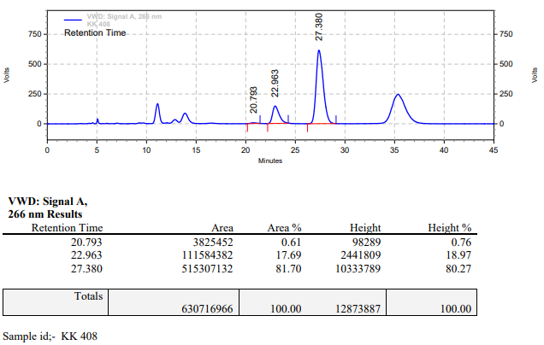

**KK-409**



**Calculation table:**

|  |  |  |  |  |  |
| --- | --- | --- | --- | --- | --- |
| Sr. No | Comp. | Mol. wt. | mmol | Eq. wt. | Wt. taken |
| 1 | Dehydrositagliptin (1) | 405.30 | 0.2135 | 100 | 86 mg |
| 2 | Rh(COD)2OTf | 468.30 | 0.0021 | 1 | 1 mg |
| 3 | L12 | 526.51 | 0.0042 | 2 | 2.2 mg |
| 4 | Salicylic acid | 138.12 | 0.4200 | 200 | 59 mg |

**Procedure:** A glass vial (4 mL) equipped with Teflon coated magnetic needle was cooled under vacuum and transferred to a glove box. The vial was then charged with 86 mg of enamine (**1**), 1 mg of [Rh(COD)2OTf] (1 mol%), ligand (L12) and salicylic acid. Reaction vial was then closed using screwcap, transferred to a large opening Schlenk type container and was then taken out from the glove box. 2 mL dry methanol was added to the vial in inert atmosphere and the resultant reaction slurry was stirred for 1 hour at room temperature (25°C). After that the reaction vial was shifted to an autoclave and the autoclave was purged three times using hydrogen gas (40 bars). Finally, the autoclave was pressurized to 30 bar hydrogen pressure at 60°C for 5 hrs time period. After the 5 hrs time period, the autoclave was cooled to room temperature (25°C), excess pressure was released and the autoclave was opened. The vials were taken out from the autoclave. The thus obtained reaction mixture was passed through neutral alumina bed, the filtrate was collect and dried to yield residue. The resultant residue was then analysed by HPLC.

**Reaction conditions:** Temp: 60°C Press.: 30 bar Solvent: Methanol Time: 5 hrs

**Result: 00%** conversion **00%** ee

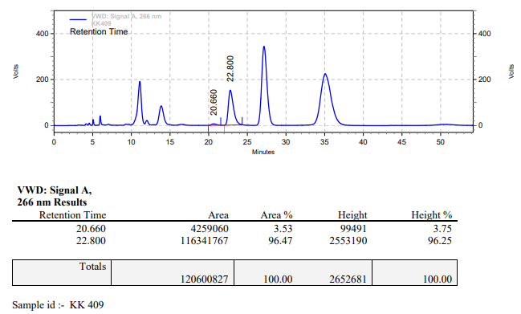

**KK-410**



**Calculation table:**

|  |  |  |  |  |  |
| --- | --- | --- | --- | --- | --- |
| Sr. No | Comp. | Mol. wt. | mmol | Eq. wt. | Wt. taken |
| 1 | Dehydrositagliptin (1) | 405.30 | 0.2135 | 100 | 86 mg |
| 2 | Rh(COD)2OTf | 468.30 | 0.0021 | 1 | 1 mg |
| 3 | L12 | 526.51 | 0.0025 | 1.2 | 1.3 mg |
| 4 | Salicylic acid | 138.12 | 0.0213 | 10 | 3 mg |

**Procedure:** A glass vial (4 mL) equipped with Teflon coated magnetic needle was cooled under vacuum and transferred to a glove box. The vial was then charged with 86 mg of enamine (**1**), 1 mg of [Rh(COD)2OTf] (1 mol%), ligand (L12) and salicylic acid. Reaction vial was then closed using screwcap, transferred to a large opening Schlenk type container and was then taken out from the glove box. 2 mL dry methanol was added to the vial in inert atmosphere and the resultant reaction slurry was stirred for 1 hour at room temperature (25°C). After that the reaction vial was shifted to an autoclave and the autoclave was purged three times using hydrogen gas (40 bars). Finally, the autoclave was pressurized to 30 bar hydrogen pressure at 60°C for 5 hrs time period. After the 5 hrs time period, the autoclave was cooled to room temperature (25°C), excess pressure was released and the autoclave was opened. The vials were taken out from the autoclave. The thus obtained reaction mixture was passed through neutral alumina bed, the filtrate was collect and dried to yield residue. The resultant residue was then analysed by HPLC.

**Reaction conditions:** Temp: 60°C Press.: 30 bar Solvent: Methanol Time: 5 hrs

**Result: 05%** conversion **89%** ee

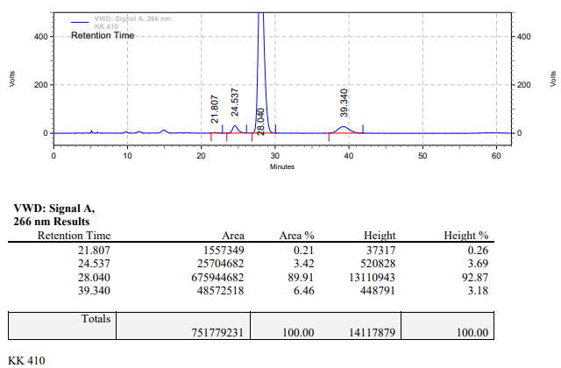

**KK-411**



**Calculation table:**

|  |  |  |  |  |  |
| --- | --- | --- | --- | --- | --- |
| Sr. No | Comp. | Mol. wt. | mmol | Eq. wt. | Wt. taken |
| 1 | Dehydrositagliptin (1) | 405.30 | 0.2135 | 100 | 86 mg |
| 2 | Rh(COD)2OTf | 468.30 | 0.0021 | 1 | 1 mg |
| 3 | L12 | 526.51 | 0.0025 | 1.2 | 1.3 mg |
| 4 | Salicylic acid | 138.12 | 0.0105 | 50 | 15 mg |

**Procedure:** A glass vial (4 mL) equipped with Teflon coated magnetic needle was cooled under vacuum and transferred to a glove box. The vial was then charged with 86 mg of enamine (**1**), 1 mg of [Rh(COD)2OTf] (1 mol%), ligand (L12) and salicylic acid. Reaction vial was then closed using screwcap, transferred to a large opening Schlenk type container and was then taken out from the glove box. 2 mL dry methanol was added to the vial in inert atmosphere and the resultant reaction slurry was stirred for 1 hour at room temperature (25°C). After that the reaction vial was shifted to an autoclave and the autoclave was purged three times using hydrogen gas (40 bars). Finally, the autoclave was pressurized to 30 bar hydrogen pressure at 60°C for 5 hrs time period. After the 5 hrs time period, the autoclave was cooled to room temperature (25°C), excess pressure was released and the autoclave was opened. The vials were taken out from the autoclave. The thus obtained reaction mixture was passed through neutral alumina bed, the filtrate was collect and dried to yield residue. The resultant residue was then analysed by HPLC.

**Reaction conditions:** Temp: 60°C Press.: 30 bar Solvent: Methanol Time: 5 hrs

**Result: 10%** conversion **91%** ee

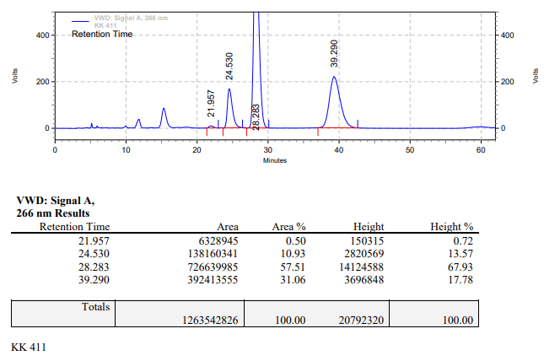

**KK-412**



**Calculation table:**

|  |  |  |  |  |  |
| --- | --- | --- | --- | --- | --- |
| Sr. No | Comp. | Mol. wt. | mmol | Eq. wt. | Wt. taken |
| 1 | Dehydrositagliptin (1) | 405.30 | 0.2135 | 100 | 86 mg |
| 2 | Rh(COD)2OTf | 468.30 | 0.0021 | 1 | 1 mg |
| 3 | L12 | 526.51 | 0.0025 | 1.2 | 1.3 mg |
| 4 | Salicylic acid | 138.12 | 0.0630 | 30 | 9 mg |

**Procedure:** A glass vial (4 mL) equipped with Teflon coated magnetic needle was cooled under vacuum and transferred to a glove box. The vial was then charged with 86 mg of enamine (**1**), 1 mg of [Rh(COD)2OTf] (1 mol%), ligand (L12) and salicylic acid. Reaction vial was then closed using screwcap, transferred to a large opening Schlenk type container and was then taken out from the glove box. 2 mL dry methanol was added to the vial in inert atmosphere and the resultant reaction slurry was stirred for 1 hour at room temperature (25°C). After that the reaction vial was shifted to an autoclave and the autoclave was purged three times using hydrogen gas (40 bars). Finally, the autoclave was pressurized to 30 bar hydrogen pressure at 60°C for 5 hrs time period. After the 5 hrs time period, the autoclave was cooled to room temperature (25°C), excess pressure was released and the autoclave was opened. The vials were taken out from the autoclave. The thus obtained reaction mixture was passed through neutral alumina bed, the filtrate was collect and dried to yield residue. The resultant residue was then analysed by HPLC.

**Reaction conditions:** Temp: 60°C Press.: 30 bar Solvent: Methanol Time: 5 hrs

**Result: 10%** conversion **91%** ee

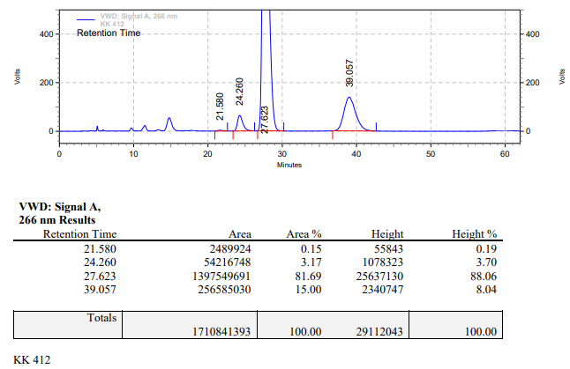

**KK-413**



**Calculation table:**

|  |  |  |  |  |  |
| --- | --- | --- | --- | --- | --- |
| Sr. No | Comp. | Mol. wt. | mmol | Eq. wt. | Wt. taken |
| 1 | Dehydrositagliptin (1) | 405.30 | 0.2135 | 100 | 86 mg |
| 2 | Rh(COD)2OTf | 468.30 | 0.0021 | 1 | 1 mg |
| 3 | L12 | 526.51 | 0.0025 | 1.2 | 1.3 mg |
| 4 | Salicylic acid | 138.12 | 0.0213 | 10 | 3 mg |

**Procedure:** A glass vial (4 mL) equipped with Teflon coated magnetic needle was cooled under vacuum and transferred to a glove box. The vial was then charged with 86 mg of enamine (**1**), 1 mg of [Rh(COD)2OTf] (1 mol%), ligand (L12) and salicylic acid. Reaction vial was then closed using screwcap, transferred to a large opening Schlenk type container and was then taken out from the glove box. 2 mL dry methanol was added to the vial in inert atmosphere and the resultant reaction slurry was stirred for 1 hour at room temperature (25°C). After that the reaction vial was shifted to an autoclave and the autoclave was purged three times using hydrogen gas (40 bars). Finally, the autoclave was pressurized to 30 bar hydrogen pressure at 60°C for 18 hrs time period. After the 18 hrs time period, the autoclave was cooled to room temperature (25°C), excess pressure was released and the autoclave was opened. The vials were taken out from the autoclave. The thus obtained reaction mixture was passed through neutral alumina bed, the filtrate was collect and dried to yield residue. The resultant residue was then analysed by HPLC.

**Reaction conditions:** Temp: 60°C Press.: 30 bar Solvent: Methanol Time: 18 hrs

**Result: 10%** conversion **91%** ee

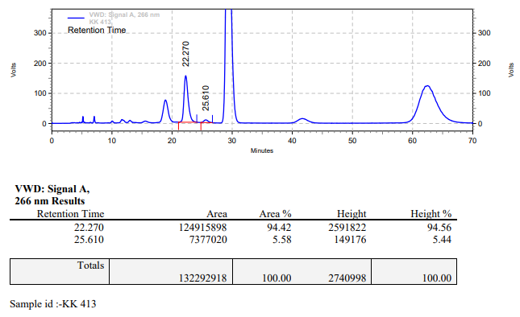

**KK-414**



**Calculation table:**

|  |  |  |  |  |  |
| --- | --- | --- | --- | --- | --- |
| Sr. No | Comp. | Mol. wt. | mmol | Eq. wt. | Wt. taken |
| 1 | Dehydrositagliptin (1) | 405.30 | 0.2135 | 100 | 86 mg |
| 2 | Rh(COD)2OTf | 468.30 | 0.0021 | 1 | 1 mg |
| 3 | L12 | 526.51 | 0.0025 | 1.2 | 1.3 mg |
| 4 | Salicylic acid | 138.12 | 0.0630 | 30 | 9 mg |

**Procedure:** A glass vial (4 mL) equipped with Teflon coated magnetic needle was cooled under vacuum and transferred to a glove box. The vial was then charged with 86 mg of enamine (**1**), 1 mg of [Rh(COD)2OTf] (1 mol%), ligand (L12) and salicylic acid. Reaction vial was then closed using screwcap, transferred to a large opening Schlenk type container and was then taken out from the glove box. 2 mL dry methanol was added to the vial in inert atmosphere and the resultant reaction slurry was stirred for 1 hour at room temperature (25°C). After that the reaction vial was shifted to an autoclave and the autoclave was purged three times using hydrogen gas (40 bars). Finally, the autoclave was pressurized to 30 bar hydrogen pressure at 60°C for 18 hrs time period. After the 18 hrs time period, the autoclave was cooled to room temperature (25°C), excess pressure was released and the autoclave was opened. The vials were taken out from the autoclave. The thus obtained reaction mixture was passed through neutral alumina bed, the filtrate was collect and dried to yield residue. The resultant residue was then analysed by HPLC.

**Reaction conditions:** Temp: 60°C Press.: 30 bar Solvent: Methanol Time: 18 hrs

**Result: 40%** conversion **92%** ee

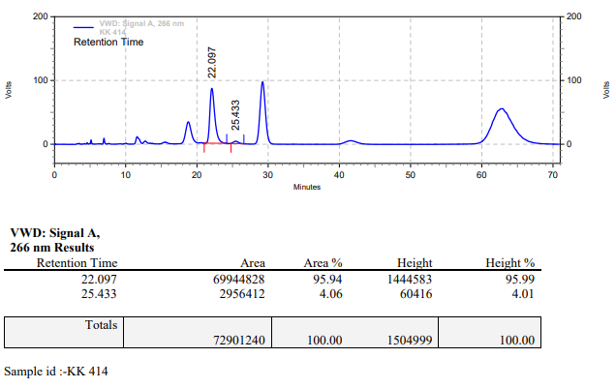

**KK-415**



**Calculation table:**

|  |  |  |  |  |  |
| --- | --- | --- | --- | --- | --- |
| Sr. No | Comp. | Mol. wt. | mmol | Eq. wt. | Wt. taken |
| 1 | Dehydrositagliptin (1) | 405.30 | 0.2135 | 100 | 86 mg |
| 2 | Rh(COD)2OTf | 468.30 | 0.0021 | 1 | 1 mg |
| 3 | L12 | 526.51 | 0.0025 | 1.2 | 1.3 mg |
| 4 | Salicylic acid | 138.12 | 0.1050 | 50 | 15 mg |

**Procedure:** A glass vial (4 mL) equipped with Teflon coated magnetic needle was cooled under vacuum and transferred to a glove box. The vial was then charged with 86 mg of enamine (**1**), 1 mg of [Rh(COD)2OTf] (1 mol%), ligand (L12) and salicylic acid. Reaction vial was then closed using screwcap, transferred to a large opening Schlenk type container and was then taken out from the glove box. 2 mL dry methanol was added to the vial in inert atmosphere and the resultant reaction slurry was stirred for 1 hour at room temperature (25°C). After that the reaction vial was shifted to an autoclave and the autoclave was purged three times using hydrogen gas (40 bars). Finally, the autoclave was pressurized to 30 bar hydrogen pressure at 60°C for 18 hrs time period. After the 18 hrs time period, the autoclave was cooled to room temperature (25°C), excess pressure was released and the autoclave was opened. The vials were taken out from the autoclave. The thus obtained reaction mixture was passed through neutral alumina bed, the filtrate was collect and dried to yield residue. The resultant residue was then analysed by HPLC.

**Reaction conditions:** Temp: 60°C Press.: 30 bar Solvent: Methanol Time: 18 hrs

**Result: 65%** conversion **93%** ee

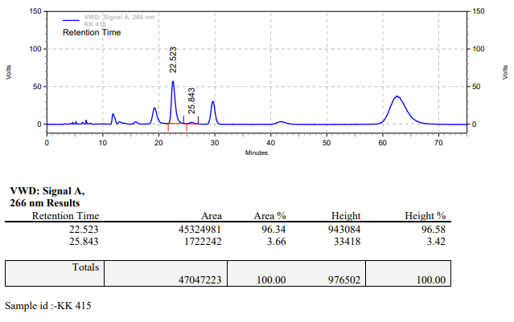

**KK-416**



**Calculation table:**

|  |  |  |  |  |  |
| --- | --- | --- | --- | --- | --- |
| Sr. No | Comp. | Mol. wt. | mmol | Eq. wt. | Wt. taken |
| 1 | Dehydrositagliptin (1) | 405.30 | 0.2135 | 100 | 86 mg |
| 2 | Rh(COD)2OTf | 468.30 | 0.0021 | 1 | 1 mg |
| 3 | L12 | 526.51 | 0.0025 | 1.2 | 1.3 mg |
| 4 | (Me3)4N+I- | 201.05 | 0.0630 | 30 | 12 mg |

**Procedure:** A glass vial (4 mL) equipped with Teflon coated magnetic needle was cooled under vacuum and transferred to a glove box. The vial was then charged with 86 mg of enamine (**1**), 1 mg of [Rh(COD)2OTf] (1 mol%), ligand (L12) and tetra methyl ammonium iodide. Reaction vial was then closed using screwcap, transferred to a large opening Schlenk type container and was then taken out from the glove box. 2 mL dry methanol was added to the vial in inert atmosphere and the resultant reaction slurry was stirred for 1 hour at room temperature (25°C). After that the reaction vial was shifted to an autoclave and the autoclave was purged three times using hydrogen gas (40 bars). Finally, the autoclave was pressurized to 30 bar hydrogen pressure at 60°C for 18 hrs time period. After the 18 hrs time period, the autoclave was cooled to room temperature (25°C), excess pressure was released and the autoclave was opened. The vials were taken out from the autoclave. The thus obtained reaction mixture was passed through neutral alumina bed, the filtrate was collect and dried to yield residue. The resultant residue was then analysed by HPLC.

**Reaction conditions:** Temp: 60°C Press.: 30 bar Solvent: Methanol Time: 18 hrs

**Result: 00%** conversion **00%** ee

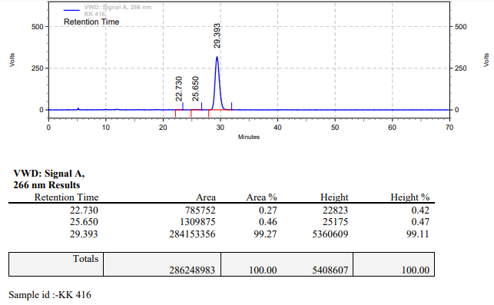

**KK-417**



**Calculation table:**

|  |  |  |  |  |  |
| --- | --- | --- | --- | --- | --- |
| Sr. No | Comp. | Mol. wt. | mmol | Eq. wt. | Wt. taken |
| 1 | Dehydrositagliptin (1) | 405.30 | 0.2135 | 100 | 86 mg |
| 2 | Rh(COD)2OTf | 468.30 | 0.0021 | 1 | 1 mg |
| 3 | L12 | 526.51 | 0.0025 | 1.2 | 1.3 mg |
| 4 | (C2H5)4N+I- | 257.15 | 0.0630 | 30 | 16 mg |

**Procedure:** A glass vial (4 mL) equipped with Teflon coated magnetic needle was cooled under vacuum and transferred to a glove box. The vial was then charged with 86 mg of enamine (**1**), 1 mg of [Rh(COD)2OTf] (1 mol%), ligand (L12) and tetra ethyl ammonium iodide. Reaction vial was then closed using screwcap, transferred to a large opening Schlenk type container and was then taken out from the glove box. 2 mL dry methanol was added to the vial in inert atmosphere and the resultant reaction slurry was stirred for 1 hour at room temperature (25°C). After that the reaction vial was shifted to an autoclave and the autoclave was purged three times using hydrogen gas (40 bars). Finally, the autoclave was pressurized to 30 bar hydrogen pressure at 60°C for 18 hrs time period. After the 18 hrs time period, the autoclave was cooled to room temperature (25°C), excess pressure was released and the autoclave was opened. The vials were taken out from the autoclave. The thus obtained reaction mixture was passed through neutral alumina bed, the filtrate was collect and dried to yield residue. The resultant residue was then analysed by HPLC.

**Reaction conditions:** Temp: 60°C Press.: 30 bar Solvent: Methanol Time: 18 hrs

**Result: 00%** conversion **00%** ee

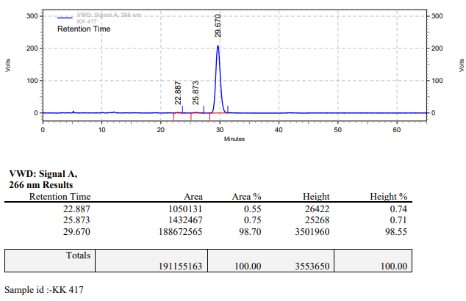

**KK-418**



**Calculation table:**

|  |  |  |  |  |  |
| --- | --- | --- | --- | --- | --- |
| Sr. No | Comp. | Mol. wt. | mmol | Eq. wt. | Wt. taken |
| 1 | Dehydrositagliptin (1) | 405.30 | 0.2135 | 100 | 86 mg |
| 2 | Rh(COD)2OTf | 468.30 | 0.0021 | 1 | 1 mg |
| 3 | L12 | 526.51 | 0.0025 | 1.2 | 1.3 mg |
| 4 | (C4H9)4N+Br- | 322.37 | 0.0630 | 30 | 20 mg |

**Procedure:** A glass vial (4 mL) equipped with Teflon coated magnetic needle was cooled under vacuum and transferred to a glove box. The vial was then charged with 86 mg of enamine (**1**), 1 mg of [Rh(COD)2OTf] (1 mol%), ligand (L12) and tetra butyl ammonium bromide. Reaction vial was then closed using screwcap, transferred to a large opening Schlenk type container and was then taken out from the glove box. 2 mL dry methanol was added to the vial in inert atmosphere and the resultant reaction slurry was stirred for 1 hour at room temperature (25°C). After that the reaction vial was shifted to an autoclave and the autoclave was purged three times using hydrogen gas (40 bars). Finally, the autoclave was pressurized to 30 bar hydrogen pressure at 60°C for 18 hrs time period. After the 18 hrs time period, the autoclave was cooled to room temperature (25°C), excess pressure was released and the autoclave was opened. The vials were taken out from the autoclave. The thus obtained reaction mixture was passed through neutral alumina bed, the filtrate was collect and dried to yield residue. The resultant residue was then analysed by HPLC.

**Reaction conditions:** Temp: 60°C Press.: 30 bar Solvent: Methanol Time: 18 hrs

**Result: 00%** conversion **00%** ee

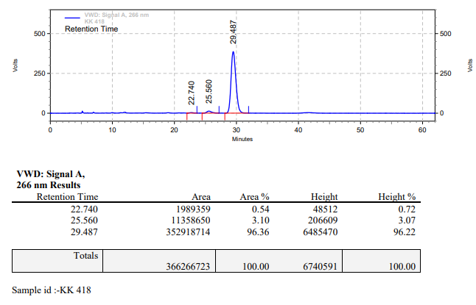

**KK-419**



**Calculation table:**

|  |  |  |  |  |  |
| --- | --- | --- | --- | --- | --- |
| Sr. No | Comp. | Mol. wt. | mmol | Eq. wt. | Wt. taken |
| 1 | Dehydrositagliptin (1) | 405.30 | 0.2135 | 100 | 86 mg |
| 2 | Rh(COD)2OTf | 468.30 | 0.0021 | 1 | 1 mg |
| 3 | L12 | 526.51 | 0.0025 | 1.2 | 1.3 mg |
| 4 | Ammonium chloride | 53.49 | 0.0213 | 10 | 1 mg |

**Procedure:** A glass vial (4 mL) equipped with Teflon coated magnetic needle was cooled under vacuum and transferred to a glove box. The vial was then charged with 86 mg of enamine (**1**), 1 mg of [Rh(COD)2OTf] (1 mol%), ligand (L12) and ammonium chloride. Reaction vial was then closed using screwcap, transferred to a large opening Schlenk type container and was then taken out from the glove box. 2 mL dry methanol was added to the vial in inert atmosphere and the resultant reaction slurry was stirred for 1 hour at room temperature (25°C). After that the reaction vial was shifted to an autoclave and the autoclave was purged three times using hydrogen gas (40 bars). Finally, the autoclave was pressurized to 30 bar hydrogen pressure at 60°C for 18 hrs time period. After the 18 hrs time period, the autoclave was cooled to room temperature (25°C), excess pressure was released and the autoclave was opened. The vials were taken out from the autoclave. The thus obtained reaction mixture was passed through neutral alumina bed, the filtrate was collect and dried to yield residue. The resultant residue was then analysed by HPLC.

**Reaction conditions:** Temp: 60°C Press.: 30 bar Solvent: Methanol Time: 18 hrs

**Result: 05%** conversion **69%** ee

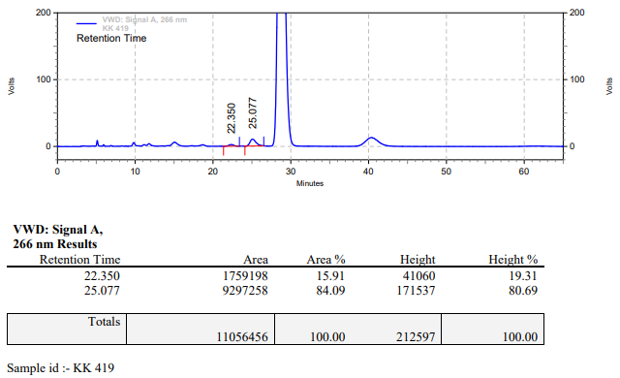

**KK-420**



**Calculation table:**

|  |  |  |  |  |  |
| --- | --- | --- | --- | --- | --- |
| Sr. No | Comp. | Mol. wt. | mmol | Eq. wt. | Wt. taken |
| 1 | Dehydrositagliptin (1) | 405.30 | 0.2135 | 100 | 86 mg |
| 2 | Rh(COD)2OTf | 468.30 | 0.0021 | 1 | 1 mg |
| 3 | L12 | 526.51 | 0.0025 | 1.2 | 1.3 mg |
| 4 | Acetic acid | 60.05 | 0.0213 | 10 | 1.3 mg |

**Procedure:** A glass vial (4 mL) equipped with Teflon coated magnetic needle was cooled under vacuum and transferred to a glove box. The vial was then charged with 86 mg of enamine (**1**), 1 mg of [Rh(COD)2OTf] (1 mol%) and ligand (L12). Reaction vial was then closed using screwcap, transferred to a large opening Schlenk type container and was then taken out from the glove box. 2 mL dry methanol was added followed by acetic acid to the vial in inert atmosphere and the resultant reaction slurry was stirred for 1 hour at room temperature (25°C). After that the reaction vial was shifted to an autoclave and the autoclave was purged three times using hydrogen gas (40 bars). Finally, the autoclave was pressurized to 30 bar hydrogen pressure at 60°C for 18 hrs time period. After the 18 hrs time period, the autoclave was cooled to room temperature (25°C), excess pressure was released and the autoclave was opened. The vials were taken out from the autoclave. The thus obtained reaction mixture was passed through neutral alumina bed, the filtrate was collect and dried to yield residue. The resultant residue was then analysed by HPLC.

**Reaction conditions:** Temp: 60°C Press.: 30 bar Solvent: Methanol Time: 18 hrs

**Result: 10%** conversion **94%** ee

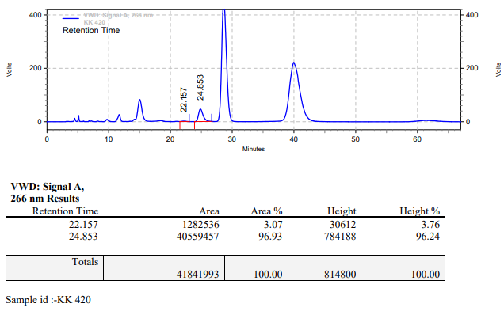

**KK-421**



**Calculation table:**

|  |  |  |  |  |  |
| --- | --- | --- | --- | --- | --- |
| Sr. No | Comp. | Mol. wt. | mmol | Eq. wt. | Wt. taken |
| 1 | Dehydrositagliptin (1) | 405.30 | 0.2135 | 100 | 86 mg |
| 2 | Rh(COD)2OTf | 468.30 | 0.0021 | 1 | 1 mg |
| 3 | L12 | 526.51 | 0.0025 | 1.2 | 1.3 mg |
| 4 | Phosphoric acid | 97.99 | 0.0213 | 10 | 2 mg |

**Procedure:** A glass vial (4 mL) equipped with Teflon coated magnetic needle was cooled under vacuum and transferred to a glove box. The vial was then charged with 86 mg of enamine (**1**), 1 mg of [Rh(COD)2OTf] (1 mol%) and ligand (L12). Reaction vial was then closed using screwcap, transferred to a large opening Schlenk type container and was then taken out from the glove box. 2 mL dry methanol was added followed by Phosphoric acid to the vial in inert atmosphere and the resultant reaction slurry was stirred for 1 hour at room temperature (25°C). After that the reaction vial was shifted to an autoclave and the autoclave was purged three times using hydrogen gas (40 bars). Finally, the autoclave was pressurized to 30 bar hydrogen pressure at 60°C for 18 hrs time period. After the 18 hrs time period, the autoclave was cooled to room temperature (25°C), excess pressure was released and the autoclave was opened. The vials were taken out from the autoclave. The thus obtained reaction mixture was passed through neutral alumina bed, the filtrate was collect and dried to yield residue. The resultant residue was then analysed by HPLC.

**Reaction conditions:** Temp: 60°C Press.: 30 bar Solvent: Methanol Time: 18 hrs

**Result: 100%** conversion **00%** ee

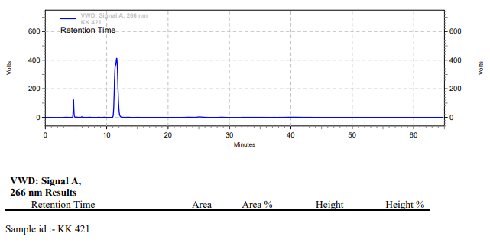

**KK-422**



**Calculation table:**

|  |  |  |  |  |  |
| --- | --- | --- | --- | --- | --- |
| Sr. No | Comp. | Mol. wt. | mmol | Eq. wt. | Wt. taken |
| 1 | Dehydrositagliptin (1) | 405.30 | 0.2135 | 100 | 86 mg |
| 2 | Rh(COD)2OTf | 468.30 | 0.0021 | 1 | 1 mg |
| 3 | L12 | 526.51 | 0.0025 | 1.2 | 1.3 mg |
| 4 | Ammonium salicylate | 155.12 | 0.0213 | 10 | 3 mg |

**Procedure:** A glass vial (4 mL) equipped with Teflon coated magnetic needle was cooled under vacuum and transferred to a glove box. The vial was then charged with 86 mg of enamine (**1**), 1 mg of [Rh(COD)2OTf] (1 mol%), ligand (L12) and ammonium salicylate. Reaction vial was then closed using screwcap, transferred to a large opening Schlenk type container and was then taken out from the glove box. 2 mL dry methanol was added to the vial in inert atmosphere and the resultant reaction slurry was stirred for 1 hour at room temperature (25°C). After that the reaction vial was shifted to an autoclave and the autoclave was purged three times using hydrogen gas (40 bars). Finally, the autoclave was pressurized to 30 bar hydrogen pressure at 60°C for 18 hrs time period. After the 18 hrs time period, the autoclave was cooled to room temperature (25°C), excess pressure was released and the autoclave was opened. The vials were taken out from the autoclave. The thus obtained reaction mixture was passed through neutral alumina bed, the filtrate was collect and dried to yield residue. The resultant residue was then analysed by HPLC.

**Reaction conditions:** Temp: 60°C Press.: 30 bar Solvent: Methanol Time: 18 hrs

**Result: 10%** conversion **85%** ee

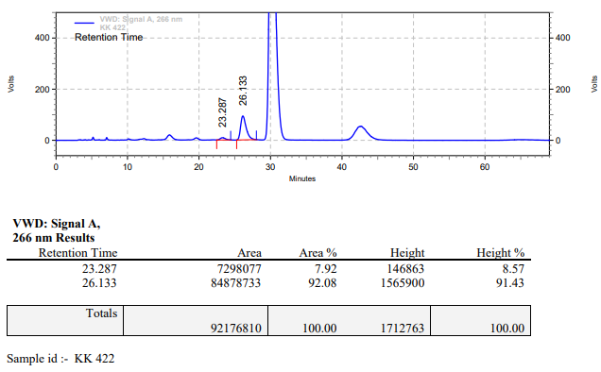

**KK-423**



**Calculation table:**

|  |  |  |  |  |  |
| --- | --- | --- | --- | --- | --- |
| Sr. No | Comp. | Mol. wt. | mmol | Eq. wt. | Wt. taken |
| 1 | Dehydrositagliptin (1) | 405.30 | 0.2135 | 100 | 86 mg |
| 2 | Rh(COD)2OTf | 468.30 | 0.0021 | 1 | 1 mg |
| 3 | L12 | 526.51 | 0.0025 | 1.2 | 1.3 mg |
| 4 | Ammonium salicylate | 155.12 | 0.0630 | 30 | 9 mg |

**Procedure:** A glass vial (4 mL) equipped with Teflon coated magnetic needle was cooled under vacuum and transferred to a glove box. The vial was then charged with 86 mg of enamine (**1**), 1 mg of [Rh(COD)2OTf] (1 mol%), ligand (L12) and ammonium salicylate. Reaction vial was then closed using screwcap, transferred to a large opening Schlenk type container and was then taken out from the glove box. 2 mL dry methanol was added to the vial in inert atmosphere and the resultant reaction slurry was stirred for 1 hour at room temperature (25°C). After that the reaction vial was shifted to an autoclave and the autoclave was purged three times using hydrogen gas (40 bars). Finally, the autoclave was pressurized to 30 bar hydrogen pressure at 60°C for 18 hrs time period. After the 18 hrs time period, the autoclave was cooled to room temperature (25°C), excess pressure was released and the autoclave was opened. The vials were taken out from the autoclave. The thus obtained reaction mixture was passed through neutral alumina bed, the filtrate was collect and dried to yield residue. The resultant residue was then analysed by HPLC.

**Reaction conditions:** Temp: 60°C Press.: 30 bar Solvent: Methanol Time: 18 hrs

**Result: 10%** conversion **88%** ee

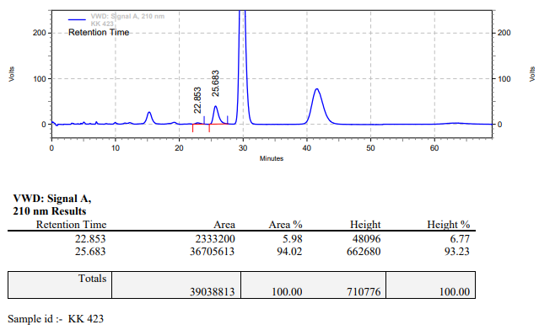

**KK-424**



**Calculation table:**

|  |  |  |  |  |  |
| --- | --- | --- | --- | --- | --- |
| Sr. No | Comp. | Mol. wt. | mmol | Eq. wt. | Wt. taken |
| 1 | Dehydrositagliptin (1) | 405.30 | 0.2135 | 100 | 86 mg |
| 2 | Rh(COD)2OTf | 468.30 | 0.0021 | 1 | 1 mg |
| 3 | L12 | 526.51 | 0.0025 | 1.2 | 1.3 mg |
| 4 | Ammonium salicylate | 155.12 | 0.1050 | 50 | 15 mg |

**Procedure:** A glass vial (4 mL) equipped with Teflon coated magnetic needle was cooled under vacuum and transferred to a glove box. The vial was then charged with 86 mg of enamine (**1**), 1 mg of [Rh(COD)2OTf] (1 mol%), ligand (L12) and ammonium salicylate. Reaction vial was then closed using screwcap, transferred to a large opening Schlenk type container and was then taken out from the glove box. 2 mL dry methanol was added to the vial in inert atmosphere and the resultant reaction slurry was stirred for 1 hour at room temperature (25°C). After that the reaction vial was shifted to an autoclave and the autoclave was purged three times using hydrogen gas (40 bars). Finally, the autoclave was pressurized to 30 bar hydrogen pressure at 60°C for 18 hrs time period. After the 18 hrs time period, the autoclave was cooled to room temperature (25°C), excess pressure was released and the autoclave was opened. The vials were taken out from the autoclave. The thus obtained reaction mixture was passed through neutral alumina bed, the filtrate was collect and dried to yield residue. The resultant residue was then analysed by HPLC.

**Reaction conditions:** Temp: 60°C Press.: 30 bar Solvent: Methanol Time: 18 hrs

**Result: 10%** conversion **90%** ee

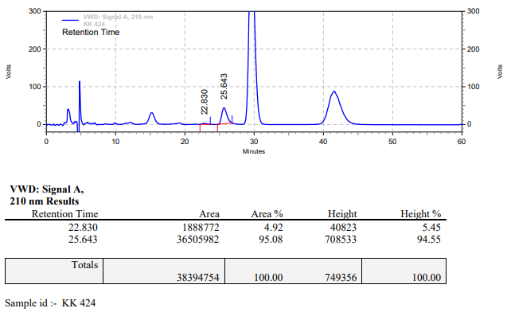

**KK-425**



**Calculation table:**

|  |  |  |  |  |  |
| --- | --- | --- | --- | --- | --- |
| Sr. No | Comp. | Mol. wt. | mmol | Eq. wt. | Wt. taken |
| 1 | Dehydrositagliptin (1) | 405.30 | 0.2135 | 100 | 86 mg |
| 2 | Rh(COD)2OTf | 468.30 | 0.0021 | 1 | 1 mg |
| 3 | L12 | 526.51 | 0.0025 | 1.2 | 1.3 mg |
| 4 | Salicylic acid | 138.12 | 0.4200 | 200 | 59 mg |

**Procedure:** A glass vial (4 mL) equipped with Teflon coated magnetic needle was cooled under vacuum and transferred to a glove box. The vial was then charged with 86 mg of enamine (**1**), 1 mg of [Rh(COD)2OTf] (1 mol%), ligand (L12) and salicylic acid. Reaction vial was then closed using screwcap, transferred to a large opening Schlenk type container and was then taken out from the glove box. 2 mL dry methanol was added to the vial in inert atmosphere and the resultant reaction slurry was stirred for 1 hour at room temperature (25°C). After that the reaction vial was shifted to an autoclave and the autoclave was purged three times using hydrogen gas (40 bars). Finally, the autoclave was pressurized to 30 bar hydrogen pressure at 60°C for 18 hrs time period. After the 18 hrs time period, the autoclave was cooled to room temperature (25°C), excess pressure was released and the autoclave was opened. The vials were taken out from the autoclave. The thus obtained reaction mixture was passed through neutral alumina bed, the filtrate was collect and dried to yield residue. The resultant residue was then analysed by HPLC.

**Reaction conditions:** Temp: 60°C Press.: 30 bar Solvent: Methanol Time: 18 hrs

**Result: 50%** conversion **84%** ee

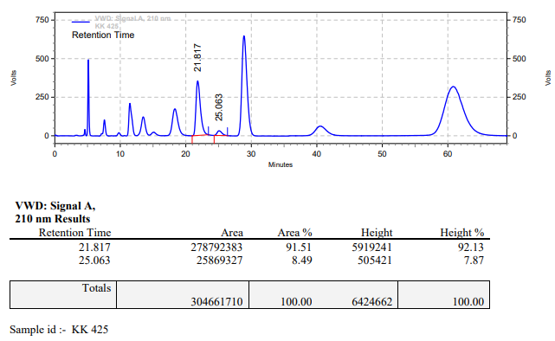

**KK-426**



**Calculation table:**

|  |  |  |  |  |  |
| --- | --- | --- | --- | --- | --- |
| Sr. No | Comp. | Mol. wt. | mmol | Eq. wt. | Wt. taken |
| 1 | Dehydrositagliptin (1) | 405.30 | 0.2135 | 100 | 86 mg |
| 2 | Rh(COD)2OTf | 468.30 | 0.0021 | 1 | 1 mg |
| 3 | L12 | 526.51 | 0.0042 | 2 | 2.2 mg |
| 4 | Salicylic acid | 138.12 | 0.0213 | 10 | 3 mg |

**Procedure:** A glass vial (4 mL) equipped with Teflon coated magnetic needle was cooled under vacuum and transferred to a glove box. The vial was then charged with 86 mg of enamine (**1**), 1 mg of [Rh(COD)2OTf] (1 mol%), ligand (L12) and salicylic acid. Reaction vial was then closed using screwcap, transferred to a large opening Schlenk type container and was then taken out from the glove box. 2 mL dry methanol was added to the vial in inert atmosphere and the resultant reaction slurry was stirred for 1 hour at room temperature (25°C). After that the reaction vial was shifted to an autoclave and the autoclave was purged three times using hydrogen gas (40 bars). Finally, the autoclave was pressurized to 30 bar hydrogen pressure at 60°C for 18 hrs time period. After the 18 hrs time period, the autoclave was cooled to room temperature (25°C), excess pressure was released and the autoclave was opened. The vials were taken out from the autoclave. The thus obtained reaction mixture was passed through neutral alumina bed, the filtrate was collect and dried to yield residue. The resultant residue was then analysed by TLC, only starting was present.

**Reaction conditions:** Temp: 60°C Press.: 30 bar Solvent: Methanol Time: 18 hrs

**Result: 00%** conversion **00%** ee

**KK-427**



**Calculation table:**

|  |  |  |  |  |  |
| --- | --- | --- | --- | --- | --- |
| Sr. No | Comp. | Mol. wt. | mmol | Eq. wt. | Wt. taken |
| 1 | Dehydrositagliptin (1) | 405.30 | 0.2135 | 100 | 86 mg |
| 2 | Rh(COD)2OTf | 468.30 | 0.0021 | 1 | 1 mg |
| 3 | L12 | 526.51 | 0.0042 | 2 | 2.2 mg |
| 4 | Salicylic acid | 138.12 | 0.0630 | 30 | 9 mg |

**Procedure:** A glass vial (4 mL) equipped with Teflon coated magnetic needle was cooled under vacuum and transferred to a glove box. The vial was then charged with 86 mg of enamine (**1**), 1 mg of [Rh(COD)2OTf] (1 mol%), ligand (L12) and salicylic acid. Reaction vial was then closed using screwcap, transferred to a large opening Schlenk type container and was then taken out from the glove box. 2 mL dry methanol was added to the vial in inert atmosphere and the resultant reaction slurry was stirred for 1 hour at room temperature (25°C). After that the reaction vial was shifted to an autoclave and the autoclave was purged three times using hydrogen gas (40 bars). Finally, the autoclave was pressurized to 30 bar hydrogen pressure at 60°C for 18 hrs time period. After the 18 hrs time period, the autoclave was cooled to room temperature (25°C), excess pressure was released and the autoclave was opened. The vials were taken out from the autoclave. The thus obtained reaction mixture was passed through neutral alumina bed, the filtrate was collect and dried to yield residue. The resultant residue was then analysed by TLC, only starting was present.

**Reaction conditions:** Temp: 60°C Press.: 30 bar Solvent: Methanol Time: 18 hrs

**Result: 00%** conversion **00%** ee

**KK-428**



**Calculation table:**

|  |  |  |  |  |  |
| --- | --- | --- | --- | --- | --- |
| Sr. No | Comp. | Mol. wt. | mmol | Eq. wt. | Wt. taken |
| 1 | Dehydrositagliptin (1) | 405.30 | 0.2135 | 100 | 86 mg |
| 2 | Rh(COD)2OTf | 468.30 | 0.0021 | 1 | 1 mg |
| 3 | L12 | 526.51 | 0.0042 | 2 | 2.2 mg |
| 4 | Ammonium salicylate | 155.12 | 0.0213 | 10 | 3 mg |

**Procedure:** A glass vial (4 mL) equipped with Teflon coated magnetic needle was cooled under vacuum and transferred to a glove box. The vial was then charged with 86 mg of enamine (**1**), 1 mg of [Rh(COD)2OTf] (1 mol%), ligand (L12) and ammonium salicylate. Reaction vial was then closed using screwcap, transferred to a large opening Schlenk type container and was then taken out from the glove box. 2 mL dry methanol was added to the vial in inert atmosphere and the resultant reaction slurry was stirred for 1 hour at room temperature (25°C). After that the reaction vial was shifted to an autoclave and the autoclave was purged three times using hydrogen gas (40 bars). Finally, the autoclave was pressurized to 30 bar hydrogen pressure at 60°C for 18 hrs time period. After the 18 hrs time period, the autoclave was cooled to room temperature (25°C), excess pressure was released and the autoclave was opened. The vials were taken out from the autoclave. The thus obtained reaction mixture was passed through neutral alumina bed, the filtrate was collect and dried to yield residue. The resultant residue was then analysed by HPLC.

**Reaction conditions:** Temp: 60°C Press.: 30 bar Solvent: Methanol Time: 18 hrs

**Result: 20%** conversion **89%** ee

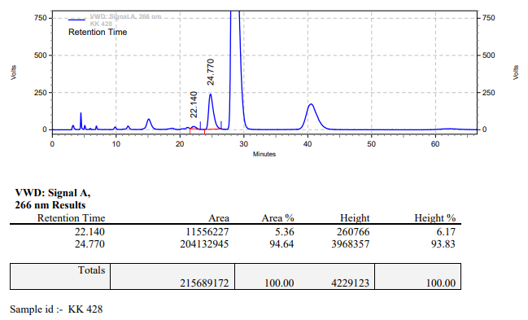

**KK-429**



**Calculation table:**

|  |  |  |  |  |  |
| --- | --- | --- | --- | --- | --- |
| Sr. No | Comp. | Mol. wt. | mmol | Eq. wt. | Wt. taken |
| 1 | Dehydrositagliptin (1) | 405.30 | 0.2135 | 100 | 86 mg |
| 2 | Rh(COD)2OTf | 468.30 | 0.0021 | 1 | 1 mg |
| 3 | L12 | 526.51 | 0.0042 | 2 | 2.2 mg |
| 4 | Ammonium salicylate | 155.12 | 0.0630 | 30 | 9 mg |

**Procedure:** A glass vial (4 mL) equipped with Teflon coated magnetic needle was cooled under vacuum and transferred to a glove box. The vial was then charged with 86 mg of enamine (**1**), 1 mg of [Rh(COD)2OTf] (1 mol%), ligand (L12) and ammonium salicylate. Reaction vial was then closed using screwcap, transferred to a large opening Schlenk type container and was then taken out from the glove box. 2 mL dry methanol was added to the vial in inert atmosphere and the resultant reaction slurry was stirred for 1 hour at room temperature (25°C). After that the reaction vial was shifted to an autoclave and the autoclave was purged three times using hydrogen gas (40 bars). Finally, the autoclave was pressurized to 30 bar hydrogen pressure at 60°C for 18 hrs time period. After the 18 hrs time period, the autoclave was cooled to room temperature (25°C), excess pressure was released and the autoclave was opened. The vials were taken out from the autoclave. The thus obtained reaction mixture was passed through neutral alumina bed, the filtrate was collect and dried to yield residue. The resultant residue was then analysed by TLC, only starting was present.

**Reaction conditions:** Temp: 60°C Press.: 30 bar Solvent: Methanol Time: 18 hrs

**Result: 00%** conversion **00%** ee

**KK-430**



**Calculation table:**

|  |  |  |  |  |  |
| --- | --- | --- | --- | --- | --- |
| Sr. No | Comp. | Mol. wt. | mmol | Eq. wt. | Wt. taken |
| 1 | Dehydrositagliptin (1) | 405.30 | 0.2135 | 100 | 86 mg |
| 2 | Rh(COD)2OTf | 468.30 | 0.0021 | 1 | 1 mg |
| 3 | L12 | 526.51 | 0.0042 | 2 | 2.2mg |
| 4 | Ammonium chloride | 53.49 | 0.0213 | 10 | 1 mg |

**Procedure:** A glass vial (4 mL) equipped with Teflon coated magnetic needle was cooled under vacuum and transferred to a glove box. The vial was then charged with 86 mg of enamine (**1**), 1 mg of [Rh(COD)2OTf] (1 mol%), ligand (L12) and ammonium chloride. Reaction vial was then closed using screwcap, transferred to a large opening Schlenk type container and was then taken out from the glove box. 2 mL dry methanol was added to the vial in inert atmosphere and the resultant reaction slurry was stirred for 1 hour at room temperature (25°C). After that the reaction vial was shifted to an autoclave and the autoclave was purged three times using hydrogen gas (40 bars). Finally, the autoclave was pressurized to 30 bar hydrogen pressure at 60°C for 18 hrs time period. After the 18 hrs time period, the autoclave was cooled to room temperature (25°C), excess pressure was released and the autoclave was opened. The vials were taken out from the autoclave. The thus obtained reaction mixture was passed through neutral alumina bed, the filtrate was collect and dried to yield residue. The resultant residue was then analysed by HPLC.

**Reaction conditions:** Temp: 60°C Press.: 30 bar Solvent: Methanol Time: 18 hrs

**Result: 10%** conversion **83%** ee

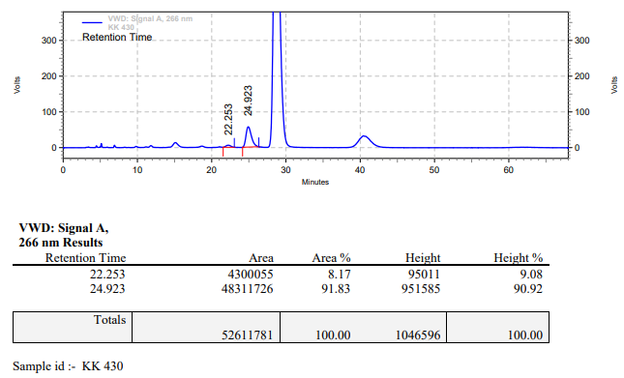

**KK-431**



**Calculation table:**

|  |  |  |  |  |  |
| --- | --- | --- | --- | --- | --- |
| Sr. No | Comp. | Mol. wt. | mmol | Eq. wt. | Wt. taken |
| 1 | Dehydrositagliptin (1) | 405.30 | 0.2135 | 100 | 86 mg |
| 2 | Rh(COD)2OTf | 468.30 | 0.0021 | 1 | 1 mg |
| 3 | L12 | 526.51 | 0.0042 | 2 | 2.2mg |
| 4 | Butyl phosphoric acid | 138.10 | 0.0213 | 10 | 3 mg |

**Procedure:** A glass vial (4 mL) equipped with Teflon coated magnetic needle was cooled under vacuum and transferred to a glove box. The vial was then charged with 86 mg of enamine (**1**), 1 mg of [Rh(COD)2OTf] (1 mol%) and ligand (L12). Reaction vial was then closed using screwcap, transferred to a large opening Schlenk type container and was then taken out from the glove box. 2 mL dry methanol was added followed by butyl phosphoric acid to the vial in inert atmosphere and the resultant reaction slurry was stirred for 1 hour at room temperature (25°C). After that the reaction vial was shifted to an autoclave and the autoclave was purged three times using hydrogen gas (40 bars). Finally, the autoclave was pressurized to 30 bar hydrogen pressure at 70°C for 24 hrs time period. After the 24 hrs time period, the autoclave was cooled to room temperature (25°C), excess pressure was released and the autoclave was opened. The vials were taken out from the autoclave. The thus obtained reaction mixture was passed through neutral alumina bed, the filtrate was collect and dried to yield residue. The resultant residue was then analysed by HPLC.

**Reaction conditions:** Temp: 70°C Press.: 30 bar Solvent: Methanol Time: 24 hrs

**Result: 34%** conversion **88%** ee

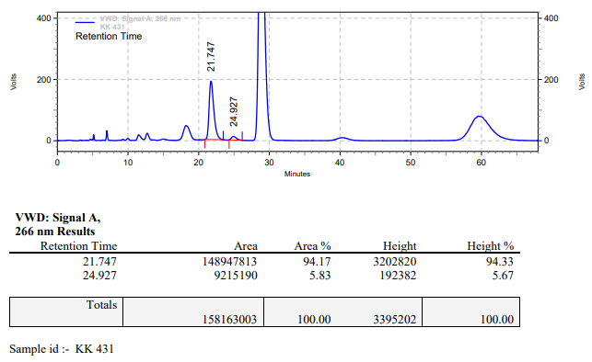

**KK-432**



**Calculation table:**

|  |  |  |  |  |  |
| --- | --- | --- | --- | --- | --- |
| Sr. No | Comp. | Mol. wt. | mmol | Eq. wt. | Wt. taken |
| 1 | Dehydrositagliptin (1) | 405.30 | 0.2135 | 100 | 86 mg |
| 2 | Rh(COD)2OTf | 468.30 | 0.0021 | 1 | 1 mg |
| 3 | L12 | 526.51 | 0.0042 | 2 | 2.2mg |
| 4 | dibutyl phosphate | 210.21 | 0.0213 | 10 | 4 mg |

**Procedure:** A glass vial (4 mL) equipped with Teflon coated magnetic needle was cooled under vacuum and transferred to a glove box. The vial was then charged with 86 mg of enamine (**1**), 1 mg of [Rh(COD)2OTf] (1 mol%) and ligand (L12). Reaction vial was then closed using screwcap, transferred to a large opening Schlenk type container and was then taken out from the glove box. 2 mL dry methanol was added followed by dibutyl phosphate to the vial in inert atmosphere and the resultant reaction slurry was stirred for 1 hour at room temperature (25°C). After that the reaction vial was shifted to an autoclave and the autoclave was purged three times using hydrogen gas (40 bars). Finally, the autoclave was pressurized to 30 bar hydrogen pressure at 70°C for 24 hrs time period. After the 24 hrs time period, the autoclave was cooled to room temperature (25°C), excess pressure was released and the autoclave was opened. The vials were taken out from the autoclave. The thus obtained reaction mixture was passed through neutral alumina bed, the filtrate was collect and dried to yield residue. The resultant residue was then analysed by HPLC.

**Reaction conditions:** Temp: 70°C Press.: 30 bar Solvent: Methanol Time: 24 hrs

**Result: 63%** conversion **90%** ee

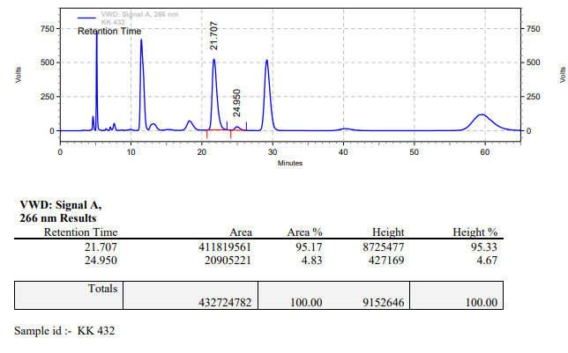

**KK-433**



**Calculation table:**

|  |  |  |  |  |  |
| --- | --- | --- | --- | --- | --- |
| Sr. No | Comp. | Mol. wt. | mmol | Eq. wt. | Wt. taken |
| 1 | Dehydrositagliptin (1) | 405.30 | 0.2135 | 100 | 86 mg |
| 2 | Rh(COD)2OTf | 468.30 | 0.0021 | 1 | 1 mg |
| 3 | L12 | 526.51 | 0.0042 | 2 | 2.2mg |
| 4 | tributyl phosphate | 266.31 | 0.0213 | 10 | 6 mg |

**Procedure:** A glass vial (4 mL) equipped with Teflon coated magnetic needle was cooled under vacuum and transferred to a glove box. The vial was then charged with 86 mg of enamine (**1**), 1 mg of [Rh(COD)2OTf] (1 mol%), ligand (L12) and tributyl phosphate. Reaction vial was then closed using screwcap, transferred to a large opening Schlenk type container and was then taken out from the glove box. 2 mL dry methanol was added to the vial in inert atmosphere and the resultant reaction slurry was stirred for 1 hour at room temperature (25°C). After that the reaction vial was shifted to an autoclave and the autoclave was purged three times using hydrogen gas (40 bars). Finally, the autoclave was pressurized to 30 bar hydrogen pressure at 70°C for 24 hrs time period. After the 24 hrs time period, the autoclave was cooled to room temperature (25°C), excess pressure was released and the autoclave was opened. The vials were taken out from the autoclave. The thus obtained reaction mixture was passed through neutral alumina bed, the filtrate was collect and dried to yield residue. The resultant residue was then analysed by HPLC.

**Reaction conditions:** Temp: 70°C Press.: 30 bar Solvent: Methanol Time: 24 hrs

**Result: 05%** conversion **83%** ee

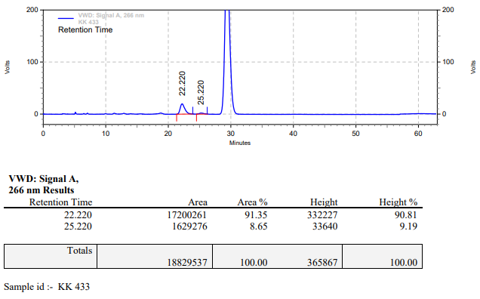

**KK-434**



**Calculation table:**

|  |  |  |  |  |  |
| --- | --- | --- | --- | --- | --- |
| Sr. No | Comp. | Mol. wt. | mmol | Eq. wt. | Wt. taken |
| 1 | Dehydrositagliptin (1) | 405.30 | 0.2135 | 1 | 86 mg |
| 2 | Rh(COD)2OTf | 468.30 | 0.0021 | 1 | 1 mg |
| 3 | tBu-Josiphos | 542.45 | 0.0021 | 1 | 1.1 mg |
| 4 | Ammonium chloride | 53.49 | 0.0213 | 10 | 1 mg |

**Procedure:** A glass vial (4 mL) equipped with Teflon coated magnetic needle was cooled under vacuum and transferred to a glove box. The vial was then charged with 86 mg of enamine (**1**), 1 mg of [Rh(COD)OTf] (1 mol%), tBu-Josiphos and ammonium chloride. Reaction vial was then closed using screwcap, transferred to a large opening Schlenk type container and was then taken out from the glove box. 5 mL dry methanol was added to the vial in inert atmosphere and the resultant reaction slurry was stirred for 1 hour at room temperature (25 °C). After that the reaction vial was shifted to an autoclave and the autoclave was purged three times using hydrogen gas (40 bars). Finally, the autoclave was pressurized to 30 bar hydrogen pressure at 60°C for 18 hrs time period. After the 18 hrs time period, the autoclave was cooled to room temperature (25 °C), excess pressure was released and the autoclave was opened. The vials were taken out from the autoclave. The thus obtained reaction mixture was passed through neutral alumina bed, the filtrate was collect and dried to yield residue. The resultant residue was then analysed by HPLC.

**Reaction conditions:** Temp: 60°C Press.: 30 bar Solvent: Methanol Time: 18 hrs

**Result: 27%** conversion **91%** ee

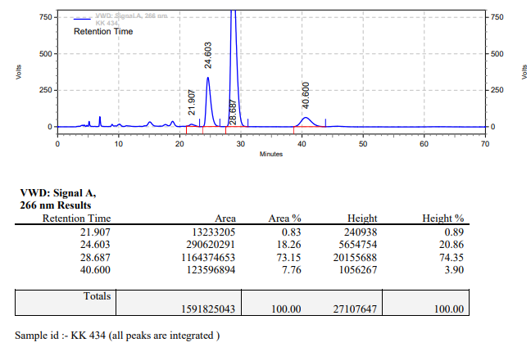

**KK-435**



**Calculation table:**

|  |  |  |  |  |  |
| --- | --- | --- | --- | --- | --- |
| Sr. No | Comp. | Mol. wt. | mmol | Eq. wt. | Wt. taken |
| 1 | Dehydrositagliptin (1) | 405.30 | 0.2135 | 100 | 86 mg |
| 2 | Rh(COD)2OTf | 468.30 | 0.0021 | 1 | 1 mg |
| 3 | L12 | 526.51 | 0.0042 | 2 | 2.2 mg |
| 4 | Salicylic acid | 138.12 | 0.1050 | 50 | 15 mg |

**Procedure:** A glass vial (4 mL) equipped with Teflon coated magnetic needle was cooled under vacuum and transferred to a glove box. The vial was then charged with 86 mg of enamine (**1**), 1 mg of [Rh(COD)2OTf] (1 mol%), ligand (L12) and salicylic acid. Reaction vial was then closed using screwcap, transferred to a large opening Schlenk type container and was then taken out from the glove box. 2 mL dry methanol was added to the vial in inert atmosphere and the resultant reaction slurry was stirred for 1 hour at room temperature (25°C). After that the reaction vial was shifted to an autoclave and the autoclave was purged three times using hydrogen gas (40 bars). Finally, the autoclave was pressurized to 30 bar hydrogen pressure at 50°C for 18 hrs time period. After the 18 hrs time period, the autoclave was cooled to room temperature (25°C), excess pressure was released and the autoclave was opened. The vials were taken out from the autoclave. The thus obtained reaction mixture was passed through neutral alumina bed, the filtrate was collect and dried to yield residue. The resultant residue was then analysed by HPLC.

**Reaction conditions:** Temp: 50°C Press.: 30 bar Solvent: Methanol Time: 18 hrs

**Result: 60%** conversion **93%** ee

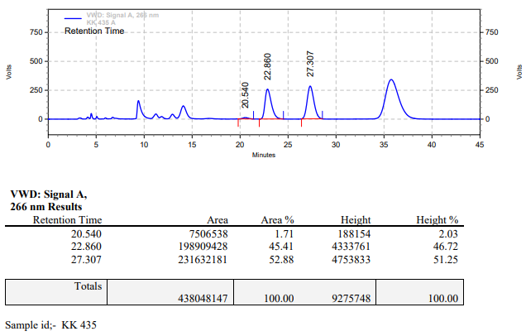

**KK-436**



**Calculation table:**

|  |  |  |  |  |  |
| --- | --- | --- | --- | --- | --- |
| Sr. No | Comp. | Mol. wt. | mmol | Eq. wt. | Wt. taken |
| 1 | Dehydrositagliptin (1) | 405.30 | 0.2135 | 100 | 86 mg |
| 2 | Rh(COD)2OTf | 468.30 | 0.0021 | 1 | 1 mg |
| 3 | L12 | 526.51 | 0.0042 | 2 | 2.2 mg |
| 4 | Salicylic acid | 138.12 | 0.2135 | 100 | 30 mg |

**Procedure:** A glass vial (4 mL) equipped with Teflon coated magnetic needle was cooled under vacuum and transferred to a glove box. The vial was then charged with 86 mg of enamine (**1**), 1 mg of [Rh(COD)2OTf] (1 mol%), ligand (L12) and salicylic acid. Reaction vial was then closed using screwcap, transferred to a large opening Schlenk type container and was then taken out from the glove box. 2 mL dry methanol was added to the vial in inert atmosphere and the resultant reaction slurry was stirred for 1 hour at room temperature (25°C). After that the reaction vial was shifted to an autoclave and the autoclave was purged three times using hydrogen gas (40 bars). Finally, the autoclave was pressurized to 30 bar hydrogen pressure at 50°C for 18 hrs time period. After the 18 hrs time period, the autoclave was cooled to room temperature (25°C), excess pressure was released and the autoclave was opened. The vials were taken out from the autoclave. The thus obtained reaction mixture was passed through neutral alumina bed, the filtrate was collect and dried to yield residue. The resultant residue was then analysed by HPLC.

**Reaction conditions:** Temp: 50°C Press.: 30 bar Solvent: Methanol Time: 18 hrs

**Result: 90%** conversion **93%** ee

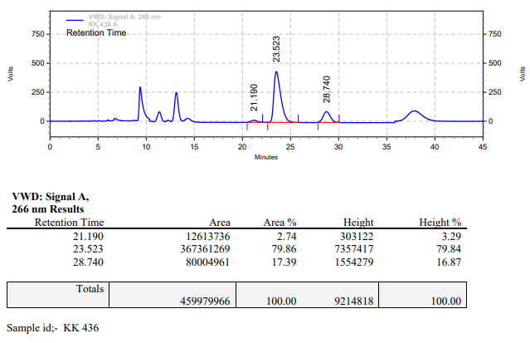

**KK-437**



**Calculation table:**

|  |  |  |  |  |  |
| --- | --- | --- | --- | --- | --- |
| Sr. No | Comp. | Mol. wt. | mmol | Eq. wt. | Wt. taken |
| 1 | Dehydrositagliptin (1) | 405.30 | 0.2135 | 100 | 86 mg |
| 2 | Rh(COD)2OTf | 468.30 | 0.0021 | 1 | 1 mg |
| 3 | L12 | 526.51 | 0.0042 | 2 | 2.2 mg |
| 4 | Salicylic acid | 138.12 | 0.3150 | 150 | 44 mg |

**Procedure:** A glass vial (4 mL) equipped with Teflon coated magnetic needle was cooled under vacuum and transferred to a glove box. The vial was then charged with 86 mg of enamine (**1**), 1 mg of [Rh(COD)2OTf] (1 mol%), ligand (L12) and salicylic acid. Reaction vial was then closed using screwcap, transferred to a large opening Schlenk type container and was then taken out from the glove box. 2 mL dry methanol was added to the vial in inert atmosphere and the resultant reaction slurry was stirred for 1 hour at room temperature (25°C). After that the reaction vial was shifted to an autoclave and the autoclave was purged three times using hydrogen gas (40 bars). Finally, the autoclave was pressurized to 30 bar hydrogen pressure at 50°C for 18 hrs time period. After the 18 hrs time period, the autoclave was cooled to room temperature (25°C), excess pressure was released and the autoclave was opened. The vials were taken out from the autoclave. The thus obtained reaction mixture was passed through neutral alumina bed, the filtrate was collect and dried to yield residue. The resultant residue was then analysed by HPLC.

**Reaction conditions:** Temp: 50°C Press.: 30 bar Solvent: Methanol Time: 18 hrs

**Result: 90%** conversion **93%** ee

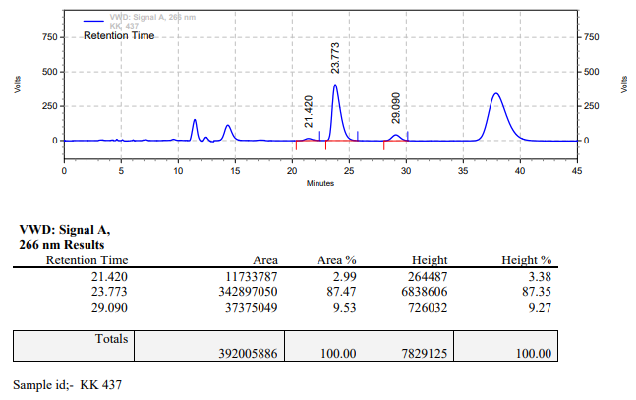

**KK-438**



**Calculation table:**

|  |  |  |  |  |  |
| --- | --- | --- | --- | --- | --- |
| Sr. No | Comp. | Mol. wt. | mmol | Eq. wt. | Wt. taken |
| 1 | Dehydrositagliptin (1) | 405.30 | 0.2135 | 100 | 86 mg |
| 2 | Rh(COD)2OTf | 468.30 | 0.0021 | 1 | 1 mg |
| 3 | L12 | 526.51 | 0.0042 | 2 | 2.2 mg |
| 4 | Salicylic acid | 138.12 | 0.4200 | 200 | 58 mg |

**Procedure:** A glass vial (4 mL) equipped with Teflon coated magnetic needle was cooled under vacuum and transferred to a glove box. The vial was then charged with 86 mg of enamine (**1**), 1 mg of [Rh(COD)2OTf] (1 mol%), ligand (L12) and salicylic acid. Reaction vial was then closed using screwcap, transferred to a large opening Schlenk type container and was then taken out from the glove box. 2 mL dry methanol was added to the vial in inert atmosphere and the resultant reaction slurry was stirred for 1 hour at room temperature (25°C). After that the reaction vial was shifted to an autoclave and the autoclave was purged three times using hydrogen gas (40 bars). Finally, the autoclave was pressurized to 30 bar hydrogen pressure at 50°C for 18 hrs time period. After the 18 hrs time period, the autoclave was cooled to room temperature (25°C), excess pressure was released and the autoclave was opened. The vials were taken out from the autoclave. The thus obtained reaction mixture was passed through neutral alumina bed, the filtrate was collect and dried to yield residue. The resultant residue was then analysed by HPLC.

**Reaction conditions:** Temp: 50°C Press.: 30 bar Solvent: Methanol Time: 18 hrs

**Result: 90%** conversion **93%** ee

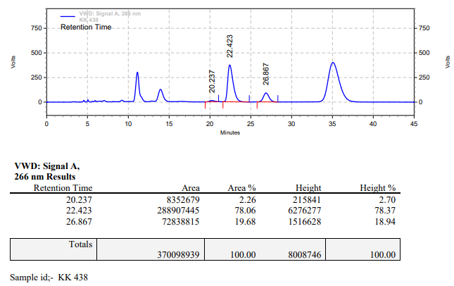

**KK-439**



**Calculation table:**

|  |  |  |  |  |  |
| --- | --- | --- | --- | --- | --- |
| Sr. No | Comp. | Mol. wt. | mmol | Eq. wt. | Wt. taken |
| 1 | Dehydrositagliptin (1) | 405.30 | 0.2135 | 100 | 86 mg |
| 2 | Rh(COD)2OTf | 468.30 | 0.0021 | 1 | 1 mg |
| 3 | L12 | 526.51 | 0.0042 | 2 | 2.2 mg |
| 4 | Salicylic acid | 138.12 | 0.4200 | 200 | 58 mg |

**Procedure:** A glass vial (4 mL) equipped with Teflon coated magnetic needle was cooled under vacuum and transferred to a glove box. The vial was then charged with 86 mg of enamine (**1**), 1 mg of [Rh(COD)2OTf] (1 mol%), ligand (L12) and salicylic acid. Reaction vial was then closed using screwcap, transferred to a large opening Schlenk type container and was then taken out from the glove box. 2 mL dry TFE (trifluoroethanol) was added to the vial in inert atmosphere and the resultant reaction slurry was stirred for 1 hour at room temperature (25°C). After that the reaction vial was shifted to an autoclave and the autoclave was purged three times using hydrogen gas (40 bars). Finally, the autoclave was pressurized to 30 bar hydrogen pressure at 50°C for 18 hrs time period. After the 18 hrs time period, the autoclave was cooled to room temperature (25°C), excess pressure was released and the autoclave was opened. The vials were taken out from the autoclave. The thus obtained reaction mixture was passed through neutral alumina bed, the filtrate was collect and dried to yield residue. The resultant residue was then analysed by HPLC.

**Reaction conditions:** Temp: 50°C Press.: 30 bar Solvent: TFE Time: 18 hrs

**Result: 95%** conversion **80%** ee

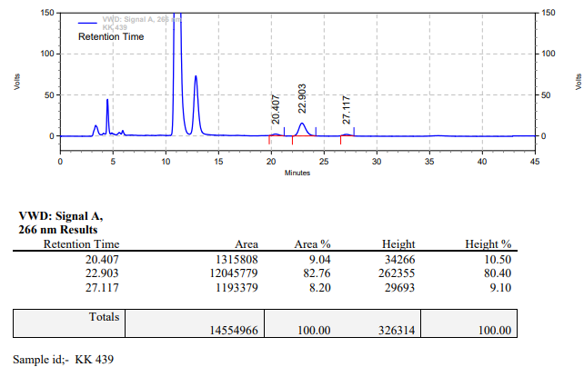

**KK-440**



**Calculation table:**

|  |  |  |  |  |  |
| --- | --- | --- | --- | --- | --- |
| Sr. No | Comp. | Mol. wt. | mmol | Eq. wt. | Wt. taken |
| 1 | Dehydrositagliptin (1) | 405.30 | 0.2135 | 100 | 86 mg |
| 2 | Rh(COD)2OTf | 468.30 | 0.0021 | 1 | 1 mg |
| 3 | L12 | 526.51 | 0.0025 | 1.2 | 1.3 mg |
| 4 | Salicylic acid | 138.12 | 0.2135 | 100 | 28 mg |

**Procedure:** A glass vial (4 mL) equipped with Teflon coated magnetic needle was cooled under vacuum and transferred to a glove box. The vial was then charged with 86 mg of enamine (**1**), 1 mg of [Rh(COD)2OTf] (1 mol%), ligand (L12) and salicylic acid. Reaction vial was then closed using screwcap, transferred to a large opening Schlenk type container and was then taken out from the glove box. 2 mL dry methanol was added to the vial in inert atmosphere and the resultant reaction slurry was stirred for 1 hour at room temperature (25°C). After that the reaction vial was shifted to an autoclave and the autoclave was purged three times using hydrogen gas (40 bars). Finally, the autoclave was pressurized to 20 bar hydrogen pressure at 50°C for 18 hrs time period. After the 18 hrs time period, the autoclave was cooled to room temperature (25°C), excess pressure was released and the autoclave was opened. The vials were taken out from the autoclave. The thus obtained reaction mixture was passed through neutral alumina bed, the filtrate was collect and dried to yield residue. The resultant residue was then analysed by HPLC.

**Reaction conditions:** Temp: 50°C Press.: 20 bar Solvent: Methanol Time: 18 hrs

**Result: 40%** conversion **95%** ee

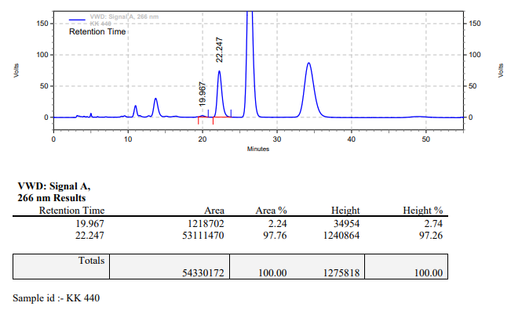

**KK-441**



**Calculation table:**

|  |  |  |  |  |  |
| --- | --- | --- | --- | --- | --- |
| Sr. No | Comp. | Mol. wt. | mmol | Eq. wt. | Wt. taken |
| 1 | Dehydrositagliptin (1) | 405.30 | 0.2135 | 100 | 86 mg |
| 2 | Rh(COD)2OTf | 468.30 | 0.0021 | 1 | 1 mg |
| 3 | L12 | 526.51 | 0.0042 | 2 | 2.2 mg |
| 4 | Salicylic acid | 138.12 | 0.2135 | 100 | 28 mg |

**Procedure:** A glass vial (4 mL) equipped with Teflon coated magnetic needle was cooled under vacuum and transferred to a glove box. The vial was then charged with 86 mg of enamine (**1**), 1 mg of [Rh(COD)2OTf] (1 mol%), ligand (L12) and salicylic acid. Reaction vial was then closed using screwcap, transferred to a large opening Schlenk type container and was then taken out from the glove box. 2 mL dry methanol was added to the vial in inert atmosphere and the resultant reaction slurry was stirred for 1 hour at room temperature (25°C). After that the reaction vial was shifted to an autoclave and the autoclave was purged three times using hydrogen gas (40 bars). Finally, the autoclave was pressurized to 20 bar hydrogen pressure at 50°C for 18 hrs time period. After the 18 hrs time period, the autoclave was cooled to room temperature (25°C), excess pressure was released and the autoclave was opened. The vials were taken out from the autoclave. The thus obtained reaction mixture was passed through neutral alumina bed, the filtrate was collect and dried to yield residue. The resultant residue was then analysed by HPLC.

**Reaction conditions:** Temp: 50°C Press.: 20 bar Solvent: Methanol Time: 18 hrs

**Result: 40%** conversion **95%** ee

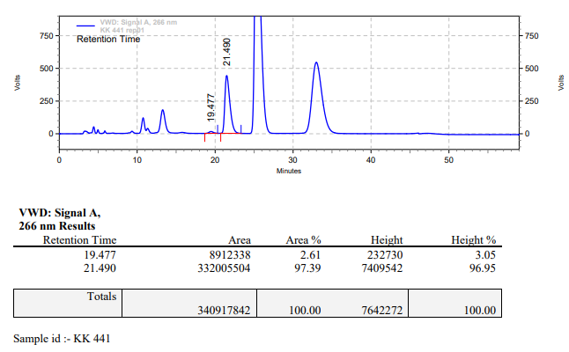

**KK-442**



**Calculation table:**

|  |  |  |  |  |  |
| --- | --- | --- | --- | --- | --- |
| Sr. No | Comp. | Mol. wt. | mmol | Eq. wt. | Wt. taken |
| 1 | Dehydrositagliptin (1) | 405.30 | 0.2135 | 100 | 86 mg |
| 2 | Rh(COD)2OTf | 468.30 | 0.0021 | 1 | 1 mg |
| 3 | L12 | 526.51 | 0.0042 | 1.2 | 1.3 mg |
| 4 | Salicylic acid | 138.12 | 0.2135 | 100 | 28 mg |

**Procedure:** A glass vial (4 mL) equipped with Teflon coated magnetic needle was cooled under vacuum and transferred to a glove box. The vial was then charged with 86 mg of enamine (**1**), 1 mg of [Rh(COD)2OTf] (1 mol%), ligand (L12) and salicylic acid. Reaction vial was then closed using screwcap, transferred to a large opening Schlenk type container and was then taken out from the glove box. 2 mL dry methanol was added to the vial in inert atmosphere and the resultant reaction slurry was stirred for 1 hour at room temperature (25°C). After that the reaction vial was shifted to an autoclave and the autoclave was purged three times using hydrogen gas (40 bars). Finally, the autoclave was pressurized to 20 bar hydrogen pressure at 60°C for 18 hrs time period. After the 18 hrs time period, the autoclave was cooled to room temperature (25°C), excess pressure was released and the autoclave was opened. The vials were taken out from the autoclave. The thus obtained reaction mixture was passed through neutral alumina bed, the filtrate was collect and dried to yield residue. The resultant residue was then analysed by HPLC.

**Reaction conditions:** Temp: 60°C Press.: 20 bar Solvent: Methanol Time: 18 hrs

**Result: 90%** conversion **92%** ee

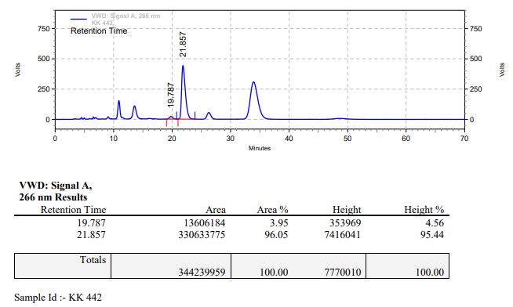

**KK-443**



**Calculation table:**

|  |  |  |  |  |  |
| --- | --- | --- | --- | --- | --- |
| Sr. No | Comp. | Mol. wt. | mmol | Eq. wt. | Wt. taken |
| 1 | Dehydrositagliptin (1) | 405.30 | 0.2135 | 100 | 86 mg |
| 2 | Rh(COD)2OTf | 468.30 | 0.0021 | 1 | 1 mg |
| 3 | L12 | 526.51 | 0.0025 | 1.2 | 1.3 mg |

**Procedure:** A glass vial (4 mL) equipped with Teflon coated magnetic needle was cooled under vacuum and transferred to a glove box. The vial was then charged with 86 mg of enamine (**1**), 1 mg of [Rh(COD)2OTf] (1 mol%), ligand (L12) and salicylic acid. Reaction vial was then closed using screwcap, transferred to a large opening Schlenk type container and was then taken out from the glove box. 2 mL dry methanol was added to the vial in inert atmosphere and the resultant reaction slurry was stirred for 1 hour at room temperature (25°C). After that the reaction vial was shifted to an autoclave and the autoclave was purged three times using hydrogen gas (40 bars). Finally, the autoclave was pressurized to 30 bar hydrogen pressure at 50°C for 18 hrs time period. After the 18 hrs time period, the autoclave was cooled to room temperature (25°C), excess pressure was released and the autoclave was opened. The vials were taken out from the autoclave. The thus obtained reaction mixture was passed through neutral alumina bed, the filtrate was collect and dried to yield residue. The resultant residue was then analysed by HPLC.

**Reaction conditions:** Temp: 50°C Press.: 30 bar Solvent: Methanol Time: 18 hrs

**Result: 10%** conversion **87%** ee

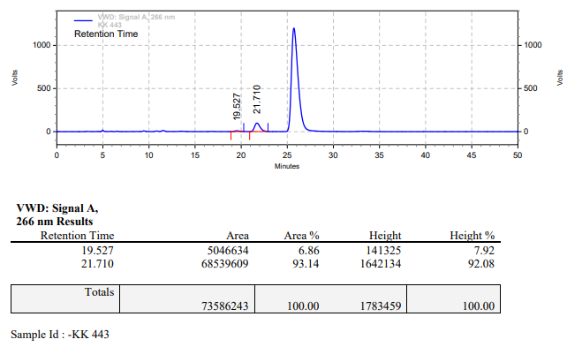

**KK-444**



**Calculation table:**

|  |  |  |  |  |  |
| --- | --- | --- | --- | --- | --- |
| Sr. No | Comp. | Mol. wt. | mmol | Eq. wt. | Wt. taken |
| 1 | Dehydrositagliptin (1) | 405.30 | 0.2135 | 100 | 86 mg |
| 2 | Rh(COD)2OTf | 468.30 | 0.0021 | 1 | 1 mg |
| 3 | L12 | 526.51 | 0.0025 | 1.2 | 1.3 mg |
| 4 | Salicylic acid | 138.12 | 0.2135 | 100 | 28 mg |

**Procedure:** A glass vial (4 mL) equipped with Teflon coated magnetic needle was cooled under vacuum and transferred to a glove box. The vial was then charged with 86 mg of enamine (**1**), 1 mg of [Rh(COD)2OTf] (1 mol%), ligand (L12) and salicylic acid. Reaction vial was then closed using screwcap, transferred to a large opening Schlenk type container and was then taken out from the glove box. 2 mL dry methanol was added to the vial in inert atmosphere and the resultant reaction slurry was stirred for 1 hour at room temperature (25°C). After that the reaction vial was shifted to an autoclave and the autoclave was purged three times using hydrogen gas (40 bars). Finally, the autoclave was pressurized to 30 bar hydrogen pressure at 50°C for 18 hrs time period. After the 18 hrs time period, the autoclave was cooled to room temperature (25°C), excess pressure was released and the autoclave was opened. The vials were taken out from the autoclave. The thus obtained reaction mixture was passed through neutral alumina bed, the filtrate was collect and dried to yield residue. The resultant residue was then analysed by HPLC.

**Reaction conditions:** Temp: 50°C Press.: 30 bar Solvent: Methanol Time: 18 hrs

**Result: 60%** conversion 94**%** ee

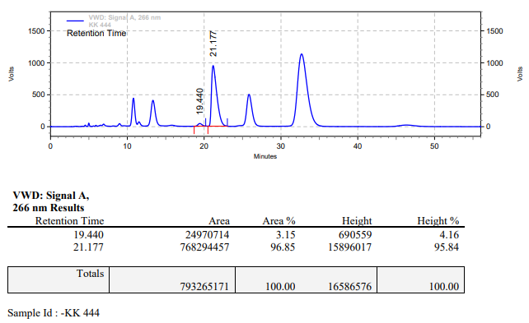

**KK-447**



**Calculation table:**

|  |  |  |  |  |  |
| --- | --- | --- | --- | --- | --- |
| Sr. No | Comp. | Mol. wt. | mmol | Eq. wt. | Wt. taken |
| 1 | Dehydrositagliptin (1) | 405.30 | 0.2135 | 1 | 86 mg |
| 2 | Rh(COD)2OTf | 468.30 | 0.0021 | 1 | 1 mg |
| 3 | tBu-Josiphos | 542.45 | 0.0021 | 1 | 1.1 mg |
| 4 | Ammonium chloride | 53.49 | 0.0213 | 10 | 1 mg |

**Procedure:** A glass vial (4 mL) equipped with Teflon coated magnetic needle was cooled under vacuum and transferred to a glove box. The vial was then charged with 86 mg of enamine (**1**), 1 mg of [Rh(COD)OTf] (1 mol%), tBu-Josiphos and ammonium chloride. Reaction vial was then closed using screwcap, transferred to a large opening Schlenk type container and was then taken out from the glove box. 5 mL dry methanol was added to the vial in inert atmosphere and the resultant reaction slurry was stirred for 1 hour at room temperature (25 °C). After that the reaction vial was shifted to an autoclave and the autoclave was purged three times using hydrogen gas (40 bars). Finally, the autoclave was pressurized to 30 bar hydrogen pressure at 60°C for 18 hrs time period. After the 18 hrs time period, the autoclave was cooled to room temperature (25 °C), excess pressure was released and the autoclave was opened. The vials were taken out from the autoclave. The thus obtained reaction mixture was passed through neutral alumina bed, the filtrate was collect and dried to yield residue. The resultant residue was then analysed by HPLC.

**Reaction conditions:** Temp: 60°C Press.: 30 bar Solvent: Methanol Time: 18 hrs

**Result: 30%** conversion **93%** ee

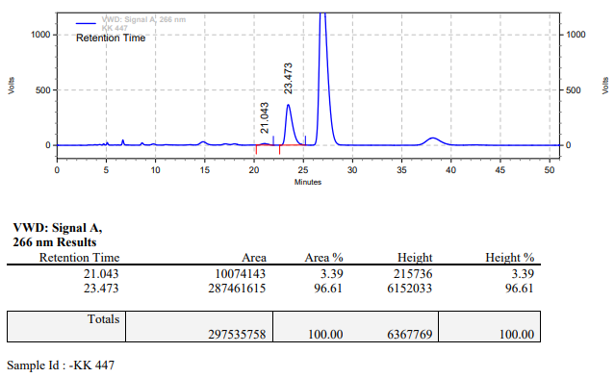

**KK-448**



**Calculation table:**

|  |  |  |  |  |  |
| --- | --- | --- | --- | --- | --- |
| Sr. No | Comp. | Mol. wt. | mmol | Eq. wt. | Wt. taken |
| 1 | Dehydrositagliptin (1) | 405.30 | 0.2135 | 100 | 86 mg |
| 2 | Rh(COD)2OTf | 468.30 | 0.0021 | 1 | 1 mg |
| 3 | L12 | 526.51 | 0.0025 | 1.2 | 1.3 mg |
| 4 | Salicylic acid | 138.12 | 0.0213 | 10 | 3 mg |

**Procedure:** A glass vial (4 mL) equipped with Teflon coated magnetic needle was cooled under vacuum and transferred to a glove box. The vial was then charged with 86 mg of enamine (**1**), 1 mg of [Rh(COD)2OTf] (1 mol%), ligand (L12) and salicylic acid. Reaction vial was then closed using screwcap, transferred to a large opening Schlenk type container and was then taken out from the glove box. 2 mL dry methanol was added to the vial in inert atmosphere and the resultant reaction slurry was stirred for 1 hour at room temperature (25°C). After that the reaction vial was shifted to an autoclave and the autoclave was purged three times using hydrogen gas (40 bars). Finally, the autoclave was pressurized to 30 bar hydrogen pressure at 60°C for 18 hrs time period. After the 18 hrs time period, the autoclave was cooled to room temperature (25°C), excess pressure was released and the autoclave was opened. The vials were taken out from the autoclave. The thus obtained reaction mixture was passed through neutral alumina bed, the filtrate was collect and dried to yield residue. The resultant residue was then analysed by HPLC.

**Reaction conditions:** Temp: 60°C Press.: 30 bar Solvent: Methanol Time: 18 hrs

**Result: 90%** conversion **94%** ee

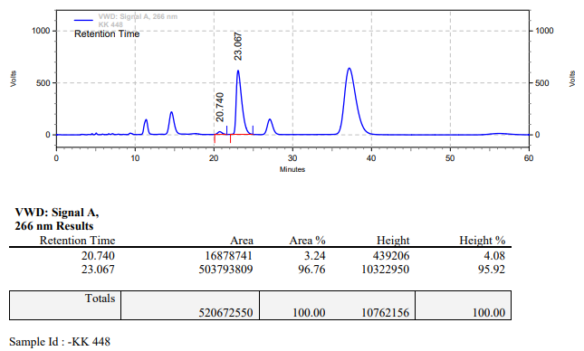

**KK-449**



**Calculation table:**

|  |  |  |  |  |  |
| --- | --- | --- | --- | --- | --- |
| Sr. No | Comp. | Mol. wt. | mmol | Eq. wt. | Wt. taken |
| 1 | Dehydrositagliptin (1) | 405.30 | 0.2135 | 100 | 86 mg |
| 2 | Rh(COD)2OTf | 468.30 | 0.0021 | 1 | 1 mg |
| 3 | L12 | 526.51 | 0.0031 | 1.5 | 1.7 mg |

**Procedure:** A glass vial (4 mL) equipped with Teflon coated magnetic needle was cooled under vacuum and transferred to a glove box. The vial was then charged with 86 mg of enamine (**1**), 1 mg of [Rh(COD)2OTf] (1 mol%) and ligand (L12). Reaction vial was then closed using screwcap, transferred to a large opening Schlenk type container and was then taken out from the glove box. 2 mL dry methanol was added to the vial in inert atmosphere and the resultant reaction slurry was stirred for 1 hour at room temperature (25°C). After that the reaction vial was shifted to an autoclave and the autoclave was purged three times using hydrogen gas (40 bars). Finally, the autoclave was pressurized to 30 bar hydrogen pressure at 60°C for 65 hrs time period. After the 65 hrs time period, the autoclave was cooled to room temperature (25°C), excess pressure was released and the autoclave was opened. The vials were taken out from the autoclave. The thus obtained reaction mixture was passed through neutral alumina bed, the filtrate was collect and dried to yield residue. The resultant residue was then analysed by HPLC.

**Reaction conditions:** Temp: 60°C Press.: 30 bar Solvent: methanol Time: 65 hrs

**Result: 10%** conversion **72%** ee

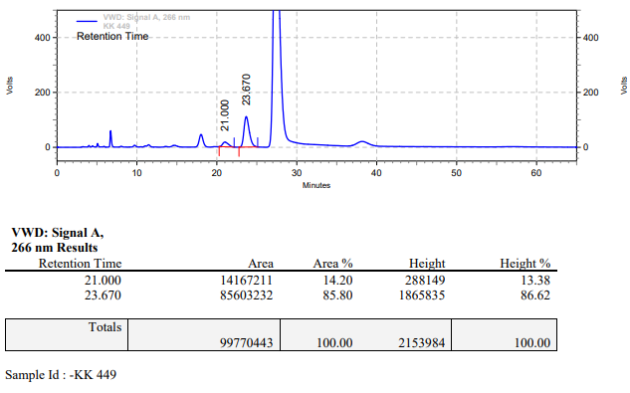

**KK-450**



**Calculation table:**

|  |  |  |  |  |  |
| --- | --- | --- | --- | --- | --- |
| Sr. No | Comp. | Mol. wt. | mmol | Eq. wt. | Wt. taken |
| 1 | Dehydrositagliptin (1) | 405.30 | 0.2135 | 100 | 86 mg |
| 2 | Rh(COD)2OTf | 468.30 | 0.0021 | 1 | 1 mg |
| 3 | L12 | 526.51 | 0.0031 | 1.5 | 1.7 mg |
| 4 | Ammonium chloride | 53.49 | 0.0213 | 10 | 1 mg |

**Procedure:** A glass vial (4 mL) equipped with Teflon coated magnetic needle was cooled under vacuum and transferred to a glove box. The vial was then charged with 86 mg of enamine (**1**), 1 mg of [Rh(COD)2OTf] (1 mol%), ligand (L12) and ammonium chloride. Reaction vial was then closed using screwcap, transferred to a large opening Schlenk type container and was then taken out from the glove box. 2 mL dry methanol was added to the vial in inert atmosphere and the resultant reaction slurry was stirred for 1 hour at room temperature (25°C). After that the reaction vial was shifted to an autoclave and the autoclave was purged three times using hydrogen gas (40 bars). Finally, the autoclave was pressurized to 30 bar hydrogen pressure at 60°C for 65 hrs time period. After the 65 hrs time period, the autoclave was cooled to room temperature (25°C), excess pressure was released and the autoclave was opened. The vials were taken out from the autoclave. The thus obtained reaction mixture was passed through neutral alumina bed, the filtrate was collect and dried to yield residue. The resultant residue was then analysed by HPLC.

**Reaction conditions:** Temp: 60°C Press.: 30 bar Solvent: Methanol Time: 65 hrs

**Result: 70%** conversion **79%** ee

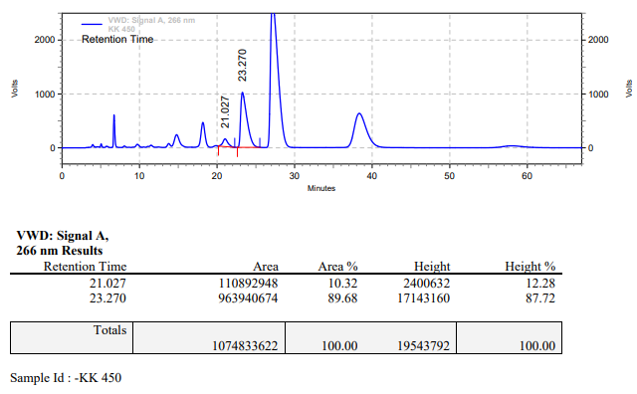

**KK-451**



**Calculation table:**

|  |  |  |  |  |  |
| --- | --- | --- | --- | --- | --- |
| Sr. No | Comp. | Mol. wt. | mmol | Eq. wt. | Wt. taken |
| 1 | Dehydrositagliptin (1) | 405.30 | 0.2135 | 100 | 86 mg |
| 2 | Rh(COD)2OTf | 468.30 | 0.0021 | 1 | 1 mg |
| 3 | L12 | 526.51 | 0.0031 | 1.5 | 1.7 mg |
| 4 | Salicylic acid | 138.12 | 0.0213 | 10 | 3 mg |

**Procedure:** A glass vial (4 mL) equipped with Teflon coated magnetic needle was cooled under vacuum and transferred to a glove box. The vial was then charged with 86 mg of enamine (**1**), 1 mg of [Rh(COD)2OTf] (1 mol%), ligand (L12) and salicylic acid. Reaction vial was then closed using screwcap, transferred to a large opening Schlenk type container and was then taken out from the glove box. 2 mL dry methanol was added to the vial in inert atmosphere and the resultant reaction slurry was stirred for 1 hour at room temperature (25°C). After that the reaction vial was shifted to an autoclave and the autoclave was purged three times using hydrogen gas (40 bars). Finally, the autoclave was pressurized to 30 bar hydrogen pressure at 60°C for 65 hrs time period. After the 65 hrs time period, the autoclave was cooled to room temperature (25°C), excess pressure was released and the autoclave was opened. The vials were taken out from the autoclave. The thus obtained reaction mixture was passed through neutral alumina bed, the filtrate was collect and dried to yield residue. The resultant residue was then analysed by HPLC.

**Reaction conditions:** Temp: 60°C Press.: 30 bar Solvent: methanol Time: 65 hrs

**Result: 70%** conversion **89%** ee

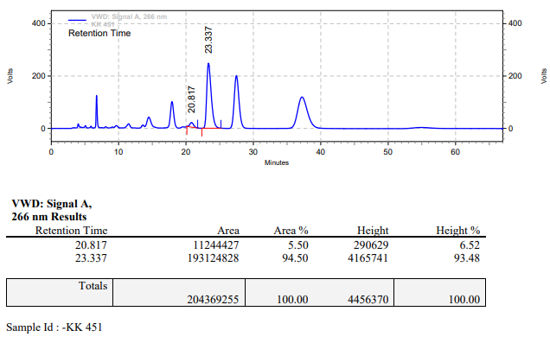

**KK-455**



**Calculation table:**

|  |  |  |  |  |  |
| --- | --- | --- | --- | --- | --- |
| Sr. No | Comp. | Mol. wt. | mmol | Eq. wt. | Wt. taken |
| 1 | Dehydrositagliptin (1) | 405.30 | 0.2135 | 100 | 86 mg |
| 2 | Rh(COD)2OTf | 468.30 | 0.0021 | 1 | 1 mg |
| 3 | L12 | 526.51 | 0.0025 | 1.2 | 1.3 mg |
| 4 | Triethyl amine | 101.19 | 0.0213 | 10 | 2 mg |

**Procedure:** A glass vial (4 mL) equipped with Teflon coated magnetic needle was cooled under vacuum and transferred to a glove box. The vial was then charged with 86 mg of enamine (**1**), 1 mg of [Rh(COD)2OTf] (1 mol%) and ligand (L12). Reaction vial was then closed using screwcap, transferred to a large opening Schlenk type container and was then taken out from the glove box. 2 mL dry methanol was added followed by triethyl amine to the vial in inert atmosphere and the resultant reaction slurry was stirred for 1 hour at room temperature (25°C). After that the reaction vial was shifted to an autoclave and the autoclave was purged three times using hydrogen gas (40 bars). Finally, the autoclave was pressurized to 30 bar hydrogen pressure at 60°C for 18 hrs time period. After the 18 hrs time period, the autoclave was cooled to room temperature (25°C), excess pressure was released and the autoclave was opened. The vials were taken out from the autoclave. The thus obtained reaction mixture was passed through neutral alumina bed, the filtrate was collect and dried to yield residue. The resultant residue was then analysed by HPLC.

**Reaction conditions:** Temp: 60°C Press.: 30 bar Solvent: methanol Time: 18 hrs

**Result: 00%** conversion **00%** ee

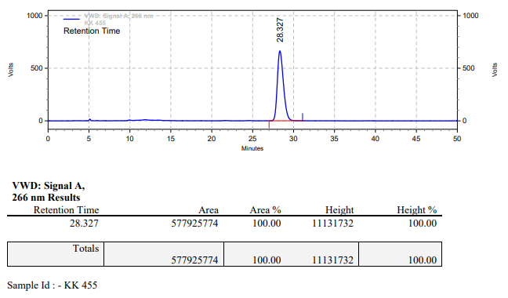

**KK-456**



**Calculation table:**

|  |  |  |  |  |  |
| --- | --- | --- | --- | --- | --- |
| Sr. No | Comp. | Mol. wt. | mmol | Eq. wt. | Wt. taken |
| 1 | Dehydrositagliptin (1) | 405.30 | 0.2135 | 100 | 86 mg |
| 2 | Rh(COD)2OTf | 468.30 | 0.0021 | 1 | 1 mg |

**Procedure:** A glass vial (4 mL) equipped with Teflon coated magnetic needle was cooled under vacuum and transferred to a glove box. The vial was then charged with 86 mg of enamine (**1**) and 1 mg of [Rh(COD)2OTf] (1 mol%). Reaction vial was then closed using screwcap, transferred to a large opening Schlenk type container and was then taken out from the glove box. 2 mL dry methanol was added to the vial in inert atmosphere and the resultant reaction slurry was stirred for 1 hour at room temperature (25°C). After that the reaction vial was shifted to an autoclave and the autoclave was purged three times using hydrogen gas (40 bars). Finally, the autoclave was pressurized to 30 bar hydrogen pressure at 60°C for 18 hrs time period. After the 18 hrs time period, the autoclave was cooled to room temperature (25°C), excess pressure was released and the autoclave was opened. The vials were taken out from the autoclave. The thus obtained reaction mixture was passed through neutral alumina bed, the filtrate was collect and dried to yield residue. The resultant residue was then analysed by HPLC.

**Reaction conditions:** Temp: 60°C Press.: 30 bar Solvent: methanol Time: 18 hrs

**Result: 00%** conversion **00%** ee

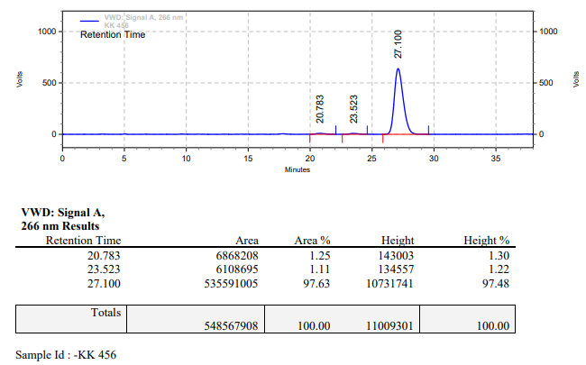

**KK-457**



**Calculation table:**

|  |  |  |  |  |  |
| --- | --- | --- | --- | --- | --- |
| Sr. No | Comp. | Mol. wt. | mmol | Eq. wt. | Wt. taken |
| 1 | Dehydrositagliptin (1) | 405.30 | 0.2135 | 100 | 86 mg |
| 2 | Rh(COD)2OTf | 468.30 | 0.0021 | 1 | 1 mg |
| 3 | L12 | 526.51 | 0.0023 | 1.1 | 1.2 mg |
| 4 | Salicylic acid | 138.12 | 0.0105 | 5 | 1.5 mg |

**Procedure:** A glass vial (4 mL) equipped with Teflon coated magnetic needle was cooled under vacuum and transferred to a glove box. The vial was then charged with 86 mg of enamine (**1**), 1 mg of [Rh(COD)2OTf] (1 mol%), ligand (L12) and salicylic acid. Reaction vial was then closed using screwcap, transferred to a large opening Schlenk type container and was then taken out from the glove box. 2 mL dry methanol was added to the vial in inert atmosphere and the resultant reaction slurry was stirred for 1 hour at room temperature (25°C). After that the reaction vial was shifted to an autoclave and the autoclave was purged three times using hydrogen gas (40 bars). Finally, the autoclave was pressurized to 15 bar hydrogen pressure at 50°C for 24 hrs time period. After the 24 hrs time period, the autoclave was cooled to room temperature (25°C), excess pressure was released and the autoclave was opened. The vials were taken out from the autoclave. The thus obtained reaction mixture was passed through neutral alumina bed, the filtrate was collect and dried to yield residue. The resultant residue was then analysed by HPLC.

**Reaction conditions:** Temp: 50°C Press.: 15 bar Solvent: Methanol Time: 24 hrs

**Result: 15%** conversion **87%** ee

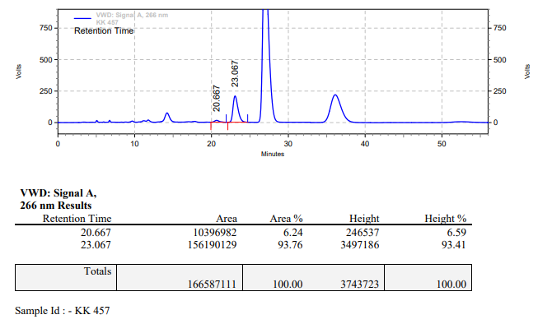

**KK-458**



**Calculation table:**

|  |  |  |  |  |  |
| --- | --- | --- | --- | --- | --- |
| Sr. No | Comp. | Mol. wt. | mmol | Eq. wt. | Wt. taken |
| 1 | Dehydrositagliptin (1) | 405.30 | 0.2135 | 100 | 86 mg |
| 2 | Rh(COD)2OTf | 468.30 | 0.0021 | 1 | 1 mg |
| 3 | L12 | 526.51 | 0.0023 | 1.1 | 1.2 mg |
| 4 | Ammonium salicylate | 155.12 | 0.0105 | 5 | 1.6 mg |
| 5 | Salicylic acid | 138.12 | 0.0105 | 5 | 1.5 mg |

**Procedure:** A glass vial (4 mL) equipped with Teflon coated magnetic needle was cooled under vacuum and transferred to a glove box. The vial was then charged with 86 mg of enamine (**1**), 1 mg of [Rh(COD)2OTf] (1 mol%), ligand (L12), salicylic acid and ammonium salicylate. Reaction vial was then closed using screwcap, transferred to a large opening Schlenk type container and was then taken out from the glove box. 2 mL dry methanol was added to the vial in inert atmosphere and the resultant reaction slurry was stirred for 1 hour at room temperature (25°C). After that the reaction vial was shifted to an autoclave and the autoclave was purged three times using hydrogen gas (40 bars). Finally, the autoclave was pressurized to 15 bar hydrogen pressure at 55°C for 24 hrs time period. After the 24 hrs time period, the autoclave was cooled to room temperature (25°C), excess pressure was released and the autoclave was opened. The vials were taken out from the autoclave. The thus obtained reaction mixture was passed through neutral alumina bed, the filtrate was collect and dried to yield residue. The resultant residue was then analysed by HPLC.

**Reaction conditions:** Temp: 55°C Press.: 15 bar Solvent: Methanol Time: 24 hrs

**Result: 20%** conversion **90%** ee

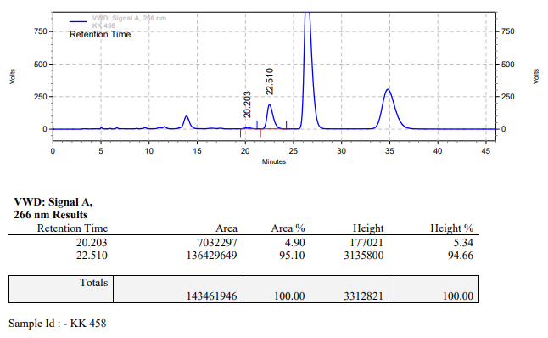

**KK-459**



**Calculation table:**

|  |  |  |  |  |  |
| --- | --- | --- | --- | --- | --- |
| Sr. No | Comp. | Mol. wt. | mmol | Eq. wt. | Wt. taken |
| 1 | Dehydrositagliptin (1) | 405.30 | 0.2135 | 100 | 86 mg |
| 2 | Rh(COD)2OTf | 468.30 | 0.0021 | 1 | 1 mg |
| 3 | L12 | 526.51 | 0.0014 | 0.7 | 0.7 mg |
| 4 | Salicylic acid | 138.12 | 0.2135 | 100 | 29 mg |

**Procedure:** A glass vial (4 mL) equipped with Teflon coated magnetic needle was cooled under vacuum and transferred to a glove box. The vial was then charged with 86 mg of enamine (**1**), 1 mg of [Rh(COD)2OTf] (1 mol%), ligand (L12) and salicylic acid. Reaction vial was then closed using screwcap, transferred to a large opening Schlenk type container and was then taken out from the glove box. 2 mL dry methanol was added to the vial in inert atmosphere and the resultant reaction slurry was stirred for 1 hour at room temperature (25°C). After that the reaction vial was shifted to an autoclave and the autoclave was purged three times using hydrogen gas (40 bars). Finally, the autoclave was pressurized to 20 bar hydrogen pressure at 60°C for 18 hrs time period. After the 18 hrs time period, the autoclave was cooled to room temperature (25°C), excess pressure was released and the autoclave was opened. The vials were taken out from the autoclave. The thus obtained reaction mixture was passed through neutral alumina bed, the filtrate was collect and dried to yield residue. The resultant residue was then analysed by HPLC.

**Reaction conditions:** Temp: 60°C Press.: 20 bar Solvent: Methanol Time: 18 hrs

**Result: 70%** conversion **93%** ee

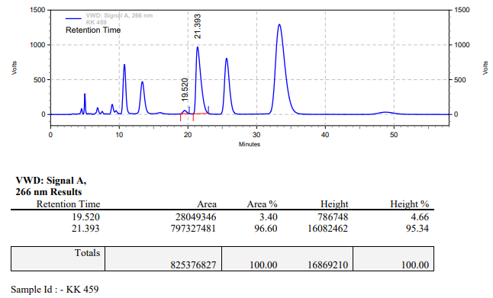

**KK-460**



**Calculation table:**

|  |  |  |  |  |  |
| --- | --- | --- | --- | --- | --- |
| Sr. No | Comp. | Mol. wt. | mmol | Eq. wt. | Wt. taken |
| 1 | Dehydrositagliptin (1) | 405.30 | 0.2135 | 100 | 86 mg |
| 2 | Rh(COD)2OTf | 468.30 | 0.0021 | 1 | 1 mg |
| 3 | L12 | 526.51 | 0.0023 | 1.1 | 1.2 mg |
| 4 | Salicylic acid | 138.12 | 0.0105 | 5 | 1.5 mg |

**Procedure:** A glass vial (4 mL) equipped with Teflon coated magnetic needle was cooled under vacuum and transferred to a glove box. The vial was then charged with 86 mg of enamine (**1**), 1 mg of [Rh(COD)2OTf] (1 mol%), ligand (L12) and salicylic acid. Reaction vial was then closed using screwcap, transferred to a large opening Schlenk type container and was then taken out from the glove box. 2 mL dry methanol was added to the vial in inert atmosphere and the resultant reaction slurry was stirred for 1 hour at room temperature (25°C). After that the reaction vial was shifted to an autoclave and the autoclave was purged three times using hydrogen gas (40 bars). Finally, the autoclave was pressurized to 10 bar hydrogen pressure at 60°C for 65 hrs time period. After the 65 hrs time period, the autoclave was cooled to room temperature (25°C), excess pressure was released and the autoclave was opened. The vials were taken out from the autoclave. The thus obtained reaction mixture was passed through neutral alumina bed, the filtrate was collect and dried to yield residue. The resultant residue was then analysed by HPLC.

**Reaction conditions:** Temp: 60°C Press.: 10 bar Solvent: Methanol Time: 65 hrs

**Result: 40%** conversion **80%** ee

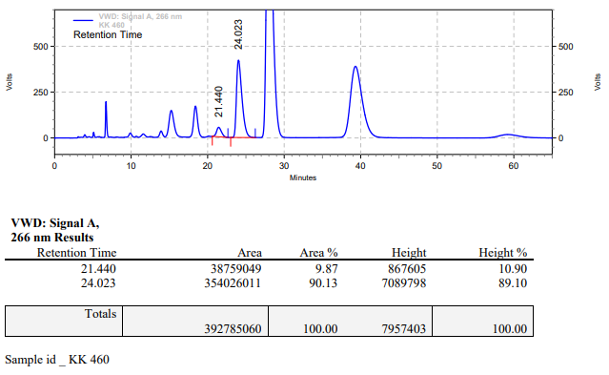

**KK-461**



**Calculation table:**

|  |  |  |  |  |  |
| --- | --- | --- | --- | --- | --- |
| Sr. No | Comp. | Mol. wt. | mmol | Eq. wt. | Wt. taken |
| 1 | Dehydrositagliptin (1) | 405.30 | 0.2052 | 1 | 83 mg |
| 2 | Rh(COD)2OTf | 468.30 | 0.3x10-3 | 0.0015 | 0.14 mg |
| 3 | tBu-Josiphos | 542.45 | 0.3x10-3 | 0.0016 | 0.17 mg |
| 4 | Ammonium chloride | 53.49 | 0.3x10-3 | 0.0015 | 0.01 mg |

**Procedure:** A glass vial (4 mL) equipped with Teflon coated magnetic needle was cooled under vacuum and transferred to a glove box. The vial was then charged with 83 mg of enamine (**1**), 0.14 mg of [Rh(COD)OTf], tBu-Josiphos and ammonium chloride. Reaction vial was then closed using screwcap, transferred to a large opening Schlenk type container and was then taken out from the glove box. 5 mL dry methanol was added to the vial in inert atmosphere and the resultant reaction slurry was stirred for 1 hour at room temperature (25 °C). After that the reaction vial was shifted to an autoclave and the autoclave was purged three times using hydrogen gas (40 bars). Finally, the autoclave was pressurized to 20 bar hydrogen pressure at 60°C for 18 hrs time period. After the 18 hrs time period, the autoclave was cooled to room temperature (25 °C), excess pressure was released and the autoclave was opened. The vials were taken out from the autoclave. The thus obtained reaction mixture was passed through neutral alumina bed, the filtrate was collect and dried to yield residue. The resultant residue was then analysed by HPLC.

**Reaction conditions:** Temp: 60°C Press.: 20 bar Solvent: Methanol Time: 18 hrs

**Result: 00%** conversion **00%** ee

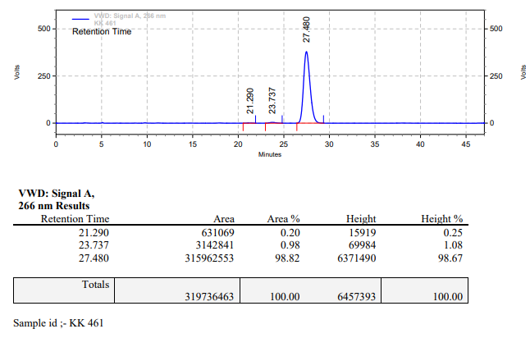

**KK-462**



**Calculation table:**

|  |  |  |  |  |  |
| --- | --- | --- | --- | --- | --- |
| Sr. No | Comp. | Mol. wt. | mmol | Eq. wt. | Wt. taken |
| 1 | Dehydrositagliptin (1) | 405.30 | 0.2052 | 1 | 83 mg |
| 2 | Rh(COD)2OTf | 468.30 | 0.3x10-3 | 0.0015 | 0.14 mg |
| 3 | L12 | 526.51 | 0.3x10-3 | 0.0016 | 0.17 mg |
| 4 | Ammonium chloride | 53.49 | 0.3x10-3 | 0.0015 | 0.01 mg |

**Procedure:** A glass vial (4 mL) equipped with Teflon coated magnetic needle was cooled under vacuum and transferred to a glove box. The vial was then charged with 83 mg of enamine (**1**), 0.14 mg of [Rh(COD)2OTf], ligand (L12) and ammonium chloride. Reaction vial was then closed using screwcap, transferred to a large opening Schlenk type container and was then taken out from the glove box. 2 mL dry methanol was added to the vial in inert atmosphere and the resultant reaction slurry was stirred for 1 hour at room temperature (25°C). After that the reaction vial was shifted to an autoclave and the autoclave was purged three times using hydrogen gas (40 bars). Finally, the autoclave was pressurized to 20 bar hydrogen pressure at 60°C for 18 hrs time period. After the 18 hrs time period, the autoclave was cooled to room temperature (25°C), excess pressure was released and the autoclave was opened. The vials were taken out from the autoclave. The thus obtained reaction mixture was passed through neutral alumina bed, the filtrate was collect and dried to yield residue. The resultant residue was then analysed by HPLC.

**Reaction conditions:** Temp: 60°C Press.: 20 bar Solvent: Methanol Time: 18 hrs

**Result: 00%** conversion **00%** ee

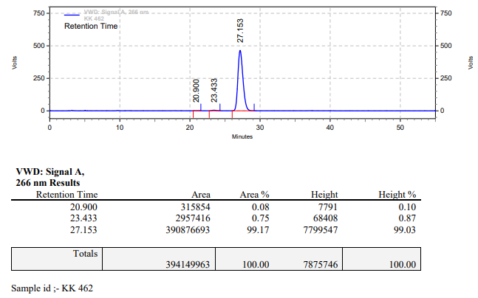

**KK-463**



**Calculation table:**

|  |  |  |  |  |  |
| --- | --- | --- | --- | --- | --- |
| Sr. No | Comp. | Mol. wt. | mmol | Eq. wt. | Wt. taken |
| 1 | Dehydrositagliptin (1) | 405.30 | 0.2052 | 1 | 83 mg |
| 2 | Rh(COD)2OTf | 468.30 | 0.3x10-2 | 0.015 | 1.4 mg |
| 3 | tBu-Josiphos | 542.45 | 0.3x10-2 | 0.016 | 1.7 mg |
| 4 | Ammonium chloride | 53.49 | 0.3x10-2 | 0.015 | 0.1 mg |

**Procedure:** A glass vial (4 mL) equipped with Teflon coated magnetic needle was cooled under vacuum and transferred to a glove box. The vial was then charged with 83 mg of enamine (**1**), 1.4 mg of [Rh(COD)OTf], tBu-Josiphos and ammonium chloride. Reaction vial was then closed using screwcap, transferred to a large opening Schlenk type container and was then taken out from the glove box. 5 mL dry methanol was added to the vial in inert atmosphere and the resultant reaction slurry was stirred for 1 hour at room temperature (25 °C). After that the reaction vial was shifted to an autoclave and the autoclave was purged three times using hydrogen gas (40 bars). Finally, the autoclave was pressurized to 30 bar hydrogen pressure at 60°C for 18 hrs time period. After the 18 hrs time period, the autoclave was cooled to room temperature (25 °C), excess pressure was released and the autoclave was opened. The vials were taken out from the autoclave. The thus obtained reaction mixture was passed through neutral alumina bed, the filtrate was collect and dried to yield residue. The resultant residue was then analysed by HPLC.

**Reaction conditions:** Temp: 60°C Press.: 30 bar Solvent: Methanol Time: 18 hrs

**Result: 76%** conversion **92%** ee

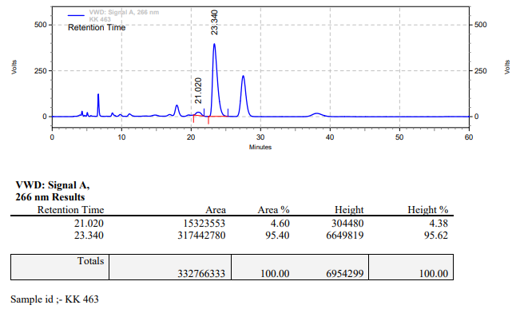

**KK-464**



**Calculation table:**

|  |  |  |  |  |  |
| --- | --- | --- | --- | --- | --- |
| Sr. No | Comp. | Mol. wt. | mmol | Eq. wt. | Wt. taken |
| 1 | Dehydrositagliptin (1) | 405.30 | 0.2052 | 1 | 83 mg |
| 2 | Rh(COD)2OTf | 468.30 | 0.3x10-2 | 0.015 | 1.4 mg |
| 3 | tBu-Josiphos | 542.45 | 0.3x10-2 | 0.016 | 1.7 mg |
| 4 | Ammonium chloride | 53.49 | 0.3x10-2 | 0.015 | 0.1 mg |

**Procedure:** A glass vial (4 mL) equipped with Teflon coated magnetic needle was cooled under vacuum and transferred to a glove box. The vial was then charged with 83 mg of enamine (**1**), 1.4 mg of [Rh(COD)OTf], tBu-Josiphos and ammonium chloride. Reaction vial was then closed using screwcap, transferred to a large opening Schlenk type container and was then taken out from the glove box. 5 mL dry methanol was added to the vial in inert atmosphere and the resultant reaction slurry was stirred for 1 hour at room temperature (25 °C). After that the reaction vial was shifted to an autoclave and the autoclave was purged three times using hydrogen gas (40 bars). Finally, the autoclave was pressurized to 30 bar hydrogen pressure at 60°C for 18 hrs time period. After the 18 hrs time period, the autoclave was cooled to room temperature (25 °C), excess pressure was released and the autoclave was opened. The vials were taken out from the autoclave. The thus obtained reaction mixture was passed through neutral alumina bed, the filtrate was collect and dried to yield residue. The resultant residue was then analysed by HPLC.

**Reaction conditions:** Temp: 60°C Press.: 30 bar Solvent: Methanol Time: 18 hrs

**Result: 60%** conversion **89%** ee

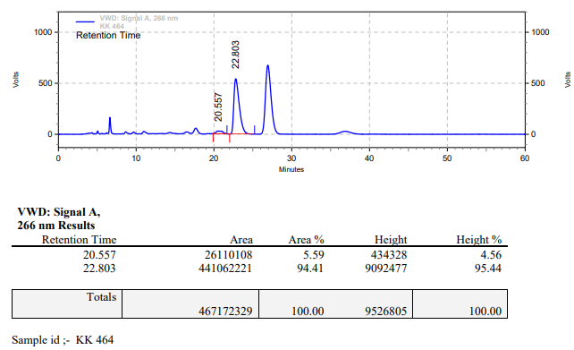

**KK-465**



**Calculation table:**

|  |  |  |  |  |  |
| --- | --- | --- | --- | --- | --- |
| Sr. No | Comp. | Mol. wt. | mmol | Eq. wt. | Wt. taken |
| 1 | Dehydrositagliptin (1) | 405.30 | 0.2052 | 1 | 83 mg |
| 2 | Rh(COD)2OTf | 468.30 | 0.3x10-2 | 0.015 | 1.4 mg |
| 3 | L12 | 526.51 | 0.3x10-2 | 0.016 | 1.7 mg |
| 4 | Salicylic acid | 138.12 | 0.3x10-2 | 0.015 | 0.1 mg |

**Procedure:** A glass vial (4 mL) equipped with Teflon coated magnetic needle was cooled under vacuum and transferred to a glove box. The vial was then charged with 86 mg of enamine (**1**), 1.4 mg of [Rh(COD)2OTf], ligand (L12) and salicylic acid. Reaction vial was then closed using screwcap, transferred to a large opening Schlenk type container and was then taken out from the glove box. 2 mL dry methanol was added to the vial in inert atmosphere and the resultant reaction slurry was stirred for 1 hour at room temperature (25°C). After that the reaction vial was shifted to an autoclave and the autoclave was purged three times using hydrogen gas (40 bars). Finally, the autoclave was pressurized to 30 bar hydrogen pressure at 60°C for 18 hrs time period. After the 18 hrs time period, the autoclave was cooled to room temperature (25°C), excess pressure was released and the autoclave was opened. The vials were taken out from the autoclave. The thus obtained reaction mixture was passed through neutral alumina bed, the filtrate was collect and dried to yield residue. The resultant residue was then analysed by HPLC.

**Reaction conditions:** Temp: 60°C Press.: 30 bar Solvent: Methanol Time: 18 hrs

**Result: 40%** conversion **79%** ee

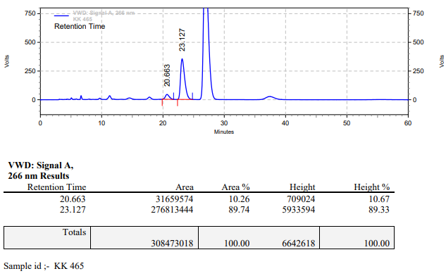

**KK-466**



**Calculation table:**

|  |  |  |  |  |  |
| --- | --- | --- | --- | --- | --- |
| Sr. No | Comp. | Mol. wt. | mmol | Eq. wt. | Wt. taken |
| 1 | Dehydrositagliptin (1) | 405.30 | 0.2052 | 1 | 83 mg |
| 2 | Rh(COD)2OTf | 468.30 | 0.3x10-2 | 0.015 | 1.4 mg |
| 3 | L12 | 526.51 | 0.3x10-2 | 0.016 | 1.7 mg |
| 4 | Salicylic acid | 138.12 | 0.3x10-2 | 0.015 | 0.1 mg |

**Procedure:** A glass vial (4 mL) equipped with Teflon coated magnetic needle was cooled under vacuum and transferred to a glove box. The vial was then charged with 86 mg of enamine (**1**), 1.4 mg of [Rh(COD)2OTf], ligand (L12) and salicylic acid. Reaction vial was then closed using screwcap, transferred to a large opening Schlenk type container and was then taken out from the glove box. 2 mL dry methanol was added to the vial in inert atmosphere and the resultant reaction slurry was stirred for 1 hour at room temperature (25°C). After that the reaction vial was shifted to an autoclave and the autoclave was purged three times using hydrogen gas (40 bars). Finally, the autoclave was pressurized to 30 bar hydrogen pressure at 60°C for 18 hrs time period. After the 18 hrs time period, the autoclave was cooled to room temperature (25°C), excess pressure was released and the autoclave was opened. The vials were taken out from the autoclave. The thus obtained reaction mixture was passed through neutral alumina bed, the filtrate was collect and dried to yield residue. The resultant residue was then analysed by HPLC.

**Reaction conditions:** Temp: 60°C Press.: 30 bar Solvent: Methanol Time: 18 hrs

**Result: 35%** conversion **83%** ee

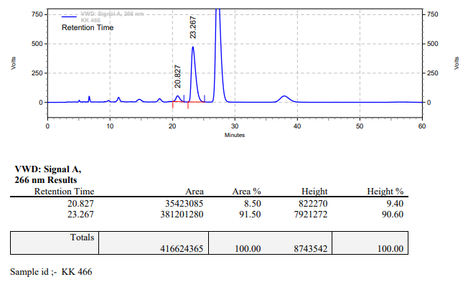

**KK-467**



**Calculation table:**

|  |  |  |  |  |  |
| --- | --- | --- | --- | --- | --- |
| Sr. No | Comp. | Mol. wt. | mmol | Eq. wt. | Wt. taken |
| 1 | Dehydrositagliptin (1) | 405.30 | 0.2135 | 100 | 86 mg |
| 2 | Rh(COD)2OTf | 468.30 | 0.0021 | 1 | 1 mg |
| 3 | L12 | 526.51 | 0.0023 | 1.2 | 1.2 mg |
| 4 | Salicylic acid | 138.12 | 0.2135 | 100 | 28 mg |

**Procedure:** A glass vial (4 mL) equipped with Teflon coated magnetic needle was cooled under vacuum and transferred to a glove box. The vial was then charged with 86 mg of enamine (**1**), 1 mg of [Rh(COD)2OTf] (1 mol%), ligand (L12) and salicylic acid. Reaction vial was then closed using screwcap, transferred to a large opening Schlenk type container and was then taken out from the glove box. 2 mL dry methanol was added to the vial in inert atmosphere and the resultant reaction slurry was stirred for 1 hour at room temperature (25°C). After that the reaction vial was shifted to an autoclave and the autoclave was purged three times using hydrogen gas (40 bars). Finally, the autoclave was pressurized to 30 bar hydrogen pressure at 60°C for 24 hrs time period. After the 24 hrs time period, the autoclave was cooled to room temperature (25°C), excess pressure was released and the autoclave was opened. The vials were taken out from the autoclave. The thus obtained reaction mixture was passed through neutral alumina bed, the filtrate was collect and dried to yield residue. The resultant residue was then analysed by HPLC.

**Reaction conditions:** Temp: 60°C Press.: 30 bar Solvent: Methanol Time: 24 hrs

**Result: 95%** conversion **92%** ee

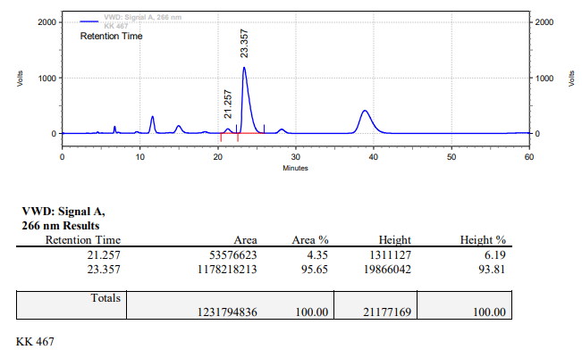

**KK-468**



**Calculation table:**

|  |  |  |  |  |  |
| --- | --- | --- | --- | --- | --- |
| Sr. No | Comp. | Mol. wt. | mmol | Eq. wt. | Wt. taken |
| 1 | Dehydrositagliptin (1) | 405.30 | 0.2135 | 100 | 86 mg |
| 2 | Rh(COD)2OTf | 468.30 | 0.0021 | 1 | 1 mg |
| 3 | L12 | 526.51 | 0.0042 | 2 | 2.2 mg |
| 4 | Salicylic acid | 138.12 | 0.2135 | 100 | 28 mg |

**Procedure:** A glass vial (4 mL) equipped with Teflon coated magnetic needle was cooled under vacuum and transferred to a glove box. The vial was then charged with 86 mg of enamine (**1**), 1 mg of [Rh(COD)2OTf] (1 mol%), ligand (L12) and salicylic acid. Reaction vial was then closed using screwcap, transferred to a large opening Schlenk type container and was then taken out from the glove box. 2 mL dry methanol was added to the vial in inert atmosphere and the resultant reaction slurry was stirred for 1 hour at room temperature (25°C). After that the reaction vial was shifted to an autoclave and the autoclave was purged three times using hydrogen gas (40 bars). Finally, the autoclave was pressurized to 30 bar hydrogen pressure at 60°C for 24 hrs time period. After the 24 hrs time period, the autoclave was cooled to room temperature (25°C), excess pressure was released and the autoclave was opened. The vials were taken out from the autoclave. The thus obtained reaction mixture was passed through neutral alumina bed, the filtrate was collect and dried to yield residue. The resultant residue was then analysed by HPLC.

**Reaction conditions:** Temp: 60°C Press.: 30 bar Solvent: Methanol Time: 24 hrs

**Result: 98%** conversion **92%** ee

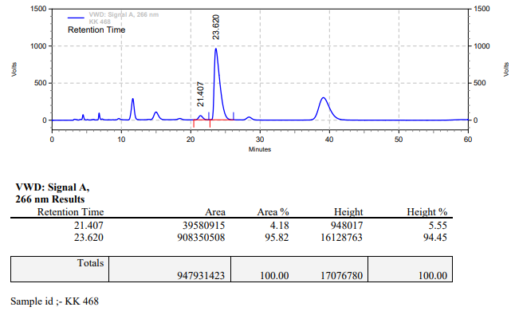

**KK-469**



**Calculation table:**

|  |  |  |  |  |  |
| --- | --- | --- | --- | --- | --- |
| Sr. No | Comp. | Mol. wt. | mmol | Eq. wt. | Wt. taken |
| 1 | Dehydrositagliptin (1) | 405.30 | 0.2135 | 100 | 86 mg |
| 2 | Rh(COD)2OTf | 468.30 | 0.0021 | 1 | 1 mg |
| 3 | L12 | 526.51 | 0.0023 | 1.2 | 1.2 mg |
| 4 | Salicylic acid | 138.12 | 0.0021 | 1 | 0.3 mg |

**Procedure:** A glass vial (4 mL) equipped with Teflon coated magnetic needle was cooled under vacuum and transferred to a glove box. The vial was then charged with 86 mg of enamine (**1**), 1 mg of [Rh(COD)2OTf] (1 mol%), ligand (L12) and salicylic acid. Reaction vial was then closed using screwcap, transferred to a large opening Schlenk type container and was then taken out from the glove box. 2 mL dry methanol was added to the vial in inert atmosphere and the resultant reaction slurry was stirred for 1 hour at room temperature (25°C). After that the reaction vial was shifted to an autoclave and the autoclave was purged three times using hydrogen gas (40 bars). Finally, the autoclave was pressurized to 30 bar hydrogen pressure at 60°C for 24 hrs time period. After the 24 hrs time period, the autoclave was cooled to room temperature (25°C), excess pressure was released and the autoclave was opened. The vials were taken out from the autoclave. The thus obtained reaction mixture was passed through neutral alumina bed, the filtrate was collect and dried to yield residue. The resultant residue was then analysed by HPLC.

**Reaction conditions:** Temp: 60°C Press.: 30 bar Solvent: Methanol Time: 24 hrs

**Result: 12%** conversion **65%** ee

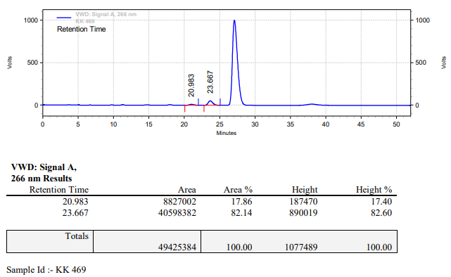

**KK-470**



**Calculation table:**

|  |  |  |  |  |  |
| --- | --- | --- | --- | --- | --- |
| Sr. No | Comp. | Mol. wt. | mmol | Eq. wt. | Wt. taken |
| 1 | Dehydrositagliptin (1) | 405.30 | 0.2135 | 100 | 86 mg |
| 2 | Rh(COD)2OTf | 468.30 | 0.0021 | 1 | 1 mg |
| 3 | L12 | 526.51 | 0.0042 | 2 | 2.2 mg |
| 4 | Salicylic acid | 138.12 | 0.0042 | 2 | 0.6 mg |

**Procedure:** A glass vial (4 mL) equipped with Teflon coated magnetic needle was cooled under vacuum and transferred to a glove box. The vial was then charged with 86 mg of enamine (**1**), 1 mg of [Rh(COD)2OTf] (1 mol%), ligand (L12) and salicylic acid. Reaction vial was then closed using screwcap, transferred to a large opening Schlenk type container and was then taken out from the glove box. 2 mL dry methanol was added to the vial in inert atmosphere and the resultant reaction slurry was stirred for 1 hour at room temperature (25°C). After that the reaction vial was shifted to an autoclave and the autoclave was purged three times using hydrogen gas (40 bars). Finally, the autoclave was pressurized to 30 bar hydrogen pressure at 60°C for 24 hrs time period. After the 24 hrs time period, the autoclave was cooled to room temperature (25°C), excess pressure was released and the autoclave was opened. The vials were taken out from the autoclave. The thus obtained reaction mixture was passed through neutral alumina bed, the filtrate was collect and dried to yield residue. The resultant residue was then analysed by HPLC.

**Reaction conditions:** Temp: 60°C Press.: 30 bar Solvent: Methanol Time: 24 hrs

**Result: 20%** conversion **85%** ee

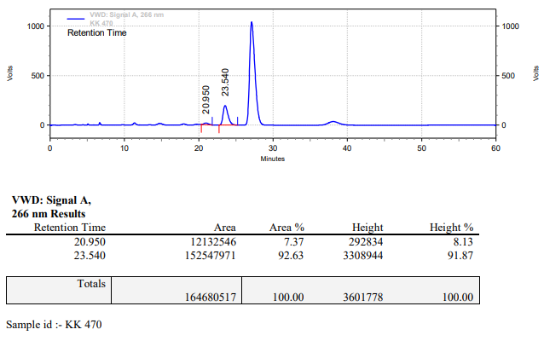

**KK-471**



**Calculation table:**

|  |  |  |  |  |  |
| --- | --- | --- | --- | --- | --- |
| Sr. No | Comp. | Mol. wt. | mmol | Eq. wt. | Wt. taken |
| 1 | Dehydrositagliptin (1) | 405.30 | 0.2135 | 100 | 86 mg |
| 2 | Rh(COD)2OTf | 468.30 | 0.0021 | 1 | 1 mg |
| 3 | L12 | 526.51 | 0.0023 | 1.2 | 1.2 mg |
| 4 | Salicylic acid | 138.12 | 0.0042 | 2 | 0.6 mg |

**Procedure:** A glass vial (4 mL) equipped with Teflon coated magnetic needle was cooled under vacuum and transferred to a glove box. The vial was then charged with 86 mg of enamine (**1**), 1 mg of [Rh(COD)2OTf] (1 mol%), ligand (L12) and salicylic acid. Reaction vial was then closed using screwcap, transferred to a large opening Schlenk type container and was then taken out from the glove box. 2 mL dry methanol was added to the vial in inert atmosphere and the resultant reaction slurry was stirred for 1 hour at room temperature (25°C). After that the reaction vial was shifted to an autoclave and the autoclave was purged three times using hydrogen gas (40 bars). Finally, the autoclave was pressurized to 30 bar hydrogen pressure at 60°C for 24 hrs time period. After the 24 hrs time period, the autoclave was cooled to room temperature (25°C), excess pressure was released and the autoclave was opened. The vials were taken out from the autoclave. The thus obtained reaction mixture was passed through neutral alumina bed, the filtrate was collect and dried to yield residue. The resultant residue was then analysed by HPLC.

**Reaction conditions:** Temp: 60°C Press.: 30 bar Solvent: Methanol Time: 24 hrs

**Result: 10%** conversion **72%** ee

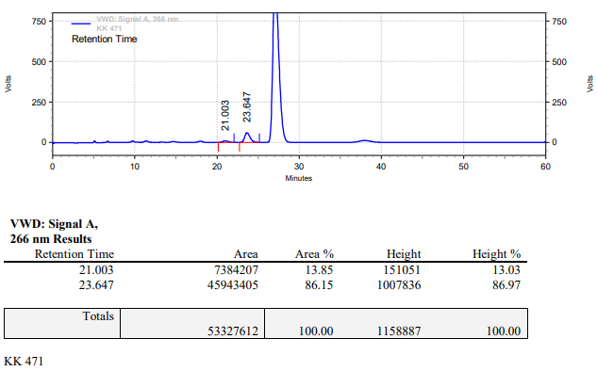

**KK-472**



**Calculation table:**

|  |  |  |  |  |  |
| --- | --- | --- | --- | --- | --- |
| Sr. No | Comp. | Mol. wt. | mmol | Eq. wt. | Wt. taken |
| 1 | Dehydrositagliptin (1) | 405.30 | 0.2135 | 100 | 86 mg |
| 2 | Rh(COD)2OTf | 468.30 | 0.0021 | 1 | 1 mg |
| 3 | L12 | 526.51 | 0.0042 | 2 | 2.2 mg |
| 4 | Salicylic acid | 138.12 | 0.0042 | 2 | 0.6 mg |

**Procedure:** A glass vial (4 mL) equipped with Teflon coated magnetic needle was cooled under vacuum and transferred to a glove box. The vial was then charged with 86 mg of enamine (**1**), 1 mg of [Rh(COD)2OTf] (1 mol%), ligand (L12) and salicylic acid. Reaction vial was then closed using screwcap, transferred to a large opening Schlenk type container and was then taken out from the glove box. 2 mL dry methanol was added to the vial in inert atmosphere and the resultant reaction slurry was stirred for 1 hour at room temperature (25°C). After that the reaction vial was shifted to an autoclave and the autoclave was purged three times using hydrogen gas (40 bars). Finally, the autoclave was pressurized to 30 bar hydrogen pressure at 60°C for 24 hrs time period. After the 24 hrs time period, the autoclave was cooled to room temperature (25°C), excess pressure was released and the autoclave was opened. The vials were taken out from the autoclave. The thus obtained reaction mixture was passed through neutral alumina bed, the filtrate was collect and dried to yield residue. The resultant residue was then analysed by HPLC.

**Reaction conditions:** Temp: 60°C Press.: 30 bar Solvent: Methanol Time: 24 hrs

**Result: 20%** conversion **85%** ee

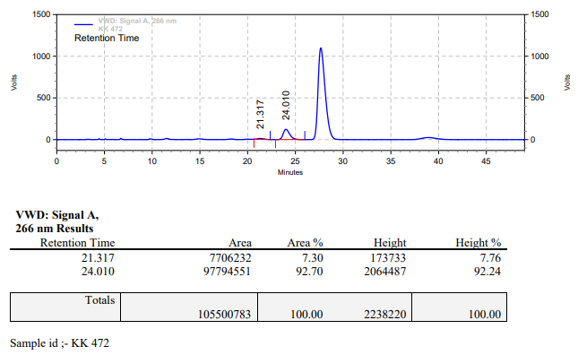

**KK-473**



**Calculation table:**

|  |  |  |  |  |  |
| --- | --- | --- | --- | --- | --- |
| Sr. No | Comp. | Mol. wt. | mmol | Eq. wt. | Wt. taken |
| 1 | Dehydrositagliptin (1) | 405.30 | 0.2135 | 100 | 86 mg |
| 2 | Rh(COD)2OTf | 468.30 | 0.0021 | 1 | 1 mg |
| 3 | L12 | 526.51 | 0.0023 | 1.2 | 1.2 mg |
| 4 | Salicylic acid | 138.12 | 0.1050 | 50 | 15 mg |

**Procedure:** A glass vial (4 mL) equipped with Teflon coated magnetic needle was cooled under vacuum and transferred to a glove box. The vial was then charged with 86 mg of enamine (**1**), 1 mg of [Rh(COD)2OTf] (1 mol%), ligand (L12) and salicylic acid. Reaction vial was then closed using screwcap, transferred to a large opening Schlenk type container and was then taken out from the glove box. 2 mL dry methanol was added to the vial in inert atmosphere and the resultant reaction slurry was stirred for 1 hour at room temperature (25°C). After that the reaction vial was shifted to an autoclave and the autoclave was purged three times using hydrogen gas (40 bars). Finally, the autoclave was pressurized to 30 bar hydrogen pressure at 50°C for 24 hrs time period. After the 24 hrs time period, the autoclave was cooled to room temperature (25°C), excess pressure was released and the autoclave was opened. The vials were taken out from the autoclave. The thus obtained reaction mixture was passed through neutral alumina bed, the filtrate was collect and dried to yield residue. The resultant residue was then analysed by HPLC.

**Reaction conditions:** Temp: 50°C Press.: 30 bar Solvent: Methanol Time: 24 hrs

**Result: 62%** conversion **91%** ee

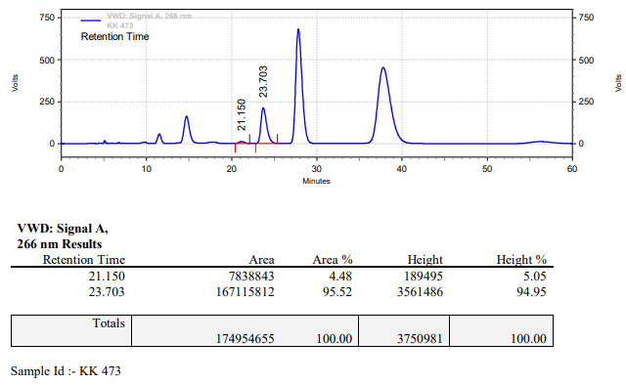

**KK-474**



**Calculation table:**

|  |  |  |  |  |  |
| --- | --- | --- | --- | --- | --- |
| Sr. No | Comp. | Mol. wt. | mmol | Eq. wt. | Wt. taken |
| 1 | Dehydrositagliptin (1) | 405.30 | 0.2135 | 100 | 86 mg |
| 2 | Rh(COD)2OTf | 468.30 | 0.0021 | 1 | 1 mg |
| 3 | L12 | 526.51 | 0.0042 | 2 | 2.2 mg |
| 4 | Salicylic acid | 138.12 | 0.1050 | 50 | 15 mg |

**Procedure:** A glass vial (4 mL) equipped with Teflon coated magnetic needle was cooled under vacuum and transferred to a glove box. The vial was then charged with 86 mg of enamine (**1**), 1 mg of [Rh(COD)2OTf] (1 mol%), ligand (L12) and salicylic acid. Reaction vial was then closed using screwcap, transferred to a large opening Schlenk type container and was then taken out from the glove box. 2 mL dry methanol was added to the vial in inert atmosphere and the resultant reaction slurry was stirred for 1 hour at room temperature (25°C). After that the reaction vial was shifted to an autoclave and the autoclave was purged three times using hydrogen gas (40 bars). Finally, the autoclave was pressurized to 30 bar hydrogen pressure at 50°C for 24 hrs time period. After the 24 hrs time period, the autoclave was cooled to room temperature (25°C), excess pressure was released and the autoclave was opened. The vials were taken out from the autoclave. The thus obtained reaction mixture was passed through neutral alumina bed, the filtrate was collect and dried to yield residue. The resultant residue was then analysed by HPLC.

**Reaction conditions:** Temp: 50°C Press.: 30 bar Solvent: Methanol Time: 24 hrs

**Result: 80%** conversion **92%** ee

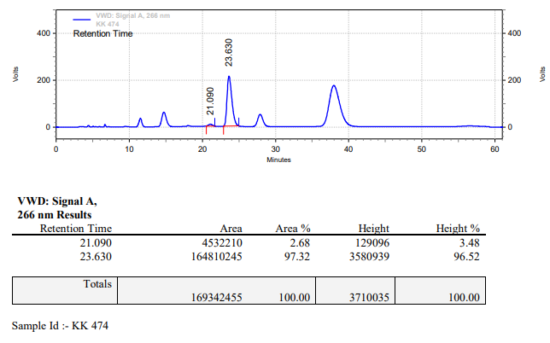

**KK-475**



**Calculation table:**

|  |  |  |  |  |  |
| --- | --- | --- | --- | --- | --- |
| Sr. No | Comp. | Mol. wt. | mmol | Eq. wt. | Wt. taken |
| 1 | Dehydrositagliptin (1) | 405.30 | 0.2135 | 100 | 86 mg |
| 2 | Rh(COD)2OTf | 468.30 | 0.0021 | 1 | 1 mg |
| 3 | L12 | 526.51 | 0.0023 | 1.2 | 1.2 mg |
| 4 | Salicylic acid | 138.12 | 0.0213 | 10 | 3 mg |

**Procedure:** A glass vial (4 mL) equipped with Teflon coated magnetic needle was cooled under vacuum and transferred to a glove box. The vial was then charged with 86 mg of enamine (**1**), 1 mg of [Rh(COD)2OTf] (1 mol%), ligand (L12) and salicylic acid. Reaction vial was then closed using screwcap, transferred to a large opening Schlenk type container and was then taken out from the glove box. 2 mL dry methanol was added to the vial in inert atmosphere and the resultant reaction slurry was stirred for 1 hour at room temperature (25°C). After that the reaction vial was shifted to an autoclave and the autoclave was purged three times using hydrogen gas (40 bars). Finally, the autoclave was pressurized to 30 bar hydrogen pressure at 50°C for 24 hrs time period. After the 24 hrs time period, the autoclave was cooled to room temperature (25°C), excess pressure was released and the autoclave was opened. The vials were taken out from the autoclave. The thus obtained reaction mixture was passed through neutral alumina bed, the filtrate was collect and dried to yield residue. The resultant residue was then analysed by HPLC.

**Reaction conditions:** Temp: 50°C Press.: 30 bar Solvent: Methanol Time: 24 hrs

**Result: 11%** conversion **87%** ee

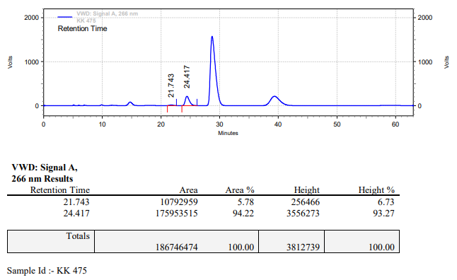

**KK-476**



**Calculation table:**

|  |  |  |  |  |  |
| --- | --- | --- | --- | --- | --- |
| Sr. No | Comp. | Mol. wt. | mmol | Eq. wt. | Wt. taken |
| 1 | Dehydrositagliptin (1) | 405.30 | 0.2135 | 100 | 86 mg |
| 2 | Rh(COD)2OTf | 468.30 | 0.0021 | 1 | 1 mg |
| 3 | L12 | 526.51 | 0.0023 | 1.2 | 1.2 mg |
| 4 | Salicylic acid | 138.12 | 0.0105 | 5 | 1.5 mg |

**Procedure:** A glass vial (4 mL) equipped with Teflon coated magnetic needle was cooled under vacuum and transferred to a glove box. The vial was then charged with 86 mg of enamine (**1**), 1 mg of [Rh(COD)2OTf] (1 mol%), ligand (L12) and salicylic acid. Reaction vial was then closed using screwcap, transferred to a large opening Schlenk type container and was then taken out from the glove box. 2 mL dry methanol was added to the vial in inert atmosphere and the resultant reaction slurry was stirred for 1 hour at room temperature (25°C). After that the reaction vial was shifted to an autoclave and the autoclave was purged three times using hydrogen gas (40 bars). Finally, the autoclave was pressurized to 30 bar hydrogen pressure at 50°C for 24 hrs time period. After the 24 hrs time period, the autoclave was cooled to room temperature (25°C), excess pressure was released and the autoclave was opened. The vials were taken out from the autoclave. The thus obtained reaction mixture was passed through neutral alumina bed, the filtrate was collect and dried to yield residue. The resultant residue was then analysed by HPLC.

**Reaction conditions:** Temp: 50°C Press.: 30 bar Solvent: Methanol Time: 24 hrs

**Result: 11%** conversion **87%** ee

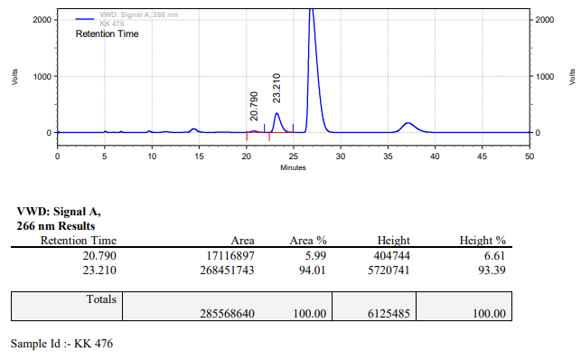

**KK-477**



**Calculation table:**

|  |  |  |  |  |  |
| --- | --- | --- | --- | --- | --- |
| Sr. No | Comp. | Mol. wt. | mmol | Eq. wt. | Wt. taken |
| 1 | Dehydrositagliptin (1) | 405.30 | 0.2135 | 100 | 86 mg |
| 2 | Rh(COD)2OTf | 468.30 | 0.0021 | 1 | 1 mg |
| 3 | L12 | 526.51 | 0.0042 | 2 | 2.2 mg |
| 4 | Salicylic acid | 138.12 | 0.0213 | 10 | 3 mg |

**Procedure:** A glass vial (4 mL) equipped with Teflon coated magnetic needle was cooled under vacuum and transferred to a glove box. The vial was then charged with 86 mg of enamine (**1**), 1 mg of [Rh(COD)2OTf] (1 mol%), ligand (L12) and salicylic acid. Reaction vial was then closed using screwcap, transferred to a large opening Schlenk type container and was then taken out from the glove box. 2 mL dry methanol was added to the vial in inert atmosphere and the resultant reaction slurry was stirred for 1 hour at room temperature (25°C). After that the reaction vial was shifted to an autoclave and the autoclave was purged three times using hydrogen gas (40 bars). Finally, the autoclave was pressurized to 30 bar hydrogen pressure at 50°C for 24 hrs time period. After the 24 hrs time period, the autoclave was cooled to room temperature (25°C), excess pressure was released and the autoclave was opened. The vials were taken out from the autoclave. The thus obtained reaction mixture was passed through neutral alumina bed, the filtrate was collect and dried to yield residue. The resultant residue was then analysed by HPLC.

**Reaction conditions:** Temp: 50°C Press.: 30 bar Solvent: Methanol Time: 24 hrs

**Result: 18%** conversion **87%** ee

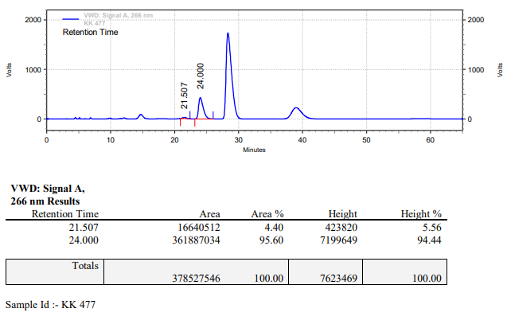

**KK-478**



**Calculation table:**

|  |  |  |  |  |  |
| --- | --- | --- | --- | --- | --- |
| Sr. No | Comp. | Mol. wt. | mmol | Eq. wt. | Wt. taken |
| 1 | Dehydrositagliptin (1) | 405.30 | 0.2135 | 100 | 86 mg |
| 2 | Rh(COD)2OTf | 468.30 | 0.0021 | 1 | 1 mg |
| 3 | L12 | 526.51 | 0.0042 | 2 | 2.2 mg |
| 4 | Salicylic acid | 138.12 | 0.0105 | 5 | 1.5 mg |

**Procedure:** A glass vial (4 mL) equipped with Teflon coated magnetic needle was cooled under vacuum and transferred to a glove box. The vial was then charged with 86 mg of enamine (**1**), 1 mg of [Rh(COD)2OTf] (1 mol%), ligand (L12) and salicylic acid. Reaction vial was then closed using screwcap, transferred to a large opening Schlenk type container and was then taken out from the glove box. 2 mL dry methanol was added to the vial in inert atmosphere and the resultant reaction slurry was stirred for 1 hour at room temperature (25°C). After that the reaction vial was shifted to an autoclave and the autoclave was purged three times using hydrogen gas (40 bars). Finally, the autoclave was pressurized to 30 bar hydrogen pressure at 50°C for 24 hrs time period. After the 24 hrs time period, the autoclave was cooled to room temperature (25°C), excess pressure was released and the autoclave was opened. The vials were taken out from the autoclave. The thus obtained reaction mixture was passed through neutral alumina bed, the filtrate was collect and dried to yield residue. The resultant residue was then analysed by HPLC.

**Reaction conditions:** Temp: 50°C Press.: 30 bar Solvent: Methanol Time: 24 hrs

**Result: 17%** conversion **87%** ee

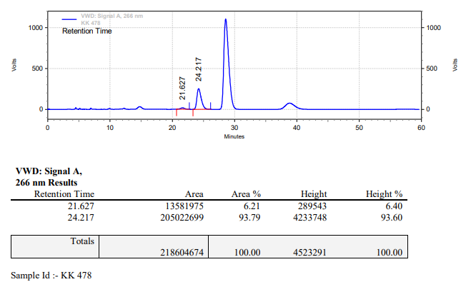

**KK-479**



**Calculation table:**

|  |  |  |  |  |  |
| --- | --- | --- | --- | --- | --- |
| Sr. No | Comp. | Mol. wt. | mmol | Eq. wt. | Wt. taken |
| 1 | Dehydrositagliptin (1) | 405.30 | 0.2135 | 100 | 86 mg |
| 2 | Rh(COD)2OTf | 468.30 | 0.0021 | 1 | 1 mg |
| 3 | L12 | 526.51 | 0.0023 | 1.2 | 1.2 mg |
| 4 | Salicylic acid | 138.12 | 0.2135 | 100 | 28 mg |

**Procedure:** A glass vial (15 mL) equipped with Teflon coated magnetic needle was cooled under vacuum and transferred to a glove box. The vial was then charged with 86 mg of enamine (**1**), 1 mg of [Rh(COD)2OTf] (1 mol%), ligand (L12) and salicylic acid. Reaction vial was then closed using screwcap, transferred to a large opening Schlenk type container and was then taken out from the glove box. 5 mL dry methanol was added to the vial in inert atmosphere and the resultant reaction slurry was stirred for 1 hour at room temperature (25°C). After that the reaction vial was shifted to an autoclave and the autoclave was purged three times using hydrogen gas (40 bars). Finally, the autoclave was pressurized to 30 bar hydrogen pressure at 50°C for 18 hrs time period. After the 18 hrs time period, the autoclave was cooled to room temperature (25°C), excess pressure was released and the autoclave was opened. The vials were taken out from the autoclave. The thus obtained reaction mixture was passed through neutral alumina bed, the filtrate was collect and dried to yield residue. The resultant residue was then analysed by HPLC.

**Reaction conditions:** Temp: 50°C Press.: 30 bar Solvent: Methanol Time: 18 hrs

**Result: 02%** conversion **00%** ee

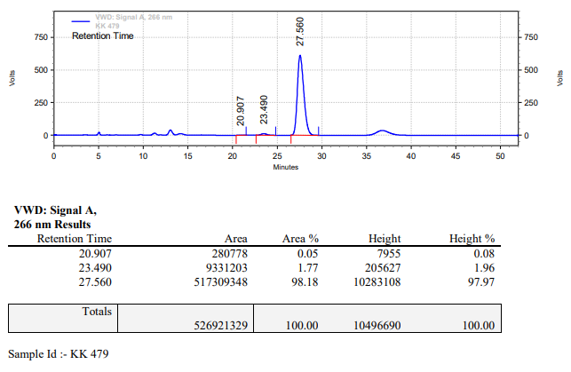

**KK-480**



**Calculation table:**

|  |  |  |  |  |  |
| --- | --- | --- | --- | --- | --- |
| Sr. No | Comp. | Mol. wt. | mmol | Eq. wt. | Wt. taken |
| 1 | Dehydrositagliptin (1) | 405.30 | 0.2135 | 100 | 86 mg |
| 2 | Rh(COD)2OTf | 468.30 | 0.0021 | 1 | 1 mg |
| 3 | L12 | 526.51 | 0.0023 | 1.2 | 1.2 mg |
| 4 | Salicylic acid | 138.12 | 0.2135 | 100 | 28 mg |

**Procedure:** A glass vial (15 mL) equipped with Teflon coated magnetic needle was cooled under vacuum and transferred to a glove box. The vial was then charged with 86 mg of enamine (**1**), 1 mg of [Rh(COD)2OTf] (1 mol%), ligand (L12) and salicylic acid. Reaction vial was then closed using screwcap, transferred to a large opening Schlenk type container and was then taken out from the glove box. 10 mL dry methanol was added to the vial in inert atmosphere and the resultant reaction slurry was stirred for 1 hour at room temperature (25°C). After that the reaction vial was shifted to an autoclave and the autoclave was purged three times using hydrogen gas (40 bars). Finally, the autoclave was pressurized to 30 bar hydrogen pressure at 50°C for 18 hrs time period. After the 18 hrs time period, the autoclave was cooled to room temperature (25°C), excess pressure was released and the autoclave was opened. The vials were taken out from the autoclave. The thus obtained reaction mixture was passed through neutral alumina bed, the filtrate was collect and dried to yield residue. The resultant residue was then analysed by HPLC.

**Reaction conditions:** Temp: 50°C Press.: 30 bar Solvent: Methanol Time: 18 hrs

**Result: 00%** conversion **00%** ee

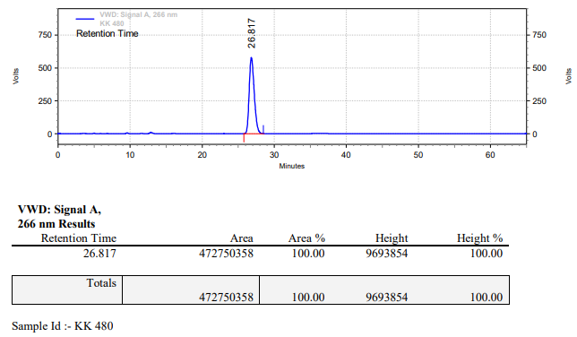

**KK-481**



**Calculation table:**

|  |  |  |  |  |  |
| --- | --- | --- | --- | --- | --- |
| Sr. No | Comp. | Mol. wt. | mmol | Eq. wt. | Wt. taken |
| 1 | Dehydrositagliptin (1) | 405.30 | 0.4270 | 100 | 173 mg |
| 2 | Rh(COD)2OTf | 468.30 | 0.0042 | 1 | 2 mg |
| 3 | L12 | 526.51 | 0.0050 | 1.2 | 2.7 mg |
| 4 | Salicylic acid | 138.12 | 0.2135 | 50 | 29 mg |

**Procedure:** A glass vial (15 mL) equipped with Teflon coated magnetic needle was cooled under vacuum and transferred to a glove box. The vial was then charged with 86 mg of enamine (**1**), 2 mg of [Rh(COD)2OTf] (1 mol%), ligand (L12) and salicylic acid. Reaction vial was then closed using screwcap, transferred to a large opening Schlenk type container and was then taken out from the glove box. 10 mL dry methanol was added to the vial in inert atmosphere and the resultant reaction slurry was stirred for 1 hour at room temperature (25°C). After that the reaction vial was shifted to an autoclave and the autoclave was purged three times using hydrogen gas (40 bars). Finally, the autoclave was pressurized to 30 bar hydrogen pressure at 50°C for 18 hrs time period. After the 18 hrs time period, the autoclave was cooled to room temperature (25°C), excess pressure was released and the autoclave was opened. The vials were taken out from the autoclave. The thus obtained reaction mixture was passed through neutral alumina bed, the filtrate was collect and dried to yield residue. The resultant residue was then analysed by HPLC.

**Reaction conditions:** Temp: 50°C Press.: 30 bar Solvent: Methanol Time: 18 hrs

**Result: 30%** conversion **94%** ee

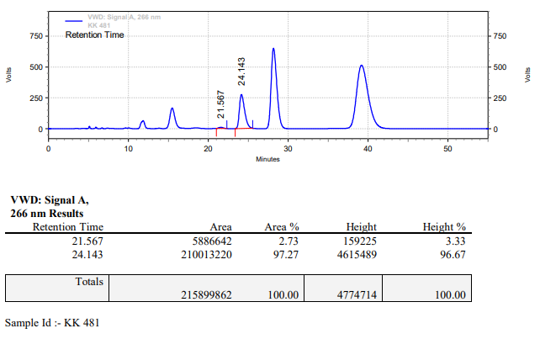

**KK-482**



**Calculation table:**

|  |  |  |  |  |  |
| --- | --- | --- | --- | --- | --- |
| Sr. No | Comp. | Mol. wt. | mmol | Eq. wt. | Wt. taken |
| 1 | Dehydrositagliptin (1) | 405.30 | 0.4270 | 100 | 173 mg |
| 2 | Rh(COD)2OTf | 468.30 | 0.0042 | 1 | 2 mg |
| 3 | L12 | 526.51 | 0.0084 | 2 | 4.4 mg |
| 4 | Salicylic acid | 138.12 | 0.2135 | 50 | 29 mg |

**Procedure:** A glass vial (15 mL) equipped with Teflon coated magnetic needle was cooled under vacuum and transferred to a glove box. The vial was then charged with 86 mg of enamine (**1**), 2 mg of [Rh(COD)2OTf] (1 mol%), ligand (L12) and salicylic acid. Reaction vial was then closed using screwcap, transferred to a large opening Schlenk type container and was then taken out from the glove box. 10 mL dry methanol was added to the vial in inert atmosphere and the resultant reaction slurry was stirred for 1 hour at room temperature (25°C). After that the reaction vial was shifted to an autoclave and the autoclave was purged three times using hydrogen gas (40 bars). Finally, the autoclave was pressurized to 30 bar hydrogen pressure at 50°C for 18 hrs time period. After the 18 hrs time period, the autoclave was cooled to room temperature (25°C), excess pressure was released and the autoclave was opened. The vials were taken out from the autoclave. The thus obtained reaction mixture was passed through neutral alumina bed, the filtrate was collect and dried to yield residue. The resultant residue was then analysed by HPLC.

**Reaction conditions:** Temp: 50°C Press.: 30 bar Solvent: Methanol Time: 18 hrs

**Result: 30%** conversion **93%** ee

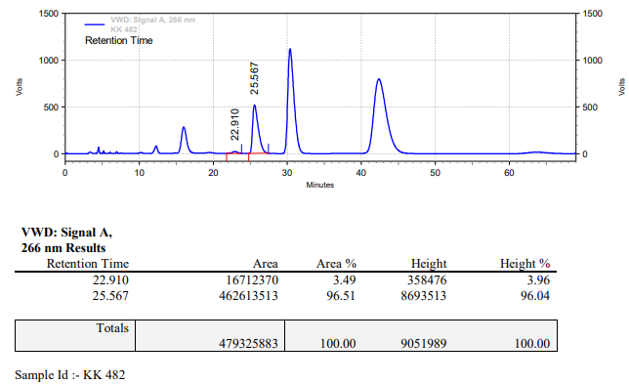

**KK-483**



**Calculation table:**

|  |  |  |  |  |  |
| --- | --- | --- | --- | --- | --- |
| Sr. No | Comp. | Mol. wt. | mmol | Eq. wt. | Wt. taken |
| 1 | Dehydrositagliptin (1) | 405.30 | 0.2135 | 100 | 86 mg |
| 2 | Rh(COD)2OTf | 468.30 | 0.0021 | 1 | 1 mg |
| 3 | L12 | 526.51 | 0.0023 | 1.2 | 1.2 mg |
| 4 | Formic acid | 46.03 | 0.0213 | 10 | 1 mg |

**Procedure:** A glass vial (4 mL) equipped with Teflon coated magnetic needle was cooled under vacuum and transferred to a glove box. The vial was then charged with 86 mg of enamine (**1**), 1 mg of [Rh(COD)2OTf] (1 mol%) and ligand (L12). Reaction vial was then closed using screwcap, transferred to a large opening Schlenk type container and was then taken out from the glove box. 2 mL dry methanol was added followed by formic acid to the vial in inert atmosphere and the resultant reaction slurry was stirred for 1 hour at room temperature (25°C). After that the reaction vial was shifted to an autoclave and the autoclave was purged three times using hydrogen gas (40 bars). Finally, the autoclave was pressurized to 30 bar hydrogen pressure at 50°C for 18 hrs time period. After the 18 hrs time period, the autoclave was cooled to room temperature (25°C), excess pressure was released and the autoclave was opened. The vials were taken out from the autoclave. The thus obtained reaction mixture was passed through neutral alumina bed, the filtrate was collect and dried to yield residue. The resultant residue was then analysed by HPLC.

**Reaction conditions:** Temp: 50°C Press.: 30 bar Solvent: Methanol Time: 18 hrs

**Result: 15%** conversion **89%** ee

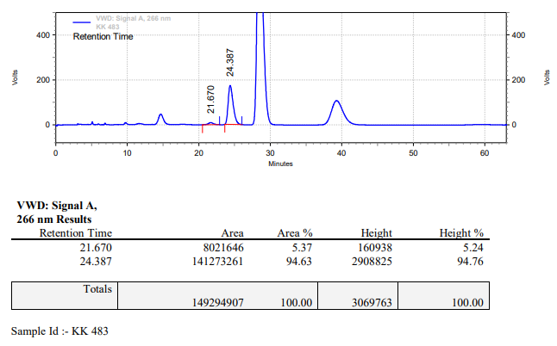

**KK-484**



**Calculation table:**

|  |  |  |  |  |  |
| --- | --- | --- | --- | --- | --- |
| Sr. No | Comp. | Mol. wt. | mmol | Eq. wt. | Wt. taken |
| 1 | Dehydrositagliptin (1) | 405.30 | 0.2135 | 100 | 86 mg |
| 2 | Rh(COD)2OTf | 468.30 | 0.0021 | 1 | 1 mg |
| 3 | L12 | 526.51 | 0.0023 | 1.2 | 1.2 mg |
| 4 | Salicylic acid | 138.12 | 0.1050 | 50 | 15 mg |

**Procedure:** A glass vial (4 mL) equipped with Teflon coated magnetic needle was cooled under vacuum and transferred to a glove box. The vial was then charged with 86 mg of enamine (**1**), 1 mg of [Rh(COD)2OTf] (1 mol%), ligand (L12) and salicylic acid. Reaction vial was then closed using screwcap, transferred to a large opening Schlenk type container and was then taken out from the glove box. 2 mL dry methanol was added to the vial in inert atmosphere and the resultant reaction slurry was stirred for 1 hour at room temperature (25°C). After that the reaction vial was shifted to an autoclave and the autoclave was purged three times using hydrogen gas (40 bars). Finally, the autoclave was pressurized to 30 bar hydrogen pressure at 50°C for 18 hrs time period. After the 18 hrs time period, the autoclave was cooled to room temperature (25°C), excess pressure was released and the autoclave was opened. The vials were taken out from the autoclave. The thus obtained reaction mixture was passed through neutral alumina bed, the filtrate was collect and dried to yield residue. The resultant residue was then analysed by HPLC.

**Reaction conditions:** Temp: 50°C Press.: 30 bar Solvent: Methanol Time: 18 hrs

**Result: 30%** conversion **94%** ee

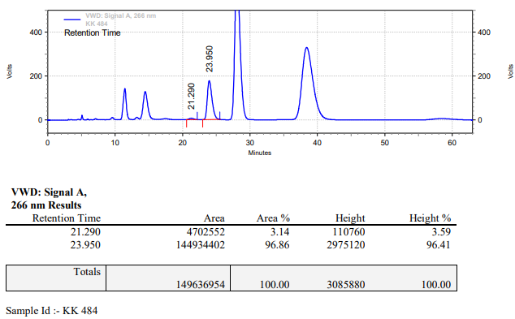

**KK-485**



**Calculation table:**

|  |  |  |  |  |  |
| --- | --- | --- | --- | --- | --- |
| Sr. No | Comp. | Mol. wt. | mmol | Eq. wt. | Wt. taken |
| 1 | Dehydrositagliptin (1) | 405.30 | 0.2135 | 100 | 86 mg |
| 2 | Rh(COD)2OTf | 468.30 | 0.0021 | 1 | 1 mg |
| 3 | L12 | 526.51 | 0.0042 | 2 | 2.2 mg |
| 4 | Salicylic acid | 138.12 | 0.2135 | 100 | 29 mg |

**Procedure:** A glass vial (4 mL) equipped with Teflon coated magnetic needle was cooled under vacuum and transferred to a glove box. The vial was then charged with 86 mg of enamine (**1**), 1 mg of [Rh(COD)2OTf] (1 mol%), ligand (L12) and salicylic acid. Reaction vial was then closed using screwcap, transferred to a large opening Schlenk type container and was then taken out from the glove box. 2 mL dry methanol was added to the vial in inert atmosphere and the resultant reaction slurry was stirred for 1 hour at room temperature (25°C). After that the reaction vial was shifted to an autoclave and the autoclave was purged three times using hydrogen gas (40 bars). Finally, the autoclave was pressurized to 30 bar hydrogen pressure at 60°C for 24 hrs time period. After the 24 hrs time period, the autoclave was cooled to room temperature (25°C), excess pressure was released and the autoclave was opened. The vials were taken out from the autoclave. The thus obtained reaction mixture was passed through neutral alumina bed, the filtrate was collect and dried to yield residue. The resultant residue was then analysed by HPLC.

**Reaction conditions:** Temp: 60°C Press.: 30 bar Solvent: Methanol Time: 24 hrs

**Result: 98%** conversion **94%** ee

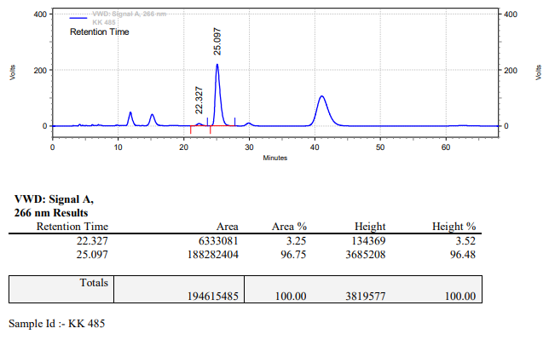

**KK-486**



**Calculation table:**

|  |  |  |  |  |  |
| --- | --- | --- | --- | --- | --- |
| Sr. No | Comp. | Mol. wt. | mmol | Eq. wt. | Wt. taken |
| 1 | Dehydrositagliptin (1) | 405.30 | 0.2135 | 100 | 86 mg |
| 2 | Rh(COD)2OTf | 468.30 | 0.0021 | 1 | 1 mg |
| 3 | L12 | 526.51 | 0.0042 | 2 | 2.2 mg |
| 4 | Salicylic acid | 138.12 | 0.2135 | 100 | 29 mg |

**Procedure:** A glass vial (4 mL) equipped with Teflon coated magnetic needle was cooled under vacuum and transferred to a glove box. The vial was then charged with 86 mg of enamine (**1**), 1 mg of [Rh(COD)2OTf] (1 mol%), ligand (L12) and salicylic acid. Reaction vial was then closed using screwcap, transferred to a large opening Schlenk type container and was then taken out from the glove box. 2 mL dry methanol was added to the vial in inert atmosphere and the resultant reaction slurry was stirred for 1 hour at room temperature (25°C). After that the reaction vial was shifted to an autoclave and the autoclave was purged three times using hydrogen gas (40 bars). Finally, the autoclave was pressurized to 30 bar hydrogen pressure at 60°C for 24 hrs time period. After the 24 hrs time period, the autoclave was cooled to room temperature (25°C), excess pressure was released and the autoclave was opened. The vials were taken out from the autoclave. The thus obtained reaction mixture was passed through neutral alumina bed, the filtrate was collect and dried to yield residue. The resultant residue was then analysed by HPLC.

**Reaction conditions:** Temp: 60°C Press.: 30 bar Solvent: Methanol Time: 24 hrs

**Result: 89%** conversion **93%** ee

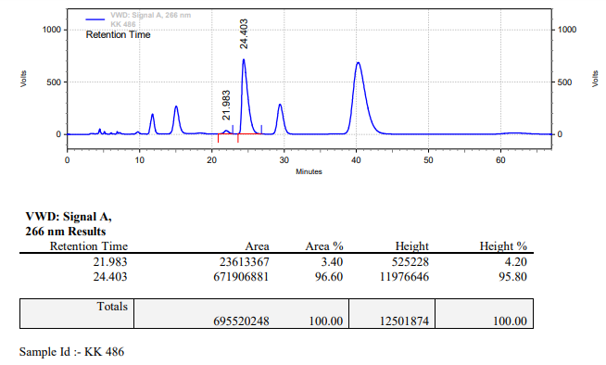

**KK-487**



**Calculation table:**

|  |  |  |  |  |  |
| --- | --- | --- | --- | --- | --- |
| Sr. No | Comp. | Mol. wt. | mmol | Eq. wt. | Wt. taken |
| 1 | Dehydrositagliptin (1) | 405.30 | 0.2135 | 100 | 86 mg |
| 2 | Rh(COD)2OTf | 468.30 | 0.0021 | 1 | 1 mg |
| 3 | L12 | 526.51 | 0.0042 | 2 | 2.2 mg |
| 4 | Salicylic acid | 138.12 | 0.2135 | 100 | 29 mg |

**Procedure:** A glass vial (4 mL) equipped with Teflon coated magnetic needle was cooled under vacuum and transferred to a glove box. The vial was then charged with 86 mg of enamine (**1**), 1 mg of [Rh(COD)2OTf] (1 mol%), ligand (L12) and salicylic acid. Reaction vial was then closed using screwcap, transferred to a large opening Schlenk type container and was then taken out from the glove box. 2 mL dry methanol was added to the vial in inert atmosphere and the resultant reaction slurry was stirred for 1 hour at room temperature (25°C). After that the reaction vial was shifted to an autoclave and the autoclave was purged three times using hydrogen gas (40 bars). Finally, the autoclave was pressurized to 30 bar hydrogen pressure at 60°C for 24 hrs time period. After the 24 hrs time period, the autoclave was cooled to room temperature (25°C), excess pressure was released and the autoclave was opened. The vials were taken out from the autoclave. The thus obtained reaction mixture was passed through neutral alumina bed, the filtrate was collect and dried to yield residue. The resultant residue was then analysed by HPLC.

**Reaction conditions:** Temp: 60°C Press.: 30 bar Solvent: Methanol Time: 24 hrs

**Result: 95%** conversion **94%** ee

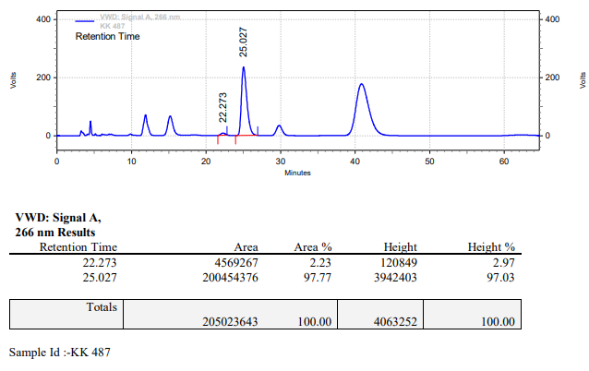

**KK-488**



**Calculation table:**

|  |  |  |  |  |  |
| --- | --- | --- | --- | --- | --- |
| Sr. No | Comp. | Mol. wt. | mmol | Eq. wt. | Wt. taken |
| 1 | Dehydrositagliptin (1) | 405.30 | 0.2135 | 100 | 86 mg |
| 2 | Rh(COD)2OTf | 468.30 | 0.0021 | 1 | 1 mg |
| 3 | L12 | 526.51 | 0.0042 | 2 | 2.2 mg |
| 4 | Salicylic acid | 138.12 | 0.1050 | 50 | 15 mg |

**Procedure:** A glass vial (4 mL) equipped with Teflon coated magnetic needle was cooled under vacuum and transferred to a glove box. The vial was then charged with 86 mg of enamine (**1**), 1 mg of [Rh(COD)2OTf] (1 mol%), ligand (L12) and salicylic acid. Reaction vial was then closed using screwcap, transferred to a large opening Schlenk type container and was then taken out from the glove box. 2 mL dry methanol was added to the vial in inert atmosphere and the resultant reaction slurry was stirred for 1 hour at room temperature (25°C). After that the reaction vial was shifted to an autoclave and the autoclave was purged three times using hydrogen gas (40 bars). Finally, the autoclave was pressurized to 30 bar hydrogen pressure at 60°C for 24 hrs time period. After the 24 hrs time period, the autoclave was cooled to room temperature (25°C), excess pressure was released and the autoclave was opened. The vials were taken out from the autoclave. The thus obtained reaction mixture was passed through neutral alumina bed, the filtrate was collect and dried to yield residue. The resultant residue was then analysed by HPLC.

**Reaction conditions:** Temp: 60°C Press.: 30 bar Solvent: Methanol Time: 24 hrs

**Result: 83%** conversion **94%** ee

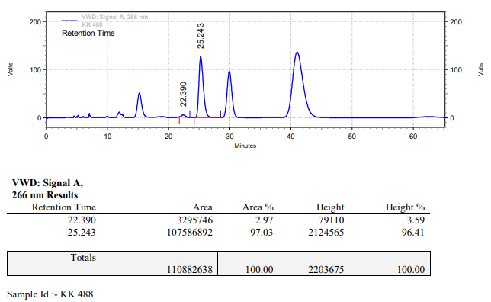

**KK-489**



**Calculation table:**

|  |  |  |  |  |  |
| --- | --- | --- | --- | --- | --- |
| Sr. No | Comp. | Mol. wt. | mmol | Eq. wt. | Wt. taken |
| 1 | Dehydrositagliptin (1) | 405.30 | 0.2135 | 100 | 86 mg |
| 2 | Rh(COD)2OTf | 468.30 | 0.0021 | 1 | 1 mg |
| 3 | L12 | 526.51 | 0.0042 | 2 | 2.2 mg |
| 4 | Salicylic acid | 138.12 | 0.2135 | 100 | 29 mg |

**Procedure:** A glass vial (4 mL) equipped with Teflon coated magnetic needle was cooled under vacuum and transferred to a glove box. The vial was then charged with 86 mg of enamine (**1**), 1 mg of [Rh(COD)2OTf] (1 mol%), ligand (L12) and salicylic acid. Reaction vial was then closed using screwcap, transferred to a large opening Schlenk type container and was then taken out from the glove box. 2 mL dry methanol was added to the vial in inert atmosphere and the resultant reaction slurry was stirred for 1 hour at room temperature (25°C). After that the reaction vial was shifted to an autoclave and the autoclave was purged three times using hydrogen gas (40 bars). Finally, the autoclave was pressurized to 30 bar hydrogen pressure at 60°C for 18 hrs time period. After the 18 hrs time period, the autoclave was cooled to room temperature (25°C), excess pressure was released and the autoclave was opened. The vials were taken out from the autoclave. The thus obtained reaction mixture was passed through neutral alumina bed, the filtrate was collect and dried to yield residue. The resultant residue was then analysed by HPLC.

**Reaction conditions:** Temp: 60°C Press.: 30 bar Solvent: Methanol Time: 18 hrs

**Result: 98%** conversion **91%** ee

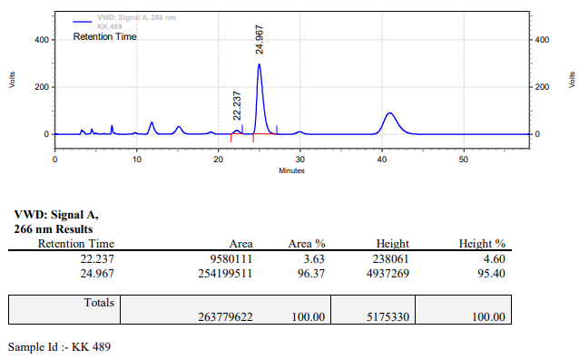

**KK-490**



**Calculation table:**

|  |  |  |  |  |  |
| --- | --- | --- | --- | --- | --- |
| Sr. No | Comp. | Mol. wt. | mmol | Eq. wt. | Wt. taken |
| 1 | Dehydrositagliptin (1) | 405.30 | 0.2135 | 100 | 86 mg |
| 2 | Rh(COD)2OTf | 468.30 | 0.0021 | 1 | 1 mg |
| 3 | L12 | 526.51 | 0.0042 | 2 | 2.2 mg |
| 4 | Salicylic acid | 138.12 | 0.2135 | 100 | 29 mg |

**Procedure:** A glass vial (4 mL) equipped with Teflon coated magnetic needle was cooled under vacuum and transferred to a glove box. The vial was then charged with 86 mg of enamine (**1**), 1 mg of [Rh(COD)2OTf] (1 mol%), ligand (L12) and salicylic acid. Reaction vial was then closed using screwcap, transferred to a large opening Schlenk type container and was then taken out from the glove box. 2 mL dry methanol was added to the vial in inert atmosphere and the resultant reaction slurry was stirred for 1 hour at room temperature (25°C). After that the reaction vial was shifted to an autoclave and the autoclave was purged three times using hydrogen gas (40 bars). Finally, the autoclave was pressurized to 30 bar hydrogen pressure at 50°C for 18 hrs time period. After the 18 hrs time period, the autoclave was cooled to room temperature (25°C), excess pressure was released and the autoclave was opened. The vials were taken out from the autoclave. The thus obtained reaction mixture was passed through neutral alumina bed, the filtrate was collect and dried to yield residue. The resultant residue was then analysed by TLC, only starting was present.

**Reaction conditions:** Temp: 50°C Press.: 30 bar Solvent: Methanol Time: 18 hrs

**Result: 00%** conversion **00%** ee

**KK-491**



**Calculation table:**

|  |  |  |  |  |  |
| --- | --- | --- | --- | --- | --- |
| Sr. No | Comp. | Mol. wt. | mmol | Eq. wt. | Wt. taken |
| 1 | Dehydrositagliptin (1) | 405.30 | 0.2135 | 100 | 86 mg |
| 2 | Rh(COD)2OTf | 468.30 | 0.0021 | 1 | 1 mg |
| 3 | L12 | 526.51 | 0.0042 | 2 | 2.2 mg |
| 4 | Salicylic acid | 138.12 | 0.2135 | 100 | 29 mg |

**Procedure:** A glass vial (4 mL) equipped with Teflon coated magnetic needle was cooled under vacuum and transferred to a glove box. The vial was then charged with 86 mg of enamine (**1**), 1 mg of [Rh(COD)2OTf] (1 mol%), ligand (L12) and salicylic acid. Reaction vial was then closed using screwcap, transferred to a large opening Schlenk type container and was then taken out from the glove box. 2 mL dry methanol was added to the vial in inert atmosphere and the resultant reaction slurry was stirred for 1 hour at room temperature (25°C). After that the reaction vial was shifted to an autoclave and the autoclave was purged three times using hydrogen gas (40 bars). Finally, the autoclave was pressurized to 30 bar hydrogen pressure at 50°C for 18 hrs time period. After the 18 hrs time period, the autoclave was cooled to room temperature (25°C), excess pressure was released and the autoclave was opened. The vials were taken out from the autoclave. The thus obtained reaction mixture was passed through neutral alumina bed, the filtrate was collect and dried to yield residue. The resultant residue was then analysed by TLC, only starting was present.

**Reaction conditions:** Temp: 50°C Press.: 30 bar Solvent: Methanol Time: 18 hrs

**Result: 00%** conversion **00%** ee

**KK-492**



**Calculation table:**

|  |  |  |  |  |  |
| --- | --- | --- | --- | --- | --- |
| Sr. No | Comp. | Mol. wt. | mmol | Eq. wt. | Wt. taken |
| 1 | Dehydrositagliptin (1) | 405.30 | 0.2135 | 100 | 86 mg |
| 2 | Rh(COD)2OTf | 468.30 | 0.0021 | 1 | 1 mg |
| 3 | L12 | 526.51 | 0.0042 | 2 | 2.2 mg |
| 4 | Salicylic acid | 138.12 | 0.2135 | 100 | 29 mg |

**Procedure:** A glass vial (4 mL) equipped with Teflon coated magnetic needle was cooled under vacuum and transferred to a glove box. The vial was then charged with 86 mg of enamine (**1**), 1 mg of [Rh(COD)2OTf] (1 mol%), ligand (L12) and salicylic acid. Reaction vial was then closed using screwcap, transferred to a large opening Schlenk type container and was then taken out from the glove box. 2 mL dry methanol was added to the vial in inert atmosphere and the resultant reaction slurry was stirred for 1 hour at room temperature (25°C). After that the reaction vial was shifted to an autoclave and the autoclave was purged three times using hydrogen gas (40 bars). Finally, the autoclave was pressurized to 30 bar hydrogen pressure at 45°C for 18 hrs time period. After the 18 hrs time period, the autoclave was cooled to room temperature (25°C), excess pressure was released and the autoclave was opened. The vials were taken out from the autoclave. The thus obtained reaction mixture was passed through neutral alumina bed, the filtrate was collect and dried to yield residue. The resultant residue was then analysed by TLC, only starting was present.

**Reaction conditions:** Temp: 45°C Press.: 30 bar Solvent: Methanol Time: 18 hrs

**Result: 00%** conversion **00%** ee

**KK-493**



**Calculation table:**

|  |  |  |  |  |  |
| --- | --- | --- | --- | --- | --- |
| Sr. No | Comp. | Mol. wt. | mmol | Eq. wt. | Wt. taken |
| 1 | Dehydrositagliptin (1) | 405.30 | 0.2135 | 100 | 86 mg |
| 2 | Rh(COD)2OTf | 468.30 | 0.0021 | 1 | 1 mg |
| 3 | L12 | 526.51 | 0.0042 | 2 | 2.2 mg |
| 4 | Salicylic acid | 138.12 | 0.2135 | 100 | 29 mg |

**Procedure:** A glass vial (4 mL) equipped with Teflon coated magnetic needle was cooled under vacuum and transferred to a glove box. The vial was then charged with 86 mg of enamine (**1**), 1 mg of [Rh(COD)2OTf] (1 mol%), ligand (L12) and salicylic acid. Reaction vial was then closed using screwcap, transferred to a large opening Schlenk type container and was then taken out from the glove box. 2 mL dry methanol was added to the vial in inert atmosphere and the resultant reaction slurry was stirred for 1 hour at room temperature (25°C). After that the reaction vial was shifted to an autoclave and the autoclave was purged three times using hydrogen gas (40 bars). Finally, the autoclave was pressurized to 30 bar hydrogen pressure at 45°C for 18 hrs time period. After the 18 hrs time period, the autoclave was cooled to room temperature (25°C), excess pressure was released and the autoclave was opened. The vials were taken out from the autoclave. The thus obtained reaction mixture was passed through neutral alumina bed, the filtrate was collect and dried to yield residue. The resultant residue was then analysed by TLC, only starting was present.

**Reaction conditions:** Temp: 45°C Press.: 30 bar Solvent: Methanol Time: 18 hrs

**Result: 00%** conversion **00%** ee

**KK-494**



**Calculation table:**

|  |  |  |  |  |  |
| --- | --- | --- | --- | --- | --- |
| Sr. No | Comp. | Mol. wt. | mmol | Eq. wt. | Wt. taken |
| 1 | Dehydrositagliptin (1) | 405.30 | 0.0740 | 1 eq | 30 mg |
| 2 | Rh(COD)2OTf | 468.30 | 0.0037 | 5 mol% | 1.8 mg |
| 3 | L12 | 526.51 | 0.0074 | 10 mol% | 3.9 mg |
| 4 | Salicylic acid | 138.12 | 0.0740 | 1 eq | 10 mg |

**Procedure:** A glass vial (4 mL) equipped with Teflon coated magnetic needle was cooled under vacuum and transferred to a glove box. The vial was then charged with 30 mg of enamine (**1**), 1.8 mg of [Rh(COD)2OTf] (1 mol%), ligand (L12) and salicylic acid. Reaction vial was then closed using screwcap, transferred to a large opening Schlenk type container and was then taken out from the glove box. 1 mL dry methanol was added to the vial in inert atmosphere and the resultant reaction slurry was stirred for 1 hour at room temperature (25°C). After that the reaction vial was shifted to an autoclave and the autoclave was purged three times using hydrogen gas (40 bars). Finally, the autoclave was pressurized to 30 bar hydrogen pressure at 50°C for 18 hrs time period. After the 18 hrs time period, the autoclave was cooled to room temperature (25°C), excess pressure was released and the autoclave was opened. The vials were taken out from the autoclave. The thus obtained reaction mixture was passed through neutral alumina bed, the filtrate was collect and dried to yield residue. The resultant residue was then analysed by HPLC.

**Reaction conditions:** Temp: 50°C Press.: 30 bar Solvent: Methanol Time: 18 hrs

**Result: 99%** conversion **95%** ee

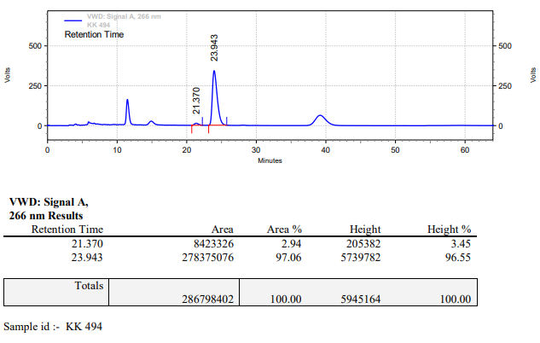

**KK-495**



**Calculation table:**

|  |  |  |  |  |  |
| --- | --- | --- | --- | --- | --- |
| Sr. No | Comp. | Mol. wt. | mmol | Eq. wt. | Wt. taken |
| 1 | Dehydrositagliptin (1) | 405.30 | 0.2135 | 100 | 86 mg |
| 2 | Rh(COD)2OTf | 468.30 | 0.0021 | 1 | 1 mg |
| 3 | L12 | 526.51 | 0.0042 | 2 | 2.2 mg |
| 4 | Salicylic acid | 138.12 | 0.2135 | 100 | 29 mg |

**Procedure:** A glass vial (4 mL) equipped with Teflon coated magnetic needle was cooled under vacuum and transferred to a glove box. The vial was then charged with 86 mg of enamine (**1**), 1 mg of [Rh(COD)2OTf] (1 mol%), ligand (L12) and salicylic acid. Reaction vial was then closed using screwcap, transferred to a large opening Schlenk type container and was then taken out from the glove box. 2 mL dry methanol was added to the vial in inert atmosphere and the resultant reaction slurry was stirred for 1 hour at room temperature (25°C). After that the reaction vial was shifted to an autoclave and the autoclave was purged three times using hydrogen gas (40 bars). Finally, the autoclave was pressurized to 30 bar hydrogen pressure at 50°C for 18 hrs time period. After the 18 hrs time period, the autoclave was cooled to room temperature (25°C), excess pressure was released and the autoclave was opened. The vials were taken out from the autoclave. The thus obtained reaction mixture was passed through neutral alumina bed, the filtrate was collect and dried to yield residue. The resultant residue was then analysed by HPLC.

**Reaction conditions:** Temp: 50°C Press.: 30 bar Solvent: Methanol Time: 18 hrs

**Result: 90%** conversion **94%** ee

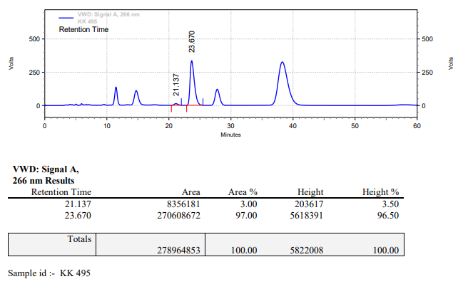

**KK-496**



**Calculation table:**

|  |  |  |  |  |  |
| --- | --- | --- | --- | --- | --- |
| Sr. No | Comp. | Mol. wt. | mmol | Eq. wt. | Wt. taken |
| 1 | Dehydrositagliptin (1) | 405.30 | 0.2135 | 100 | 86 mg |
| 2 | Rh(COD)2OTf | 468.30 | 0.0021 | 1 | 1 mg |
| 3 | L12 | 526.51 | 0.0042 | 2 | 2.2 mg |
| 4 | Salicylic acid | 138.12 | 0.2135 | 100 | 29 mg |

**Procedure:** A glass vial (4 mL) equipped with Teflon coated magnetic needle was cooled under vacuum and transferred to a glove box. The vial was then charged with 86 mg of enamine (**1**), 1 mg of [Rh(COD)2OTf], ligand (L12) and salicylic acid. Reaction vial was then closed using screwcap, transferred to a large opening Schlenk type container and was then taken out from the glove box. 2 mL dry methanol was added to the vial in inert atmosphere and the resultant reaction slurry was stirred for 1 hour at room temperature (25°C). After that the reaction vial was shifted to an autoclave and the autoclave was purged three times using hydrogen gas (40 bars). Finally, the autoclave was pressurized to 30 bar hydrogen pressure at 50°C for 18 hrs time period. After the 18 hrs time period, the autoclave was cooled to room temperature (25°C), excess pressure was released and the autoclave was opened. The vials were taken out from the autoclave. The thus obtained reaction mixture was passed through neutral alumina bed, the filtrate was collect and dried to yield residue. The resultant residue was then analysed by HPLC.

**Reaction conditions:** Temp: 50°C Press.: 30 bar Solvent: Methanol Time: 18 hrs

**Result: 95%** conversion **94%** ee

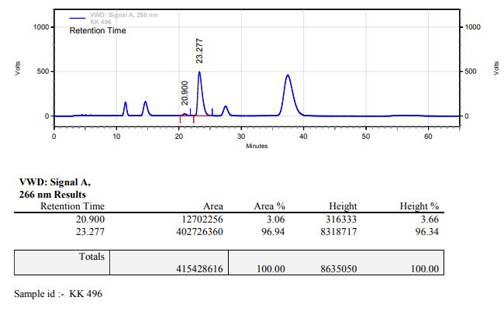

**KK-497**



**Calculation table:**

|  |  |  |  |  |  |
| --- | --- | --- | --- | --- | --- |
| Sr. No | Comp. | Mol. wt. | mmol | Eq. wt. | Wt. taken |
| 1 | Dehydrositagliptin (1) | 405.30 | 0.0740 | 1 eq | 30 mg |
| 2 | Rh(COD)2OTf | 468.30 | 0.0037 | 5 mol% | 1.8 mg |
| 3 | L12 | 526.51 | 0.0074 | 10 mol% | 3.9 mg |
| 4 | Salicylic acid | 138.12 | 0.0740 | 1 eq | 10 mg |

**Procedure:** A glass vial (4 mL) equipped with Teflon coated magnetic needle was cooled under vacuum and transferred to a glove box. The vial was then charged with 30 mg of enamine (**1**), 1.8 mg of [Rh(COD)2OTf], ligand (L12) and salicylic acid. Reaction vial was then closed using screwcap, transferred to a large opening Schlenk type container and was then taken out from the glove box. 1 mL dry methanol was added to the vial in inert atmosphere and the resultant reaction slurry was stirred for 1 hour at room temperature (25°C). After that the reaction vial was shifted to an autoclave and the autoclave was purged three times using hydrogen gas (40 bars). Finally, the autoclave was pressurized to 30 bar hydrogen pressure at 50°C for 6 hrs time period. After the 6 hrs time period, the autoclave was cooled to room temperature (25°C), excess pressure was released and the autoclave was opened. The vials were taken out from the autoclave. The thus obtained reaction mixture was passed through neutral alumina bed, the filtrate was collect and dried to yield residue. The resultant residue was then analysed by HPLC.

**Reaction conditions:** Temp: 50°C Press.: 30 bar Solvent: Methanol Time: 6 hrs

**Result: 96%** conversion **93%** ee

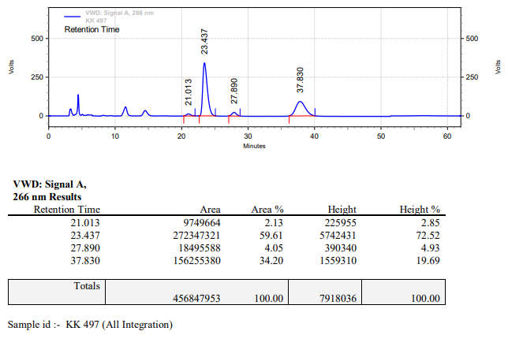

**KK-498**



**Calculation table:**

|  |  |  |  |  |  |
| --- | --- | --- | --- | --- | --- |
| Sr. No | Comp. | Mol. wt. | mmol | Eq. wt. | Wt. taken |
| 1 | Dehydrositagliptin (1) | 405.30 | 0.0740 | 1 eq | 30 mg |
| 2 | Rh(COD)2OTf | 468.30 | 0.0037 | 5 mol% | 1.8 mg |
| 3 | L12 | 526.51 | 0.0074 | 10 mol% | 3.9 mg |
| 4 | Salicylic acid | 138.12 | 0.0740 | 1 eq | 10 mg |

**Procedure:** A glass vial (4 mL) equipped with Teflon coated magnetic needle was cooled under vacuum and transferred to a glove box. The vial was then charged with 30 mg of enamine (**1**), 1.8 mg of [Rh(COD)2OTf], ligand (L12) and salicylic acid. Reaction vial was then closed using screwcap, transferred to a large opening Schlenk type container and was then taken out from the glove box. 1 mL dry methanol was added to the vial in inert atmosphere and the resultant reaction slurry was stirred for 1 hour at room temperature (25°C). After that the reaction vial was shifted to an autoclave and the autoclave was purged three times using hydrogen gas (40 bars). Finally, the autoclave was pressurized to 30 bar hydrogen pressure at 50°C for 6 hrs time period. After the 6 hrs time period, the autoclave was cooled to room temperature (25°C), excess pressure was released and the autoclave was opened. The vials were taken out from the autoclave. The thus obtained reaction mixture was passed through neutral alumina bed, the filtrate was collect and dried to yield residue. The resultant residue was then analysed by HPLC.

**Reaction conditions:** Temp: 50°C Press.: 30 bar Solvent: Methanol Time: 6 hrs

**Result: 65%** conversion **93%** ee

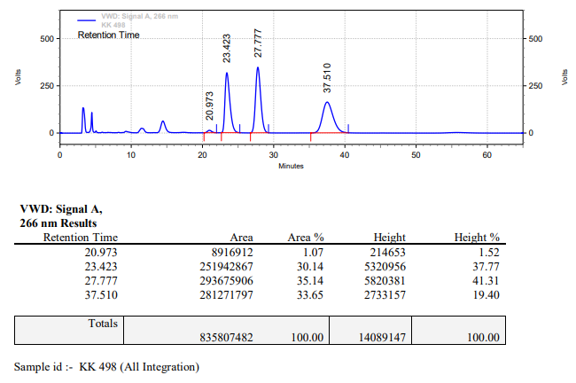

**KK-499**



**Calculation table:**

|  |  |  |  |  |  |
| --- | --- | --- | --- | --- | --- |
| Sr. No | Comp. | Mol. wt. | mmol | Eq. wt. | Wt. taken |
| 1 | Dehydrositagliptin (1) | 405.30 | 0.0740 | 1 eq | 30 mg |
| 2 | Rh(COD)2OTf | 468.30 | 0.0037 | 5 mol% | 1.8 mg |
| 3 | L12 | 526.51 | 0.0074 | 10 mol% | 3.9 mg |
| 4 | Salicylic acid | 138.12 | 0.0740 | 0.5 eq | 5 mg |

**Procedure:** A glass vial (4 mL) equipped with Teflon coated magnetic needle was cooled under vacuum and transferred to a glove box. The vial was then charged with 30 mg of enamine (**1**), 1.8 mg of [Rh(COD)2OTf], ligand (L12) and salicylic acid. Reaction vial was then closed using screwcap, transferred to a large opening Schlenk type container and was then taken out from the glove box. 1 mL dry methanol was added to the vial in inert atmosphere and the resultant reaction slurry was stirred for 1 hour at room temperature (25°C). After that the reaction vial was shifted to an autoclave and the autoclave was purged three times using hydrogen gas (40 bars). Finally, the autoclave was pressurized to 30 bar hydrogen pressure at 50°C for 6 hrs time period. After the 6 hrs time period, the autoclave was cooled to room temperature (25°C), excess pressure was released and the autoclave was opened. The vials were taken out from the autoclave. The thus obtained reaction mixture was passed through neutral alumina bed, the filtrate was collect and dried to yield residue. The resultant residue was then analysed by HPLC.

**Reaction conditions:** Temp: 50°C Press.: 30 bar Solvent: Methanol Time: 6 hrs

**Result: 60%** conversion **94%** ee

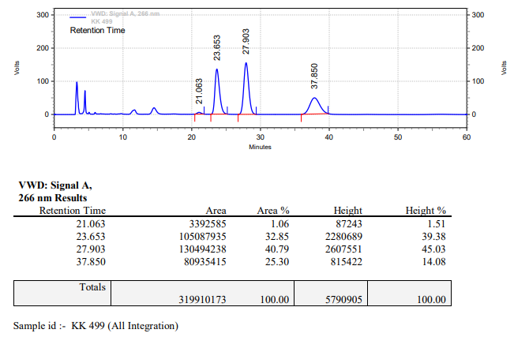

**KK-500**



**Calculation table:**

|  |  |  |  |  |  |
| --- | --- | --- | --- | --- | --- |
| Sr. No | Comp. | Mol. wt. | mmol | Eq. wt. | Wt. taken |
| 1 | Dehydrositagliptin (1) | 405.30 | 0.0740 | 1 eq | 30 mg |
| 2 | Rh(COD)2OTf | 468.30 | 0.0037 | 5 mol% | 1.8 mg |
| 3 | L12 | 526.51 | 0.0074 | 10 mol% | 3.9 mg |
| 4 | Salicylic acid | 138.12 | 0.0740 | 0.5 eq | 5 mg |

**Procedure:** A glass vial (4 mL) equipped with Teflon coated magnetic needle was cooled under vacuum and transferred to a glove box. The vial was then charged with 30 mg of enamine (**1**), 1.8 mg of [Rh(COD)2OTf], ligand (L12) and salicylic acid. Reaction vial was then closed using screwcap, transferred to a large opening Schlenk type container and was then taken out from the glove box. 1 mL dry methanol was added to the vial in inert atmosphere and the resultant reaction slurry was stirred for 1 hour at room temperature (25°C). After that the reaction vial was shifted to an autoclave and the autoclave was purged three times using hydrogen gas (40 bars). Finally, the autoclave was pressurized to 30 bar hydrogen pressure at 50°C for 6 hrs time period. After the 6 hrs time period, the autoclave was cooled to room temperature (25°C), excess pressure was released and the autoclave was opened. The vials were taken out from the autoclave. The thus obtained reaction mixture was passed through neutral alumina bed, the filtrate was collect and dried to yield residue. The resultant residue was then analysed by HPLC.

**Reaction conditions:** Temp: 50°C Press.: 30 bar Solvent: Methanol Time: 6 hrs

**Result: 68%** conversion **92%** ee

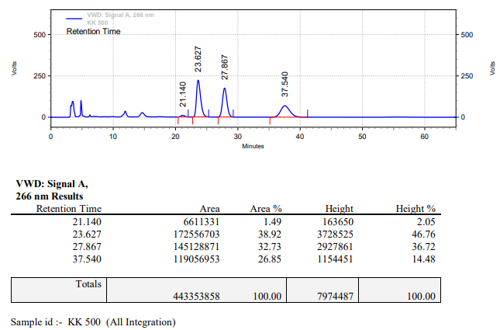

**KK-501**



**Calculation table:**

|  |  |  |  |  |  |
| --- | --- | --- | --- | --- | --- |
| Sr. No | Comp. | Mol. wt. | mmol | Eq. wt. | Wt. taken |
| 1 | Dehydrositagliptin (1) | 405.30 | 0.0740 | 1 eq | 30 mg |
| 2 | Rh(COD)2OTf | 468.30 | 0.0037 | 5 mol% | 1.8 mg |
| 3 | L12 | 526.51 | 0.0074 | 10 mol% | 3.9 mg |
| 4 | Salicylic acid | 138.12 | 0.0740 | 1 eq | 10 mg |

**Procedure:** A glass vial (4 mL) equipped with Teflon coated magnetic needle was cooled under vacuum and transferred to a glove box. The vial was then charged with 30 mg of enamine (**1**), 1.8 mg of [Rh(COD)2OTf], ligand (L12) and salicylic acid. Reaction vial was then closed using screwcap, transferred to a large opening Schlenk type container and was then taken out from the glove box. 1 mL dry methanol was added to the vial in inert atmosphere and the resultant reaction slurry was stirred for 1 hour at room temperature (25°C). After that the reaction vial was shifted to an autoclave and the autoclave was purged three times using hydrogen gas (40 bars). Finally, the autoclave was pressurized to 30 bar hydrogen pressure at 50°C for 3 hrs time period. After the 3 hrs time period, the autoclave was cooled to room temperature (25°C), excess pressure was released and the autoclave was opened. The vials were taken out from the autoclave. The thus obtained reaction mixture was passed through neutral alumina bed, the filtrate was collect and dried to yield residue. The resultant residue was then analysed by HPLC.

**Reaction conditions:** Temp: 50°C Press.: 30 bar Solvent: Methanol Time: 3 hrs

**Result: 70%** conversion **94%** ee

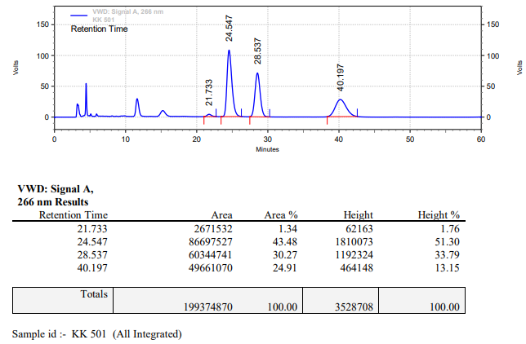

**KK-502**



**Calculation table:**

|  |  |  |  |  |  |
| --- | --- | --- | --- | --- | --- |
| Sr. No | Comp. | Mol. wt. | mmol | Eq. wt. | Wt. taken |
| 1 | Dehydrositagliptin (1) | 405.30 | 0.0740 | 1 eq | 30 mg |
| 2 | Rh(COD)2OTf | 468.30 | 0.0037 | 5 mol% | 1.8 mg |
| 3 | L12 | 526.51 | 0.0074 | 10 mol% | 3.9 mg |
| 4 | Salicylic acid | 138.12 | 0.113 | 150 mol% | 15 mg |

**Procedure:** A glass vial (4 mL) equipped with Teflon coated magnetic needle was cooled under vacuum and transferred to a glove box. The vial was then charged with 30 mg of enamine (**1**), 1.8 mg of [Rh(COD)2OTf], ligand (L12) and salicylic acid. Reaction vial was then closed using screwcap, transferred to a large opening Schlenk type container and was then taken out from the glove box. 1 mL dry methanol was added to the vial in inert atmosphere and the resultant reaction slurry was stirred for 1 hour at room temperature (25°C). After that the reaction vial was shifted to an autoclave and the autoclave was purged three times using hydrogen gas (40 bars). Finally, the autoclave was pressurized to 30 bar hydrogen pressure at 50°C for 3 hrs time period. After the 3 hrs time period, the autoclave was cooled to room temperature (25°C), excess pressure was released and the autoclave was opened. The vials were taken out from the autoclave. The thus obtained reaction mixture was passed through neutral alumina bed, the filtrate was collect and dried to yield residue. The resultant residue was then analysed by HPLC.

**Reaction conditions:** Temp: 50°C Press.: 30 bar Solvent: Methanol Time: 3 hrs

**Result: 80%** conversion **94%** ee

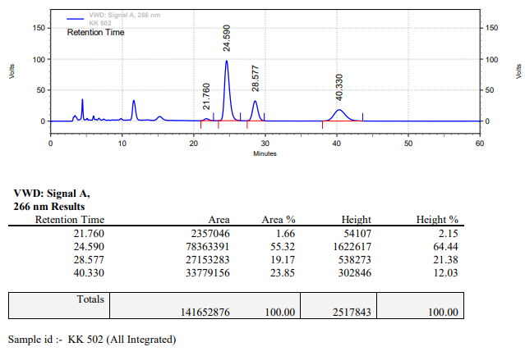

**KK-503**



**Calculation table:**

|  |  |  |  |  |  |
| --- | --- | --- | --- | --- | --- |
| Sr. No | Comp. | Mol. wt. | mmol | Eq. wt. | Wt. taken |
| 1 | Dehydrositagliptin (1) | 405.30 | 0.0740 | 1 eq | 30 mg |
| 2 | Rh(COD)2OTf | 468.30 | 0.0037 | 5 mol% | 1.8 mg |
| 3 | L12 | 526.51 | 0.0074 | 10 mol% | 3.9 mg |
| 4 | Salicylic acid | 138.12 | 0.1484 | 200 mol% | 20 mg |

**Procedure:** A glass vial (4 mL) equipped with Teflon coated magnetic needle was cooled under vacuum and transferred to a glove box. The vial was then charged with 30 mg of enamine (**1**), 1.8 mg of [Rh(COD)2OTf], ligand (L12) and salicylic acid. Reaction vial was then closed using screwcap, transferred to a large opening Schlenk type container and was then taken out from the glove box. 1 mL dry methanol was added to the vial in inert atmosphere and the resultant reaction slurry was stirred for 1 hour at room temperature (25°C). After that the reaction vial was shifted to an autoclave and the autoclave was purged three times using hydrogen gas (40 bars). Finally, the autoclave was pressurized to 30 bar hydrogen pressure at 50°C for 3 hrs time period. After the 3 hrs time period, the autoclave was cooled to room temperature (25°C), excess pressure was released and the autoclave was opened. The vials were taken out from the autoclave. The thus obtained reaction mixture was passed through neutral alumina bed, the filtrate was collect and dried to yield residue. The resultant residue was then analysed by HPLC.

**Reaction conditions:** Temp: 50°C Press.: 30 bar Solvent: Methanol Time: 3 hrs

**Result: 87%** conversion **94%** ee

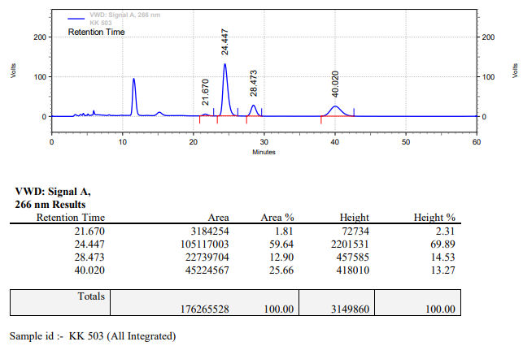

**KK-504**



**Calculation table:**

|  |  |  |  |  |  |
| --- | --- | --- | --- | --- | --- |
| Sr. No | Comp. | Mol. wt. | mmol | Eq. wt. | Wt. taken |
| 1 | Dehydrositagliptin (1) | 405.30 | 0.2052 | 1 eq | 83 mg |
| 2 | Rh(COD)2OTf | 468.30 | 0.0102 | 5 mol% | 4.9 mg |
| 3 | L12 | 526.51 | 0.0205 | 10 mol% | 10.8 mg |
| 4 | Salicylic acid | 138.12 | 0.3079 | 150 mol% | 43 mg |

**Procedure:** A glass vial (4 mL) equipped with Teflon coated magnetic needle was cooled under vacuum and transferred to a glove box. The vial was then charged with 30 mg of enamine (**1**), 4.9 mg of [Rh(COD)2OTf], ligand (L12) and salicylic acid. Reaction vial was then closed using screwcap, transferred to a large opening Schlenk type container and was then taken out from the glove box. 2 mL dry methanol was added to the vial in inert atmosphere and the resultant reaction slurry was stirred for 1 hour at room temperature (25°C). After that the reaction vial was shifted to an autoclave and the autoclave was purged three times using hydrogen gas (40 bars). Finally, the autoclave was pressurized to 30 bar hydrogen pressure at 50°C for 3 hrs time period. After the 3 hrs time period, the autoclave was cooled to room temperature (25°C), excess pressure was released and the autoclave was opened. The vials were taken out from the autoclave. The thus obtained reaction mixture was passed through neutral alumina bed, the filtrate was collect and dried to yield residue. The resultant residue was then analysed by HPLC.

**Reaction conditions:** Temp: 50°C Press.: 30 bar Solvent: Methanol Time: 3 hrs

**Result: 75%** conversion **95%** ee

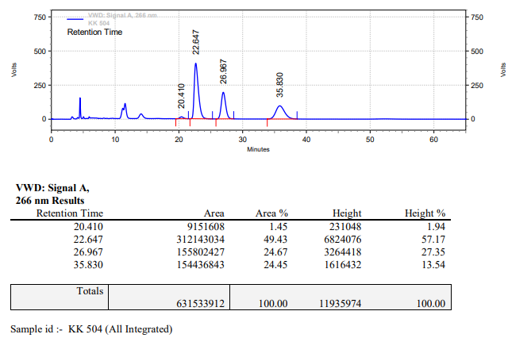

**KK-505**



**Calculation table:**

|  |  |  |  |  |  |
| --- | --- | --- | --- | --- | --- |
| Sr. No | Comp. | Mol. wt. | mmol | Eq. wt. | Wt. taken |
| 1 | Dehydrositagliptin (1) | 405.30 | 0.2052 | 1 eq | 83 mg |
| 2 | Rh(COD)2OTf | 468.30 | 0.0102 | 5 mol% | 4.9 mg |
| 3 | L12 | 526.51 | 0.0205 | 10 mol% | 10.8 mg |
| 4 | Salicylic acid | 138.12 | 0.3079 | 150 mol% | 43 mg |

**Procedure:** A glass vial (4 mL) equipped with Teflon coated magnetic needle was cooled under vacuum and transferred to a glove box. The vial was then charged with 30 mg of enamine (**1**), 4.9 mg of [Rh(COD)2OTf], ligand (L12) and salicylic acid. Reaction vial was then closed using screwcap, transferred to a large opening Schlenk type container and was then taken out from the glove box. 2 mL dry methanol was added to the vial in inert atmosphere and the resultant reaction slurry was stirred for 1 hour at room temperature (25°C). After that the reaction vial was shifted to an autoclave and the autoclave was purged three times using hydrogen gas (40 bars). Finally, the autoclave was pressurized to 30 bar hydrogen pressure at 50°C for 4 hrs time period. After the 4 hrs time period, the autoclave was cooled to room temperature (25°C), excess pressure was released and the autoclave was opened. The vials were taken out from the autoclave. The thus obtained reaction mixture was passed through neutral alumina bed, the filtrate was collect and dried to yield residue. The resultant residue was then analysed by HPLC.

**Reaction conditions:** Temp: 50°C Press.: 30 bar Solvent: Methanol Time: 4 hrs

**Result: 99%** conversion **94%** ee

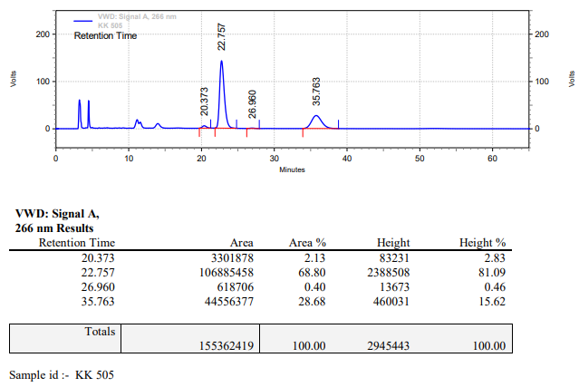

**KK-506**



**Calculation table:**

|  |  |  |  |  |  |
| --- | --- | --- | --- | --- | --- |
| Sr. No | Comp. | Mol. wt. | mmol | Eq. wt. | Wt. taken |
| 1 | Dehydrositagliptin (1) | 405.30 | 2.4734 | 100 | 1000 mg |
| 2 | Rh(COD)2OTf | 468.30 | 0.0247 | 1 | 12 mg |
| 3 | L12 | 526.51 | 0.0494 | 2 | 26 mg |
| 4 | Salicylic acid | 138.12 | 3.7101 | 150 | 512 mg |

**Procedure:** A high pressure Parr reactor (100 mL) equipped with Teflon coated magnetic needle was charged with 1 g of enamine (**1**), under argon atmosphere. Subsequently, 12 mg of [Rh(COD)2OTf] (1 mol%), 26 mg of ligand **L12** and salicylic acid was added to the above reactor. 20 mL dry methanol was added to the reactor in inert atmosphere and the resultant reaction slurry was stirred for 1 hour at room temperature (25 °C). After that the autoclave was purged three times using hydrogen gas (40 bars). Finally, the autoclave was pressurized to 30 bar hydrogen pressure at 50°C for 3 hrs time period. After the 3 hrs time period, the autoclave was cooled to room temperature (25 °C), excess pressure was released and the autoclave was opened. The thus obtained reaction mixture was passed through neutral alumina bed, the filtrate was collect and dried to yield residue. The resultant residue was then analysed by HPLC.

**Reaction conditions:** Temp: 50°C Press.: 30 bar Solvent: methanol Time: 3 hrs

**Result: 03%** conversion **92%** ee

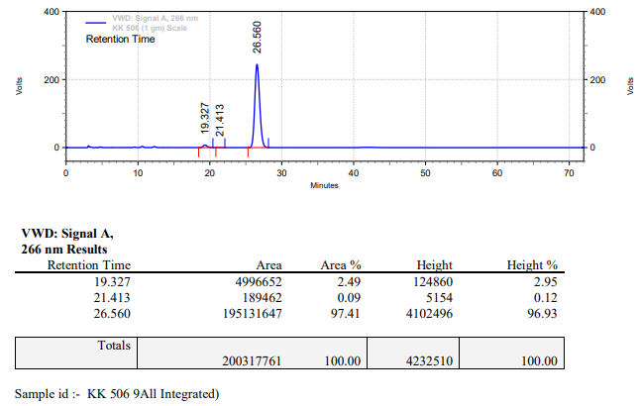

**KK-507**



**Calculation table:**

|  |  |  |  |  |  |
| --- | --- | --- | --- | --- | --- |
| Sr. No | Comp. | Mol. wt. | mmol | Eq. wt. | Wt. taken |
| 1 | Dehydrositagliptin (1) | 405.30 | 2.4734 | 100 | 1000 mg |
| 2 | Rh(COD)2OTf | 468.30 | 0.0247 | 1 | 12 mg |
| 3 | L12 | 526.51 | 0.0296 | 1.2 | 16 mg |
| 4 | Salicylic acid | 138.12 | 2.4734 | 100 | 340 mg |

**Procedure:** A high pressure Parr reactor (100 mL) equipped with Teflon coated magnetic needle was charged with 1 g of enamine (**1**), under argon atmosphere. Subsequently, 12 mg of [Rh(COD)2OTf] (1 mol%), 16 mg of ligand **L12** and salicylic acid was added to the above reactor. 20 mL dry methanol was added to the reactor in inert atmosphere and the resultant reaction slurry was stirred for 1 hour at room temperature (25 °C). After that the autoclave was purged three times using hydrogen gas (40 bars). Finally, the autoclave was pressurized to 30 bar hydrogen pressure at 50°C for 18 hrs time period. After the 18 hrs time period, the autoclave was cooled to room temperature (25 °C), excess pressure was released and the autoclave was opened. The thus obtained reaction mixture was passed through neutral alumina bed, the filtrate was collect and dried to yield residue. The resultant residue was then analysed by HPLC.

**Reaction conditions:** Temp: 50°C Press.: 30 bar Solvent: methanol Time: 18 hrs

**Result: 89%** conversion **94%** ee

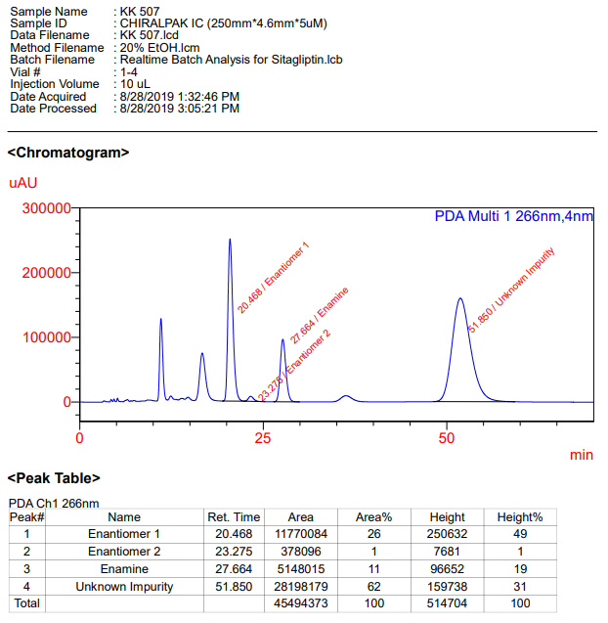

**KK-508**



**Calculation table:**

|  |  |  |  |  |  |
| --- | --- | --- | --- | --- | --- |
| Sr. No | Comp. | Mol. wt. | mmol | Eq. wt. | Wt. taken |
| 1 | Dehydrositagliptin (1) | 405.30 | 2.4734 | 100 | 1000 mg |
| 2 | Rh(COD)2OTf | 468.30 | 0.0247 | 1 | 12 mg |
| 3 | L12 | 526.51 | 0.0296 | 1.2 | 16 mg |
| 4 | Salicylic acid | 138.12 | 2.4734 | 100 | 340 mg |

**Procedure:** A high pressure Parr reactor (100 mL) equipped with Teflon coated magnetic needle was charged with 1 g of enamine (**1**), under argon atmosphere. Subsequently, 12 mg of [Rh(COD)2OTf] (1 mol%), 16 mg of ligand **L12** and salicylic acid was added to the above reactor. 20 mL dry methanol was added to the reactor in inert atmosphere and the resultant reaction slurry was stirred for 1 hour at room temperature (25 °C). After that the autoclave was purged three times using hydrogen gas (40 bars). Finally, the autoclave was pressurized to 30 bar hydrogen pressure at 50°C for 18 hrs time period. After the 18 hrs time period, the autoclave was cooled to room temperature (25 °C), excess pressure was released and the autoclave was opened. The thus obtained reaction mixture was passed through neutral alumina bed, the filtrate was collect and dried to yield residue. The resultant residue was then analysed by HPLC.

**Reaction conditions:** Temp: 50°C Press.: 30 bar Solvent: methanol Time: 18 hrs

**Result: 93%** conversion **94%** ee

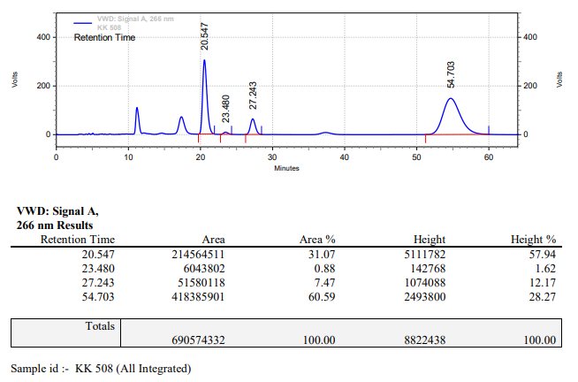

**KK-509**



**Calculation table:**

|  |  |  |  |  |  |
| --- | --- | --- | --- | --- | --- |
| Sr. No | Comp. | Mol. wt. | mmol | Eq. wt. | Wt. taken |
| 1 | Dehydrositagliptin (1) | 405.30 | 2.4734 | 1 | 1000 mg |
| 2 | Rh(COD)2OTf | 468.30 | 0.1236 | 5 mol% | 60 mg |
| 3 | L12 | 526.51 | 0.2473 | 10 mol% | 130 mg |
| 4 | Salicylic acid | 138.12 | 3.7109 | 150 mol% | 512 mg |

**Procedure:** A high pressure Parr reactor (100 mL) equipped with Teflon coated magnetic needle was charged with 1 g of enamine (**1**), under argon atmosphere. Subsequently, 60 mg of [Rh(COD)2OTf] (1 mol%), 130 mg of ligand **L12** and salicylic acid was added to the above reactor. 20 mL dry methanol was added to the reactor in inert atmosphere and the resultant reaction slurry was stirred for 1 hour at room temperature (25 °C). After that the autoclave was purged three times using hydrogen gas (40 bars). Finally, the autoclave was pressurized to 30 bar hydrogen pressure at 50°C for 4 hrs time period. After the 4 hrs time period, the autoclave was cooled to room temperature (25 °C), excess pressure was released and the autoclave was opened. The thus obtained reaction mixture was passed through neutral alumina bed, the filtrate was collect and dried to yield residue. The resultant residue was then analysed by HPLC.

**Reaction conditions:** Temp: 50°C Press.: 30 bar Solvent: methanol Time: 4 hrs

**Result: 38%** conversion **97%** ee

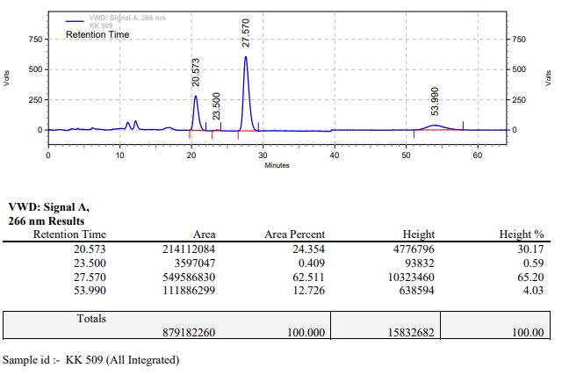

**KK-510**



**Calculation table:**

|  |  |  |  |  |  |
| --- | --- | --- | --- | --- | --- |
| Sr. No | Comp. | Mol. wt. | mmol | Eq. wt. | Wt. taken |
| 1 | Dehydrositagliptin (1) | 405.30 | 2.4734 | 1 | 1000 mg |
| 2 | Rh(COD)2OTf | 468.30 | 0.1236 | 5 mol% | 60 mg |
| 3 | L12 | 526.51 | 0.2473 | 10 mol% | 130 mg |
| 4 | Salicylic acid | 138.12 | 3.7109 | 150 mol% | 512 mg |

**Procedure:** A high pressure Parr reactor (100 mL) equipped with Teflon coated magnetic needle was charged with 1 g of enamine (**1**), under argon atmosphere. Subsequently, 60 mg of [Rh(COD)2OTf] (1 mol%), 130 mg of ligand **L12** and salicylic acid was added to the above reactor. 20 mL dry methanol was added to the reactor in inert atmosphere and the resultant reaction slurry was stirred for 1 hour at room temperature (25 °C). After that the autoclave was purged three times using hydrogen gas (40 bars). Finally, the autoclave was pressurized to 30 bar hydrogen pressure at 50°C for 4 hrs time period. After the 4 hrs time period, the autoclave was cooled to room temperature (25 °C), excess pressure was released and the autoclave was opened. The thus obtained reaction mixture was passed through neutral alumina bed, the filtrate was collect and dried to yield residue. The resultant residue was then analysed by HPLC.

**Reaction conditions:** Temp: 50°C Press.: 30 bar Solvent: methanol Time: 4 hrs

**Result: 99%** conversion **94%** ee

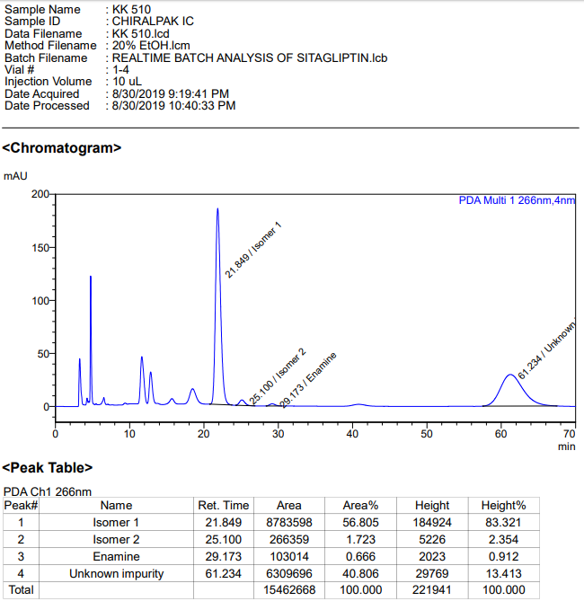

**KK-511**



**Calculation table:**

|  |  |  |  |  |  |
| --- | --- | --- | --- | --- | --- |
| Sr. No | Comp. | Mol. wt. | mmol | Eq. wt. | Wt. taken |
| 1 | Dehydrositagliptin (1) | 405.30 | 2.4734 | 1 | 1000 mg |
| 2 | Rh(COD)2OTf | 468.30 | 0.1236 | 5 mol% | 60 mg |
| 3 | L12 | 526.51 | 0.2473 | 10 mol% | 130 mg |
| 4 | Salicylic acid | 138.12 | 3.7109 | 150 mol% | 512 mg |

**Procedure:** A high pressure Parr reactor (100 mL) equipped with Teflon coated magnetic needle was charged with 1 g of enamine (**1**), under argon atmosphere. Subsequently, 60 mg of [Rh(COD)2OTf] (1 mol%), 130 mg of ligand **L12** and salicylic acid was added to the above reactor. 20 mL dry methanol was added to the reactor in inert atmosphere and the resultant reaction slurry was stirred for 1 hour at room temperature (25 °C). After that the autoclave was purged three times using hydrogen gas (40 bars). Finally, the autoclave was pressurized to 30 bar hydrogen pressure at 45°C for 3.5 hrs time period. After the 3.5 hrs time period, the autoclave was cooled to room temperature (25 °C), excess pressure was released and the autoclave was opened. The thus obtained reaction mixture was passed through neutral alumina bed, the filtrate was collect and dried to yield residue. The resultant residue was then analysed by HPLC.

**Reaction conditions:** Temp: 45°C Press.: 30 bar Solvent: methanol Time: 3.5 hrs

**Result: 60%** conversion **94%** ee

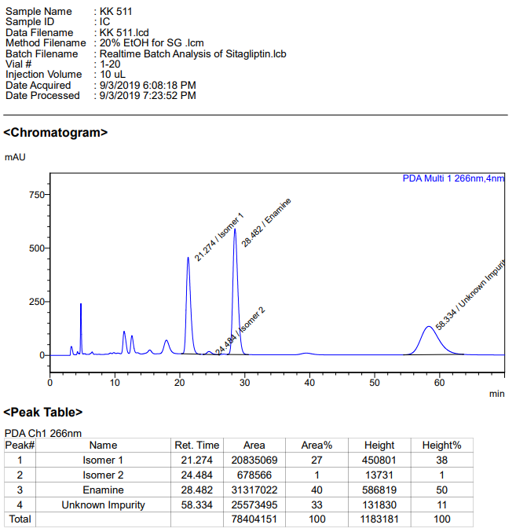

**KK-512**



**Calculation table:**

|  |  |  |  |  |  |
| --- | --- | --- | --- | --- | --- |
| Sr. No | Comp. | Mol. wt. | mmol | Eq. wt. | Wt. taken |
| 1 | Dehydrositagliptin (1) | 405.30 | 0.2135 | 100 | 86 mg |
| 2 | Rh(COD)2OTf | 468.30 | 0.0021 | 1 | 1 mg |
| 3 | L12 | 526.51 | 0.0022 | 1.1 | 1.2 mg |
| 4 | Sodium benzoate | 144.10 | 0.2135 | 100 | 30 mg |

**Procedure:** A glass vial (4 mL) equipped with Teflon coated magnetic needle was cooled under vacuum and transferred to a glove box. The vial was then charged with 86 mg of enamine (**1**), 1 mg of [Rh(COD)2OTf] (1 mol%), ligand (L12) and sodium benzoate. Reaction vial was then closed using screwcap, transferred to a large opening Schlenk type container and was then taken out from the glove box. 2 mL dry methanol was added to the vial in inert atmosphere and the resultant reaction slurry was stirred for 1 hour at room temperature (25°C). After that the reaction vial was shifted to an autoclave and the autoclave was purged three times using hydrogen gas (40 bars). Finally, the autoclave was pressurized to 30 bar hydrogen pressure at 50°C for 18 hrs time period. After the 18 hrs time period, the autoclave was cooled to room temperature (25°C), excess pressure was released and the autoclave was opened. The vials were taken out from the autoclave. The thus obtained reaction mixture was passed through neutral alumina bed, the filtrate was collect and dried to yield residue. The resultant residue was then analysed by TLC, only starting was present.

**Reaction conditions:** Temp: 50°C Press.: 30 bar Solvent: methanol Time: 18 hrs

**Result: 00%** conversion **00%** ee

**KK-514**



**Calculation table:**

|  |  |  |  |  |  |
| --- | --- | --- | --- | --- | --- |
| Sr. No | Comp. | Mol. wt. | mmol | Eq. wt. | Wt. taken |
| 1 | Dehydrositagliptin (1) | 405.30 | 0.2135 | 100 | 86 mg |
| 2 | Rh(COD)2OTf | 468.30 | 0.0021 | 1 | 1 mg |
| 3 | (*R*)-Xylyl-P-Phos (**L7**) | 756.85 | 0.0022 | 1.1 | 1.7 mg |
| 4 | Salicylic acid | 138.12 | 0.2135 | 100 | 28 mg |

**Procedure:** A glass vial (4 mL) equipped with Teflon coated magnetic needle was cooled under vacuum and transferred to a glove box. The vial was then charged with 86 mg of enamine (**1**), 1 mg of [Rh(COD)2OTf] (1 mol%), ligand (L7) and salicylic acid. Reaction vial was then closed using screwcap, transferred to a large opening Schlenk type container and was then taken out from the glove box. 2 mL dry methanol was added to the vial in inert atmosphere and the resultant reaction slurry was stirred for 1 hour at room temperature (25°C). After that the reaction vial was shifted to an autoclave and the autoclave was purged three times using hydrogen gas (40 bars). Finally, the autoclave was pressurized to 30 bar hydrogen pressure at 50°C for 18 hrs time period. After the 18hrs time period, the autoclave was cooled to room temperature (25°C), excess pressure was released and the autoclave was opened. The vials were taken out from the autoclave. The thus obtained reaction mixture was passed through neutral alumina bed, the filtrate was collect and dried to yield residue. The resultant residue was then analysed by HPLC.

**Reaction conditions:** Temp: 50°C Press.: 30 bar Solvent: methanol Time: 18 hrs

**Result: 00%** conversion **00%** ee

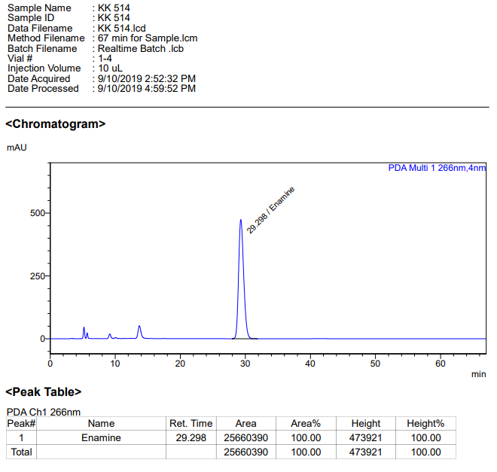

**KK-515**



**Calculation table:**

|  |  |  |  |  |  |
| --- | --- | --- | --- | --- | --- |
| Sr. No | Comp. | Mol. wt. | mmol | Eq. wt. | Wt. taken |
| 1 | Dehydrositagliptin (1) | 405.30 | 0.4112 | 100 | 166 mg |
| 2 | Rh(COD)2OTf | 468.30 | 0.0041 | 1 | 2 mg |
| 3 | (*R*) Quinox (**L10**) | 334.38 | 0.0045 | 1.1 | 1.5 mg |
| 4 | Salicylic acid | 138.12 | 0.4112 | 100 | 56 mg |

**Procedure:** A glass vial (4 mL) equipped with Teflon coated magnetic needle was cooled under vacuum and transferred to a glove box. The vial was then charged with 166 mg of enamine (**1**), 2 mg of [Rh(COD)2OTf] (1 mol%), ligand (L10) and salicylic acid. Reaction vial was then closed using screwcap, transferred to a large opening Schlenk type container and was then taken out from the glove box. 2 mL dry methanol was added to the vial in inert atmosphere and the resultant reaction slurry was stirred for 1 hour at room temperature (25°C). After that the reaction vial was shifted to an autoclave and the autoclave was purged three times using hydrogen gas (40 bars). Finally, the autoclave was pressurized to 30 bar hydrogen pressure at 50°C for 18 hrs time period. After the 18 hrs time period, the autoclave was cooled to room temperature (25°C), excess pressure was released and the autoclave was opened. The vials were taken out from the autoclave. The thus obtained reaction mixture was passed through neutral alumina bed, the filtrate was collect and dried to yield residue. The resultant residue was then analysed by HPLC.

**Reaction conditions:** Temp: 50°C Press.: 30 bar Solvent: methanol Time: 18 hrs

**Result: 00%** conversion **00%** ee

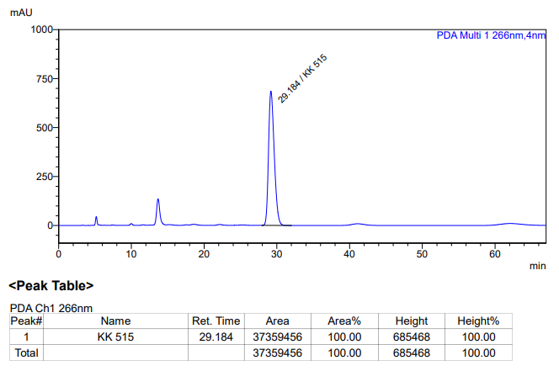

**KK-516**



**Calculation table:**

|  |  |  |  |  |  |
| --- | --- | --- | --- | --- | --- |
| Sr. No | Comp. | Mol. wt. | mmol | Eq. wt. | Wt. taken |
| 1 | Dehydrositagliptin (1) | 405.30 | 0.2135 | 100 | 86 mg |
| 2 | Rh(COD)2OTf | 468.30 | 0.0021 | 1 | 2 mg |
| 3 | (*S*)-Tol-SDP (**L8**) | 644.76 | 0.0022 | 1.1 | 1.4 mg |
| 4 | Salicylic acid | 138.12 | 0.2135 | 100 | 28 mg |

**Procedure:** A glass vial (4 mL) equipped with Teflon coated magnetic needle was cooled under vacuum and transferred to a glove box. The vial was then charged with 86 mg of enamine (**1**), 2 mg of [Rh(COD)2OTf] (1 mol%), ligand (L8) and salicylic acid. Reaction vial was then closed using screwcap, transferred to a large opening Schlenk type container and was then taken out from the glove box. 2 mL dry methanol was added to the vial in inert atmosphere and the resultant reaction slurry was stirred for 1 hour at room temperature (25°C). After that the reaction vial was shifted to an autoclave and the autoclave was purged three times using hydrogen gas (40 bars). Finally, the autoclave was pressurized to 30 bar hydrogen pressure at 50°C for 18 hrs time period. After the 18 hrs time period, the autoclave was cooled to room temperature (25°C), excess pressure was released and the autoclave was opened. The vials were taken out from the autoclave. The thus obtained reaction mixture was passed through neutral alumina bed, the filtrate was collect and dried to yield residue. The resultant residue was then analysed by HPLC.

**Reaction conditions:** Temp: 50°C Press.: 30 bar Solvent: methanol Time: 18 hrs

**Result: 00%** conversion **00%** ee

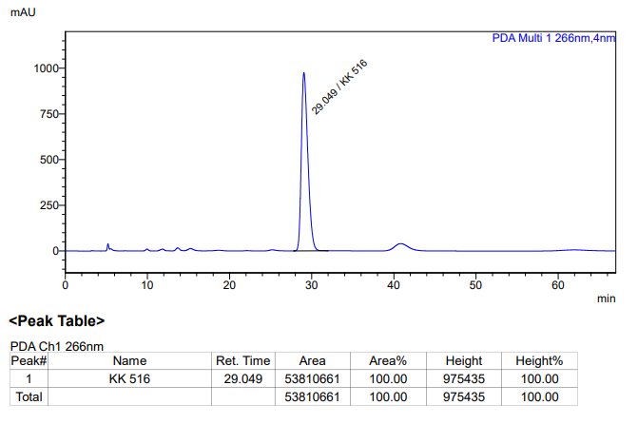

**KK-517**



**Calculation table:**

|  |  |  |  |  |  |
| --- | --- | --- | --- | --- | --- |
| Sr. No | Comp. | Mol. wt. | mmol | Eq. wt. | Wt. taken |
| 1 | Dehydrositagliptin (1) | 405.30 | 0.2135 | 100 | 86 mg |
| 2 | Rh(COD)2OTf | 468.30 | 0.0021 | 1 | 1 mg |
| 3 | (*R*)-Xyl-SDP (**L9**) | 700.87 | 0.0022 | 1.1 | 1.5 mg |
| 4 | Salicylic acid | 138.12 | 0.2135 | 100 | 28 mg |

**Procedure:** A glass vial (4 mL) equipped with Teflon coated magnetic needle was cooled under vacuum and transferred to a glove box. The vial was then charged with 86 mg of enamine (**1**), 1 mg of [Rh(COD)2OTf] (1 mol%), ligand (L9) and salicylic acid. Reaction vial was then closed using screwcap, transferred to a large opening Schlenk type container and was then taken out from the glove box. 2 mL dry methanol was added to the vial in inert atmosphere and the resultant reaction slurry was stirred for 1 hour at room temperature (25°C). After that the reaction vial was shifted to an autoclave and the autoclave was purged three times using hydrogen gas (40 bars). Finally, the autoclave was pressurized to 30 bar hydrogen pressure at 50°C for 18 hrs time period. After the 18 hrs time period, the autoclave was cooled to room temperature (25°C), excess pressure was released and the autoclave was opened. The vials were taken out from the autoclave. The thus obtained reaction mixture was passed through neutral alumina bed, the filtrate was collect and dried to yield residue. The resultant residue was then analysed by HPLC.

**Reaction conditions:** Temp: 50°C Press.: 30 bar Solvent: methanol Time: 18 hrs

**Result: 00%** conversion **00%** ee

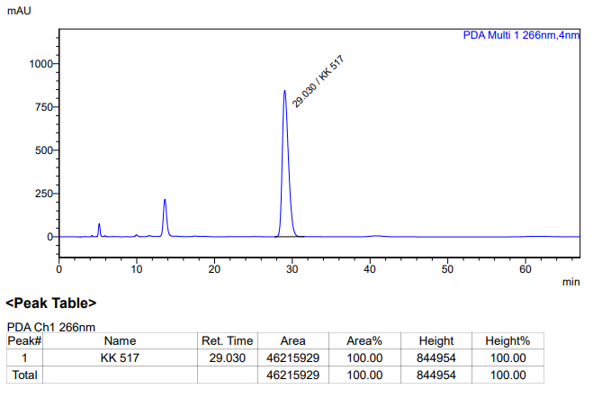

**KK-518**



**Calculation table:**

|  |  |  |  |  |  |
| --- | --- | --- | --- | --- | --- |
| Sr. No | Comp. | Mol. wt. | mmol | Eq. wt. | Wt. taken |
| 1 | Dehydrositagliptin (1) | 405.30 | 0.2135 | 100 | 86 mg |
| 2 | Rh(COD)2OTf | 468.30 | 0.0021 | 1 | 1 mg |
| 3 | L4 | 306.36 | 0.0022 | 1.1 | 0.7 mg |
| 4 | Salicylic acid | 138.12 | 0.2135 | 100 | 28 mg |

**Procedure:** A glass vial (4 mL) equipped with Teflon coated magnetic needle was cooled under vacuum and transferred to a glove box. The vial was then charged with 86 mg of enamine (**1**), 1 mg of [Rh(COD)2OTf] (1 mol%), ligand (L4) and salicylic acid. Reaction vial was then closed using screwcap, transferred to a large opening Schlenk type container and was then taken out from the glove box. 2 mL dry methanol was added to the vial in inert atmosphere and the resultant reaction slurry was stirred for 1 hour at room temperature (25°C). After that the reaction vial was shifted to an autoclave and the autoclave was purged three times using hydrogen gas (40 bars). Finally, the autoclave was pressurized to 30 bar hydrogen pressure at 50°C for 18 hrs time period. After the 18 hrs time period, the autoclave was cooled to room temperature (25°C), excess pressure was released and the autoclave was opened. The vials were taken out from the autoclave. The thus obtained reaction mixture was passed through neutral alumina bed, the filtrate was collect and dried to yield residue. The resultant residue was then analysed by HPLC.

**Reaction conditions:** Temp: 50°C Press.: 30 bar Solvent: methanol Time: 18 hrs

**Result: 00%** conversion **00%** ee

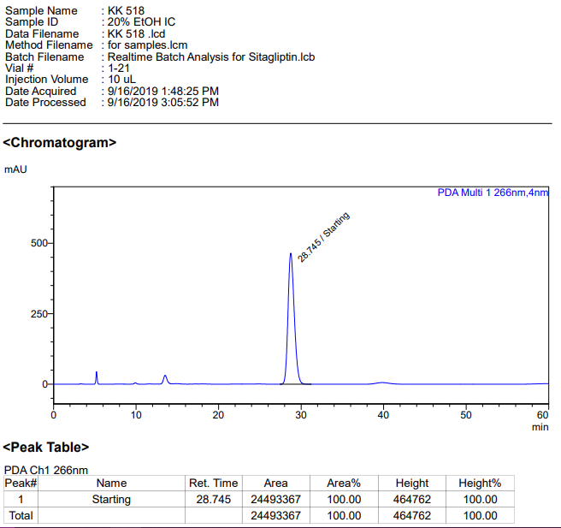

**KK-519**



**Calculation table:**

|  |  |  |  |  |  |
| --- | --- | --- | --- | --- | --- |
| Sr. No | Comp. | Mol. wt. | mmol | Eq. wt. | Wt. taken |
| 1 | Dehydrositagliptin (1) | 405.30 | 0.2135 | 100 | 86 mg |
| 2 | Rh(COD)2OTf | 468.30 | 0.0021 | 1 | 1 mg |
| 3 | L6 | 418.58 | 0.0022 | 1.1 | 0.9 mg |
| 4 | Salicylic acid | 138.12 | 0.2135 | 100 | 28 mg |

**Procedure:** A glass vial (4 mL) equipped with Teflon coated magnetic needle was cooled under vacuum and transferred to a glove box. The vial was then charged with 86 mg of enamine (**1**), 1 mg of [Rh(COD)2OTf] (1 mol%), ligand (L6) and salicylic acid. Reaction vial was then closed using screwcap, transferred to a large opening Schlenk type container and was then taken out from the glove box. 2 mL dry methanol was added to the vial in inert atmosphere and the resultant reaction slurry was stirred for 1 hour at room temperature (25°C). After that the reaction vial was shifted to an autoclave and the autoclave was purged three times using hydrogen gas (40 bars). Finally, the autoclave was pressurized to 30 bar hydrogen pressure at 50°C for 18 hrs time period. After the 18 hrs time period, the autoclave was cooled to room temperature (25°C), excess pressure was released and the autoclave was opened. The vials were taken out from the autoclave. The thus obtained reaction mixture was passed through neutral alumina bed, the filtrate was collect and dried to yield residue. The resultant residue was then analysed by HPLC.

**Reaction conditions:** Temp: 50°C Press.: 30 bar Solvent: methanol Time: 18 hrs

**Result: 00%** conversion **00%** ee

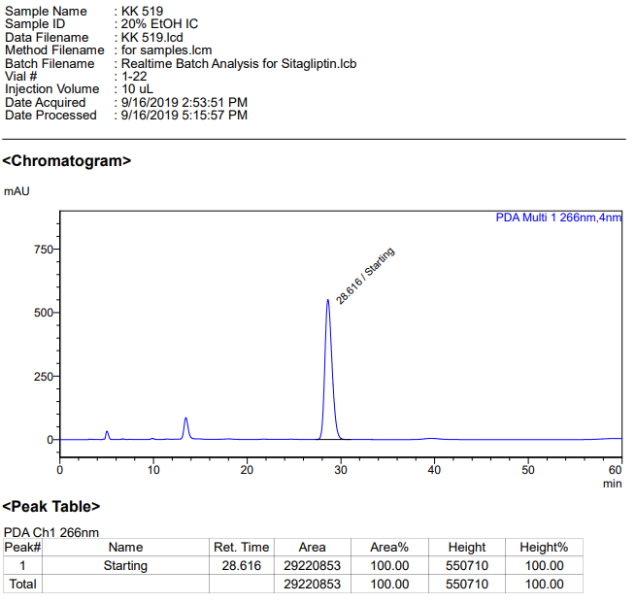

**KK-520**



**Calculation table:**

|  |  |  |  |  |  |
| --- | --- | --- | --- | --- | --- |
| Sr. No | Comp. | Mol. wt. | mmol | Eq. wt. | Wt. taken |
| 1 | Dehydrositagliptin (1) | 405.30 | 0.2135 | 100 | 86 mg |
| 2 | Rh(COD)2OTf | 468.30 | 0.0021 | 1 | 1 mg |
| 3 | L5 | 362.47 | 0.0022 | 1.1 | 0.8 mg |
| 4 | Salicylic acid | 138.12 | 0.2135 | 100 | 28 mg |

**Procedure:** A glass vial (4 mL) equipped with Teflon coated magnetic needle was cooled under vacuum and transferred to a glove box. The vial was then charged with 86 mg of enamine (**1**), 1 mg of [Rh(COD)2OTf] (1 mol%), ligand (L5) and salicylic acid. Reaction vial was then closed using screwcap, transferred to a large opening Schlenk type container and was then taken out from the glove box. 2 mL dry methanol was added to the vial in inert atmosphere and the resultant reaction slurry was stirred for 1 hour at room temperature (25°C). After that the reaction vial was shifted to an autoclave and the autoclave was purged three times using hydrogen gas (40 bars). Finally, the autoclave was pressurized to 30 bar hydrogen pressure at 50°C for 18 hrs time period. After the 18 hrs time period, the autoclave was cooled to room temperature (25°C), excess pressure was released and the autoclave was opened. The vials were taken out from the autoclave. The thus obtained reaction mixture was passed through neutral alumina bed, the filtrate was collect and dried to yield residue. The resultant residue was then analysed by HPLC.

**Reaction conditions:** Temp: 50°C Press.: 30 bar Solvent: methanol Time: 18 hrs

**Result: 00%** conversion **00%** ee

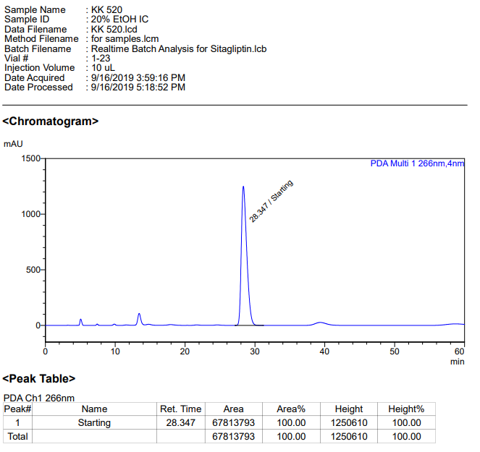

**KK-520**



**Calculation table:**

|  |  |  |  |  |  |
| --- | --- | --- | --- | --- | --- |
| Sr. No | Comp. | Mol. wt. | mmol | Eq. wt. | Wt. taken |
| 1 | Dehydrositagliptin (1) | 405.30 | 0.2135 | 100 | 86 mg |
| 2 | Rh(COD)2OTf | 468.30 | 0.0021 | 1 | 1 mg |
| 3 | L3 | 414.28 | 0.0022 | 1.1 | 0.9 mg |
| 4 | Salicylic acid | 138.12 | 0.2135 | 100 | 28 mg |

**Procedure:** A glass vial (4 mL) equipped with Teflon coated magnetic needle was cooled under vacuum and transferred to a glove box. The vial was then charged with 86 mg of enamine (**1**), 1 mg of [Rh(COD)2OTf] (1 mol%), ligand (L3) and salicylic acid. Reaction vial was then closed using screwcap, transferred to a large opening Schlenk type container and was then taken out from the glove box. 2 mL dry methanol was added to the vial in inert atmosphere and the resultant reaction slurry was stirred for 1 hour at room temperature (25°C). After that the reaction vial was shifted to an autoclave and the autoclave was purged three times using hydrogen gas (40 bars). Finally, the autoclave was pressurized to 30 bar hydrogen pressure at 50°C for 18 hrs time period. After the 18 hrs time period, the autoclave was cooled to room temperature (25°C), excess pressure was released and the autoclave was opened. The vials were taken out from the autoclave. The thus obtained reaction mixture was passed through neutral alumina bed, the filtrate was collect and dried to yield residue. The resultant residue was then analysed by HPLC.

**Reaction conditions:** Temp: 50°C Press.: 30 bar Solvent: methanol Time: 18 hrs

**Result: 00%** conversion **00%** ee

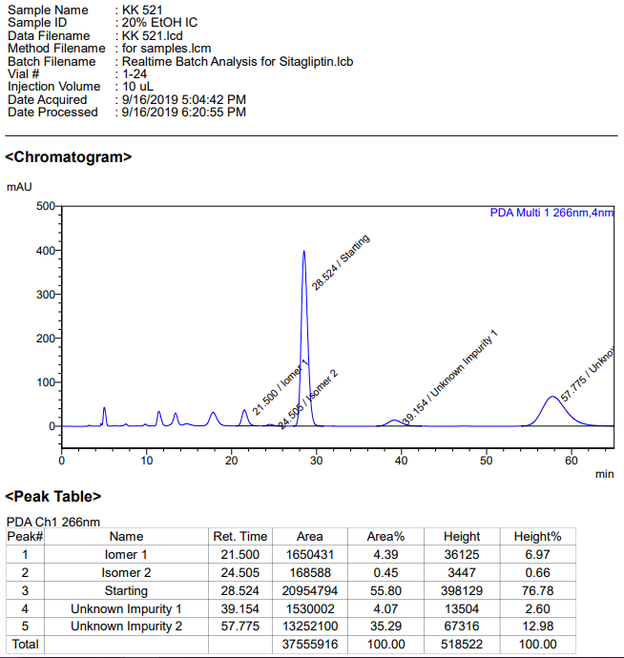

**KK-531**



**Calculation table:**

|  |  |  |  |  |  |
| --- | --- | --- | --- | --- | --- |
| Sr. No | Comp. | Mol. wt. | mmol | Eq. wt. | Wt. taken |
| 1 | Dehydrositagliptin (1) | 405.30 | 0.2135 | 100 | 86 mg |
| 2 | Rh(COD)2OTf | 468.30 | 0.0021 | 1 | 1 mg |
| 3 | L12 | 526.51 | 0.0022 | 1.1 | 1.2 mg |
| 4 | Sodium benzoate | 144.10 | 0.0022 | 1.1 | 0.3 mg |

**Procedure:** A glass vial (4 mL) equipped with Teflon coated magnetic needle was cooled under vacuum and transferred to a glove box. The vial was then charged with 86 mg of enamine (**1**), 1 mg of [Rh(COD)2OTf] (1 mol%), ligand (L12) and sodium benzoate. Reaction vial was then closed using screwcap, transferred to a large opening Schlenk type container and was then taken out from the glove box. 2 mL dry methanol was added to the vial in inert atmosphere and the resultant reaction slurry was stirred for 1 hour at room temperature (25°C). After that the reaction vial was shifted to an autoclave and the autoclave was purged three times using hydrogen gas (40 bars). Finally, the autoclave was pressurized to 30 bar hydrogen pressure at 50°C for 18 hrs time period. After the 18 hrs time period, the autoclave was cooled to room temperature (25°C), excess pressure was released and the autoclave was opened. The vials were taken out from the autoclave. The thus obtained reaction mixture was passed through neutral alumina bed, the filtrate was collect and dried to yield residue. The resultant residue was then analysed by HPLC.

**Reaction conditions:** Temp: 50°C Press.: 30 bar Solvent: methanol Time: 18 hrs

**Result: 00%** conversion **00%** ee

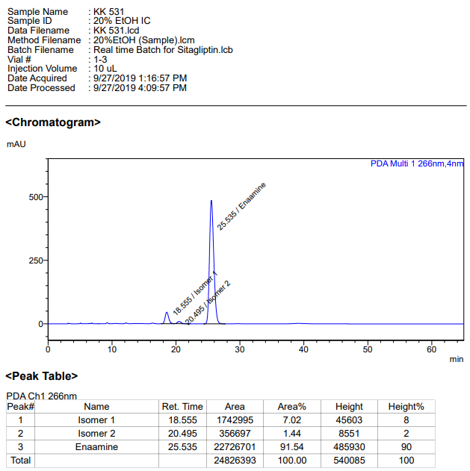

**KK-532**



**Calculation table:**

|  |  |  |  |  |  |
| --- | --- | --- | --- | --- | --- |
| Sr. No | Comp. | Mol. wt. | mmol | Eq. wt. | Wt. taken |
| 1 | Dehydrositagliptin (1) | 405.30 | 0.2135 | 100 | 86 mg |
| 2 | Rh(COD)2OTf | 468.30 | 0.0021 | 1 | 1 mg |
| 3 | L12 | 526.51 | 0.0022 | 1.1 | 1.2 mg |
| 4 | PPTS | 251.30 | 0.0022 | 1.1 | 0.6 mg |

**Procedure:** A glass vial (4 mL) equipped with Teflon coated magnetic needle was cooled under vacuum and transferred to a glove box. The vial was then charged with 86 mg of enamine (**1**), 1 mg of [Rh(COD)2OTf] (1 mol%), ligand (L12) and pyridinium *p*-toluenesulfonate. Reaction vial was then closed using screwcap, transferred to a large opening Schlenk type container and was then taken out from the glove box. 2 mL dry methanol was added to the vial in inert atmosphere and the resultant reaction slurry was stirred for 1 hour at room temperature (25°C). After that the reaction vial was shifted to an autoclave and the autoclave was purged three times using hydrogen gas (40 bars). Finally, the autoclave was pressurized to 30 bar hydrogen pressure at 50°C for 18 hrs time period. After the 18 hrs time period, the autoclave was cooled to room temperature (25°C), excess pressure was released and the autoclave was opened. The vials were taken out from the autoclave. The thus obtained reaction mixture was passed through neutral alumina bed, the filtrate was collect and dried to yield residue. The resultant residue was then analysed by HPLC.

**Reaction conditions:** Temp: 50°C Press.: 30 bar Solvent: methanol Time: 18 hrs

**Result: 00%** conversion **00%** ee

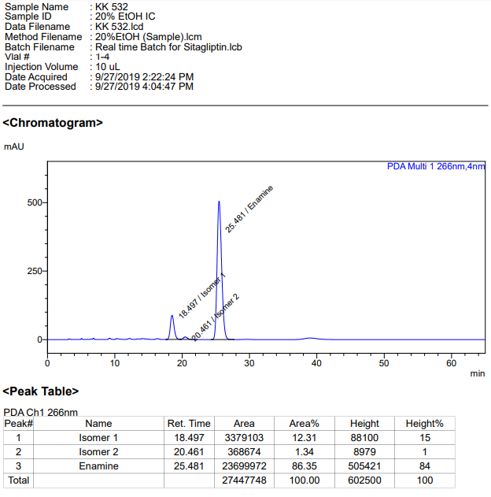

**KK-533**



**Calculation table:**

|  |  |  |  |  |  |
| --- | --- | --- | --- | --- | --- |
| Sr. No | Comp. | Mol. wt. | mmol | Eq. wt. | Wt. taken |
| 1 | Dehydrositagliptin (1) | 405.30 | 0.2135 | 100 | 86 mg |
| 2 | Rh(COD)2OTf | 468.30 | 0.0021 | 1 | 1 mg |
| 3 | L12 | 526.51 | 0.0022 | 1.1 | 1.2 mg |
| 4 | PPTS | 251.30 | 0.2135 | 100 | 52 mg |

**Procedure:** A glass vial (4 mL) equipped with Teflon coated magnetic needle was cooled under vacuum and transferred to a glove box. The vial was then charged with 86 mg of enamine (**1**), 1 mg of [Rh(COD)2OTf] (1 mol%), ligand (L12) and pyridinium *p*-toluenesulfonate. Reaction vial was then closed using screwcap, transferred to a large opening Schlenk type container and was then taken out from the glove box. 2 mL dry methanol was added to the vial in inert atmosphere and the resultant reaction slurry was stirred for 1 hour at room temperature (25°C). After that the reaction vial was shifted to an autoclave and the autoclave was purged three times using hydrogen gas (40 bars). Finally, the autoclave was pressurized to 30 bar hydrogen pressure at 50°C for 18 hrs time period. After the 18 hrs time period, the autoclave was cooled to room temperature (25°C), excess pressure was released and the autoclave was opened. The vials were taken out from the autoclave. The thus obtained reaction mixture was passed through neutral alumina bed, the filtrate was collect and dried to yield residue. The resultant residue was then analysed by HPLC.

**Reaction conditions:** Temp: 50°C Press.: 30 bar Solvent: methanol Time: 18 hrs

**Result: 15%** conversion **92%** ee

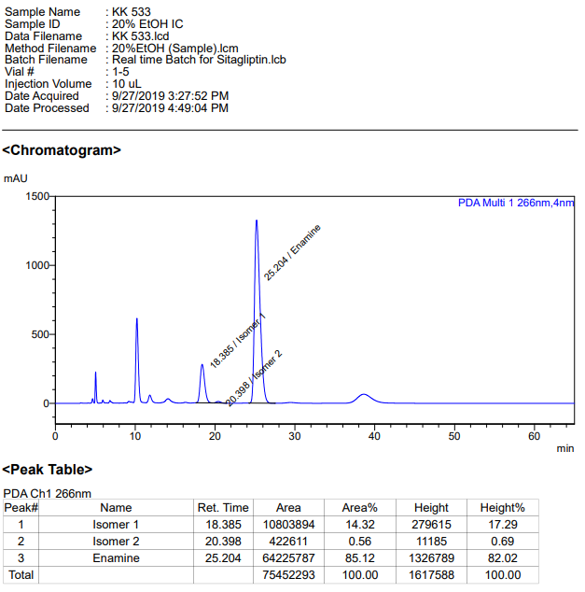

**KK-534**



**Calculation table:**

|  |  |  |  |  |  |
| --- | --- | --- | --- | --- | --- |
| Sr. No | Comp. | Mol. wt. | mmol | Eq. wt. | Wt. taken |
| 1 | Dehydrositagliptin (1) | 405.30 | 12.3380 | 100 | 5000 mg |
| 2 | Rh(COD)2OTf | 468.30 | 0.1233 | 1 | 60 mg |
| 3 | L12 | 526.51 | 0.1480 | 1.2 | 78 mg |
| 4 | Salicylic acid | 138.12 | 12.3380 | 100 | 1740 mg |

**Procedure:** A high pressure Parr reactor (450 mL) equipped with overhead stirring was charged with 5 g of enamine (**1**) under argon atmosphere. Subsequently, 60 mg of [Rh(COD)2­OTf] (2 mol%), 78 mg of ligand **L12** and 1740 mg of salicylic acid (12.33 mmol) was added to the above reactor. 100 mL dry methanol was added to the reactor in inert atmosphere and the resultant reaction slurry was stirred for 1 hour at room temperature (25 °C). After that the autoclave was purged three times using hydrogen gas (40 bar). Finally, the autoclave was pressurized to 30 bar hydrogen pressure and was heated to 45 °C for 8 hrs. After 8 hrs, the autoclave was cooled to room temperature (25 °C), excess pressure was released and the autoclave was opened. A sample (0.5 ml) was taken out for HPLC and the remaining content was purified by column chromatography (the column was flushed with 100 mL ethyl acetate, followed by 90:10, DCM:Methanol) to yield of sitagliptin free base (**2**).

**Reaction conditions:** Temp: 45°C Press.: 30 bar Solvent: Methanol Time: 8 hrs

**Result: 85%** conversion **92%** ee

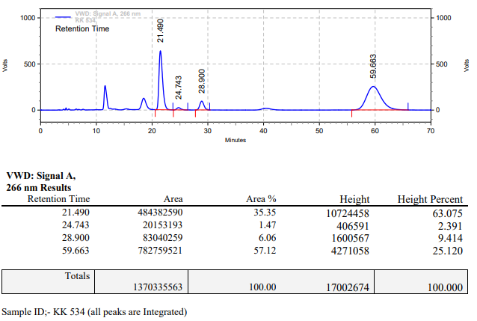

**KK-535**



**Calculation table:**

|  |  |  |  |  |  |
| --- | --- | --- | --- | --- | --- |
| Sr. No | Comp. | Mol. wt. | mmol | Eq. wt. | Wt. taken |
| 1 | Dehydrositagliptin (1) | 405.30 | 0.2135 | 100 | 86 mg |
| 2 | Rh(COD)2OTf | 468.30 | 0.0021 | 1 | 1 mg |
| 3 | L4 | 306.36 | 0.0022 | 1.05 | 0.6 mg |
| 4 | Ammonium chloride | 53.49 | 0.0213 | 10 | 1 mg |

**Procedure:** A glass vial (4 mL) equipped with Teflon coated magnetic needle was cooled under vacuum and transferred to a glove box. The vial was then charged with 86 mg of enamine (**1**), 1 mg of [Rh(COD)2OTf] (1 mol%), ligand (L4) and ammonium chloride. Reaction vial was then closed using screwcap, transferred to a large opening Schlenk type container and was then taken out from the glove box. 2 mL dry methanol was added to the vial in inert atmosphere and the resultant reaction slurry was stirred for 1 hour at room temperature (25°C). After that the reaction vial was shifted to an autoclave and the autoclave was purged three times using hydrogen gas (40 bars). Finally, the autoclave was pressurized to 20 bar hydrogen pressure at 90°C for 18 hrs time period. After the 18 hrs time period, the autoclave was cooled to room temperature (25°C), excess pressure was released and the autoclave was opened. The vials were taken out from the autoclave. The thus obtained reaction mixture was passed through neutral alumina bed, the filtrate was collect and dried to yield residue. The resultant residue was then analysed by HPLC.

**Reaction conditions:** Temp: 90°C Press.: 20 bar Solvent: methanol Time: 18 hrs

**Result: 00%** conversion **00%** ee

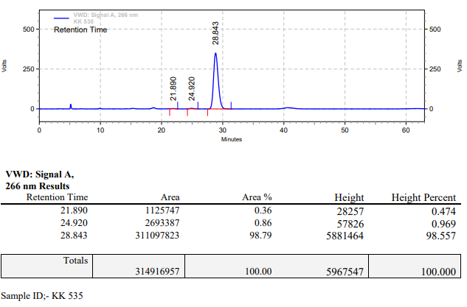

**KK-536**



**Calculation table:**

|  |  |  |  |  |  |
| --- | --- | --- | --- | --- | --- |
| Sr. No | Comp. | Mol. wt. | mmol | Eq. wt. | Wt. taken |
| 1 | Dehydrositagliptin (1) | 405.30 | 0.2135 | 100 | 86 mg |
| 2 | Rh(COD)2OTf | 468.30 | 0.0021 | 1 | 1 mg |
| 3 | L1 | 498.93 | 0.0021 | 1.05 | 1.1 mg |
| 4 | Ammonium chloride | 53.49 | 0.0213 | 10 | 1 mg |

**Procedure:** A glass vial (4 mL) equipped with Teflon coated magnetic needle was cooled under vacuum and transferred to a glove box. The vial was then charged with 86 mg of enamine (**1**), 1 mg of [Rh(COD)2OTf] (1 mol%), ligand (L1) and ammonium chloride. Reaction vial was then closed using screwcap, transferred to a large opening Schlenk type container and was then taken out from the glove box. 2 mL dry methanol was added to the vial in inert atmosphere and the resultant reaction slurry was stirred for 1 hour at room temperature (25°C). After that the reaction vial was shifted to an autoclave and the autoclave was purged three times using hydrogen gas (40 bars). Finally, the autoclave was pressurized to 20 bar hydrogen pressure at 90°C for 18 hrs time period. After the 18 hrs time period, the autoclave was cooled to room temperature (25°C), excess pressure was released and the autoclave was opened. The vials were taken out from the autoclave. The thus obtained reaction mixture was passed through neutral alumina bed, the filtrate was collect and dried to yield residue. The resultant residue was then analysed by HPLC.

**Reaction conditions:** Temp: 90°C Press.: 20 bar Solvent: methanol Time: 18 hrs

**Result: 00%** conversion **00%** ee

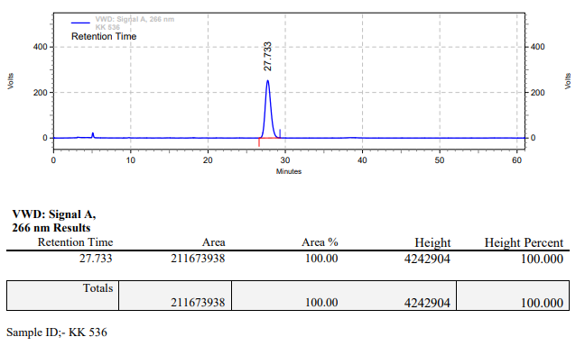

**KK-537**



**Calculation table:**

|  |  |  |  |  |  |
| --- | --- | --- | --- | --- | --- |
| Sr. No | Comp. | Mol. wt. | mmol | Eq. wt. | Wt. taken |
| 1 | Dehydrositagliptin (1) | 405.30 | 0.2135 | 100 | 86 mg |
| 2 | Rh(COD)2OTf | 468.30 | 0.0021 | 1 | 1 mg |
| 3 | L2 | 426.47 | 0.0021 | 1.05 | 0.9 mg |
| 4 | Ammonium chloride | 53.49 | 0.0213 | 10 | 1 mg |

**Procedure:** A glass vial (4 mL) equipped with Teflon coated magnetic needle was cooled under vacuum and transferred to a glove box. The vial was then charged with 86 mg of enamine (**1**), 1 mg of [Rh(COD)2OTf] (1 mol%), ligand (L2) and ammonium chloride. Reaction vial was then closed using screwcap, transferred to a large opening Schlenk type container and was then taken out from the glove box. 2 mL dry methanol was added to the vial in inert atmosphere and the resultant reaction slurry was stirred for 1 hour at room temperature (25°C). After that the reaction vial was shifted to an autoclave and the autoclave was purged three times using hydrogen gas (40 bars). Finally, the autoclave was pressurized to 20 bar hydrogen pressure at 90°C for 18 hrs time period. After the 18 hrs time period, the autoclave was cooled to room temperature (25°C), excess pressure was released and the autoclave was opened. The vials were taken out from the autoclave. The thus obtained reaction mixture was passed through neutral alumina bed, the filtrate was collect and dried to yield residue. The resultant residue was then analysed by HPLC.

**Reaction conditions:** Temp: 90°C Press.: 20 bar Solvent: methanol Time: 18 hrs

**Result: 00%** conversion **00%** ee

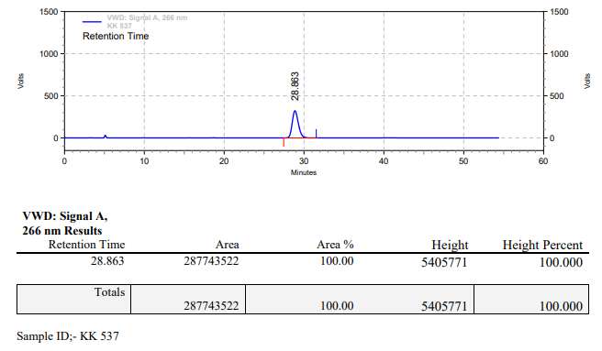

**KK-538**



**Calculation table:**

|  |  |  |  |  |  |
| --- | --- | --- | --- | --- | --- |
| Sr. No | Comp. | Mol. wt. | mmol | Eq. wt. | Wt. taken |
| 1 | Dehydrositagliptin (1) | 405.30 | 0.2135 | 100 | 86 mg |
| 2 | Rh(COD)2OTf | 468.30 | 0.0021 | 1 | 1 mg |
| 3 | L6 | 418.58 | 0.0021 | 1.05 | 0.9 mg |
| 4 | Ammonium chloride | 53.49 | 0.0213 | 10 | 1 mg |

**Procedure:** A glass vial (4 mL) equipped with Teflon coated magnetic needle was cooled under vacuum and transferred to a glove box. The vial was then charged with 86 mg of enamine (**1**), 1 mg of [Rh(COD)2OTf] (1 mol%), ligand (L6) and ammonium chloride. Reaction vial was then closed using screwcap, transferred to a large opening Schlenk type container and was then taken out from the glove box. 2 mL dry methanol was added to the vial in inert atmosphere and the resultant reaction slurry was stirred for 1 hour at room temperature (25°C). After that the reaction vial was shifted to an autoclave and the autoclave was purged three times using hydrogen gas (40 bars). Finally, the autoclave was pressurized to 20 bar hydrogen pressure at 90°C for 18 hrs time period. After the 18 hrs time period, the autoclave was cooled to room temperature (25°C), excess pressure was released and the autoclave was opened. The vials were taken out from the autoclave. The thus obtained reaction mixture was passed through neutral alumina bed, the filtrate was collect and dried to yield residue. The resultant residue was then analysed by HPLC.

**Reaction conditions:** Temp: 90°C Press.: 20 bar Solvent: methanol Time: 18 hrs

**Result: 00%** conversion **00%** ee

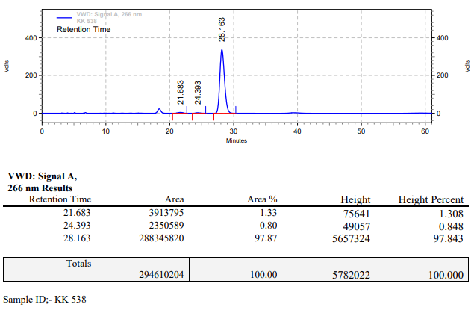

**KK-539**



**Calculation table:**

|  |  |  |  |  |  |
| --- | --- | --- | --- | --- | --- |
| Sr. No | Comp. | Mol. wt. | mmol | Eq. wt. | Wt. taken |
| 1 | Dehydrositagliptin (1) | 405.30 | 0.2135 | 100 | 86 mg |
| 2 | Rh(COD)2OTf | 468.30 | 0.0021 | 1 | 1 mg |
| 3 | (*R*)-Xylyl-P-Phos (L7) | 756.85 | 0.0021 | 1.05 | 1.6 mg |
| 4 | Ammonium chloride | 53.49 | 0.0213 | 10 | 1 mg |

**Procedure:** A glass vial (4 mL) equipped with Teflon coated magnetic needle was cooled under vacuum and transferred to a glove box. The vial was then charged with 86 mg of enamine (**1**), 1 mg of [Rh(COD)2OTf] (1 mol%), ligand (L7) and ammonium chloride. Reaction vial was then closed using screwcap, transferred to a large opening Schlenk type container and was then taken out from the glove box. 2 mL dry methanol was added to the vial in inert atmosphere and the resultant reaction slurry was stirred for 1 hour at room temperature (25°C). After that the reaction vial was shifted to an autoclave and the autoclave was purged three times using hydrogen gas (40 bars). Finally, the autoclave was pressurized to 20 bar hydrogen pressure at 90°C for 18 hrs time period. After the 18 hrs time period, the autoclave was cooled to room temperature (25°C), excess pressure was released and the autoclave was opened. The vials were taken out from the autoclave. The thus obtained reaction mixture was passed through neutral alumina bed, the filtrate was collect and dried to yield residue. The resultant residue was then analysed by HPLC.

**Reaction conditions:** Temp: 90°C Press.: 20 bar Solvent: methanol Time: 18 hrs

**Result: 00%** conversion **00%** ee

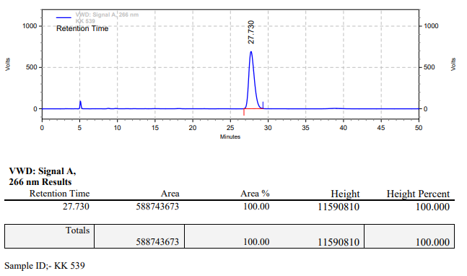

**KK-540**



**Calculation table:**

|  |  |  |  |  |  |
| --- | --- | --- | --- | --- | --- |
| Sr. No | Comp. | Mol. wt. | mmol | Eq. wt. | Wt. taken |
| 1 | Dehydrositagliptin (1) | 405.30 | 0.2135 | 100 | 86 mg |
| 2 | Rh(COD)2OTf | 468.30 | 0.0021 | 1 | 1 mg |
| 3 | (*R*) QuinoxP (L10) | 334.38 | 0.0021 | 1.05 | 0.7 mg |
| 4 | Ammonium chloride | 53.49 | 0.0213 | 10 | 1 mg |

**Procedure:** A glass vial (4 mL) equipped with Teflon coated magnetic needle was cooled under vacuum and transferred to a glove box. The vial was then charged with 86 mg of enamine (**1**), 1 mg of [Rh(COD)2OTf] (1 mol%), ligand (L7) and ammonium chloride. Reaction vial was then closed using screwcap, transferred to a large opening Schlenk type container and was then taken out from the glove box. 2 mL dry methanol was added to the vial in inert atmosphere and the resultant reaction slurry was stirred for 1 hour at room temperature (25°C). After that the reaction vial was shifted to an autoclave and the autoclave was purged three times using hydrogen gas (40 bars). Finally, the autoclave was pressurized to 20 bar hydrogen pressure at 90°C for 18 hrs time period. After the 18 hrs time period, the autoclave was cooled to room temperature (25°C), excess pressure was released and the autoclave was opened. The vials were taken out from the autoclave. The thus obtained reaction mixture was passed through neutral alumina bed, the filtrate was collect and dried to yield residue. The resultant residue was then analysed by HPLC.

**Reaction conditions:** Temp: 90°C Press.: 20 bar Solvent: methanol Time: 18 hrs

**Result: 00%** conversion **00%** ee

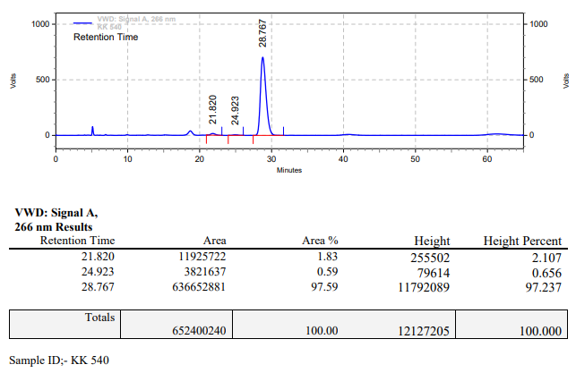

**KK-541**



**Calculation table:**

|  |  |  |  |  |  |
| --- | --- | --- | --- | --- | --- |
| Sr. No | Comp. | Mol. wt. | mmol | Eq. wt. | Wt. taken |
| 1 | Dehydrositagliptin (1) | 405.30 | 0.2135 | 100 | 86 mg |
| 2 | Rh(COD)2OTf | 468.30 | 0.0021 | 1 | 1 mg |
| 3 | (*S*)-Tol-SDP (L8) | 644.76 | 0.0021 | 1.05 | 1.4 mg |
| 4 | Ammonium chloride | 53.49 | 0.0213 | 10 | 1 mg |

**Procedure:** A glass vial (4 mL) equipped with Teflon coated magnetic needle was cooled under vacuum and transferred to a glove box. The vial was then charged with 86 mg of enamine (**1**), 1 mg of [Rh(COD)2OTf] (1 mol%), ligand (L8) and ammonium chloride. Reaction vial was then closed using screwcap, transferred to a large opening Schlenk type container and was then taken out from the glove box. 2 mL dry methanol was added to the vial in inert atmosphere and the resultant reaction slurry was stirred for 1 hour at room temperature (25°C). After that the reaction vial was shifted to an autoclave and the autoclave was purged three times using hydrogen gas (40 bars). Finally, the autoclave was pressurized to 20 bar hydrogen pressure at 90°C for 18 hrs time period. After the 18 hrs time period, the autoclave was cooled to room temperature (25°C), excess pressure was released and the autoclave was opened. The vials were taken out from the autoclave. The thus obtained reaction mixture was passed through neutral alumina bed, the filtrate was collect and dried to yield residue. The resultant residue was then analysed by HPLC.

**Reaction conditions:** Temp: 90°C Press.: 20 bar Solvent: methanol Time: 18 hrs

**Result: 00%** conversion **00%** ee

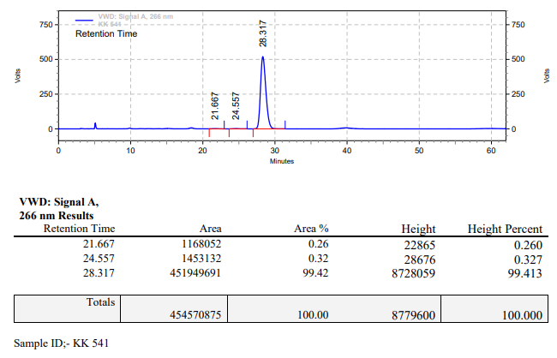

**KK-542**



**Calculation table:**

|  |  |  |  |  |  |
| --- | --- | --- | --- | --- | --- |
| Sr. No | Comp. | Mol. wt. | mmol | Eq. wt. | Wt. taken |
| 1 | Dehydrositagliptin (1) | 405.30 | 0.2135 | 100 | 86 mg |
| 2 | Rh(COD)2OTf | 468.30 | 0.0021 | 1 | 1 mg |
| 3 | (*R*)-Xyl-SDP (L9) | 700.87 | 0.0021 | 1.05 | 1.5 mg |
| 4 | Ammonium chloride | 53.49 | 0.0213 | 10 | 1 mg |

**Procedure:** A glass vial (4 mL) equipped with Teflon coated magnetic needle was cooled under vacuum and transferred to a glove box. The vial was then charged with 86 mg of enamine (**1**), 1 mg of [Rh(COD)2OTf] (1 mol%), ligand (L9) and ammonium chloride. Reaction vial was then closed using screwcap, transferred to a large opening Schlenk type container and was then taken out from the glove box. 2 mL dry methanol was added to the vial in inert atmosphere and the resultant reaction slurry was stirred for 1 hour at room temperature (25°C). After that the reaction vial was shifted to an autoclave and the autoclave was purged three times using hydrogen gas (40 bars). Finally, the autoclave was pressurized to 20 bar hydrogen pressure at 90°C for 18 hrs time period. After the 18 hrs time period, the autoclave was cooled to room temperature (25°C), excess pressure was released and the autoclave was opened. The vials were taken out from the autoclave. The thus obtained reaction mixture was passed through neutral alumina bed, the filtrate was collect and dried to yield residue. The resultant residue was then analysed by HPLC.

**Reaction conditions:** Temp: 90°C Press.: 20 bar Solvent: methanol Time: 18 hrs

**Result: 00%** conversion **00%** ee

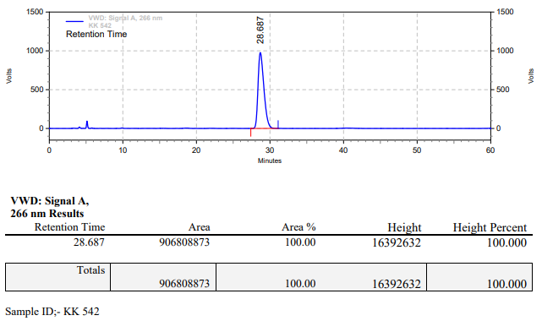

**KK-545**



**Calculation table:**

|  |  |  |  |  |  |
| --- | --- | --- | --- | --- | --- |
| Sr. No | Comp. | Mol. wt. | mmol | Eq. wt. | Wt. taken |
| 1 | Dehydrositagliptin (1) | 405.30 | 0.2135 | 100 | 86 mg |
| 2 | Rh(COD)2OTf | 468.30 | 0.0021 | 1 | 1 mg |
| 3 | L12 | 526.51 | 0.0022 | 1.1 | 1.2 mg |
| 4 | Salicylic acid | 138.12 | 0.2135 | 100 | 28 mg |

**Procedure:** A glass vial (4 mL) equipped with Teflon coated magnetic needle was cooled under vacuum and transferred to a glove box. The vial was then charged with 86 mg of enamine (**1**), 1 mg of [Rh(COD)2OTf] (1 mol%), ligand (L12) and salicylic acid. Reaction vial was then closed using screwcap, transferred to a large opening Schlenk type container and was then taken out from the glove box. 2 mL dry DMSO was added to the vial in inert atmosphere and the resultant reaction slurry was stirred for 1 hour at room temperature (25°C). After that the reaction vial was shifted to an autoclave and the autoclave was purged three times using hydrogen gas (40 bars). Finally, the autoclave was pressurized to 30 bar hydrogen pressure at 50°C for 18 hrs time period. After the 18 hrs time period, the autoclave was cooled to room temperature (25°C), excess pressure was released and the autoclave was opened. The vials were taken out from the autoclave. The thus obtained reaction mixture was passed through neutral alumina bed, the filtrate was collect and dried to yield residue. The resultant residue was then analysed by HPLC.

**Reaction conditions:** Temp: 50°C Press.: 30 bar Solvent: DMSO Time: 18 hrs

**Result: 00%** conversion **00%** ee

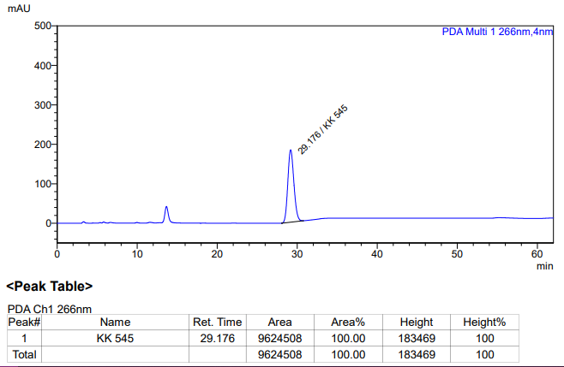

**KK-546**



**Calculation table:**

|  |  |  |  |  |  |
| --- | --- | --- | --- | --- | --- |
| Sr. No | Comp. | Mol. wt. | mmol | Eq. wt. | Wt. taken |
| 1 | Dehydrositagliptin (1) | 405.30 | 0.2135 | 100 | 86 mg |
| 2 | Rh(COD)2OTf | 468.30 | 0.0021 | 1 | 1 mg |
| 3 | L12 | 526.51 | 0.0022 | 1.1 | 1.2 mg |
| 4 | Salicylic acid | 138.12 | 0.2135 | 100 | 28 mg |

**Procedure:** A glass vial (4 mL) equipped with Teflon coated magnetic needle was cooled under vacuum and transferred to a glove box. The vial was then charged with 86 mg of enamine (**1**), 1 mg of [Rh(COD)2OTf] (1 mol%), ligand (L12) and salicylic acid. Reaction vial was then closed using screwcap, transferred to a large opening Schlenk type container and was then taken out from the glove box. 2 mL dry DMSO:Methanol (10:90) was added to the vial in inert atmosphere and the resultant reaction slurry was stirred for 1 hour at room temperature (25°C). After that the reaction vial was shifted to an autoclave and the autoclave was purged three times using hydrogen gas (40 bars). Finally, the autoclave was pressurized to 30 bar hydrogen pressure at 50°C for 18 hrs time period. After the 18 hrs time period, the autoclave was cooled to room temperature (25°C), excess pressure was released and the autoclave was opened. The vials were taken out from the autoclave. The thus obtained reaction mixture was passed through neutral alumina bed, the filtrate was collect and dried to yield residue. The resultant residue was then analysed by HPLC.

**Reaction conditions:** Temp:50°C Press.:30bar Solvent: DMSO:MeOH (10:90) Time: 18 hrs

**Result: 00%** conversion **00%** ee

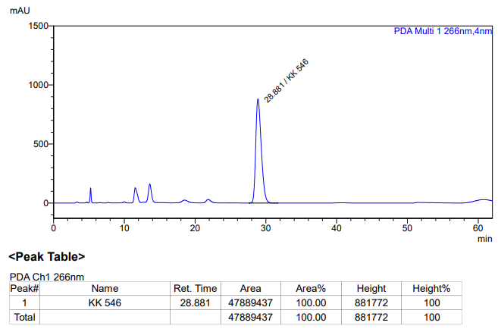

**KK-547**



**Calculation table:**

|  |  |  |  |  |  |
| --- | --- | --- | --- | --- | --- |
| Sr. No | Comp. | Mol. wt. | mmol | Eq. wt. | Wt. taken |
| 1 | Dehydrositagliptin (1) | 405.30 | 0.2135 | 100 | 86 mg |
| 2 | Rh(COD)2OTf | 468.30 | 0.0021 | 1 | 1 mg |
| 3 | L12 | 526.51 | 0.0042 | 2 | 2.2 mg |
| 4 | Salicylic acid | 138.12 | 0.4112 | 200 | 57 mg |

**Procedure:** A glass vial (4 mL) equipped with Teflon coated magnetic needle was cooled under vacuum and transferred to a glove box. The vial was then charged with 86 mg of enamine (**1**), 1 mg of [Rh(COD)2OTf] (1 mol%), ligand (L12) and salicylic acid. Reaction vial was then closed using screwcap, transferred to a large opening Schlenk type container and was then taken out from the glove box. 2 mL dry methanol was added to the vial in inert atmosphere and the resultant reaction slurry was stirred for 1 hour at room temperature (25°C). After that the reaction vial was shifted to an autoclave and the autoclave was purged three times using hydrogen gas (40 bars). Finally, the autoclave was pressurized to 30 bar hydrogen pressure at 45°C for 18 hrs time period. After the 18 hrs time period, the autoclave was cooled to room temperature (25°C), excess pressure was released and the autoclave was opened. The vials were taken out from the autoclave. The thus obtained reaction mixture was passed through neutral alumina bed, the filtrate was collect and dried to yield residue. The resultant residue was then analysed by HPLC.

**Reaction conditions:** Temp: 45°C Press.: 30 bar Solvent: Methanol Time: 18 hrs

**Result: 85%** conversion **98%** ee

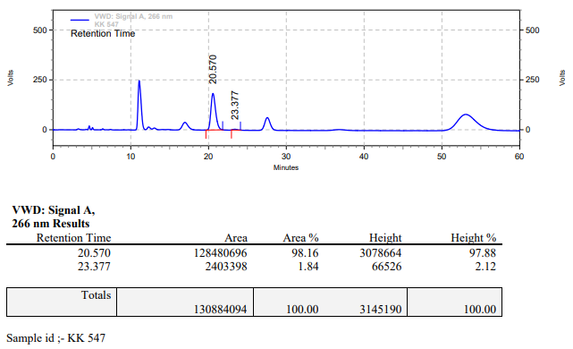

**KK-548**



**Calculation table:**

|  |  |  |  |  |  |
| --- | --- | --- | --- | --- | --- |
| Sr. No | Comp. | Mol. wt. | mmol | Eq. wt. | Wt. taken |
| 1 | Dehydrositagliptin (1) | 405.30 | 0.2135 | 100 | 86 mg |
| 2 | Rh(COD)2OTf | 468.30 | 0.0021 | 1 | 1 mg |
| 3 | L12 | 526.51 | 0.0042 | 2 | 2.2 mg |
| 4 | Salicylic acid | 138.12 | 0.4112 | 200 | 57 mg |

**Procedure:** A glass vial (4 mL) equipped with Teflon coated magnetic needle was cooled under vacuum and transferred to a glove box. The vial was then charged with 86 mg of enamine (**1**), 1 mg of [Rh(COD)2OTf] (1 mol%), ligand (L12) and salicylic acid. Reaction vial was then closed using screwcap, transferred to a large opening Schlenk type container and was then taken out from the glove box. 2 mL dry methanol was added to the vial in inert atmosphere and the resultant reaction slurry was stirred for 1 hour at room temperature (25°C). After that the reaction vial was shifted to an autoclave and the autoclave was purged three times using hydrogen gas (40 bars). Finally, the autoclave was pressurized to 30 bar hydrogen pressure at 45°C for 18 hrs time period. After the 18 hrs time period, the autoclave was cooled to room temperature (25°C), excess pressure was released and the autoclave was opened. The vials were taken out from the autoclave. The thus obtained reaction mixture was passed through neutral alumina bed, the filtrate was collect and dried to yield residue. The resultant residue was then analysed by HPLC.

**Reaction conditions:** Temp: 45°C Press.: 30 bar Solvent: Methanol Time: 18 hrs

**Result: 85%** conversion **98%** ee

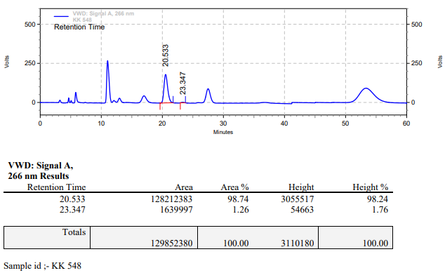

**KK-549**



**Calculation table:**

|  |  |  |  |  |  |
| --- | --- | --- | --- | --- | --- |
| Sr. No | Comp. | Mol. wt. | mmol | Eq. wt. | Wt. taken |
| 1 | Dehydrositagliptin (1) | 405.30 | 0.2135 | 100 | 86 mg |
| 2 | Rh(COD)2OTf | 468.30 | 0.0021 | 1 | 1 mg |
| 3 | L3 | 414.29 | 0.0042 | 2 | 2 mg |
| 4 | Ammonium chloride | 53.49 | 0.0213 | 10 | 1 mg |

**Procedure:** A glass vial (4 mL) equipped with Teflon coated magnetic needle was cooled under vacuum and transferred to a glove box. The vial was then charged with 86 mg of enamine (**1**), 1 mg of [Rh(COD)2OTf] (1 mol%), ligand (L12) and ammonium chloride. Reaction vial was then closed using screwcap, transferred to a large opening Schlenk type container and was then taken out from the glove box. 2 mL dry methanol was added to the vial in inert atmosphere and the resultant reaction slurry was stirred for 1 hour at room temperature (25°C). After that the reaction vial was shifted to an autoclave and the autoclave was purged three times using hydrogen gas (40 bars). Finally, the autoclave was pressurized to 10 bar hydrogen pressure at 70°C for 18 hrs time period. After the 18 hrs time period, the autoclave was cooled to room temperature (25°C), excess pressure was released and the autoclave was opened. The vials were taken out from the autoclave. The thus obtained reaction mixture was passed through neutral alumina bed, the filtrate was collect and dried to yield residue. The resultant residue was then analysed by HPLC.

**Reaction conditions:** Temp: 70°C Press.: 10 bar Solvent: Methanol Time: 18 hrs

**Result: 00%** conversion **00%** ee

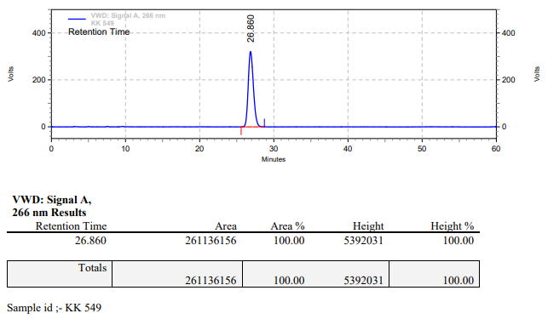

**KK-550**



**Calculation table:**

|  |  |  |  |  |  |
| --- | --- | --- | --- | --- | --- |
| Sr. No | Comp. | Mol. wt. | mmol | Eq. wt. | Wt. taken |
| 1 | Dehydrositagliptin (1) | 405.30 | 0.2135 | 100 | 86 mg |
| 2 | Rh(COD)2OTf | 468.30 | 0.0021 | 1 | 1 mg |
| 3 | L3 | 414.29 | 0.0042 | 2 | 2 mg |
| 4 | Ammonium chloride | 53.49 | 0.0213 | 10 | 1 mg |

**Procedure:** A glass vial (4 mL) equipped with Teflon coated magnetic needle was cooled under vacuum and transferred to a glove box. The vial was then charged with 86 mg of enamine (**1**), 1 mg of [Rh(COD)2OTf] (1 mol%), ligand (L12) and ammonium chloride. Reaction vial was then closed using screwcap, transferred to a large opening Schlenk type container and was then taken out from the glove box. 2 mL dry methanol was added to the vial in inert atmosphere and the resultant reaction slurry was stirred for 1 hour at room temperature (25°C). After that the reaction vial was shifted to an autoclave and the autoclave was purged three times using hydrogen gas (40 bars). Finally, the autoclave was pressurized to 20 bar hydrogen pressure at 70°C for 18 hrs time period. After the 18 hrs time period, the autoclave was cooled to room temperature (25°C), excess pressure was released and the autoclave was opened. The vials were taken out from the autoclave. The thus obtained reaction mixture was passed through neutral alumina bed, the filtrate was collect and dried to yield residue. The resultant residue was then analysed by HPLC.

**Reaction conditions:** Temp: 70°C Press.: 20 bar Solvent: Methanol Time: 18 hrs

**Result: 26%** conversion **85%** ee

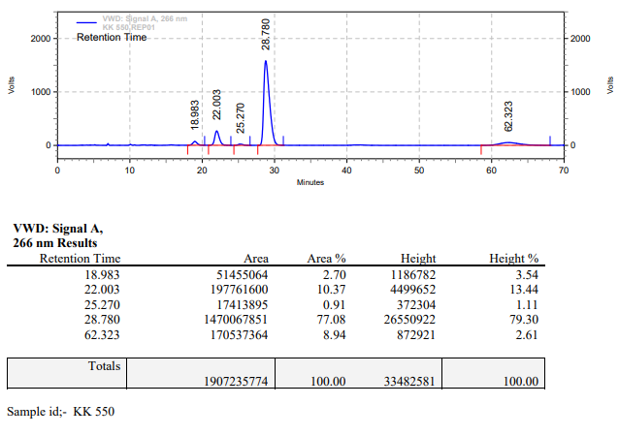

**KK-551**



**Calculation table:**

|  |  |  |  |  |  |
| --- | --- | --- | --- | --- | --- |
| Sr. No | Comp. | Mol. wt. | mmol | Eq. wt. | Wt. taken |
| 1 | Dehydrositagliptin (1) | 405.30 | 0.2135 | 100 | 86 mg |
| 2 | Rh(COD)2OTf | 468.30 | 0.0021 | 1 | 1 mg |
| 3 | L12 | 526.51 | 0.0021 | 1 | 1.1 mg |

**Procedure:** A glass vial (4 mL) equipped with Teflon coated magnetic needle was cooled under vacuum and transferred to a glove box. The vial was then charged with 86 mg of enamine (**1**), 1 mg of [Rh(COD)2OTf] (1 mol%) and ligand (L12). Reaction vial was then closed using screwcap, transferred to a large opening Schlenk type container and was then taken out from the glove box. 2 mL dry methanol was added to the vial in inert atmosphere and the resultant reaction slurry was stirred for 1 hour at room temperature (25°C). After that the reaction vial was shifted to an autoclave and the autoclave was purged three times using hydrogen gas (40 bars). Finally, the autoclave was pressurized to 30 bar hydrogen pressure at 60°C for 18 hrs time period. After the 18 hrs time period, the autoclave was cooled to room temperature (25°C), excess pressure was released and the autoclave was opened. The vials were taken out from the autoclave. The thus obtained reaction mixture was passed through neutral alumina bed, the filtrate was collect and dried to yield residue. The resultant residue was then analysed by HPLC.

**Reaction conditions:** Temp: 60°C Press.: 30 bar Solvent: Methanol Time: 18 hrs

**Result: 00%** conversion **00%** ee

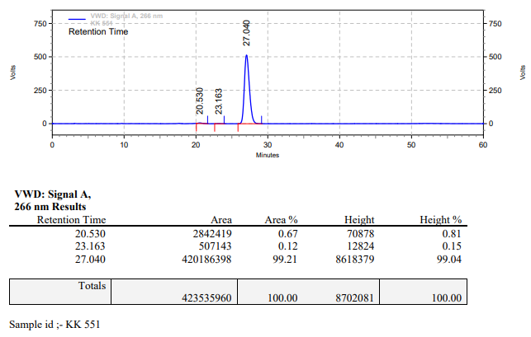

**KK-552**



**Calculation table:**

|  |  |  |  |  |  |
| --- | --- | --- | --- | --- | --- |
| Sr. No | Comp. | Mol. wt. | mmol | Eq. wt. | Wt. taken |
| 1 | Dehydrositagliptin (1) | 405.30 | 0.2135 | 100 | 86 mg |
| 2 | Rh(COD)2OTf | 468.30 | 0.0021 | 1 | 1 mg |
| 3 | L12 | 526.51 | 0.0021 | 1 | 1.1 mg |
| 4 | Salicylic acid | 138.12 | 0.0105 | 5 | 1.5 mg |

**Procedure:** A glass vial (4 mL) equipped with Teflon coated magnetic needle was cooled under vacuum and transferred to a glove box. The vial was then charged with 86 mg of enamine (**1**), 1 mg of [Rh(COD)2OTf] (1 mol%), ligand (L12) and salicylic acid. Reaction vial was then closed using screwcap, transferred to a large opening Schlenk type container and was then taken out from the glove box. 2 mL dry methanol was added to the vial in inert atmosphere and the resultant reaction slurry was stirred for 1 hour at room temperature (25°C). After that the reaction vial was shifted to an autoclave and the autoclave was purged three times using hydrogen gas (40 bars). Finally, the autoclave was pressurized to 30 bar hydrogen pressure at 60°C for 18 hrs time period. After the 18 hrs time period, the autoclave was cooled to room temperature (25°C), excess pressure was released and the autoclave was opened. The vials were taken out from the autoclave. The thus obtained reaction mixture was passed through neutral alumina bed, the filtrate was collect and dried to yield residue. The resultant residue was then analysed by HPLC.

**Reaction conditions:** Temp: 60°C Press.: 30 bar Solvent: Methanol Time: 18 hrs

**Result: 56%** conversion **82%** ee

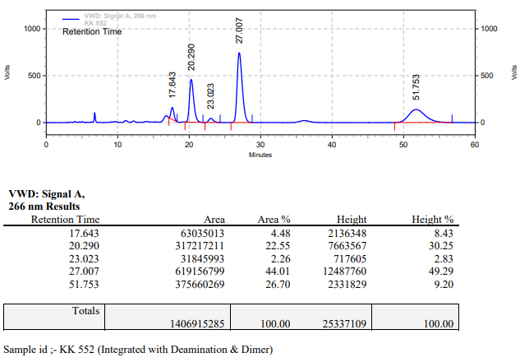

**KK-553**



**Calculation table:**

|  |  |  |  |  |  |
| --- | --- | --- | --- | --- | --- |
| Sr. No | Comp. | Mol. wt. | mmol | Eq. wt. | Wt. taken |
| 1 | Dehydrositagliptin (1) | 405.30 | 0.2135 | 100 | 86 mg |
| 2 | Rh(COD)2OTf | 468.30 | 0.0021 | 1 | 1 mg |
| 3 | L12 | 526.51 | 0.0021 | 1 | 1.1 mg |
| 4 | TFE | 100.04 | 0.0213 | 10 | 2 mg |

**Procedure:** A glass vial (4 mL) equipped with Teflon coated magnetic needle was cooled under vacuum and transferred to a glove box. The vial was then charged with 86 mg of enamine (**1**), 1 mg of [Rh(COD)2OTf] (1 mol%) and ligand (L12). Reaction vial was then closed using screwcap, transferred to a large opening Schlenk type container and was then taken out from the glove box. 2 mL dry methanol was added followed by trifluoroethanol to the vial in inert atmosphere and the resultant reaction slurry was stirred for 1 hour at room temperature (25°C). After that the reaction vial was shifted to an autoclave and the autoclave was purged three times using hydrogen gas (40 bars). Finally, the autoclave was pressurized to 30 bar hydrogen pressure at 60°C for 18 hrs time period. After the 18 hrs time period, the autoclave was cooled to room temperature (25°C), excess pressure was released and the autoclave was opened. The vials were taken out from the autoclave. The thus obtained reaction mixture was passed through neutral alumina bed, the filtrate was collect and dried to yield residue. The resultant residue was then analysed by HPLC.

**Reaction conditions:** Temp: 60°C Press.: 30 bar Solvent: Methanol Time: 18 hrs

**Result: 08%** conversion **69%** ee

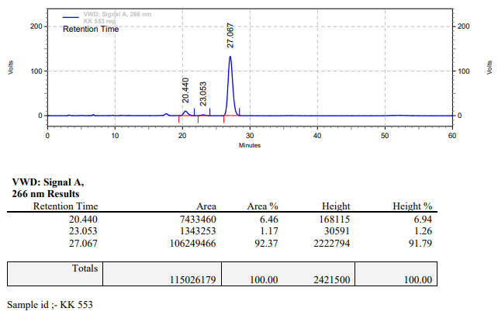

**KK-554**



**Calculation table:**

|  |  |  |  |  |  |
| --- | --- | --- | --- | --- | --- |
| Sr. No | Comp. | Mol. wt. | mmol | Eq. wt. | Wt. taken |
| 1 | Dehydrositagliptin (1) | 405.30 | 0.2135 | 100 | 86 mg |
| 2 | Rh(COD)2OTf | 468.30 | 0.0021 | 1 | 1 mg |
| 3 | L12 | 526.51 | 0.0021 | 1 | 1.1 mg |
| 4 | Salicylic acid | 138.12 | 0.0050 | 2.5 | 0.7 mg |

**Procedure:** A glass vial (4 mL) equipped with Teflon coated magnetic needle was cooled under vacuum and transferred to a glove box. The vial was then charged with 86 mg of enamine (**1**), 1 mg of [Rh(COD)2OTf] (1 mol%), ligand (L12) and salicylic acid. Reaction vial was then closed using screwcap, transferred to a large opening Schlenk type container and was then taken out from the glove box. 2 mL dry methanol was added to the vial in inert atmosphere and the resultant reaction slurry was stirred for 1 hour at room temperature (25°C). After that the reaction vial was shifted to an autoclave and the autoclave was purged three times using hydrogen gas (40 bars). Finally, the autoclave was pressurized to 30 bar hydrogen pressure at 50°C for 63 hrs time period. After the 63 hrs time period, the autoclave was cooled to room temperature (25°C), excess pressure was released and the autoclave was opened. The vials were taken out from the autoclave. The thus obtained reaction mixture was passed through neutral alumina bed, the filtrate was collect and dried to yield residue. The resultant residue was then analysed by HPLC.

**Reaction conditions:** Temp: 50°C Press.: 30 bar Solvent: Methanol Time: 63 hrs

**Result: 28%** conversion **88%** ee

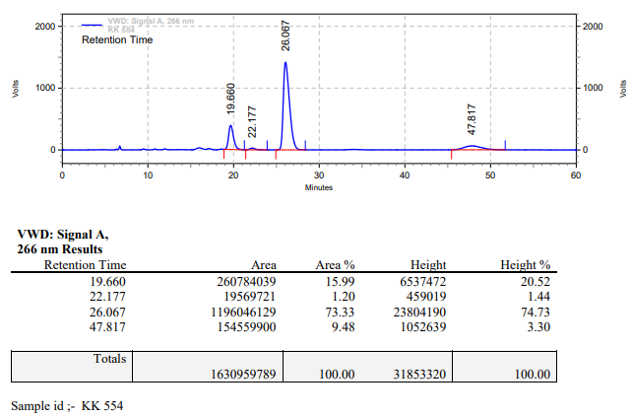

**KK-555**



**Calculation table:**

|  |  |  |  |  |  |
| --- | --- | --- | --- | --- | --- |
| Sr. No | Comp. | Mol. wt. | mmol | Eq. wt. | Wt. taken |
| 1 | Dehydrositagliptin (1) | 405.30 | 0.2135 | 100 | 86 mg |
| 2 | Rh(COD)2OTf | 468.30 | 0.0021 | 1 | 1 mg |
| 3 | L12 | 526.51 | 0.0021 | 1 | 1.1 mg |
| 4 | Salicylic acid | 138.12 | 0.0050 | 2.5 | 0.7 mg |

**Procedure:** A glass vial (4 mL) equipped with Teflon coated magnetic needle was cooled under vacuum and transferred to a glove box. The vial was then charged with 86 mg of enamine (**1**), 1 mg of [Rh(COD)2OTf] (1 mol%), ligand (L12) and salicylic acid. Reaction vial was then closed using screwcap, transferred to a large opening Schlenk type container and was then taken out from the glove box. 2 mL dry methanol was added to the vial in inert atmosphere and the resultant reaction slurry was stirred for 1 hour at room temperature (25°C). After that the reaction vial was shifted to an autoclave and the autoclave was purged three times using hydrogen gas (40 bars). Finally, the autoclave was pressurized to 30 bar hydrogen pressure at 50°C for 63 hrs time period. After the 63 hrs time period, the autoclave was cooled to room temperature (25°C), excess pressure was released and the autoclave was opened. The vials were taken out from the autoclave. The thus obtained reaction mixture was passed through neutral alumina bed, the filtrate was collect and dried to yield residue. The resultant residue was then analysed by HPLC.

**Reaction conditions:** Temp: 50°C Press.: 30 bar Solvent: Methanol Time: 63 hrs

**Result: 45%** conversion **88%** ee

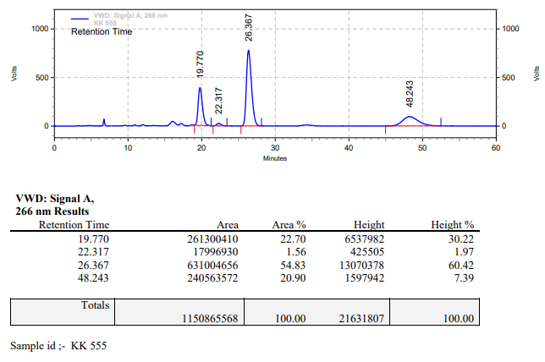

**KK-556**



**Calculation table:**

|  |  |  |  |  |  |
| --- | --- | --- | --- | --- | --- |
| Sr. No | Comp. | Mol. wt. | mmol | Eq. wt. | Wt. taken |
| 1 | Dehydrositagliptin (1) | 405.30 | 0.2135 | 100 | 86 mg |
| 2 | Rh(COD)2OTf | 468.30 | 0.0021 | 1 | 1 mg |
| 3 | L12 | 526.51 | 0.0021 | 1 | 1.1 mg |
| 4 | TFE | 100.04 | 0.0213 | 10 | 2 mg |

**Procedure:** A glass vial (4 mL) equipped with Teflon coated magnetic needle was cooled under vacuum and transferred to a glove box. The vial was then charged with 86 mg of enamine (**1**), 1 mg of [Rh(COD)2OTf] (1 mol%) and ligand (L12). Reaction vial was then closed using screwcap, transferred to a large opening Schlenk type container and was then taken out from the glove box. 2 mL dry methanol was added followed by trifluoroethanol to the vial in inert atmosphere and the resultant reaction slurry was stirred for 1 hour at room temperature (25°C). After that the reaction vial was shifted to an autoclave and the autoclave was purged three times using hydrogen gas (40 bars). Finally, the autoclave was pressurized to 30 bar hydrogen pressure at 60°C for 42 hrs time period. After the 42 hrs time period, the autoclave was cooled to room temperature (25°C), excess pressure was released and the autoclave was opened. The vials were taken out from the autoclave. The thus obtained reaction mixture was passed through neutral alumina bed, the filtrate was collect and dried to yield residue. The resultant residue was then analysed by HPLC.

**Reaction conditions:** Temp: 60°C Press.: 30 bar Solvent: Methanol Time: 42 hrs

**Result: 05%** conversion **72%** ee

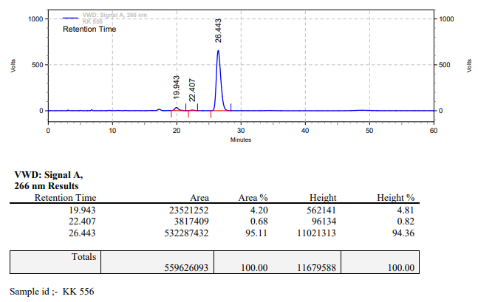

**KK-557**



**Calculation table:**

|  |  |  |  |  |  |
| --- | --- | --- | --- | --- | --- |
| Sr. No | Comp. | Mol. wt. | mmol | Eq. wt. | Wt. taken |
| 1 | Dehydrositagliptin (1) | 405.30 | 0.2135 | 100 | 86 mg |
| 2 | Rh(COD)2OTf | 468.30 | 0.0021 | 1 | 1 mg |
| 3 | L12 | 526.51 | 0.0021 | 1 | 1.1 mg |
| 4 | TFE | 100.04 | 0.0213 | 10 | 2 mg |

**Procedure:** A glass vial (4 mL) equipped with Teflon coated magnetic needle was cooled under vacuum and transferred to a glove box. The vial was then charged with 86 mg of enamine (**1**), 1 mg of [Rh(COD)2OTf] (1 mol%) and ligand (L12). Reaction vial was then closed using screwcap, transferred to a large opening Schlenk type container and was then taken out from the glove box. 2 mL dry methanol was added followed by trifluoroethanol to the vial in inert atmosphere and the resultant reaction slurry was stirred for 1 hour at room temperature (25°C). After that the reaction vial was shifted to an autoclave and the autoclave was purged three times using hydrogen gas (40 bars). Finally, the autoclave was pressurized to 30 bar hydrogen pressure at 60°C for 42 hrs time period. After the 42 hrs time period, the autoclave was cooled to room temperature (25°C), excess pressure was released and the autoclave was opened. The vials were taken out from the autoclave. The thus obtained reaction mixture was passed through neutral alumina bed, the filtrate was collect and dried to yield residue. The resultant residue was then analysed by HPLC.

**Reaction conditions:** Temp: 60°C Press.: 30 bar Solvent: Methanol Time: 42 hrs

**Result: 07%** conversion **72%** ee

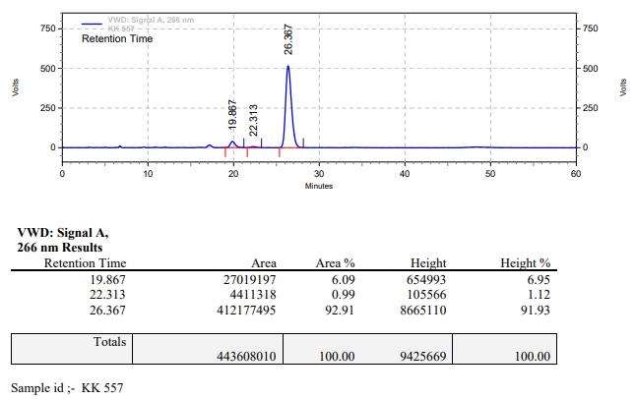

**KK-558**



**Calculation table:**

|  |  |  |  |  |  |
| --- | --- | --- | --- | --- | --- |
| Sr. No | Comp. | Mol. wt. | mmol | Eq. wt. | Wt. taken |
| 1 | Dehydrositagliptin (1) | 405.30 | 0.4112 | 200 | 173 mg |
| 2 | Rh(COD)2OTf | 468.30 | 0.0021 | 1 | 1 mg |
| 3 | L12 | 526.51 | 0.0021 | 1 | 1.1 mg |
| 4 | Salicylic acid | 138.12 | 0.4112 | 200 | 57 mg |

**Procedure:** A glass vial (4 mL) equipped with Teflon coated magnetic needle was cooled under vacuum and transferred to a glove box. The vial was then charged with 173 mg of enamine (**1**), 1 mg of [Rh(COD)2OTf] (0.5 mol%), ligand (L12) and salicylic acid. Reaction vial was then closed using screwcap, transferred to a large opening Schlenk type container and was then taken out from the glove box. 2 mL dry methanol was added to the vial in inert atmosphere and the resultant reaction slurry was stirred for 1 hour at room temperature (25°C). After that the reaction vial was shifted to an autoclave and the autoclave was purged three times using hydrogen gas (40 bars). Finally, the autoclave was pressurized to 30 bar hydrogen pressure at 50°C for 18 hrs time period. After the 18 hrs time period, the autoclave was cooled to room temperature (25°C), excess pressure was released and the autoclave was opened. The vials were taken out from the autoclave. The thus obtained reaction mixture was passed through neutral alumina bed, the filtrate was collect and dried to yield residue. The resultant residue was then analysed by HPLC.

**Reaction conditions:** Temp: 50°C Press.: 30 bar Solvent: Methanol Time: 18 hrs

**Result: 76%** conversion **94%** ee

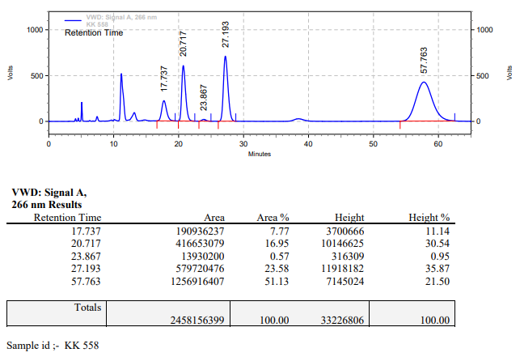

**KK-559**



**Calculation table:**

|  |  |  |  |  |  |
| --- | --- | --- | --- | --- | --- |
| Sr. No | Comp. | Mol. wt. | mmol | Eq. wt. | Wt. taken |
| 1 | Dehydrositagliptin (1) | 405.30 | 2.0000 | 1000 | 808.6 mg |
| 2 | Rh(COD)2OTf | 468.30 | 0.0021 | 1 | 1 mg |
| 3 | L12 | 526.51 | 0.0021 | 1 | 1.1 mg |
| 4 | Salicylic acid | 138.12 | 0.4112 | 200 | 57 mg |

**Procedure:** A glass vial (15 mL) equipped with Teflon coated magnetic needle was cooled under vacuum and transferred to a glove box. The vial was then charged with 808.6 mg of enamine (**1**), 1 mg of [Rh(COD)2OTf] (0.001 mol%), ligand (L12) and salicylic acid. Reaction vial was then closed using screwcap, transferred to a large opening Schlenk type container and was then taken out from the glove box. 10 mL dry methanol was added to the vial in inert atmosphere and the resultant reaction slurry was stirred for 1 hour at room temperature (25°C). After that the reaction vial was shifted to an autoclave and the autoclave was purged three times using hydrogen gas (40 bars). Finally, the autoclave was pressurized to 30 bar hydrogen pressure at 50°C for 18 hrs time period. After the 18 hrs time period, the autoclave was cooled to room temperature (25°C), excess pressure was released and the autoclave was opened. The vials were taken out from the autoclave. The thus obtained reaction mixture was passed through neutral alumina bed, the filtrate was collect and dried to yield residue. The resultant residue was then analysed by HPLC.

**Reaction conditions:** Temp: 50°C Press.: 30 bar Solvent: Methanol Time: 18 hrs

**Result: 00%** conversion **00%** ee

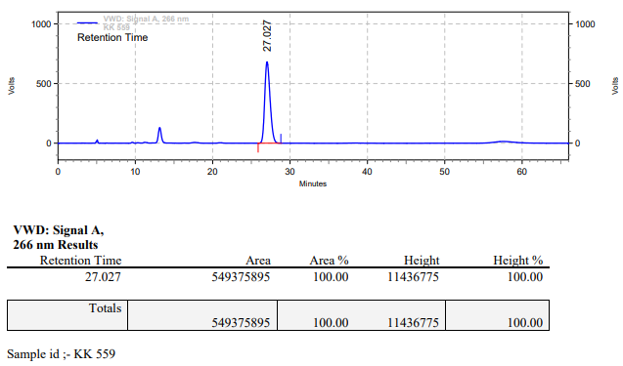

**KK-560**



**Calculation table:**

|  |  |  |  |  |  |
| --- | --- | --- | --- | --- | --- |
| Sr. No | Comp. | Mol. wt. | mmol | Eq. wt. | Wt. taken |
| 1 | Dehydrositagliptin (1) | 405.30 | 0.4112 | 200 | 173 mg |
| 2 | Rh(COD)2OTf | 468.30 | 0.0021 | 1 | 1 mg |
| 3 | L12 | 526.51 | 0.0021 | 1 | 1.1 mg |
| 4 | Salicylic acid | 138.12 | 0.0050 | 2.5 | 0.7 mg |

**Procedure:** A glass vial (4 mL) equipped with Teflon coated magnetic needle was cooled under vacuum and transferred to a glove box. The vial was then charged with 173 mg of enamine (**1**), 1 mg of [Rh(COD)2OTf] (0.5 mol%), ligand (L12) and salicylic acid. Reaction vial was then closed using screwcap, transferred to a large opening Schlenk type container and was then taken out from the glove box. 2 mL dry methanol was added to the vial in inert atmosphere and the resultant reaction slurry was stirred for 1 hour at room temperature (25°C). After that the reaction vial was shifted to an autoclave and the autoclave was purged three times using hydrogen gas (40 bars). Finally, the autoclave was pressurized to 30 bar hydrogen pressure at 50°C for 72 hrs time period. After the 72 hrs time period, the autoclave was cooled to room temperature (25°C), excess pressure was released and the autoclave was opened. The vials were taken out from the autoclave. The thus obtained reaction mixture was passed through neutral alumina bed, the filtrate was collect and dried to yield residue. The resultant residue was then analysed by HPLC.

**Reaction conditions:** Temp: 50°C Press.: 30 bar Solvent: Methanol Time: 72 hrs

**Result: 35%** conversion **80%** ee

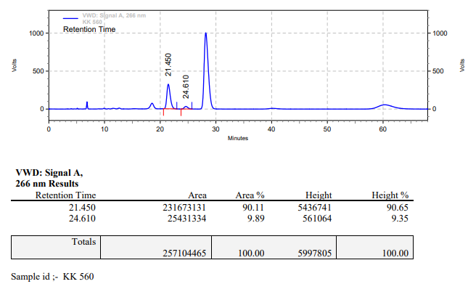

**KK-561**



**Calculation table:**

|  |  |  |  |  |  |
| --- | --- | --- | --- | --- | --- |
| Sr. No | Comp. | Mol. wt. | mmol | Eq. wt. | Wt. taken |
| 1 | Dehydrositagliptin (1) | 405.30 | 2.0000 | 1000 | 808.6 mg |
| 2 | Rh(COD)2OTf | 468.30 | 0.0021 | 1 | 1 mg |
| 3 | L12 | 526.51 | 0.0021 | 1 | 1.1 mg |
| 4 | Salicylic acid | 138.12 | 0.0050 | 2.5 | 0.7 mg |

**Procedure:** A glass vial (15 mL) equipped with Teflon coated magnetic needle was cooled under vacuum and transferred to a glove box. The vial was then charged with 808.6 mg of enamine (**1**), 1 mg of [Rh(COD)2OTf] (0.001 mol%), ligand (L12) and salicylic acid. Reaction vial was then closed using screwcap, transferred to a large opening Schlenk type container and was then taken out from the glove box. 10 mL dry methanol was added to the vial in inert atmosphere and the resultant reaction slurry was stirred for 1 hour at room temperature (25°C). After that the reaction vial was shifted to an autoclave and the autoclave was purged three times using hydrogen gas (40 bars). Finally, the autoclave was pressurized to 30 bar hydrogen pressure at 50°C for 72 hrs time period. After the 72 hrs time period, the autoclave was cooled to room temperature (25°C), excess pressure was released and the autoclave was opened. The vials were taken out from the autoclave. The thus obtained reaction mixture was passed through neutral alumina bed, the filtrate was collect and dried to yield residue. The resultant residue was then analysed by HPLC.

**Reaction conditions:** Temp: 50°C Press.: 30 bar Solvent: Methanol Time: 72 hrs

**Result: 00%** conversion **00%** ee

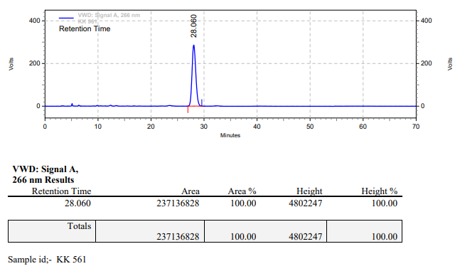

**KK-562**



**Calculation table:**

|  |  |  |  |  |  |
| --- | --- | --- | --- | --- | --- |
| Sr. No | Comp. | Mol. wt. | mmol | Eq. wt. | Wt. taken |
| 1 | Dehydrositagliptin (1) | 405.30 | 0.2135 | 100 | 86 mg |
| 2 | Rh(COD)2OTf | 468.30 | 0.0021 | 1 | 1 mg |
| 3 | L12 | 526.51 | 0.0042 | 2 | 2.2 mg |
| 4 | Salicylic acid | 138.12 | 0.4260 | 200 | 58 mg |

**Procedure:** A glass vial (4 mL) equipped with Teflon coated magnetic needle was cooled under vacuum and transferred to a glove box. The vial was then charged with 86 mg of enamine (**1**), 1 mg of [Rh(COD)2OTf] (1 mol%), ligand (L12) and salicylic acid. Reaction vial was then closed using screwcap, transferred to a large opening Schlenk type container and was then taken out from the glove box. 2 mL dry methanol was added to the vial in inert atmosphere and the resultant reaction slurry was stirred for 1 hour at room temperature (25°C). After that the reaction vial was shifted to an autoclave and the autoclave was purged three times using hydrogen gas (40 bars). Finally, the autoclave was pressurized to 10 bar hydrogen pressure at 50°C for 18 hrs time period. After the 18hrs time period, the autoclave was cooled to room temperature (25°C), excess pressure was released and the autoclave was opened. The vials were taken out from the autoclave. The thus obtained reaction mixture was passed through neutral alumina bed, the filtrate was collect and dried to yield residue. The resultant residue was then analysed by HPLC.

**Reaction conditions:** Temp: 50°C Press.: 10 bar Solvent: Methanol Time: 18 hrs

**Result: 81%** conversion **94%** ee

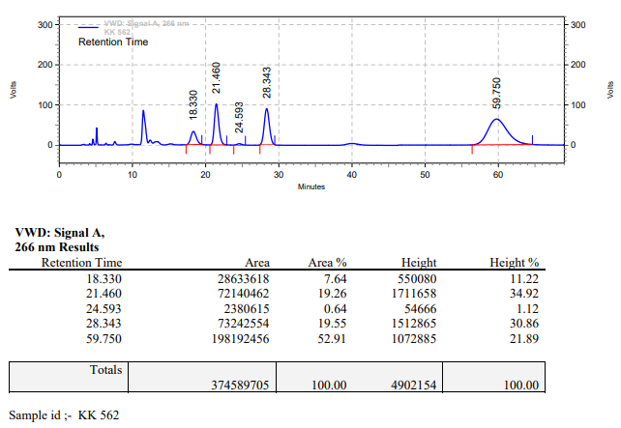

**KK-563**



**Calculation table:**

|  |  |  |  |  |  |
| --- | --- | --- | --- | --- | --- |
| Sr. No | Comp. | Mol. wt. | mmol | Eq. wt. | Wt. taken |
| 1 | Dehydrositagliptin (1) | 405.30 | 0.2135 | 1 | 86 mg |
| 2 | Rh(COD)2OTf | 468.30 | 0.0106 | 5 mol% | 5 mg |
| 3 | L12 | 526.51 | 0.0213 | 10 mol% | 11 mg |
| 4 | Salicylic acid | 138.12 | 0.3201 | 150 mol% | 44 mg |

**Procedure:** A glass vial (15 mL) equipped with Teflon coated magnetic needle was cooled under vacuum and transferred to a glove box. The vial was then charged with 86 mg of enamine (**1**), 1 mg of [Rh(COD)2OTf], ligand (L12) and salicylic acid. Reaction vial was then closed using screwcap, transferred to a large opening Schlenk type container and was then taken out from the glove box. 10 mL dry methanol was added to the vial in inert atmosphere and the resultant reaction slurry was stirred for 1 hour at room temperature (25°C). After that the reaction vial was shifted to an autoclave and the autoclave was purged three times using hydrogen gas (40 bars). Finally, the autoclave was pressurized to 30 bar hydrogen pressure at 50°C for 3 hrs time period. After the 3 hrs time period, the autoclave was cooled to room temperature (25°C), excess pressure was released and the autoclave was opened. The vials were taken out from the autoclave. The thus obtained reaction mixture was passed through neutral alumina bed, the filtrate was collect and dried to yield residue. The resultant residue was then analysed by HPLC.

**Reaction conditions:** Temp: 50°C Press.: 30 bar Solvent: Methanol Time: 3 hrs

**Result: 98%** conversion **94%** ee

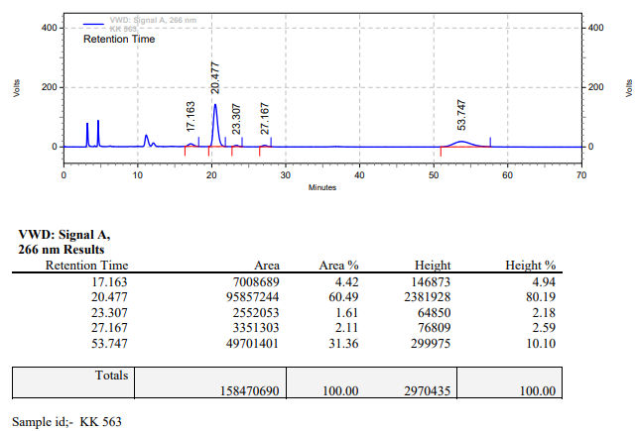

**KK-564**



**Calculation table:**

|  |  |  |  |  |  |
| --- | --- | --- | --- | --- | --- |
| Sr. No | Comp. | Mol. wt. | mmol | Eq. wt. | Wt. taken |
| 1 | Dehydrositagliptin (1) | 405.30 | 0.2135 | 1 | 86 mg |
| 2 | Rh(COD)2OTf | 468.30 | 0.0106 | 5 mol% | 5 mg |
| 3 | L12 | 526.51 | 0.0213 | 10 mol% | 11 mg |
| 4 | Salicylic acid | 138.12 | 0.3201 | 150 mol% | 44 mg |

**Procedure:** A glass vial (15 mL) equipped with Teflon coated magnetic needle was cooled under vacuum and transferred to a glove box. The vial was then charged with 86 mg of enamine (**1**), 1 mg of [Rh(COD)2OTf], ligand (L12) and salicylic acid. Reaction vial was then closed using screwcap, transferred to a large opening Schlenk type container and was then taken out from the glove box. 2 mL dry methanol was added to the vial in inert atmosphere and the resultant reaction slurry was stirred for 1 hour at room temperature (25°C). After that the reaction vial was shifted to an autoclave and the autoclave was purged three times using hydrogen gas (40 bars). Finally, the autoclave was pressurized to 30 bar hydrogen pressure at 50°C for 3 hrs time period. After the 3 hrs time period, the autoclave was cooled to room temperature (25°C), excess pressure was released and the autoclave was opened. The vials were taken out from the autoclave. The thus obtained reaction mixture was passed through neutral alumina bed, the filtrate was collect and dried to yield residue. The resultant residue was then analysed by HPLC.

**Reaction conditions:** Temp: 50°C Press.: 30 bar Solvent: Methanol Time: 3 hrs

**Result: 99%** conversion **94%** ee

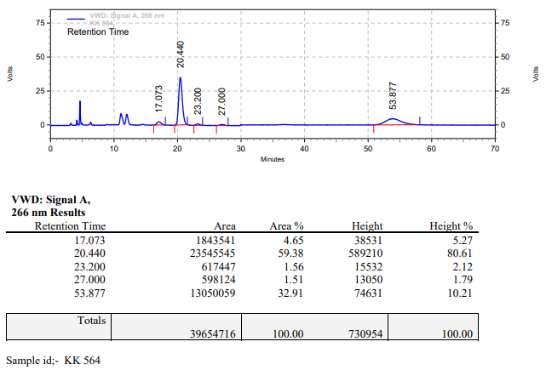

**KK-565**



**Calculation table:**

|  |  |  |  |  |  |
| --- | --- | --- | --- | --- | --- |
| Sr. No | Comp. | Mol. wt. | mmol | Eq. wt. | Wt. taken |
| 1 | Dehydrositagliptin (1) | 405.30 | 0.2135 | 100 | 86 mg |
| 2 | Rh(COD)2OTf | 468.30 | 0.0021 | 1 | 1 mg |
| 3 | L12 | 526.51 | 0.0042 | 2 | 2.2 mg |
| 4 | Salicylic acid | 138.12 | 0.6300 | 300 | 87 mg |

**Procedure:** A glass vial (15 mL) equipped with Teflon coated magnetic needle was cooled under vacuum and transferred to a glove box. The vial was then charged with 86 mg of enamine (**1**), 1 mg of [Rh(COD)2OTf] (1 mol%), ligand (L12) and salicylic acid. Reaction vial was then closed using screwcap, transferred to a large opening Schlenk type container and was then taken out from the glove box. 2 mL dry methanol was added to the vial in inert atmosphere and the resultant reaction slurry was stirred for 1 hour at room temperature (25°C). After that the reaction vial was shifted to an autoclave and the autoclave was purged three times using hydrogen gas (40 bars). Finally, the autoclave was pressurized to 30 bar hydrogen pressure at 50°C for 24 hrs time period. After the 24 hrs time period, the autoclave was cooled to room temperature (25°C), excess pressure was released and the autoclave was opened. The vials were taken out from the autoclave. The thus obtained reaction mixture was passed through neutral alumina bed, the filtrate was collect and dried to yield residue. The resultant residue was then analysed by TLC, only starting was present.

**Reaction conditions:** Temp: 50°C Press.: 30 bar Solvent: Methanol Time: 24 hrs

**Result: 00%** conversion **00%** ee

**KK-566**



**Calculation table:**

|  |  |  |  |  |  |
| --- | --- | --- | --- | --- | --- |
| Sr. No | Comp. | Mol. wt. | mmol | Eq. wt. | Wt. taken |
| 1 | Dehydrositagliptin (1) | 405.30 | 0.8656 | 1 | 350 mg |
| 2 | Rh(COD)2OTf | 468.30 | 0.0021 | 0.25 | 1 mg |
| 3 | L12 | 526.51 | 0.0021 | 0.25 | 1.1 mg |
| 4 | Salicylic acid | 138.12 | 0.8656 | 1 | 119 mg |

**Procedure:** A glass vial (15 mL) equipped with Teflon coated magnetic needle was cooled under vacuum and transferred to a glove box. The vial was then charged with 350 mg of enamine (**1**), 1 mg of [Rh(COD)2OTf], ligand (L12) and salicylic acid. Reaction vial was then closed using screwcap, transferred to a large opening Schlenk type container and was then taken out from the glove box. 2 mL dry methanol was added to the vial in inert atmosphere and the resultant reaction slurry was stirred for 1 hour at room temperature (25°C). After that the reaction vial was shifted to an autoclave and the autoclave was purged three times using hydrogen gas (40 bars). Finally, the autoclave was pressurized to 30 bar hydrogen pressure at 50°C for 18 hrs time period. After the 18 hrs time period, the autoclave was cooled to room temperature (25°C), excess pressure was released and the autoclave was opened. The vials were taken out from the autoclave. The thus obtained reaction mixture was passed through neutral alumina bed, the filtrate was collect and dried to yield residue. The resultant residue was then analysed by HPLC.

**Reaction conditions:** Temp: 50°C Press.: 30 bar Solvent: Methanol Time: 18 hrs

**Result: 48%** conversion **96%** ee

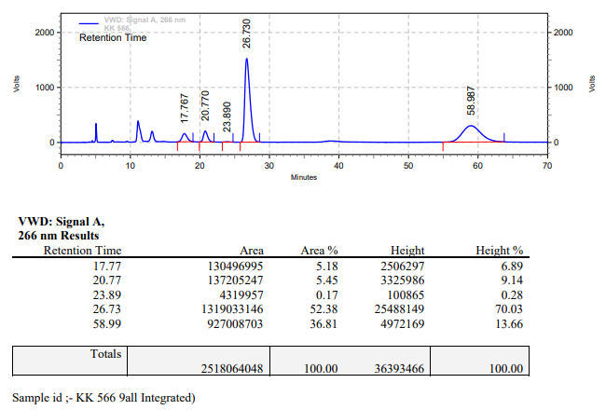

**KK-567**



**Calculation table:**

|  |  |  |  |  |  |
| --- | --- | --- | --- | --- | --- |
| Sr. No | Comp. | Mol. wt. | mmol | Eq. wt. | Wt. taken |
| 1 | Dehydrositagliptin (1) | 405.30 | 0.4270 | 200 | 173 mg |
| 2 | Rh(COD)2OTf | 468.30 | 0.0021 | 1 | 1 mg |
| 3 | L12 | 526.51 | 0.0021 | 1 | 1.1 mg |
| 4 | Salicylic acid | 138.12 | 0.2135 | 100 | 29 mg |

**Procedure:** A glass vial (15 mL) equipped with Teflon coated magnetic needle was cooled under vacuum and transferred to a glove box. The vial was then charged with 173 mg of enamine (**1**), 1 mg of [Rh(COD)2OTf] (0.5 mol%), ligand (L12) and salicylic acid. Reaction vial was then closed using screwcap, transferred to a large opening Schlenk type container and was then taken out from the glove box. 2 mL dry methanol was added to the vial in inert atmosphere and the resultant reaction slurry was stirred for 1 hour at room temperature (25°C). After that the reaction vial was shifted to an autoclave and the autoclave was purged three times using hydrogen gas (40 bars). Finally, the autoclave was pressurized to 30 bar hydrogen pressure at 50°C for 18 hrs time period. After the 18 hrs time period, the autoclave was cooled to room temperature (25°C), excess pressure was released and the autoclave was opened. The vials were taken out from the autoclave. The thus obtained reaction mixture was passed through neutral alumina bed, the filtrate was collect and dried to yield residue. The resultant residue was then analysed by HPLC.

**Reaction conditions:** Temp: 50°C Press.: 30 bar Solvent: Methanol Time: 18 hrs

**Result: 59%** conversion **94%** ee

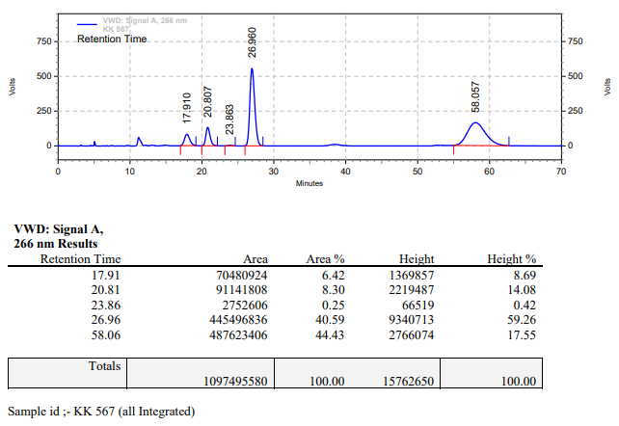

**KK-568**



**Calculation table:**

|  |  |  |  |  |  |
| --- | --- | --- | --- | --- | --- |
| Sr. No | Comp. | Mol. wt. | mmol | Eq. wt. | Wt. taken |
| 1 | Dehydrositagliptin (1) | 405.30 | 0.2135 | 100 | 86 mg |
| 2 | Rh(COD)2OTf | 468.30 | 0.0021 | 1 | 1 mg |
| 3 | L12 | 526.51 | 0.0042 | 2 | 2.2 mg |
| 4 | Salicylic acid | 138.12 | 0.2135 | 100 | 29 mg |

**Procedure:** A glass vial (15 mL) equipped with Teflon coated magnetic needle was cooled under vacuum and transferred to a glove box. The vial was then charged with 86 mg of enamine (**1**), 1 mg of [Rh(COD)2OTf] (1 mol%), ligand (L12) and salicylic acid. Reaction vial was then closed using screwcap, transferred to a large opening Schlenk type container and was then taken out from the glove box. 2 mL dry methanol was added to the vial in inert atmosphere and the resultant reaction slurry was stirred for 1 hour at room temperature (25°C). After that the reaction vial was shifted to an autoclave and the autoclave was purged three times using hydrogen gas (40 bars). Finally, the autoclave was pressurized to 30 bar hydrogen pressure at 50°C for 18 hrs time period. After the 18 hrs time period, the autoclave was cooled to room temperature (25°C), excess pressure was released and the autoclave was opened. The vials were taken out from the autoclave. The thus obtained reaction mixture was passed through neutral alumina bed, the filtrate was collect and dried to yield residue. The resultant residue was then analysed by HPLC.

**Reaction conditions:** Temp: 50°C Press.: 30 bar Solvent: Methanol Time: 18 hrs

**Result: 89%** conversion **94%** ee

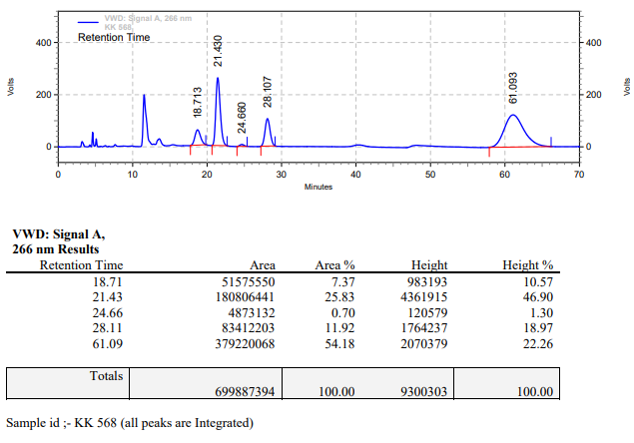

**KK-569**



**Calculation table:**

|  |  |  |  |  |  |
| --- | --- | --- | --- | --- | --- |
| Sr. No | Comp. | Mol. wt. | mmol | Eq. wt. | Wt. taken |
| 1 | Dehydrositagliptin (1) | 405.30 | 0.2135 | 100 | 86 mg |
| 2 | Rh(COD)2OTf | 468.30 | 0.0021 | 1 | 1 mg |
| 3 | L12 | 526.51 | 0.0042 | 2 | 2.2 mg |
| 4 | Salicylic acid | 138.12 | 0.2135 | 100 | 29 mg |
| 5 | tBu bicarbonate | 218.25 | 0.2135 | 100 | 46 mg |

**Procedure:** A glass vial (4 mL) equipped with Teflon coated magnetic needle was cooled under vacuum and transferred to a glove box. The vial was then charged with 86 mg of enamine (**1**), 1 mg of [Rh(COD)2OTf] (1 mol%), ligand (L12) and salicylic acid. Reaction vial was then closed using screwcap, transferred to a large opening Schlenk type container and was then taken out from the glove box. 2 mL dry methanol was added followed by tBu-bicarbonate to the vial in inert atmosphere and the resultant reaction slurry was stirred for 1 hour at room temperature (25°C). After that the reaction vial was shifted to an autoclave and the autoclave was purged three times using hydrogen gas (40 bars). Finally, the autoclave was pressurized to 30 bar hydrogen pressure at 50°C for 18 hrs time period. After the 18 hrs time period, the autoclave was cooled to room temperature (25°C), excess pressure was released and the autoclave was opened. The vials were taken out from the autoclave. The thus obtained reaction mixture was passed through neutral alumina bed, the filtrate was collect and dried to yield residue. The resultant residue was then analysed by HPLC.

**Reaction conditions:** Temp: 50°C Press.: 30 bar Solvent: Methanol Time: 18 hrs

**Result: 92%** conversion **95%** ee

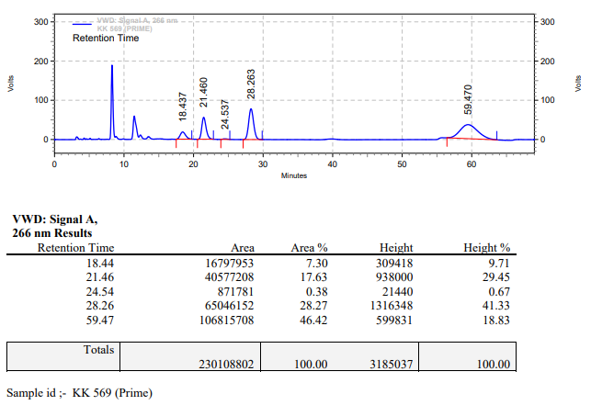

**KK-570**



**Calculation table:**

|  |  |  |  |  |  |
| --- | --- | --- | --- | --- | --- |
| Sr. No | Comp. | Mol. wt. | mmol | Eq. wt. | Wt. taken |
| 1 | Dehydrositagliptin (1) | 405.30 | 0.2135 | 100 | 86 mg |
| 2 | Rh(COD)2OTf | 468.30 | 0.0021 | 1 | 1 mg |
| 3 | L12 | 526.51 | 0.0042 | 2 | 2.2 mg |
| 4 | Salicylic acid | 138.12 | 0.2135 | 100 | 29 mg |
| 5 | Ethyl acetate | 88.10 | 0.2135 | 100 | 19 mg |

**Procedure:** A glass vial (4 mL) equipped with Teflon coated magnetic needle was cooled under vacuum and transferred to a glove box. The vial was then charged with 86 mg of enamine (**1**), 1 mg of [Rh(COD)2OTf] (1 mol%), ligand (L12) and salicylic acid. Reaction vial was then closed using screwcap, transferred to a large opening Schlenk type container and was then taken out from the glove box. 2 mL dry methanol was added followed by ethyl acetate to the vial in inert atmosphere and the resultant reaction slurry was stirred for 1 hour at room temperature (25°C). After that the reaction vial was shifted to an autoclave and the autoclave was purged three times using hydrogen gas (40 bars). Finally, the autoclave was pressurized to 30 bar hydrogen pressure at 50°C for 18 hrs time period. After the 18 hrs time period, the autoclave was cooled to room temperature (25°C), excess pressure was released and the autoclave was opened. The vials were taken out from the autoclave. The thus obtained reaction mixture was passed through neutral alumina bed, the filtrate was collect and dried to yield residue. The resultant residue was then analysed by HPLC.

**Reaction conditions:** Temp: 50°C Press.: 30 bar Solvent: Methanol Time: 18 hrs

**Result: 85%** conversion **95%** ee

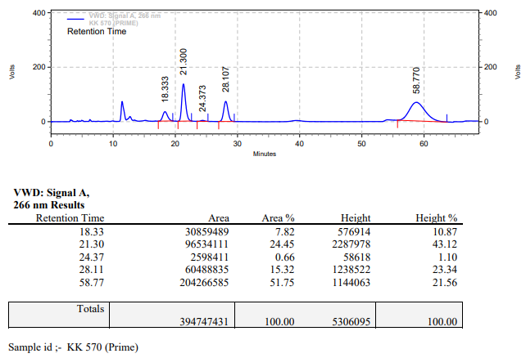

**KK-571**



**Calculation table:**

|  |  |  |  |  |  |
| --- | --- | --- | --- | --- | --- |
| Sr. No | Comp. | Mol. wt. | mmol | Eq. wt. | Wt. taken |
| 1 | Dehydrositagliptin (1) | 405.30 | 0.2135 | 100 | 86 mg |
| 2 | Rh(COD)2OTf | 468.30 | 0.0021 | 1 | 1 mg |
| 3 | L12 | 526.51 | 0.0042 | 2 | 2.2 mg |
| 4 | tBu bicarbonate | 218.25 | 0.2135 | 100 | 46 mg |

**Procedure:** A glass vial (4 mL) equipped with Teflon coated magnetic needle was cooled under vacuum and transferred to a glove box. The vial was then charged with 86 mg of enamine (**1**), 1 mg of [Rh(COD)2OTf] (1 mol%) and ligand (L12). Reaction vial was then closed using screwcap, transferred to a large opening Schlenk type container and was then taken out from the glove box. 2 mL dry methanol was added followed by tBu-bicarbonate to the vial in inert atmosphere and the resultant reaction slurry was stirred for 1 hour at room temperature (25°C). After that the reaction vial was shifted to an autoclave and the autoclave was purged three times using hydrogen gas (40 bars). Finally, the autoclave was pressurized to 30 bar hydrogen pressure at 50°C for 18 hrs time period. After the 18 hrs time period, the autoclave was cooled to room temperature (25°C), excess pressure was released and the autoclave was opened. The vials were taken out from the autoclave. The thus obtained reaction mixture was passed through neutral alumina bed, the filtrate was collect and dried to yield residue. The resultant residue was then analysed by HPLC.

**Reaction conditions:** Temp: 50°C Press.: 30 bar Solvent: Methanol Time: 18 hrs

**Result: 05%** conversion **91%** ee

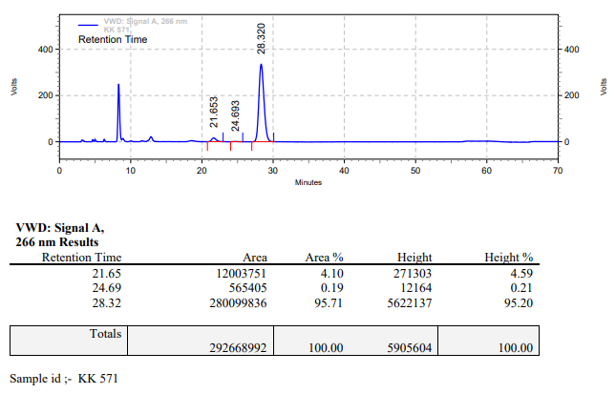

**KK-572**



**Calculation table:**

|  |  |  |  |  |  |
| --- | --- | --- | --- | --- | --- |
| Sr. No | Comp. | Mol. wt. | mmol | Eq. wt. | Wt. taken |
| 1 | Dehydrositagliptin (1) | 405.30 | 0.2135 | 100 | 86 mg |
| 2 | Rh(COD)2OTf | 468.30 | 0.0021 | 1 | 1 mg |
| 3 | L12 | 526.51 | 0.0042 | 2 | 2.2 mg |
| 4 | Ethyl acetate | 88.10 | 0.2135 | 100 | 19 mg |

**Procedure:** A glass vial (4 mL) equipped with Teflon coated magnetic needle was cooled under vacuum and transferred to a glove box. The vial was then charged with 86 mg of enamine (**1**), 1 mg of [Rh(COD)2OTf] (1 mol%) and ligand (L12). Reaction vial was then closed using screwcap, transferred to a large opening Schlenk type container and was then taken out from the glove box. 2 mL dry methanol was added followed by ethyl acetate to the vial in inert atmosphere and the resultant reaction slurry was stirred for 1 hour at room temperature (25°C). After that the reaction vial was shifted to an autoclave and the autoclave was purged three times using hydrogen gas (40 bars). Finally, the autoclave was pressurized to 30 bar hydrogen pressure at 50°C for 18 hrs time period. After the 18 hrs time period, the autoclave was cooled to room temperature (25°C), excess pressure was released and the autoclave was opened. The vials were taken out from the autoclave. The thus obtained reaction mixture was passed through neutral alumina bed, the filtrate was collect and dried to yield residue. The resultant residue was then analysed by HPLC.

**Reaction conditions:** Temp: 50°C Press.: 30 bar Solvent: Methanol Time: 18 hrs

**Result: 05%** conversion **86%** ee

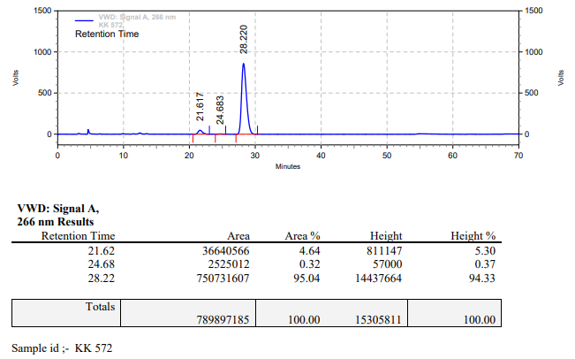

**KK-593**



**Calculation table:**

|  |  |  |  |  |  |
| --- | --- | --- | --- | --- | --- |
| Sr. No | Comp. | Mol. wt. | mmol | Eq. wt. | Wt. taken |
| 1 | Dehydrositagliptin (1) | 405.30 | 12.3380 | 1 | 5000 mg |
| 2 | Rh(COD)2OTf | 468.30 | 0.2473 | 2 mol% | 115 mg |
| 3 | L12 | 526.51 | 0.2968 | 2.4 mol% | 156 mg |
| 4 | Salicylic acid | 138.12 | 12.3380 | 1 | 1707 mg |

**Procedure:** A high pressure Parr reactor (450 mL) equipped with overhead stirring was charged with 5 g of enamine (**1**) under argon atmosphere. Subsequently, 115 mg of [Rh(COD)2­OTf], 156 mg of ligand **L12** and 1707 mg of salicylic acid was added to the above reactor. 100 mL dry methanol was added to the reactor in inert atmosphere and the resultant reaction slurry was stirred for 1 hour at room temperature (25 °C). After that the autoclave was purged three times using hydrogen gas (40 bar). Finally, the autoclave was pressurized to 30 bar hydrogen pressure and was heated to 45 °C for 4.5 hrs. After 4.5 hrs, the autoclave was cooled to room temperature (25 °C), excess pressure was released and the autoclave was opened. A sample (0.5 ml) was taken out for HPLC and the remaining content was purified by column chromatography (the column was flushed with 100 mL ethyl acetate, followed by 90:10, DCM:Methanol) to yield of sitagliptin free base (**2**).

**Reaction conditions:** Temp: 45°C Press.: 30 bar Solvent: Methanol Time: 4.5 hrs

**Result: 96%** conversion **96%** ee

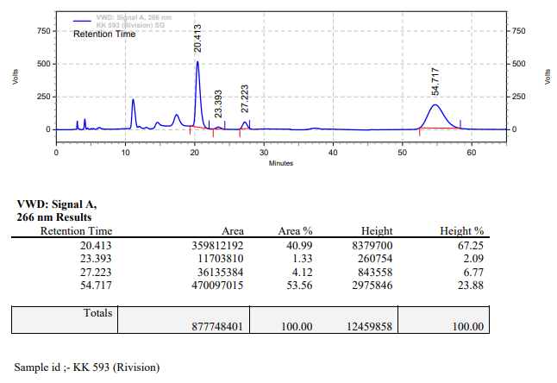

**KK-594**



**Calculation table:**

|  |  |  |  |  |  |
| --- | --- | --- | --- | --- | --- |
| Sr. No | Comp. | Mol. wt. | mmol | Eq. wt. | Wt. taken |
| 1 | Dehydrositagliptin (1) | 405.30 | 4.9468 | 1 | 2000 mg |
| 2 | Rh(COD)2OTf | 468.30 | 0.2473 | 5 mol% | 115 mg |
| 3 | L12 | 526.51 | 0.2968 | 6 mol% | 156 mg |
| 4 | Salicylic acid | 138.12 | 4.9468 | 1 | 683 mg |

**Procedure:** A high pressure Parr reactor (450 mL) equipped with overhead stirring was charged with 2 g of enamine (**1**) under argon atmosphere. Subsequently, 115 mg of [Rh(COD)2­OTf], 156 mg of ligand **L12** and 683 mg of salicylic acid was added to the above reactor. 40 mL dry methanol was added to the reactor in inert atmosphere and the resultant reaction slurry was stirred for 1 hour at room temperature (25 °C). After that the autoclave was purged three times using hydrogen gas (40 bar). Finally, the autoclave was pressurized to 30 bar hydrogen pressure and was heated to 45 °C for 4.5 hrs. After 4.5 hrs, the autoclave was cooled to room temperature (25 °C), excess pressure was released and the autoclave was opened. A sample (0.5 ml) was taken out for HPLC and the remaining content was purified by column chromatography (the column was flushed with 100 mL ethyl acetate, followed by 90:10, DCM:Methanol) to yield of sitagliptin free base (**2**).

**Reaction conditions:** Temp: 45°C Press.: 30 bar Solvent: Methanol Time: 4.5 hrs

**Result: 32%** conversion **98%** ee

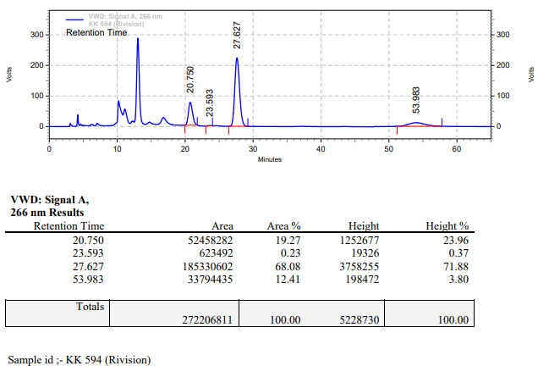

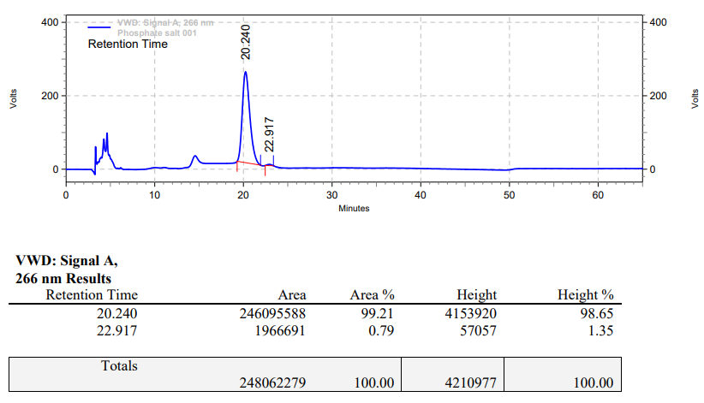

HPLC chromatogram of sitagliptin-phosphate salt.

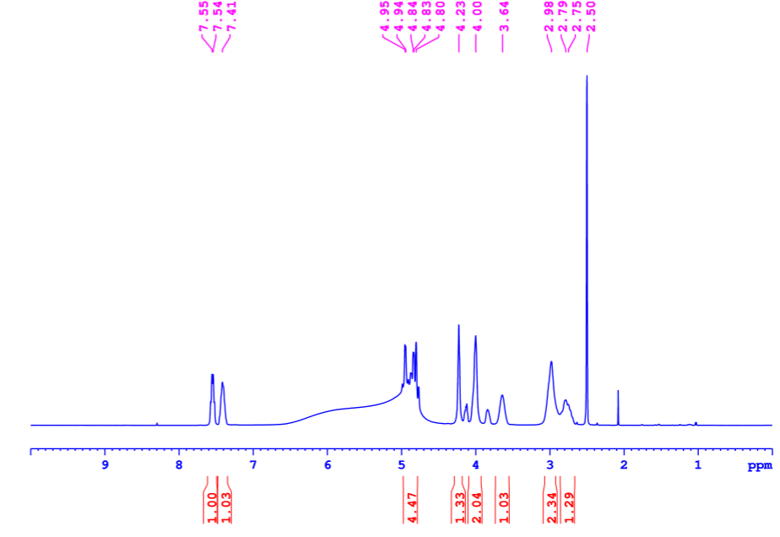

1H NMR of sitagliptin-phosphate salt in DMSO-d6

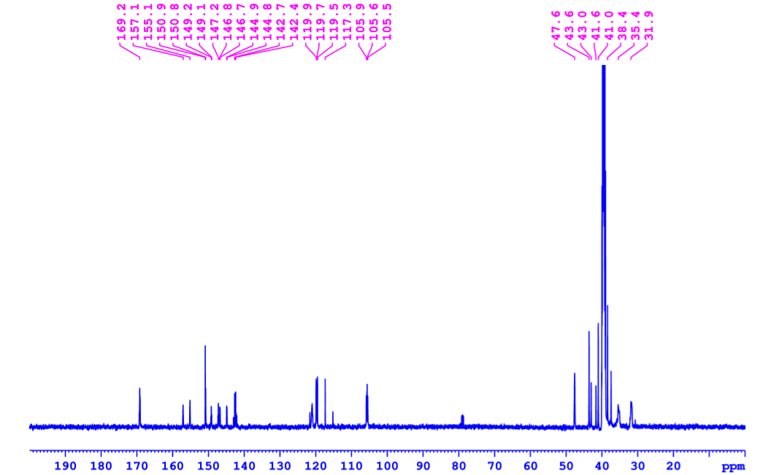

13C-NMR of sitagliptin-phosphate salt in DMSO-d6

**1H NMR** (500 MHz, DMSO-d6) δ = 2.75 (m, 1H), 2.98 (s, 2H), 3.64 (s, 1H), 4.00 (s, 2H), 4.23 (s, 1H), 4.84 (m, 4H), 7.41 (m, 1H), 7.55 (m, 1H). **13C NMR** (125 MHz, DMSO-d6) δ = 31.0, 35.4, 38.4, 41.6, 43.6, 47.6, 105.9, 117.3, 119.5, 119.9, 142.7, 146.7, 149.2, 150.9, 157.1, 169.2.